RECORDING SYSTEM
"AVIATOR"

Operator's Manual

Total sheets 233

Moscow
2018

Contents
Introduction 6
1 Purpose of the complex software 7
2 The complex software performance conditions 8
2.1 Hardware conditions 8
2.2 Software conditions 8
3 User interface 9
3.1 Basic elements of graphical interface 9
3.1.1 Button 9
3.1.2 Selector switch 9
3.1.3 Сheckbox 10
3.1.4 Slider 10
3.1.5 Progress indicator 10
3.1.6 Status indicator (light) 11
3.1.7 List 12
3.1.8 Group 12
3.2 Control Panel Window 13
3.2.1 Miscellaneous 14
3.2.2 Log 15
3.2.3 Status bar 15
3.2.4 Right-hand panel 16
3.2.5 Workspace 16
4 Control Panel operation modes 17
4.1 Mode "WS" 17
4.1.1 General Information 19
4.1.1.1 Information on removable storage 20
4.1.1.2 Information about printer 25
4.1.1.3 Information on condition of hard drives 26
4.1.2 General settings 32
4.1.2.1 Settings of the panel "Miscellaneous" 33
4.1.2.2 Setting of network interfaces 34
4.1.2.3 Printer settings 36
4.1.2.4 Sound settings 37
4.1.2.5 Clock settings 38
4.2 Mode "Recording server" 39
4.2.1 Information about the recording servers 39
4.2.1.1 General Information 40
4.2.1.2 Information on AAU 40
4.2.1.3 Information on Topaz servers 46
4.2.1.4 Information on screens 47
4.2.1.5 Information on Time Server (TSS) 48
4.2.1.6 Information on Internal (online) archives 49
4.2.1.7 Information on removable storage 50
4.2.1.8 Information about connections 54
4.2.1.9 Information about UPS 55
4.2.1.10 Information about RAID 56
4.2.1.11 Information about digital telephony 57
4.2.1.12 Voice communication system (VCS) record status information 59
4.2.1.13 Stream data record status information 61
4.2.1.14 RTSP record status information 63
4.2.1.15 RTP2NET status information 65
4.2.1.16 Information about the status of switches 67
4.2.2 Setting of recording servers 68
4.2.2.1 Setting of AAU 70
4.2.2.2 Voice communication system (VCS) record settings 77
4.2.2.3 E1 stream data record settings 81
4.2.2.4 Settings of monitor screens 85
4.2.2.5 User and group settings 87
4.2.2.6 Settings for digital telephony 100
4.2.2.7 RTSP parameter settings 101
4.2.2.8 RTP2NET configuring 106
4.2.2.9 Configuring of the Switch Status 111
4.3 Mode "Monitoring" 112
4.3.1 Monitoring of AAU stations 113
4.3.2 Online voice communication system abonent monitoring and listening 124
4.3.3 Online E1 stream data monitoring and listening 127
4.3.4 Monitoring of Radar Data Workstations "Topaz" 130
4.3.5 Monitoring of RSTP 131
4.3.6 Screen Data Monitoring 133
4.3.7 Control of digital telephony 136
4.4 Mode "Archive" 137
4.4.1 Selection of archive fragment 138
4.4.2 Playback of archive fragment 140
4.4.2.1 AAU data 142
4.4.2.2 Radar Data 152
4.4.2.3 Data from screen displays 153
4.4.2.4 Digital telephony data 156
4.4.2.5 Playback of voice communication system (VCS) data from archive 157
4.4.2.6 Playback of E1 stream data recorded from archive 160
4.4.2.7 RTSP data 163
4.4.2.8 Transcriptions editor 165
4.4.3 Viewing of statistics for an archive fragment 169
4.4.4 Export of the archive fragment 171
4.5 Mode "Journal" 179
5 Complex software 182
5.1 Components of the complex software 182
5.1.1 Recording server 183
5.1.1.1 File structure of long-term archive 184
5.2 Monitoring Workstation 185
5.2.1 Purpose 185
5.2.2 Basic operations performed at monitoring workstation 185
5.2.2.1 Status scan of recording servers 186
5.2.2.2 Set-up of recording servers 188
5.2.2.2.1 Set-up of AAU parameters 190
5.2.2.2.2 Set-up of user accounts and rights 192
5.2.2.3 Listening of point-to-point channel 195
5.2.2.4 Viewing of Radar Data information 200
5.2.2.5 Replacement of removable storage in recording server 203
5.2.2.6 Playback from archive 206
5.2.2.7 Viewing of archive statistics 209
5.2.2.8 Operations with long-term archive and removable storage 210
5.3 Playback station 212
5.3.1 Purpose of the complex software 212
5.3.2 Basic operations performed at Playback station 212
5.3.2.1 Selection of archive fragment 213
5.3.2.2 Playback from AAU data archive 217
5.3.2.3 Playback from Radar Data archive 220
5.3.2.4 Playback of screen shots from the archive 222
5.3.2.5 Export of data from archive 225
А List of Abbreviations 227
В Log messages 228

Introduction
Complex "Aviator" is designed for recording voice and radar data and information from working position monitors. This complex represents a digital generation of air traffic control process recording systems among the Russian suppliers of recording facilities.
This operator's manual is applicable to software of recording system "Aviator" and contains the description of both functionality and graphical interface of the complex user.

Purpose of the complex software
The software is intended for realisation of functional and tuning capabilities of the complex:
- Compression of data sent to input of the complex system units;
- Control of record and playback of voice and radar data, viewing screens of Automated Working Position, including synchronous playback of data for all recorded sources from the online or long-term archives (removable storage);
- Binding recorded data to signals of exact time;
- Remote control of all sub-systems of the complex;
- Real-time listening of point-to-point channel, viewing screens of Automated Working Position without stopping data recording;
- Logging of personnel's operations;
- Multi-level differentiation of user rights in accordance with account data for each user;
- Playback speed scaling;
- Adjustable scanning of record fragments by markers of signal delivery for each channel, as well as scanning by time and name of channel;
- Processing, displaying and printing out of statistical information on occupancy of channels, availability of a signal in lines and recording time.
The complex "Aviator" software is operable in the environment of Linux operating systems (kernel version 3.10 and above (Red Hat 7), using all capabilities of multi-stream and parallel processing of initial data and access control to confidential data of various user categories. The used operating system has a security system, which operates in accordance with the access control principle. The operating system supports security data related both to the access subject (user, group) and to the access objects (files, printers, etc.). The security system enables or disables access to the object requested by a user or a program run as a user. The object owner gives permissions or denies access to objects for users and groups of users in accordance with discretionary access control. The security system identifies and checks the user authenticity and then allows only those actions with objects that are permitted to it by object owners.

The complex software performance conditions

Hardware conditions
- using system units with processor not worse than i3 with frequency of 2,5 GHz and random-access memory (RAM) of not less than 2048 MB at all workstations of the complex (including Radar Data Playback Station);
- using a system unit with video memory of not less than 2048 MB at Radar Data Playback station.

Software conditions
- installation of additional software (not included into the delivery set) into the system units of the complex is prohibited;
- modification of system parameters of the operating system and LAN parameters of the complex during normal operation is prohibited.

User interface

Basic elements of graphical interface
This section describes the elements of graphical interface (EGI) used on the Control panel.

Button
The button is an image of mechanical button on the screen display that performs similar functions (Figure 3.1). The button has two states: pressed and released. When it is pressed, an associated software action or event occurs. Pressing means, in particular, a mouse click on the button image. Marked edge of the button means, that the button is pressed by the key <Space> on the keyboard.
Figure 3.1 – Button

Selector switch
Selector switch (Figure 3.2) enables the user to select one option from predetermined set. The set consists of two or more elements. Text with description of option is displayed near each element of the set. An option is selected by mouse click on the relevant checkbox.
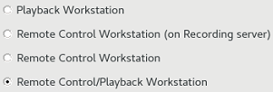
Figure 3.2 – Selector switch

Сheckbox
Сheckbox (Figure 3.3) is an element of graphical interface which provides a user with the multiple-choice alternative. The checkbox is a square of small size, which has two states: on and off. When the checkbox is on, a mark is displayed inside the checkbox (a check mark or a cross). When mouse-clicked the checkbox changes its status.
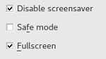
Figure 3.3 – Activated and deactivated checkbox

Slider
Slider (Figure 3.4) is used for setting some value within a certain range. The value is changed by pressing the left mouse button on the slider knob with simultaneous deflection of the knob along the slider rail.
Figure 3.4 – Slider

Progress indicator
Progress indicator (Figure 3.5) is used for displaying the level of a specific operation completion or the extent of a certain space filling.
Figure 3.5 – Progress indicator

Status indicator (light)
Status indicator (Figure 3.6) is intended for monitoring of the object status in the system and may have several various statuses displayed by colour:
- Grey colour: monitored object is disabled in the settings or unavailable, and its value is neglected;
- Green colour: the object is ok;
- Yellow colour: warning on the object status, which shall be corrected. Recorded data are not lost in this status;
- Red colour: reports on a problem with the monitored object as well as on potential loss of data during recording.

Figure 3.6 – Status indicator

List
List is an element of the graphical user interface which displays the scrolling list with elements (Figure 3.7). It enables the user to select one or several elements from the list, generally with held down "Ctrl" or "Shift" keys in order to make a multiple choice. Lists may be simple and nested, having a tree structure.
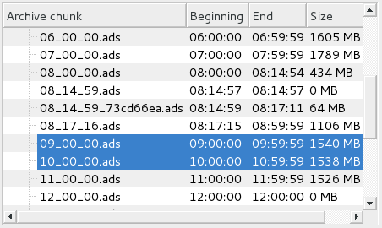
Figure 3.7 – List

Group
Group (Figure 3.8) allows visual combining of several graphical elements as one single unit. Normally, the name of group is indicated on the top (e. g., Recording server 1)
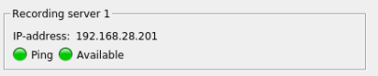
Figure 3.8 – Group

Control Panel Window
Control Panel Window (Figure 3.9) can be logically divided into the following parts:
- Miscellaneous;
- Workspace;
- Right-hand panel;
- Log;
- Status bar.
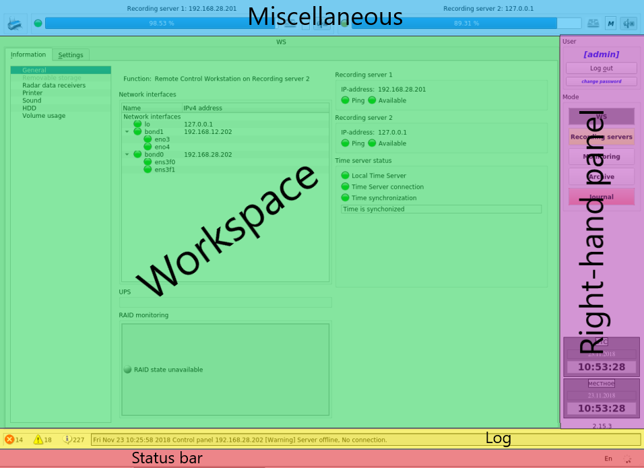
Figure 3.9 – Main window of control panel

Miscellaneous
Miscellaneous (Figure 3.10) is intended for easy access to important information, operations with removable storage and disconnection of sound alarm in case of the system failures.
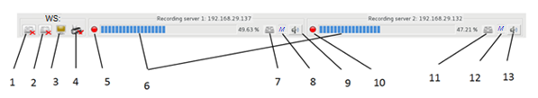
Figure 3.10 – Miscellaneous
Depending on configuration and performed steps it may contain the following elements (the number of element is shown in brackets according to Figure 3.10):
- Mount/unmount removable storage with archive [1];
- Mount/unmounts export storage [2];
- Connection to Radar data Workstation [3];
- Printer state [4];
- Recording server 1 general state [5];
- Indicator for exporting data associated with filling the memory of the internal (online) archive to the external drive [6];
- Unmount external storage on Recording server 1 [7];
- Data copying mode to removable storage on Recording server 1 [8];
- Audio Alarm for Recording server 1 on / off [9];
- Recording server 2 general state [10];
- Unmount external storage on Recording server 2 [11];
- Data copying mode to removable storage on Recording server 2 [12];
- Audio Alarm for Recording server 2 on / off [13].
Logically all elements are united in three groups: this AWS, recording server No. 1, recording server No. 2. When the mouse cursor is pointed over any element of control panel, a pop-up help appears prompting about the function of the element.

Log
Log (Figure 3.11) contains information on the number of unread critical, warning and information messages. It also displays information on the most critical of the log messages unread by the current user. Error messages are highlighted in red, and warnings – in yellow. Log is only displayed if the current user has access to view it.
Figure 3.11 – Log

Status bar
Status bar is located at the bottom of the Control Panel (Figure 3.12). Status bar displays auxiliary information about the element currently pointed over by the mouse cursor. The right section of the status bar accommodates a text ID (identifier) of the current keyboard layout and control panel activation indicator.
Figure 3.12 – Status bar

Right-hand panel
The main function of right-hand panel (Figure 3.13) is an option of Control panel operation mode selection [2]. A form for user authorization [1] and information on current time [3] are also accommodated on the right-hand panel.
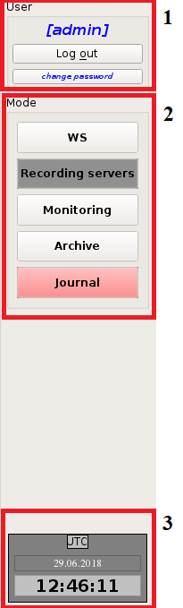
Figure 3.13 – Right-hand panel

Workspace
Workspace is the main area of Control Panel. In the workspace the user may perform settings, control playback and view various information on the complex state. The content of workspace depends on mode selected on the right-hand panel.

Control Panel operation modes
The complex Control Panel can operate in the following modes:
- WS;
- Recording server;
- Monitoring;
- Archive;
- Journal.
Mode is selected on the right-hand panel (please see 3.2.4). Depending on the set configuration and current user rights, some modes may be unavailable. The name of current operation mode is displayed on the top of the main panel.

Mode "WS"
In this mode the workspace contains two tabs (Figure 4.1).
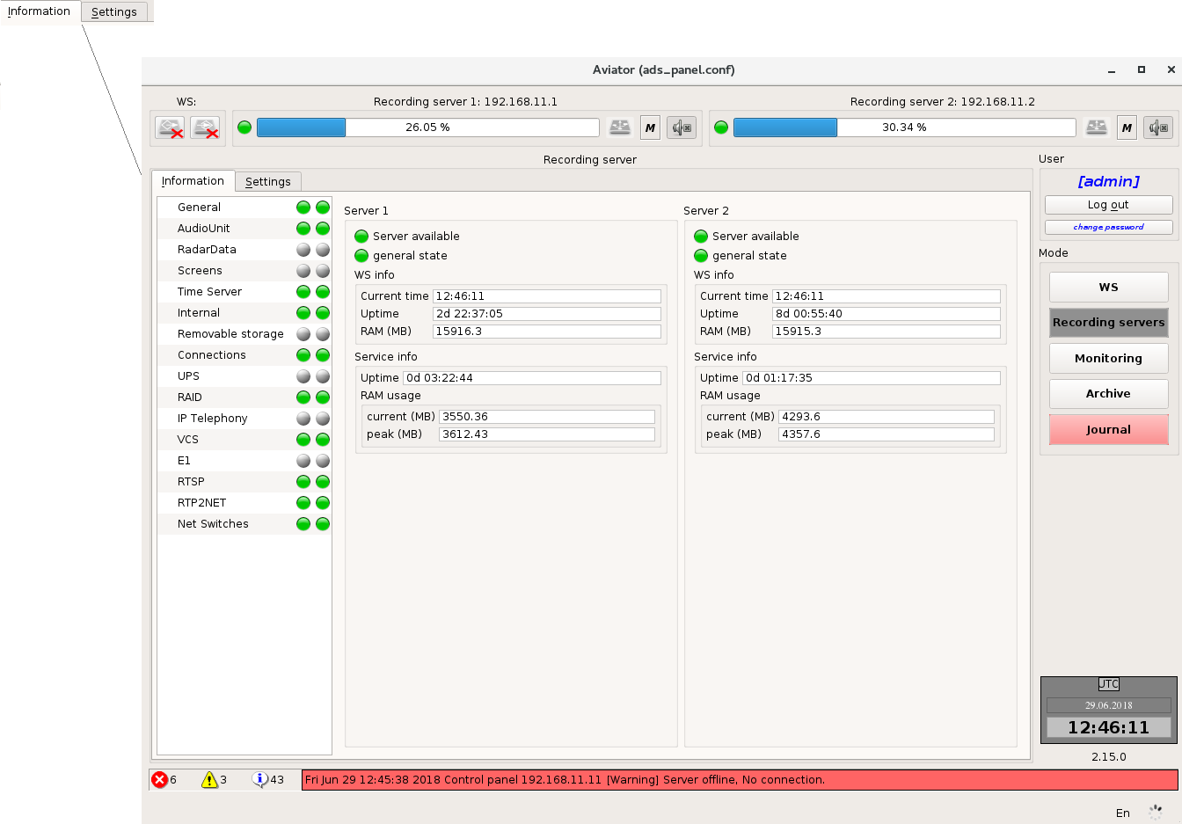
Figure 4.1 – Tabs of WS mode
From the tab "Information" the user gets access to the data about this WS. On the tab "Settings" the user may change the settings of this WS.
The right section of tabs "Information" and "Settings" contain the list of several items. From these lists, the user can select what type of information he wants to view and what properties to set up.
When moving to tab "Settings" you need to enter the password of the operating system current user (Figure 4.2).

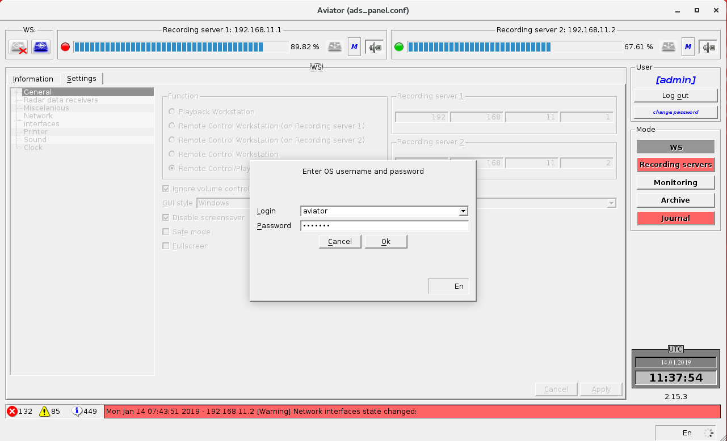
Figure 4.2 – Password input window

General Information
General information (Figure 4.3) includes the data on configuration (functionality) of this WS; operation of network interfaces, UPS, RAID; connectivity with recording servers, Radar Data Playback Workstation and Time Server.
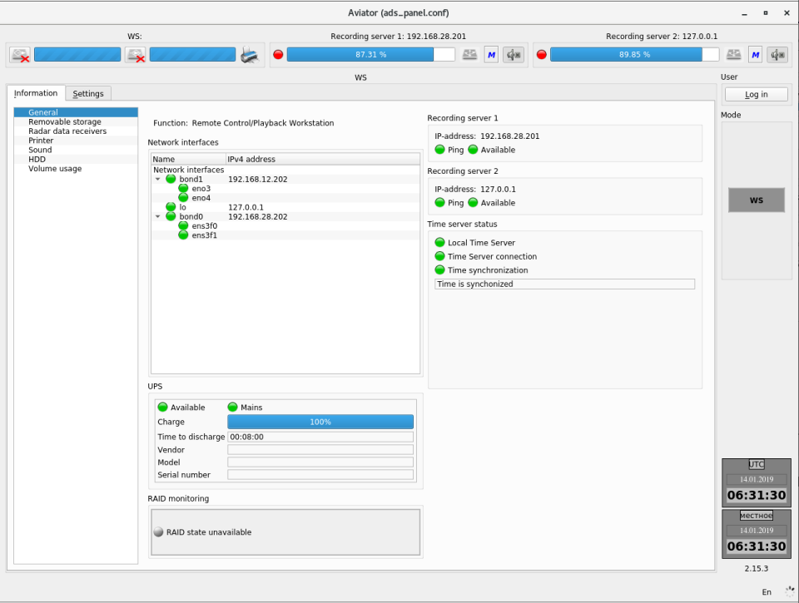
Figure 4.3 – General information on WS

Information on removable storage
Tab provides the user with information on the state of removable storage of the archives and exported data.
All fields will be empty and indicators will have grey colour, if removable storages are not connected (Figure 4.4).

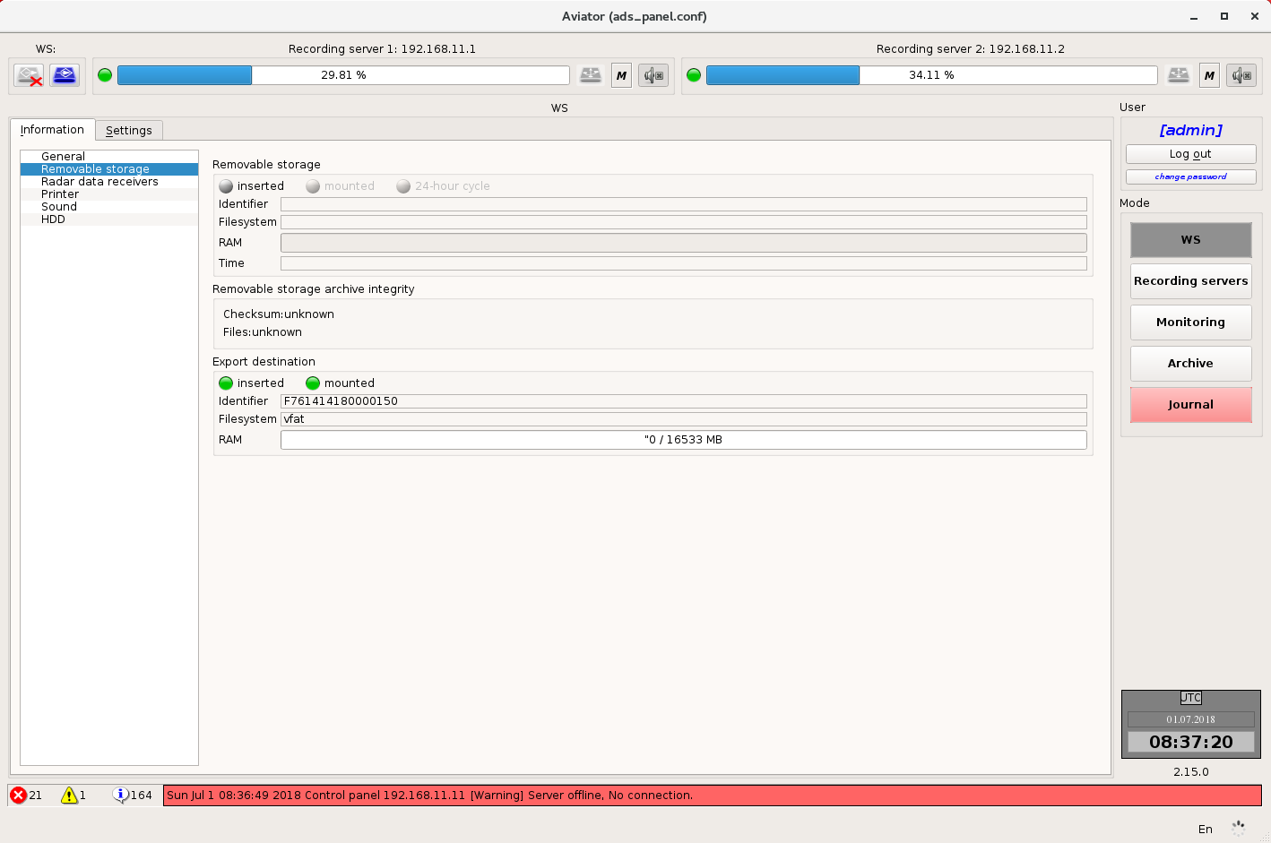
Figure 4.4 – Information on removable storage

When removable storage is connected indicators "Inserted" and "Mounted" will become green and information on the storage will appear in the fields: ID (name) of storage in the system, the removable storage file system, rate of removable storage memory filling (Figure 4.5).

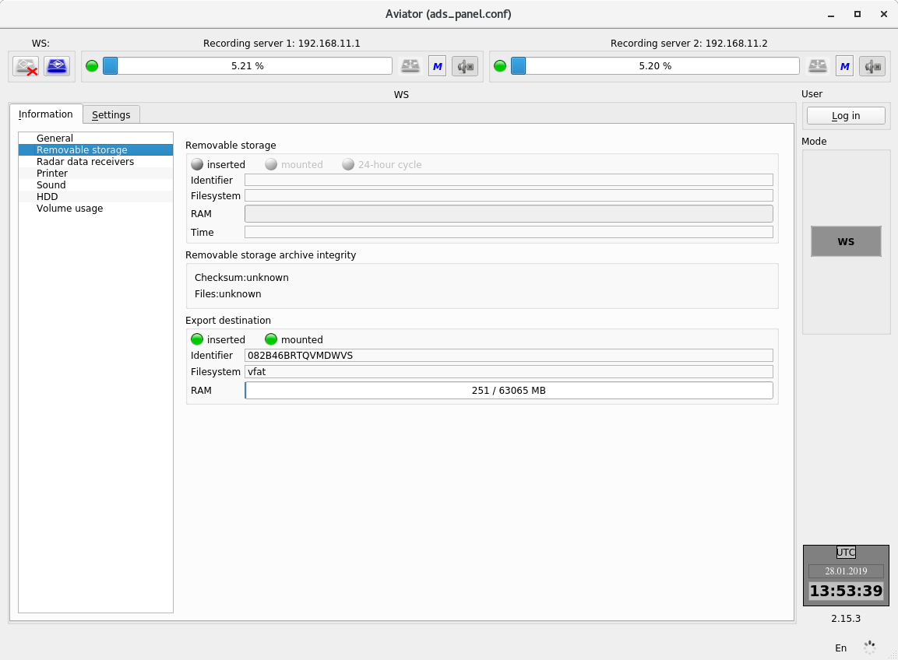
Figure 4.5 – Information on removable storage – the removable storage is mounted
For a removable storage with archives there is an additional indicator "24-hour cycle" and indicator of time interval, for which there are records on the removable storage.
The colour of indicator "24-hour cycle" depends on how the work with removable storage was completed on the server. If the removable storage was removed in normal mode (after completion of all tasks) the indicator colour will become green. If the removable storage was removed forcefully before completion of all tasks, the indicator colour will become yellow.

After removable storage with archives connection the program will check files and checksums to them (Figure 4.6).
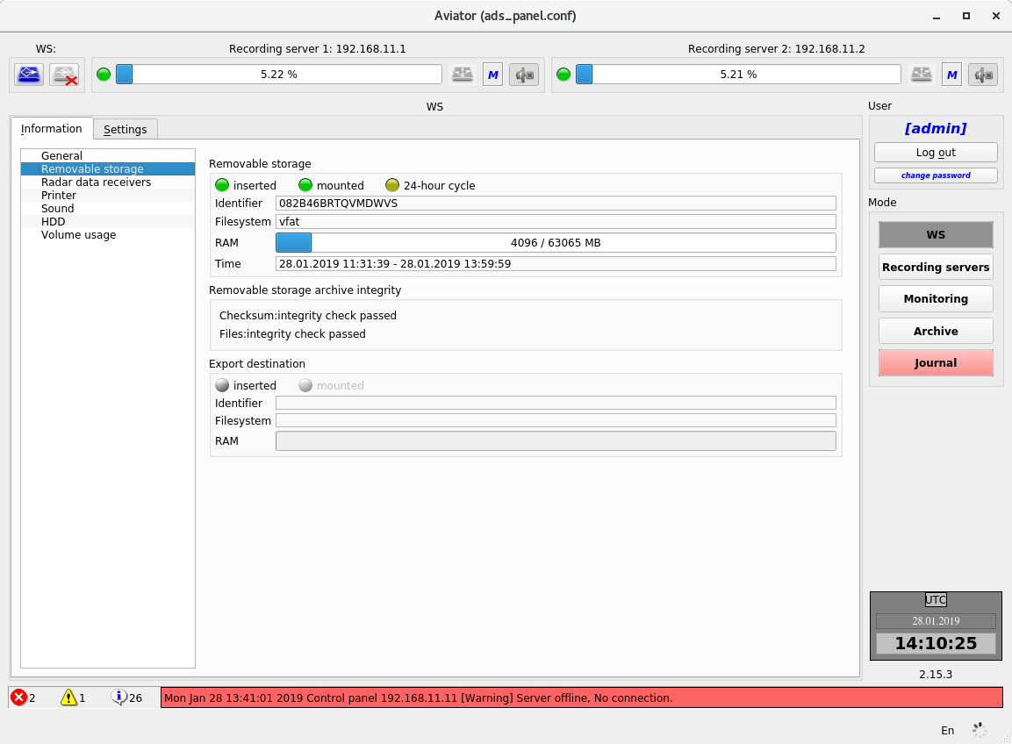
Figure 4.6 – Check of data integrity
If the check is successful, both lines will show an inscription "integrity check passed" (Figure 4.5).

If the check proves that the file checksums are damaged, an inscription "integrity check failed!!!" will be displayed in line "Checksum" (Figure 4.7).
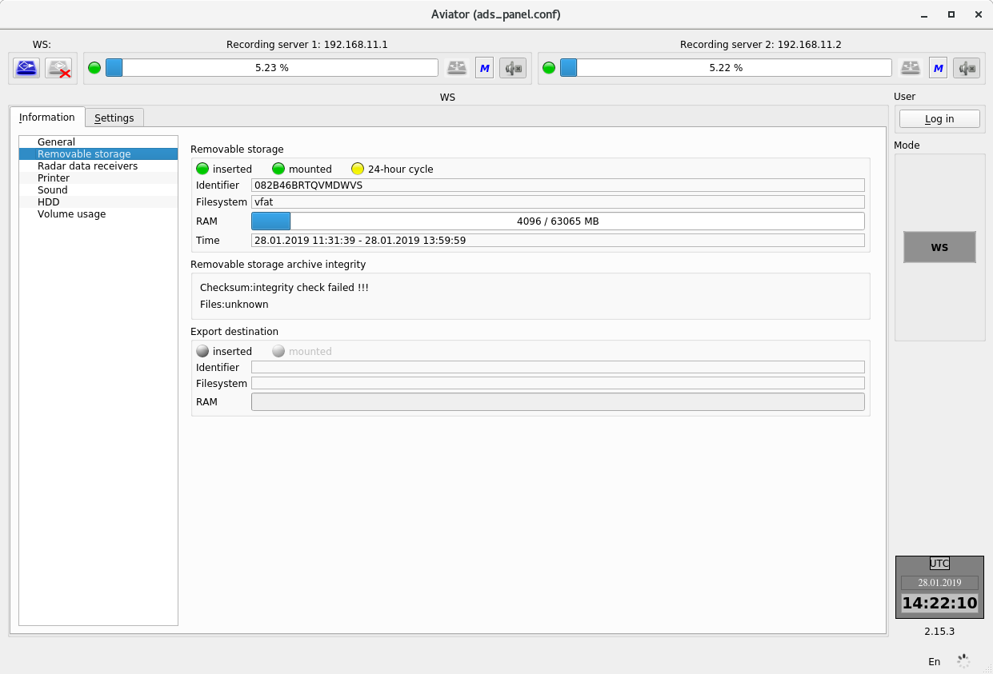
Figure 4.7 – Integrity of checksums is damaged

If the check proves that the very files are damaged, an inscription "integrity check failed!!!" will be displayed in line "Files" (Figure 4.8).
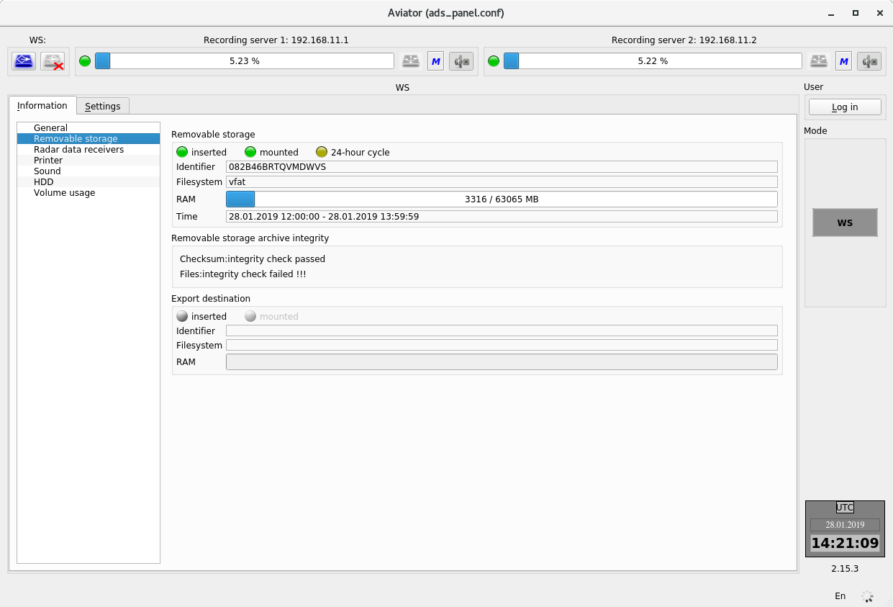
Figure 4.8 – Integrity of files is failed

Information about printer
Information about printer (Figure 4.9) allows the user to obtain the data on printer settings and the list of tasks for it.
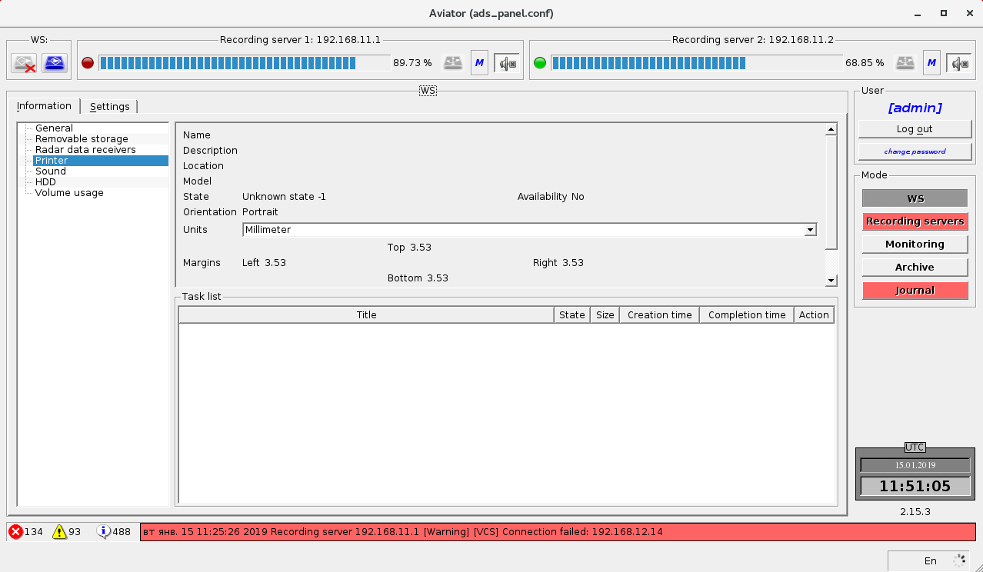
Figure 4.9 – Information about printer
Adjustment of printer settings is described in item 4.1.2.3.

Information on condition of hard drives
Tab provides the user with information on condition of hard drives based on S.M.A.R.T. data (Self-Monitoring, Analysis and Reporting Technology) (Figure 4.10).
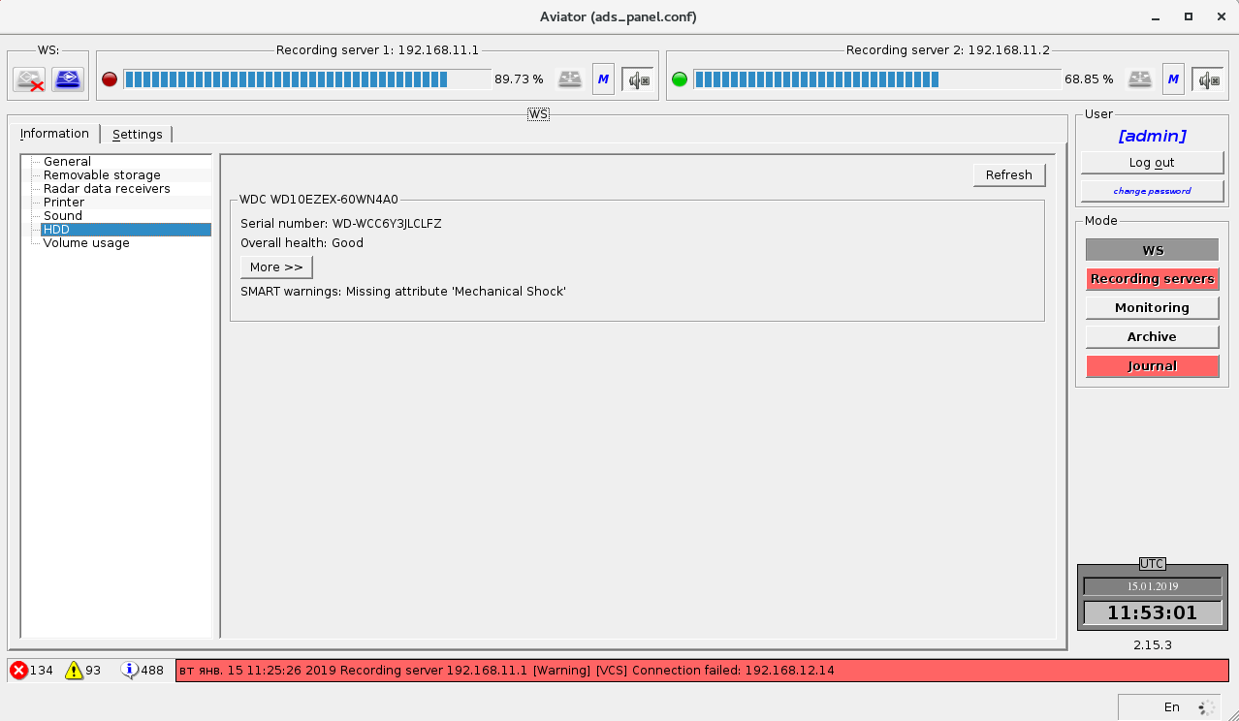
Figure 4.10 – Information on condition of hard drives
Button "Refresh" updates the list of hard drives connected to PC and supporting S.M.A.R.T. During analysis of the system inscription about updating information on HDD is displayed. If no drives supporting S.M.A.R.T. are detected in the system or authorities for starting the check is not enough, inscription "SMART is not supported or disabled" is displayed. Otherwise after completion of analysis the panels of drives are displayed instead of the inscription.
The drive panel presents identification information, details of the drive overall condition and button "Details", which is used for displaying or hiding S.M.A.R.T. attribute panel.
Identification information is represented by the panel header containing the name of device and serial number, which is displayed after inscription "Serial number".
Overall condition of the drive is evaluated on the basis of estimation of the current value of attributes. If the values of all attributes are within the standard limits, inscription "Overall health: Good" is displayed. If the minor attributes are not within the standard limits, inscription "Overall health: Problems are detected") is displayed. This inscription means that the drive shall be periodically inspected for degradation of its condition. If critical attributes are not within the standard limits, inscription "Overall condition: Critical condition, breakdown is possible" is displayed, and the drive shall be replaced.
A table with current values of attributes is displayed on tab "Parameters" of the attribute panel (Figure 4.11).
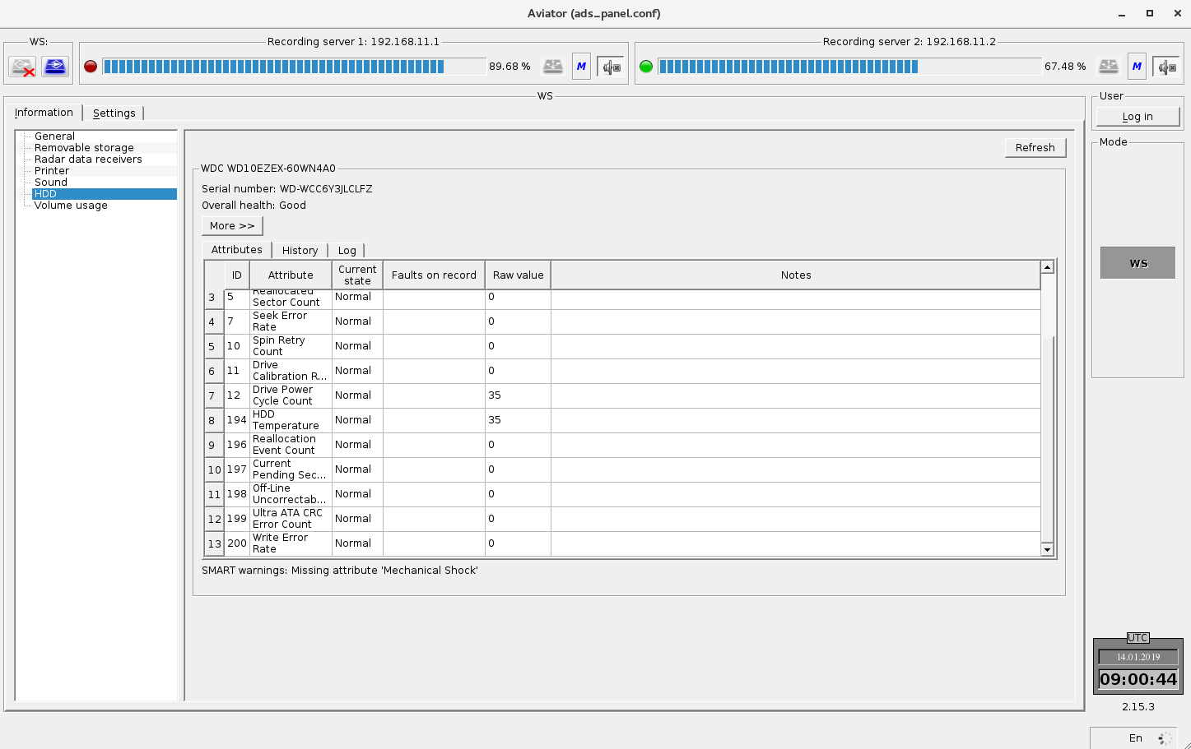
Figure 4.11 – S.M.A.R.T. attributes
Column "ID" displays the ID, which uniquely defines the attributes. Column "Attribute" displays the attribute name. Column "Current state" contains the estimated attribute value. If the value is within the admissible limits, word "Normal" is displayed, otherwise "Failed" is displayed. Column "Faults on record" displays word "Yes", when the attribute value was outside of the standard limits any time in the past. Column "Raw value" displays the value of attributes. If an attribute value exceeds admissible limits, the line in the table related to this parameter will be coloured. The colour depends on importance of the attribute. Non-essential parameters are coloured yellow, while the critical ones are coloured red. If the critical parameter had malfunctions only in the past, it is still coloured yellow.
Tab "History" of the attribute panel shows how the values of attributes have changed from the first start of the program. Variations of the values of each attribute are displayed in its own time curve. The attribute name is displayed above the relevant curve. A control element enabling collapse and expand the curve is arranged to the left of the name. Control element "Show all", located in the left top corner of tab "History" of the attribute panel, enables to collapse and expand all curves simultaneously
Selector switches "Raw value" and "Value" are located in the right top corner of the tab.
When selector switch "Raw value" is off, the curves will show time variations of attributes values (Figure 4.12).
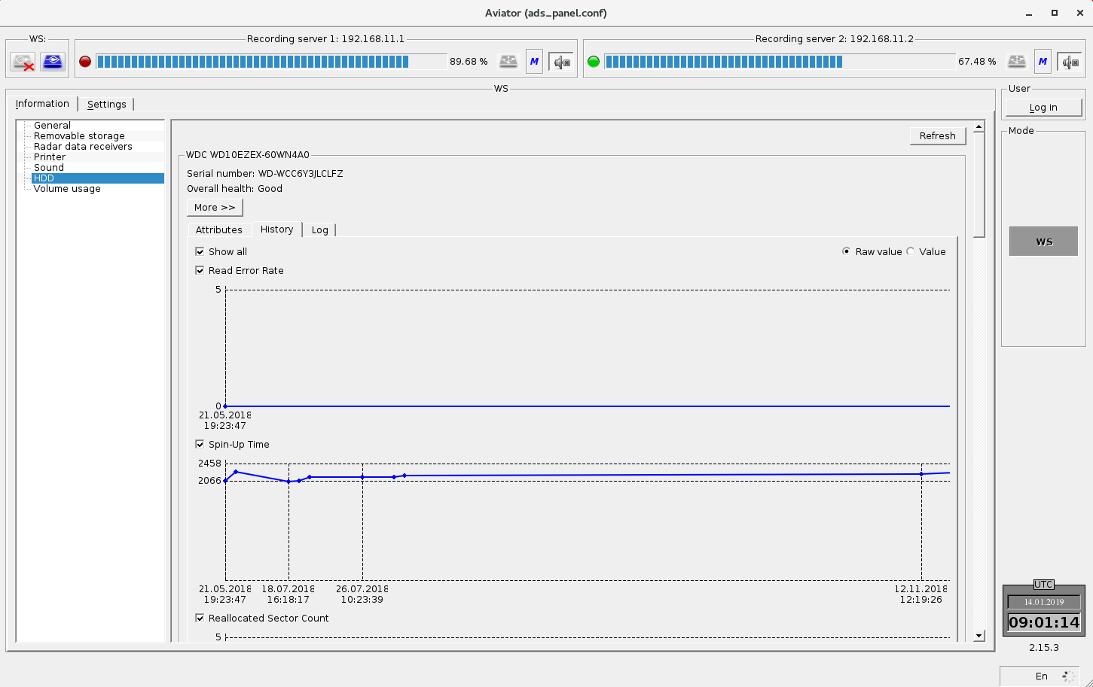
Figure 4.12 – Archive of the values of S.M.A.R.T. attributes in graphical form

When selector switch "Value" is on, the curves will show variations of the estimated values (Figure 4.13).
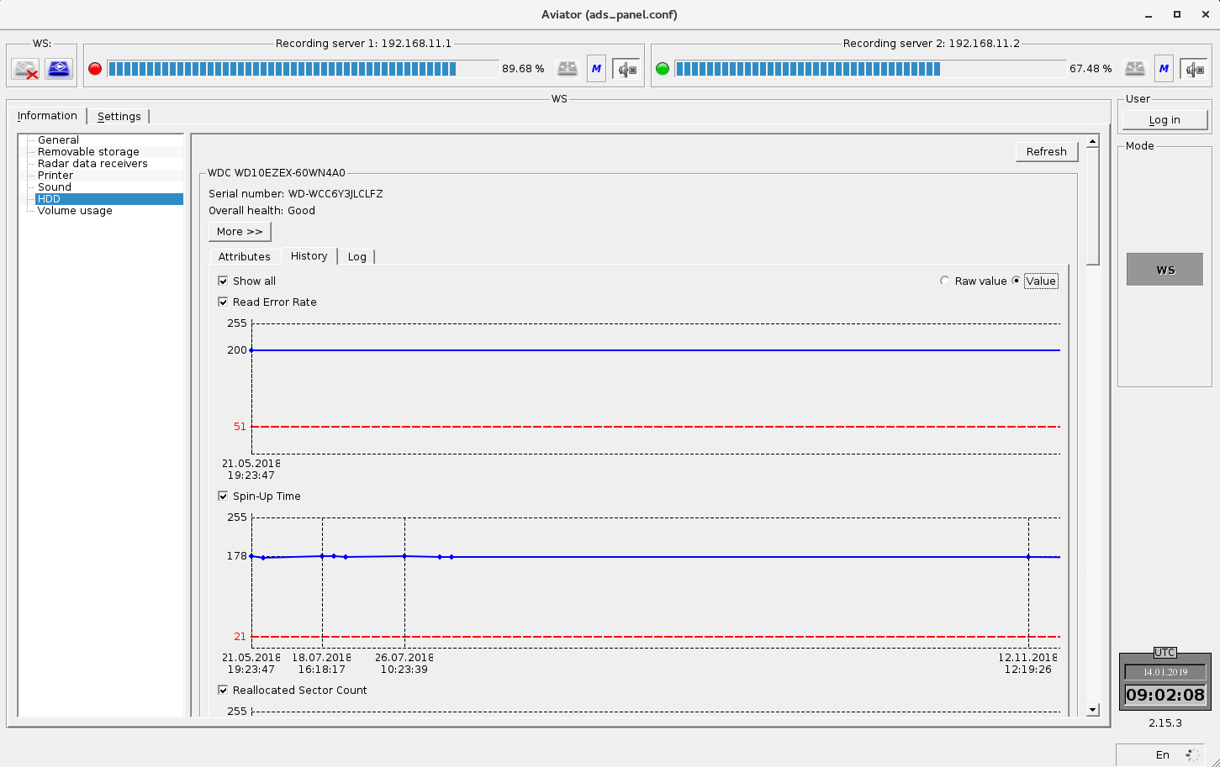
Figure 4.13 – Archive of estimated values of S.M.A.R.T. attributes in graphical form
Such values represent abstract figures calculated by each manufacturer of drives according to their own algorithm. Normally these figures will be not less than the abstract critical level, which is also determinable by each drive manufacturer independently. The critical level is shown on the curve as a red dotted horizontal line.

Tab "Log" of the attribute panel (Figure 4.14) displays variations of the attributes' values in text form.
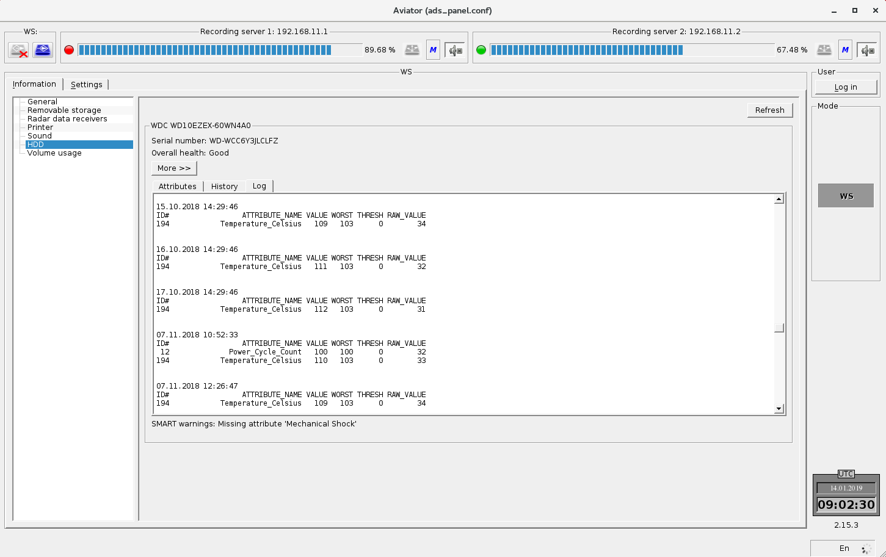
Figure 4.14 – Archive of S.M.A.R.T. data in text form
Text description has the following structure. The first two lines contain the device name and its serial number, which are displayed after words "WDS" and "Serial Number:" respectively.
Records with the values of attributes divided by blank lines follow next. Each record starts from the time tag relevant to the time of measurement of the attributes' values.

Time tag format:
"dd.MM.yyyy hh:mm:ss" where:
- dd – day;
- MM – month;
- yyyy – year;
- hh – hour;
- mm – minutes;
- ss – seconds.
A table with the attributes is shown below the time tag. It indicates the value of attributes relevant to the time tag.
Column "ID" displays an identifier that uniquely identifies the attributes.
Column "ATTRIBUTE_NAME" displays name of attribute in the English language.
Column "VALUE" displays an abstract attribute, which is calculated according to own algorithms of hard drive manufacturer and characterises the attribute value correctness.
Column "WORST" displays the minimum value ("VALUE") for the entire drive operation period. Column "THRESH" displays the value of abstract critical level below which the values "VALUE" and "WORST" should not go.
Column "RAW_VALUE" displays the attribute value.

General settings
In general settings (Figure 4.15) the user may select WS function (configuration), set IP-addresses of recording servers and Radar Data Playback Station, set the clock or add a clock, choose the GUI style (recommended style "Windows").
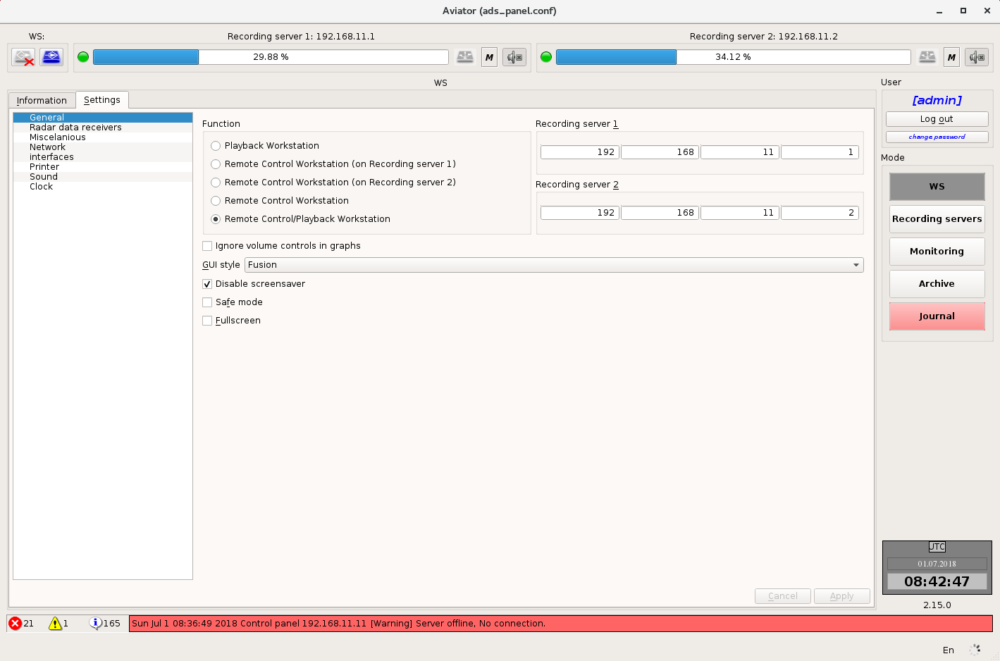
Figure 4.15 – General settings
Checkbox "Disable screensaver" enables to block the launch of screen saver in case of long idleness of the system.
Activation of check mark "Safe mode" results that the only "Control panel" of the complex remains active. All other programs become unavailable (at the same time check mark "Full-screen mode" is set automatically).
Checkbox "Full-screen mode" is intended for switching the program from the window mode to the full-screen mode and back.

Settings of the panel "Miscellaneous"
Settings of the panel "Miscellaneous" are intended to specify, which elements exactly will be displayed in the panel "Miscellaneous" or completely hide it (Figure 4.16).
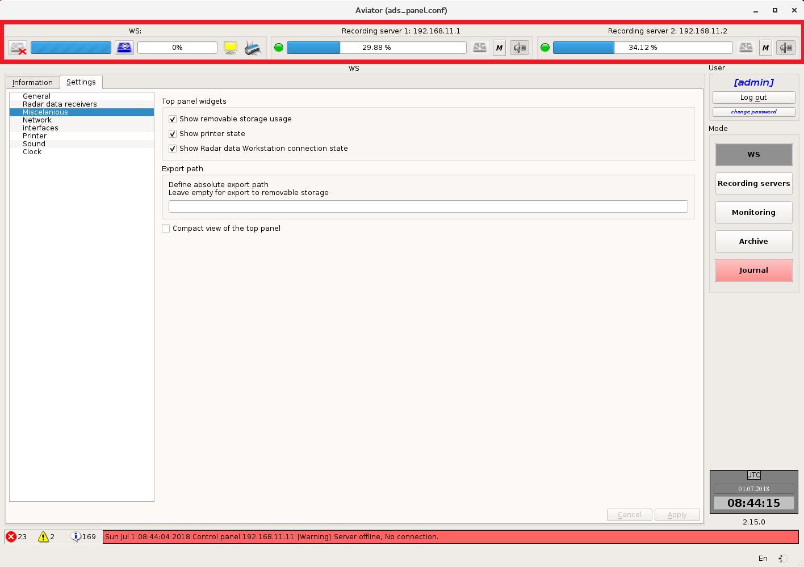
Figure 4.16 – Settings of the panel "Miscellaneous"
Activation of one or another check mark results to display respective element. After changing the settings press button "Apply".

Setting of network interfaces
All network interfaces detected in the system are displayed in Figure 4.17.
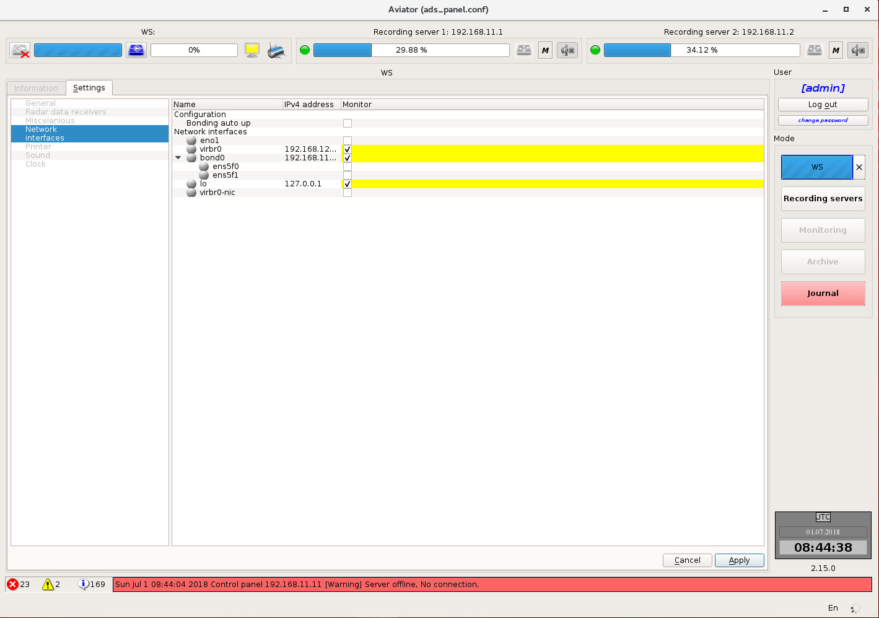
Figure 4.17 – Setting of network interfaces
A user may select, what network interfaces are to be displayed in column "Monitor" when viewing general information about the system (see item 4.1.1). All changes made by the user but not saved yet are highlighted in yellow. Press the button "Apply" to save the setting. After pressing the button, a window will be displayed stating that the settings were changed.
If checkbox "Bonding auto - up" is selected, the program will track the bonding condition and restore its operability if required.

Activation of a check mark leads to display the relevant element. After changing the settings press button "OK" (Figure 4.18).
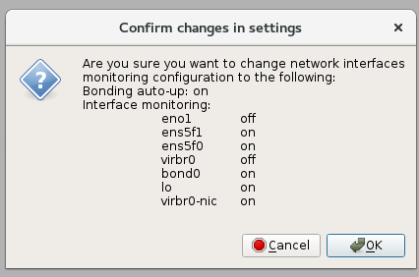
Figure 4.18 – Confirmation window

Printer settings
This tab accommodates all printer settings (Figure 4.19).
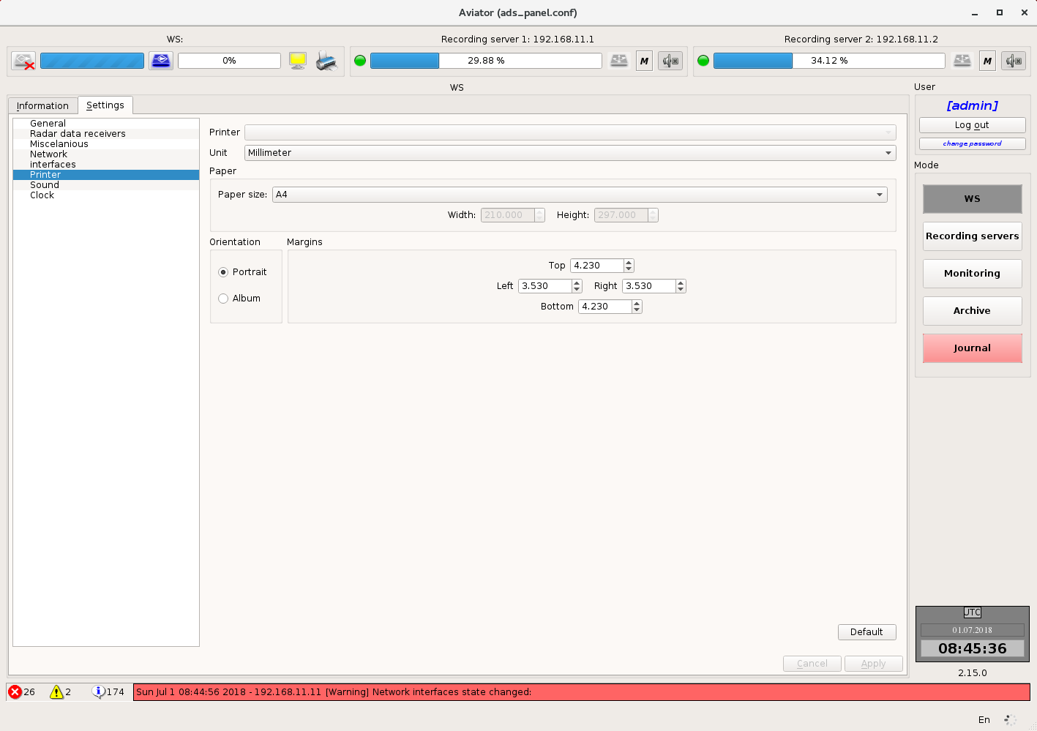
Figure 4.19 – Printer settings
The user may choose the printer, which will be used for printing, select the paper format and printing orientation, adjust the margins.
Button "Default" restores factory settings of the program.
After making changes press button "Apply".

Sound settings
Sound settings allows you to select a device to output the audio signal at WS and adjust the playback quality (Figure 4.20).
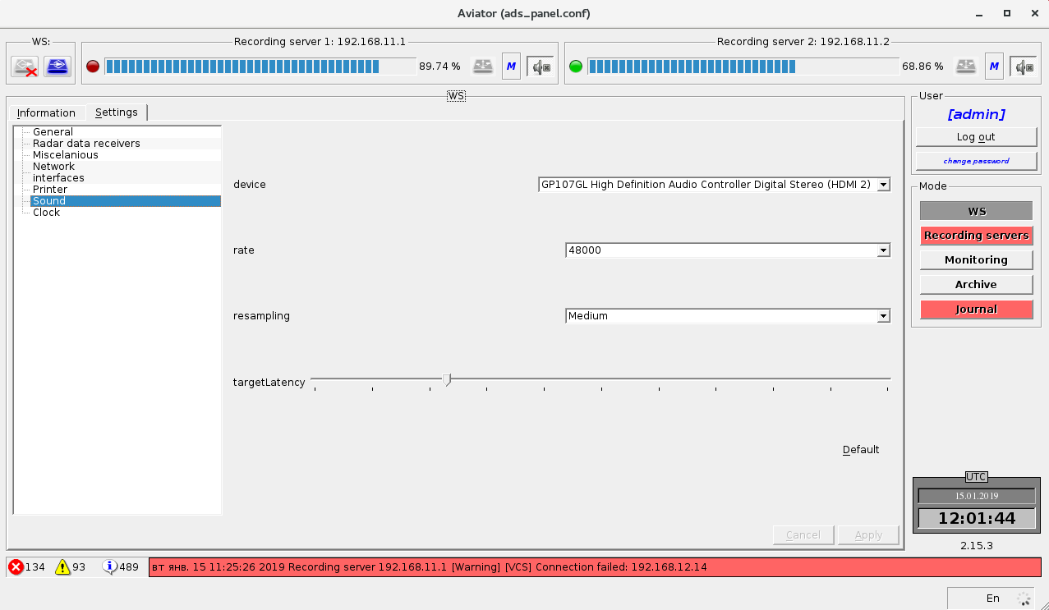
Figure 4.20 – Sound settings

Clock settings
Clock settings allows you to display additional clock, except for the main ones with the UTC time (Figure 4.21).
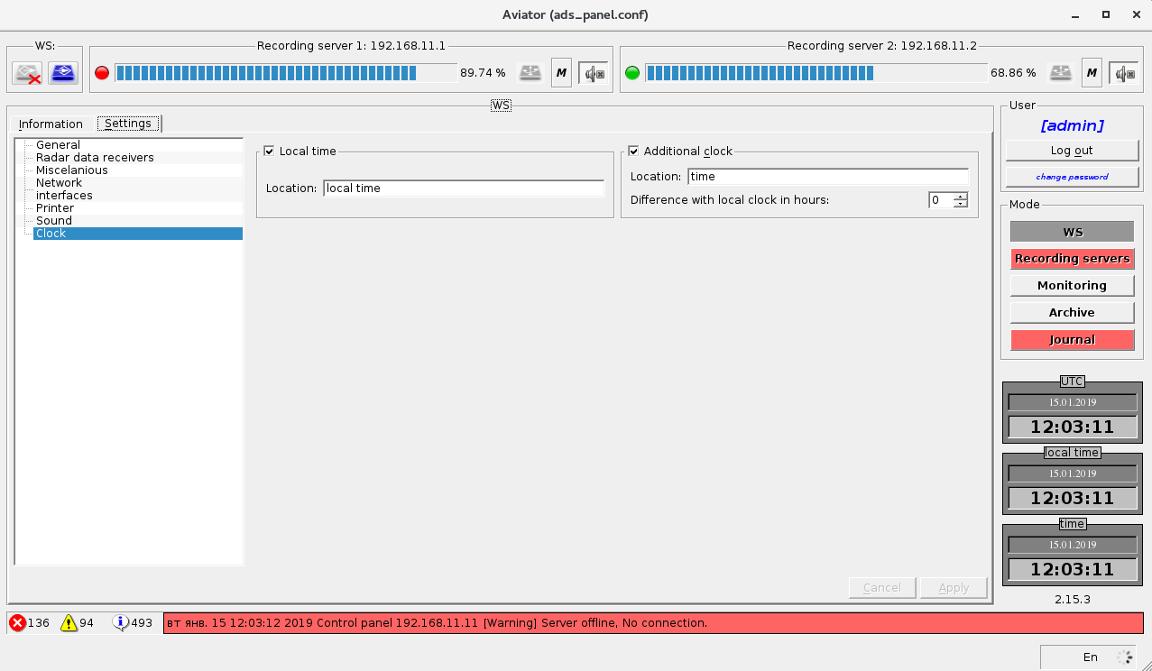
Figure 4.21 – Clock settings

Mode "Recording server"
Mode "Recording server" is used for:
- viewing the state of recording server sub-systems (tab "Information");
- controlling of operation modes and settings of recording servers (tab "Settings").

Information about the recording servers
The right part of the tab accommodates the list of items (Figure 4.22), from which the user may select, what information he wants to receive.
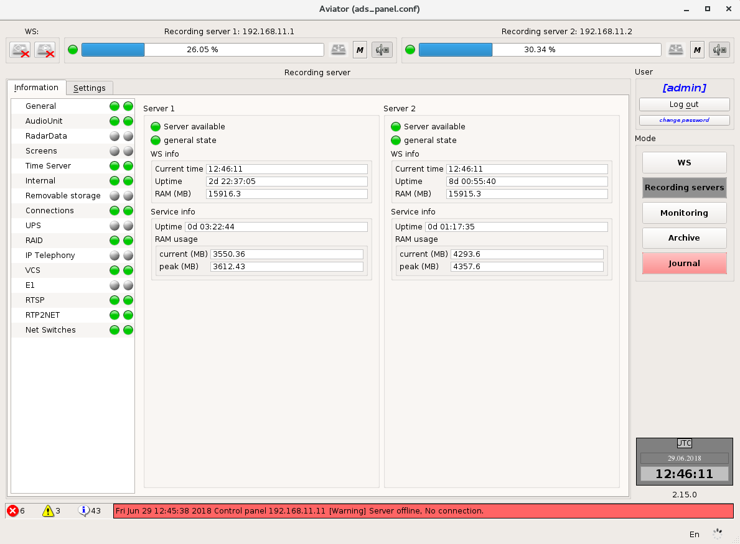
Figure 4.22 – General information
Each tab has two indicators - one per each recording server. The indicator colour warns of serviceability (green indicator) or malfunction (red or yellow indicator) of the corresponding server.

General Information
This tab (Figure 4.22) displays information on availability of recording servers, current system time, time of uninterrupted operation documentation server, volume of RAM, the time of operation of the complex SW and on the volume of memory occupied by such SW, as well as information about the occupancy.

Information on AAU
The workspace is divided into two parts. Each part provides information on the state of AAU on the server (Figure 4.23).
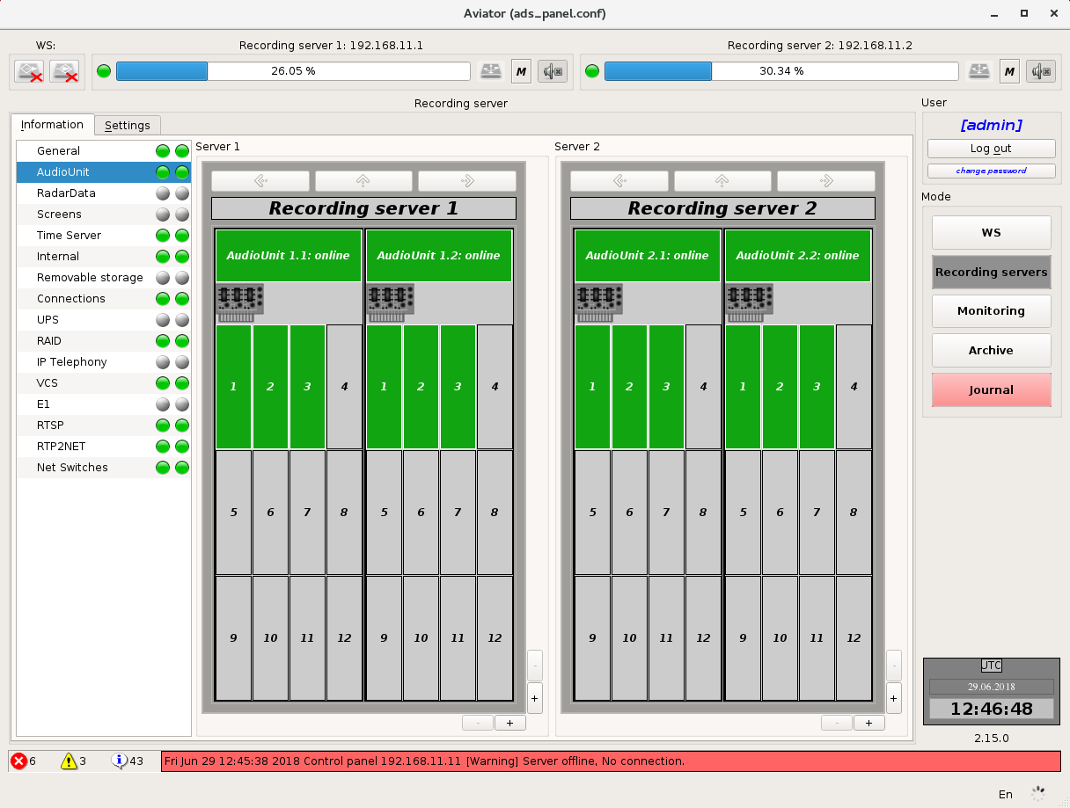
Figure 4.23 – Information on AAU

Representation of AAU has several levels of detail:
Device level
On this level (Figure 4.24) the user has an access to information about AAU devices on the server and condition of cards on devices.
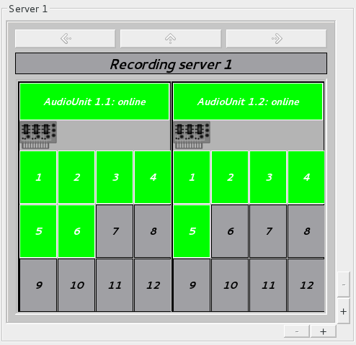
Figure 4.24 – Device level
The upper part shows the name of the server, where such devices are arranged. The device ID is specified for each of devices below the upper part in a format: <server number, device number> with information on its condition. If a device appears defective or disconnected, the field colour will be red. If device operation is normal, the field colour will be green.
The cards of devices are presented in the form of rectangles and numbered from 1 to 12. If card monitoring is disabled from settings, the rectangle colour will be grey, otherwise the rectangle colour indicates the state of the relevant card: green – serviceable card, red – defective card.
You can select specific device by mouse-clicking on it. This allows you to go to the next level of detail.

Card level
On this level (Figure 4.25) the user is provided with information about the cards of selected device and condition of channels on the cards.
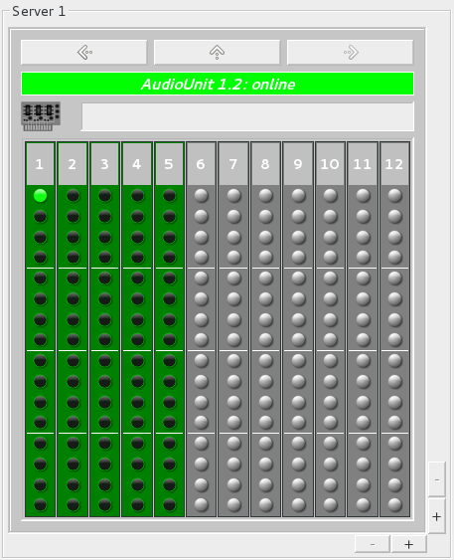
Figure 4.25 – Card level
The device ID is shown in the upper part. Background colour of this area indicates the condition of the device. An information about the cards is shown below.
The cards, monitoring over which was disabled in the settings are of grey colour. Other cards have either green colour – the card operates normally, or red colour – the card is inoperative (e.g., removed).
The condition of channels on the card is presented in the form of indicators. The channels, monitoring for which was disabled in the settings, have grey colour of indicator. For other channels the indicator colour has a green shade, the brightness of which depends on the power of signal in the channel. If the user is not allowed to monitor this channel, the indicator icon will be crossed out.
In this mode the user gains an access to navigation buttons (buttons with arrows above the device name). Using the arrows "left" and "right" you can navigate between devices of one AAU, pressing of the arrow "up" allows you to go back to the higher level of detail (device level).
Selection of specific card (mouse-clicking on it) allows you to go to the next level of detail.

Channel level
On this level (Figure 4.26) the user has access to information on the channels of selected card.
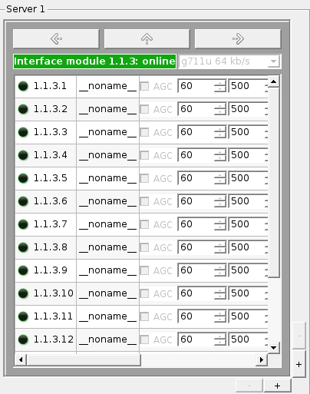
Figure 4.26 – Channel level
The card ID is shown in the upper part. Background colour of this area indicates the condition of the card. Information on the channels is arranged below.
Information on the channels is presented in the form of a table. An ID (in format <server number>, <device number>, <card number>, <channel number>), channel name, signal threshold level (if the signal in the channel is below this level, during recording it will be considered as missing signal), channel status indicator are specified for each of the channels. The channels whose monitoring was disabled in the settings have grey colour of indicator. For other channels the indicator colour has a green shade, the brightness of which depends on the power of signal in the channel. If the user is not allowed to monitor this channel, the indicator icon will be crossed out.
You can navigate between the cards of device using the arrows "left" and "right". Pressing the arrow "up" allows you to go back to the higher level of detail (card level).
By default, the user has access to one field for providing information on the status of AAU on the server. But the number of fields may be increased (up to two or four) using buttons "+" and "–" in the right bottom corner (Figure 4.27). For each of the fields you can select an individual level of detail.
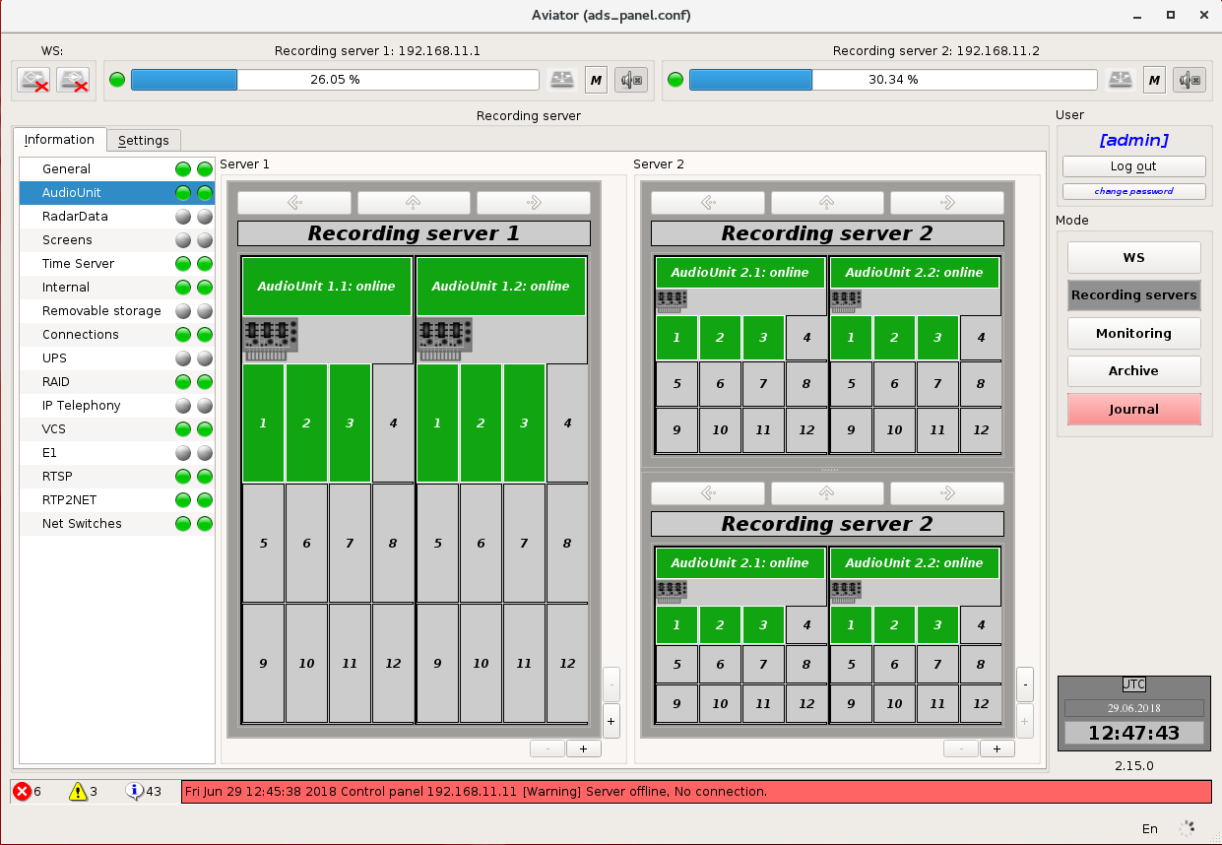
Figure 4.27 – Multiple viewing fields

Information on Topaz servers
In this tab the user receives information on accessibility of Radar Data servers from recording servers (Figure 4.28).
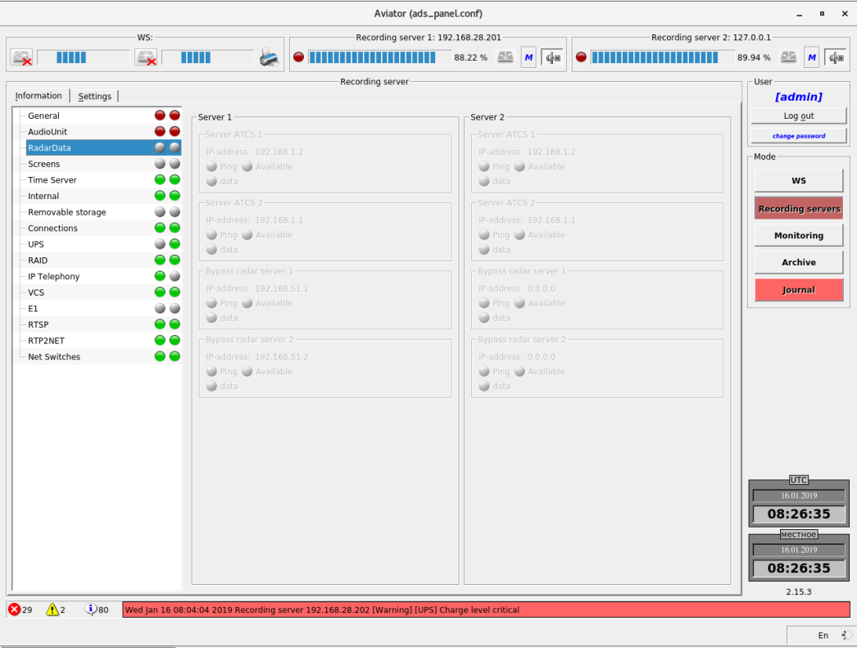
Figure 4.28 – Information on Topaz servers

Information on screens
This tab displays information on computers in the network, from which monitors the data is recorded to the archive on each of the servers (Figure 4.29).
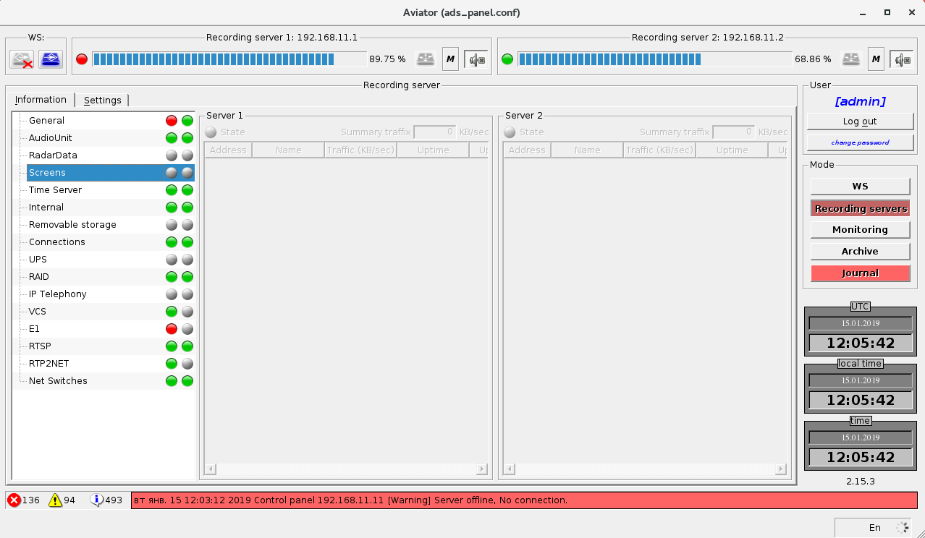
Figure 4.29 – Information on screens

Information on Time Server (TSS)
Tab contains information on condition of the local TSS, accessibility of time server and time synchronization on each of the recording servers (Figure 4.30).
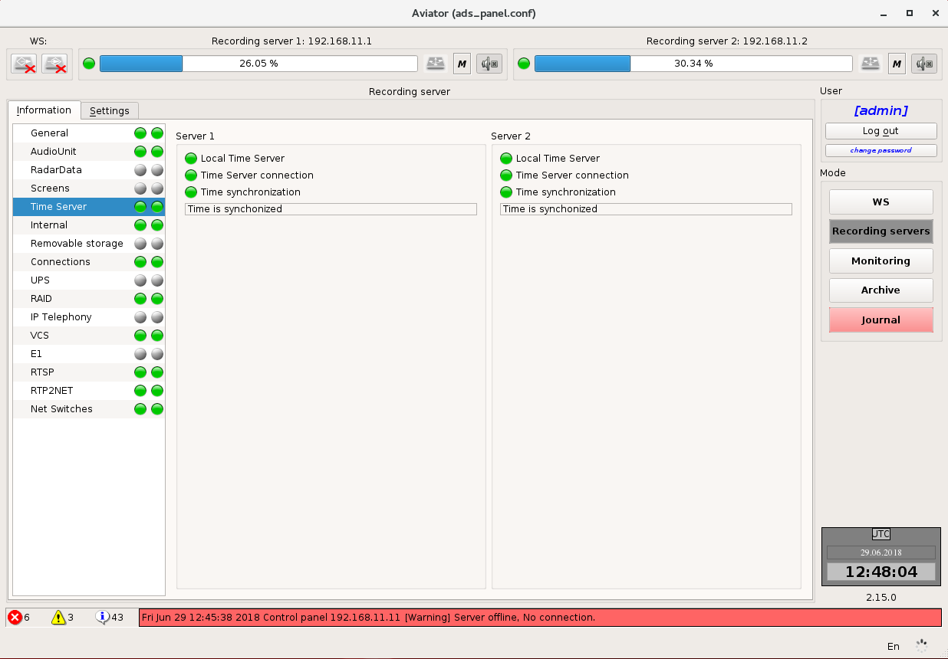
Figure 4.30 – Information on Time Server

Information on Internal (online) archives
Tab contains information about the progress of recording on the server (recording indicator), rate of the online archives filling and records in such archives (Figure 4.31).
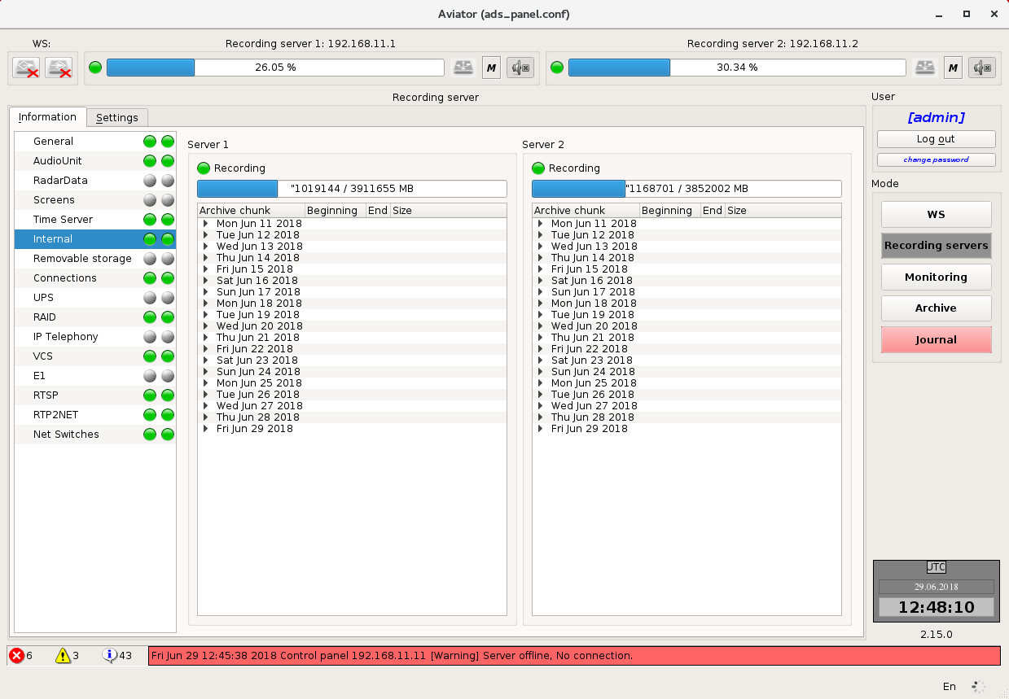
Figure 4.31 – Information on Internal (online) archives
Records in the archives are grouped by dates and presented in the form of nested list. The name, recording beginning time, recording end time and space occupied on the drive (size) are indicated for each record.

Information on removable storage
Tab contains information on removable storage connected to recording servers.
If a removable storage is missing on the recording server, all fields will be empty, indicators will be grey and indicator in the list on the left for this server will be grey (Figure 4.32).
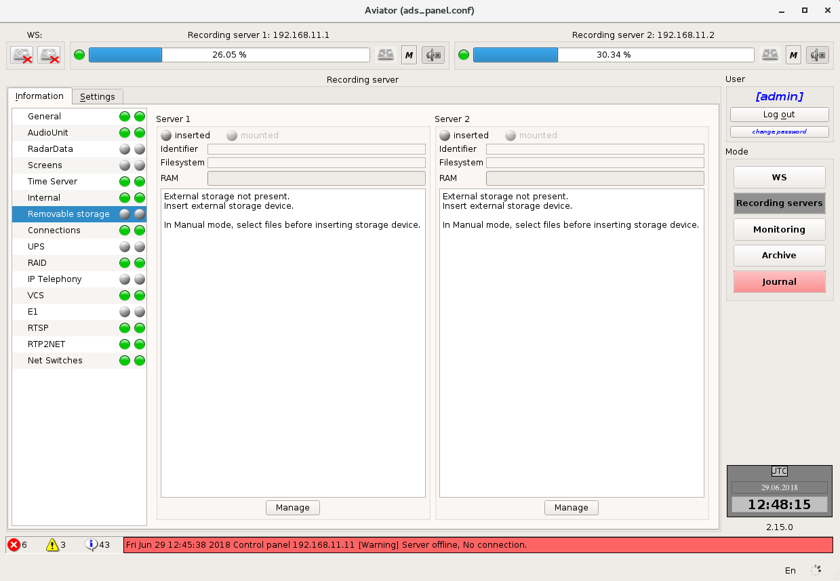
Figure 4.32 – Information on removable storage – the removable storage is missing

If a removable storage is available on recording server (Figure 4.33) indicator "Inserted" for this server will be green, and information on the removable storage will be displayed in the fields as follows: Identifier of removable storage in the system, file system of the removable storage, occupancy (RAM). At the same time, the indicator in the list on the left for this server will be green, with the "Auto" operating mode.
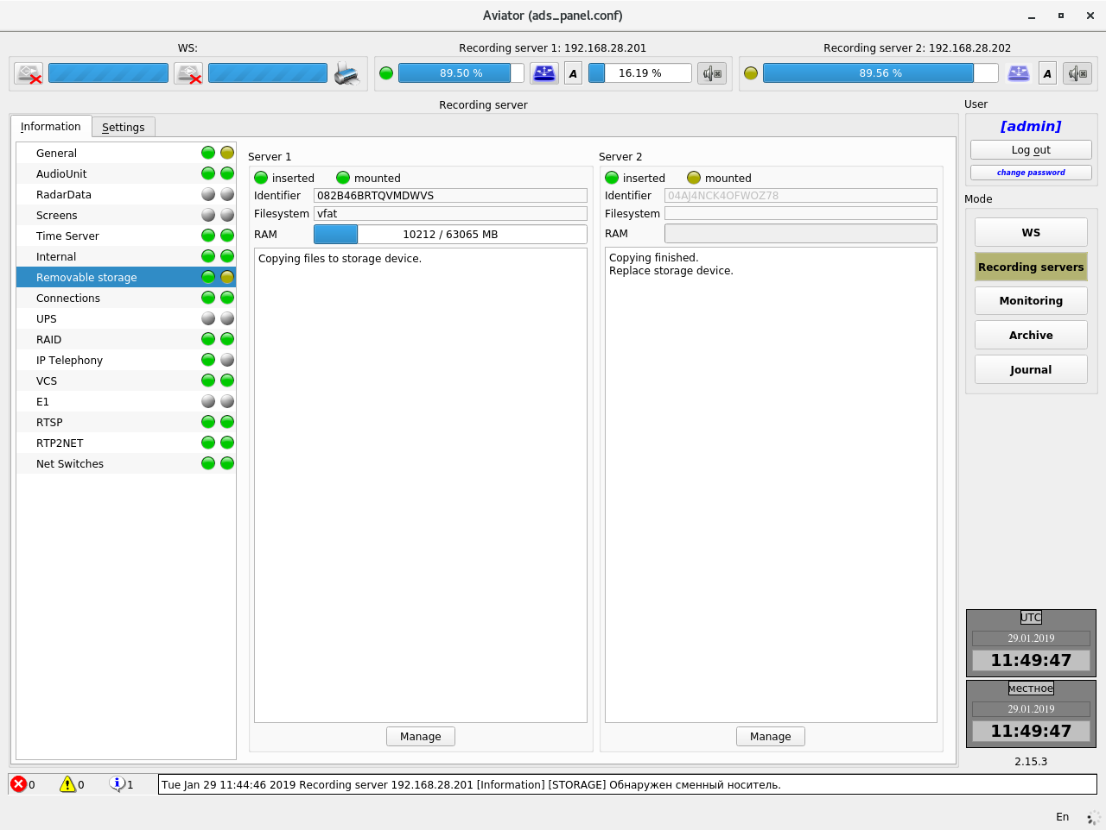
Figure 4.33 – Information on removable storage – the removable storage is available

Button "Manage" is located in the lower part for each of the servers. By pressing of this button, the user goes to the window for control of recording to removable storage on the server (Figure 4.34).
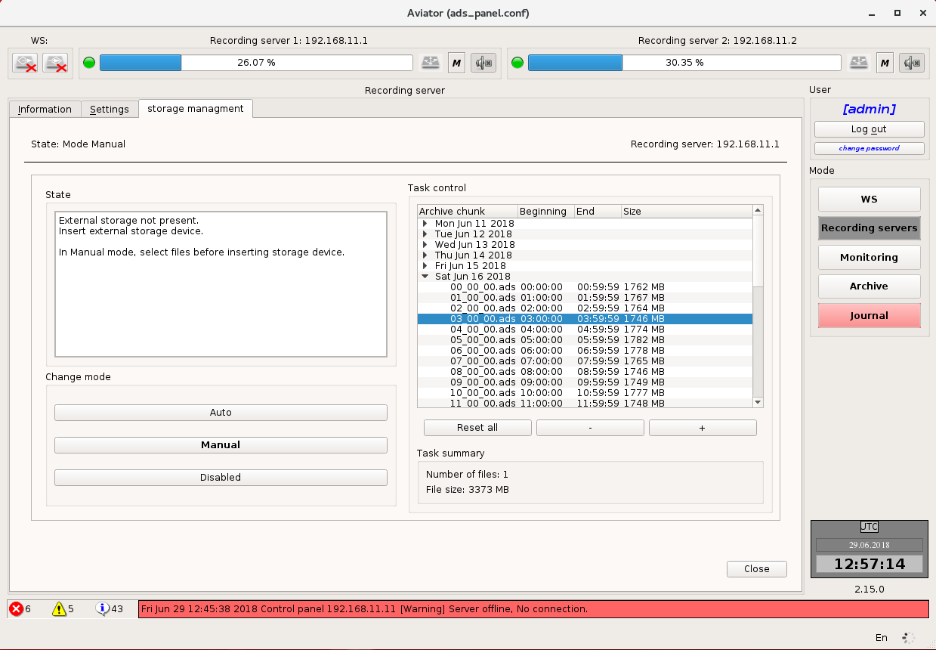
Figure 4.34 – Storage management window of the copying process to a removable storage
In the left part of this window there is an information field displaying the status of copying process. The buttons located below are intended to be used for selection of the copying mode:
"Manual" – in this mode the user has an opportunity to select the records, which he wants to copy to a removable storage. Records are selected from the list in the right-hand part of the window by using buttons "+" (adds the record to a queue for copying) and "–" (removes the record from a queue for copying). Button "Reset all" deletes all records from a queue for copying. The selected tasks are highlighted in blue colour. Information on the number of selected records and space occupied by them on the disc is displayed under the add "+" and delete "-" buttons. Copying starts with pressing button "close" at the bottom part of the window.
"Auto" – copying to a removable storage happens automatically. After full filling of a removable storage a message will be given indicating that the removable storage is full and shall be changed to the next one. In this mode the list of records on the right is inaccessible.
The current mode is highlighted in bold text.
Changing the settings is available only when the removable storage is extracted, if you click the button "Manage" while copying data, all elements in the control window will be unavailable (Figure 4.35).
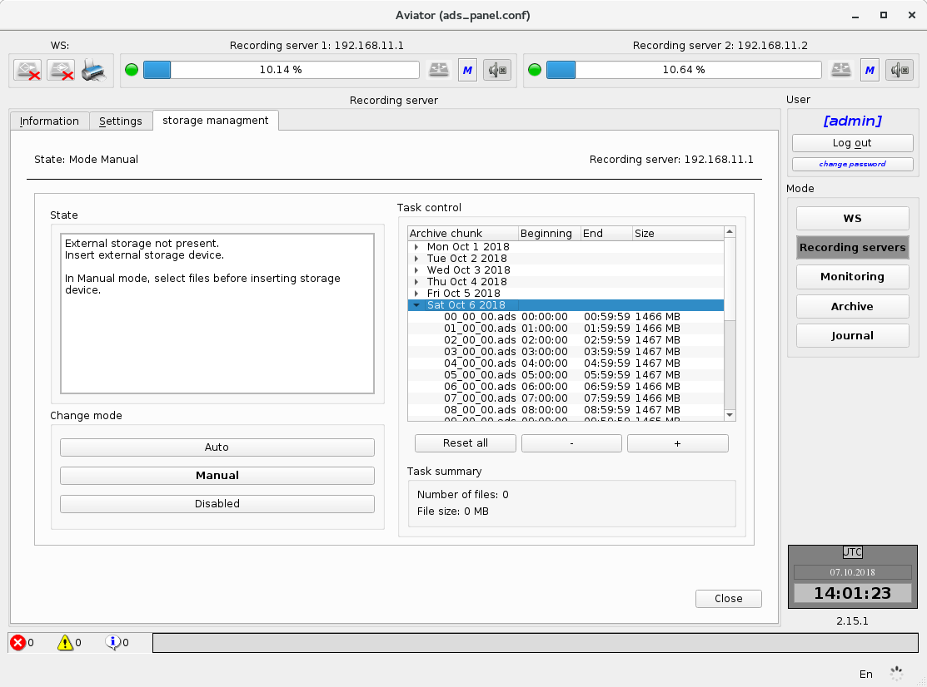
Figure 4.35 – Control window during data copying

Information about connections
Tab "Connections" contains information about computers in the network, on which the clients’ part of the complex SW is launched (Figure 4.36).
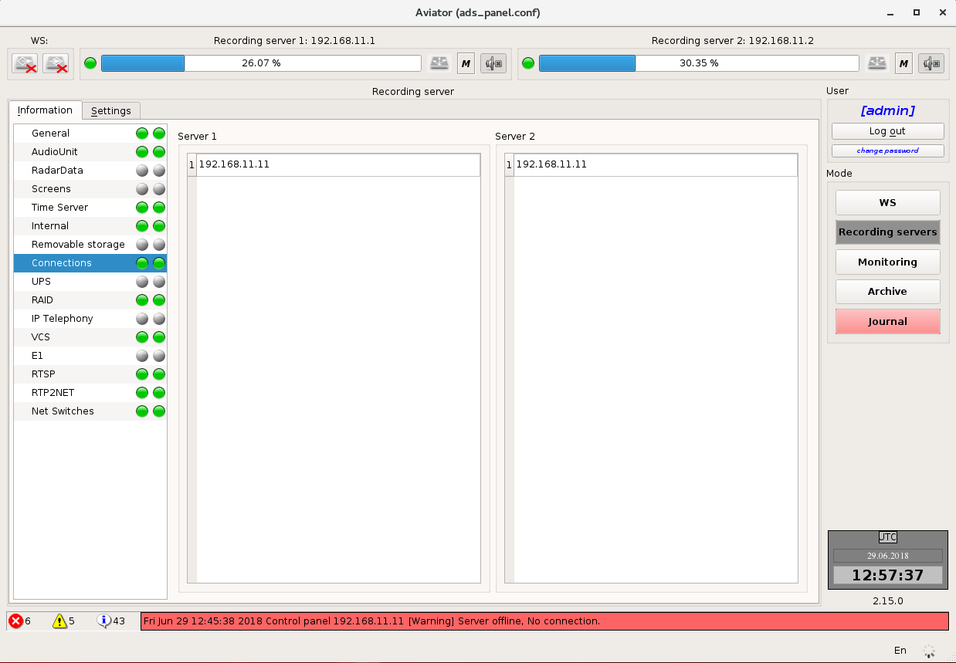
Figure 4.36 – Information on clients

Information about UPS
Tab "UPS" contains information on the status of UPS on recording servers (Figure 4.37).
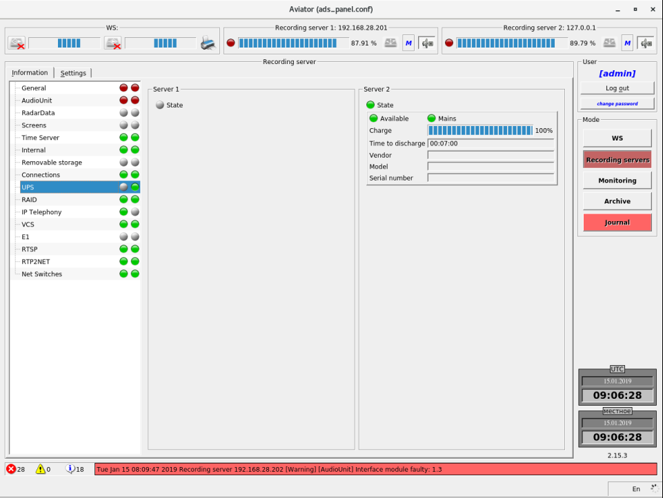
Figure 4.37 – Information about UPS

Information about RAID
Tab "RAID" contains information about the structure of RAID-array and condition of partitions on each of recording servers (Figure 4.38).
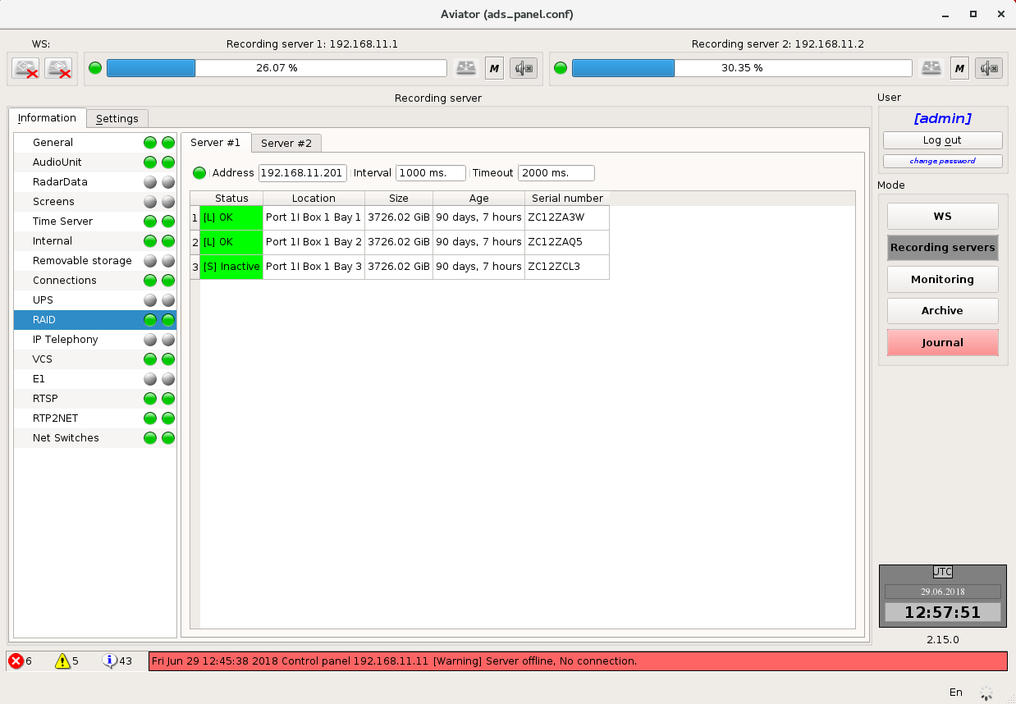
Figure 4.38 – Information about RAID
The indicator colour shows the physical condition of the disk:
- Green – the hard drive is operating normally;
- Yellow – there are data loss or bad sectors on the hard drive;
- Red - the hard drive is failed or removed from its slot on the server.

Information about digital telephony
Tab "Digital telephony" (Figure 4.39) provides information about connection to PBX and about the status of abonents for each of recording servers.
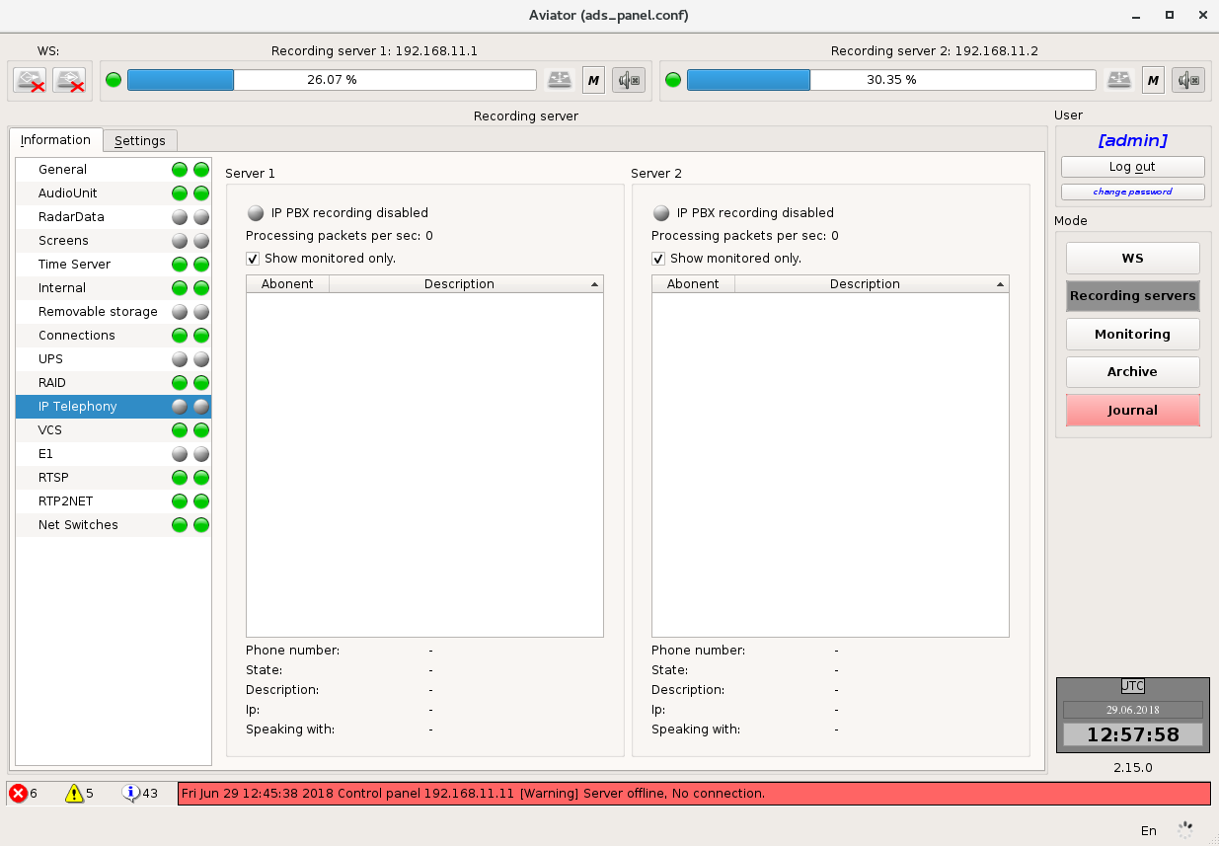
Figure 4.39 – Information on digital telephony
In normal state the PBX connection status indicator has green colour. The PBX connection status indicator becomes red if there is no communication with PBX during one minute.
Indicator colour of abonents total status is determined on the basis of observable abonents. The list of abonents is presented in the form of a table. Abonents indicator colour is determined as follows:
- Green – Observation of the abonent is on. The abonent is available;
- Yellow – Observation of the abonent is on. The abonent is unavailable (e. g. telephone is switched off);
- Grey – Observation of the abonent is off.
If the abonent observation is on and the abonent is available, additionally the abonent status is determined. There is a phone handset icon displayed on the left of the abonents’ name.
- Green phone handset – the abonent is free;
- Red phone handset – the abonent is engaged.
Detailed information about selected in the table abonent is shown under the list of abonents. For selection of the specific abonent it is enough to click on his icon with the left mouse button.

Voice communication system (VCS) record status information
Control panel of the RS "Aviator" contains the following information on status of the voice communication system (VCS) recording module (Figure 4.40):
- VCS connection status indicator;
- Number of packets received from the network / number of packets processed;
- VCS abonent status.

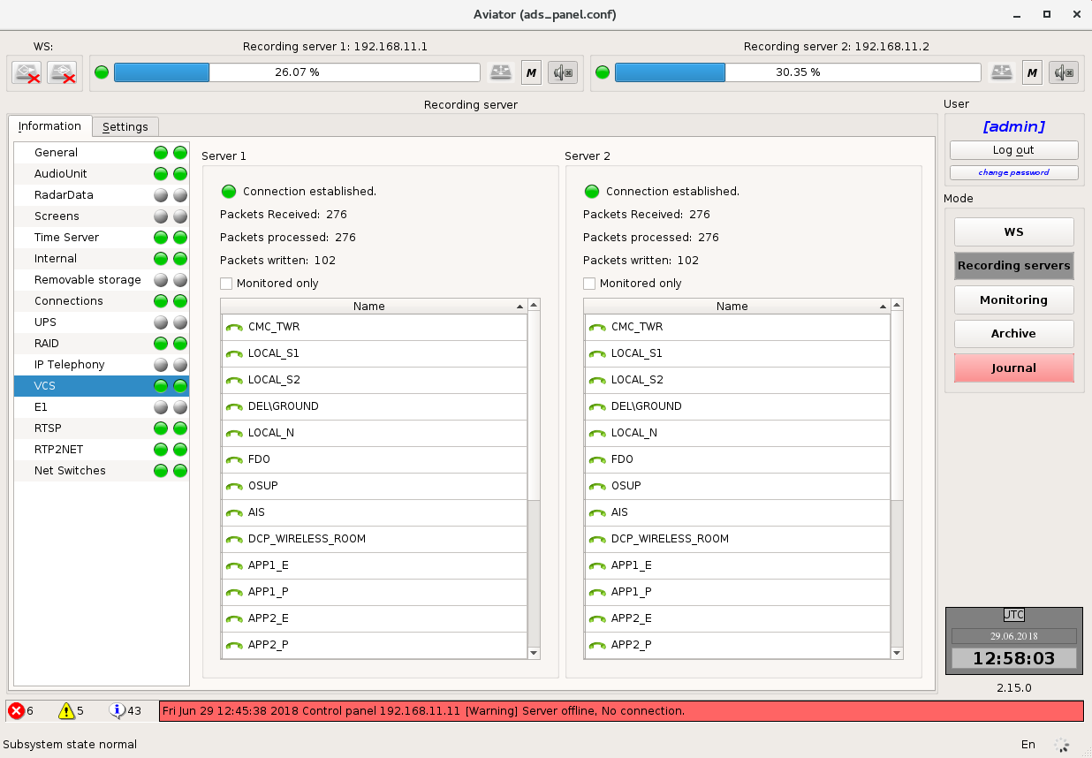
Figure 4.40 – Information on voice communication system (VCS) recording module

VCS connection status
Connected to VCS. Data are available for record to full extent.
Connected to VCS. Data recording is in progress. Warning of unavailable data from one of VCS network loops.
Connected to VCS. Data are not recorded. Data are completely unavailable for record.
VCS monitoring and recording are disabled.

VCS abonent information is presented in the form of a table. The status and name are indicated for each abonent.

Abonent is online. Available.
Abonent is online. Engaged.
Abonent is offline.

When moving the mouse cursor over a certain abonent, a pop-up help containing more details will appear in some time (Figure 4.41):

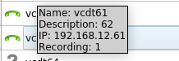
Figure 4.41 – Additional information on an abonent
The pop-up help contains abonent name, its description, IP address as well as indicates whether abonent status and voice data are recorded to archive.

Stream data record status information

Control panel of the RS "Aviator" contains the following information on status of the E1 channel phone conversation recording module (Figure 4.42):
- E1 stream data record status;
- E1 abonent status.
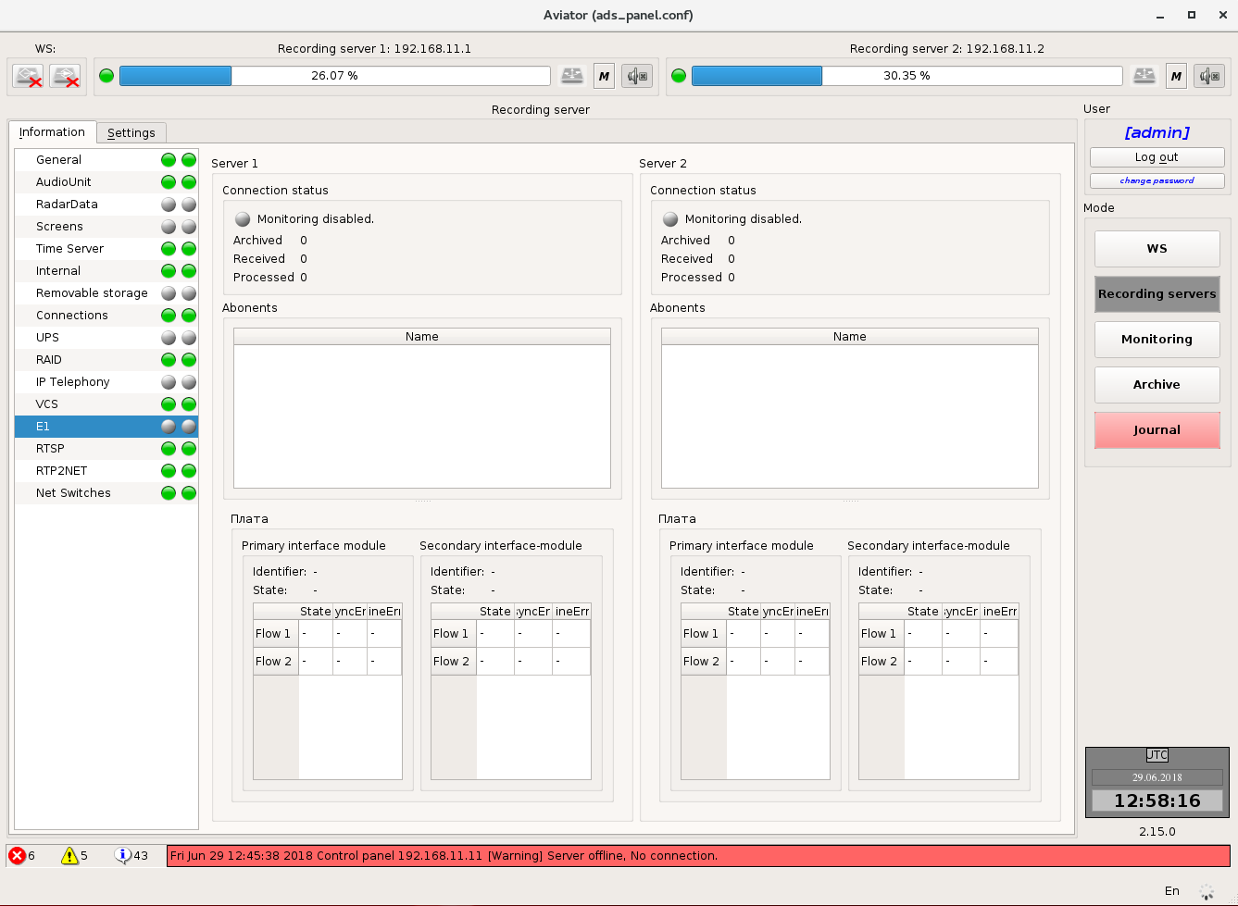
Figure 4.42 – Information on status of the E1 channel phone conversation recording module
E1 stream data record status
E1 stream recording subsystem is in operation. Data recording is in progress.
E1 stream recording subsystem does not function. Data recording process failed.
Recording of data from E1 stream decoding unit is disabled.

All diagnostic data are recorded to log with details.
Abonent information is presented in the form of a table. The status and name are indicated for each abonent.
Abonent is engaged.
Abonent is available or offline.

Note: Due to specific features of the E1 digital stream, it is impossible to define the abonent availability in the network when the abonent does not take part in conversation. It makes this data source type differ from VoIP source.
When clicking on the abonent with the mouse cursor, detailed information on the abonent will appear (Figure 4.43):

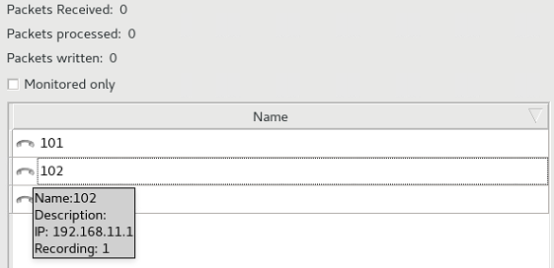
Figure 4.43 – Additional information on an abonent
The pop-up help contains abonent name, its description as well as indicates whether abonent voice data and status are recorded to archive.

RTSP record status information
RTSP - Real-Time Streaming Protocol. It is a standard Ethernet network protocol, which describes commands for managing the video stream and is presented in RFC 2326 format. It is designed for recording video sources, such as IP - cameras and working position screens.
The workspace is divided into two parts. Each part provides information about the status of source RTSP on the server (Figure 4.44).
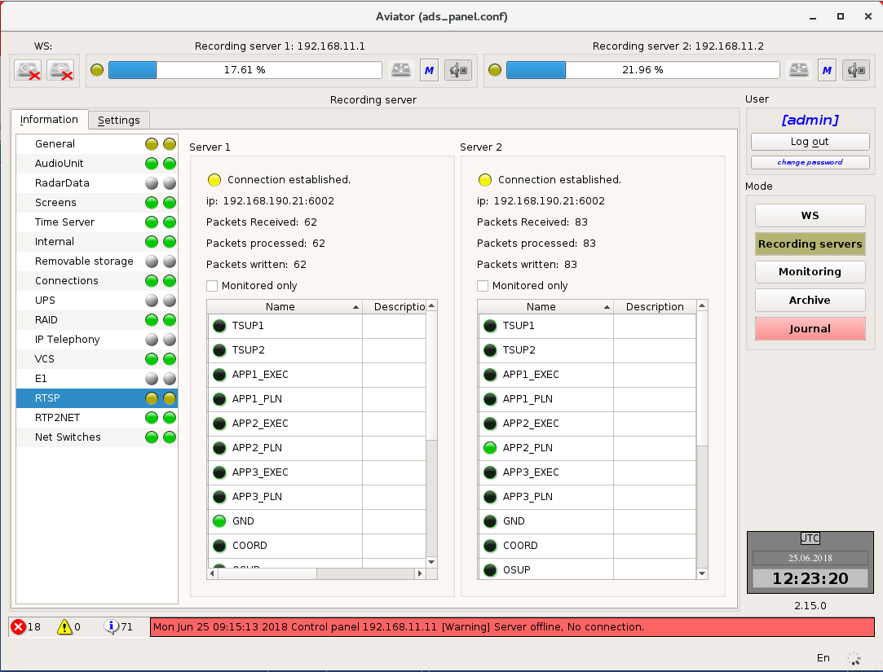
Figure 4.44 – Information about RTSP
The status indicator of the RTSP connections is displayed at the top.
Indication states:
• Green - connection to the server is stable, all sources are available and send a stream;
• Yellow - there are some problems in connection with sources, e.g. inaccessibility of the working position or camera, long-term switching between duplicated video stream sources;
• Red - connection to the server is lost, impossibility to establish any video session.
Below there is the information containing;
• ip-address of the RSTP-source to which the current connection is established;
• Number of received packets;
• Number of processed packets;
• Number of recorded packets.
Designation in the table of recorded sources:
• Bright green - the session is established, recording is in progress;
• Dark green - session is established, no data flow. Session is expected to be restored;
• Red - session is lost;
• Gray - session is configured not to be monitored.

RTP2NET status information
RTP2NET is intended for the issuance of documentation audio sources recorded in the RS “Aviator” to external systems.
Each outgoing RTP stream is sent via individual UDP connection ports according to the settings and can contain an arbitrary number of audio channels of various types mixed into one standard G711 channel.
The workspace is divided into two parts. Each part provides information about the status of RTP2NET on the server (Figure 4.45).
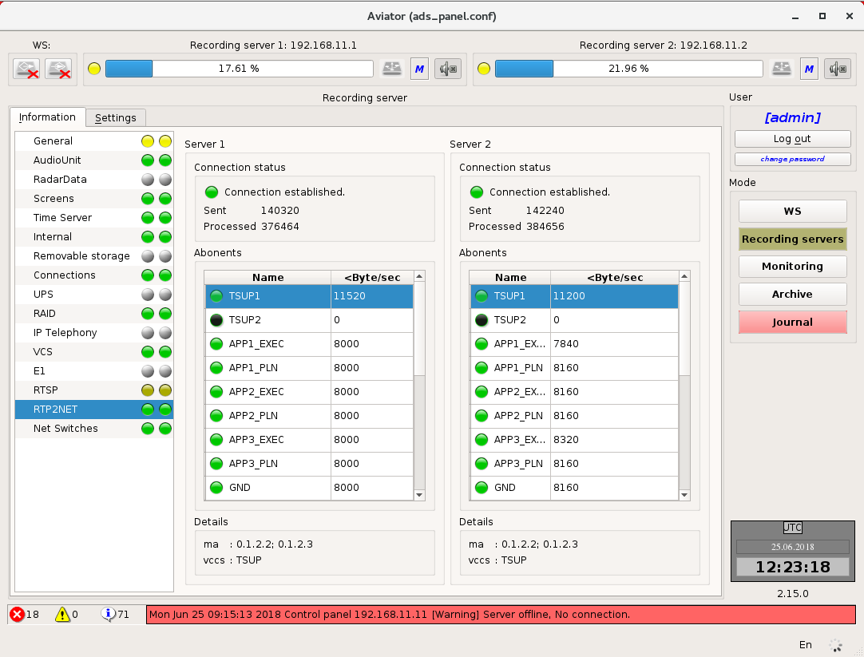
Figure 4.45 – The workspace of the RTP2NET
Indicator on the RTP2TNET connection status is displayed at the top.
Indication states:
- Green - the stream of data goes from the sources to the specified IP – addresses;
- Dark green - there is no data (conversations or settings are absent).

Note: Since the output of channels is realized through an unidirectional network UDP stream, it is not possible to determine the state and / or the readiness of the receiving party.
Below there is the information containing:
- Number of sent packets;
- Number of processed packets.
The designation in the source table:
- Channel name;
- Connection speed (Byte / sec).
The "Details" table shows the sources divided into the following groups:
- MA;
- ME;
- VCS;
- Phone.

Information about the status of switches
The control panel of the RS "Aviator" presents the following information about the status of the switch ports (Figure 4.46):
- IP - address of the monitored switch;
- Port Status;
- Information on each monitored port (port number, connection status, port name, connection type, MTU, port speed, mac-address, ip-address);
- Time between requests of the switch in milliseconds;
- Response timeout from the switch in milliseconds.
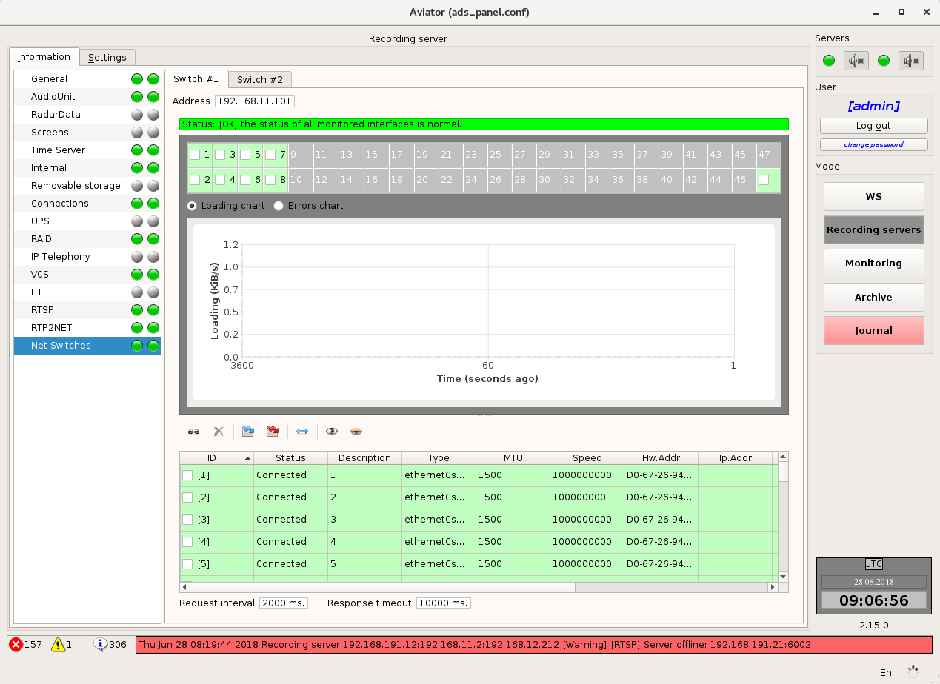
Figure 4.46 – Information about the status of the switch ports

Setting of recording servers
When switching to the Settings tab, enter the administrator password (Figure 4.47).
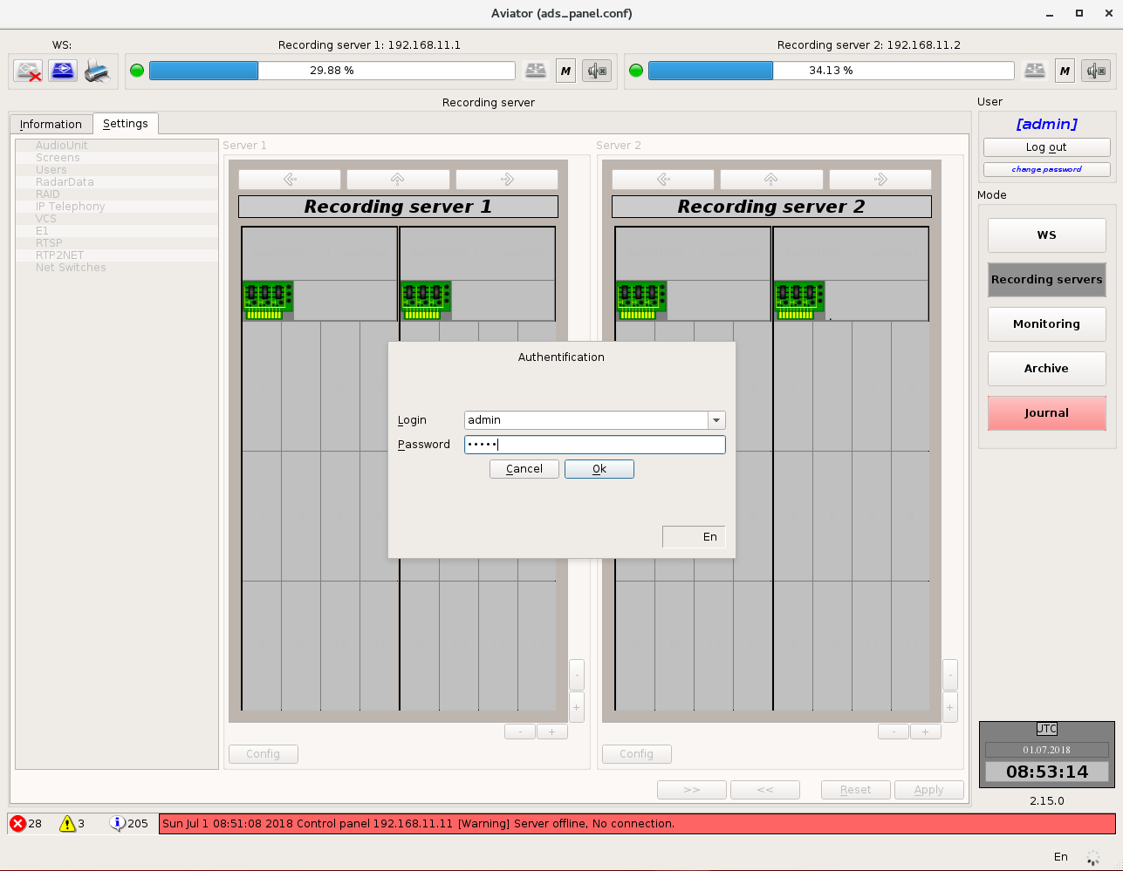
Figure 4.47 – Authorization for switching to settings
The right part of the tab involves the list of items, from which the user may select that particular items he wants to set. For all tabs (except for tab "Users") the field on the left of the list is separated in two parts: "Server 1" and "Server 2". Each of the parts is intended for setting of the relevant recording server.

Four buttons are arranged at the bottom part on the right side. Buttons "Reset" and "Apply" allow you to cancel or save settings made by the user.
If the user has changed settings without saving them, all items in the list on the left side and buttons "Monitoring" and "Archive" will be unavailable and the button of recording server will change to moving indicator, which includes the button for cancelling changes located to the right of it (Figure 4.48).

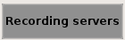
Figure 4.48 – View of the button "Recording server" when there are unsaved changes

Buttons and allow copying of the settings from the first server to the second one and from the second server to the first one, accordingly.

Setting of AAU
On this tab the user can control AAU devices, cards and channels.
The workspace is divided in two parts. Each part represents a schematic image of AAU on the server (Figure 4.49).
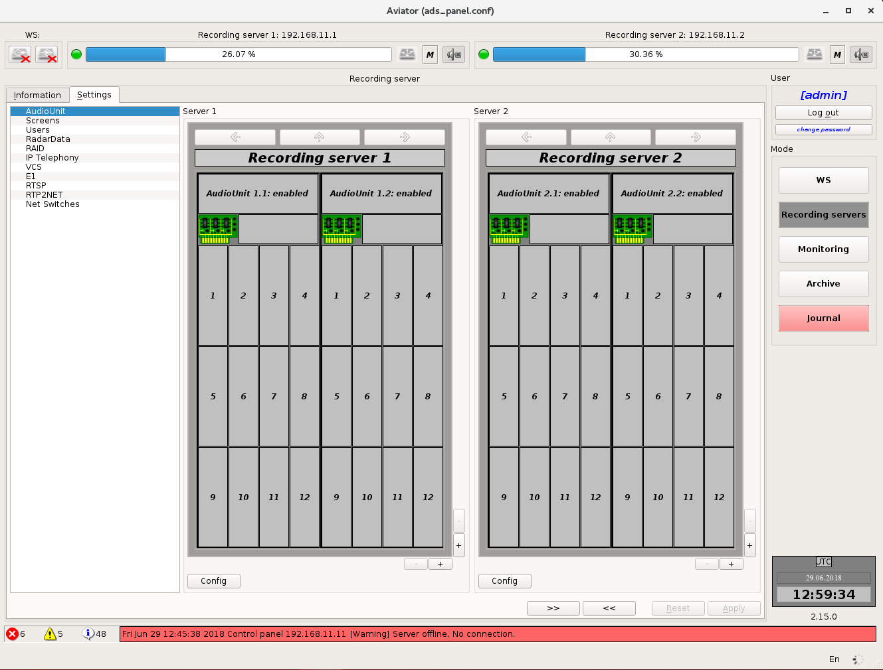
Figure 4.49 – Setting of AAU
Representation of AAU has several levels of detail:

Device level
Information on AAU devices incorporated in the recording server is presented schematically on this level (Figure 4.50).
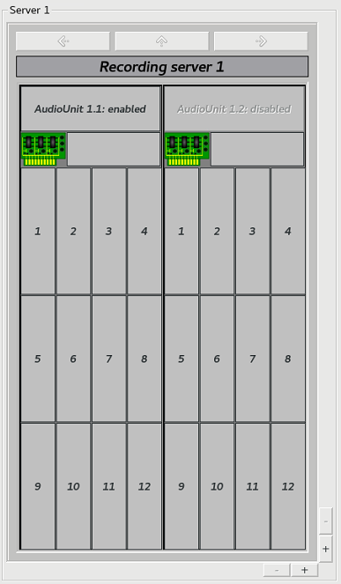
Figure 4.50 – Device level
The upper part shows the name of the server, on which such devices are arranged. Device ID is specified below for each of devices in format <server number>.<device number>.
You can select specific device by mouse-clicking on it. This allows you to go to the next level of detail.

Card level
On this level (Figure 4.51) the user is provided with information about the cards of selected device and status of channels on the cards.
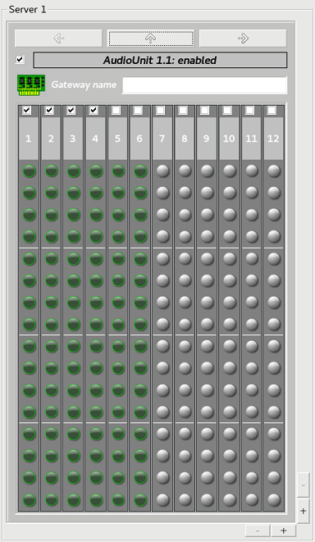
Figure 4.51 – Card level
The device ID is shown in the upper part. Information about the cards and current status of the channels on them is arranged below.
The checkbox enabling to switch on/off monitoring of card status is arranged above the sequence number of each card. All changes, which were made by the user but not saved yet, are highlighted in yellow.
The status of channels on the card is presented in the form of indicators. The channels, monitoring for which is disabled, have grey colour of indicator. The channels, monitoring for which is enabled, have green colour of indicator. If the user is not allowed to configure a certain channel, the indicator icon will be crossed out.
In this mode the user gains access to navigation buttons (buttons with arrows above the device name). Using the arrows "left" and "right" you can navigate between devices of one AAU. Pressing of the arrow "up" allows you to go back to the higher level of detail (device level).
Selection of specific card (mouse-clicking on it) allows you to go to the next level of detail.

Channel level
On this level (Figure 4.52) the user has an access to information about the channels of selected card.
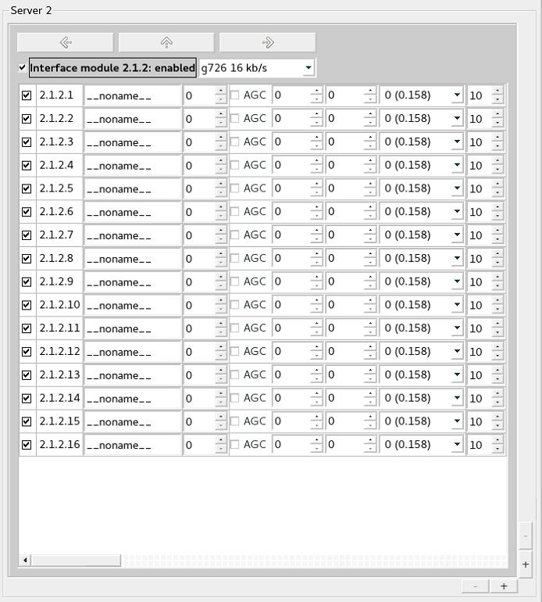
Figure 4.52 – Channel level
The card ID is shown in the upper part.
The checkbox, which enables to switch on/off monitoring of the whole card as a unit is arranged to the left of the card ID. The drop-down list with codecs and bitrate for the stream issued by the card is arranged to the right of the card ID. Information on the channels is arranged in the form of a table below the card ID.
The following items are displayed for each channel:
- Checkbox for channel monitoring enables to switch on/off monitoring of the relevant channel;
- Channel ID is preset automatically in format: <server number>.<device number>.<card number>.<channel number>;
- Name of the channel is preset by the user;
- AGC. If the checkmark is set, automatic control of signal level is enabled for the relevant channel on the card;
- Voice detector debounce ON time;
- Voice detector debounce OFF time;
- Chanel gain;
- VOX threshold (if the signal in the channel is below this level during recording process, the signal will be considered to be missing).
All changes, which were made by user but not saved yet, are highlighted in yellow.
You can navigate between the device cards using the arrows "left" and "right". By pressing the arrow "up" you may return to the higher level of detail (card level).

By default, the user has an access to one field for providing information about the status of AAU on the server. But the number of fields may be increased (up to two or four) with the buttons "+" and "–" in the right bottom corner (Figure 4.53). For each of the fields you can select an individual level of detail.
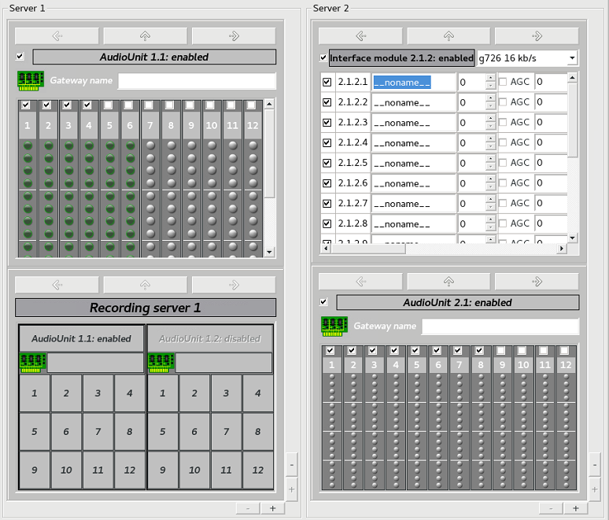
Figure 4.53 – Multiple viewing fields

Voice communication system (VCS) record settings
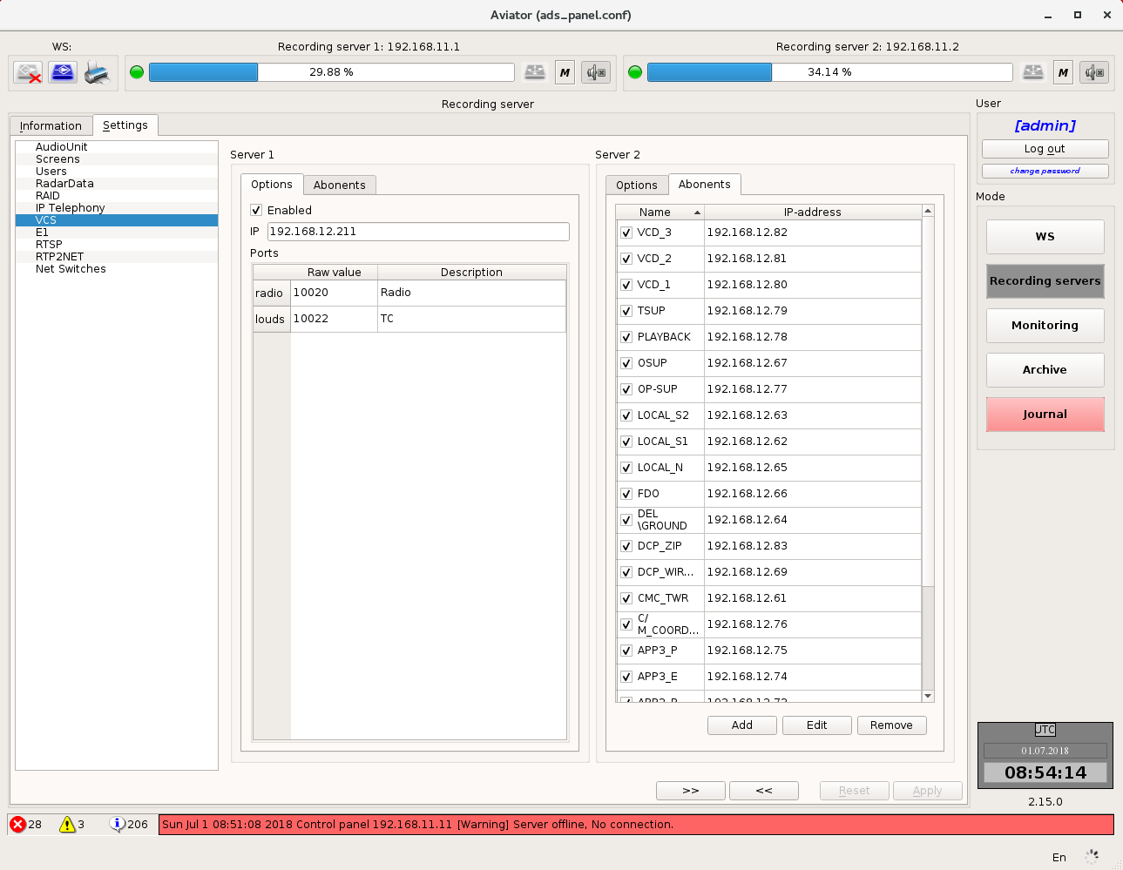
Figure 4.54 – VCS record settings
Voice communication system (VCS) record settings are divided in two groups:
- Options;
- Abonents.
Each group is located in its respective tab.

General parameters (Figure 4.55). This tab contains IP - address of the network interface and numbers of ports, which the VCS terminals send data to be recorded to.
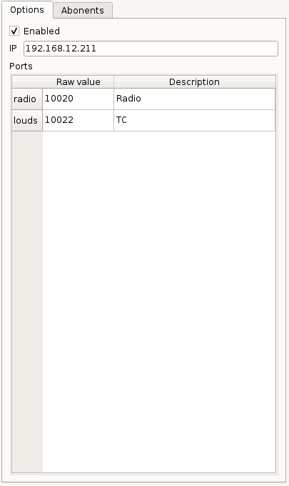
Figure 4.55 – General parameters
Radio and LSC channels are recorded separately for each terminal, a respective port is indicated for each channel. To change an option, make a left double click on the respective table field.
To disable monitoring of the VCS, set the IP - address value to 0.0.0.0.

Abonents (Figure 4.56)
This tab allows editing the list of abonents being monitored and recorded.

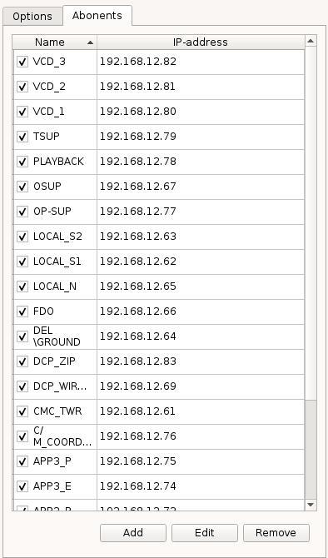
Figure 4.56 – Abonents
To the left of each abonent, there is a check box that allows disabling record of data from a certain abonent.
Abonent data changing (Figure 4.57)
To edit other abonent parameters, select the desired line in the table and press the button "Edit" down the list:
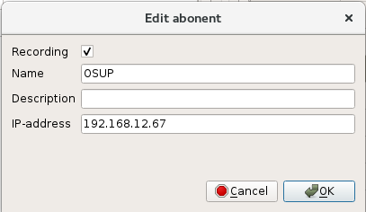
Figure 4.57 – Abonent data changing
The pop-up window allows changing the abonent description, its IP address, starting or stopping recording of data from this abonent. To apply changes, press the button "OK". To cancel changes, press the button "Cancel" (Figure 4.58).
Note: Abonent name cannot be changed. To change the name, delete the abonent and add a new one.
To add a new abonent, press the button "Add" down the list of abonents:

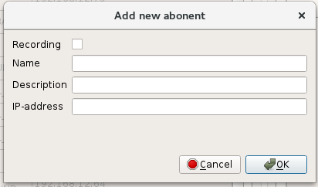
Figure 4.58 – Pop-up window for changing the abonent data
Enter abonent name, its description, IP - address in the pop-up window and check or uncheck the record box. To apply changes, press the button "OK". To cancel changes, press the button "Cancel".
Note: A new abonent will not be added when entered abonent name already exists. A window with respective warning will appear (Figure 4.59):

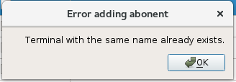
Figure 4.59 – Error warning "Terminal with the same name already exists"
Note: A new abonent will not be added when adding an abonent the IP - address of which already exists. A window with respective warning will appear (Figure 4.60):
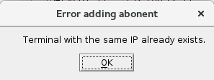
Figure 4.60 – Error warning "Terminal with the same IP already exists"
To delete an abonent, select the respective line in the table and press the button "Remove" down the list.

E1 stream data record settings
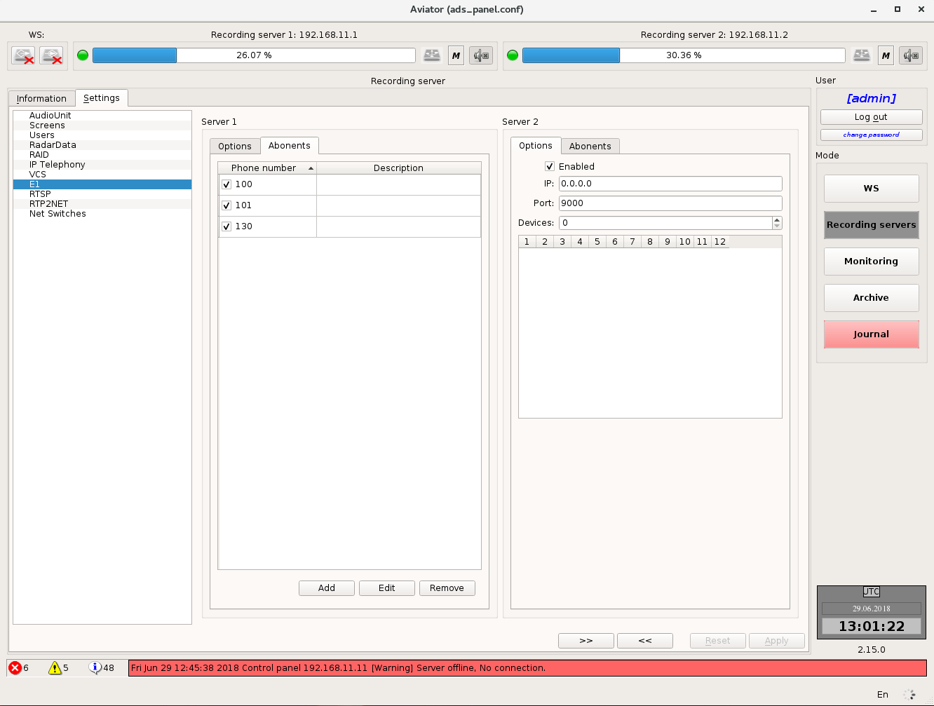
Figure 4.61 – E1 stream data record settings
E1 stream data recording module settings are divided in two groups:
- Options;
- Abonents.
Each group is located in its respective tab.

General parameters (Figure 4.62)
This tab allows setting IP - address of the network interface and number of the port on a recording server that receive data from the E1 stream data decoding unit.

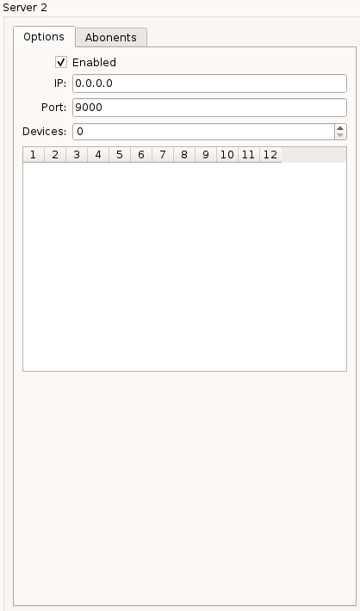
Figure 4.62 – General parameters. Tab "Options"
Abonents (Figure 4.63)
This tab allows editing the list of abonents being monitored and recorded.
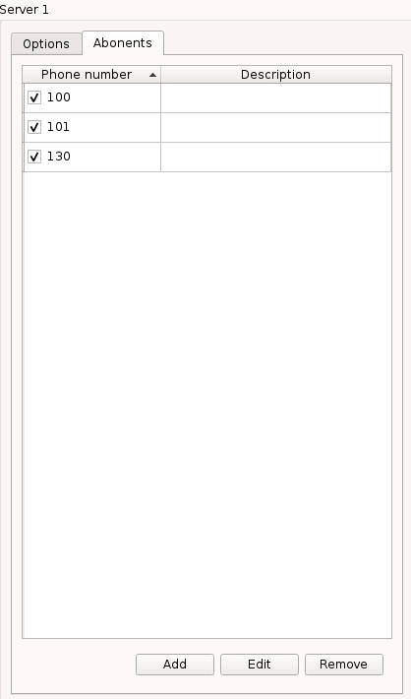
Figure 4.63 – Tab "Abonents"
To the left of each abonent, there is a check box that allows disabling record of data from a certain abonent.
To edit abonent data, select the desired line in the table and press the button "Edit" down the list (Figure 4.64):

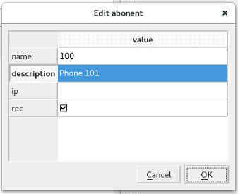
Figure 4.64 – Abonent data changing
The pop-up window allows changing the abonent description, starting or stopping recording of data from this abonent. To apply changes, press the button "OK". To cancel changes, press the button "Cancel".
Note: To change the abonent name, delete the abonent and add a new one. If the abonent name has not been set up manually, a telephone number obtained automatically will be used.
To add a new abonent, press the button "Add" down the list of abonents (Figure 4.65):
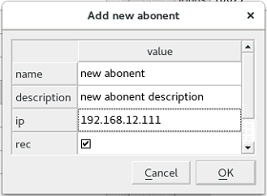
Figure 4.65 – New abonent adding
Enter abonent name, its description in the pop-up window and check or uncheck the record box. To apply changes, press the button "OK". To cancel changes, press the button "Cancel".
Note: A new abonent will not be added when entered abonent name already exists. A window with respective warning will appear (Figure 4.66):
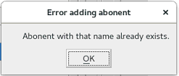
Figure 4.66 – Error warning "Abonent with that name already exists"
To delete an abonent, select the respective line in the table and press the button "Remove" down the list.

Settings of monitor screens
Settings in this tab (Figure 4.67) allow you to define the list of data sources and specify the list of monitors, for which the information will be recorded in archive.
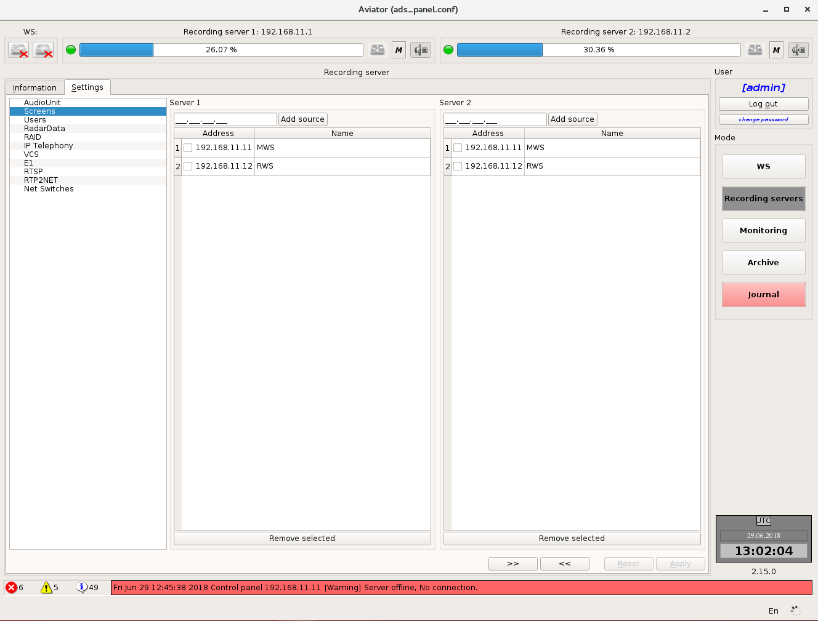
Figure 4.67 – Settings of monitor screens
The main part is occupied by the list of data sources. IP-address of computer and name are indicated for each source. In order to change the name, double-click the relevant field with the left mouse button.
To the left of IP-address there is a checkbox, which determines if the information from the display of the relevant source is to be recorded to the archive.

All changes made by the user, but not saved yet, are highlighted in yellow (Figure 4.68).
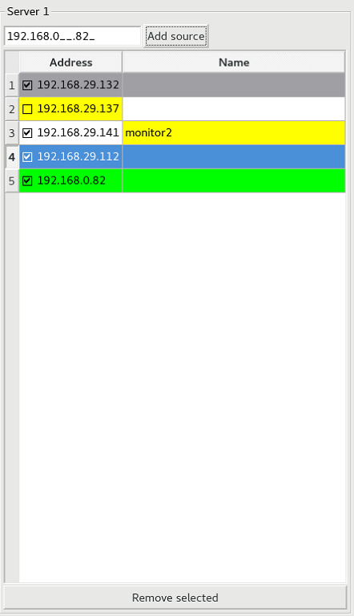
Figure 4.68 – Changing the monitor display list
In order to add a new data source to the list, enter the IP-address of computer in the text field above the list of existing sources and press button "Add source". The line with the newly added data source will be highlighted in green colour (Figure 4.68).
For data source deletion the relevant line shall be selected with the mouse followed by pressing button "Remove selected". The line with deleted source will become grey (Figure 4.68) and will be removed from the list after the changes are saved.

User and group settings
This item (Figure 4.69) contains the settings of users and groups.
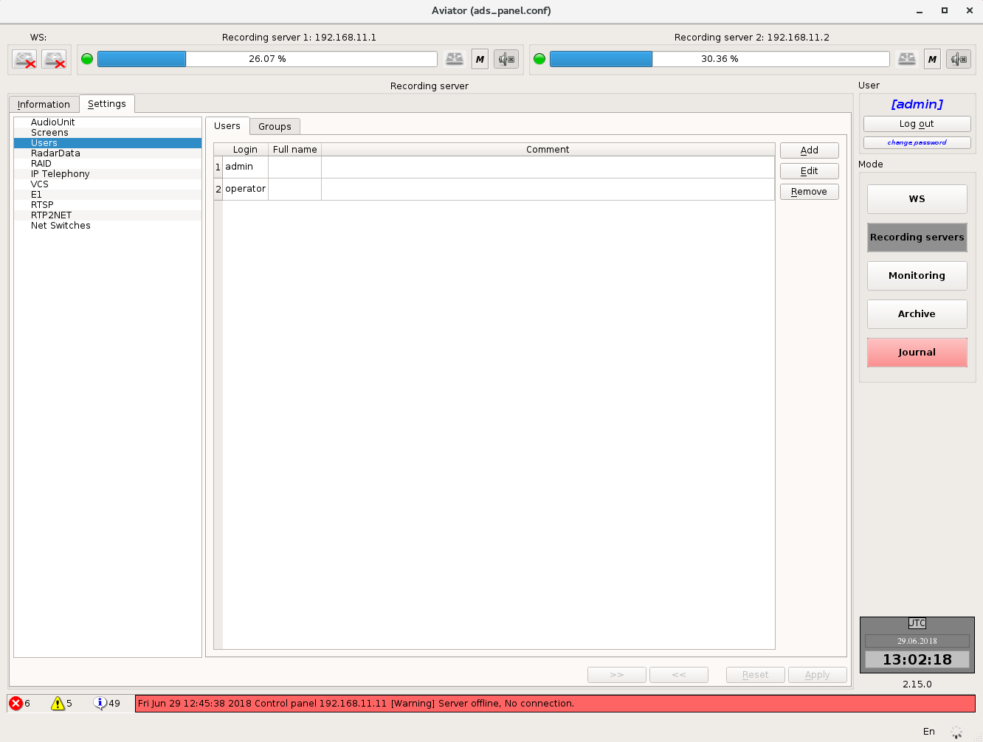
Figure 4.69 – User and group settings

"Users"
This tab (Figure 4.70) contains information on the complex users as well as the elements for adding, editing and removing of users.
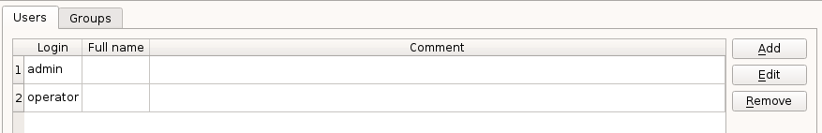
Figure 4.70 – Information on users
Information on the users is presented in the form of a table. Login, name and comment are specified for each user.
The buttons for adding a new user, editing information about the existing user and removing of user are arranged to the right of the table.

• Adding a new user (Figure 4.71).
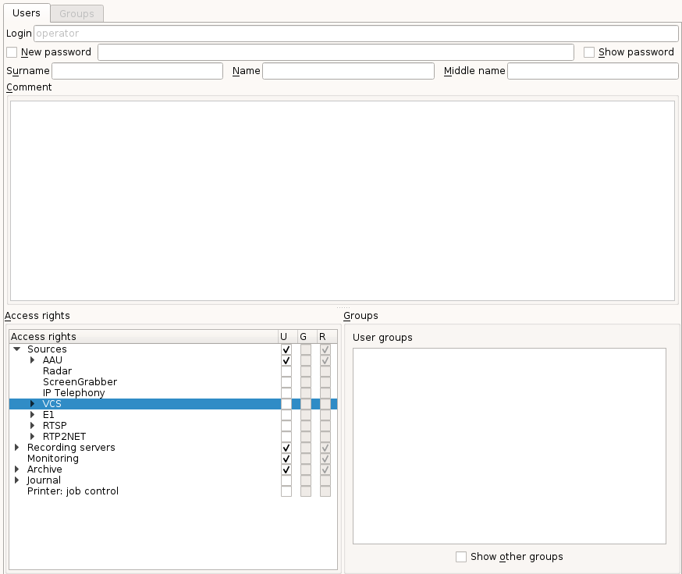
Figure 4.71 – Adding a new user
When adding a new user you should fill in fields "Login", "Password", "Surname", "Name", "Middle name" and "Comment" (Figure 4.72).
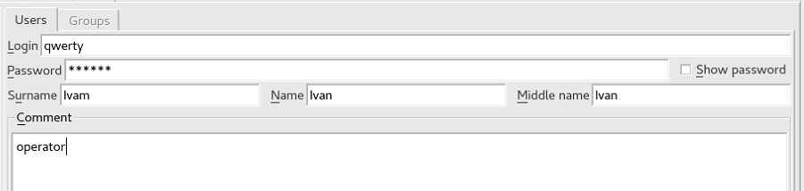
Figure 4.72 – Information about a new user
Fields "Login" and "Password" are mandatory for filling. Unless they are filled or if they are filled incorrectly, button "Apply" at the bottom of the window will be inactive. The length of password shall be at least 6 symbols. By default, the entered password is hidden (displayed as asterisks). For displaying the password you should set a check mark "Show password" to the right of the input field.
After this you should specify the access rights for new user (Figure 4.73), i. e. what operations will be available to this user in the system.
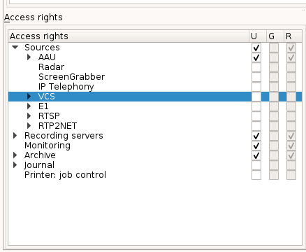
Figure 4.73 – Assignment of rights to user
User rights (column "U") are made up of the rights of groups, to which the user belongs (column "G") and the rights assigned to user on an individual basis (column "R").
Note: group authorizations have higher priority than user authorizations. I. e. if a user is registered in a group and certain actions are permitted to this group, we cannot forbid the user these actions.

For adding a user to a group (Figure 4.74) you should set check mark "Show other groups" and after that set check marks in the list "Other groups" opposite to those groups, to which the user should be added. For user deletion from the group, the check mark opposite to the required group in the list "User groups" should be removed.
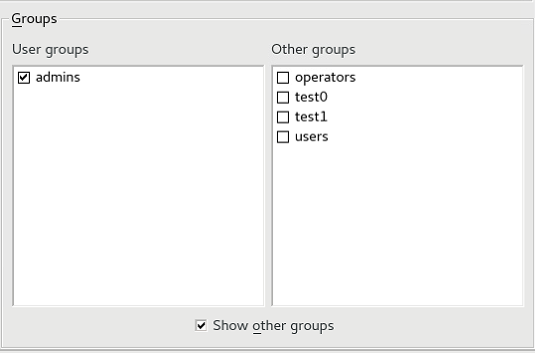
Figure 4.74 – Adding a user to a group
In order to authorize the user for a certain action, except for those permitted for the group, a check mark should be set in column "U".

• Changing the data of the existing user (Figure 4.75).
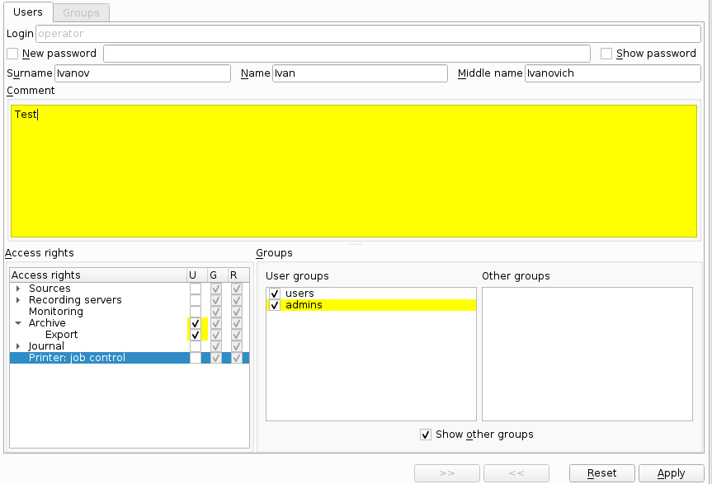
Figure 4.75 – Changing the data of the existing user
All actions are completely similar to adding a new user. All changes made but not saved yet are highlighted in yellow.

• Deletion of user account.
For deletion of a user, select the relevant user account with mouse and press button "Reset". The line in the table will become grey and disappear after the changes are applied (Figure 4.76).
You can select and delete several users at the same time.
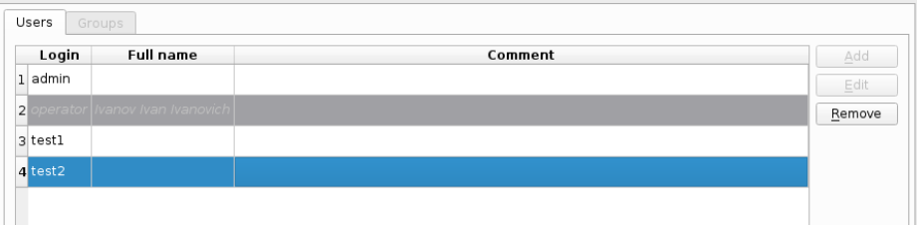
Figure 4.76 – Deletion of user account

"Groups"
This tab (Figure 4.77) includes information on user groups, as well as the elements for adding, editing and removing of groups.
Information on the groups is presented in the form of a table. Name and comment are shown for each group.
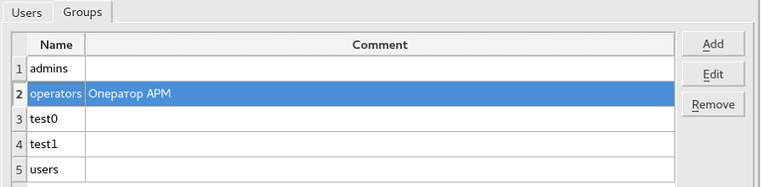
Figure 4.77 – Information about groups
To the right of the table there are buttons for adding a new group, editing an existing group and deleting a group.

- Adding a new group (Figure 4.78).
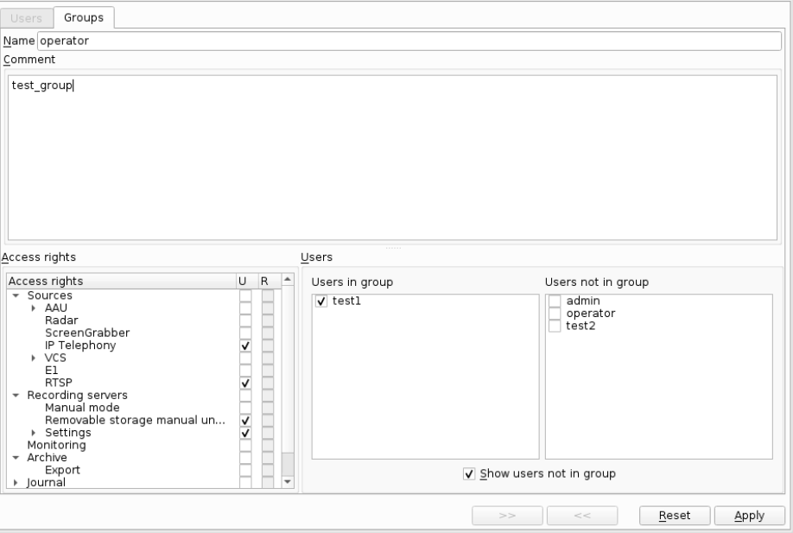
Figure 4.78 – Adding a new group
For adding a new group, field "Name" must be filled (Figure 4.79). Unless this field is filled, button "Apply" at the bottom of the window will be unavailable and the field itself will be of red colour.
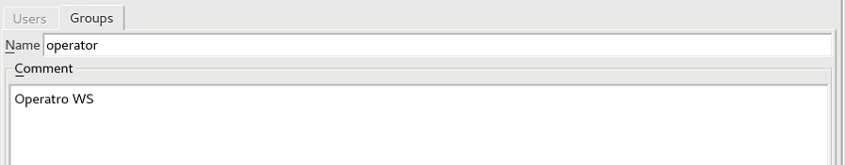
Figure 4.79 – Information about a new group

After this you should specify the access rights for a new group (Figure 4.80), i. e. what operations in the system will be available to members of this group. For assignment of access rights, set a check mark opposite to the relevant line in column "U".
Figure 4.80 – Rights assigning to the group
Note: users of a group will gain access to specific element, only if access is allowed to all "parent" elements. E. g., if access to listening of channels on the card is allowed to the group users but they are denied to access to the card itself, as the result the access to channel listening will be denied.

For adding users to a group you should set check mark "Show users not in a group" and after that set the check marks in list " Users not in a group " opposite to those users which should be members of the group. For deletion of a user from the group, the check mark opposite to the required user in list "Users in group" should be removed (Figure 4.81).
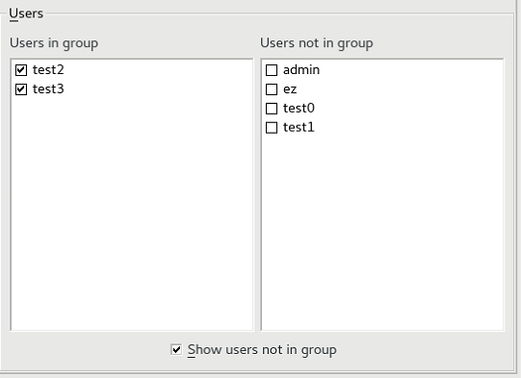
Figure 4.81 – Adding users to the group

- Editing the existing group (Figure 4.82).
All actions are completely similar to adding a new group. Additionally, all changes made but not saved yet are highlighted in yellow.
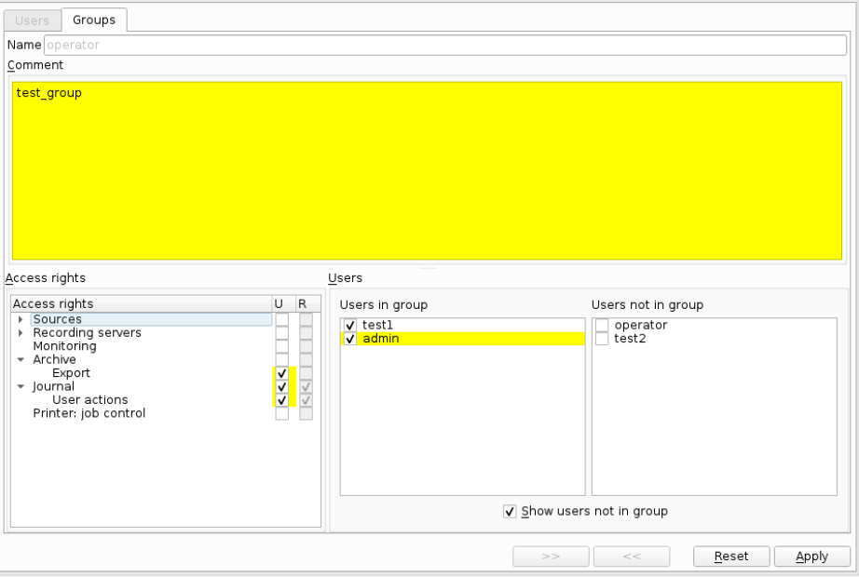
Figure 4.82 – Editing the existing group

- Removing of a group (Figure 4.83).
For deletion of a group, select the relevant account with mouse and press button "Delete". The line in the table will become grey and disappear after the changes are applied.
You can select and delete several groups at the same time.
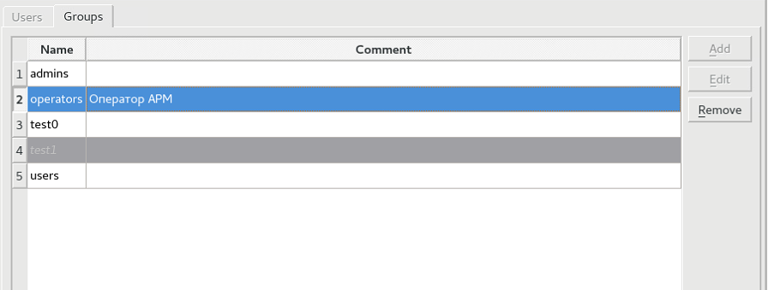
Figure 4.83 – Deletion of a group

Settings for digital telephony
On this tab the list of abonents is presented for each of the servers. For each of the abonents you can change description and IP-address. Besides, you may specify for each abonent if the data pertaining to it should be recorded (voice data and status) to the archive. If the abonent is temporary, he can be added to the list of permanent abonents. The list of permanent abonents is stored on the server and restored in case of restarting the recording server (Figure 4.84).
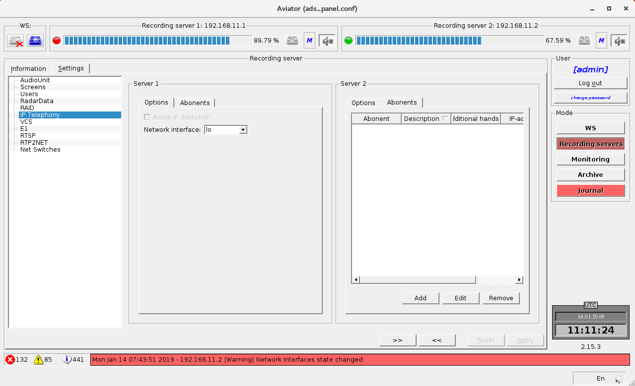
Figure 4.84 – Settings for digital telephony

RTSP parameter settings
The workspace is divided into two parts. Each part provides information about the RTSP configuration on the server (Figure 4.85).

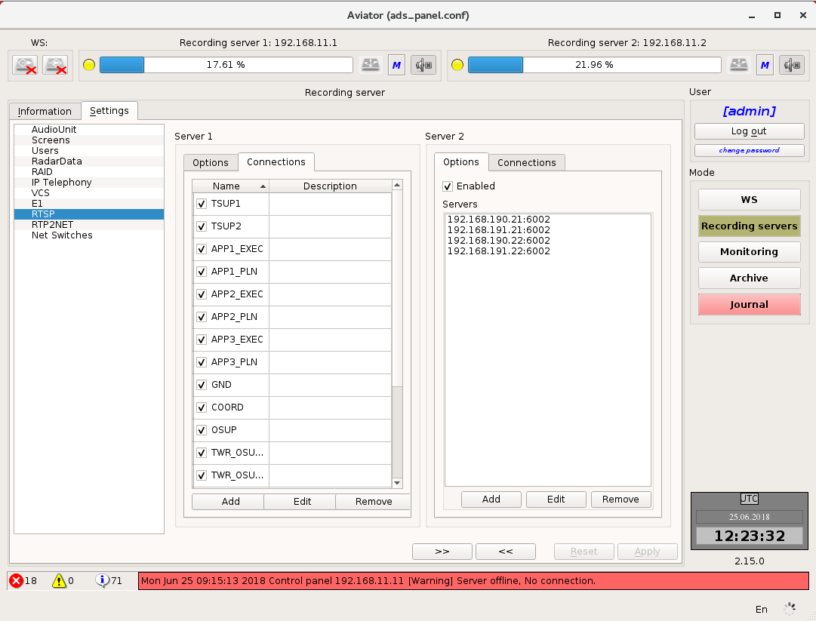
Figure 4.85 – The workspace of the RTSP parameter settings
The following parameters are available for RTP2NET configuring (Figure 4.85):
• Add / remove / edit the servers;
• Add / remove / edit the streams.

Adding a new RTSP-source (server) is done in the "Options" tab by clicking on the function button "Add".
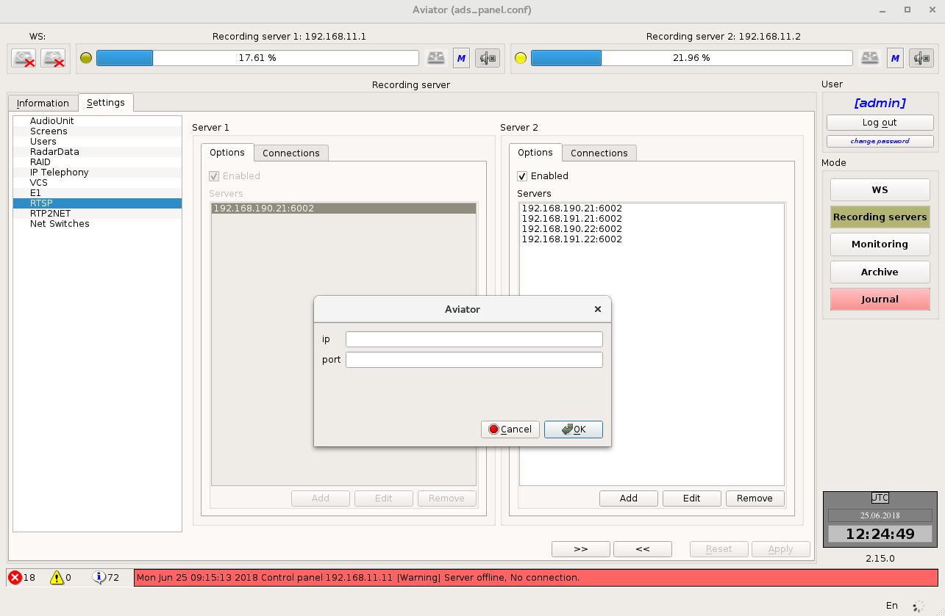
Figure 4.86 – Adding a new RTSP-source (server)
In the appeared form there are two ip parameter available (Figure 4.86):
• ip - ip address of the RTP2NET source;
• port - the port, to which you are connecting the RSTP source.

Editing parameters of the RTSP-source is carried out by clicking on the function button "Edit" (Figure 4.87).

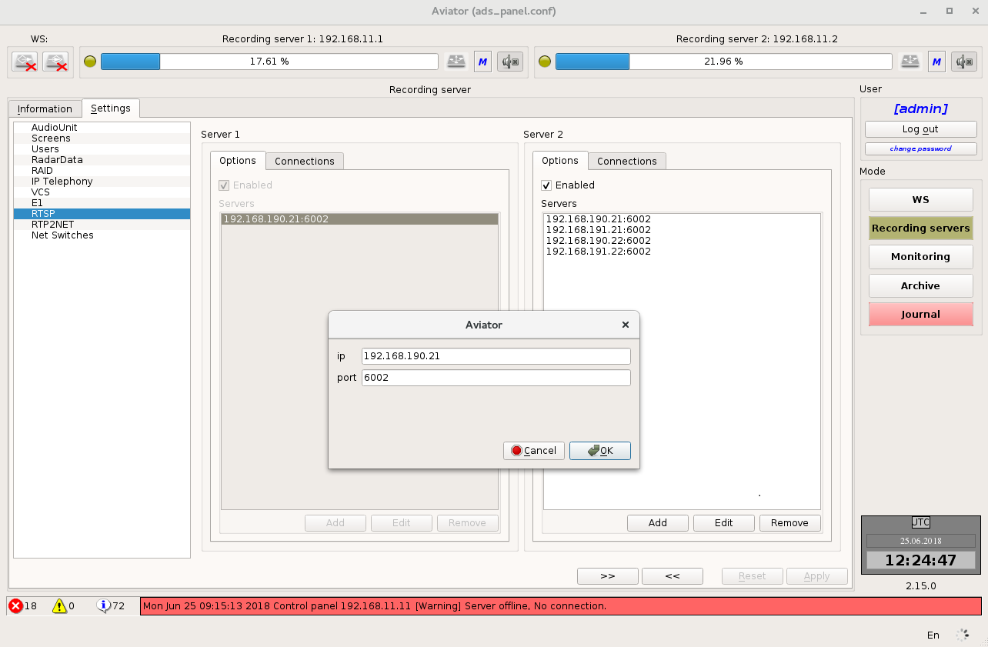
Figure 4.87 – Editing parameters of the RTSP-source

Removal of the selected RTSP-source is carried out by clicking on the function key "Remove".
Adding a new RTSP-source (AWP screen) is carried out on the tab "Options" by clicking on the function button "Add" (Figure 4.88).
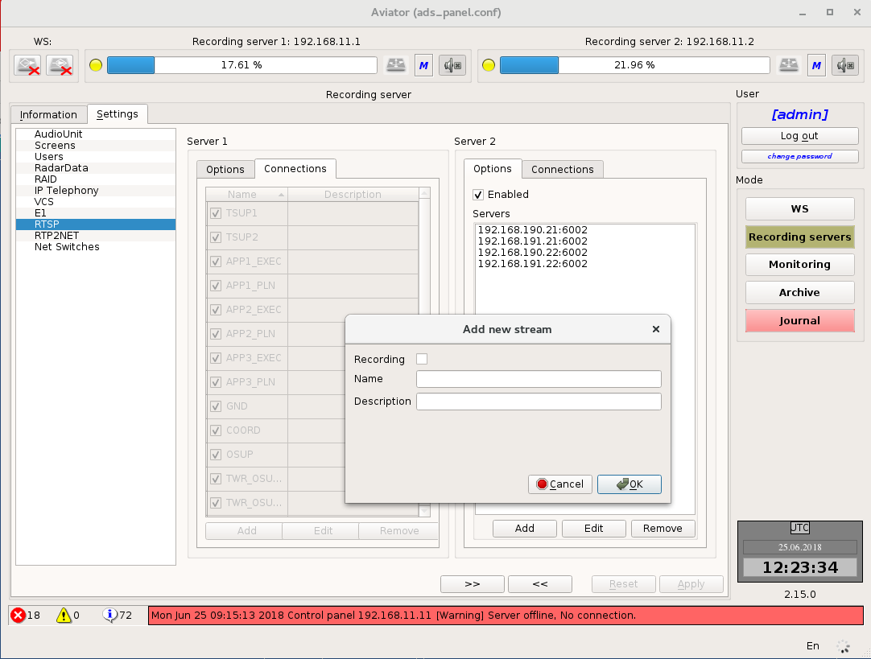
Figure 4.88 – Adding a new RTSP-source (AWP screen)
In the appeared form there are 3 parameters available (Figure 4.88):
• Recording - enable / disable the RTSP channel recording;
• Name - the RTSP - channel name specified on the RTSP - source;
• Description - description of the RTSP channel.

Editing the RTSP channel parameter is carried out by clicking on the function button "Edit" (Figure 4.89).
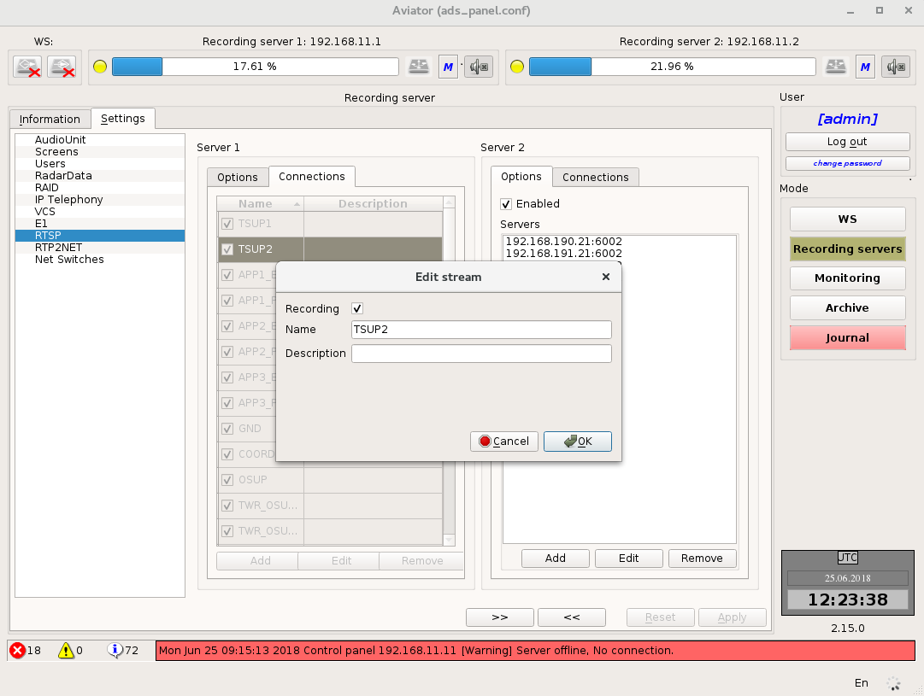
Figure 4.89 – Editing the RTSP stream

RTP2NET configuring
The workspace is divided into two parts. Each part provides information about the configuration of RTP2NET on the server (Figure 4.90).
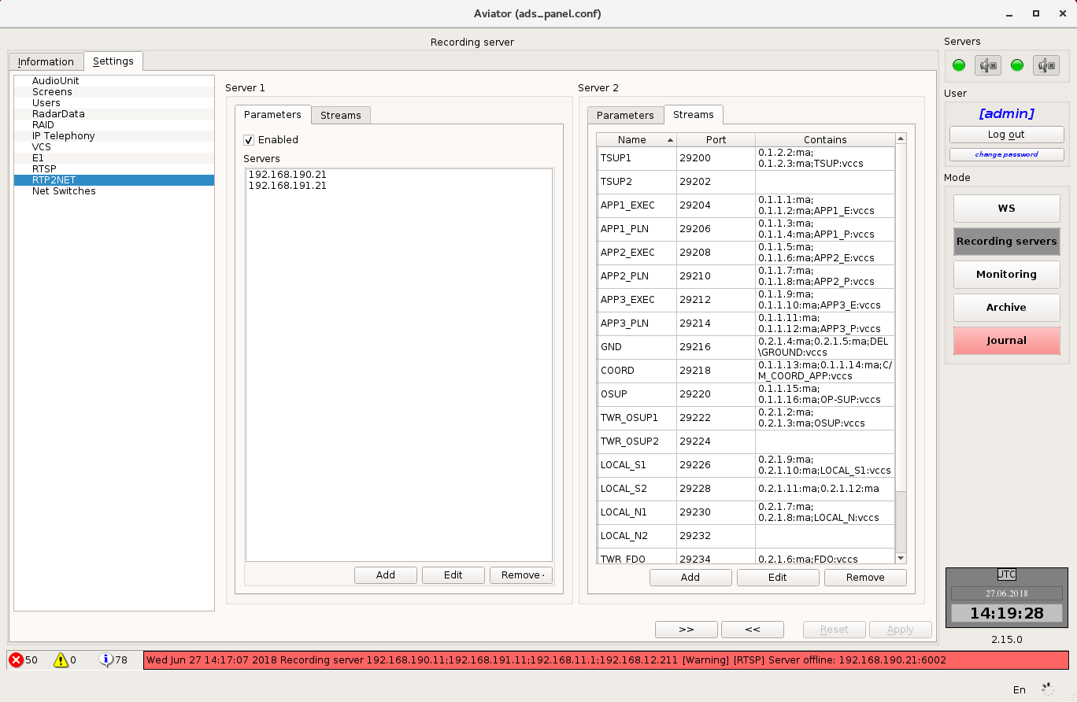
Figure 4.90 – The workspace of RTP2NET
The following parameters are available for RTP2NET configuring (Figure 4.90):
• Add / remove / edit the servers;
• Add / remove / edit the streams.

Adding a new RTP2NET server is done in the "Parameters" tab by clicking on the "Add" function button (Figure 4.91).
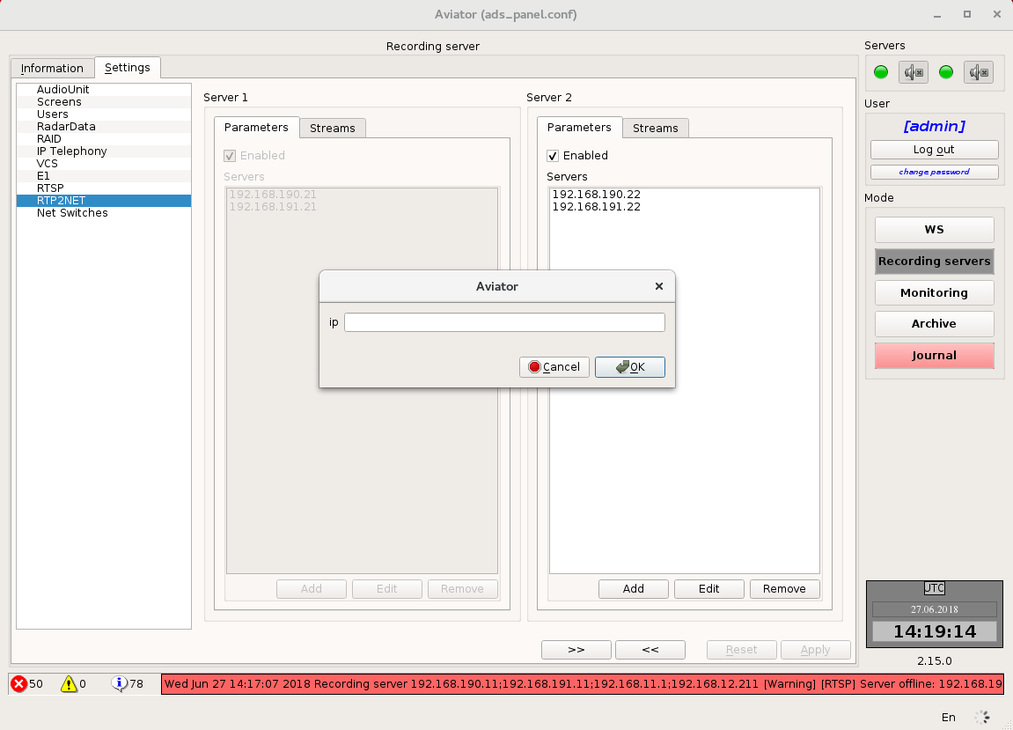
Figure 4.91 – Adding a new RTP2NET server
In the appeared form the ip parameter is available (Figure 4.91):
• ip - ip address of the RTP2NET server.
Editing parameters of the RTSP-server is carried out by clicking on the function button "Edit".
Removal of the selected RTSP-server is carried out by clicking on the function key "Remove".

Adding a new RTP2NET stream is carried out on the tab "Streams" by clicking on the function button "Add" (Figure 4.92).
In the appeared form there are 3 parameters available (Figure 4.92):
• Name - the name of the stream;
• Description - the RTP2NET stream description;
• Port - port for transferring an RTP2NET stream.
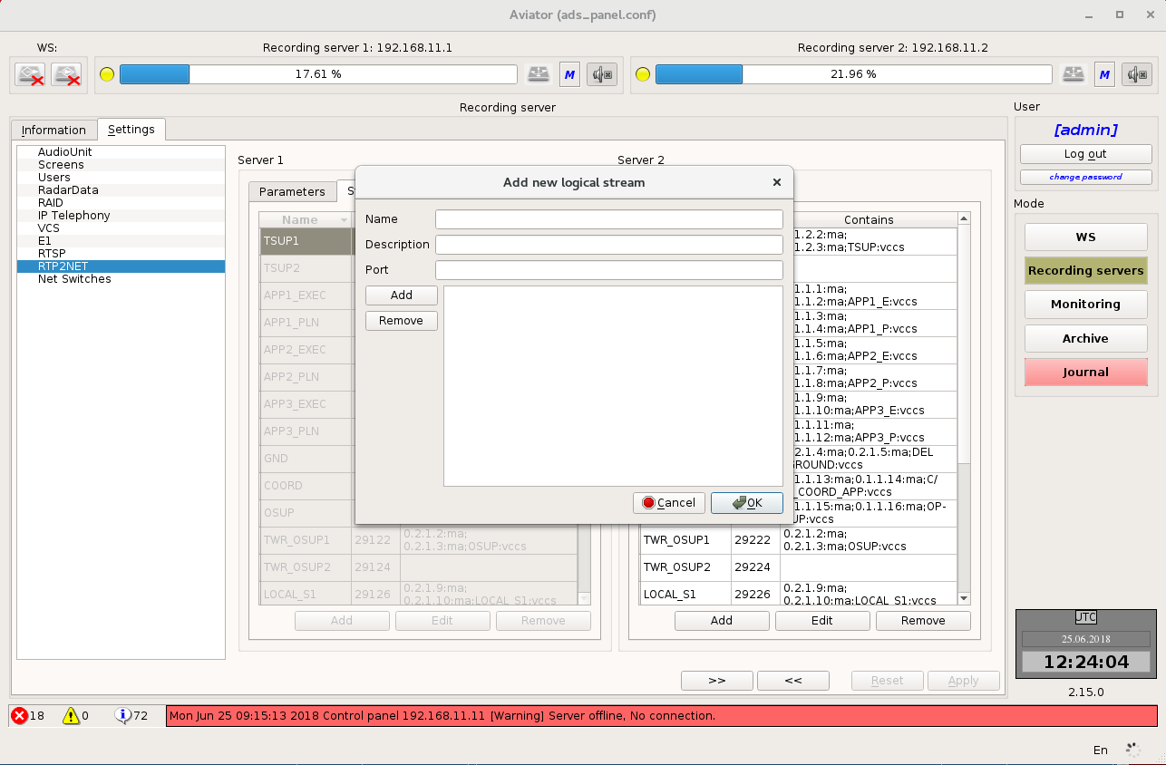
Figure 4.92 – Adding a new RTP2NET stream

After creating the RTP2NET stream, add a new element that serves as one of the audio documentation channels: a channel from the AAU unit (ma/me), a VCS channel or an IP Telephony channel (phone).
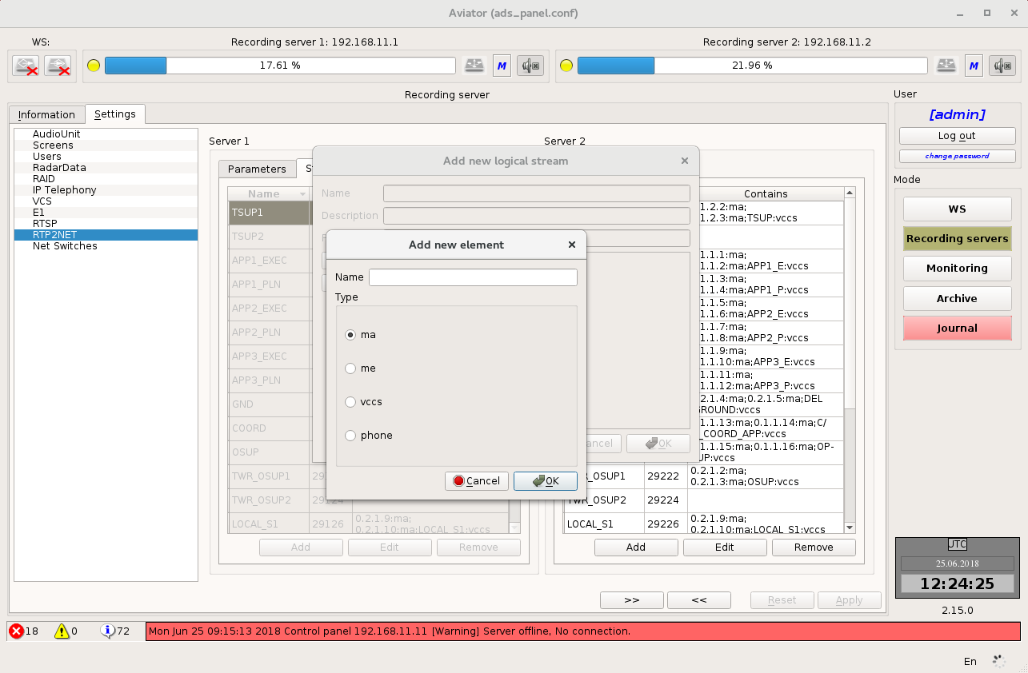
Figure 4.93 – Adding a new element of the RTP2NET stream

The RTP2NET stream parameter editing is carried out by clicking the function button "Edit" (Figure 4.94).
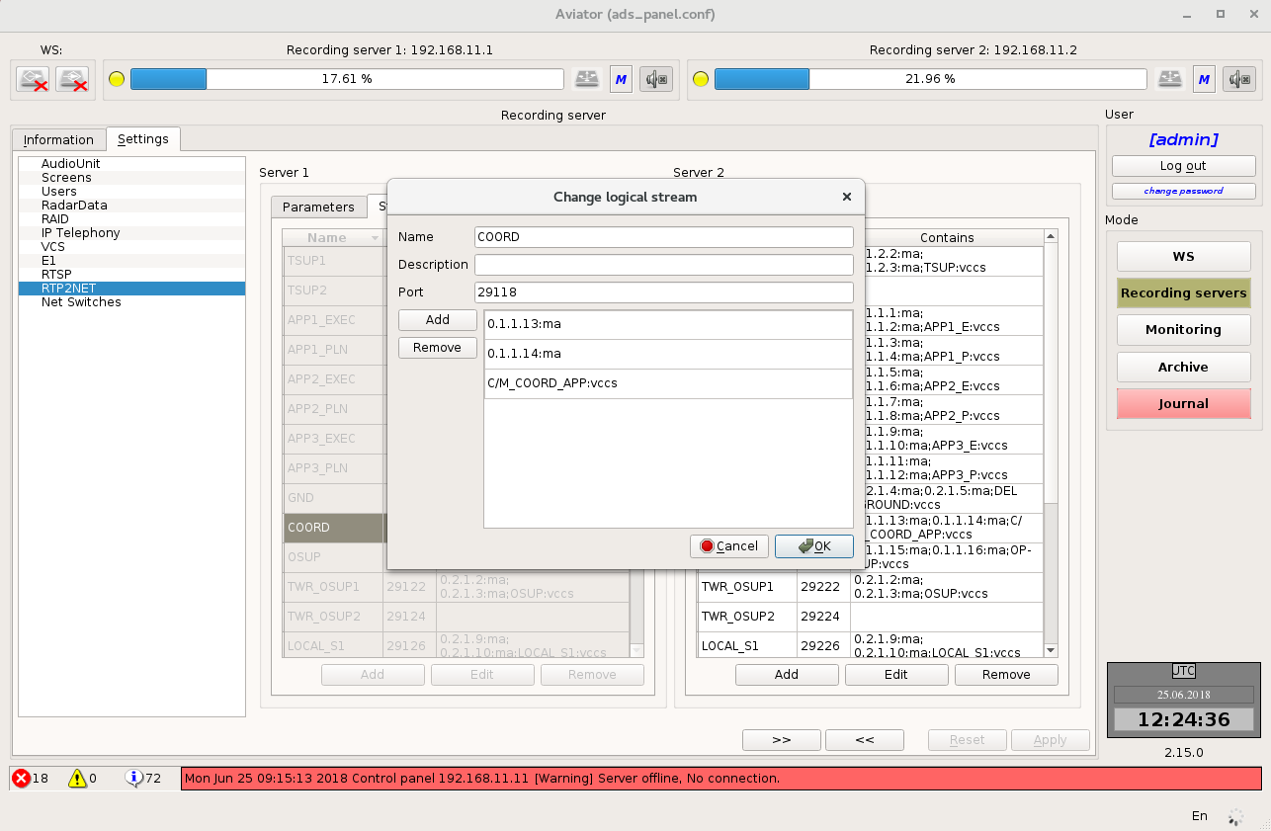
Figure 4.94 – Editing the RTP2NET stream parameter
Removal of the selected RTP2NET stream is carried out by clicking on the function button "Remove".

Configuring of the Switch Status
To configure the switch, select the "Address" field and enter the device ip-address.
Make changes in the parameters of the request interval and the response timeout, if necessary (Figure 4.95).
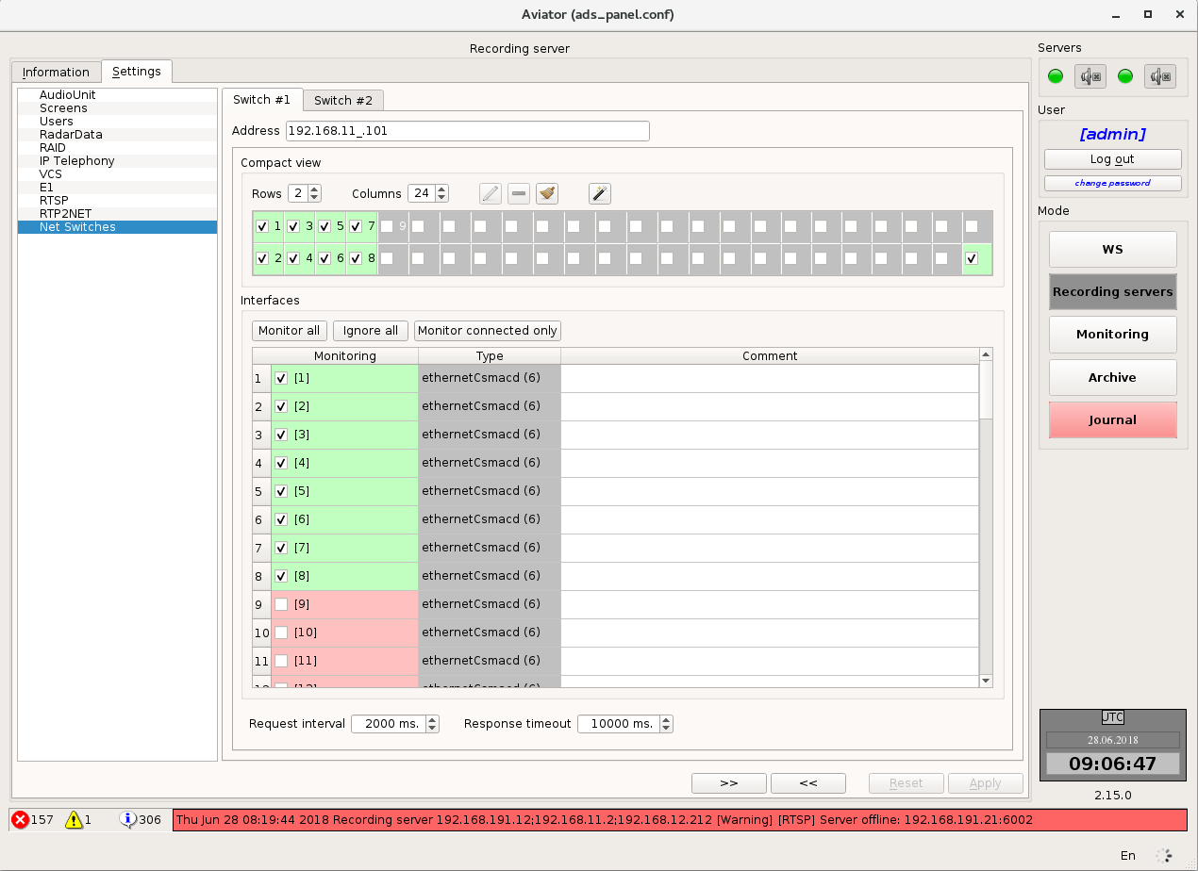
Figure 4.95 – Configuring of the Switch Status
Using the panel “Compact view”, configure the graphical display of the switch:
• Set the number of rows;
• Set the number of columns;
• Select ports for monitoring.

Function Buttons:
• "Monitor all" - enable monitoring of all switch ports;
• "Ignore all" - disable monitoring of all switch ports;
• "Monitor connected only" - enable monitoring of switch ports where the connection to the target equipment is established.

Mode "Monitoring"
Mode "Monitoring" - Real time listening - (Figure 4.96) enables the user to listen to the data recorded in the recording server (point-to-point channel) in real time.
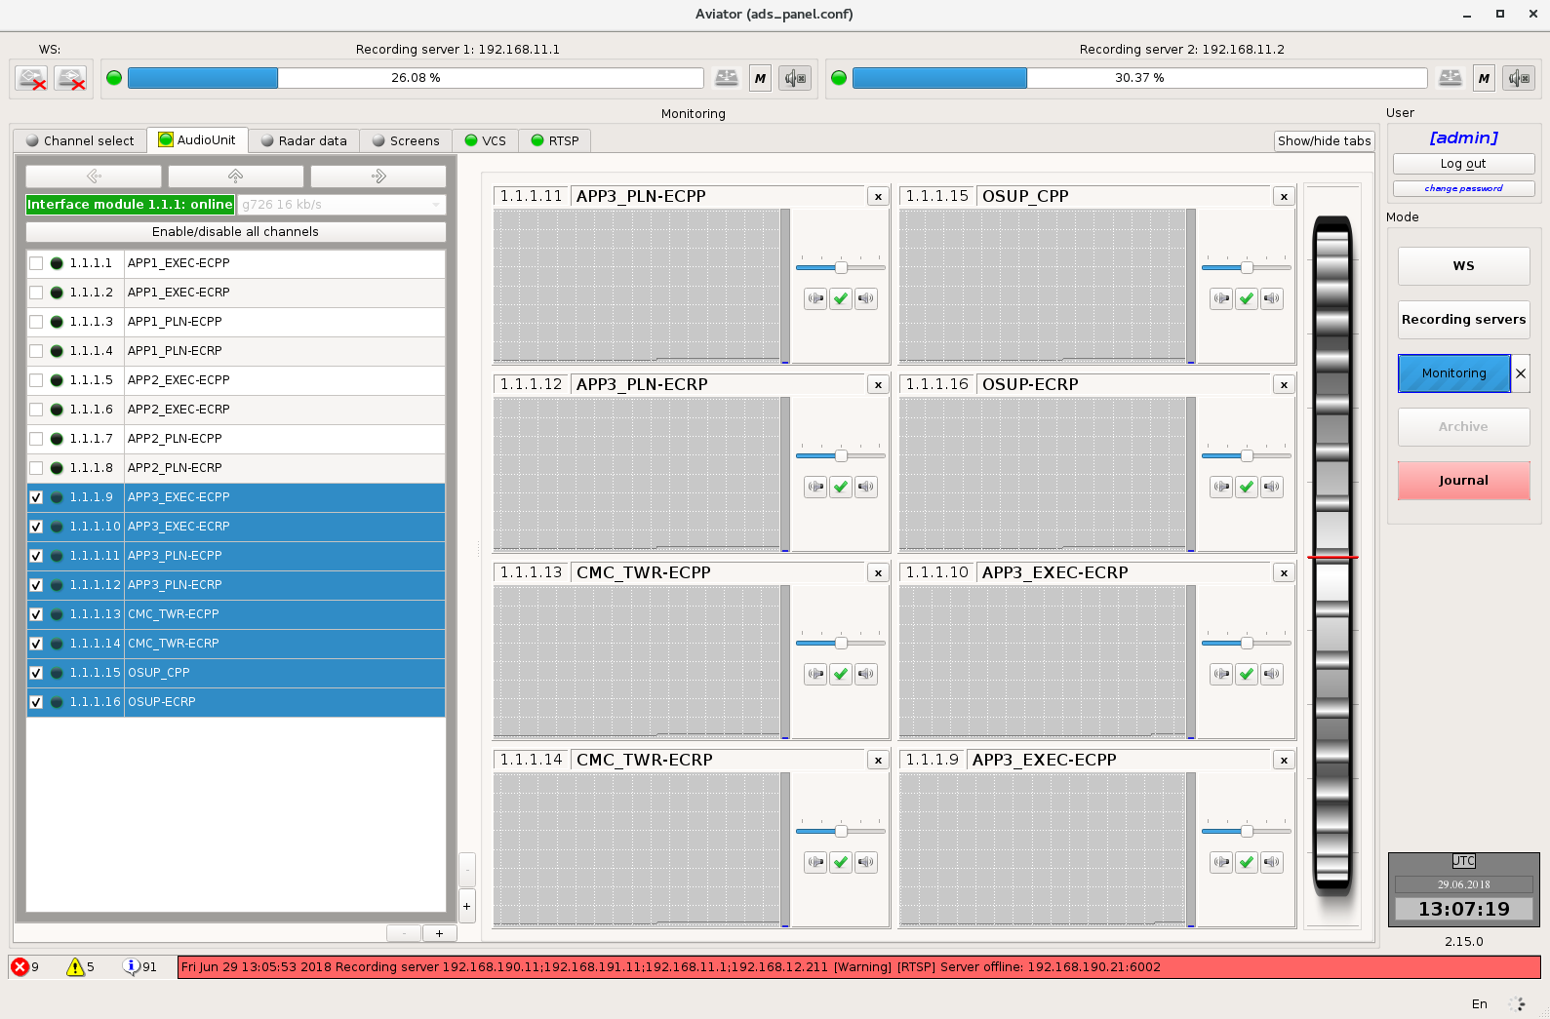
Figure 4.96 – Mode "Monitoring"
In this mode, the workspace contains tabs "Channel select", "AudioUnit", "Radar date", "Screens", "IP Telephony", "VCS", "E1", "RTSP". The tab "Audio Unit" enables to control data playback actually sent through AAU channels at the moment of archiving. The tab "Radar Data" enables to control playback of Radar Data actually sent for archiving from Topaz servers.
Each tab has an indicator. Green colour of indicator means that there is connection with the server and the data is being transferred.

Monitoring of AAU stations
The area for selection of channels to be listened is arranged in the left part of tab "Audio Unit".
The area for selection of channels to be listened has several levels of detail:
Server level
On this level the user is provided with information on the recording servers making a part of the complex and condition of devices on the servers. Devices on the servers are presented in the form of rectangles on which the device ID is displayed in format <server number>.<device number> and status of device (off, malfunctioning, online and in order). The background colour changes depending on the device status. If device is OK, background colour will be green. If device appears malfunctioning, the background colour will be red (Figure 4.97).
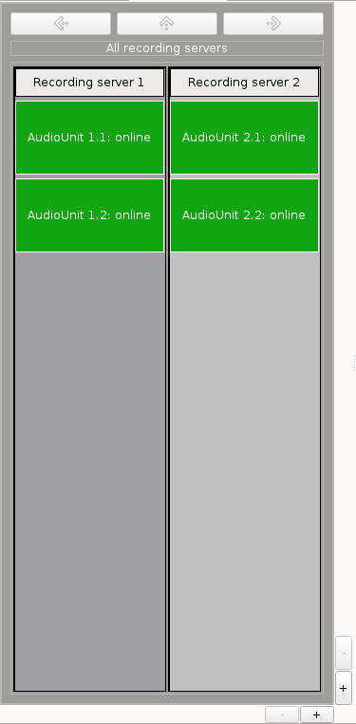
Figure 4.97 – Server level
You can select specific server by mouse-clicking on it. This allows you to go to the next level of detail.
Device level
On this level the user is shown information on AAU devices on the server and condition of cards on devices (Figure 4.98).
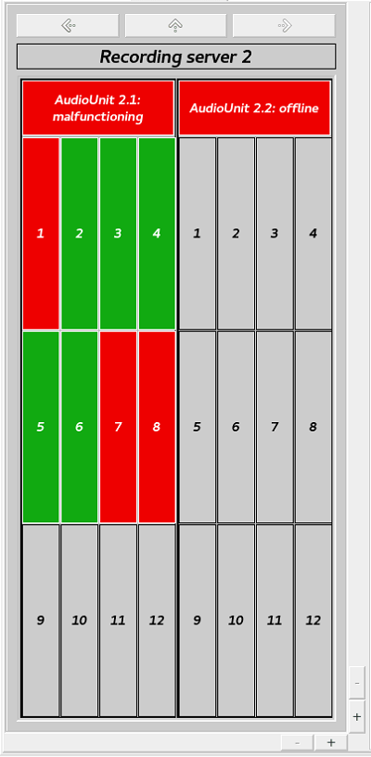
Figure 4.98 – Device level
The upper part shows the name of the server, where such devices are arranged. Below, the device ID is specified for each of devices in format <server number>.<device number> with information on its condition. If a device appears malfunctioning, the field colour will be red. If device operation is normal – online and in order, the field colour will be green.
The cards of devices are presented in the form of rectangles and numbered from 1 to 12. If monitoring of card is disabled in configuration, the rectangle colour will be grey, otherwise the rectangle colour indicates the state of the relevant card: green –card is online and in order, red –malfunctioning card.
In this mode the user gains access to navigation buttons (buttons with arrows above the name of a server). Using the arrows "left" and "right" you can navigate between servers of the complex. By pressing the arrow "up" you may return to the higher level of detail (server level).
You can select specific device by mouse-clicking on it. This allows you to go to the next level of detail.

Card level
On this level the user is provided with information on the cards of selected device and status of channels on the cards (Figure 4.99).
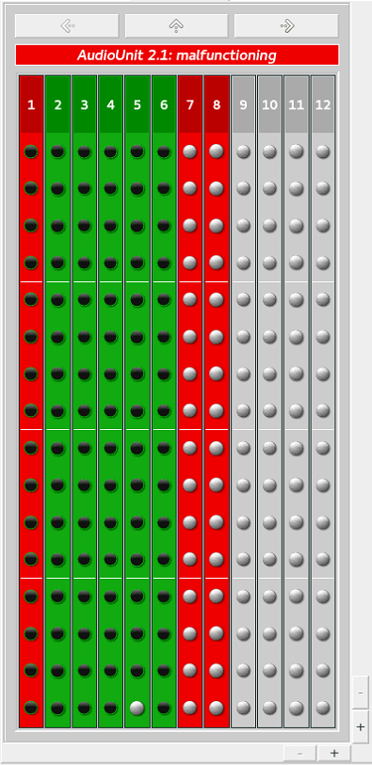
Figure 4.99 – Card level
The device ID and its status are indicated in the upper part. Background colour of this field depends on the device condition. Green – device is online and in order, red –malfunctioning device.
Information on the cards is shown below. The cards, monitoring over which was disabled in the configuration, are of grey colour.
Other cards have either green colour – the card operates normally, or red colour – the card is not operative (e. g., removed).
The status of channels on the card is presented in the form of indicators. The channels whose monitoring was disabled in the configuration have grey colour of indicator. For other channels the indicator colour has a green shade, the brightness of which depends on the power of signal in the channel. If the user is not allowed to observe this channel, the indicator icon will be crossed out.
Using the arrows "left" and "right" you can navigate between devices of one AAU. By pressing the arrow "up" you may return to the higher level of detail (device level).
You can select specific card by mouse-clicking on it. This allows you to go to the next level of detail.

Channel level
On this level (Figure 4.100) the user is provided with information on the channels of selected card.
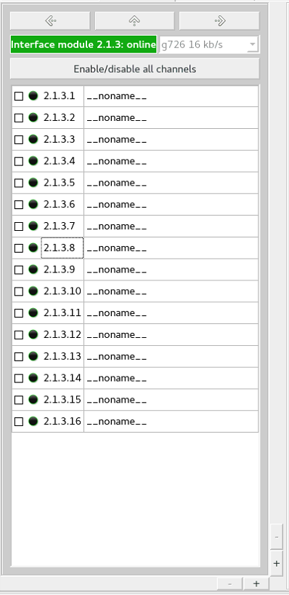
Figure 4.100 – Channel level

The card ID and its status are indicated in the upper part. Background colour of this field depends on the card condition. Information on the channels is arranged below.
Information on the channels is presented in the form of a table. ID for each of the channels is indicated in format <server number>.<device number>.<card number>.<channel number>, channel name, channel status indicator. The channels, whose monitoring was disabled in the configuration, have grey colour of indicator. For other channels the indicator colour has a green shade, the brightness of which depends on the power of signal in the channel. If the user is not allowed to observe this channel, the indicator icon will be crossed out.
You can navigate between the cards of device using the arrows "left" and "right". Pressing the arrow "up" allows you to go back to the higher level of detail (card level).
Channels are selected for listening on this level. Set a check mark opposite to the channel to add it to the list to be listened. You can select at once up to 16 channels. It will not be possible to select one more channel afterwards.

By default, the user may only have an access to one field for selection of channels for listening. But the number of fields may be increased up to two or four. This is done using buttons "+" and "–" in the right bottom corner (Figure 4.101). For each of the fields you can select an individual level of detail.
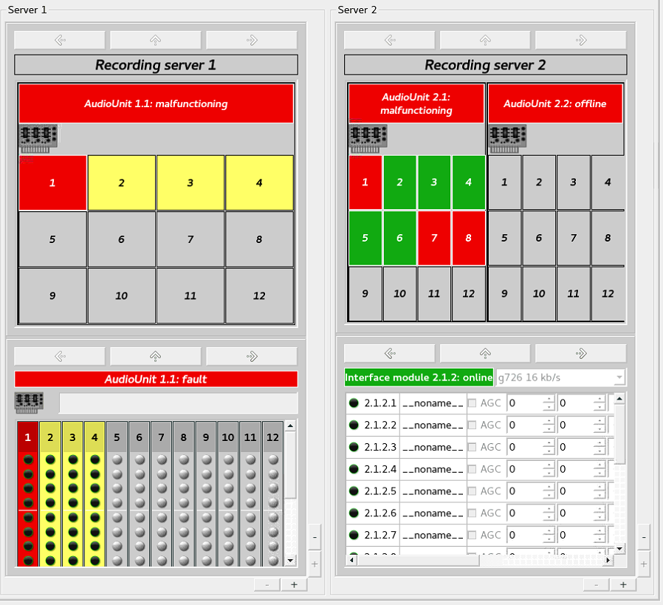
Figure 4.101 – Several fields for selection of channels to be listened

The diagram display field is located on the right of the area for selection of channels to be listened (Figure 4.102).
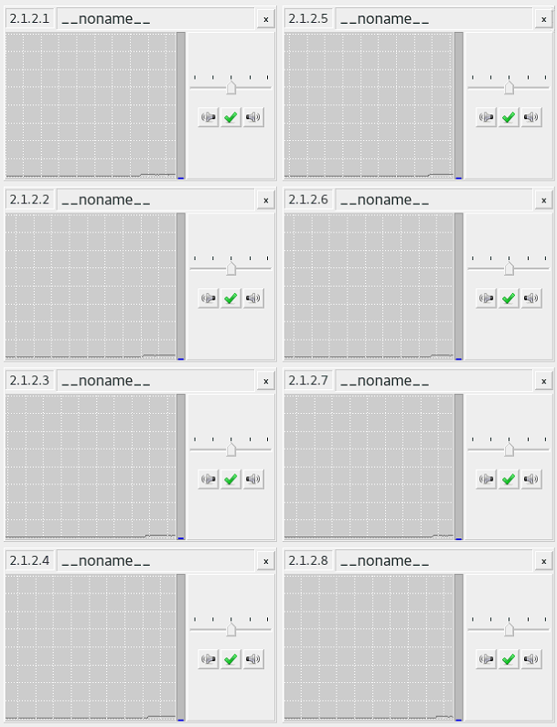
Figure 4.102 – Channel mixer

After the user selects a channel to be listened (Figure 4.100), a channel control window will appear in this field. It includes (Figure 4.103) channel ID [1], channel name [2], button for closing the channel from mixer [3], channel volume control [4], buttons for switching off the left and right speakers [5], visual representation of the signal level in a channel [6].
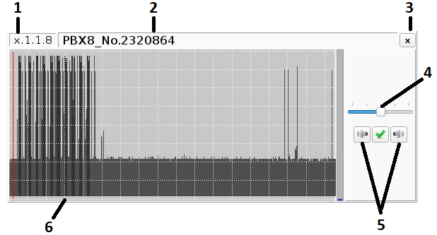
Figure 4.103 – Channel listening field
To change volume level use all channels volume control wheel (Figure 4.104). For this purpose you should point the mouse cursor at the wheel and, holding down the left mouse button, move the cursor up and down. Having set the desired channel volume level, press the green check mark at the top right corner of the volume control wheel.

Figure 4.104 – Channel volume control
For changing the volume level, you can also point the mouse at the volume control and start to turn the mouse wheel or click on the volume control to display the advanced volume control field. In this case, you may point the mouse at the wheel and, holding down left mouse button, move the cursor up and down.
Note: if the cursor is pointed above the channel volume control, the volume may be changed with the mouse wheel.
General volume level adjuster is located on the right-hand side of the mixer (Figure 4.103). For changing the volume, you should point the mouse cursor and start to rotate the wheel up or down. The red line on volume control adjuster indicates the volume by default (50 %).
Double click of the left mouse button on the wheel restores the default volume.

Online voice communication system abonent monitoring and listening
Online VCS abonent status monitoring and listening function is available in the tab "VCS" in the monitoring mode (Figure 4.105):
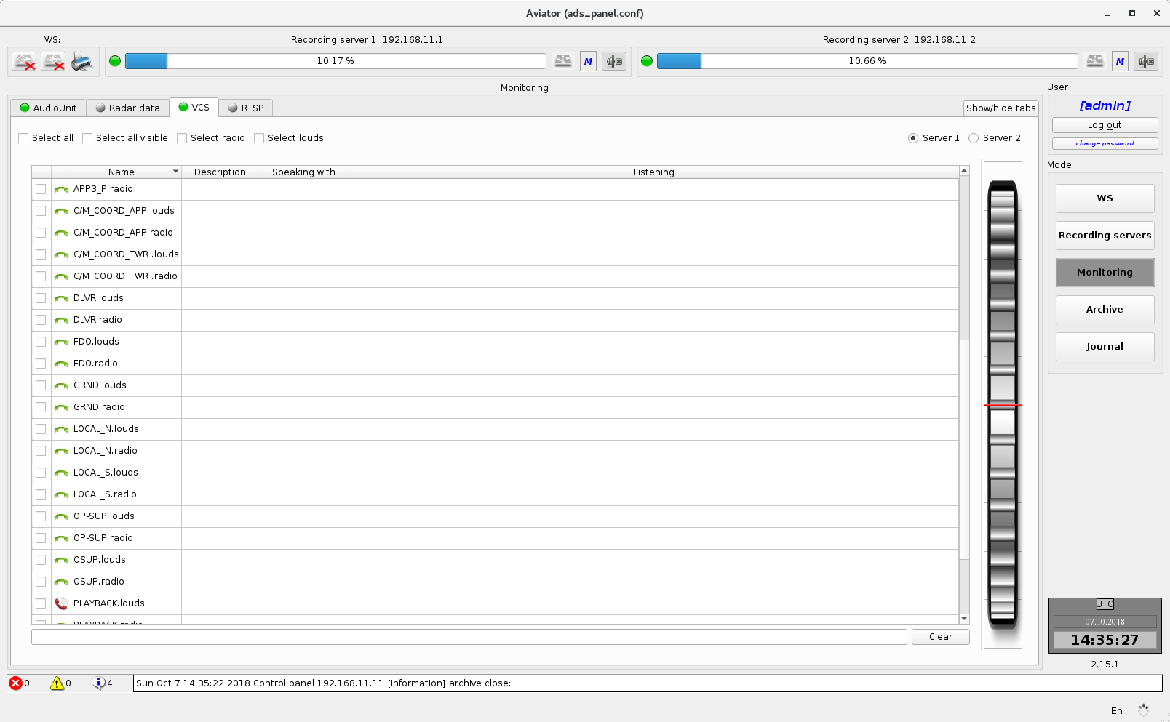
Figure 4.105 – VCS abonent status monitoring and listening function

There are two lines in the abonent table for each VCS abonent. One line is used for LSC channel and another – for radio channel. Thus, it allows separate playing back of these channels.

Selection of server for listening (Figure 4.106)
List of recording servers (server 1 or server 2) available for selection is located at the top of the tab. After the recording server has been selected, the list of abonents to be monitored will be available.
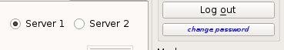
Figure 4.106 – Selection of server for listening

Abonent listening (Figure 4.107)
For listening, select the respective abonent in the list using a check box:
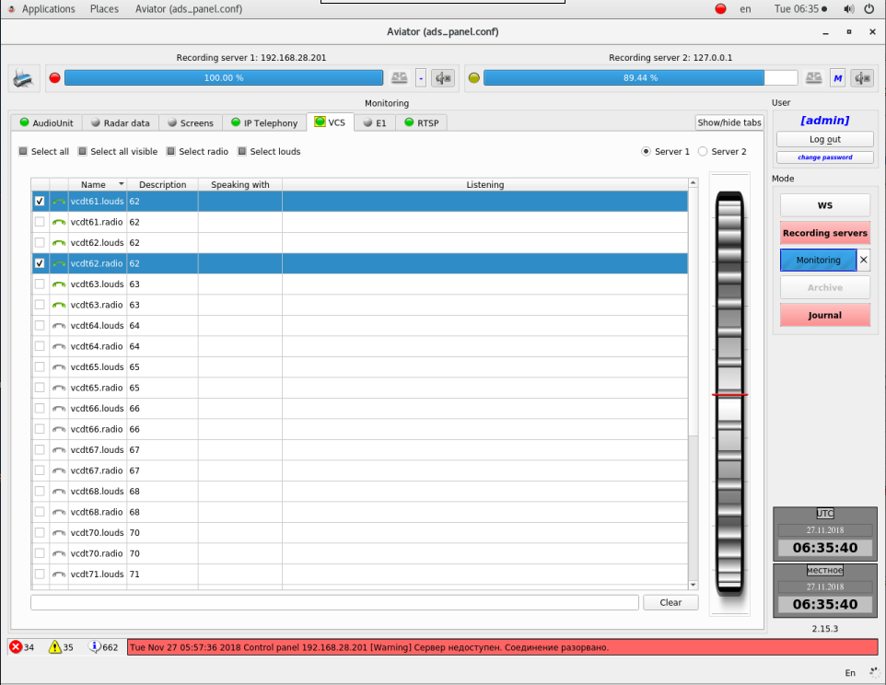
Figure 4.107 – Abonent listening
Above the abonent list, there is the check box "Select all" that allows selecting the entire list of abonents to be listened.

Filter bar is located at the bottom, below the list of abonents (Figure 4.108):
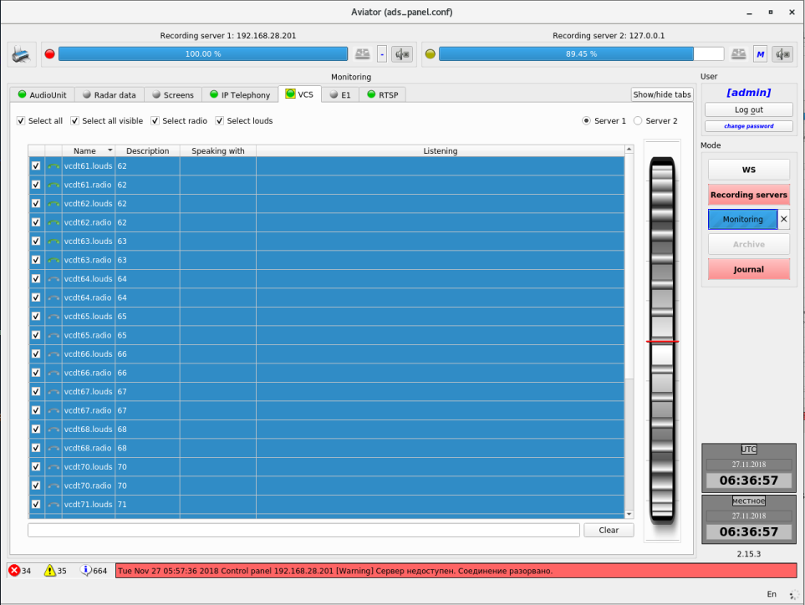
Figure 4.108 – Abonents filtering
Filter string is located below the list of abonents. Search is made in the fields "Name" and "Description". To quickly clear the filter, use the button "Clear" to the right of the bar.

Online E1 stream data monitoring and listening

Online abonent status monitoring and listening function is available in the tab "E1" in the monitoring mode (Figure 4.109):
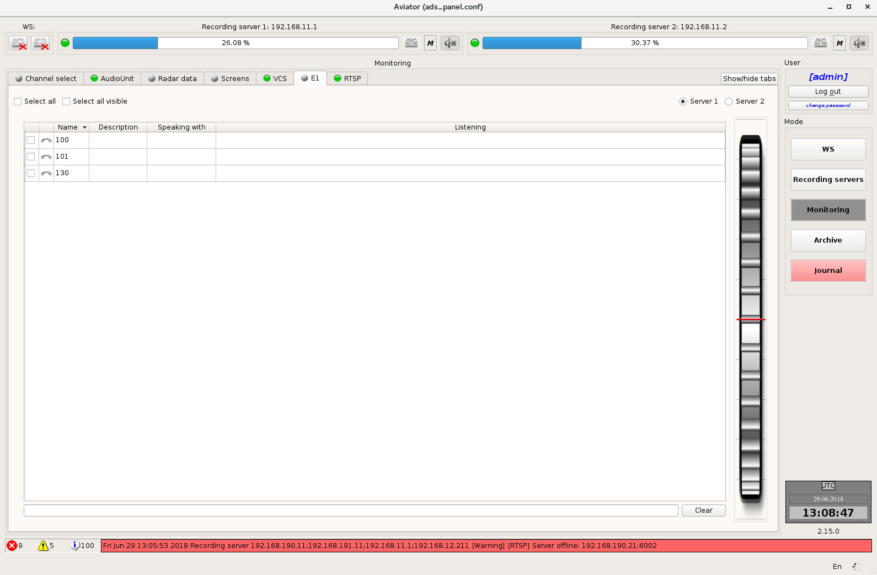
Figure 4.109 – Tab E1. Online abonent status monitoring and listening function
Note: Due to specific features of the E1 digital stream, it is impossible to define the abonent availability in the network when the abonent does not take part in conversation. It makes this data source type differ from VoIP source.

Selection of server for listening (Figure 4.110)
List of available recording servers is located at the top of the tab. After the recording server has been selected, the list of abonents to be monitored will be available.

Figure 4.110 – Selection of server for listening
For listening, select the respective abonent in the list (Figure 4.111):
Figure 4.111 – Abonent listening
Above the abonent list, there is a check box "Select all" that allows selecting all abonents to be listened, using one click.

Filter bar is located at the bottom, below the list of abonents (Figure 4.112):
Figure 4.112 – Abonent filtering
Search is made in the fields "Name" and "Description". To quickly clear the filter, use the button "Clear" to the right of the filter bar.

Monitoring of Radar Data Workstations "Topaz"
This tab accommodates the elements for playback control of Radar Data sent at the moment of archiving from servers of ATC AS "Topaz" (Figure 4.113).
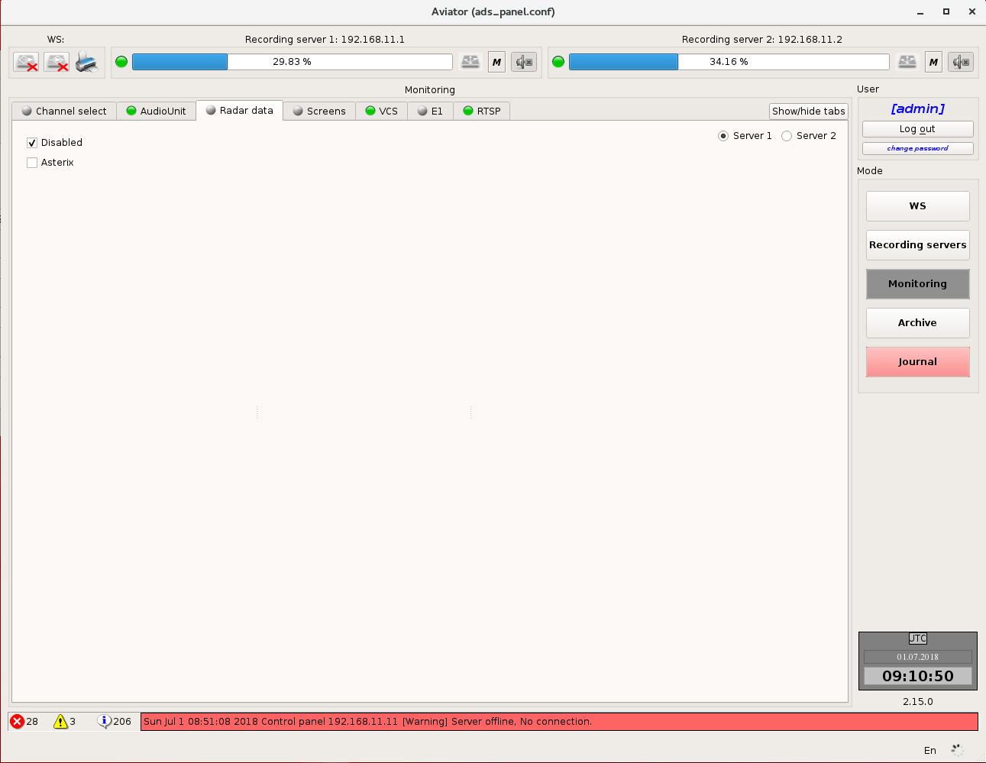
Figure 4.113 – Tab "Radar Data"
The playback itself is carried out at Radar Data Playback Workstation, while Monitoring and Playback Workstations can only transfer the necessary data. Two groups of selector switches are provided for playback control:
- Data source enables to select the source, from which records will be transmitted. If selector switch "Disabled" is set, data transfer will be stopped;
- Source type (processed or unprocessed data) that will be sent to Radar Data Playback Workstation for playing back.
Button "Clear" allows clearing of display at Radar Data Playback Workstation at any moment of time.

Monitoring of RSTP
On the "RTSP" tab, the user can select one of two RS “Aviator” servers as the playback source. The choice is performed in check box by switching over between Server 1 and Server 2.
Information about the channels is presented in the form of a table. Channel name and information on its connection status with the RTSP-source are available for each channel in the table (Figure 4.114).
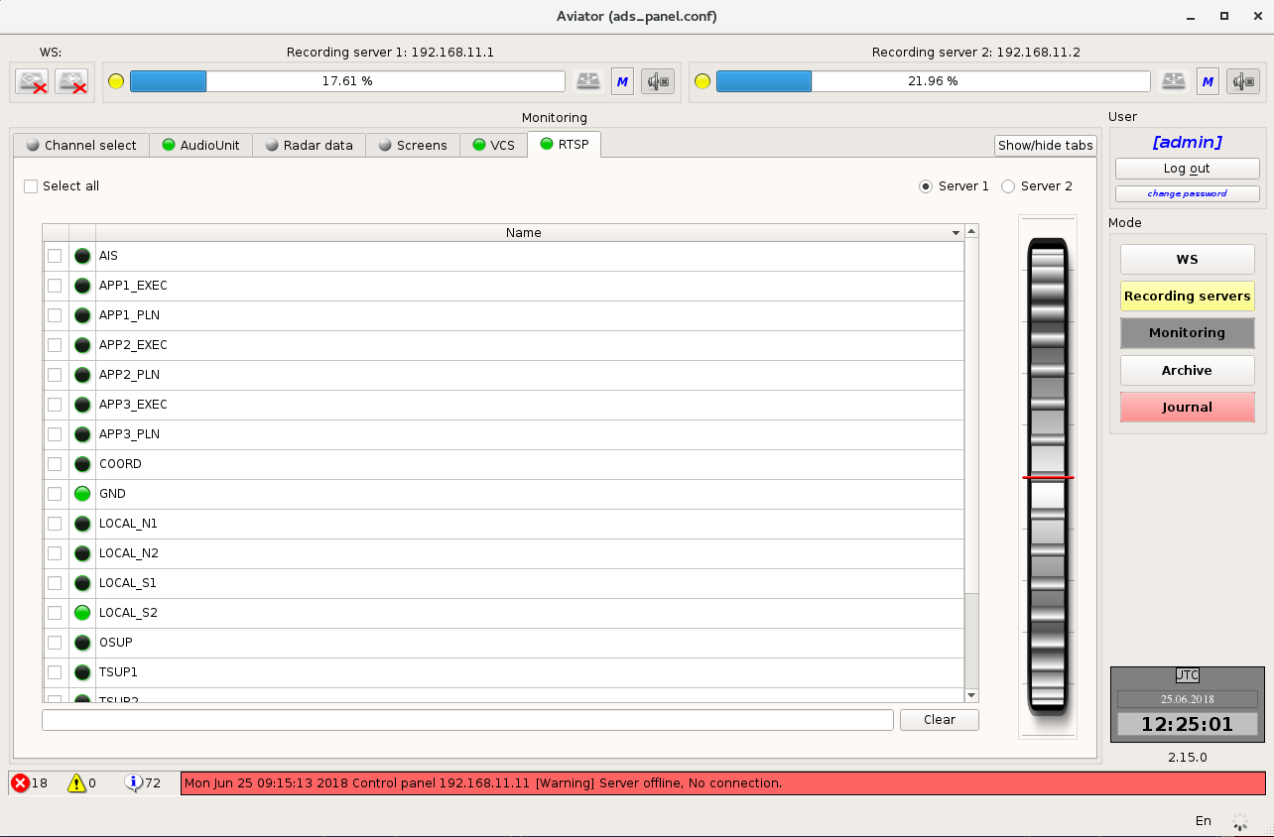
Figure 4.114 – Information about the channels

For channel selection to view, check the box next to this channel switch (Figure 4.115).
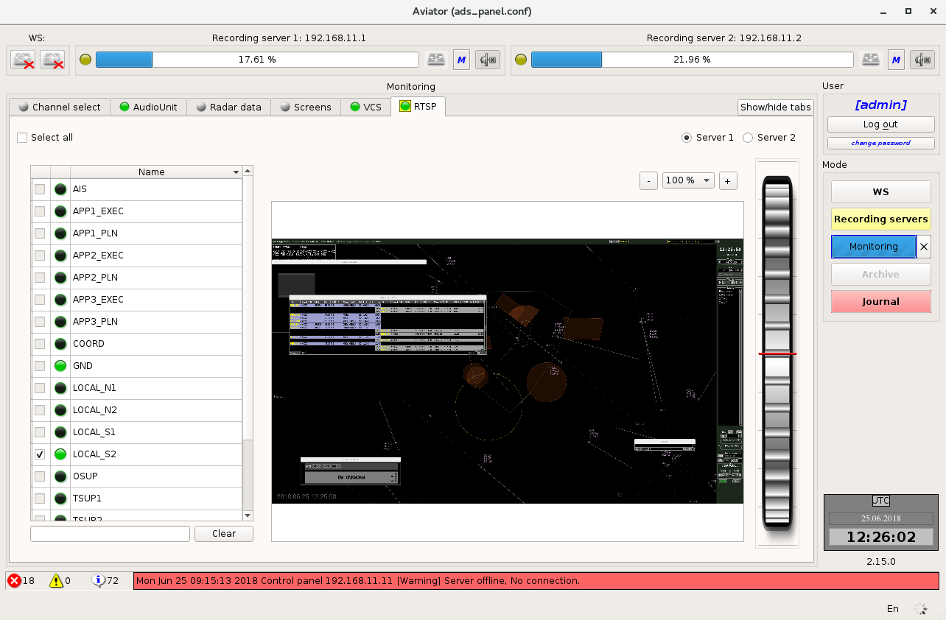
Figure 4.115 – Viewing a particular channel

Screen Data Monitoring
The "Screens" tab (Figure 4.116) allows the user to view data from the screens. The user can select one of two RS “Aviator” servers as the playback source. The choice is performed in check box by switching over between Server 1 and Server 2.
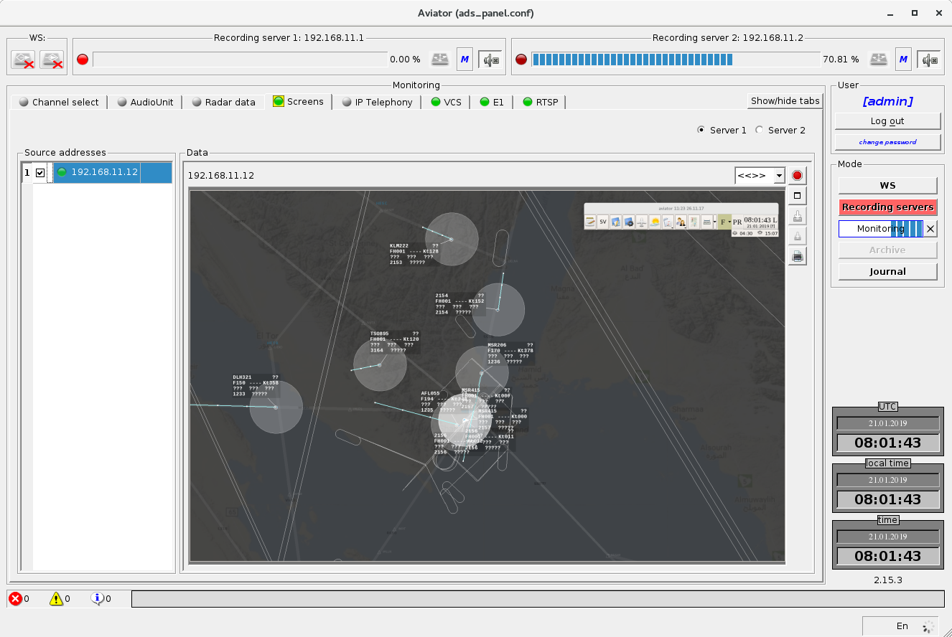
Figure 4.116 – The "Screens" tab
In the left part there is a list of computers for which data was recorded from the screen to the archive. Each computer has an IP address, a name, and an indicator. If the indicator colour is green, then the data for this screen was, if the indicator is gray, then there was no data. To select a screen for monitoring, check the box next to the desired line. After the screen has been selected, a viewing area will open in the right side of the tab, in which data will be displayed. Up to four screens can be opened at a time.

In addition to the screen [2] itself, the viewing area (Figure 4.117) allows the user to: find out the computer name and its IP address [1], select the image scale [3], close the viewing area, put the viewing area into full-screen mode [5], take a screenshot and write it to removable storage for data export [6]. If there is no removable storage for data export, the [6] button will be unavailable. Save the visible area from the screenshot to removable storage [7], print the visible area from the screenshot [8].
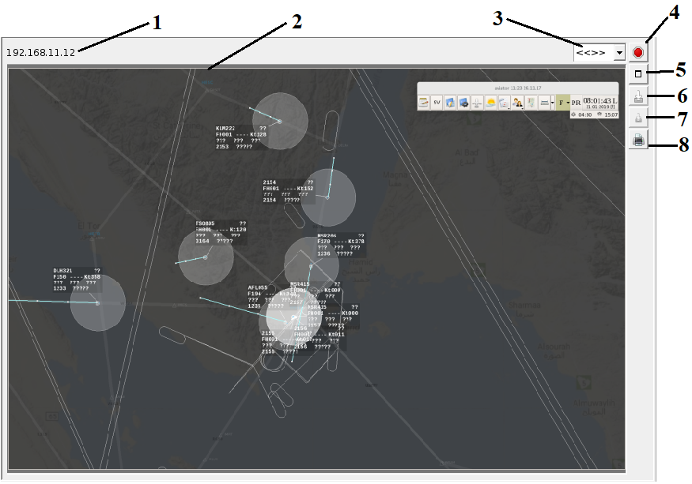
Figure 4.117 – Screen viewing area

In full screen mode (Figure 4.118), instead of the full screen mode transfer button, the return to normal mode button [3] is displayed. In addition, information about the current position in the played fragment [1] is displayed, and a button appears that allows you to pause playback [2]. To continue playback, press the [2] button again.
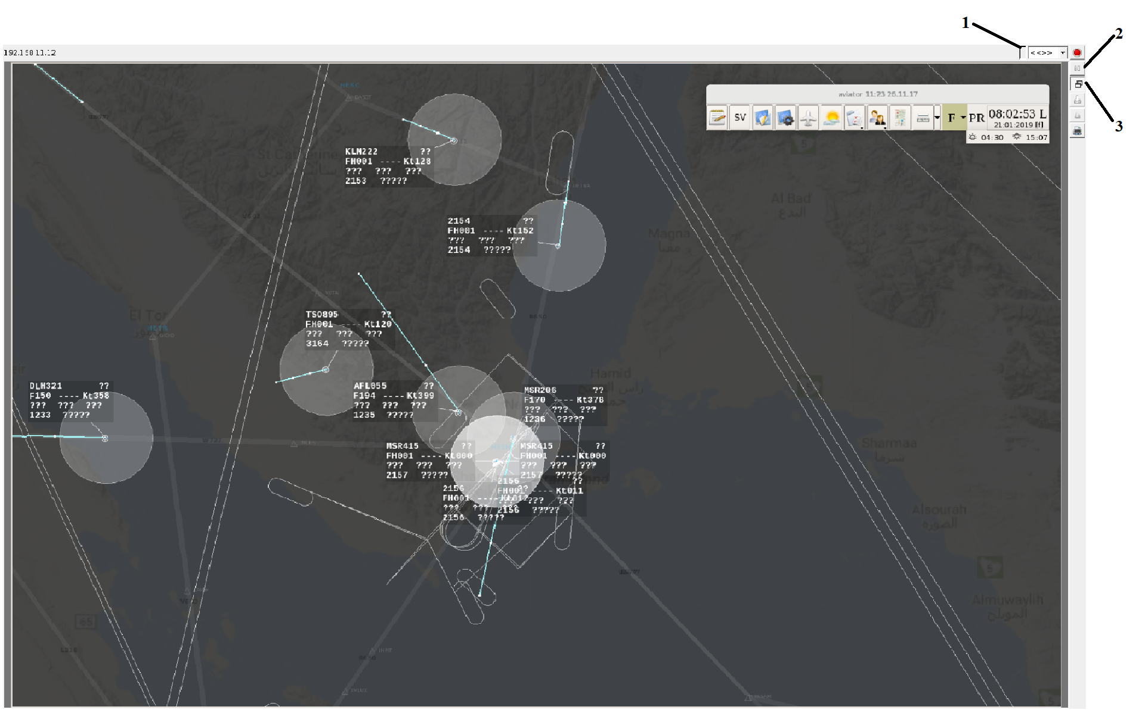
Figure 4.118 – Screen viewing area - full screen mode

Control of digital telephony
On the "IP telephony" tab (Figure 4.119), the status monitoring and listening of VCS subscribers in real time is available, as well as the choice of one of the two RS “Aviator” servers as the playback source. The selection is made by switching the flag between “Server 1” and “Server 2”.
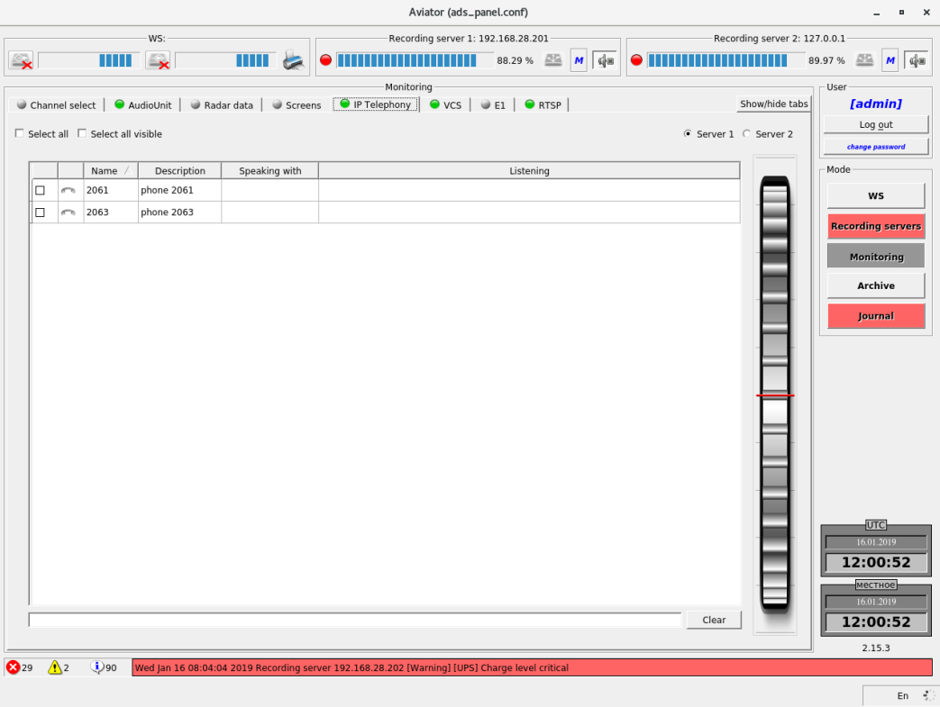
Figure 4.119 – The "IP Telephony" tab
On the left is a list of subscribers available for selection. To start listening to a specific subscriber, you should tick it off.

Mode "Archive"
Mode "Archive" (Figure 4.120) provides an access to some data that are stored in archives on the servers and removable storage. Such operations include: data playback, viewing of statistics, data export. All control elements are distributed among six tabs: "Select", "Playback", "Stats", "Bookmarks", "Markers", "Export". The tab "Select" is always available. Other tabs become available only after selection of an element for playback.
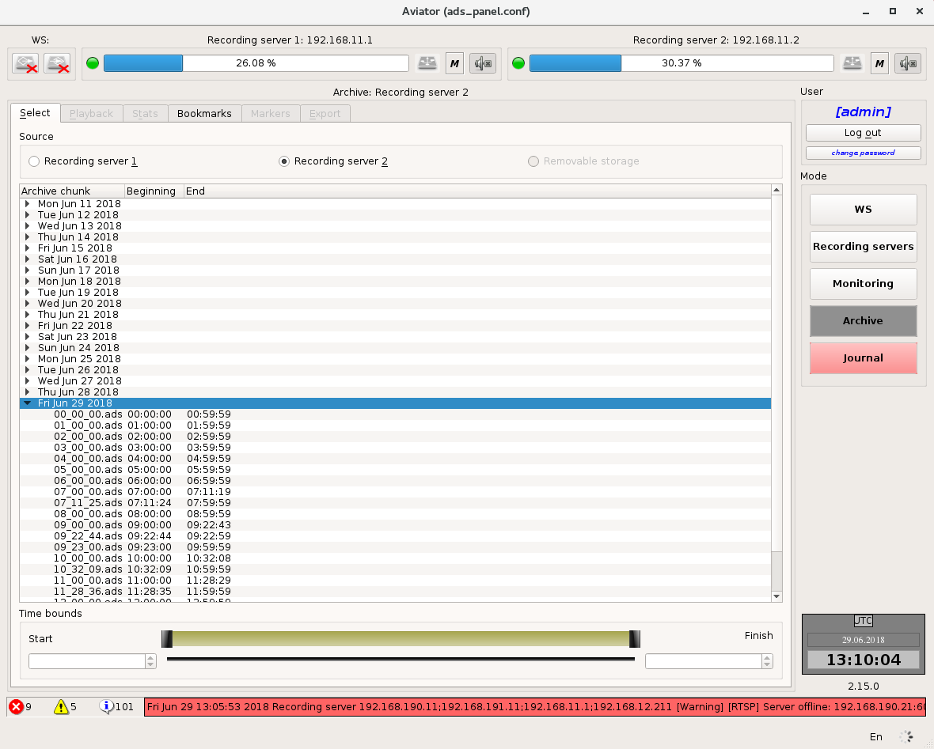
Figure 4.120 – Mode "Archive"

Selection of archive fragment
On top of the tab "Select" there is a group of selector switches that allows choosing a source with data archive: Recording server 1, Recording server 2 or removable storage (Figure 4.121). If any of the sources is missing (server is switched off, removable storage is not inserted), the relevant item will be unavailable.
The list of records stored in the archive is located below. The records are grouped by days. Name, recording start time and recording end time are specified for each record. Records are selected by means of the mouse. You can select several records at a time.
Below the list of records there are two numerical fields displaying the start and end time of the fragment selected for playback. By default, the start and end of fragment match the start and end of record in the archive (if several records are selected, the start of fragment for playback corresponds to the start of the first record, and the end of fragment – to the end of the last record). The start and end time of a fragment for playback can be changed either by using buttons "up" / "down" in the left part of the numerical field, or by entering the required value from the keyboard. Two sliders are arranged between numerical fields for visual displaying of start and end of the fragment selected for playback. When the values in numerical fields are changed, they change their position. The start and end time of fragment can also be set by using sliders by means of moving them with the mouse.
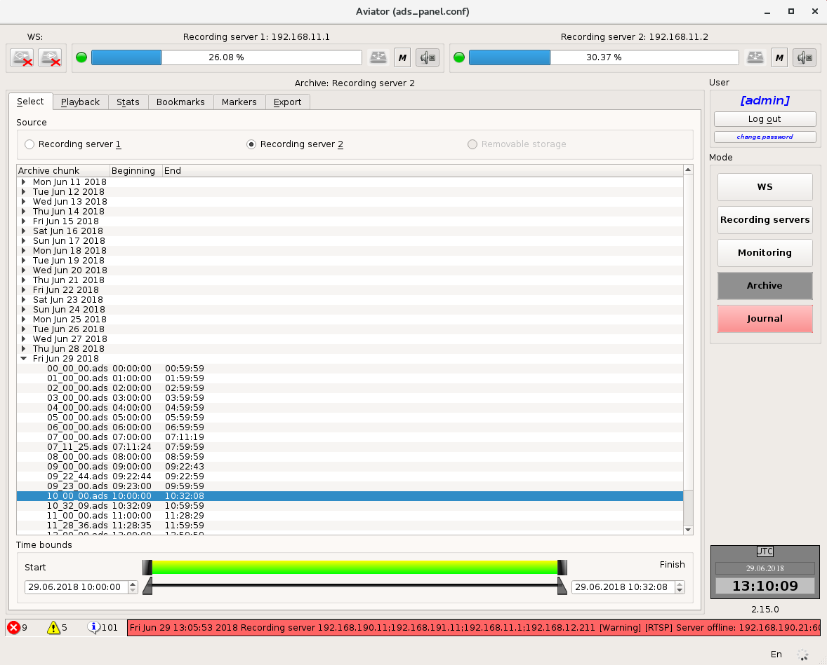
Figure 4.121 – Tab "Select"

Playback of archive fragment
Tab "Playback" (Figure 4.122) enables to control of the playback process, as well as to select what data exactly should be played back.
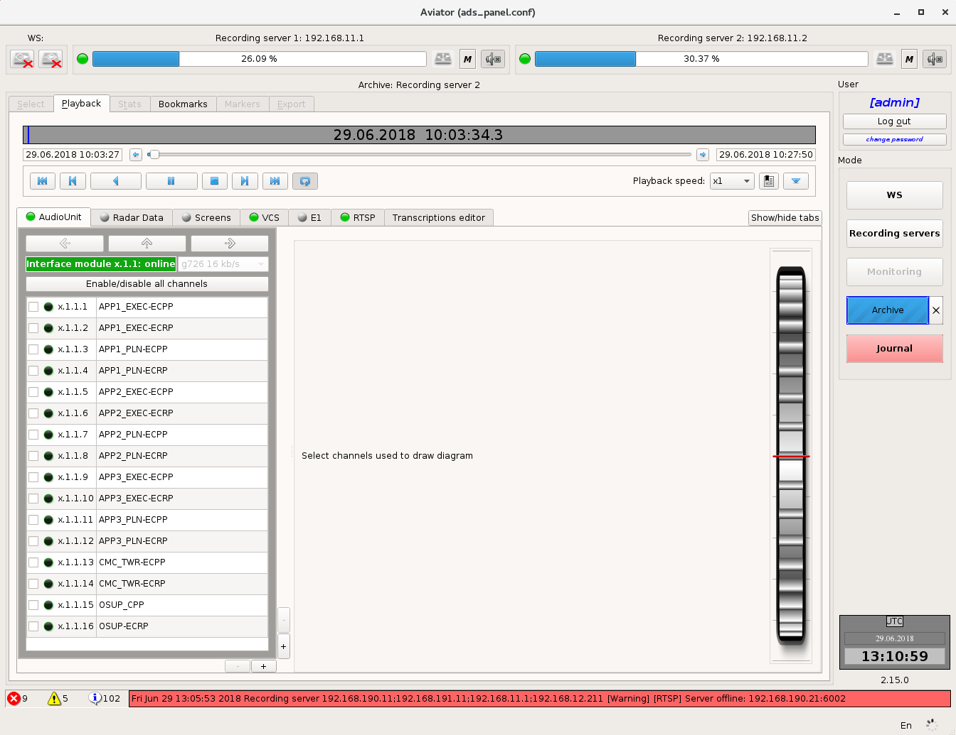
Figure 4.122 – Tab "Playback"
The elements of playback control are arranged on the "player" (Figure 4.123).
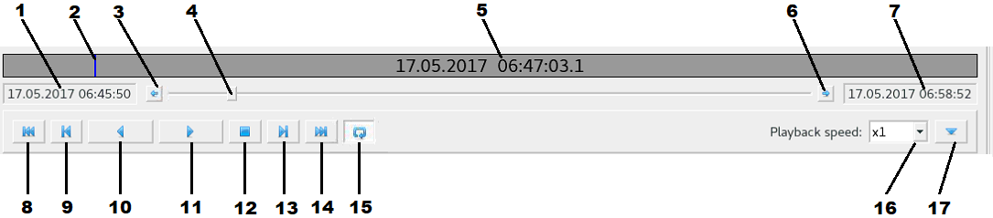
Figure 4.123 – Player
The graphical representation of the record fragment [5] and current position of playback [2] is located on the top of the player. Information on the date and time relevant to the current position of playback is displayed here as well. If you mouse-click on this field, a box for modification of the current position will be shown (Figure 4.124). A new value can be set either using buttons "up" / "down" on the right of the time value, or directly, by entering the required value from the keyboard. After pressing button "Apply" the current playback position will move to the new one.
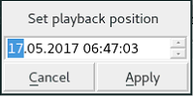
Figure 4.124 – Сurrent position selection window
The slider [4], which also displays the current position of playback, is located below. By shifting the slider with the mouse, you can change the current position of the played back record fragment. Buttons [3] and [6] are arranged on the left and on the right of the slider. Pressing of these buttons will cause movement of the current position to the relevant direction by 1 second. Text fields with the date and time corresponding to the start [1] and end [7] of the played back fragment are located on the left and right of the buttons.
Playback control buttons are arranged at the very bottom of the player: seek to the start of fragment [8], seek backward [9], seek backward and play [10] (time interval is specified in additional settings, play [11], stop [12], seek forward [13], seek to the end of fragment [14], loop playback [15], playback speed[16] (you can select х0.25, х0.5, x1, х2, х4 from the normal speed), additional controls [17].
Pressing the button of additional controls will result in displaying of advanced settings (Figure 4.125), time interval which is used when searching by voice (if the voice comes up within such interval, the interval is deemed that there was no break); rewind interval with the pressed button in Figure 4.123.
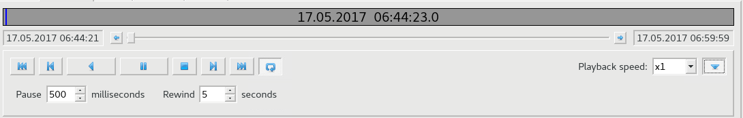
Figure 4.125 – Additional controls of player
Three tabs are arranged below the player. Each of the tabs is intended for playback of the specific type of data. The colour of indicator in the tab name depends on whether the data of relevant type was transferred. If data was transferred, the indicator will be green, if data was not transferred, the indicator will be grey.

AAU data
On this tab (Figure 4.126) the information from AAU devices is displayed.
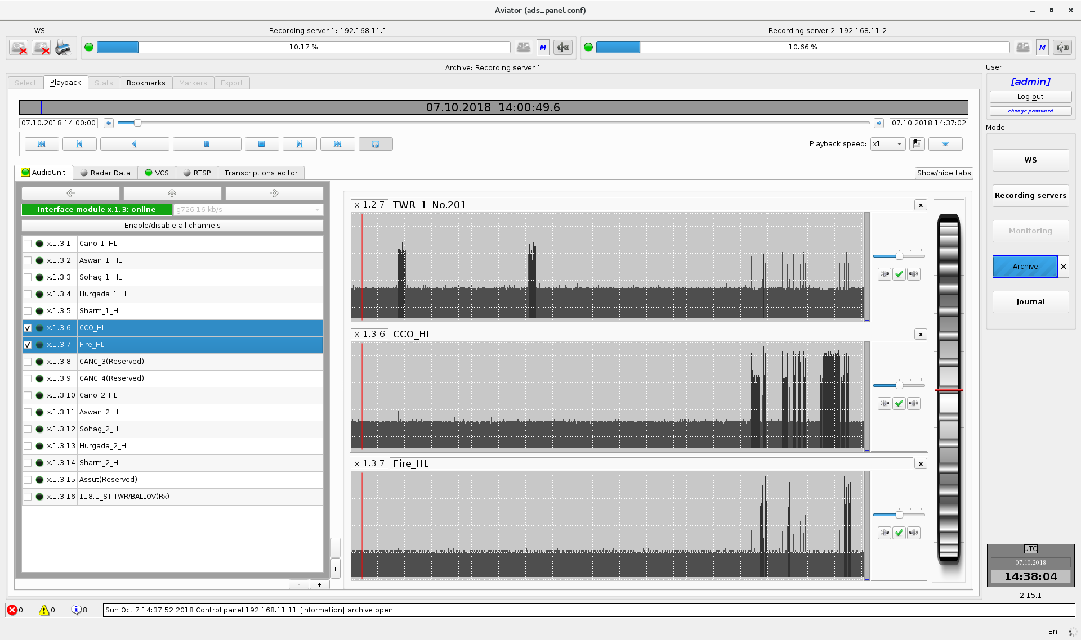
Figure 4.126 – AAU data
The area for selection of channels to be listened is arranged in the left part of the tab. The area for selection of channels to be listened has several levels of detail:

Server level
On this level (Figure 4.127) the user is provided with information about the recording servers making a part of the complex and condition of devices on the servers. Devices on the servers are presented in the form of rectangles on which the device ID is displayed in format <server number>, <device number> and status of device (off, malfunctioning, online and in order).
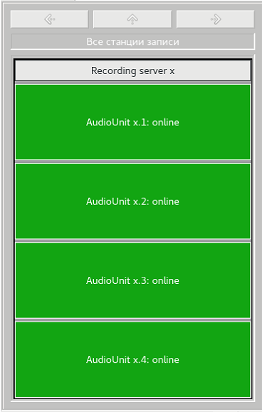
Figure 4.127 – Server level
The background colour changes depending on the device status. If device is OK, background colour will be green. If device appears malfunctioning, the background colour will be red.
You can select specific server by mouse-clicking on it. This allows you to go to the next level of detail.

Device level
On this level (Figure 4.128) the user is provided with information on AAU devices on the server and condition of cards on devices, with the name of the server, on which the devices are arranged, specified in the upper part. The device ID is specified for each device below the name of the device in format <server number>.<device number> with information on its condition. If a device appears malfunctioning, the field colour will be red. If device operation is normal, the field colour will be green.
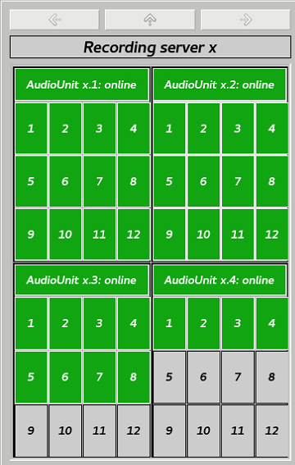
Figure 4.128 – Device level
The cards of devices are presented in the form of rectangles and numbered from 1 to 12. If card monitoring is switched off in the configuration, the rectangle will be grey. In other cases the rectangle colour indicates the condition of the relevant card: green – online and in order card, red – malfunctioning card.
In this mode the user gains access to navigation buttons (buttons with arrows above the name of server). Using the arrows "left" and "right" you can navigate between servers of the complex. By pressing the arrow "up" you may return to the higher level of detail (server level).
You can select specific device by mouse-clicking on it. This allows you to go to the next level of detail.
Card level
On this level (Figure 4.129) the user is provided with information on the cards of selected device and status of channels on the cards.
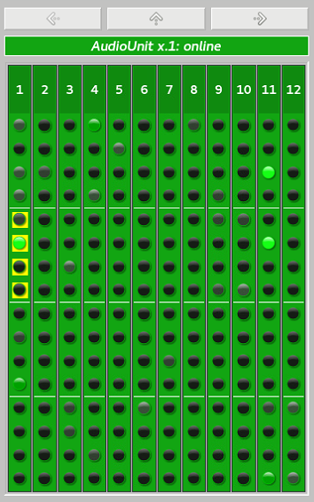
Figure 4.129 – Card level
The device ID and its status are indicated in the upper part. Background colour of this field depends on the device condition. Green – device is online and in order, red – malfunctioning device.
Information on the cards is shown below. The cards, monitoring over which was disabled in the configuration, are of grey colour. Other cards have either green colour – the card operates normally, or red colour – the card is not operative (e. g., removed).
The status of channels on the card is presented in the form of indicators. The channels, monitoring over which was disabled, have grey colour of indicator in the configuration. For other channels the indicator colour has a green shade, the brightness of which depends on the power of signal in the channel. If the user is not allowed to observe this channel, the indicator icon will be crossed out.
The channels that were selected for listening will have yellow colour of background.
You can navigate between devices of one AAU using the arrows "left" and "right". By pressing the arrow "up" you may return to the higher level of detail (device level).
You can select specific card by mouse-clicking on it. This allows you to go to the next level of detail.
Channel level
On this level (Figure 4.130) the user is provided with information on the channels of selected card.
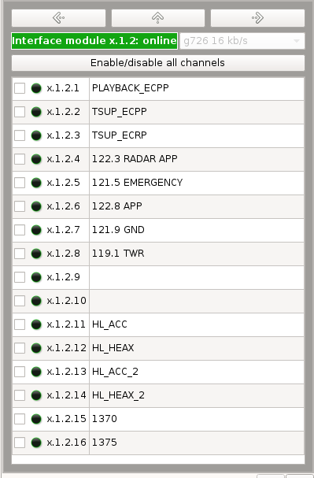
Figure 4.130 – Channel level
The card ID and its status are indicated in the upper part. Background colour of this field depends on the card condition. Information on the channels is arranged below.
Information on the channels is presented in the form of a table. Channels ID is indicated in a format: <server number>.<device number>.<card number>.<channel number>, channel name, channel status indicator. The channels, monitoring over which was disabled, have grey colour of indicator in the configuration. For other channels the indicator colour has a green shade, the brightness of which depends on the power of signal in the channel. If the user is not allowed to observe this channel, the indicator icon will be crossed out.
Using the arrows "left" and "right" you can navigate between the device cards. By pressing the arrow "up" you may return to the higher level of detail (card level).
Channels are selected for listening on this level. To add a channel to the ones to be listened, set a check mark opposite to this channel. You can select at once up to 16 channels. It will not be possible to select one more channel afterwards.
By default, the user may only have an access to one field for selection of channels for listening. But the number of fields may be increased up to two or four. This is done using the buttons "+" and "–" in the right bottom corner (Figure 4.131). For each of the fields you can select an individual level of detail.
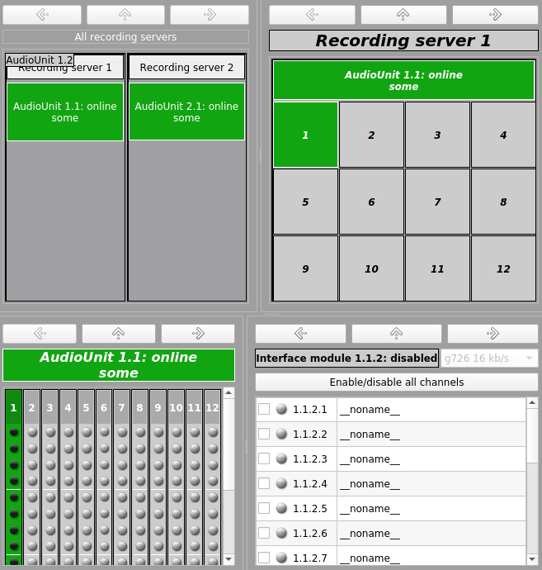
Figure 4.131 – Several fields for selection of channels to be listened

There is a "Mixer" on the right side of the field for selection of channels to be listened (Figure 4.132).
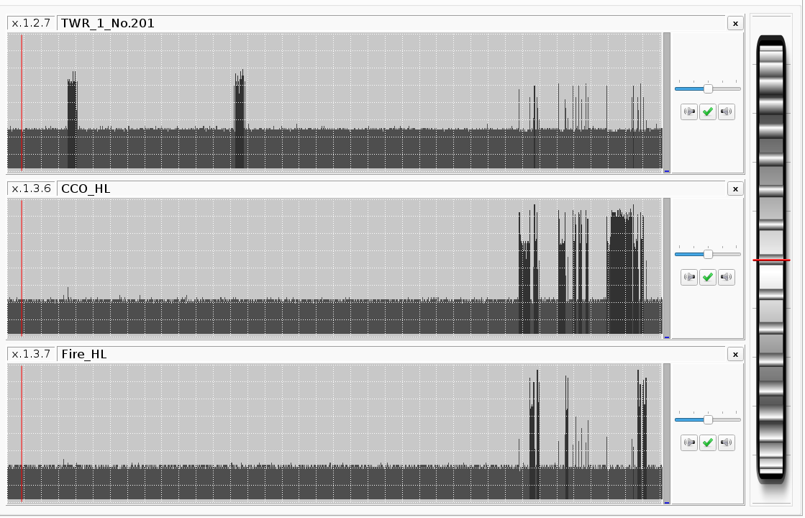
Figure 4.132 – Channel mixer
After the user selects a channel to be listened (Figure 4.132), a channel control window will appear in this field (Figure 4.133).
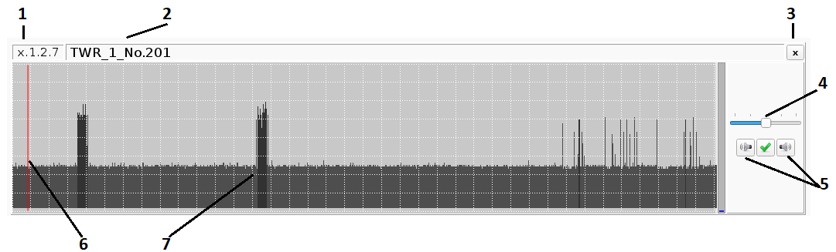
Figure 4.133 – Channel listening field

It includes: channel ID [1], channel name [2], button for deletion of channel from mixer [3], channel volume control [4], buttons for switching off the left and right speakers [5], indicator of current playback position [6], visual representation of the signal level in channel [7].
Note: after the cursor is above the channel volume control, the volume may be changed with the mouse wheel.
General volume level is located on the right-hand side of the mixer (Figure 4.133). Here the volume may be changed both with the wheel and with the numerical field above the wheel (values may be changed using the buttons "up" and "down" or by simply entering the required value in per cent from the keyboard).

Radar Data
This tab (Figure 4.134) shows what Radar Data (processed or unprocessed) should be played back.
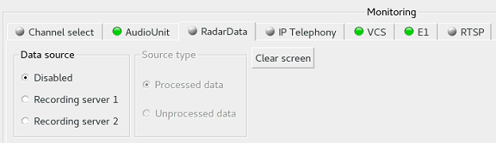
Figure 4.134 – Radar Data
The playback itself is carried out at Radar Data Playback Workstation, while Monitoring and Playback Workstation can only transfer the necessary data. Button "Clear screen" allows clearing of display at Radar Data Playback Workstation at any moment of time.

Data from screen displays
On this tab (Figure 4.135) the user is enabled to view the data from screen displays.
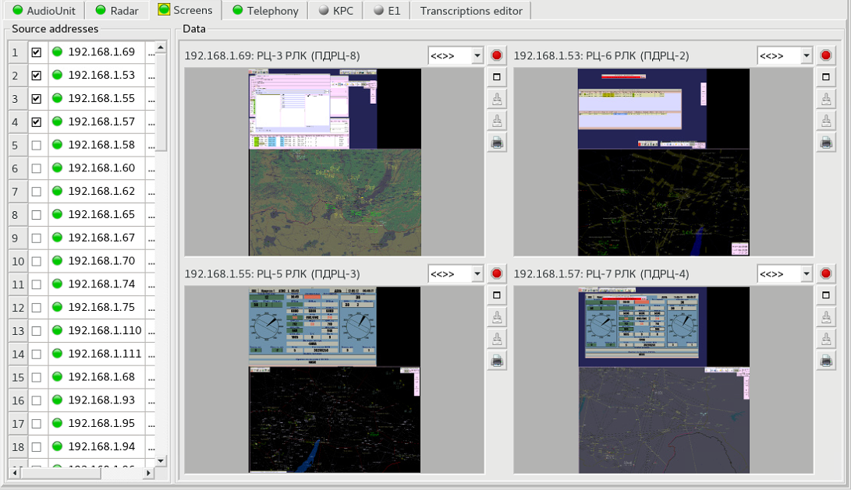
Figure 4.135 – Data from screen displays
The left part contains the list of computers, for which the data was recorded from display to archive. IP-address, name and indicator are specified for each computer. If the indicator colour is green, the data for such display were provided, if the indicator is grey, the data were not available. For selection of a display for monitoring, the check mark should be set opposite to the required line. After a display is selected, a preview area for a display will be opened in the right part of the tab, where the data will be displayed. You can open for viewing up to four displays at the same time.
Apart from the display itself [1], preview area (Figure 4.136) allows: to learn the name of computer and its IP-address [2], select image scale [3], close the preview area [4], change preview area to full-screen mode [5], make a screen shot and record it on a removable storage for data export [6]. If a removable storage for data export is missing, button [6] will be inaccessible. Save the visible area from the screen shot to removable storage [7], print the visible area from the screen shot [8].
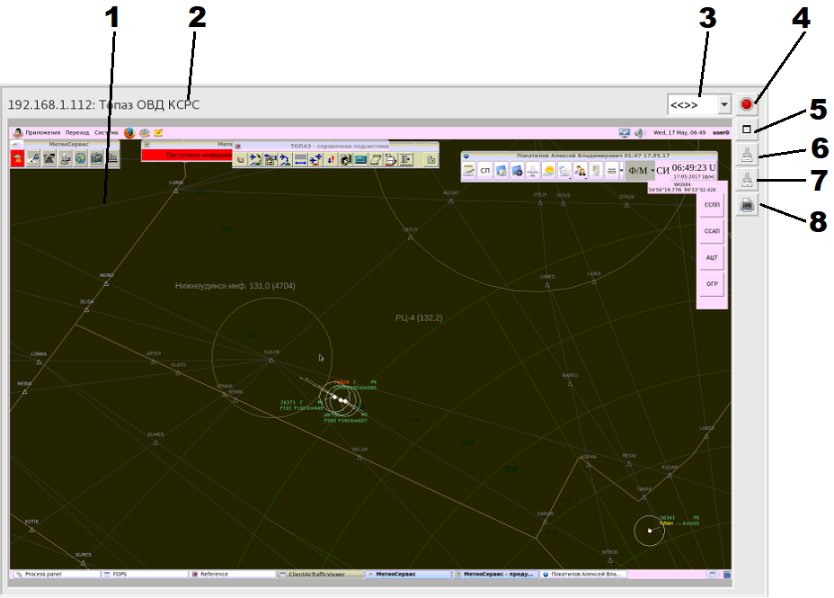
Figure 4.136 – Display area

In full-screen mode (Figure 4.137) the button for returning to normal mode [3] is displayed instead of the button for switching to full-screen mode. Additionally, information on the current position in displayed fragment [1] is output and the button appears which allows suspending playback [2]. To continue a playback you should press button [2] once again.
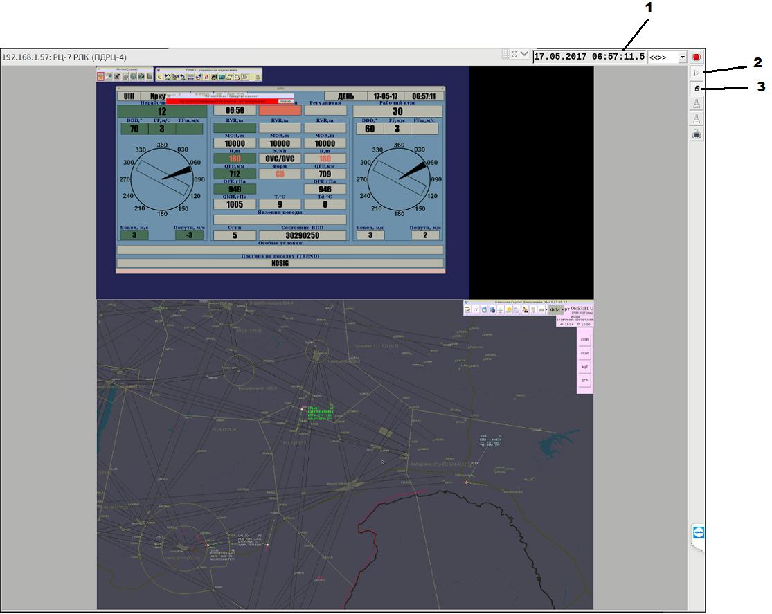
Figure 4.137 – Display area – Full-screen mode

Digital telephony data

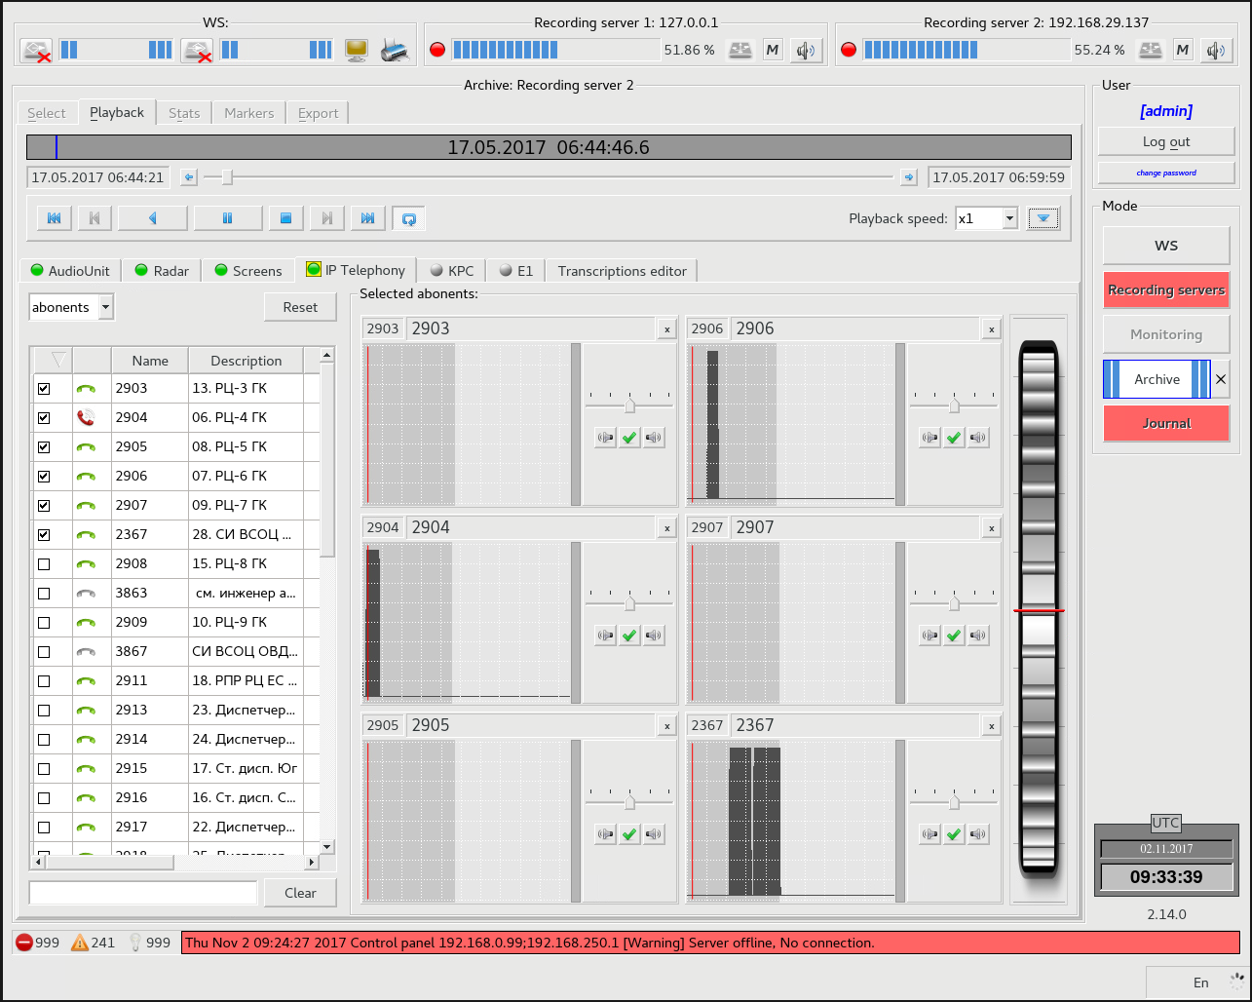
Figure 4.138 – Digital telephony data
On the left (Figure 4.138) there is a list of abonents available for selection. To start listening to a particular abonent, you should check it.
Apart from voice data, the condition of abonent at the time of recording is displayed too.

Playback of voice communication system (VCS) data from archive
After the archive fragment has been selected and the playback has been started in the tab "VCS", the status information of the abonents, who have been monitored within the selected time interval will be displayed (Figure 4.139):
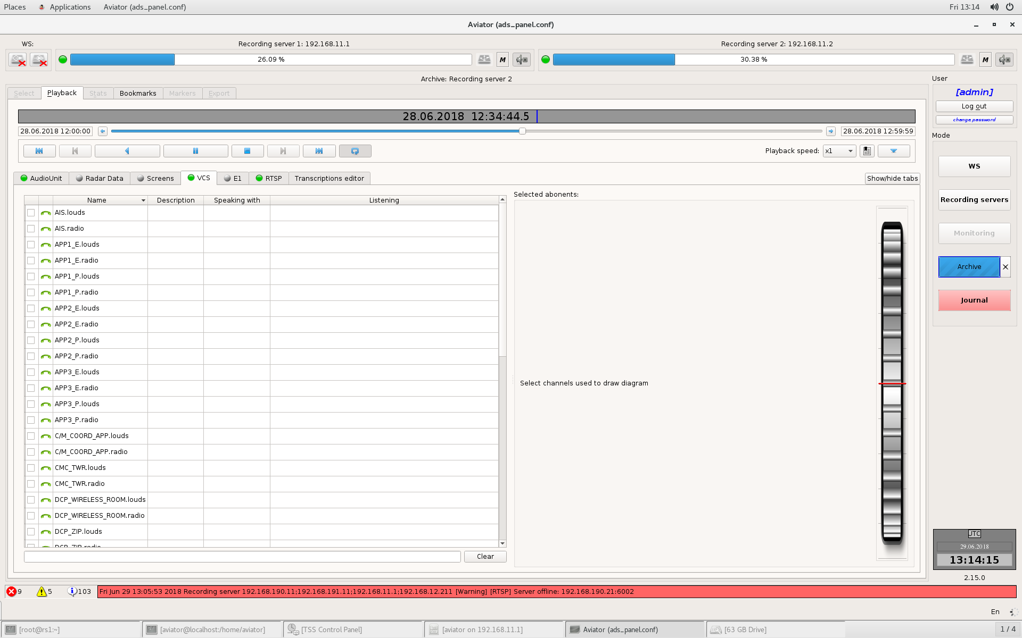
Figure 4.139 – Playback of voice communication system (VCS) data from archive
There are two lines in the abonent table for each VCS abonent. One line is used for LSC channel and another – for Radio channel. Thus, it allows separate playing back of these channels.

To play back certain abonent data, select the abonent by checking the box on the left in the respective line of the list (Figure 4.140):
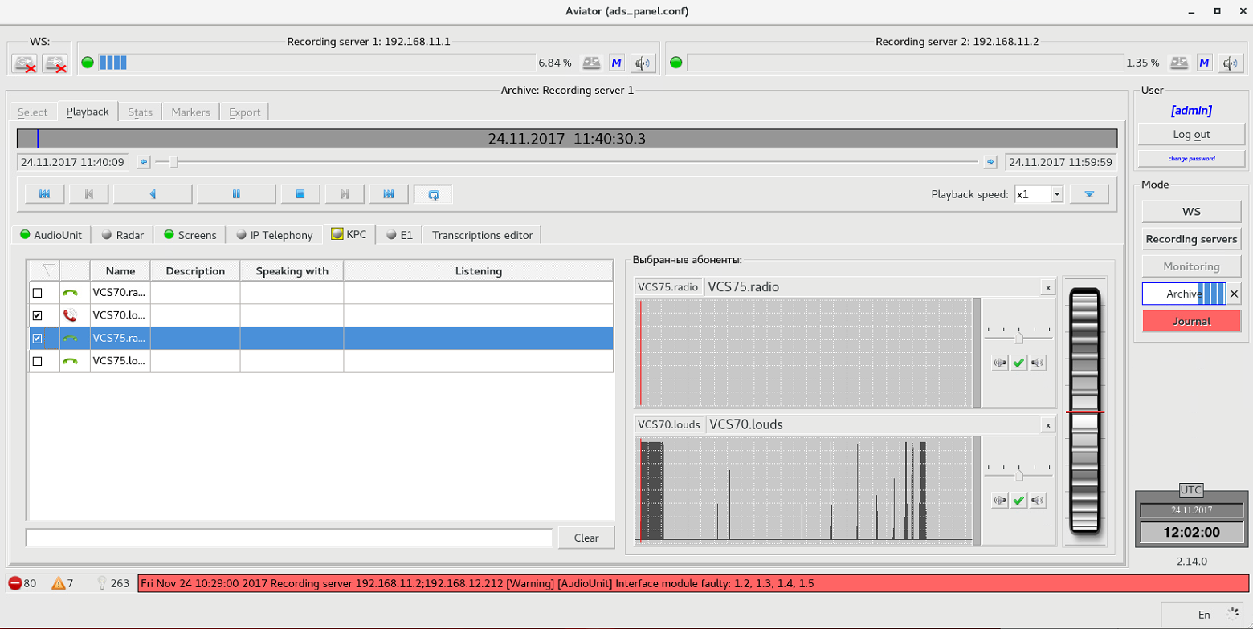
Figure 4.140 – Playback
After the abonent has been selected, the voice data bar chart will be displayed for each abonent to the right of the abonent list. This facilitates the search of beginning of conversation within a certain period of time.

Filter bar is located at the bottom, below the list of abonents (Figure 4.141):
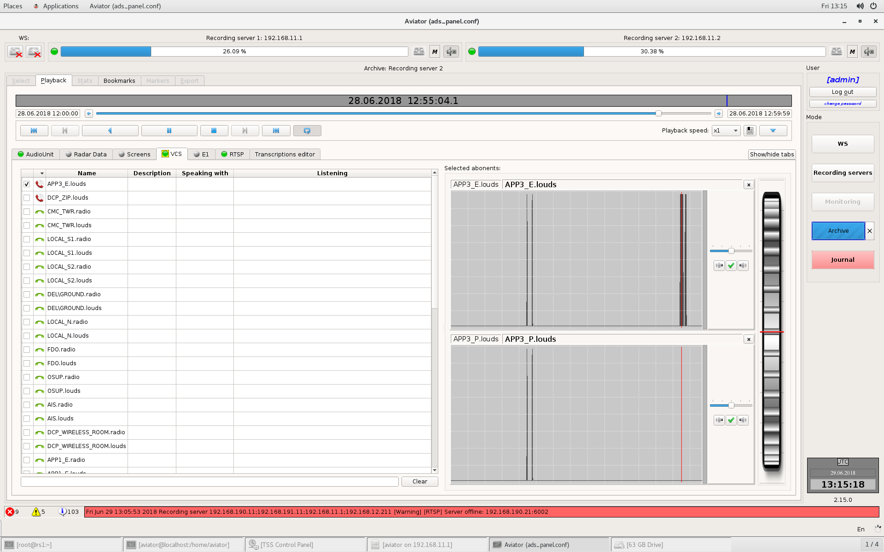
Figure 4.141 – Abonent filtering
Search is made in the fields "Name" and "Description". To quickly clear the filter, use the button "Clear" to the right of the bar.

Playback of E1 stream data recorded from archive
After the archive fragment has been selected and the playback has been started in the tab "E1", the status information of the abonents, who have been monitored within the selected time interval will be displayed (Figure 4.142):
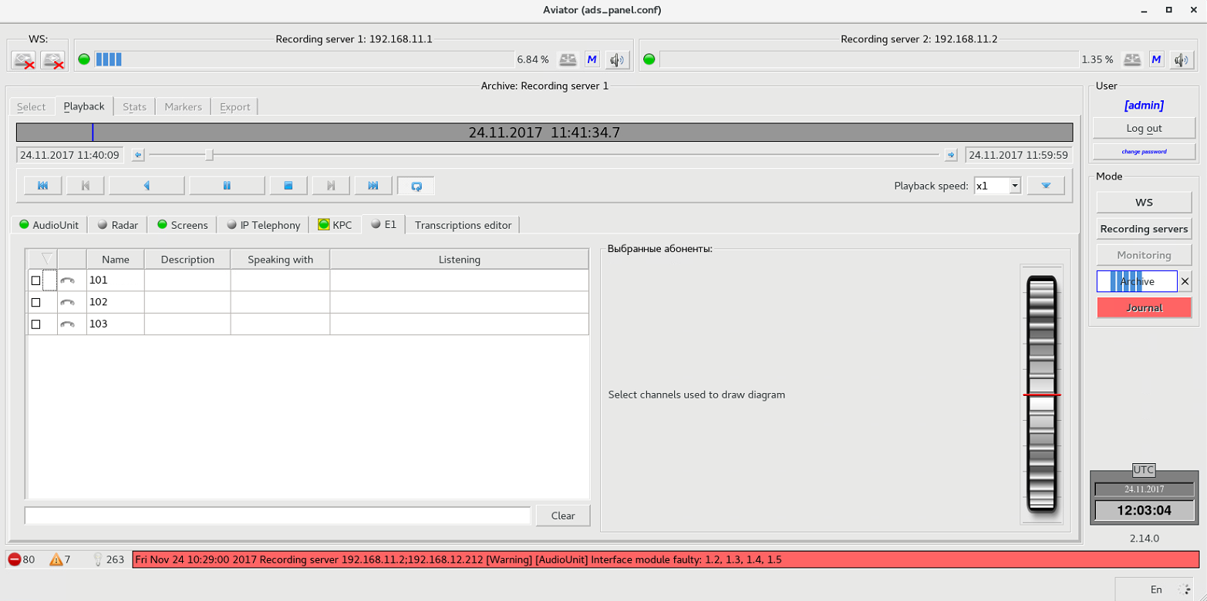
Figure 4.142 – Playback of E1 stream data recorded from archive
Note: Due to specific features of the communication via E1 stream, it is impossible to define the abonent availability in the network when the abonent does not take part in conversation.

To play back data recorded for the abonent, select the abonent by checking the box on the left in the respective line of the abonent list (Figure 4.143):
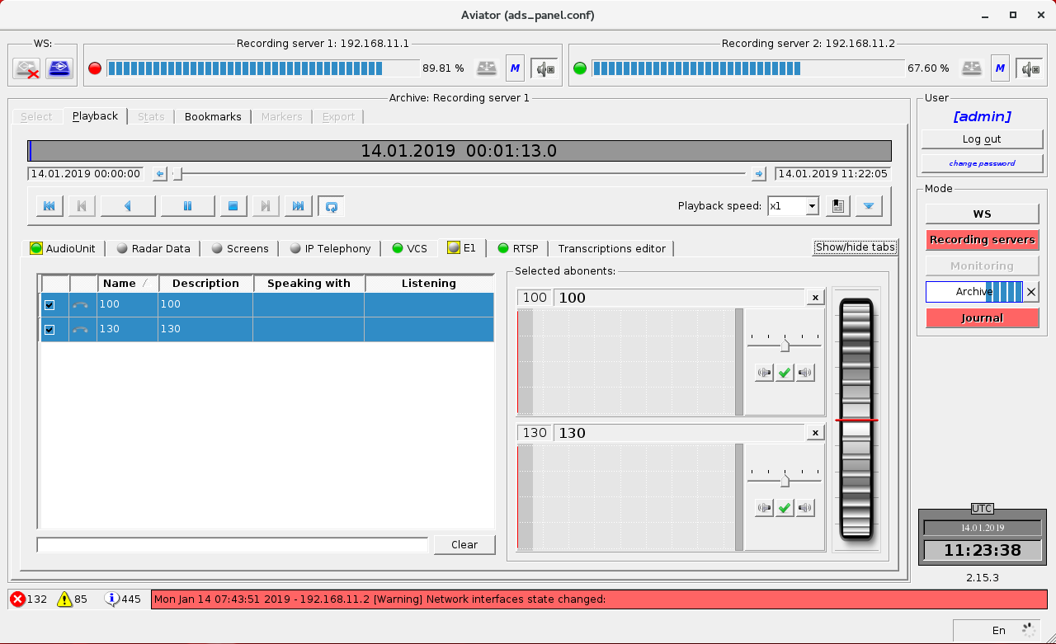
Figure 4.143 – Playback
Voice data bar chart is opened for each selected abonent to the right of the list. The bar chart displays availability of conversation within a certain period of time.

Filter bar is located at the bottom, below the list of abonents (Figure 4.144):
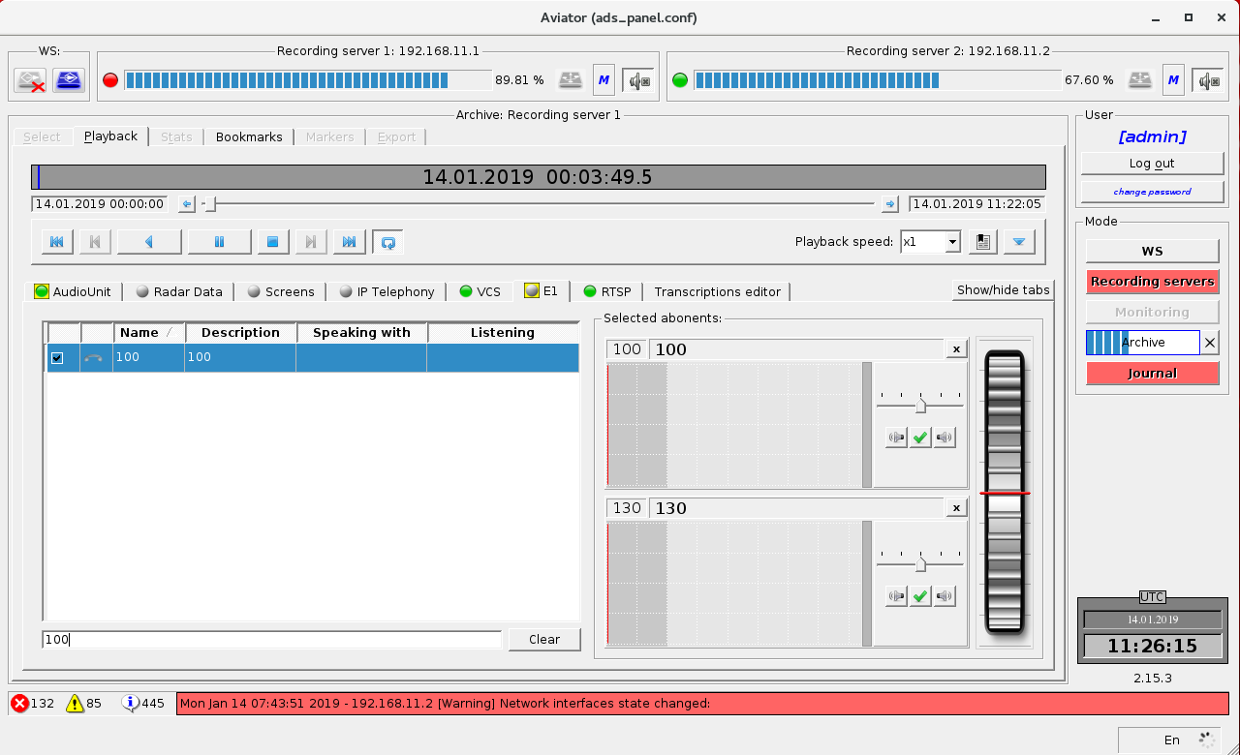
Figure 4.144 – Abonent filtering
Search is made in the fields "Name" and "Description". To quickly clear the filter, use the button "Clear" to the right of the bar.

RTSP data
Information about the channels is presented in the form of a table. Channel name and information about its connection status with the RTSP-source are available for each channel at the selected time (Figure 4.145).
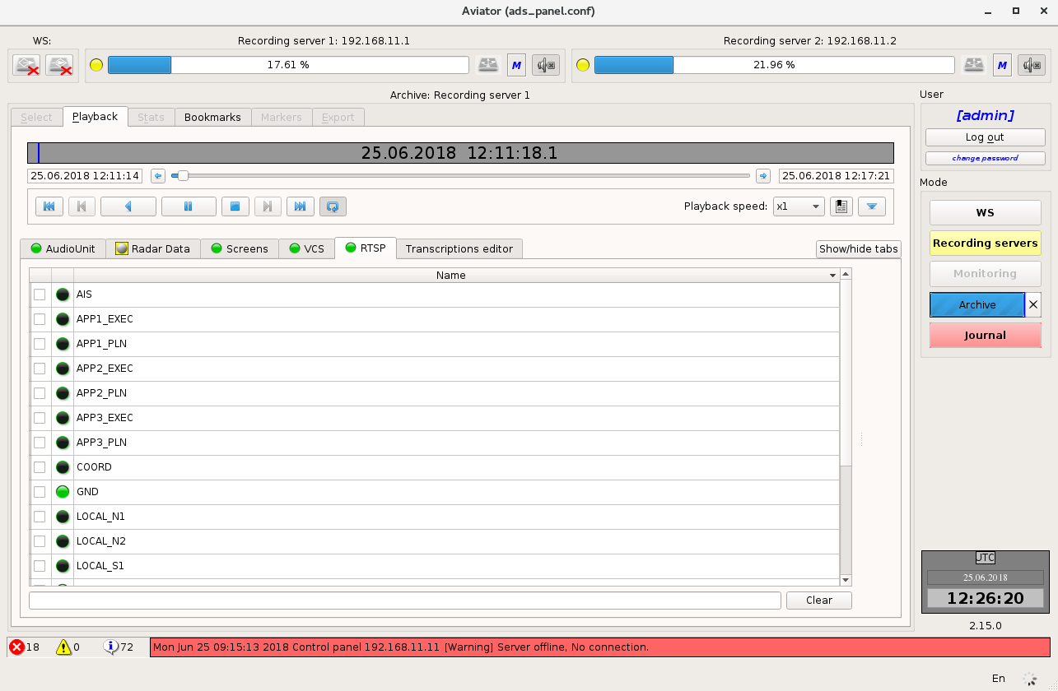
Figure 4.145 – Information about the channels

To start viewing a particular RTSP-channel, select its check box (Figure 4.146).
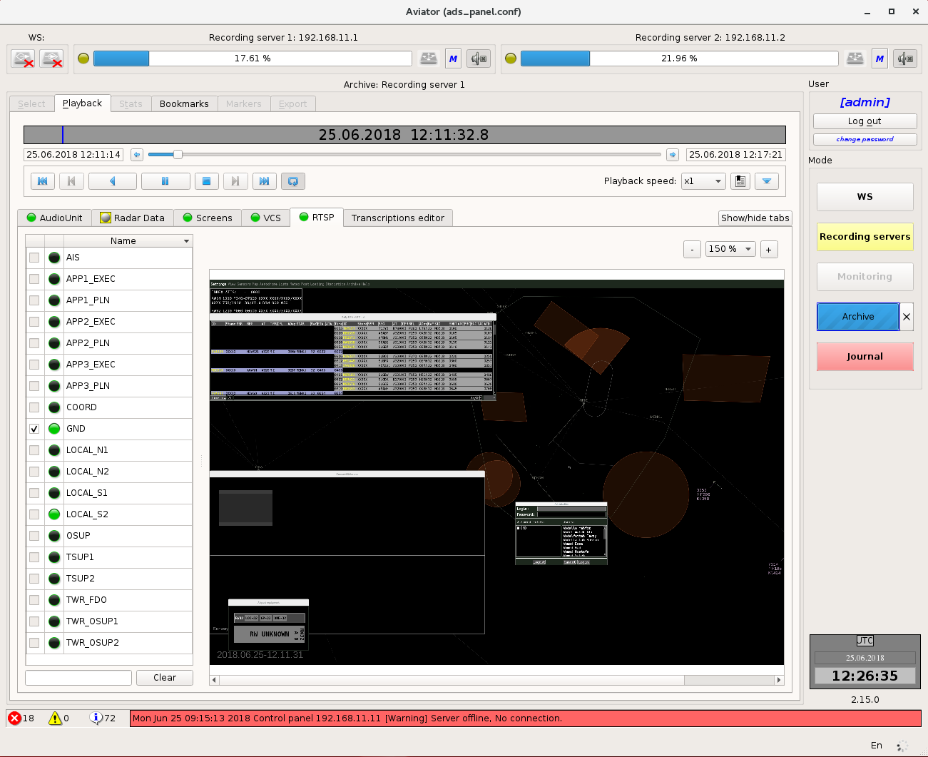
Figure 4.146 – Viewing a particular RTSP-channel

Transcriptions editor
Transcriptions editor is designed for recording the results of radio exchange decoding, followed by the report export to shared formats (.odt and .csv) and its printing out (if possible) (Figure 4.147).
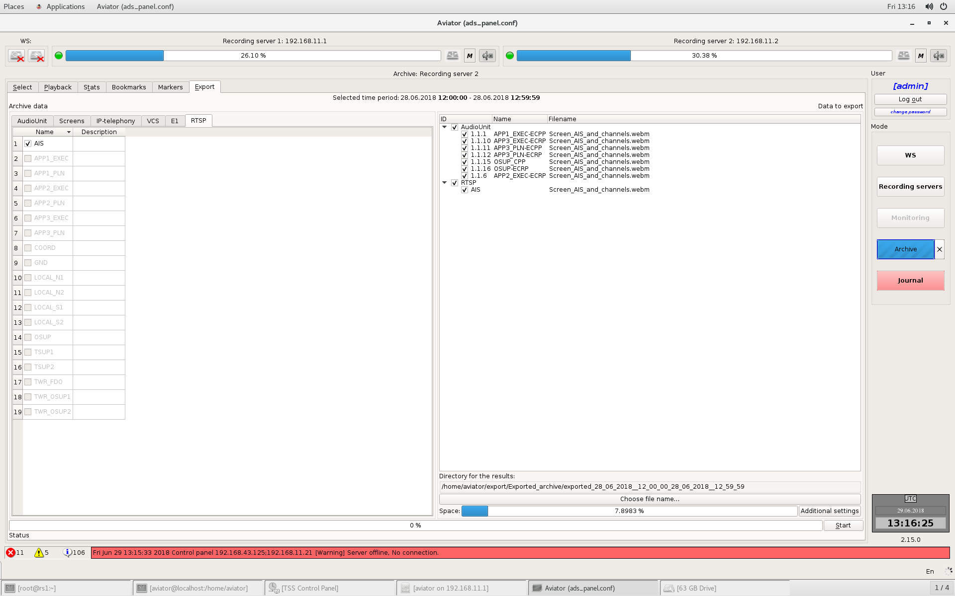
Figure 4.147 – Transcriptions editor

Information on radio exchange is presented in the form of a table. Each line of the table, apart from the message itself, contains information on its source (call sign) and time. When filling in the table, all previously entered call signs are saved and when another line is being added the already existing call sign can be selected from drop-down list (Figure 4.148).
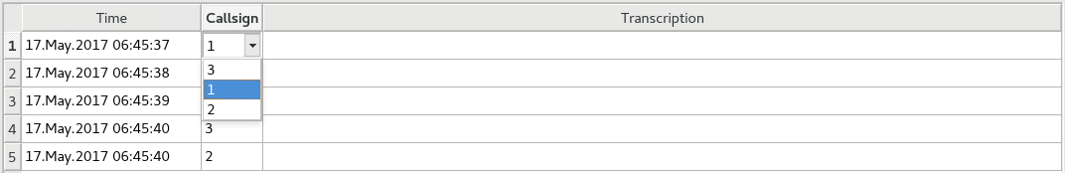
Figure 4.148 – Selection of call sign from drop-down list
Above the table with decoded messages, there is a field with control buttons (Figure 4.149), which allow you to: add a line row to table [1], insert row into table [2], remove selected rows [3], insert current time into the current [4], clear the contents of the entire table [5], clear the contents of current cell [6], automatic insertion [7], (Button has two positions. If the button is pressed, current playback time will be automatically set when a new line is added), cancel action – undo [8], repeat the action – redo [9], print out the report [10], export the report to file [11].
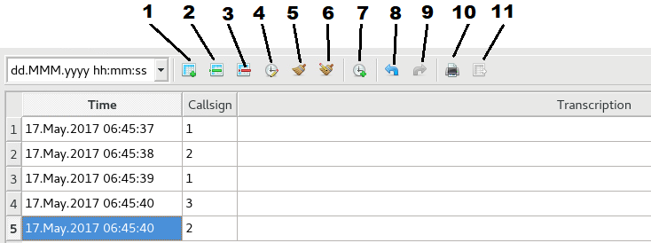
Figure 4.149 – Field of buttons of report writer
To the right of control buttons there is a field, in which you can set time format in the table. Basic formats are represented in the drop-down list. You can also select your desired time format.
When the print button is pressed, the printing settings dialogue will be displayed (Figure 4.150). In the dialogue you can set the document title, select a printer, adjust the margins, number of copies, paper size and document orientation. The report will be sent for printing after "OK" - button pressing.
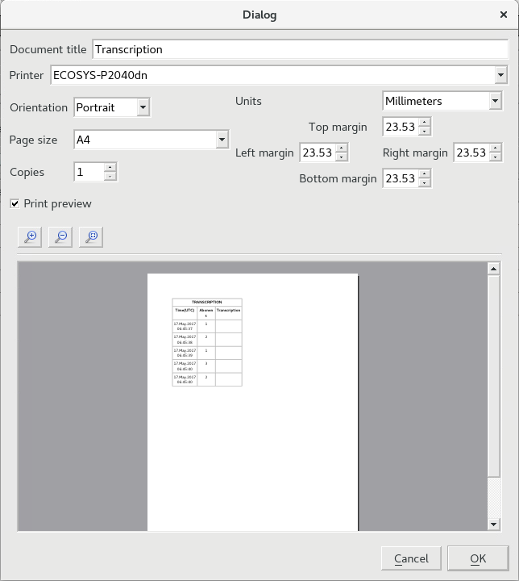
Figure 4.150 – Printing dialogue

When the export button is pressed, the file saving dialogue will be displayed (Figure 4.151).
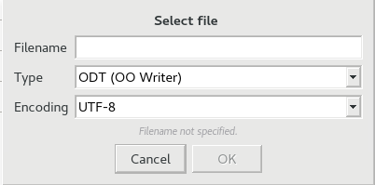
Figure 4.151 – Dialogue for export to file

The dialogue allows you to assign the file name, select encoding and file type. Two file types are available:
- *.ODT – file in Open Office format,
- *.CSV – file in MS Office format.
The export button is only available with inserted removable storage for data export.

Viewing of statistics for an archive fragment
Tab "Statistics" contains all statistics on the archive fragment selected for playback. The tab (Figure 4.152) presents information on time interval of the archive fragment selected for playback (start and end of interval), total recording time (length of selected archive fragment), overall load by channels (total time for all channels, during which the signal was observed as available), total number of tags. Tags are set during recording of channels in the server. A tag is set when the signal exceeds the power threshold level. Tags are used for voice search.
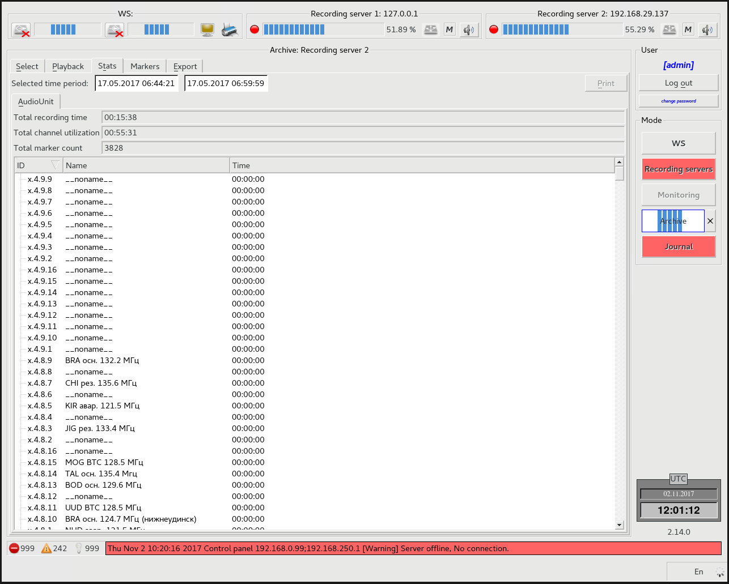
Figure 4.152 – Tab "Statistics"
Below the summary information, there is the list of channels, which are contained in the selected archive fragment. For each channel its ID is shown in format: <server number>.<device number>.<card number>.<channel number>, channel name and time of signal availability in the channel (this time is used for calculation of channels occupancy).
The print button allows printing statistics on the channels selected from the list. It is enough to mouse-click on a channel to select it from the list. You can select several channels at the same time.

Export of the archive fragment
Tab "Export" (Figure 4.153) is only available if the data from specific source (recording server, removable storage) were selected on tab "Select".
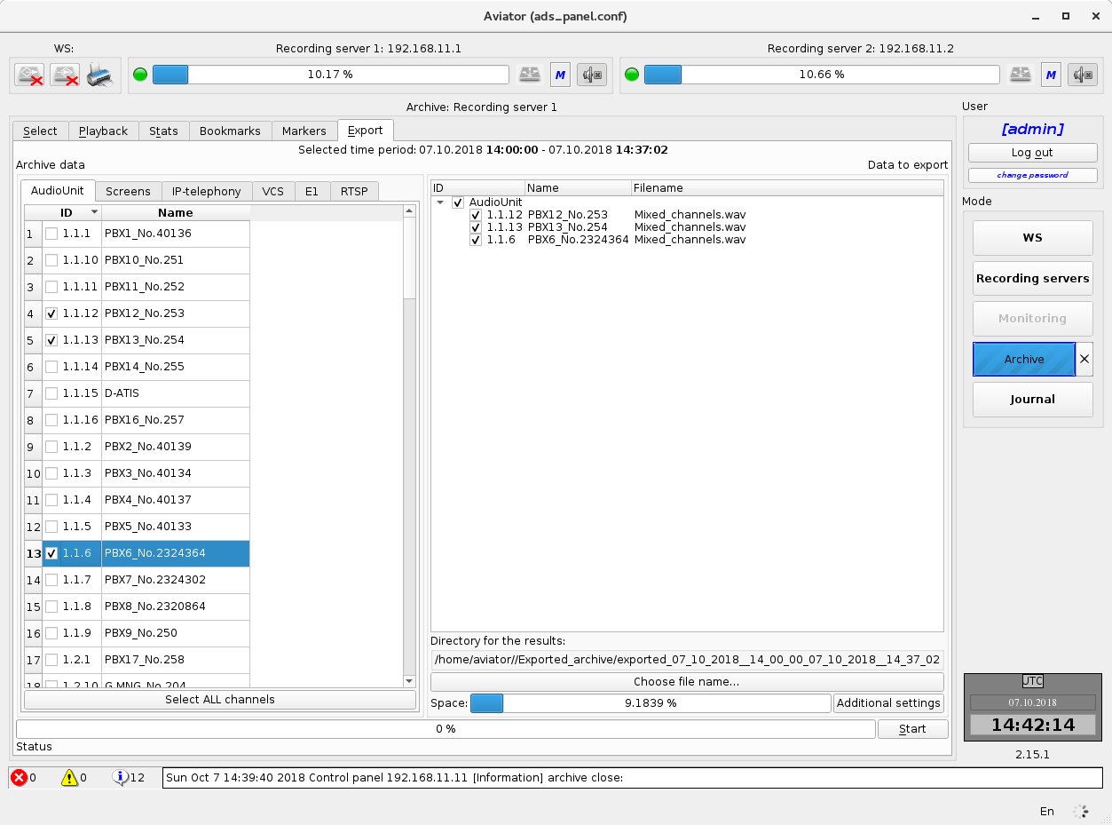
Figure 4.153 – Tab "Export"
The tab accommodates the control elements for data export to shared formats for further playback on other computers.
Audio data are exported to .ogg format. Video data are exported to .ogv format.

Two tabs are arranged in the left part. Tab "Audio Unit" (Figure 4.154) contains the list of AAU channels.
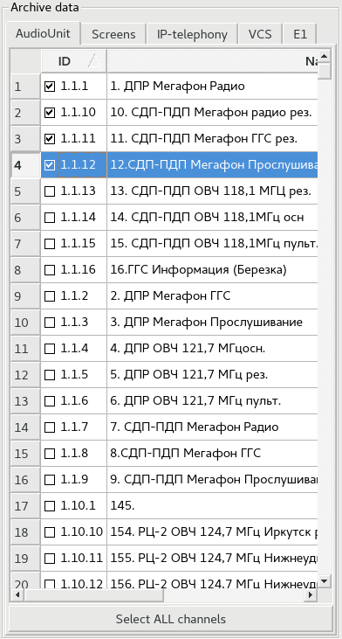
Figure 4.154 – AAU channels
ID and name are specified for each channel. A checkbox is available together with the channel ID, which allows you to add a channel to the list for export. If the check mark is selected, the channel is in the list (selection is made by mouse-clicking on the check box). Below the list of channels there is button "Select all channels". By pressing this button all channels are added to the list for export.

Tab "Screens" (Figure 4.155) contains the list of computers, from which displays the information was recorded. IP-address and name are specified for each computer. A checkbox, which allows choosing the display for export is available with the IP-address. You can select only one display at a time.
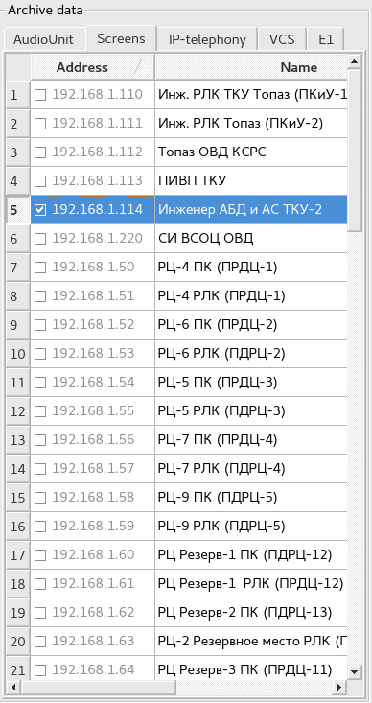
Figure 4.155 – Tab "Screens"

In the right part of tab "Export" (Figure 4.156) there is the list of channels and displays which were selected for export. Channel or display ID, its title and name of output file are indicated for each record in the list. A checkbox is available opposite each line. Removal of the check mark (with mouse-click) will cause the record to be removed from the list.
If you remove the check mark opposite item "Audio Unit" or "Screens" (list nodes), this will result in removal of all channels or displays respectively.
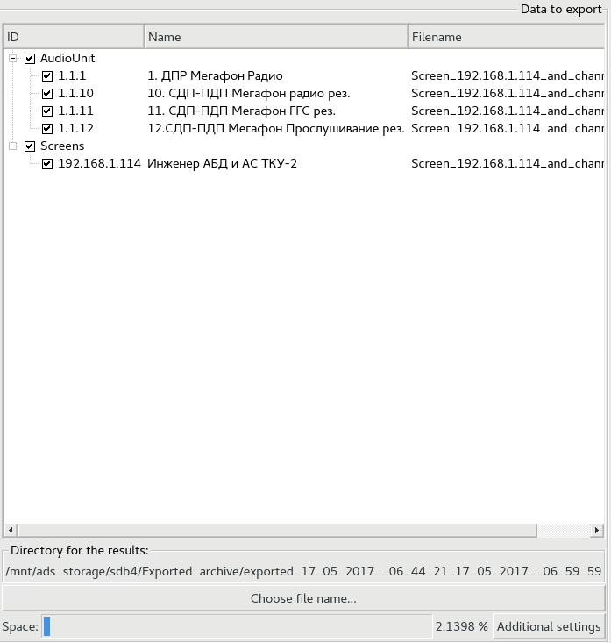
Figure 4.156 – Exported data

Below the list of exported documents there is an indicator, which shows how much free space will be occupied on a removable storage after export of data. If the size of exported data exceeds the amount of free space on the disc, the indicator will change its colour to red (Figure 4.157).
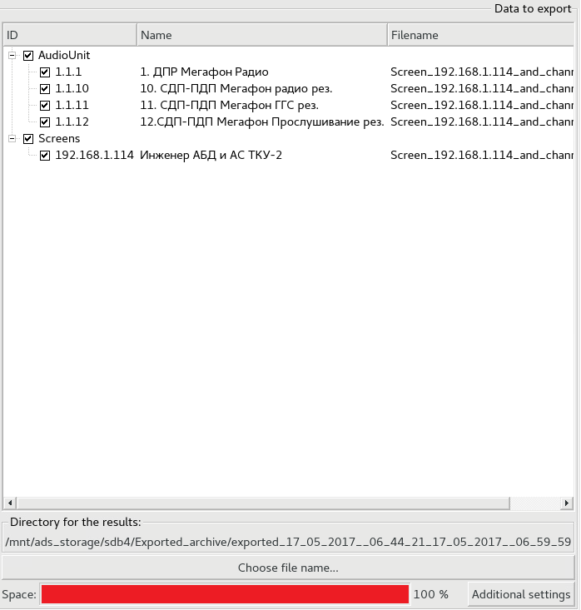
Figure 4.157 – Lack of free space at data export

At the right of the occupied space indicator there is button "Additional settings". Pressing this button will result in displaying of additional export settings (Figure 4.158).
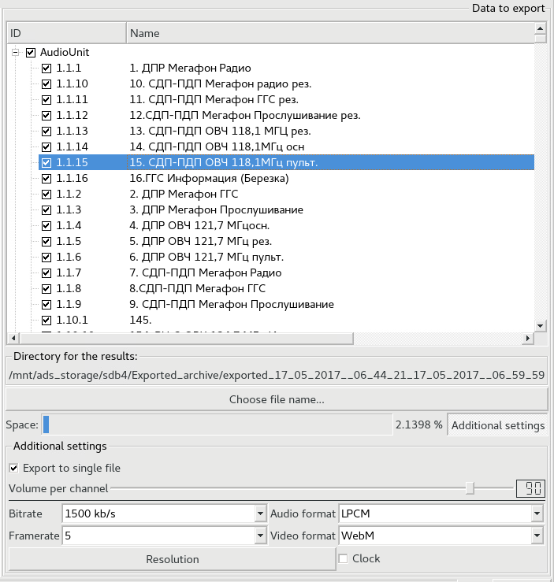
Figure 4.158 – Additional settings for data export
Using a slider it is possible to select the record volume for AAU channels.
From the drop-down lists you can choose bit rate, frame rate, audio and video formats, screen resolution, aspect ratio and framing rate for the display.
If you set check mark "Export to single file", all channels and a display will be recorded together into one file. At the same time when you use slider for adjustment "Volume per channel" the optimum volume for each channel will be calculated with setting up the relevant value.
For starting the export you should press button "Start" in the bottom right corner of tab "Export" (Figure 4.159).
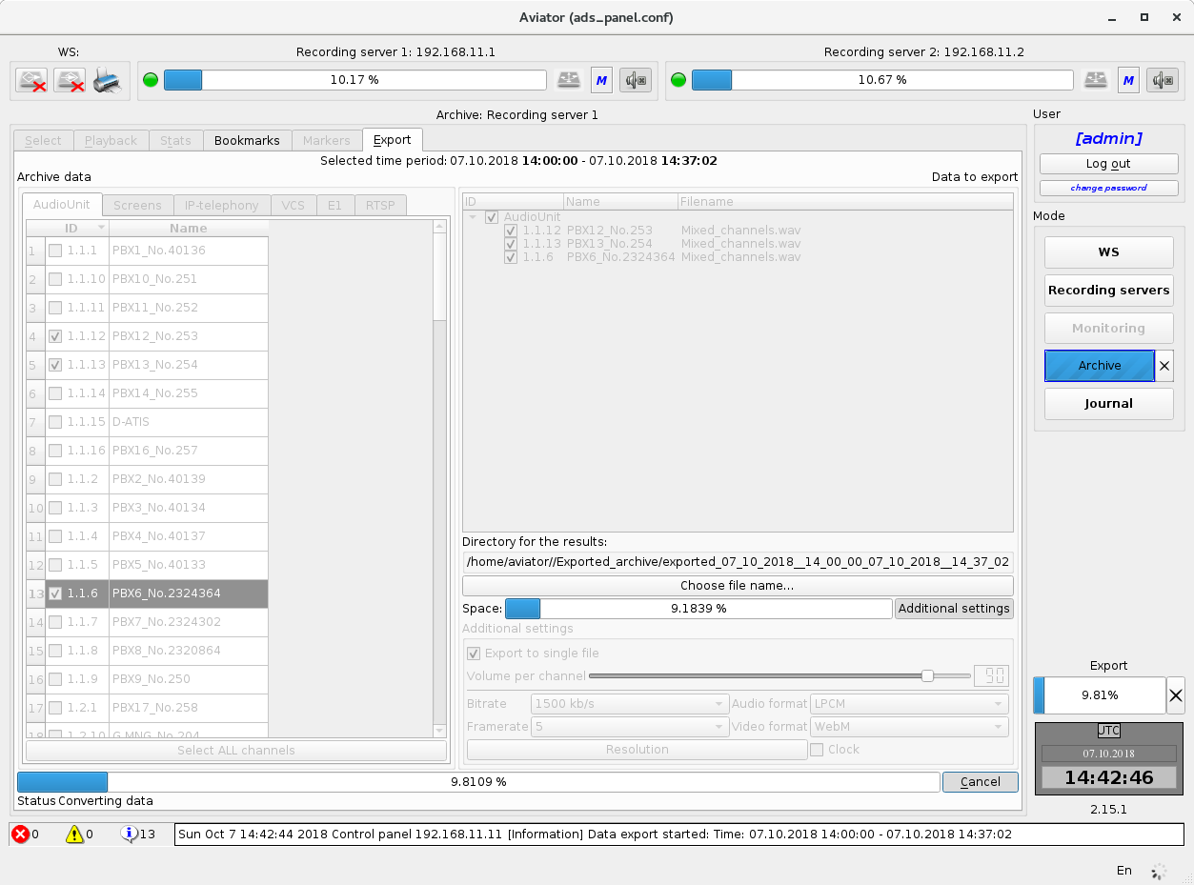
Figure 4.159 – Data export process
The percentage of operation completion will display on progress scale during export with text description of the current export phase located below. For the period of export button "Start" will be changed to button "Cancel". Pressing this button will result in stopping of data export.

Also, during export, the export process indicator is shown on the right-hand panel (Figure 4.160). It consists of progress scale [1] and operation cancellation button [2].
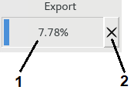
Figure 4.160 – Data export indicator on the right-hand panel
During export all controls except for operation cancellation buttons, become unavailable.

Mode "Journal"
Mode "Journal" (Figure 4.161) gives an operator the possibility to view the messages on various events related to the complex operation.
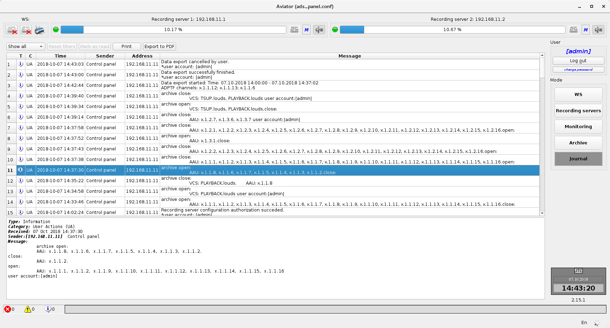
Figure 4.161 – Mode Journal
The events are presented in the form of a table. Type, category, time of occurrence, name of program sending the message, source IP-address and the message itself are indicated for each event. In terms of importance the events are divided into informational, caution and warning. By category, the events are divided into system (the event source is a program) and panel operations (the event source is operator's actions). Sender of a message may be the Control panel (client part of software complex) or Recording service (server part of software complex).
The list of all events is given in Appendix B.
The Journal has capabilities for filtration of messages. In order to filter out messages by a certain column mouse-click on the column header. As a result, a window with filtration parameters will be shown on the display (Figure 4.162).

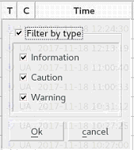
Figure 4.162 – Control box of log message filter
For filter activation select a check mark opposite to the uppermost item "Filter by…" adjust the filter parameters and press button "Ok".
You can filter out by several criteria (columns) at the same time. In order to reset all filters you should press button "Reset filters" above the list of events (Figure 4.161).
Below the list of events there is an area of detailed information on the current message. The current message is highlighted in the list of events in blue colour (Figure 4.161). Below the detailed information, there is a mini-log line (Figure 4.163).

Figure 4.163 – Mini-log line

This line is visible in all program operation modes, contains the message counters and the most critical of unread messages.
New unread messages in the list of events are shown in bold type (Figure 4.161). A message is marked as read automatically when the operator selects it with a mouse. If you need to mark as read several messages simultaneously, you should select them with a mouse and press button "Mark as read" above the list of events (Figure 4.161).
Besides, there is the possibility for displaying in the list only read, only unread or show all messages
Note: Due to peculiarities of SW implementation, when the settings are applied in mode "WS", the settings of network interfaces are rewritten. As a result, an alert message on loss of communication with other computers of the complex or with TOPAZ servers will be shown, but at the next second a message on recovery of communication will be displayed. In this situation the message on loss of communication is for information purposes only without any effect on operability of the complex.
Note: If a message on recovery of communication appears within 5 seconds after the message on loss of communication with TOPAZ ATC AS servers, the former message is not an indication of emergency, it is for information purposes only and has no effect on operability of the complex.

Complex software

Components of the complex software
The complex "Aviator" software includes the following components:
- Recording station ensures processing and recording of incoming information, provides control of the complex hardware and processing of user requests;
- Monitoring Workstation supports the functions of remote control over condition of all sub-systems of the complex; timely notifying of service personnel about failures of the complex; listening of point-to-point channel; audio data playback; displaying of screens of monitors and radar data from online archive;
- Playback Workstation supports the function of playback of recorded data from a removable storage; data export to most common formats for further playback of information at unprepared stations;
- Radar Data Playback Workstation ensures displaying of played back digital radar data.
Application software of the complex operates under control of operating environment Linux, which is supplied on DVD disc. All program components of application software of the complex are supplied on the installation CD or DVD disc (application software "Aviator"). Software installation is performed by means of an installation program on supplied disc.

Recording server
Recording station is designed to record the information coming from the sources connected to it.
The following data is to be recorded:
- Voice information from connected voice frequency channels;
- Digital radar data coming from TOPAZ servers;
- Screen shots of monitors at air traffic controllers’ working positions.
Information is recorded in the online and long-term archives. The online archive is located on hard disc drives of the recording station and used for temporary storage of information before saving to the long-term archive. The long-term archive is stored on removable storage (flash-memory, external hard drive, etc.).
The software of recording station is implemented as operating system service, it has no graphical interface for interaction with the user and is run automatically at once after the end of operating system initialisation.

File structure of long-term archive
All data of long-term archive are stored in folder aviator_archive (Figure 5.1). The data are grouped by years and months. A folder is created for each month with the corresponding name in format: <year>_<month>. Inside these folders the data are grouped by days. Folder name corresponds to the date. The name of files corresponds to the recording start time.
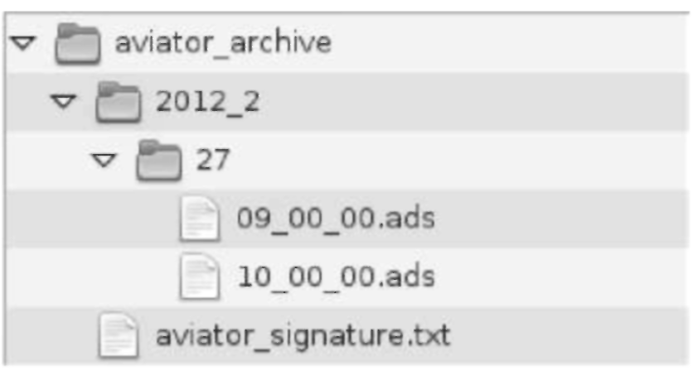
Figure 5.1 – File structure of long-term archive
Checking information is calculated for each file in the long-term archive what allows you to determine the record authenticity. This information is collected in file aviator_signature.txt in folder aviator_archive. If the record was changed, damaged or deleted, when the removable storage is being checked for data integrity, this information will be different.
The file name, digital signature and check sum calculated by the algorithm sha1 are to be specified for every record in the archive: filename: /2012_02/27/10_00_00.ads
sha_hash: 1148466e805f2776b66134c750fl73bllf7a646d
checkkey: 04291e2ca6869a0d28aelba3f7b46blb5b5b8303
Besides, digital signature for the entire archive as a unit is calculated in the file end:
aviator archive’s signature file
C09b085da9d4fl3a4ce7cd5a3da96f64e39929dl

Monitoring Workstation

Purpose
Monitoring Workstation supports the following main functions:
- remote monitoring of condition of all sub-systems of the complex (online and long-term archives of recording server, AAU units (with an accuracy down to the card) of recording servers, local area network, etc.;
- set-up of recording servers;
- timely notice of service personnel on failures of the complex;
- playback of point-to-point channel from any of recording servers;
- playback of online archive from any of recording servers.

Basic operations performed at monitoring workstation
Every operation performed at monitoring workstation and related to access to the recording station may be permitted or prohibited in the user account.

Status scan of recording servers
Status scan of recording servers takes place when mode "recording server" is selected on the right-hand panel. The list of elements related to data sections on the station components will be displayed on tab "Information" on the left (Figure 5.2). The left column with lights displays overall condition of nodes of the Recording Server 1, and, respectively, the right column displays overall condition of Recording Server 2.
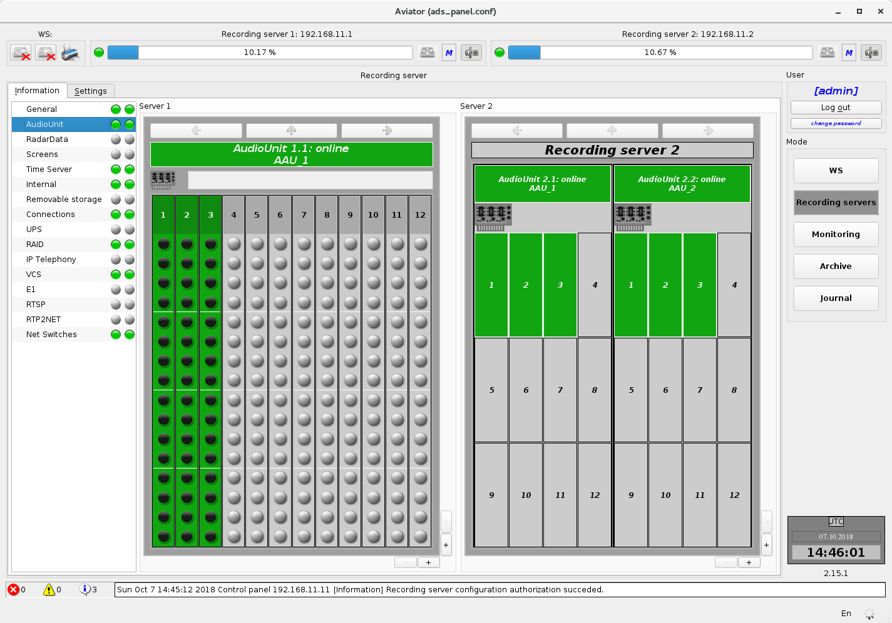
Figure 5.2 – Status scan of recording servers

The section with more details on the component will be displayed if an element in the list is selected. Basic composition of the list of observable nodes of the complex:
- General = Overall condition (overall condition of all nodes);
- Audio Unit;
- Radar Data;
- Screens;
- Time Server;
- Internal;
- Removable storage;
- Connections (list of connected AWP with network addresses);
- UPS (uninterrupted power supply);
- RAID;
- Telephony;
- VCS;
- E1;
- Video (RTSP-stream);
- RTP2NET (audio stream from RS “Aviator” via RTP protocol);
- Net Switches.

Set-up of recording servers
Recording servers are set up when mode "Recording server" is selected on the right-hand panel with changeover to the settings tab in the workspace. An attempt of operator authorisation will be made at the same time with request to enter login and password (Figure 5.3).
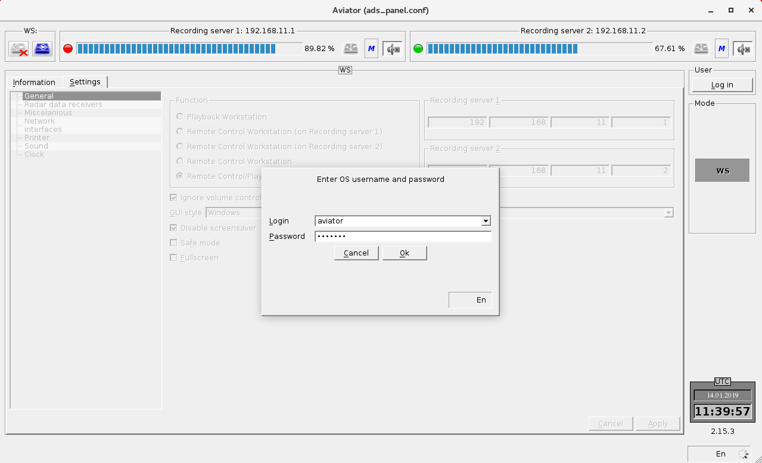
Figure 5.3 – Authorisation for set-up of recording server

Set-up of parameters of the recording servers is only available after successful authorisation of the operator. Every component available to the operator for setting up is in the list on the left. You need to select the required node in the list, further edit the required values and press button "Apply". If the entered settings are incorrect or you need to cancel the operation, press button "Cancel". You can copy the settings from one recording server server to another, for this purpose press button – to transfer settings from the first recording server server to the second one, or – to transfer settings from the second recording server server to the first one, after which confirm the action by pressing "Apply" (Figure 5.4).

Figure 5.4 – Setting of recording server parameters

Set-up of AAU parameters
The following parameters are available for set-up of AAU:
- Switching on/off of device card;
- Switching on/off of channel on the card;
- Name of channel;
- Time for channel inactivity warning(minutes).
EGI- checkboxes are provided for switching on and off devices, cards and channels. The preset check mark corresponds to activated device (card or channel).
For changing the parameters of the specific card enter the device representation down to the card level (Figure 5.5) where the following elements are presented from left to right for each channel:
- AGC (Automatic Gain Control);
- Voice detector debounce ON time;
- Voice detector debounce OFF time;
- Channel Gain;
- VOX threshold (0…100%).
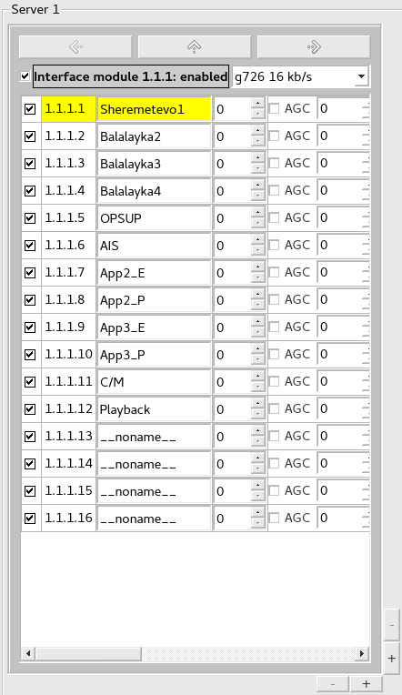
Figure 5.5 – Set-up of AAU parameters
SS level is designed for channel filtration from noise during automatic identification of a signal availability (and further quick search in the archive) and can have values within the range from 0 to 100 per cent of the signal peak value. When the lights of AAU channel indicators are displayed in mode "Monitoring" or "Recording server", the SS value of specific channel is taken into account, e.g. when signal level is low the colour of light is grey, but when SS limit is exceeded it becomes green.

Set-up of user accounts and rights
Set-up of the complex user accounts is only available after successful authorization of the operator. Select mode "Users" in the list, further edit the required values and press button "Apply". If the entered settings are incorrect or you need to cancel the operation, press button "Reset" (Figure 5.6).
Figure 5.6 – Setting of AAU recording server parameters
Groups are provided for easy grouping of rights. User may be a member of several groups. The setting procedure is identical for users and groups. Three types of operations are available in these modes:
- Add a user or a group;
- Edit a user or a group;
- Delete a user or a group.

In mode "Add" or mode "Edit" a check box is available with an option to set the rights for each operation using check marks. A user can also be added to a group, the necessary rights for which are already set up (Figure 5.7).
Figure 5.7 – Editing of user rights

In mode "Add" or "Edit" a check box is available with an option to set the rights for each operation using check marks. You can also add (or remove) a user from the current group (Figure 5.8).
Figure 5.8 – Editing of user group rights

Listening of point-to-point channel
For listening of point-to-point channel proceed as follows:
- Select mode " Monitoring " on the right-hand panel (Figure 5.9)
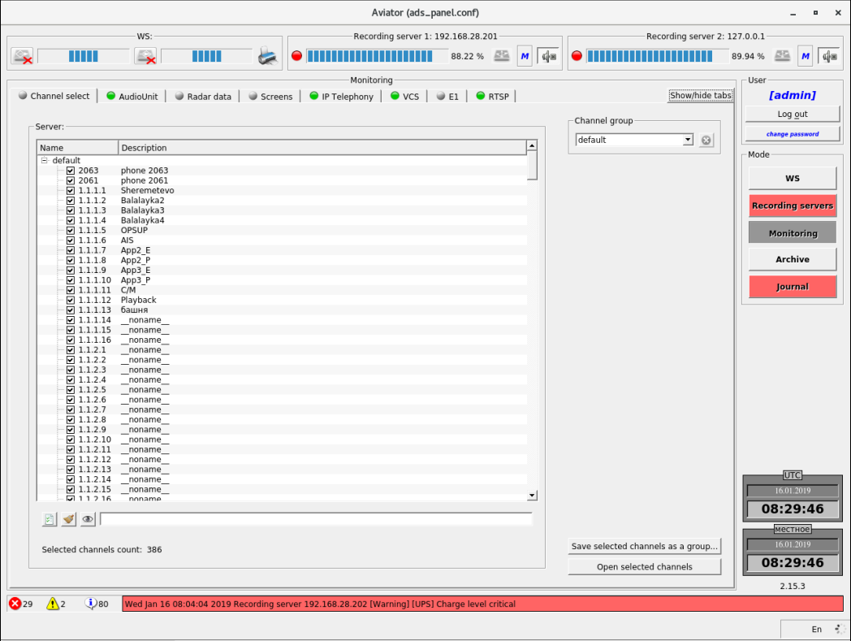
Figure 5.9 – Selection of mode "Monitoring"

- Go to tab "Audio Unit" and select the recording server (Figure 5.10)
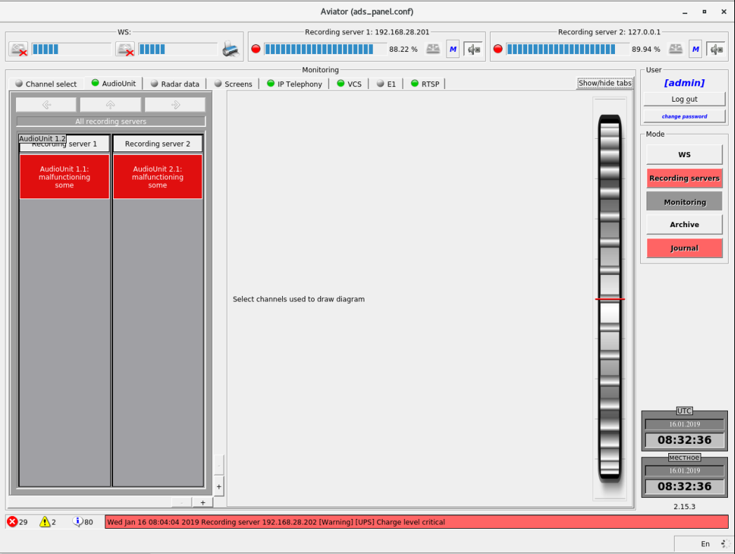
Figure 5.10 – Tab "Audio Unit"

- Select device on the recording server (Figure 5.11)
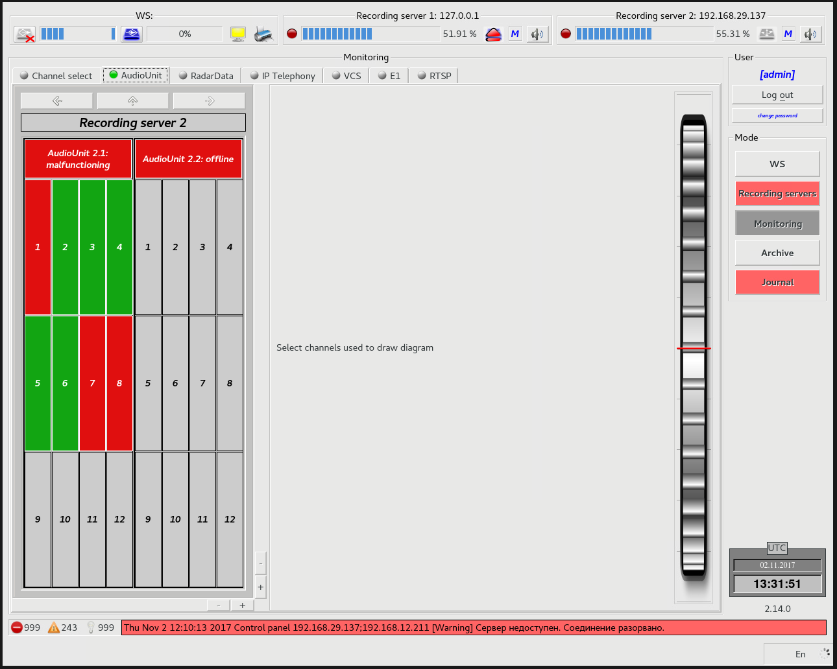
Figure 5.11 – Selection of recording server

- Select card (Figure 5.12)

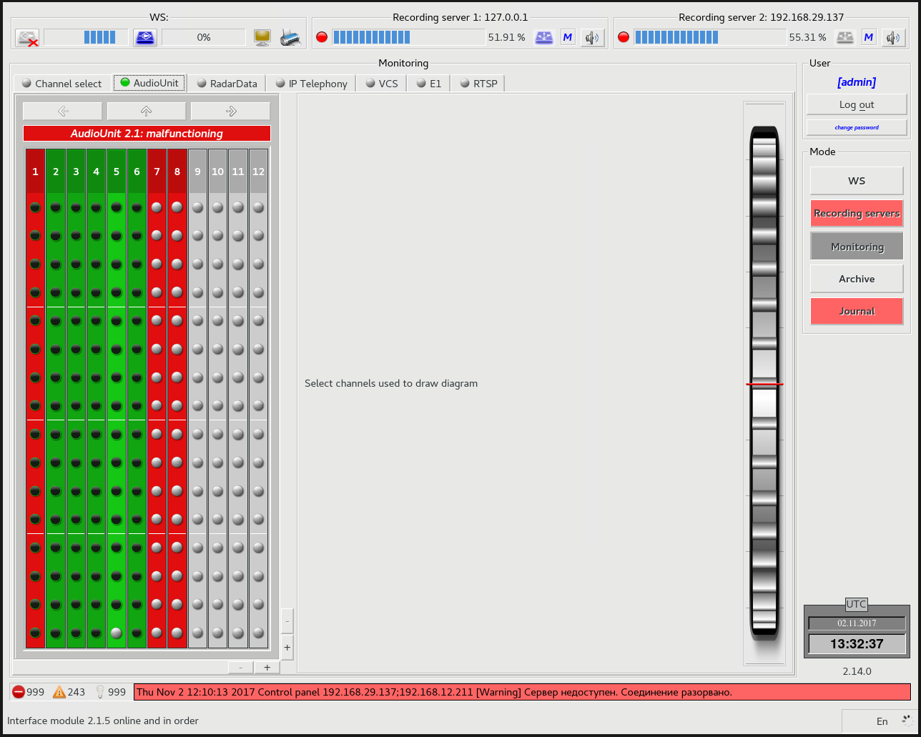
Figure 5.12 – Selection of device on recording server

- Mark the necessary channels (Figure 5.13)
Graphic representation of signal in the channel will appear to the right of the selected channels.
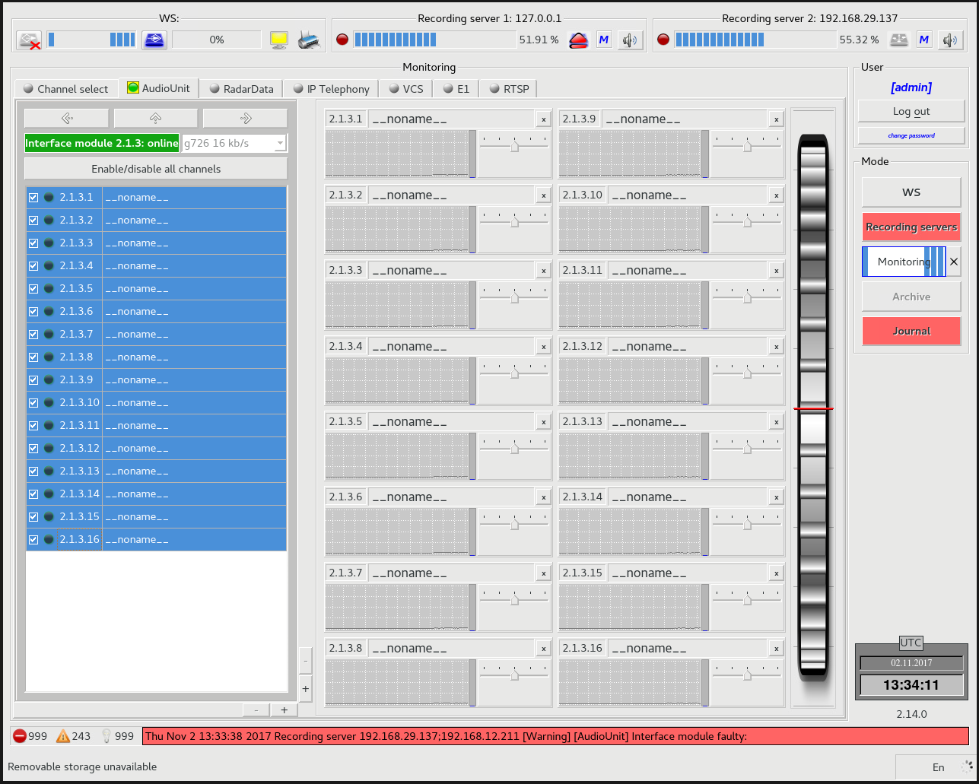
Figure 5.13 – Selection of channels for listening

Viewing of Radar Data information
For viewing of Radar Data information proceed as follows:
Select mode "Monitoring" on the right-hand panel (Figure 5.14)
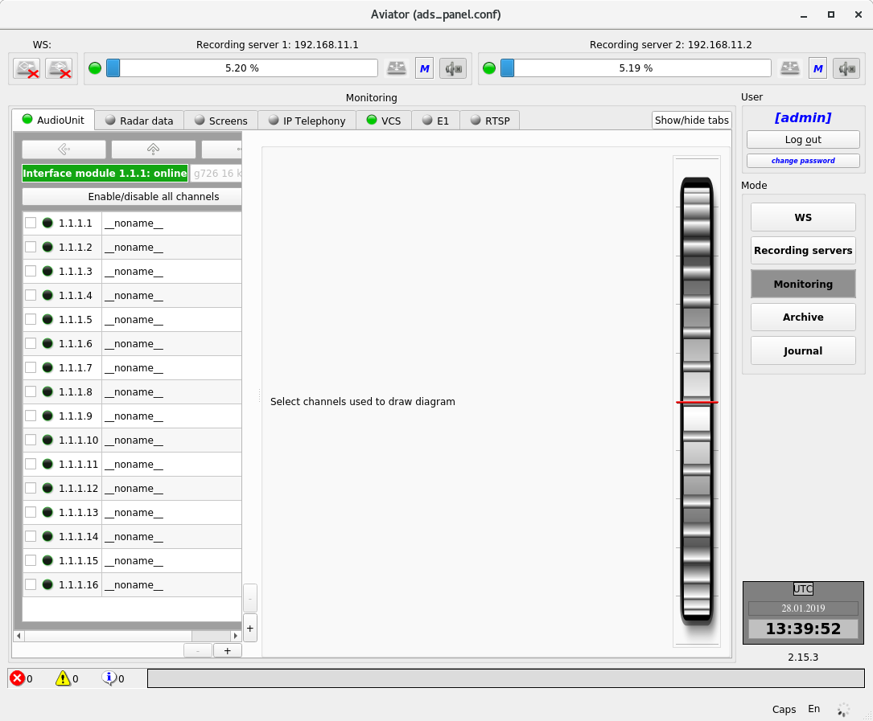
Figure 5.14 – Selection of mode "Monitoring"

- Go to tab "Radar Data" (Figure 5.15)
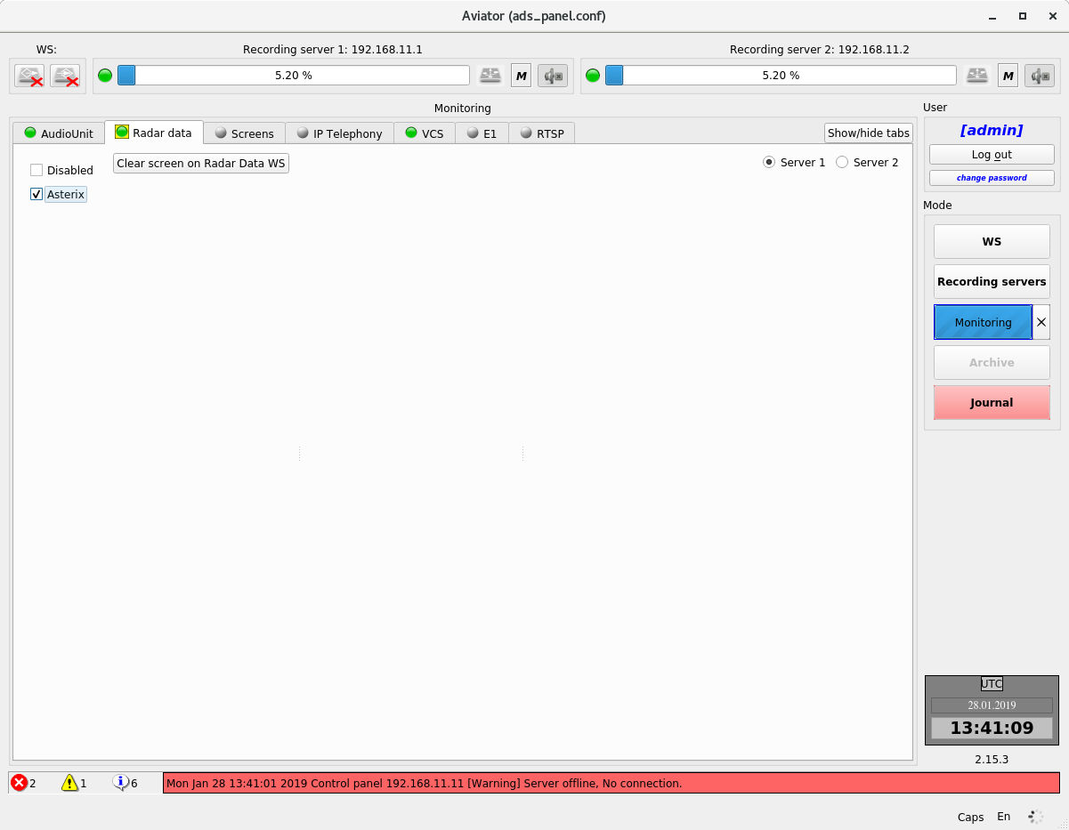
Figure 5.15 – Tab "Radar Data"
- Choose the recording server from which information will be played back;
- Select type of data (processed or unprocessed);
- On the left of the main display window of the Radar Data Playback Workstation, select the main or redundant set (Figure 5.16).

Radar information will be displayed on the screen of Radar Data Playback Workstation (Figure 5.16).
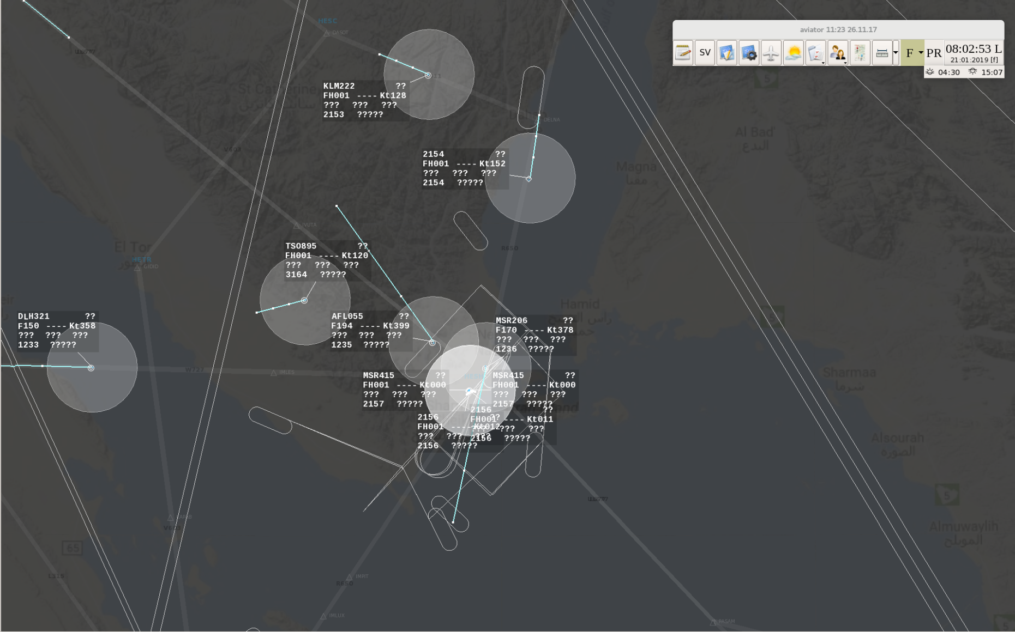
Figure 5.16 – Radar Data Playback Workstation window with radar information

Replacement of removable storage in recording server
Yellow indicator on the upper panel and red flashing symbol "unmount" over the symbol of the removable storage availability in the system indicate that it is high time to replace the removable storage in the recording server (Figure 5.18).
For replacement of the removable storage proceed as follows:
- Select mode "Recording server" on the right-hand panel (Figure 5.17)
Figure 5.17 – Selection of mode "Recording servers"

- Select item "Removable storage" on the left.
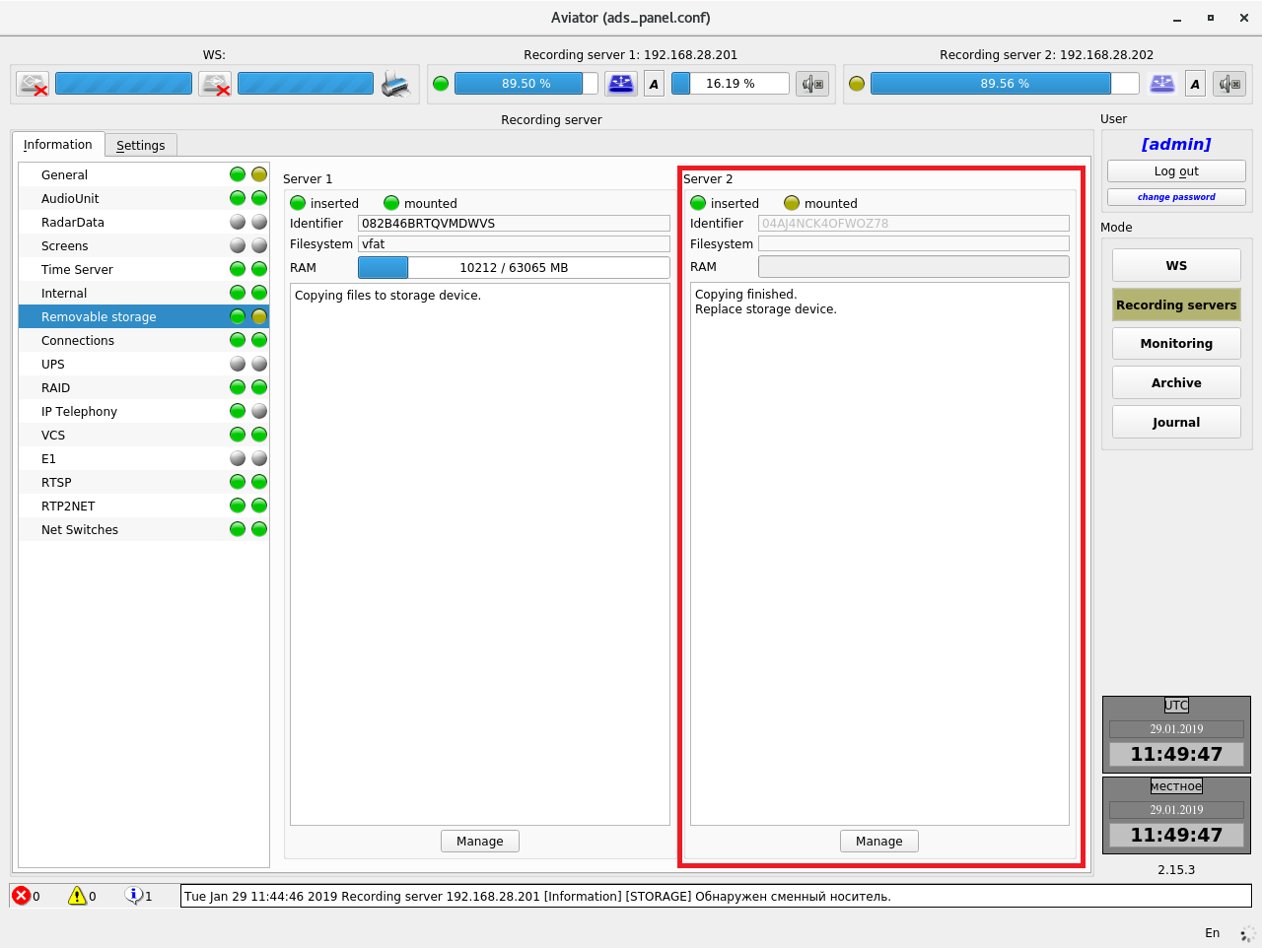
Figure 5.18 – Removable storage replacement criteria
- Make sure that the following text is displayed below information about removable storage "Copying finished. Replace storage device" (Figure 5.18);
- Replace the removable storage in the recording server;
- Make sure that the recording server indicator on the upper panel has turned green, and text "Copying finished. Replace storage device" has changed to "Copying files to storage device" (Figure 5.19).
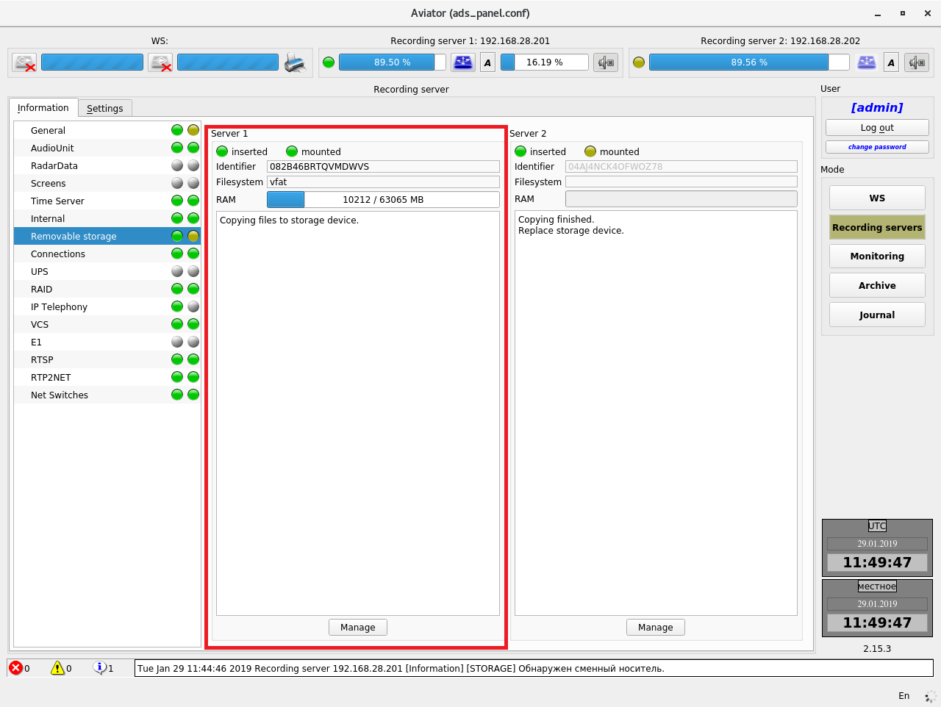
Figure 5.19 – System condition after replacement of removable storage

Playback from archive
Playback of online (and long-term) archive on Playback Workstation takes place when mode "Archive" is selected on the right-hand panel. Before playback (or another operation with archives) select only one archive source – the proper recording server (removable storage is available for Playback Workstation as well), after which select archive files and time limits from the list of available archives. (Time limits may be unselected, as after selection of files they are set automatically) (Figure 5.20). For playing back the selected archives go to tab "Playback".
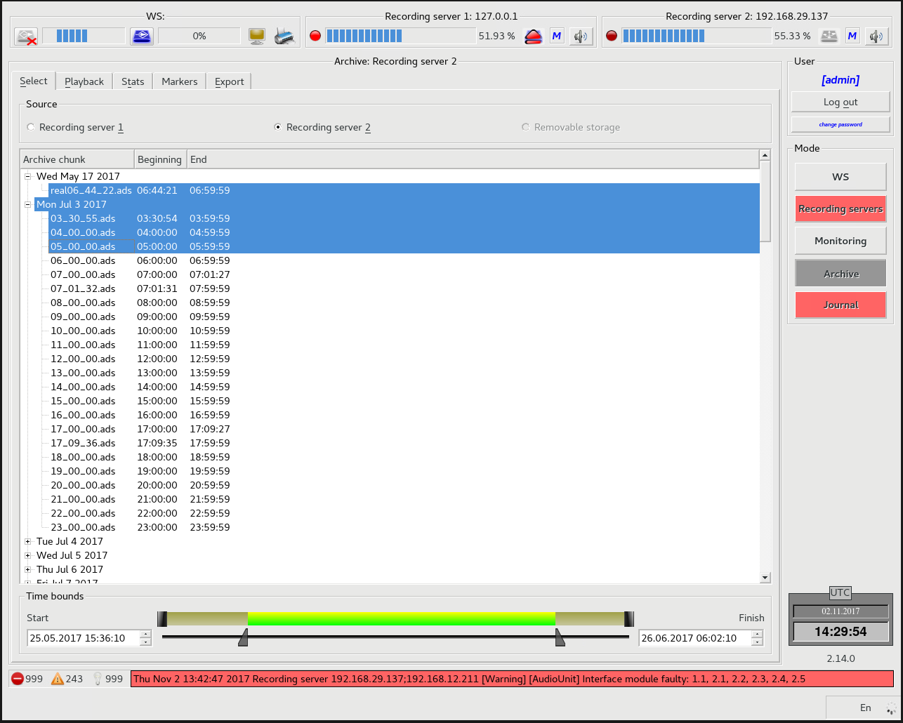
Figure 5.20 – Selection of archive source and time limits

Contents of tab "Playback" are completely similar to the contents of the mode "Monitoring" for point-to-point channel with additional control elements. For playback also select a source and a channel (Figure 5.21).
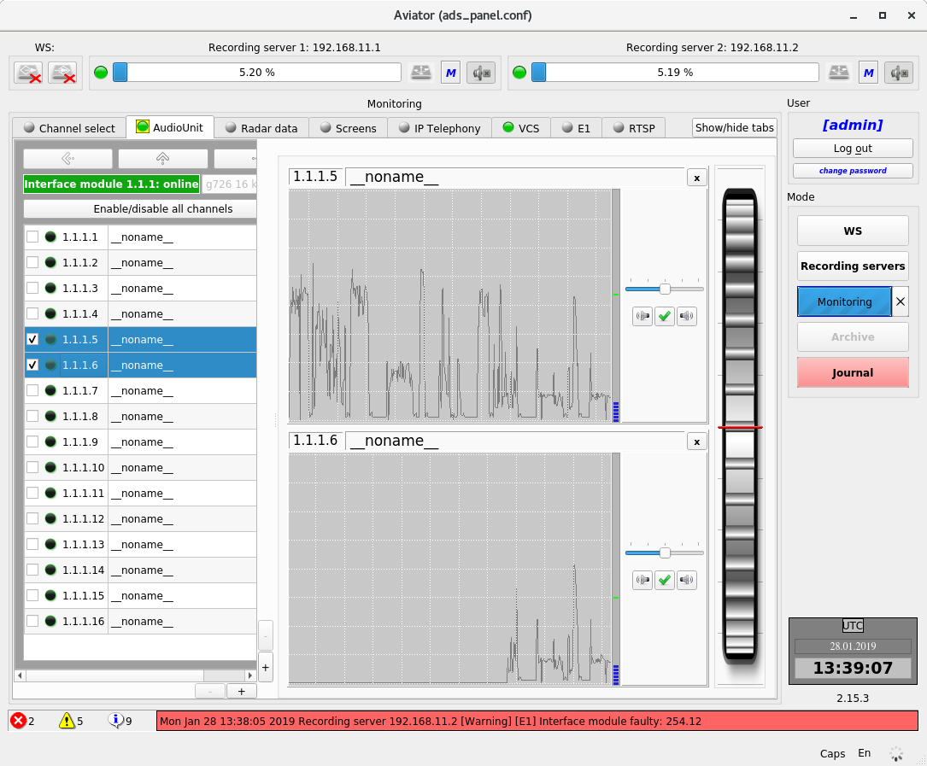
Figure 5.21 – Playback of data from archive

Playback control elements (from left to right Figure 5.22):
- Text fields with the date and time corresponding to the start [1] and end [7] of the played back fragment;
- The sliders [2] and [4] display the current position of playback;
- Pressing of buttons [3] and [6] will cause movement of the current position to the relevant direction by 1 second;
- Field [5] shows current playback time and date;
- seek to the start of fragment [8];
- seek backward [9];
- seek backward and play [10];
- play [11];
- stop [12];
- seek forward [13];
- seek to the end of fragment [14];
- loop playback [15];
- playback speed[16] (select х0.25, х0.5, x1, х2, х4 from the normal speed);
- additional controls [17].
Figure 5.22 – Control elements for playback of data from archives

Viewing of archive statistics
Viewing the statistics of online (and long-term) archive on Playback Workstation takes place when mode "Archive" is selected on the right-hand panel. Before viewing the statistics (or another operation with archives) select only one source of archives – the required recording server (removable storage is also available for Playback station), then select archive files and time limits from the list of available archives. (Time limits may be unselected, as they are set automatically after selection of files). After selection go to the statistics tab (Figure 5.23). For printing out the statistics press button "Print" (available only with connected printer).
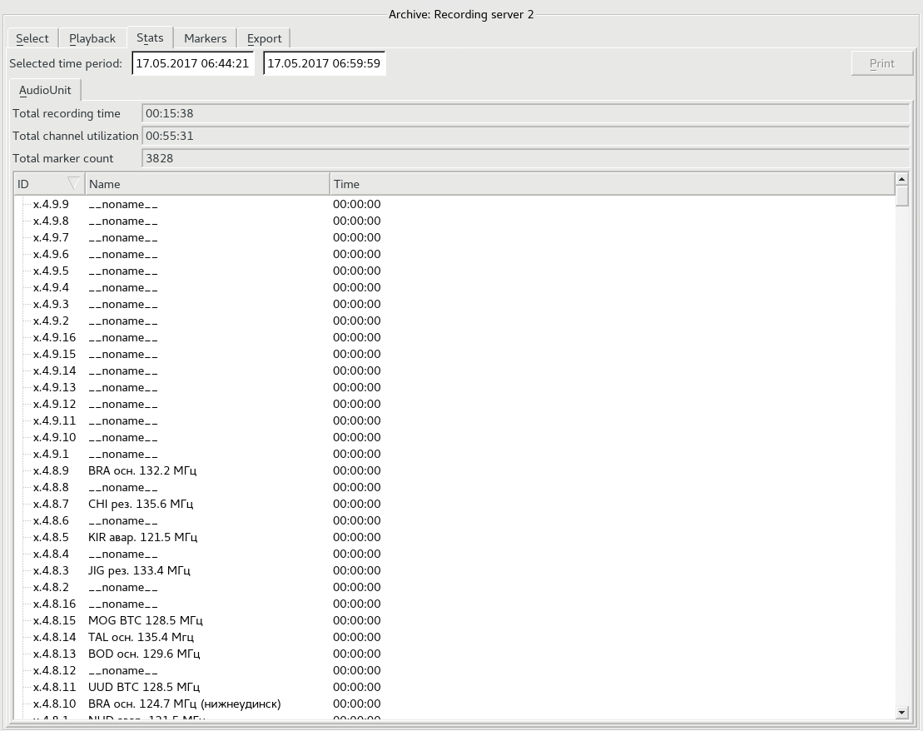
Figure 5.23 – Viewing of archive statistics

Operations with long-term archive and removable storage
Each operation performed with long-term removable storage interrupting the work cycle requires acknowledgement of operator's rights – repeated authorisation takes place. Status scan of the long-term removable storage takes place when mode "Recording servers" is selected on the right-hand panel. The list of elements related to the data sections on the station components is displayed on tab "Info" on the left. For display of information on removable storage select the relevant item. By default, the recording server copies the data from the online archive to the long-term archive in fully automatic mode with duration of recorded data 24.5 hours minimum per one removable storage with due regard for record overlapping. If necessary, the operator is notified (audio announcement, log record, light blinking) that the removable storage shall be replaced. The removable storage inserted into the recording server shall not be recorded earlier than 14 days ago (or another preset time in the recording server settings), otherwise the record will not be made and the system will inform the operator about an error. The mode for manual relocation of archives to removable storage is selected by setting the check mark in field "Manual copying" (Figure 5.24). Select the required archive files and press the copy button. The data on the removable storage will be tagged by the system for possible rewriting in automatic mode (without limitation of rewriting time).
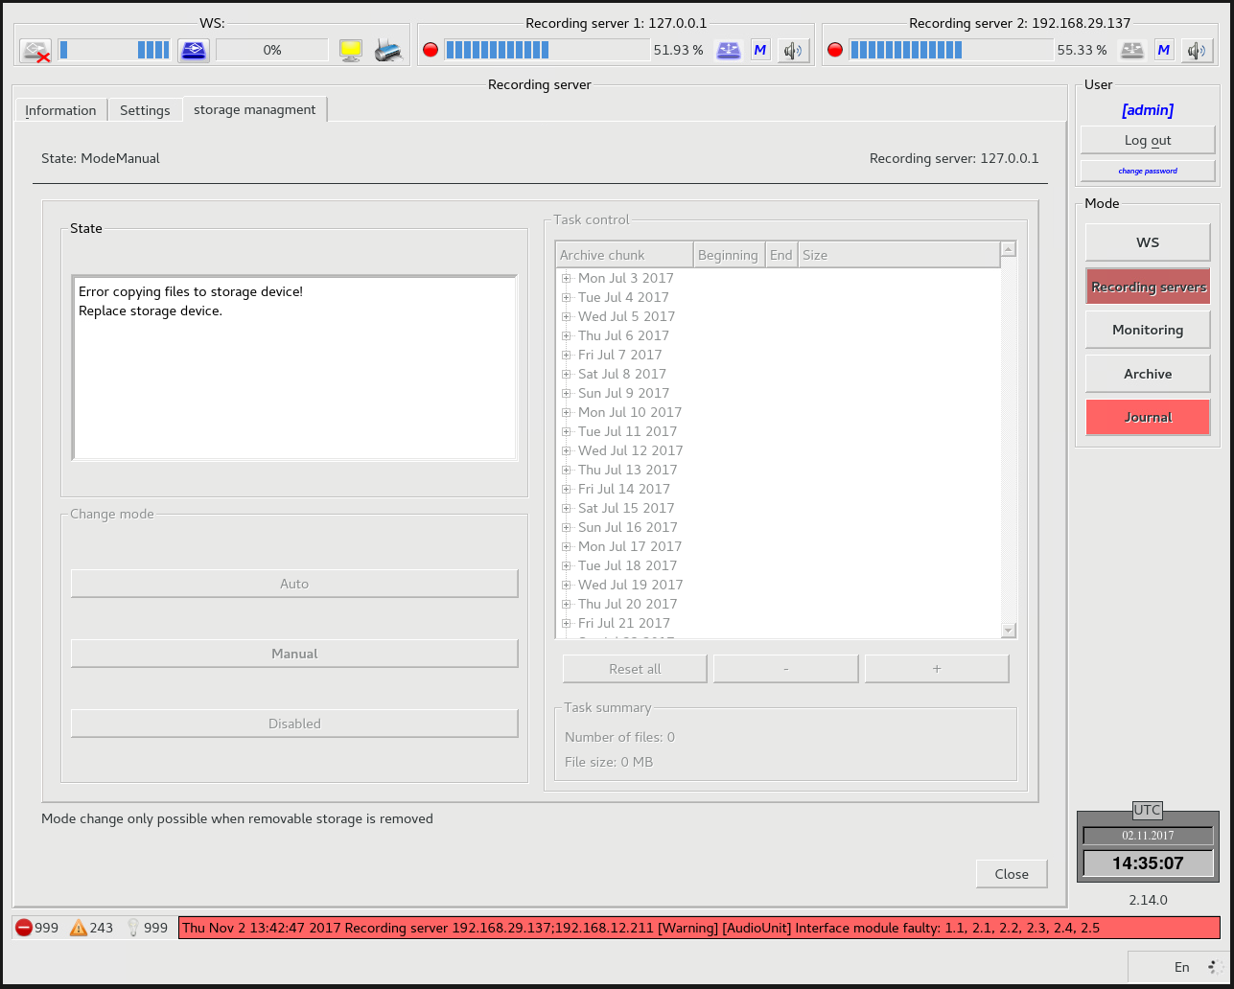
Figure 5.24 – Operations with long-term archive

Playback station

Purpose of the complex software
Playback Workstation supports playback of recorded information from long-term archive. Also, it supports all available to Monitoring Workstation functions provided there is a connection to the recording server via LAN.

Basic operations performed at Playback station
Each operation performed at Playback Workstation and related to access to recording servers may be permitted or prohibited in the user account. Operations performed at Playback Workstation and related to playback of archives are fully identical to the operations at Monitoring Workstation, with the only difference that Playback Workstation allows playing back archives from removable storage and exporting data to a blank storage (USB external drive).

Selection of archive fragment
Select mode "Archive" in the Right-hand Panel (Figure 5.25):
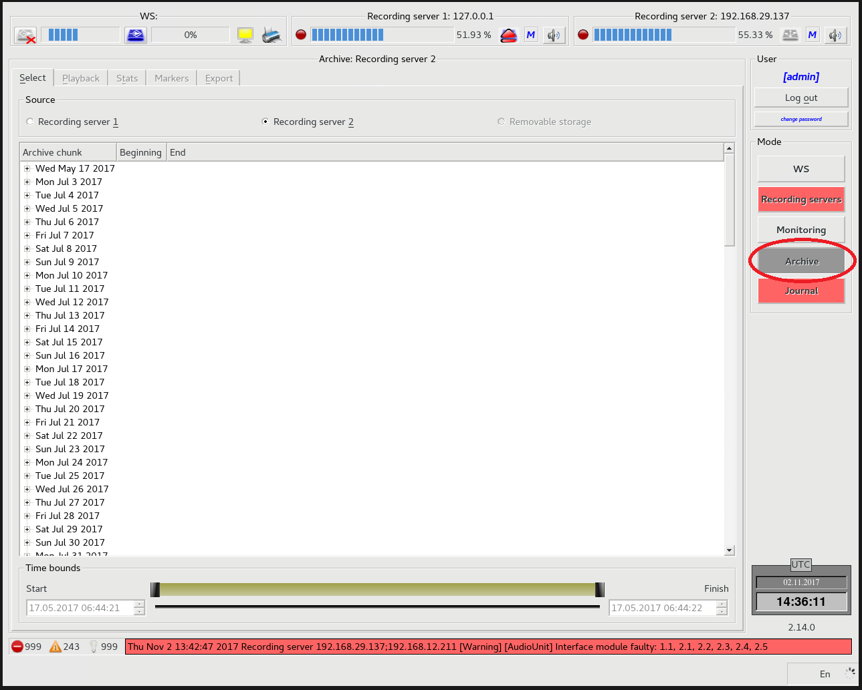
Figure 5.25 – Selection of mode "Archive"
Go to tab "Select" (Figure 5.26):
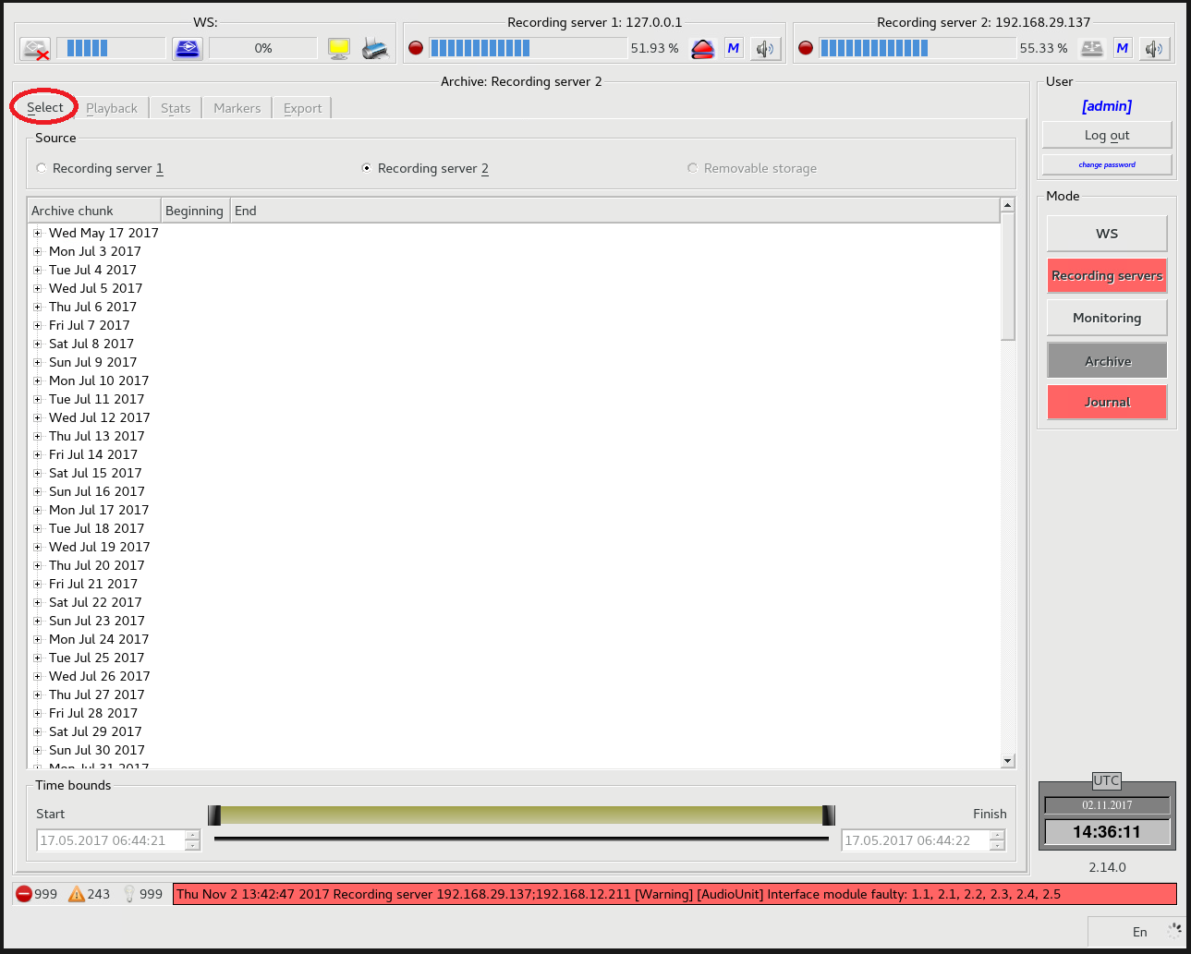
Figure 5.26 – Tab "Select"
Select data source Recording server 1, Recording server 2 or removable storage (Figure 5.27):
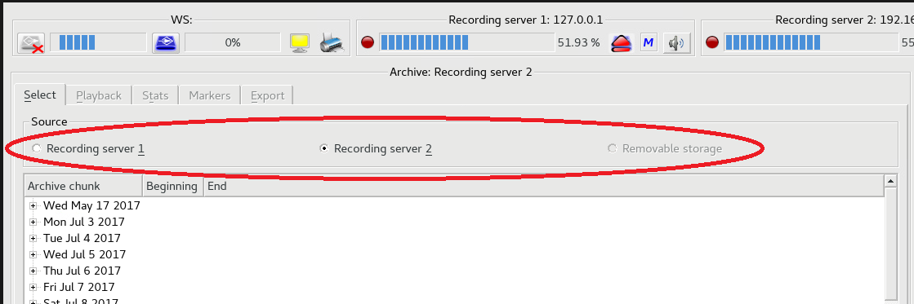
Figure 5.27 – Selection of data source

Define (select) the required interval with an hour accuracy (Figure 5.28):
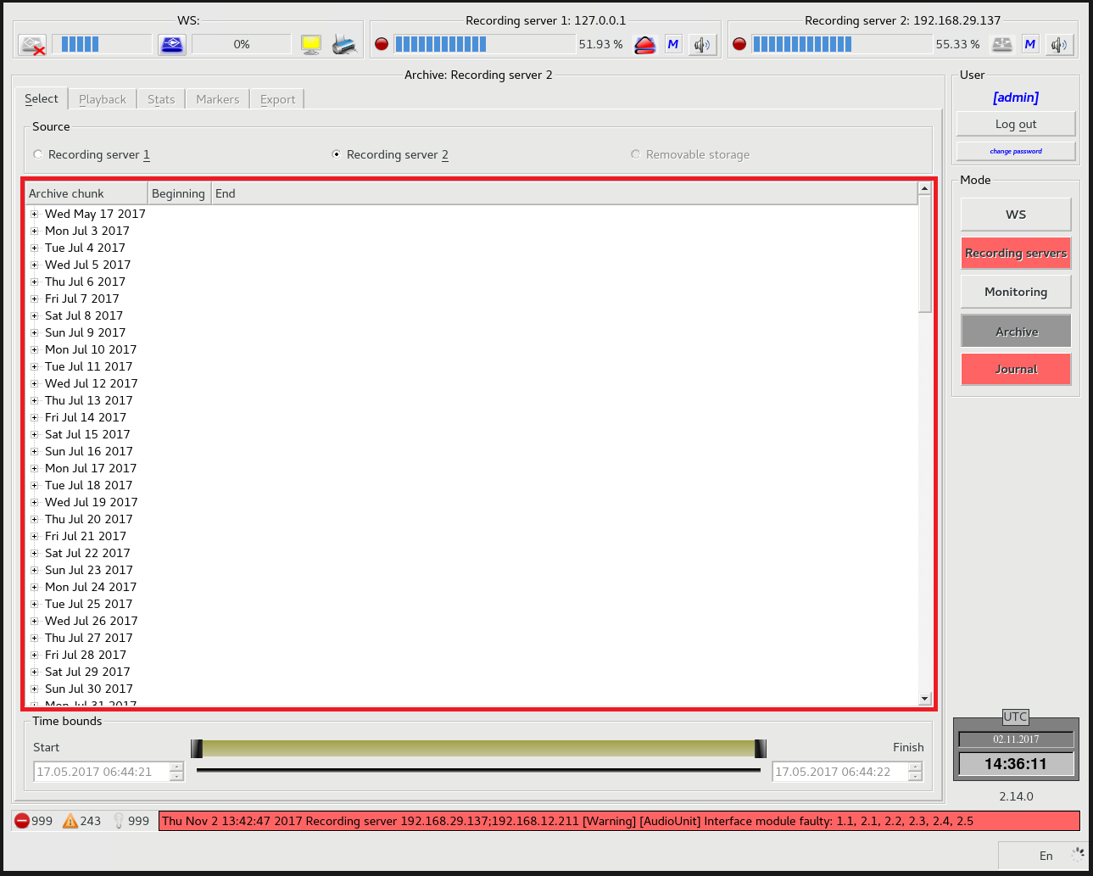
Figure 5.28 – Selection of data from the list of records in the archive

Update the time of fragment start and end using the sliders (Figure 5.29):
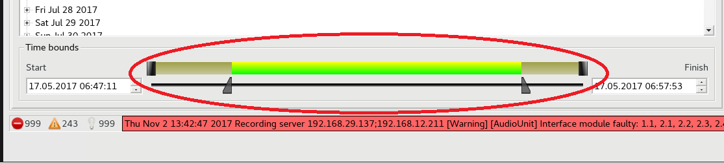
Figure 5.29 – Updating fragment limits

Playback from AAU data archive
Select an archive fragment for playback. Go to tab "Playback" (Figure 5.30):
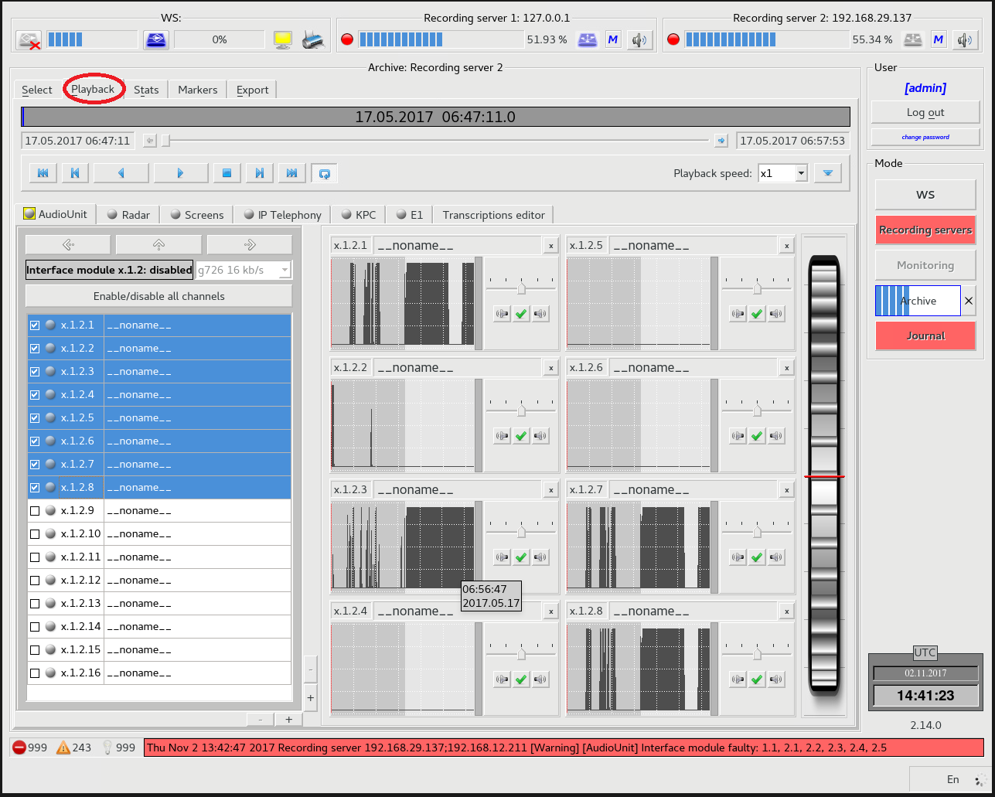
Figure 5.30 – Tab "Playback"
Press the play button (Figure 5.31):
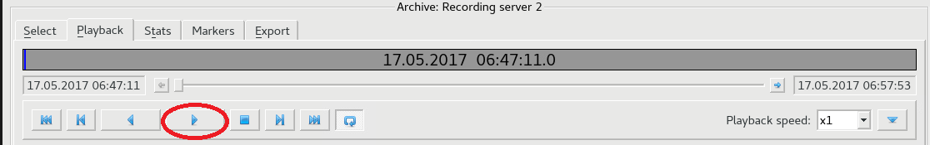
Figure 5.31 – Playback start

Select tab "Audio Unit" under the player (Figure 5.32):
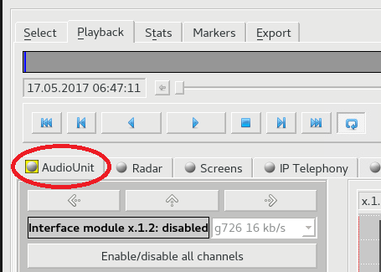
Figure 5.32 – Tab "Audio Unit"
Mark the necessary channels (you can select up to 8 channels) (Figure 5.33):
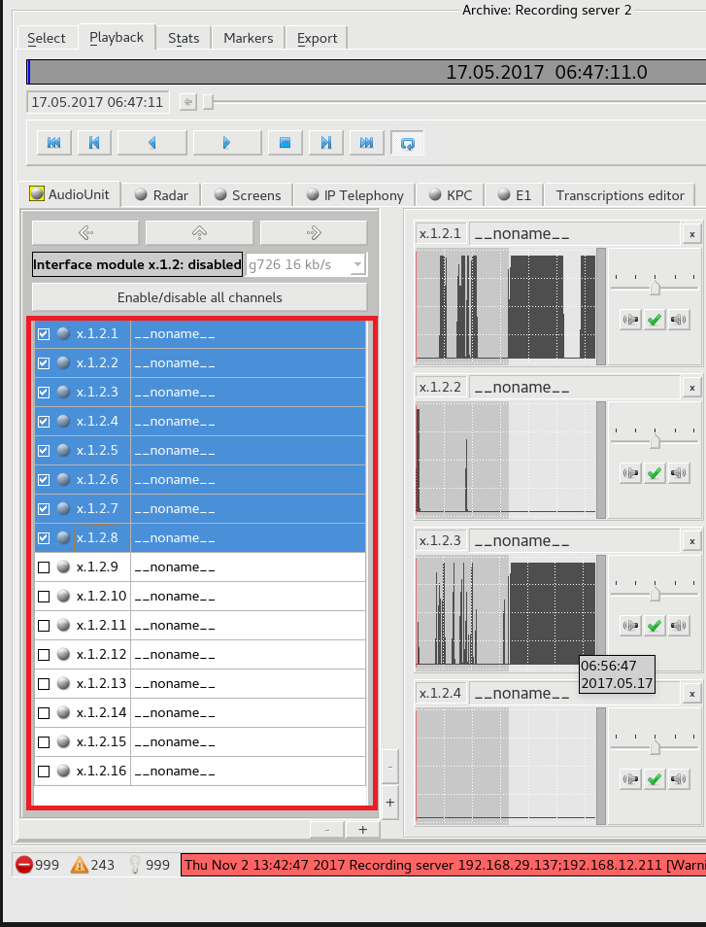
Figure 5.33 – Selection of channels for playback

The graphic representation of signal in the channel will appear to the right of channel list, for selected channels (Figure 5.34).
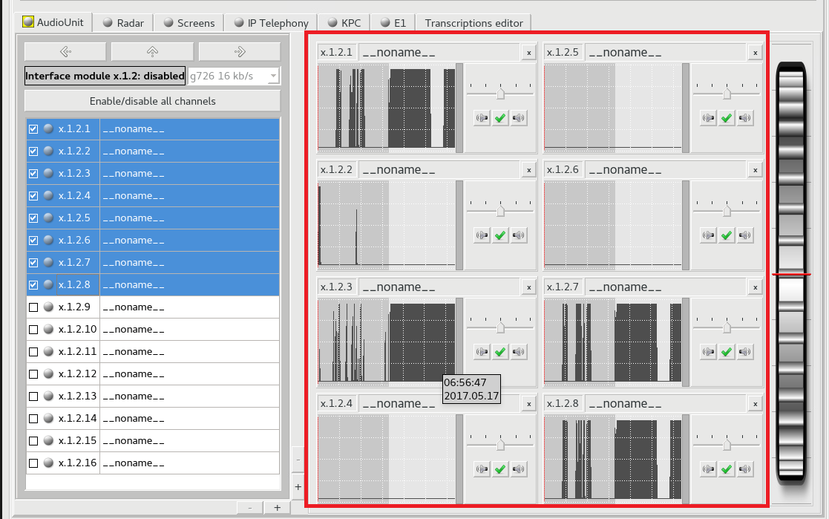
Figure 5.34 – Graphic representation of signals

Playback from Radar Data archive
Select an archive fragment for playback 5.3.2.1: Go to tab "Playback" (Figure 5.35):
Figure 5.35 – Tab "Playback"
Press the play button (Figure 5.36):
Figure 5.36 – Play button

Select tab "Radar Data" under the player (Figure 5.37):
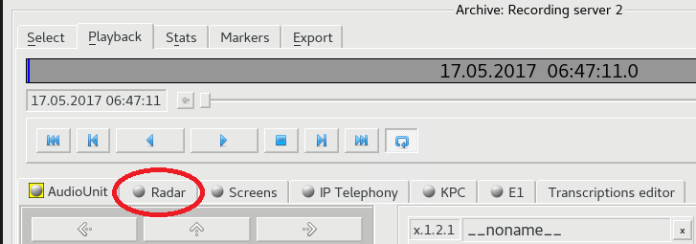
Figure 5.37 – Tab "Radar Data"
Select type of data (off, processed data, unprocessed data) (Figure 5.38):
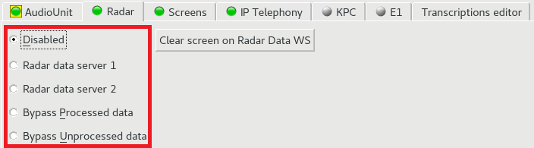
Figure 5.38 – Selection of played back data type

Playback of screen shots from the archive
Select an archive fragment for playback 5.3.2.1:
Go to tab "Playback" (Figure 5.39):
Figure 5.39 – Tab "Playback"

Press the playback button (Figure 5.40):
Figure 5.40 – Playback start
Select tab "Screens" under the player (Figure 5.41):
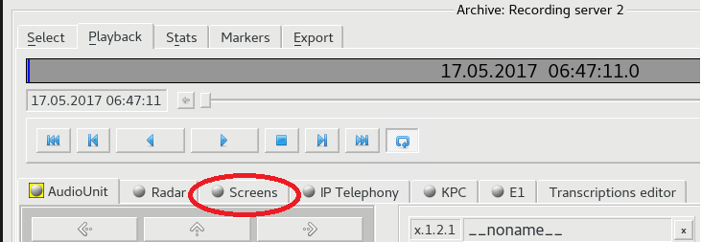
Figure 5.41 – Tab "Screens"

Select displays for playback from the list (you can choose up to 4 displays) (Figure 5.42):
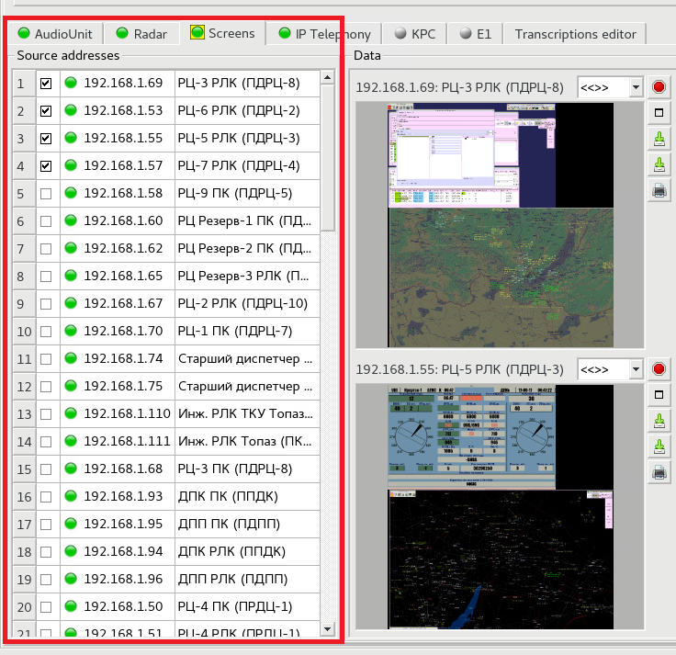
Figure 5.42 – Selection of displays for playback

Information from the selected ones will be displayed on the right of the display list (Figure 5.43):
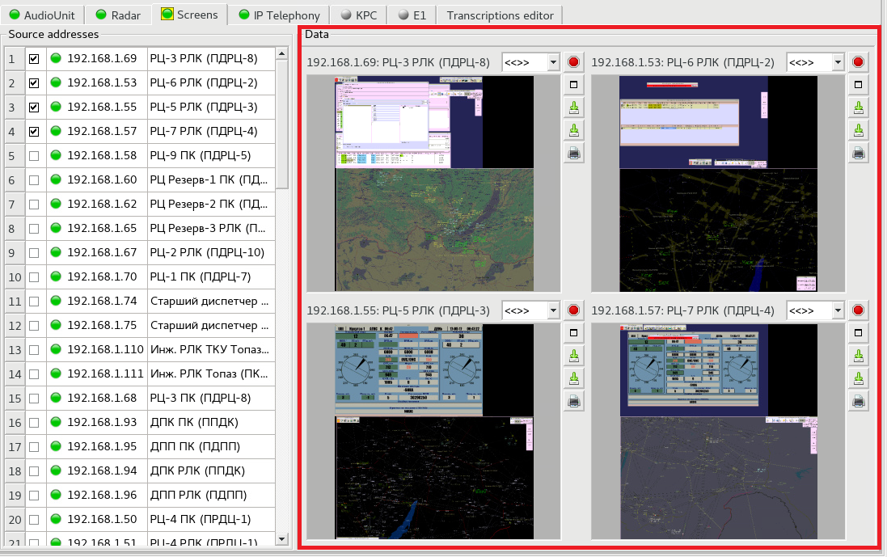
Figure 5.43 – Data display area

Export of data from archive
Export of data is only done provided that a blank storage is inserted (hard disc drive, USB flash drive), otherwise export of data will be blocked. Data export from long-term archive takes place when mode "Archive" is selected on the right-hand panel. Before data export (or another operation with archives) select only one archive source – the required recording server or removable storage, then select the files and time limits from the list of available archives. (Time limits may be unselected, as after selection of files they are set automatically). Go to tab "Export" after selection (Figure 5.44).
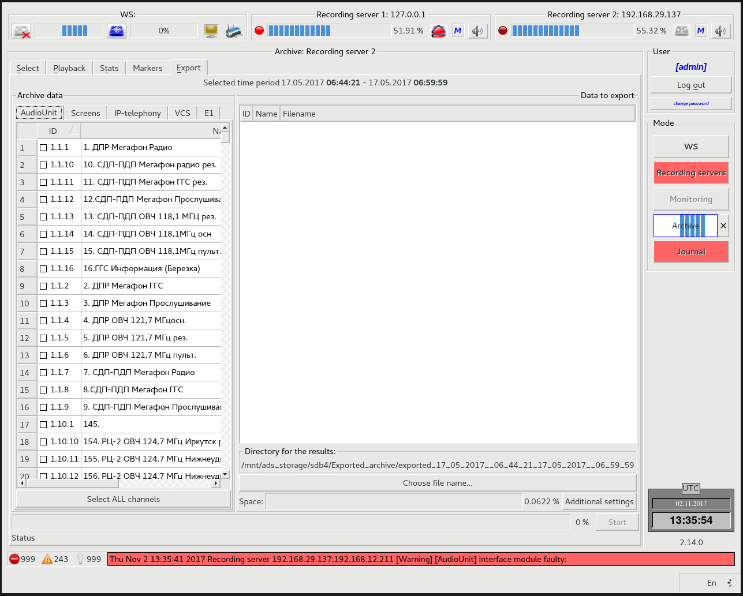
Figure 5.44 – Export of data from archive
This tab is used for export of data from archive files to standard files for playback by third party programs. Export of AAU data to audio files of WAV format is available. The following buttons are available for selection of channels for export:
- Select all channels;
- Select dedicated channels;
- Remove dedicated channels from selected channels;
- Remove all channels from selected channels.
Select the required channels and press button "Export", the button will change its name to "Cancel" and a time consuming process will start which time depends on the length of a record fragment and the number of selected channels.
During export an additional indicator is also displayed at the bottom of the right-hand panel with the button pressing on which will stop the export. If the export was not finished, the same data will be re-exported again.

А List of Abbreviations

AAU – Aviator Audio Unit
AGC – Automatic Gain Control
AS – Air Situation
ATMS – Air Traffic Management System
AWP – Automated Working Position
EGI – Element of Graphical Interface
IAS – Integrated Automation System
ID – Identifier
LAN – Local Area Network
PBX – Private Automatic Branch eXchange
PC – Personal Computer
RAID – Redundant Array of Independent Disks
RAM – Random – Access Memory
RD – Radar Data
RTSP – Real-Time Streaming Protocol
S.M.A.R.T. – Self-Monitoring, analysis and reporting technology
SS – Signal Sensor
SW – Software
UPS – Uninterrupted Power Supply
VCS – Voice Communication System
WDS – Device Model
WS – Workstation

В Log messages
No. | Type | Category | Sender | Text template
1 | Information | SYS | Control panel | Test (monitoring) panel is started.
2 | Information | CP | Control panel | RD data playback is started in test mode.
3 | Information | CP | Control panel | RD data playback is stopped in test mode.
4 | Information | CP | Control panel | Listening of AAU channel is enabled in mode ("Monitoring")
5 | Information | CP | Control panel | Listening of AAU channel is disabled in mode ("Monitoring") channel: Х.Х.Х.Х
6 | Information | SYS | Control panel | Removable storage with archives is detected. Removable storage ID: X
7 | Information | SYS | Control panel | Removable storage for export is detected. Removable storage ID: X
8 | Warning | SYS | Control panel | Removable storage installation error. Possible damage to the removable storage, not formatted or the removable storage file system is not supported.  Removable storage ID: X
9 | Information | CP | Control panel | Change of removable storage mode to <mode> recording server: XX.XX.XX.XX
10 | Information | CP | Control panel | Sound notification is on, recording server: X
11 | Information | CP | Control panel | Sound notification is off, recording server: X
12 | Information | SYS | Control panel | Electrical power supply from mains to UPS is connected.
No. | Type | Category | Sender | Text template
13 | Warning | SYS | Control panel | UPS was disconnected from electrical power source.
14 | Information | SYS | Control panel | UPS battery charge level: ХХ%.
15 | Warning | SYS | Control panel | UPS battery charge level: ХХ%.
16 | Emergency | SYS | Control panel | UPS battery charge level: ХХ%.
17 | Information | SYS | Control panel | Server is available. Connection is established. recording server: XX.XX.XX.XX
18 | Emergency | SYS | Control panel | Server is unavailable. Connection is broken. recording server: XX.XX.XX.XX
19 | Warning | CP | Control panel | A request was sent for deinstallation of removable storage in the recording server. recording station server: XX.XX.XX.XX
20 | Warning | CP | Control panel | An attempt to deinstall removable storage without proper rights.
21 | Warning | CP | Control panel | Control panel configuration is changed. GUICONFIG
22 | Warning | CP | Control panel | New configuration of "Audio Unit" source is transmitted to recording server.  recording server: XX.XX.XX.XX source parameters: CONFIG
23 | Warning | CP | Control panel | New configuration of source "Radar Data" transmitted to recording server.  recording server: XX.XX.XX.XX  server address RD1: XX.XX.XX.XX  server address RD2: XX.XX.XX.XX

No. | Type |  | Category |  | Sender | Text template
24 | Warning |  | CP |  | Control panel | New configuration of source "monitor displays" is transmitted to recording server. recording server: XX.XX.XX.XX activated addresses: UP_  LIST disabled addresses: DOWNLIST
25 | Information |  | CP |  | Control panel | Successful local authorisation for control panel set-up.
26 | Warning |  | CP |  | Control panel | Unsuccessful attempt of local authorisation for control panel set-up.
27 | Information |  | CP |  | Control panel | Successful authorisation for recording server set-up.
28 | Warning |  | CP |  | Control panel | Unsuccessful authorisation attempt for recording server set-up.
29 | Information |  | CP |  | Control panel | User is successfully authorized.
30 | Warning |  | CP |  | Control panel | User authorisation failed. Incorrect login or password. login XXX
31 | Warning |  | CP |  | Control panel | User authorisation failed. Network error.  login XXX
32 | Warning |  | CP |  | Control panel | User authorisation failed. No network. login XXX
33 | Information |  | CP |  | Control panel | USER user logged out.
34 | Information |  | CP |  | Control panel | System unit switching off.
35 | Warning |  | CP |  | Control panel | System unit switching off failed.
36 | Information |  | CP |  | Control panel | Password for login is successfully changed: XXX.
37 | Warning |  | CP |  | Control panel | Change of password for login failed. XXX.
No. | Type |  | Category |  | Sender | Text template
38 | Information |  | CP |  | Control panel | Saving data source image "monitor displays" to file. source ip-address: XX.XX.XX.XX
39 | Information |  | SYS |  | Control panel | "Monitor display" image was successfully recorded to file.  filename: ХХХХ
40 | Warning |  | SYS |  | Control panel | Screen shot saving failed as the removable storage for export is not connected.
41 | Warning |  | SYS |  | Control panel | Creation of folder ХХХХ on the removable storage for 'monitor display' screen shot failed.
42 | Warning |  | SYS |  | Control panel | Screen shot recording to file failed file name: ХХХХ
43 | Information |  | CP |  | Control panel | User started to export the following data: <list of data>
44 | Information |  | CP |  | Control panel | Data export is successfully finished.
45 | Information |  | CP |  | Control panel | Data export was stopped by user.
46 | Warning |  | SYS |  | Control panel | Export was aborted as the current user was denied relevant access.
47 | Warning |  | SYS |  | Control panel | Export was aborted as the access to currently exported data was banned.
48 | Warning |  | SYS |  | Control panel | Data export was aborted due to technical issues: <error description>
49 | Information |  | SYS |  | Recording service | [TSC] time synchronization is operating
50 | Emergency |  | SYS |  | Recording service | [TSC] Time synchronization is not performed. Too high time offset from timing reference on TSC servers.
No. | Type |  | Category |  | Sender | Text template
51 | Emergency |  | SYS |  | Recording service | [TSC] Time synchronization is not performed. No synchronization with TSC servers
52 | Emergency |  | SYS |  | Recording service | [TSC] Time synchronization is not performed. No connection with local TSC service
53 | Emergency |  | SYS |  | Recording service | [TSC] Unknown error: ERRID
54 | Information |  | SYS |  | Recording service | [UPS] no data
55 | Information |  | SYS |  | Recording service | [UPS] mains supply
56 | Warning |  | SYS |  | Recording service | [UPS] battery supply
57 | Emergency |  | SYS |  | Recording service | [UPS] critical charge level
58 | Information |  | SYS |  | Recording service | [AAU] unit disconnected in configuration: XX
59 | Information |  | SYS |  | Recording service | [AAU] unit operating without errors: XX
60 | Emergency |  | SYS |  | Recording service | [AAU] unit disconnected or not OK: XX
61 | Emergency |  | SYS |  | Recording service | [AAU] card fault detected: XX
62 | Information |  | SYS |  | Recording service | [AAU] card operating without errors: XX
No. | Type |  | Category |  | Sender | Text template
63 | Information |  | SYS |  | Recording service | [RD] TOPAZ server was connected, Radar Data server address: XX.XX.XX.XX
64 | Warning |  | SYS |  | Recording service | [RD] TOPAZ server was reconnected, Radar Data server address: XX.XX.XX.XX
65 | Emergency |  | SYS |  | Recording service | [RD] TOPAZ server was disconnected. Radar Data server address: XX.XX.XX.XX
66 | Information |  | SYS |  | Recording service | Reading of monitor displays operating without errors: XX.XX.XX.XX
67 | Emergency |  | SYS |  | Recording service | Monitor display reading is out of service: ХХ.ХХ.ХХ.ХХ
68 | Information |  | SYS |  | Recording service | RAID operating without errors
69 |  | Warning |  | SYS | Recording service | RAID detected malfunction
70 |  | Information |  | SYS | Recording service | Removable storage is detected, removable storage ID: X
71 |  | Information |  | SYS | Recording service | Removable storage extracted, removable storage ID: X
72 |  | Information |  | SYS | Recording service  and/or  Control panel | Status of network interfaces changed: 5<description of changed interfaces>
73 |  | Warning |  | SYS | Recording service  and/or  Control panel | Status of network interfaces changed: <description of changed interfaces>
74 |  | Emergency |  | SYS | Recording service  and/or  Control panel | Status of network interfaces changed: <description of changed interfaces>
75 |  | Information |  | CP | Recording service  and/or  Control panel | Network interface monitoring configuration is changed:  <description of new configuration>

