Recording System AVIATOR for ATC Systems

Operator's Manual
(Part 2)
Radar Data Playback Automated Workstation

ЦИВР.00101-02 34 01

Total sheets 134

Moscow
2017

Contents
1 Interface and operator messages 4
1.1 Air Situation Window 4
1.1.1 Coordinate radar data 5
1.1.2 Tracking forms (TF) 7
1.1.3 Extrapolated location vectors 21
1.1.4 Radio direction finding information 22
1.1.5 Mapping information 23
1.1.6 Azimuth-distance grid and geographical grid 24
1.1.7 Measuring vector 24
1.1.8 Information on airspaces 27
1.1.9 Mode “Landing” 30
1.1.10 Additional air situation window “Zoom-window” 32
1.2 Window “Current time” and window “Main menu” 35
1.3 Window “Control display” 39
1.4 Window “Aircraft toolbox” 57
1.4.1 Scale setting 58
1.4.2 Center offset 59
1.4.3 Extrapolation control 59
1.4.4 Setting the number of traces 60
1.4.5 Selection of the airspace to be zoomed in in ASW 60
1.4.6 Altitude filter control 60
1.5 Window “Display settings” 61
1.5.1 General parameters setting 62
1.5.2 Setting parameters of measuring tools (functions) 63
1.5.3 Mapping parameters setting 69
1.5.4 Aeronautical data display setting 73
1.5.5 Setting A/C display parameters 76
1.5.6 Setting display parameters for plots 81
1.5.7 Setting of displayed data on ADF, analog devices and RW windows 82
1.5.8 Display settings for flight plan route 85
1.5.9 Setting display parameters for airspaces 86
1.5.10 Setting display parameters for meteorological information 91
1.5.11 Display settings for window “Zoom” 94
1.6 Auxiliary display control windows 96
1.6.1 A/C list 96
1.6.2 Window “Lost aircraft” 100
1.6.3 Window “Awaiting list” 101
1.6.4 LCC airspaces pressure 102
1.6.5 Window “SSR codes” 103
1.6.6 Window “Airport information” 105
1.6.7 RW occupancy display panel 107
1.6.8 Vertical assistance window 108
1.6.9 Air traffic safety hazards window 111
1.6.10 Window “DPPE” 114
1.6.11 Window “Alert window” 120
1.6.12 Meteo solution 121
2 Control functions: 122
2.1 Measuring vector 122
2.1.1 The measuring vector form contains two, three or four data groups. 122
2.2 Measurement of geographical coordinates 123
2.3 General viewing of TF 124
2.4 Manual relocation of TFs 125
2.5 Individual viewing of TF 125
2.6 Individual settings for TF 125
2.7 Duty takeover and individual display settings for AWS 127
List of Abbreviations 133

Interface and operator messages

Air Situation Window
The air situation window (ASW) is the main window permanently displayed at workstations. The window cannot be closed, moved and resized in the operating mode as a part of the complex of air traffic controller’s automated workstations (AWS).
An example of the window is given in Figure 1.
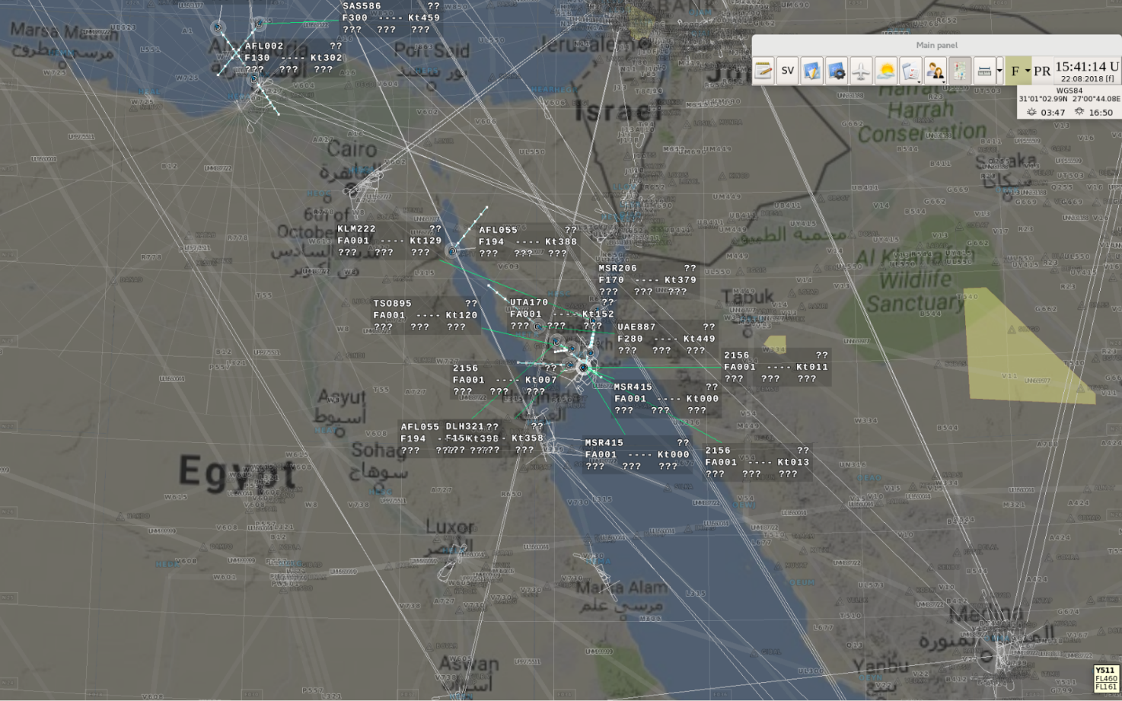
Figure 1 - Air Situation Window
The air situation window is used for displaying the information related to air traffic in the graphical, symbolic and alphanumeric form including:
- digital and analog coordinate radar data;
- tracking forms;
- extrapolation vectors;
- radio direction finding information;
- mapping (aeronautical) information;
- azimuth-distance grid;
- geographical grid;
- measuring vectors;
- elements of meteorological information (zones of dangerous weather phenomena from WSR (weather surveillance radar), actual or expected information on sounding balloon (radiosonde));
- elements of plan information (flight plan route);
- information on restricted flight areas;
- system functional windows and functional message windows.
Note – Meteorological information can only be displayed in the air situation window when ATC AS is interfaced with the respective meteorological information sources.
Display panel “No connection to server” shown at the top section of the indicator represents one of functional message windows when connection of the workstation to the radar sub-system server is lost. An example of the respective display is given in Figure 2.
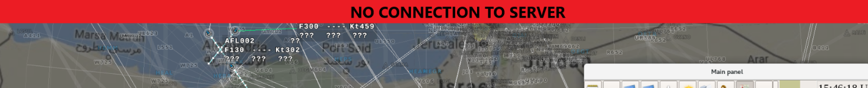
Figure 2 - Display panel “No connection to server”
Such a message indicates a malfunction of the workstation or the entire complex, and the necessity of using the backup workstation or sub-system “By-pass”.

Coordinate radar data
Coordinate data may be displayed in the air situation window in the analog format and the digital format.
Analog radar data is displayed in ASW as special plots (filled contours or “arc-shaped marks”) from mobile or stationary objects detected by the radar while the air space surveillance. The objects are A/C, airborne moisture targets (clouds), terrain features, mountains, etc.
Note – Analog radar data may only be displayed at workstations of the complex when the complex is interfaced with analog radars.
The air situation window may simultaneously display information from several analog sources (from 4 sources, maximum), herewith information from various sources may be highlighted in colors.
An example of the analog RD display is given in Figure 3.
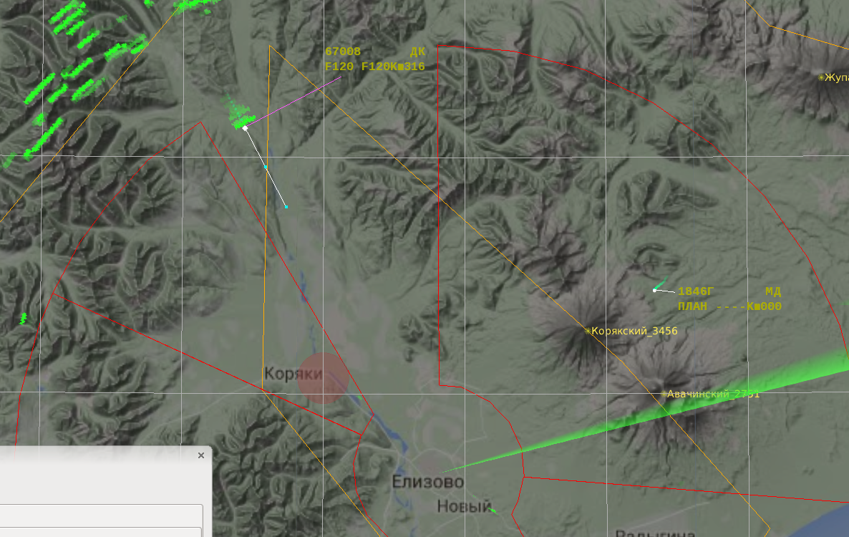
Figure 3 - Analog radar data

Note – The figure shows analog coordinate information for the aircraft with side number 67008 together with digital information.
The dimensions and shape of analog plots depend on Reflectivitying surface of the object and the scale selected on the indicator. The plots are updated while the sweep trace is rotating. In ASW the sweep trace (scanning beam) rotates from the point corresponding to location of the radar selected by the air traffic controller at the speed corresponding to its scanning rate.
Both the plots obtained during the current radar surveillance and the plots obtained during the previous surveillance cycles may be displayed. Analog plots related to different scans are displayed in variable gray gradations: fading grows as far as the distance to the current scan increases. The fading degree is adjustable.
The analog information displaying at the workstation (enabling/disabling the source) may be controlled through window “Control display”. Display parameters (color, visibility, beam width) are adjusted individually for each analog source via window “Display settings”.
Digital coordinate radar data is displayed in the air situation window as special symbols showing the target location in the air space and characterizing the radar data source and progress of data processing in the system.
Digital coordinate symbols are as follows:
- coordinate symbols designating the current location of the A/C not locked on for tracking (“plots”);
- coordinate symbols designating the current location of the A/C locked on for tracking (“tracks”);
- coordinate symbols designating the previous location of the A/C – history symbols (“traces”).
For the “plots” the symbols given in Table 3 are used.
Table 3 Symbols for the “plots”
Radar data (RD) source | Symbol
Primary surveillance radar (PSR)
Secondary surveillance radar (SSR)
Integrated data from PSR and SSR
Display of “plots” may be enabled/disabled from the control panel using functional window “Display settings”. Besides, for plots the so called pop-up help may be displayed (if the respective option is selected in window “Display settings”). In this case, if the mouse cursor is pointed over the “plot” coordinate symbol, the special display panel appears (see the example in Figure 4). The pop-up help contains the data on source type (the example shows the secondary surveillance radar (SSR)), the number assigned to the source in the radar data processing module (it matches the source number in window “DPPE”), surveillance time and geographical coordinates of the plot).
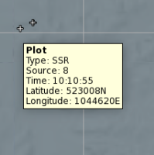
Figure 4 - Pop-up help for the plot
For tracks, the coordinate symbols given in Table 4 shall be used.

RD source | Symbol
Primary surveillance radar (PSR)
Secondary surveillance radar (SSR)
PSR + SSR
Automatic dependent surveillance (ADS)
The PSR track referenced to the plan information
The SSR track referenced to the plan information
The ADS track referenced to the plan information
The track of A/C provided by function «Track by plan”
The IFFR track
The IFFR track referenced to the plan information
Table 4. Symbols for tracks
Symbol “” is used to designate the previous location of A/C (“trace”). The number of displayed traces may be set by the air traffic controller from the control panel. The combination of traces is displayed on the basis of gray gradations, i. e. the traces adjacent to the current location of A/C are displayed in a brighter manner. The example of the combination of traces displayed with a track coordinate symbol is given in Figure 5.
Figure 5 - The symbol of a track with traces

Tracking forms (TF)
Tracking forms contain additional information on A/C displayed as a single-line data collection or a data block composed of two, three, four or five data lines. The form background may be highlighted in color. These options are selected in functional window “Display settings” (see Section 2.3).
The tracking form is connected to the A/C coordinate symbol by means of a binding line drawn at the preset angle to the A/C flight direction.
There are 4 basic options of TFs arrangement relative to the coordinate symbol displayed in ASW (the options of the binding line orientation) depending on the A/C flight direction – 90, 180, 225 and 135 degrees. If the automatic positioning mode is not preset (option “Auto” in functional window “Aircraft toolbox” is off), all TFs in the air situation window (excluding those affected by the manual relocation function) are arranged under the preset angle relative to the A/C flight direction. Herewith, for those TFs the automatic relocation function is not active when TFs overlap each other.
If the automatic positioning mode is set for TFs in ASW (option “Auto” in functional window “Aircraft toolbox” is on), each TF may be arranged individually depending on the situation shown in the air situation window. This is just the case when the automatic relocation mode is active for the overlapped TFs. Initially, the angle of 90 degrees relative to the current heading is preset in ASW for each TF provided that other forms do not prevent this tracking form from taking such a position relative to the A/C coordinate symbol when the form is displayed for the first time in the air situation window. If this is impossible, the system selects such a position for TF that it does not overlap the forms of other A/C or overlaps them to the minimum extent. If further the possibility arises to orient TF at the angle of 90 degrees relative to the heading, the form will be moved accordingly. Otherwise, the TF will retain the initial parameters. In case of TFs overlapping, the form may be moved to a new position without changing the length of the binding line. Then the form will follow with the new position (the new direction of the binding line) until there is the possibility to arrange it at the angle of 90 degrees.
The manual relocation function enables moving the form to a random screen area, herewith the binding line will be extended accordingly. In this case, the directional angle and the length of the binding line obtained using the control panel are recorded – further TF is moved with these parameters of the binding line until the form is returned to the automatic positioning mode.
The examples of displayed forms featuring different orientation relative to the coordinate symbol (having different direction of the binding line) are given in Figure 6.
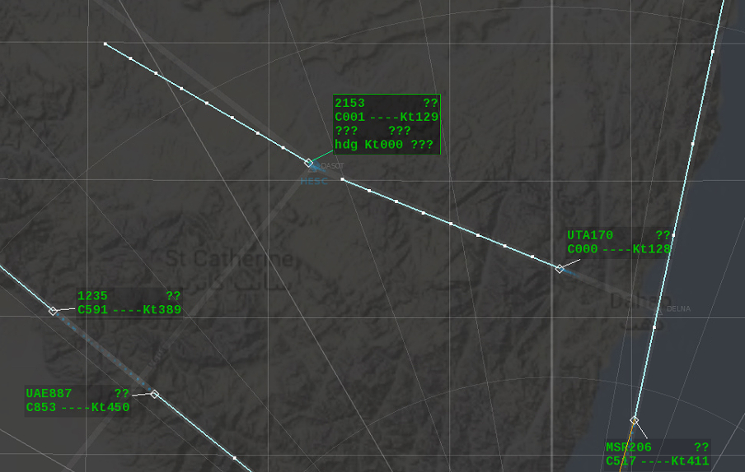
Figure 6 - The examples of displayed TFs
The binding line of the manually relocated TF is highlighted in the special color (in red by default, but a custom color may be set in window “Display settings”).
There are three possible states of a tracking form: basic, selected and extended.
The basic state is a normal state of a tracking form. The number of lines is preset in functional window “Display settings”.
The selected state is the state the TF changes over to when called from the control panel by the operator. As a rule, in this state some data contained in the form is entered or corrected. The TF changes over to the selected state when the mouse cursor is pointed over the TF or the A/C coordinate symbol. In this state the TF (if reduced to one line - three lines) is filled in to the maximum extent (4 lines). As soon as the mouse cursor is moved away from the TF or the A/C plot, the TF will return to the previous basic state. When the mouse cursor is moved across the TF fields while being in the selected state, the fields supporting data entry and correction are highlighted in blue (or another color set in window “Display settings”) for the specific TF.
Note – When the CRP symbol as a part of the aeronautical information (but not as a part of the vector mapping) is called, TFs with appropriate size may be highlighted in the air situation window. In this case, the forms of all A/C flying across the given CRP according to the flight plan will become complete and contain four lines.
The extended form is called from the control panel (by clicking on the call sign field with the right mouse button), and it contains additional data blocks (frames) relative to the basic tracking form. As a rule, such a form is used for short-time viewing. Repeated clicking on the call sign field with the right mouse button collapses the extended form.
The basic form (with maximum four lines fullness) and the selected form contain the following information:
Line 0:
Alerts on air traffic situations requiring special attention of the operator, including:
- dangerous A/C descent down to the minimum safe flight altitude (MSAW) and below this altitude (indication “MSAW” displayed on the yellow background or the red background);
- conflict situation arising between the aircraft according to the plan information – Medium Term Conflict (indication “MTC” displayed on the red background);
- A/C entry to the air space restricted use area or prohibited use area - Area Proximity Warning (indication “APW”) displayed on the yellow background or the red background;
- A/C entry to the dangerous weather phenomena zone (indication “DWP” displayed on the red background);
- potential conflict situation or preliminary potential conflict situation between A/C (indication “PCS” or indication “PPCS” displayed on the yellow background) according to the radar data;
- violation of separation rules for A/C (indication “STCA” displayed on the red background) according to the radar data;
- conflict situation between A/C (flag “CA” displayed on the red background) according to the radar data;
- double codes of SSR are detected (indication “DS” displayed on the yellow background);
- emergency codes sent via the SSR channel (flags “ES”, “UERC”, “HJ” displayed on the red background);
- the SSR individual code is not assigned (indication “CNA” displayed on the yellow background);
- A/C altitude error of more than 90 meters (indication “FLB” displayed on the red background);
- A/C deviation from the flight plan route in the horizontal plane and by time (indication “DEV” displayed on the yellow background);
- a prompt on the necessity to transmit to the air traffic controller of a ATC adjacent center the information on the conditions of A/C entry to the air traffic controller's area of responsibility via voice communication channels (indication “Transmit ACT” displayed on the blue background);
- mismatch between weather conditions of the destination airport and the weather minimum set by the A/C pilot-in-command – indication “MMP” displayed on the yellow background;
- mismatch between weather conditions of the destination airport and the weather minimum of the airport set for this type of A/C – indication “MMA” (weather minimum of A/C) displayed on the yellow background;
- an earlier arrival (by more than 30 minutes – changeable system parameter) to the destination airport (according to the updated estimated data – indication “EARLY”.
Notes:
1. Line 0 may simultaneously display several flags of off-nominal situations and accident and conflict situations for air traffic. If it is not possible to display all indications at a time, one should follow the priority principle (first of all the flags of a conflict between A/C and the indications of emergency situations on-board the A/C are displayed).
2. If “MSAW” and “APW” alerts are issued, the yellow color is used when there is a threat of A/C entry to the respective areas, while the red color is set when the A/C has already entered such areas.
3. If several indications are displayed at a time, the color highlighting a line corresponds to the most dangerous indication, i. e. if at least one indication is highlighted in red, all other flags are highlighted in red as well.
4. Line 0 is displayed in a forced manner only when the respective air traffic situation arises.
5. The display of prompt “Transmit ACT” is enabled from the control panel and is related to A/C flying to the area of responsibility of the ATC adjacent center with which no automatic information exchange via the OLDI protocol has been established.
6. The mismatch between the current weather conditions at the destination airport and the meteorological minimum set to the A/C pilot-in-command with indication “MMP” shown in line 0 of the TF is determined by comparing the parameters of horizontal visibility and cloud ceiling specified in the weather data on the airport with the related values given in the meteorological minimum set to the aircraft pilot-in-command and specified in field 18 of the flight plan.
7. The mismatch between the current weather conditions at the airport, the airfield weather minimum set for this type of A/C and indication “MMA” shown in line 0 of the TF is determined by comparing the parameters of horizontal visibility and cloud ceiling specified in the weather data on the airport with the related system parameters.
8. Upon interfacing with the IFFR channel at workstations with rights assigned to the military sector, line 0 of the TF may display the following messages: “FRIEND”, “FOE”, “FRIEND (M)”, “FOE (M)”, “Unknown (M)”, “ES”. Herewith, letter “M” denotes the manual entry flag, while “Unknown” – unidentified aerial object.
Line 1:
- call sign (flight number according to the flight plan), SSR transponder code (in international or native secondary radar mode) or A/C registration number;
- state A/C index (letter “S” in the eighth character location of the first line);
- control sector identifier;
- indicator of RD missing in the current surveillance cycle – symbol “∗”.
Notes:
- If the control sector identifier is not assigned, “??” is displayed instead.
- The state aviation index is taken from field 8 of the flight plan – letter “S”.
Line 2:
- current barometric altitude expressed in tens of meters or hundreds of feet;
- airfield pressure flag;
- altitude variation symbol (“” – for climb, “” – for descent) or space;
- assigned flight altitude expressed in tens of meters or hundreds of feet entered by the air traffic controller from the control panel;
- single-letter symbols of measurement system (foot/metric);
- current ground speed expressed in knots or km/h.
Notes
For A/C tracked using PSR symbol “----” is displayed on the character locations designated for the current altitude.
For SSR tracks symbol “….” is displayed when altitude data is missing for more than 1 scanning cycle.
For A/C tracked using function “Track by plan” letter combination “PLAN” is displayed on the character locations designated for the current altitude.
Letter “С” designates the metric system of measurements for altitude, while letter “F” designates foot measurement system. The flags are displayed in the beginning of the respective field.
A capital letter or an upper case letter A denotes airfield pressure: “А” or “а”. The letter follows the measurement system indication.
If the respective “foot” property is set for AWS (D), flight altitude (current and specified) is displayed in all TFs in ASW in hundreds of feet, otherwise altitude is displayed in tens of meters. In the combined mode “Feet + meters”, the metric display mode for altitudes and flight levels is active in the airfield area below the special measurement system change altitude level (MSCAL), while the foot display mode runs above the MSCAL and in the off-airfield space.
When the current flight altitude differs from the target altitude entered in the form by 60 meters and more, the indication of this event appears – current and specified altitudes are highlighted in red. The indication does not appear when A/C is climbing or descending.
The specific data displayed in the third line and the fourth line may be adjusted both for all TFs and individually. According to the basic option (compliant with the Eurocontrol recommendations), the third line shows the data on the transfer flight level in feet or meters and on the next waypoint specified in the flight route.
Basically, the fourth line comprises the following data:
- current heading in degrees;
- flight speed cleared for A/C by the air traffic controller;
- vertical rate of descent or climb expressed in meters per second or feet per minute.
Besides, the third line or the fourth line may display various combinations of the above and below data (the required combination is set in functional window “Display settings”):
- departure airport;
- time of departure;
- destination airport;
- the next sector;
- A/C registration number specified in the flight plan;
- requested altitude (flight level according to the flight plan);
- weather minimum set to the aircraft pilot-in-command;
- flight level according to the flight plan;
- scheduled flight heading;
- speed according to the flight plan;
- vertical rate given by the air traffic controller;
- A/C type and wake vortex category;
- A/C flight status;
- azimuth/distance relative to the reference point in the ATC area or sector;
- transponder code;
- flag of radio set with frequency spacing of 8.33 kHz available/unavailable on-board A/C – indication “8.33” highlighted in color.
Notes:
1. Vertical rate of descent while descending is indicated with sign “–”.
2. When a radio set with frequency spacing of 8.33 kHz is not available on-board A/C, indication “8.33” is highlighted in red color, if such a radio set is available, the color is the same as that of the whole form.
3. If the values of flight speed and heading are not given by the air traffic controller, indications “spd” and “hdg”, respectively, are displayed on the corresponding character locations of the form.
4. If A/C follows in a horizontal flight, indication “vrc” is displayed on the character locations for vertical flight speed.
The example of a two-line basic tracking form is given in Figure 7.
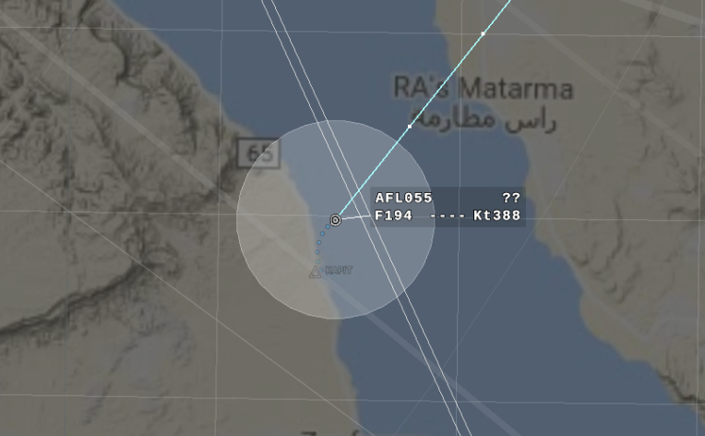
Figure 7 - The example of a TF in the basic state
Figure 8 shows the examples of TFs in the selected state.
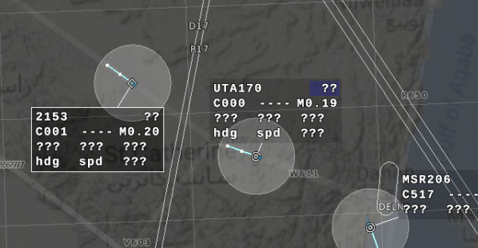
Figure 8 - The example of a TF in the selected state
The right-hand figure shows the selected field of the sector identifier in the first line of TF. The identifier is referenced while taking over control of A/C from the control panel.
At each air traffic controller's automated workstation (AWS (D)) forced display of TFs is effected for “own” A/C. The display has the level of detail preset by the air traffic controller for the air situation window of his workstation. The “own” A/C is an A/C taken up for control manually or automatically, herewith the sector identifier corresponding to that AWS (D) shall be displayed in the first line of the form.
For “other” A/C there are the options of both enabling the display of tracking forms and disabling the display of tracking forms. Three modes of “other’s” TFs viewing are provided: general (all TFs), sector-wise (all TFs in the given sector (sectors)) and individual (for a specific A/C). Besides, “other’s” A/C may be viewed in such a way that a single-line form containing the data on flight altitude is displayed.
Irrespective of the TF viewing mode selected at the workstation, the forms for A/C being under emergency and conflict situations as well as in the control takeover/ hand over mode are displayed in a forced manner.
Using window “Display settings”, one may set font size and type for alphanumerical information contained in TF as well as the options of TF color highlighting depending on various air traffic situations.
In particular, the entire TF may be highlighted in color and/or in font size as regards the A/C control state:
- under control (“own”);
- not under control in any sector (“nobody’s”);
- under control in one of adjacent sectors (“other’s”);
- transferable (A/C is subjected to control takeover/hand over between the sectors).
Note – At the AWS taking over the control the blinking mode of the form display is enabled along with the TF highlighting in color while handing over the A/C control.
Colors of TFs for those states may be adjusted. Figure 9 shows the example of TF display in the “handing over” mode.
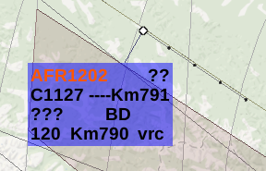
Figure 9 - The example of a TF displayed in the “handing over” mode
Along with highlighting the whole TF in color, individual elements of the form may be highlighted in color. In particular, the zero-line background is highlighted in color provided the line contains the alerts on A/C near-midair collision, on minimum safe flight altitude, entry to the dangerous weather phenomena areas, to the restricted flight area or on a conflict according to the plan information (red or yellow color). In the second line of TF the red color highlights the values of current altitude and specified altitude if the difference between them is more than 60 meters while in the level flight.
The A/C call sign or transponder code may be highlighted in red in the first line of the form for those A/C which are located at the altitude subject to RVSM rules (at flight level of 290–410) and for which a flag from the planned subsystem was received or manually by the air traffic controller on the absence of equipment necessary for for flight performance according to the RVSM rules. Such a situation is shown in Figures 8 and 9. The blue color highlights flight number (call sign) or transponder code in the first line of TF upon reception of a SPI (Special identification position pulse) flag from the airborne transponder.
The examples of color highlighting of the data contained in TF under air traffic conflict and off-nominal situations are given in Figure 10. In particular, the situation of alert on minimum safe flight altitude with indication “MSAW” displayed in the TF zero line and alert on entry to the prohibited area with indication “APW” displayed in the TF zero line are shown.
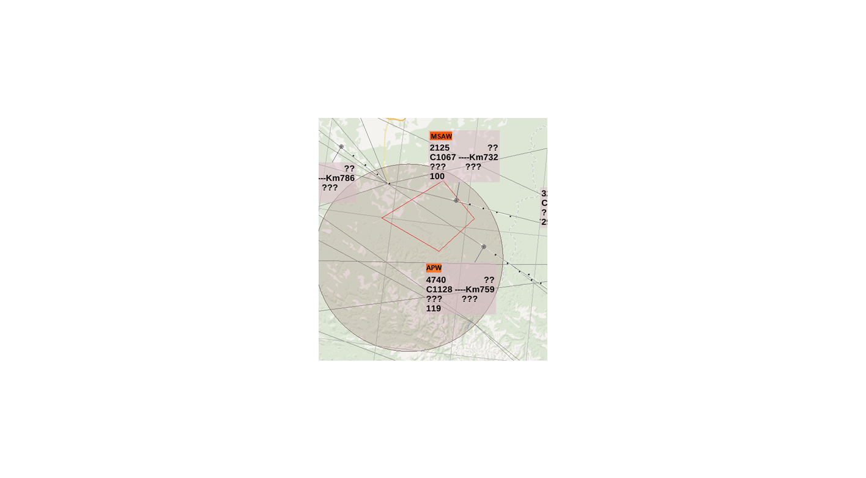
Figure 10 - The examples of indications displayed in line 0 of the TF
Notes:
1. The minimum safe flight altitude warning appears when the current flight altitude sent from the airborne transponder is equal or below the value of minimum safe flight altitude effective for this airspace segment.
2. The altitude preset by the air traffic controller (if entered by the air traffic controller to the TF) is used when the current flight altitude is not specified in the algorithms of detecting the situations of A/C entry to the prohibited areas (restricted flight areas) or in case of descending below the minimum safe flight altitude.
The proper system parameters for the algorithm detecting and alerting A/C hazardous descent are set at AWS of technical control and monitoring system (TCMS) through special window «Configurator”. Provided are both the alert on A/C direct entry to the MSA area (in this case the alert is issued in red color) and the alert on A/C predicted entry to such an area – in 2 minutes (this is an adjustable parameter) before the A/C track crosses the area boundary in the horizontal plane or the vertical plane. In this case the alert is issued in yellow color.
Figure 11 shows the example of alert on a conflict according to the plan information for A/C with flag “MTC” displayed in line 0.
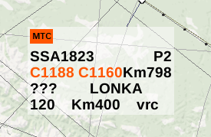
Figure 11 - The example of flag “MTC” displayed in line 0 of the TF
The same figure shows the indication of mismatch between the specified flight altitude and the current flight altitude displayed in the second line of TF.
For the transfer flight level in the take-over/hand-over mode between air traffic controllers of adjacent ATC sectors there is option of color highlighting of this flight level value in the third line or the fourth line of TF with additional blinking mode at the AWS that takes over control. Also, if TF of the aircraft for which the transfer flight level is agreed or the control hand over procedure is under way lies beyond the display screen of such AWS, the form is displayed near the respective edge of the air situation window in a forced manner.
If the airfield pressure flag is received from the airborne transponder, the second line of TF displays letter symbol “А” after the value of current flight altitude.
Note – The option of the airfield pressure flag transfer is only provided for the transponders operating in “ATC” mode specific for Russia.
For A/C located within the take off and landing area at one major airfield of the area at altitudes below the transition flight level the system recalculates the received data on barometric altitude taking into account airfield pressure or airfield pressure normalized to the sea level in case that no airfield pressure flag is received from the airborne transponder. In this case, the second line of TF shows the flight altitude value recalculated based on airfield pressure and the flag represented by symbol “а”.
Note – The option of A/C flight altitude recalculation based on airfield pressure and airfield pressure normalized to the sea level is available not only for the major airfield of the area but for another domestic airfield of the area provided that the relevant parameters of the airfield are entered to the system.
The starting point for recalculation (the moment when letter “а” appears in TF) is the altitude below the level of transition to the adjustable system parameter (so called recalculation starting point) in the range of 20–200 m (for example, 50 m).
The current values of airfield pressure (QFE), pressure normalized to the sea level (QNH), transition flight level and the correction for calculation of the pressure altitude recalculation starting point are entered to the system through window «Airport” from the special-purpose AWS within the complex.
Three stages of a conflict situation detection are included in the algorithms for detection of A/C hazardous approach situations based on radar data:
- potential conflict situation;
- separation rules violation;
- conflict.
For each stage the respective flag is displayed in the zero line of “conflicting A/C”: “PCS” (“PPCS”)), “STCA” and “CA”. Flag “PCS” is highlighted in yellow, flags “STCA” and “CA” are highlighted in red.
The situations of A/C hazardous proximity are considered individually for area control center (ACC), Approach and Radar units. If conflicting A/C are located in different areas, the higher criteria is effective.
At the PCS stage the situations of potential separation rules violation in the horizontal and vertical planes are revealed in advance (0.1–10 minutes – VSP) before such violation takes place taking into account extrapolation of the current location for a pair of A/C.
Note – The PCS stage may be divided into two time phases: the phase of first alert “PPCS” (as a rule within the period of 10 to 2 minutes before separation rules violation) and the phase of the second alert “PCS” (2 minutes and less before separation rules violation). The required parameters are entered from the system administrator's (shift engineer's) AWS. Herewith, PPCS is indicated by yellow color of light shade, while PCS is indicated by yellow color of dark shade. If the same time parameter is set for PPCS and PCS, the alerts related to PCS only will be displayed.
At the STCA stage violation of the specified separation rules between two A/C in the vertical plane or the horizontal plane is recorded.
At the CA stage the situation when the distance between A/C is less than that given in the specified separation rules by more than 50 % is recorded.
Flags “PCS”, “STCA” and “CA” are used to draw the air traffic controller’s attention to the situation when the current or predicted distance between a pair of A/C in the horizontal plane as well as the distance between A/C in the vertical plane turn out to be less than the “hazardous proximity” parameters preset in the system.
For the purpose of better identification, the conflicting A/C are shown using the vector that interconnects coordinate symbols of the A/C.
The following parameters are entered to the conflict situation detection algorithms: the threshold values of distance between A/C in the vertical plane (flight altitudes/levels difference), the threshold values of distance between A/C in the horizontal plane, the prediction (extrapolation) intervals for A/C flight path at the PCS stage, vertical rate of A/C closure in the vertical plane. If the rate of A/C mutual closure is more than 2 m/s, an additive to altitude is introduced to increase the vertical distance in order to detect a potential conflict situation when one A/C or two A/C tend to change their altitude in advanced manner.
The prediction intervals for the PCS stage and the additional altitude introduced to the basic altitude parameter (for the situation when closing rates of A/C in the vertical plane exceed 2 m/s) may be adjusted while in-service. The above parameters are set individually for three altitude segments in the off-airfield space of the control area (up to 8850, 8850 to 12,500 and above 12,500 meters) as well as within the airfield area for approach and radar units.
To detect any violation of horizontal and vertical separation rules, the operational parameters may be viewed, and corrected (if necessary) in window «Configurator” at TCMS AWS or at shift engineer’s AWS.
The conflict situation detection algorithm operates as follows: for the pair of A/C checked for potential conflict, the A/C identity to one of allocated areas (ACC, approach and radar unit) of airspace and the relevant combination of CS detection system parameters are defined.
Relative position of A/C in the vertical plane is checked. The difference in flight altitudes of the A/C checked for potential conflicts is compared with the relevant altitude parameter for a conflict situation (210 meters for separation with the 300 meter interval and 420 meters for separation with the 600 meter interval – the adjustable system parameter). In particular, at the altitude subject to RVSM rules the increased parameter (420 meters) is used if at least one A/C has no clearance for flight according to the reduced vertical separation minima rules.
If the current surveillance cycle reveals the tendency of altitude change between A/C resulting in reduction of the distance between the A/C in the vertical plane, vertical rate of A/C closure is checked. And if the closure rate exceeds 2 m/s, a special parameter (an addition to the basic altitude parameter) is entered to detect a potential conflict situation arising in the vertical plane. The parameter value is adjusted individually for ACC, approach and radar units.
If the data on A/C current flight altitude is missing (for example, the A/C is tracked with reference to the data received from the primary radar or as a track according to the flight plan), then should the specified flight altitude/level (entered by the air traffic controller to the tracking form) be known for this A/C, this value of altitude is included in the conflict situation detection algorithms instead of the current flight altitude.
If the altitude difference exceeds the parameter preset for a potential conflict situation (PCS), further check for conflicts between these A/C stops. If the altitude difference is equal or less than the above parameter, relative position of A/C is checked in the horizontal plane. Current and predicted relative positions of A/C in the horizontal plane are checked taking into account the extrapolation of their flight path parameters. To that end, location of each A/C is calculated according to the radar tracking data with the extrapolation interval provided for PCS (this is the parameter in the range of 10–600 seconds set for the allocated airspace). Then the values of resultant distance between A/C in the horizontal plane are calculated. The obtained values are compared with the relevant system parameter (the horizontal separation rule) set for the same airspace zone.
If the extrapolated or current distance exceeds the preset parameter, further check for PCS stops.
If any potential or current violation both for vertical and horizontal separation rules is detected, each track checked for conflicts is assigned a “conflict” flag, and the relevant visual and sound alarms are issued.
For A/C located within the airfield area (within the Radar Unit area) the check for conflict situations is done taking into account weight characteristics of A/C (wake vortex categories). For the situation when an A/C of category “М” or an A/C of category “L” follows an A/C of category “H” in the airfield area, the horizontal separation parameter equal to 10 km is used. If an A/C of category “М” or an A/C of category “L” is followed by an A/C of any type, the horizontal separation parameter equal to 5 km is used. The wake vortex category characteristic is given in the flight plan (provided that plan information and radar data on A/C are correlated). If the plan is not referenced to the radar track, the air traffic controller can enter a letter symbol of wake vortex category from the control panel. If such a flag for the A/C is missing, the worst case scenario is assumed by default – an A/C of category “H” is considered to be a leader. For the situation when an A/C of category “J” (Airbus А380-800 type) is the first to enter the airfield area the increased horizontal separation distances are provided taking into account the category of the A/C that follows the preceding A/C: 11.1 km for a pair of J/H, 13 km for a pair of J/M and 14.8 km for a pair of J/L.
For controlled airspace one may set conflict situation detection zones. If such zones are set (in functional window «Configurator” at TCMS AWS), conflicts are detected in these zones only. If such zones are not set, conflicts are detected in the entire airspace controlled by surveillance facilities.
According to effective separation rules for the horizontal plane, the safety zone around the A/C track representing a circle with a radius of 10 or 5 km may be displayed. The zone may be filled or non-filled depending on the settings entered in window “Display settings”. The settings may be entered individually for a specific A/C (using the menu provided for the tracking form) or simultaneously for all tracked A/C (using functional window “Display settings”). An example of the respective display is given in Figure 12.

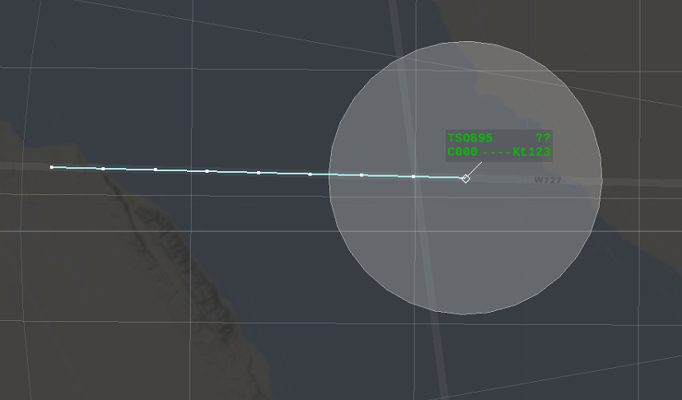
Figure 12 - Safety zone around the track
For A/C of categories “H” and “J” located within the airfield area (Radar unit area) a figure of a more complex geometrical shape shall be used with the account of the situation when the A/C moving in the same direction may enter the area of jet blast from the leading aircraft. An example of the figure is given in Figure 13.
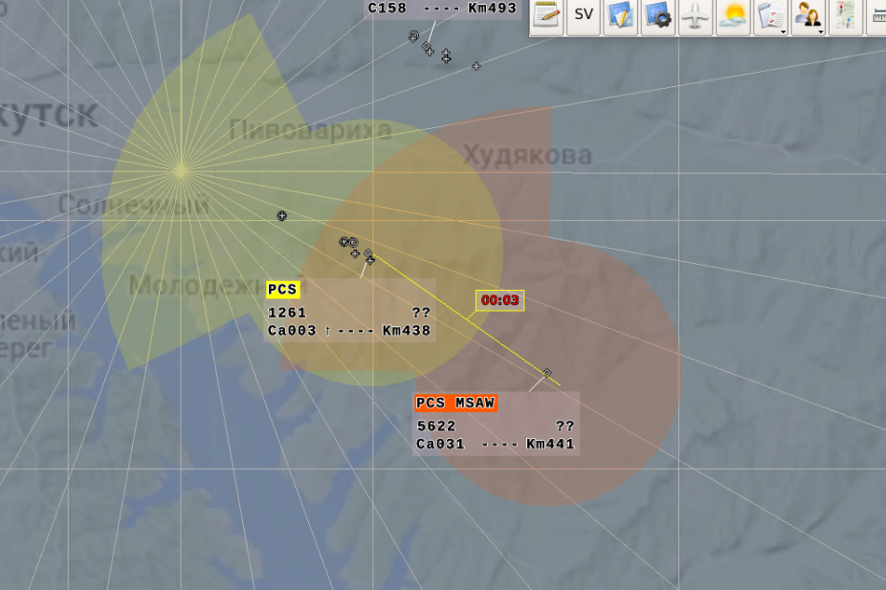
Figure 13 - Safety zone around the A/C track of categories “H” and “J” located within the airfield area
If no potential or current violation of separation rules is detected, the color of the circle corresponds to the color set for the respective TF. If any violation is detected, flag “PCS” is highlighted in yellow, and flags “PCS” and “MSAW” are highlighted in red or yellow. If any conflict situation arises, safety zones are displayed in a forced manner. An example of the respective display is given in Figure 14.
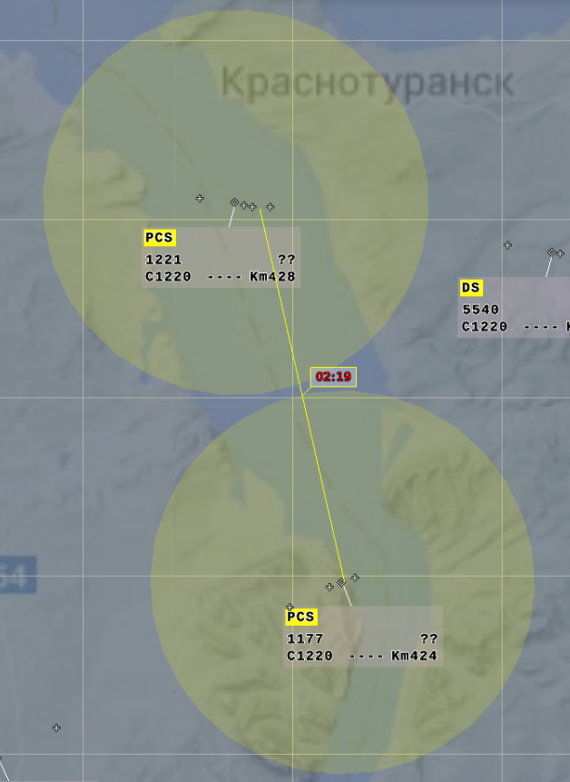
Figure 14 - Indication of a potential conflict situation
Along with the safety zones displayed in a forced manner, the display panel showing a digital time value in minutes and seconds is displayed near the connecting line center before the separation rules are violated. If a violation has already occurred (flags “STCA” or “PCS”), “00:00” is displayed. When the mouse cursor is pointed over the display panel and the left mouse button is held pressed, the additional information on the specific conflict situation is presented in the graphical and digital form. The graphical image includes the sectors of extrapolated location vectors highlighted in red which are exactly related to the stage of separation rules violation. The additional digital information includes the values of current distance between the conflicting A/C (in kilometres or nautical miles) and the minimum distance they are expected to approach on course. If the left mouse button is released, the display of additional information is stopped.
The left mouse button click on the above mentioned display panel will result in continuous display of additional information with immediate data updating (so called “on-line” mode). The mode is cancelled by repeated clicking with the left mouse button.
An example of graphical and digital information on the conflict situation displayed in detail is given in Figure 15.
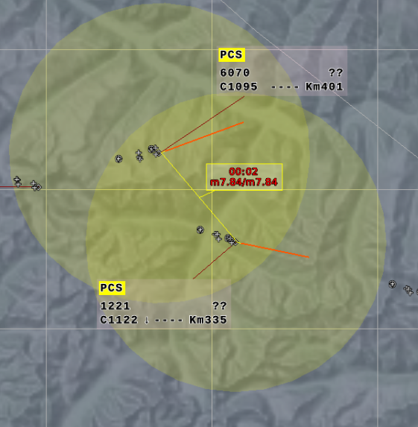
Figure 15 - Additional indication of a potential conflict situation
When code 2000 is received from the airborne transponder of the A/C located in the controlled airspace, non-assignment of ICAO SSR individual code is alerted. The zero line of such A/C form displays letter symbol “CNA” whose background is highlighted in yellow. If the above symbol appears, the air traffic controller of mentioned area of responsibility shall assign (transmit to A/C) a four-digit code of the SSR transponder from the set of ICAO codes combination provided for the ATC area.
Along with conflict situations detection based just on the radar data, there is the option of conflict situations detection based on flight plans. If a common area of routes intersection wherein vertical or horizontal separation distances are not maintained is detected for two active flight plans, flag “MTC” appears in line 0 of the “conflicting” A/C, and the respective warning information is displayed in window “Alert window”. In case of the situation when the planned flight route according to the activated flight plan crosses the restricted flight area, flag «MTAPW” is displayed in line 0 of the TF.
For each A/C (radar targets) assigned a same (double) SSR code flag “DS” (“Double squawk”) is displayed in the zero line of the form.
Note – Double codes may be detected for two real A/C, as well as may occur when decoy targets appear due to multipath propagation in the SSR channel.
The extended form (macro-form) is called by clicking on the call sign (flight number) displayed in the first line of the basic or selected TF with the left mouse button. Repeated execution of the above procedure clears the macro-form from display. The macro-form contains extra data on the specified aircraft available in the system. The extended form may be called both for “own” or “other’s” A/C.
The extended TF is displayed instead of the basic TF, moves together with the A/C coordinate symbol and connected to it by means of a binding line. Just as TF, it can be manually moved, and direction and length of the binding line may be changed from the control panel. Automatic relocation of the macro-form overlapping another TF or another macro-form is done provided that there is enough free space in the air situation window where the macro- form may be transferred to, herewith length of the binding line shall remain the same. An example of the macro-form is given in Figure 16.
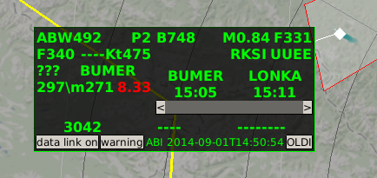
Figure 16 - Macro- form
The extended form (macro-form) contains the following extra data:
- A/C type and wake vortex category;
- speed in kilometres per hour, knots or Mach numbers from the flight plan;
- flight level in tens of meters or hundreds of feet from the flight plan (Н_{FPL});
- departure point and destination point;
- SSR transponder code;
- flight route presented as a series of waypoints;
- time of waypoints flyover;
- radio-communication frequency of the next sector;
- information on the last received or sent message of the OLDI protocol (type of message, date and time of the message reception or sending);
- additional functions call buttons “data link on”, “warning”, “OLDI”.
Notes:
1 If the flight route contains over three waypoints, the waypoints located beyond the field may be viewed by means of the scroll bar.
2 Buttons located in the bottom section of the macro-form (“data link on”, “warning”, “OLDI”) in ATC AS «Topaz” items not supporting the respective functions are not active.
Upon pressing button “OLDI”, for A/C which supported intersystem exchange with plan messages via the OLDI protocol a display panel appears at the bottom containing the history of such exchange (the list and contents of received and sent messages).

Extrapolated location vectors
There are two types of extrapolated location vectors: by time and by distance.
The vector of extrapolation by time is a vector originating from the A/C coordinate symbol and ending in the point corresponding to the extrapolated location of A/C with the preset time interval (1–15 minutes) provided that A/C will fly with the current flight parameters (heading and speed). The sectors corresponding to minute intervals are labelled with point marks.
The extrapolation time is set from the control panel at each workstation for all A/C being tracked or individually.
The vector of extrapolation by distance is a vector of the preset length in kilometres or nautical miles originating from the A/C coordinate symbol according to the current flight direction. The length is set from the control panel simultaneously for all aircraft being tracked.
The vector type to be displayed (extrapolation by time/ distance) is selected by means of alternative action buttons in window “Display settings”.
Along with vectors of so called “general settings”, individual extrapolation vectors may be displayed for A/C being tracked. Their display is controlled through the special menu started using the right mouse button when calling the A/C coordinate symbol or unoccupied character locations in TF. Upon selection of menu line «Prediction”, one may set a vector type (by distance/by time) and an extrapolation value in minutes or kilometres. If it is just necessary to change the extrapolation value for such a vector, point the mouse cursor over the A/C coordinate symbol, press the left mouse button, and rotate the mouse “wheel” (“scroll”) while holding the left mouse button pressed. An individual extrapolation vector may be highlighted in deep red color (or in another color depending on the workstation settings).

Radio direction finding information
Radio direction finding information is displayed in ASW as bearing lines and forms whose quantity depends on the direction finding channels selected by the air traffic controller for display. Each direction finding channel is assigned the respective bearing line and the form.
Besides, digital values of radio communication frequencies selected for the workstation may be displayed in special table-based window “Bearings” containing two columns: «Frequency” and «Bearing”. The window may be resized and moved across the indicator screen. If AWS has two indicators, the window may be moved to the auxiliary indicator. Each frequency to be fixed corresponds to the respective line with background color highlighting, and the color corresponds to the color selected for the bearing line and form. The window is called from the list menu by selecting menu line “Bearings”.
Examples of radio direction finding information displayed in the air situation window are given in Figure 17. Besides, the figure shows table-based window “Bearings”.
The bearing line is drawn from the ADF station point at the angle corresponding to the direction to the A/C whose bearing is taken. The form contains the digital data on direct and reverse azimuth of the A/C whose bearing is taken relative to the ADF.

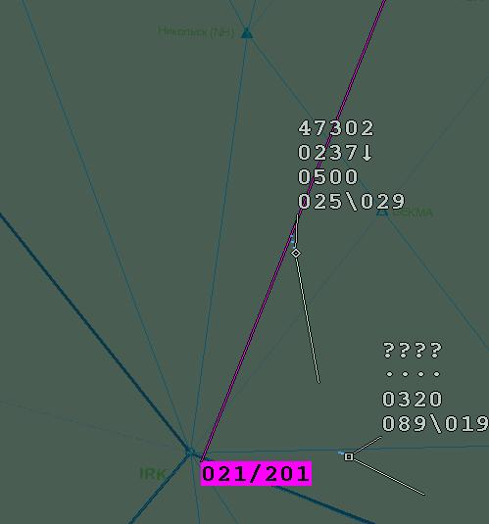
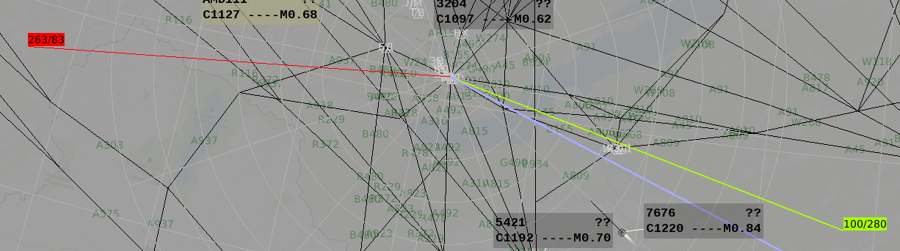
Figure 17 - Examples of displayed radio direction finding information
The air traffic controller may optionally display the form in the beginning or in the end of the bearing line. The air traffic controller may set color coding of direction finding information individually for each direction finding channel (for each radio communication frequency to be fixed).
Depending on the workstation settings, azimuth values are displayed relative to true or magnetic north.
Direction finding channels (radio communication frequencies to be fixed) are selected and direction finding information display modes are set in windows “Control display” and “Display settings”.
The bearing line is displayed in the air situation window during a radio communications session at the frequency selected by the air traffic controller. The bearing line display time is VSP that is set in functional window «Configurator” at the technical control and monitoring AWS. The time of the form and the line display in window “Bearing finders” is set individually in window “Display settings” for each workstation.

Mapping information
The mapping information contains the set of data on the structure and parameters of airspace and ground surface of the own and adjacent ATC areas presented in the graphical, alphanumerical and symbolic form. The operator may promptly select the specific mapping information to be displayed from the mapping data arrays previously entered to the system memory. There are three data arrays:
- aeronautical information received from specialized external sources such as CAICA (Center of Aeronautical Information of Civil Aviation) or consolidated center of UATMS;
- additional aeronautical information – so called vector mapping;
- geographical map of ground surface – so called raster mapping.
Aeronautical information received from CAICA and consolidated center of UATMS comprises the data on tracks, control zones, restricted flight areas, route points, standard routes of flight within the airfield zones, etc. extracted from global arrays of ANI (aeronautical information) used to provide flights in the international and Russian airspace. ATC AS “Topaz” supports the option of handling each of the above sources. From CAICA these data is transferred in the international standard “ARINC 424” format, and the corresponding file is loaded automatically to ATC AS “Topaz”. The above procedures shall be carried out at the special-purpose AWS within the complex, and the mapping data array shall be further updated at all AWS within the complex. ASUP ATC AS is the source of the consolidated center of UATMS aeronautical information for ATC AS “Topaz”, herewith the information is received via the special interface protocol. Besides, aeronautical information may be corrected (including the option of adding or deleting some elements, creation of groups by selecting required elements from various layers) in window «Configurator” at TCMS AWS.
For elements (layers) of aeronautical information pop-up help may be displayed if the respective mode is selected in window “Display settings”. In this mode, the name of the associated track and the effective altitude range for the respective track section are displayed when the mouse cursor is pointed over the track line in the air situation window, and the name of the respective waypoint and its geographical coordinates are displayed when the mouse cursor is pointed over the waypoint symbol.
As a rule, vector mapping contains the data missing in the data array received from CAICA or the consolidated center of UATMS (as a rule, the data characteristic of the given ATC area), for example, local airlines, the boundaries of LCC (local control centers) and ATC sectors, landing (approach) patterns according to visual flight rules, etc. The data can be “drawn” using the mapping editor specially developed for ATC AS “Topaz” or by means of a standard computer graphic editor, and then transferred to the «Topaz” software.
Raster mapping is a ground surface image showing cities, populated localities, rivers, lakes, roads, mountain groups, etc.
For all types of mapping (aeronautical) information (excluding raster information) the data to be displayed and display parameters may be set individually in the air situation window using functional windows “Display settings” and “Control display”.
In particular, color coding of various types and elements of mapping information is provided. Various linear map elements may be highlighted based on a line type (solid line, dotted line, dashed line, dash-dotted line) or width (1, 2, 3 typographical points, etc.). Along with color, font size and type, underlining mode may be used to highlight individual alphanumerical map elements.
Mapping information is displayed at the workstation relative to the reference point set as a gnomonic projection center for the workstation.
Mapping information arrays are created at the stage of the complex software adaptation for the object to be installed with reference to the agreed initial data. Further, during operation of the complex the array may be corrected using special software.

Azimuth-distance grid and geographical grid
Azimuth-distance grid is displayed as a combination of range rings and azimuth lines drawn relative to the preset reference point. Usually, the major airfield reference point (ARP) in the ATC area is set as a reference point. But ARPs of other airfields of the area, radar positions (RP) of radar facilities interfaced with the complex as well as any predetermined prominent reference objects (points) of the control zone (RNP, CRP, RW thresholds, etc.) may be used as well.
The specific azimuth rings and plots as well as the reference center are promptly entered from the control panel (using display control window «Control display») individually for each AWS. Displayed azimuth plots may be selected with the interval of 10 and 30 degrees and range plots may be selected with the interval of 2, 5, 10 and 50 km, and they may be color-coded individually. The zero azimuth line is additionally displayed as a thick line. For each type of plots one may set a coverage by range, a line type and thickness and an image color in window “Display settings”.
Note – If image rotation by the magnetic variation in the air situation window is set at the workstation, the azimuth scale is displayed relative to magnetic north. If image rotation by the magnetic variation is not set, the azimuth scale is displayed relative to true north. The rotation mode is only applicable to the situation when ARP is used as a reference point for azimuth and direction finding information.
The geographical grid is a combination of latitude and longitude lines plotted with the interval of 1 degree and the relevant “degree” digital designations displayed at the edges of the indicator screen. The longitude lines are drawn taking into account meridian convergence relative to the reference point selected for the AWS (the given ATC sector) as a gnomonic projection center.
The display of azimuth-distance grid and geographical grid is controlled using functional windows “Display settings” and “Control display”.

Measuring vector
Measuring vector is a line interconnecting several objects in the air situation window and the form containing the data on range, direct and reverse azimuth between the objects, as well as time of flight to the specified object (for A/C). A/C tracks or mapping elements may be regarded as measuring objects. If a radar track is selected as at least one measuring object, the measuring vector has a dynamic nature, and data is updated while the track is moving. If mapping elements or arbitrary points in ASW represent two objects, the measuring vector has a static nature.
A form containing two, three or four lines is displayed in the center of the measuring vector.
Several measuring vectors may be simultaneously displayed on the screen.
Figure 18 shows the examples of the measuring vector displayed while taking measurements of relative position between two A/C, between two points and between the point and A/C in the air situation window.
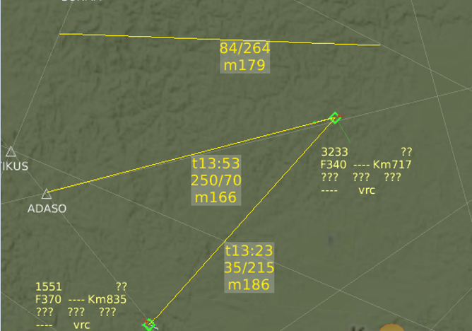
Figure 18 - Examples of measuring vector displayed in ASW
In the measuring vector form:
- the first field (t13.53 in the middle form) – time of flight to the specified point (ADASO) in minutes and seconds;
- the second field (250/70 in the same form) – forward and reverse azimuths, respectively, in degrees.
- the third field (m166 in the given example) – the distance between objects in kilometres or nautical miles with letter symbol of the measurement system (“м” – kilometers or “N” – nautical miles).
Flight time is only specified for measurements with the A/C track being an initial point. In this case, a three-line form is used. While taking measurements between two points, a two-line form is always displayed.
If A/C features flight altitude variation, the form is supplemented with a line showing the design altitude of A/C calculated based on current vertical flight speed in the final measurement point. An example of the form is given in Figure 19.
Move the measuring vector form in the air situation window. To that end, point the mouse cursor over the form, press the left mouse button and without releasing the button move the form to the proper area in ASW, and then release the button. In this case, the form will be displayed with a binding line drawn from the form to the middle of the measuring vector. An example of the respective display is given in Figure 19.
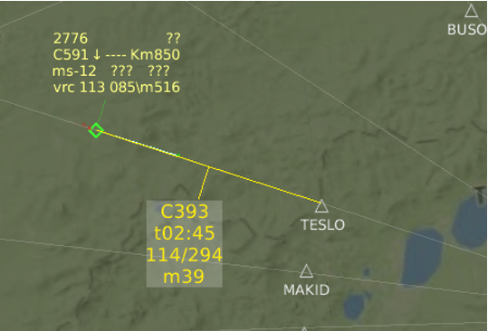
Figure 19 - An example of the four-line form of measuring vector
There is the option of taking measurements along the curved flight path between more than two objects. Herewith, a composite measuring vector consisting of several sections is displayed. The total form is displayed in the middle of the last vector, and it specifies the total range for the curved flight path, forward/reverse azimuth for the last section, total flight time (if measurements are taken relative to the A/C) and the quantity of the sections contained in the composite vector. Figure 20 shows an example of the vector.

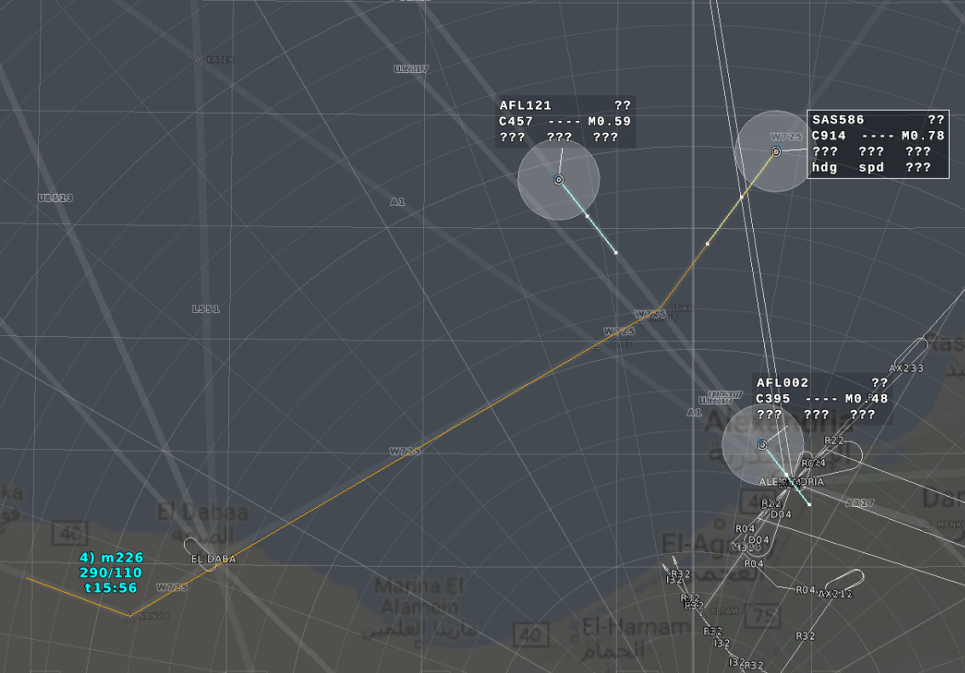
Figure 20 - An example of composite measuring vector
In the given example: “t15:56” – total flight time along the entire flight path, “290/110” – forward/reverse azimuth of the last flight leg, “4”) – quantity of the sections contained in the vector, and “m226” – total distance in kilometers.
If a scale below 15 kilometers is selected in ASW, the format of the measuring vector form is changed as follows: in the beginning of the first line letter symbol “М” is displayed, then follows the letter symbol of the measurement system enclosed in parentheses, the value of distance is given in second decimal places of a kilometer (in tens of meters), and the values of azimuth are shown in degrees. For example, “М(m)1.25 86/266”.
Depending on the mode preset in window “Display settings”, azimuth values are displayed relative to true or magnetic north.
Display color for the data of the measuring vector, size of the form, font, line width and type are adjustable parameters for each workstation.

Information on airspaces
The air situation window displays the information on airspace restricted areas as well as on airspaces where special algorithms for air traffic information processing are effective. The above information may be displayed in the air situation window in the graphical and alphanumerical format: airspace outline with a form.
The displayed information comprises restricted flight areas, airspaces where the algorithms for detecting minimum safe altitude (MSA) are effective, airspaces where the algorithms for detecting conflict situations are effective, radar data blanking airspaces and meteo airspaces.
Airspaces display may be enabled/disabled in window “Control display”, and representation options (color, font type and size, line type) may be selected in window “Display settings”.
The information on restricted flight areas may be displayed in the on-request display mode (from window “Control display”, tab «Airspaces”, sub-tab «Restrictive” and in the automatic forced display mode when the restriction concerns the given sector and the sector is active. In the former case, information may be called and cleared. In the latter case, information is permanently displayed until the restriction period expires, the active state is disabled or the restriction concerning the given sector is cancelled.
The airspace outline is a filled or non-filled (according to the display settings of the workstation) figure representing a polygon, a circle or a corridor with adjustable width (for example, with width of 5 or 10 kilometers). As a rule, the “corridor” restriction is plotted along the axis of a track or an off-airway route.
The form is displayed near the point whose coordinates are to be specified first when entering spatial location parameters for the restricted flight area. For circle-shaped restrictions the form is displayed near the figure center (its upper left corner adjoins the center).
The form contains at least two lines (provided that altitude limits are not specified). Each altitude layer will be assigned a relevant extra line. For example, there are seven lines if five altitude layers subject to restrictions are specified.
The form display is enabled/disabled using the special menu called by the right mouse button click on the area within the graphic image of the zone. Select line “Form” in this menu. Repeated selection of the line clears the form from the display.
Note - When the restriction is called for the first time, the form is not displayed.
The first line displays the restriction name and the flag (“*”) of operation according to the given restriction of the detection algorithm and warning on A/C entry or a threat of A/C entry to its coverage area. The second line and the next four lines show the maximum altitude ranges (lower and upper altitude limits) in tens of meters or hundreds of feet as well as letter symbol of the measurement system (“F” or “C”). Each restriction may be assigned 5 altitude ranges maximum. The last line (it may be the third one if there is a single altitude range, and may be the fourth, the fifth, the sixth and the seventh one if several altitude ranges are available) shows the time span (the starting time – the end time) of the restriction expressed in hours and minutes.
Notes:
1. If altitudes are displayed in feet according to the workstation settings, the altitude limits are displayed in hundreds of feet, otherwise - in tens of meters.
2. If the lower altitude limit equals to 0, the form shows letter designation “GND”. If the upper altitude limit is not specified, the form shows letter designation “UNLTD”.
The examples of displayed information on restricted flight areas of various types are given in Figure 21.
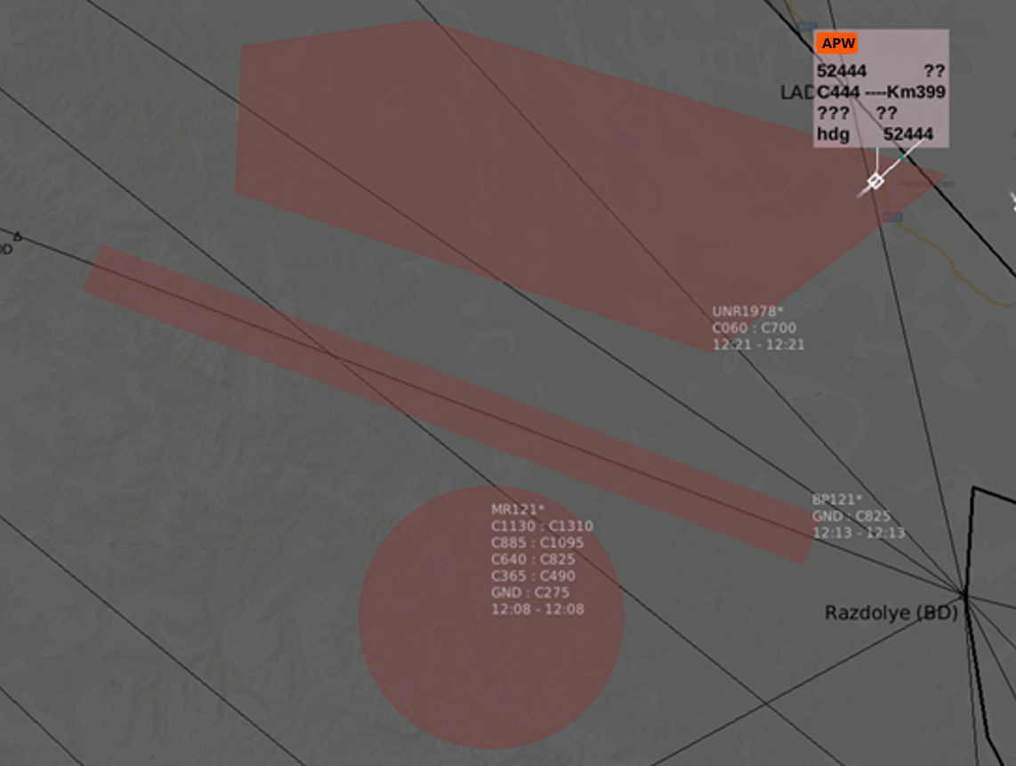
Figure 21 - Examples of displayed information on restricted flight areas
In particular, the figure shows the example of the alert on A/C entry to the restricted flight area. Herewith, the background of the TF zero line is highlighted and warning designation “APW” (flight mode violation) is displayed. Such an alert is issued when A/C enters the area of spatial and altitude limits or when there is a threat of entering the area (a 2-minute forecast of A/C trajectory parameters – variable system parameter) provided that the actual status is assigned to the restriction.
Note - An alert for the aircraft is not issued when the restriction does not apply to the given A/C according to the restricted flight area settings. The respective option is selected in table-based window “Restrictions”.
An example of the menu displayed for the restricted flight area is given in Figure 22.
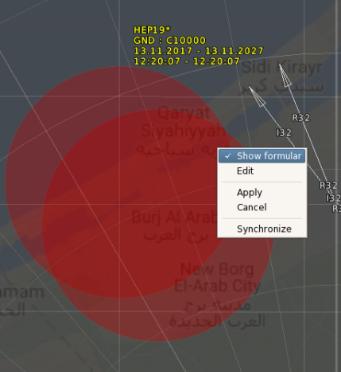
Figure 22 - Menu for restricted flight area
Only option “Form” is available in the menu for air traffic controllers. The other options are intended for specialists authorized for editing the information on ASU (air space use) restrictions (for example, FOD) in order to perform dynamic editing of the boundaries of the restricted flight area right in the air situation window, to record and cancel the completed corrections as well as the corrections done in the synchronization mode (the corrections are to be done in the on-line mode).
In general, MSA airspaces, conflict detection zones and radar data blanking zones are displayed in a similar way. But there are some specific features for displaying the forms of those airspaces which are the summary of the restricted flight area form.
Meteo airspaces include zones created on the basis of the weather radar data and the zones created as per the results of the SIGMET-type weather reports processing. Depending on the specific weather event, the airspace color may vary. According to the SIGMET information, the zone outline is plotted based on coordinates specified in the message text. Herewith, one message may correspond to several zones: current and forecast location zones. The form of SIGMET zone is displayed when the mouse cursor is pointed over the zone. An example of the respective display is given in Figure 23. In the given example designation “VA CLD” corresponds to a volcanic ash cloud.

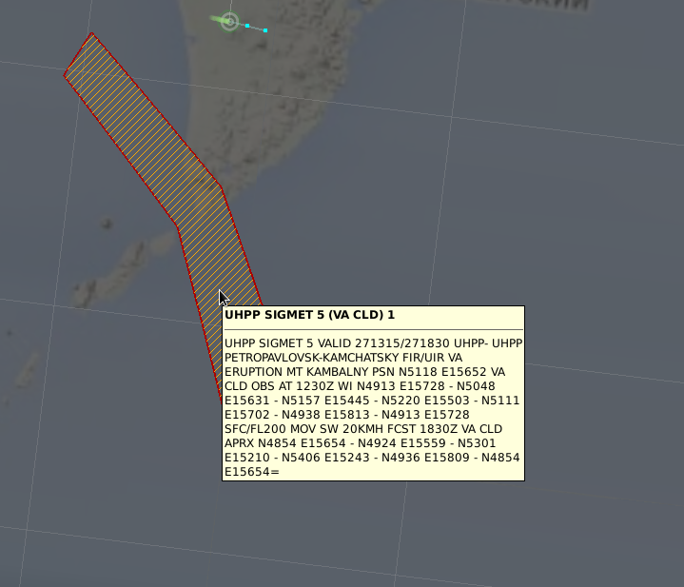
Figure 23 - Zone and form for a SIGMET message

If a SIGMET message contains a too long span between the time of the first formation of a volcanic ash cloud and the final (forecast) location of the cloud, intermediate location zones with the basic spacing of 30 minutes are to be calculated (if the maximum interval between the initial and final location doesn’t exceed 6 hours). If the interval is more than 6 hours, the spacing is calculated by division of the time interval by 12.
Meteo zones are displayed in a forced manner and “on-request”. The forced display mode is set in window “Display settings” and is only applicable to actual (current) zones, the “on-request” display mode is set in window “Control display’’ for any zones.

Mode “Landing”
In the landing mode the information display mode is provided for the facilities where ATC AS “Topaz” is interfaced with approach radars. For the facilities having no interface with approach radars, converted information from the surveillance radar may be displayed in this mode. Mode “Landing” features the traditional for landing systems radar data presentation type (as regards the A/C approaching to land) with two sections (windows): glide slope section and heading section. An example of the respective display is given in Figure 24.
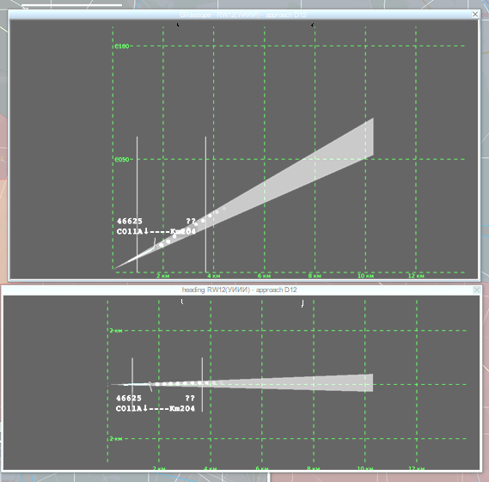
Figure 24 - ASW in mode “Landing”
Glide slope and heading windows may be moved across the indicator screen and resized. Landing mode windows may be called and cleared from display through the list menu by selecting functional line “Landing” (see the figure in the beginning of Section 2.6).
The header of each window gives the window name “Glide slope” and “Heading”, RW (landing heading) designation, four-letter designation of airfield and the selected standard landing (approach) pattern. The airfield designation corresponds to the designation selected in window “Airport” (see Section 2.6.7). Designation of RW and landing (approach) pattern is set in the settings menu of glide slope and heading windows.
Information on the A/C approaching to land is presented in the way similar to that of the air situation window: A/C coordinate symbol, TF, extrapolation vector, historical data.
Graphical information is displayed as a glide slope line, a heading line, lines of permissible deviations according to ICAO standards and scale range plots and angular plots.
Information display in the window is controlled by means of the menu called by clicking with the right mouse button when the mouse cursor is pointed over one of landing mode windows (glide slope or heading). The saved settings will be effective for another landing mode window as well. An example of the menu is given in Figure 25.
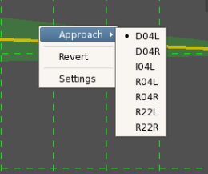
Figure 25 - Menu for glide slope and heading windows
The first line “Approach” of the menu is intended to select simultaneously the effective landing (approach) pattern as well as operational RW via the special sub-menu. Designations of standard landing (approach) patterns from the set of aeronautical data for the selected airfield are given in the sub-menu. The second line “Turn” sets a 180-degree turn of an image displayed in the landing mode windows.
Selection of line “Settings” calls window “Display settings” (see Figure 26).

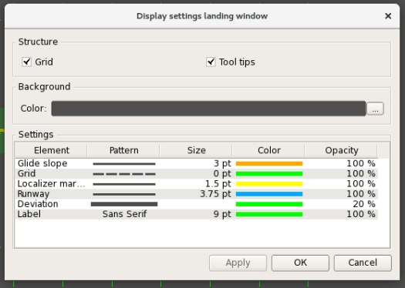
Figure 26 - Window “Display settings”
Using this window, one may set color of display elements in the window, type and size of linear elements, type and size of font for descriptive notes.

Additional air situation window “Zoom-window”
The additional air situation window “Zoom-window” is used to display air situation in the area of the controlled airspace selected by the air traffic controller with adjusted parameters (scale, center offset) as compared with the main air situation window of the workstation.
The additional window overlays the main air situation window, it may be promptly moved across the screen, its size may be changed, and it may be closed. The example of “Zoom-window” displayed on the background of the main air situation window is given in Figure 27.
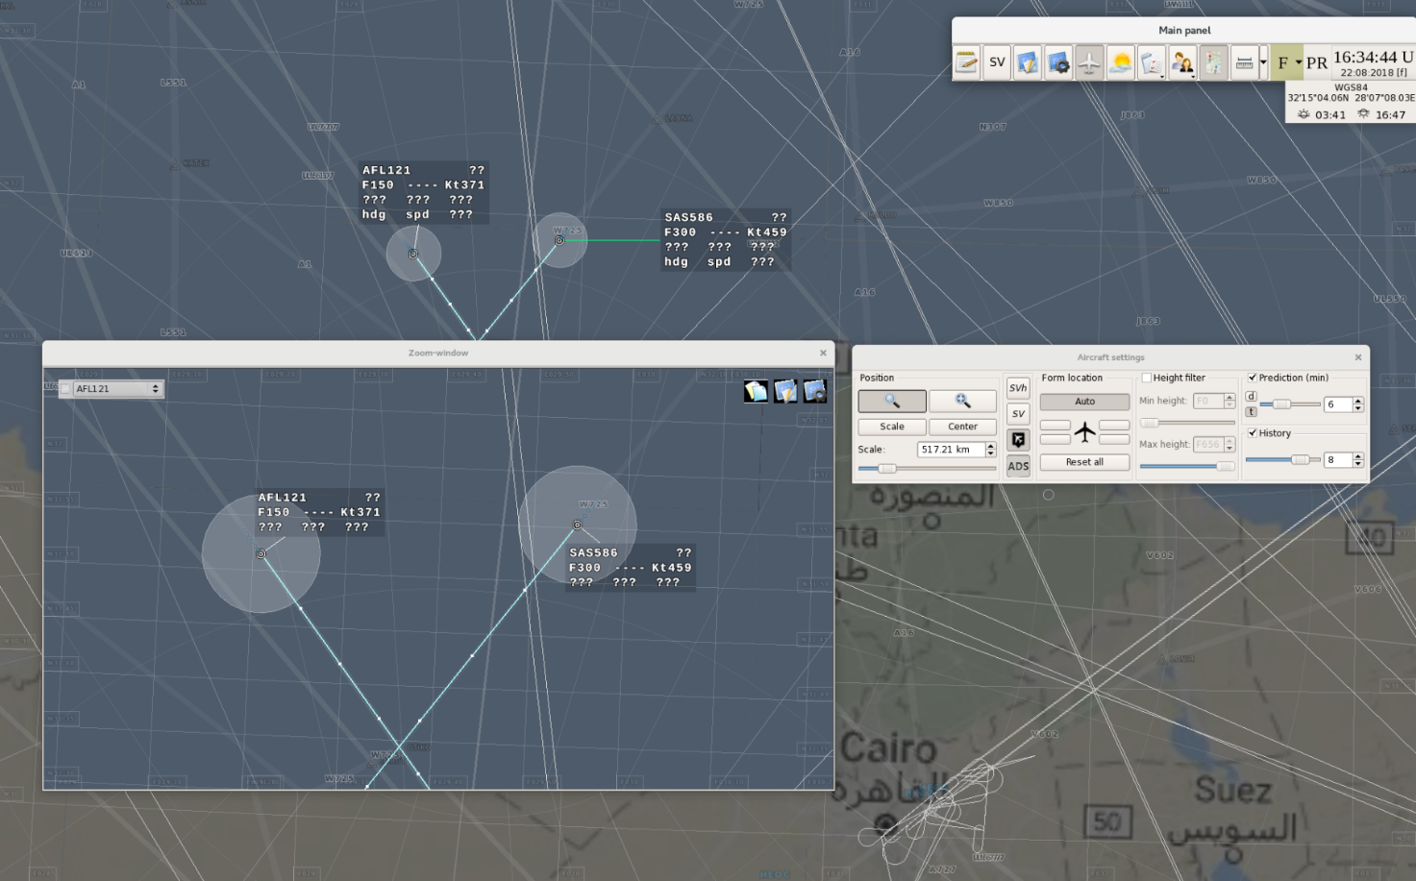
Figure 27 - Additional air situation window
The additional air situation window “Zoom-window” is called by pressing button in functional window “Aircraft toolbox”. Repeated pressing of the button clears the additional window from the display.
The procedure of “Zoom-window” creation is as follows:
Press button in window “Aircraft toolbox”.
Move the mouse cursor to the main air situation window.
Point the mouse cursor over the extreme point of the area to be selected, press the left mouse button, and without releasing the button move the mouse cursor to the opposite extreme point of the area being selected. Movement of the mouse cursor causes the appearance of a dynamic image of a dashed rectangle.
Make sure that the required airspace area fits into the dashed rectangle drawn on the screen, and release the left mouse button. After that, the additional air situation window will be displayed on top of the main air situation window on the indicator screen.
During the initial start of AWS the additional air situation window appears in the left top corner of the indicator screen. If any changes are made, the last position of the window is saved to the memory. The window is closed by pressing button “Х” in the right top corner of the window.
The color pattern of the image displayed in the additional air situation window, the format and contents of the radar, mapping data, tracking forms and ASU restricted areas in main ASW and “Zoom-window” may be fully identical and may differ. To set up display elements in the “Zoom-window”, use three buttons in the right top section of the window. The first button 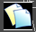, being the direct-action button sets the fully identical image settings in the main air situation window and in the Zoom window.
The second button calls functional window “Control display zoom-window”, the third button calls functional window “Display settings zoom-window”. The description of the windows is given in Sections 2.3 and 2.5.
Individual display settings for tracking forms may be entered in the “Zoom-window”. Such settings are as follows: extrapolation time or distance, the contents of the third or fourth line of TF, as well as TF individual position relative to coordinate symbol (in case of manual relocation).
The basic operations from the control panel related to TF (including taking over control of A/C, entry of target altitude, target speed, control handover) may be done both when calling up the form in ASW and in the additional air situation window.

Window “Current time” and window “Main menu”
Window “Current time” is a system window (see the example in Figure 28) permanently displayed on the main or auxiliary (when two monitors are connected) indicator of the workstation.
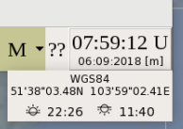
Figure 28 - Window “Current time”
The window displays the values of current time, current date, the measurement system flag for altitudes and flight levels, the control sector index (the AWS index), the surname of the air traffic controller who works in the sector (for those AWS subjected to the duty takeover/handover) and the time of the duty takeover. Besides, the window has button 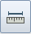 and 2 buttons . Also, the bottom right section of the display panel may indicate the data on the gnomonic projection selected for AWS, on current geographical coordinates of the mouse cursor as well as on the time of sunrise and the time of sunset at the point selected in the air situation window by means of the mouse cursor.
Button is used to enable function “Measuring vector”. Next to the above button there is button intended to call the menu with options for setting operation modes of measuring vector. Button arranged next to the effective measurement system flag and to the left of the sector identifier is intended to call the menu with options for selecting the proper measurement system for values of altitude, range and speed displayed in the air situation window. An example of the menu is given in Figure 29. To select the proper option, left click on the respective menu line.
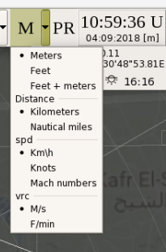
Figure 29 - Measurement system selection menu
The following letter designations are used as a flag for the altitude and flight level display mode enabled at the AWS: “М” (metric mode), “F” (foot mode) and “F/M” (combined foot-metric mode).
Foot or metric property of the workstation is set from the control panel right at the workstation, and is intended to represent values of altitudes and flight levels in tens of meters or hundreds of feet, respectively, in various forms and lists. In the combined mode “Feet + meters”, the metric display mode for altitudes is active within the take-off and landing zone of the major airfield of the area as well as of other domestic airfields of the area (for which the airfield zones boundaries and the values of transition flight level are set) at the special measurement system change altitude level (MSCAL) and below, while the foot display mode runs above the MSCAL and in the off-airfield airspace.
Note – MSCAL is obtained by subtracting the preset altitude system parameter (altitude correction) from the value of transition flight level.
The altitude measurements mode may be switched for a short time. With the key with measurement system index “М” or “F” held pressed, the left mouse button switches the display mode to the alternative mode – the foot mode instead of the metric mode and the metric mode instead of the foot mode. When the key is released, the user returns to the basic mode of the workstation. In this case, the key functions as a hot key for short-time (when the key is pressed) switching of the altitude and distance measurement system in the air situation window.
Note – The user goes to the common metric mode from combined mode “Feet + meters”.
The current time window cannot be closed or resized, still it can be moved across the indicator screen field.
As selected by the operator, the current time value is displayed relative to universal time coordinated (UTC) or the local time. Single-letter symbols are used for identification: “U” for UTC and “L” for local time. The display option is selected by clicking the proper parameter “Local time” / “UTC time”) in the special menu called with the right mouse button when the mouse cursor is pointed over the current time values in the window. Besides, there are the following functional lines in the menu:
- “Clock”;
- “Clock settings”;
- “Show coordinates”);
- “Show sunrise/sunset”;
- “Change time”;
- “Reset windows geometries”.
An example of the menu is given in Figure 30.

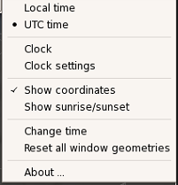
Figure 30 - Window “Current time” menu
Selection of menu line “Change time” displays window “Date and time” (see the example in Figure 31) intended for viewing all current parameters associated with date and time. Only two options are available for the operator in the window: selection of current or local time and setting the time zone corresponding to the complex installation area.

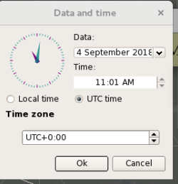
Figure 31 - Window “Date and time”
Menu line “Reset all window geometries” is to be used when for any reason tabular list boxes and some other auxiliary windows are beyond the indicator screen workspace, and not displayed upon pressing the corresponding call buttons.
Menu line “Show coordinates” is intended to display the data on the gnomonic projection selected for the workstation and current geographical coordinates of the mouse cursor when the latter is within the air situation window (the examples of displayed menu lines are shown in Figures 28 and 33). Repeated selection of menu line “Show coordinates” clears the above information from the display.
Menu line “Show sunrise/sunset” is intended to display the data on the time of sunrise and the time of sunset at the ground surface point selected in the air situation window by means of the mouse cursor. An example of the menu line is given in Figure 32. Repeated selection of menu line “Show sunrise/sunset” clears the above information from the display. Depending on the time selected for the workstation (“Local time” / “UTC time”), the data on the time of sunrise and the time of sunset are displayed relative to the local time or the UTC.

Figure 32 - Displayed data on the time of sunrise and the time of sunset
Selection of menu line “Clock” displays the special window (see Figure 33) from time synchronization complex (TSC).
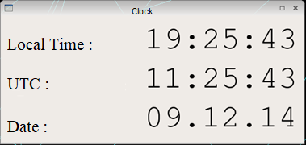
Figure 33 - Window “Clock”
Large font to display current time and date may be set for the window. Display parameters for the TSC window (first of all setting font type and size) are set using special functional window “Edit settings” called upon selection of menu line “Clock settings”.
Note – All parameters in window “Clock settings” shall be changed (excluding font type and size) by a technical specialist assigned system administrator’s rights.
Window “Main menu” is called by pressing the display panel showing the current time values in window “Current time”. Repeated pressing clears the main menu from the display. The main menu window is used to call functional windows to control display in ASW. An example of displayed window “Main menu” is given in Figure 34.
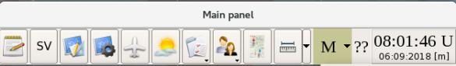

Figure 34 - Window “Main menu”
The main menu window is intended to call the following windows, panels and control elements are shown in figure 35:
 |  | Memo book
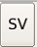 |  | Airspace sector filter
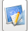 |  | Control display
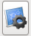 |  | Display settings
 |  | Aircraft toolbox
 |  | Meteo
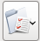 |  | Lists and additional windows
 |  | Users
 | Figure 35 - Window “Main menu” panels and control elements

Window “Control display”
The window is opened upon clicking on icon of the main menu. The window is intended to set the contents of information displayed in the air situation window. Information is displayed in the window on the tab principle. This window features vertical orientation of tabs. Below a selected tab displayed is the informational part of the window containing functional elements to select the required type of displayed information. An example of the window displayed upon selection of tab “Measuring tools” is given in Figure 36.

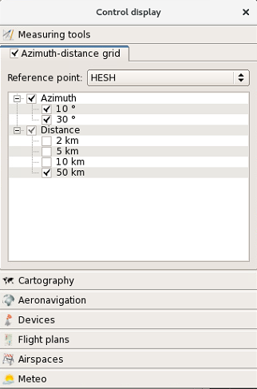
Figure 36 - Window “Control display”, tab “Measuring tools”
This tab has one sub-tab “Azimuth-distance grid”. The azimuth and distance plots display mode is enabled by left click on the sub-tab header. Repeated clicking disables the mode. Accordingly, flag “√” in the beginning of the line is shown/hidden.
A reference point for azimuth and range plots drawing is selected in line “Reference point” of this sub-tab. Selection is made in the menu called using button .
Note – The reference point for range and azimuth plots may differ from the reference point selected in window “Display settings” and intended for centering the image of mapping and radar information in the air situation window as well as for calculating azimuthal-range finding location of A/C to display the associated parameters in tracking forms.
The informational part of the window, sections “Distance” and “Azimuth”, may be used to enable/disable the option of range and azimuth plots display in the air situation window. To that end, select the proper combination of distance rings (2, 5, 10 and 50 km) and azimuth plots (azimuth lines) (10 and 30 degrees). Point the mouse cursor over the required field and click on the field with the left mouse button. Repeated clicking clears the flag and cancels the displayed azimuth and direction finding information. Herewith, if menu line “Azimuth” is clicked, all azimuth plots are selected at a time, if menu line “Distance” is clicked, all range plots are selected at a time. If a line with one range and azimuth parameter is selected, only the specified plots will be displayed. The selected value is indicated with symbol “√”.
An example of the window displayed upon selection of tab “Cartography” with sub-tab is given in Figure 37.
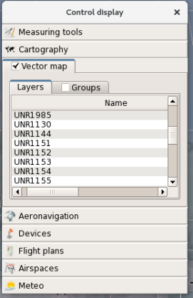
Figure 37 - Window “Control display», tab “Cartography», sub-tab “Vector map»
Using the tab, one may select the contents of vector mapping displayed in the air situation window. Usually, the vector mapping comprises extra aeronautical data unique for the installation object and missing in the basic aeronautical information received from specialized ANI centers such as CAICA (for example, points or landing areas for LCC, volcanoes, meteo squares, etc.). Also, the tab may be used to present basic aeronautical data in another way, for example, to display tracks as corridors instead of center lines.
The vector mapping display is set with the left mouse button by clicking on menu line “Vector map”, that results in display of flag “√” in the beginning of the line. Repeated clicking with the left mouse button will cancel the vector mapping display and clear flag “√”.
Then, select a vector mapping display option: by layers or by groups. Usually, a group is a set of individual elements from various map layers (for example, a group for specific SID may include a set of graphical elements corresponding to the SID from layer “SID”, CRP symbol designations from layer “Waypoint”, their letter designations from layer “Waypoint names”, designations of radio navigation facilities from layer «Radio beacon», etc.). If flag “√” is set in menu line “Group”, the “group” option will be enabled. If there is no such flag, the “layer» option will be enabled. To select the display options for required groups or layers, set/clear flag “√» by clicking on the lines containing the names of groups or map layers with the left mouse button.
Upon selection of a group, designations of associated layers will be displayed on the right. If the proper layer is not selected (there is no flag “√”), enable the layer display by clicking on it with the left mouse button.
Note – The combination of additional vector mapping groups is created by means of special integrated mapping editor for ATC AS “Topaz”.
An example of the window displayed upon selection of sub-tab “Groups” is given in Figure 38.
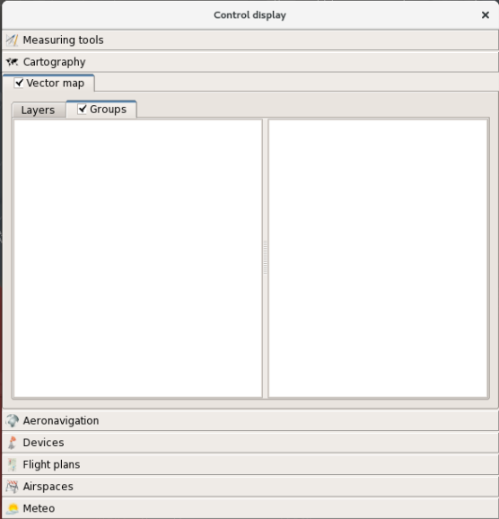
Figure 38 - Sub-tab “Groups”
For sub-tab “Layers” (see Figure 37) the following functional capabilities are provided:
- showing/hiding map layers;
- showing/hiding the inscriptions for alphanumeric designations on maps (designations of CRP, radio navigation points, tracks, RW, etc.);
- setting the inscription display area as well as selection of a parameter to be used as an inscription from the associated data set (for example, a geographical name, a standard letter designation, geographical coordinates, etc.).
To show/hide a map layer, click with the left mouse button on the check box in column “On/Off layer” of the respective line – flag “√” will be displayed or cleared.
To show/hide an inscription, click with the left mouse button on the check box in column «Name” – flag “√” will be displayed or cleared.
Note – To display inscriptions (alphanumeric designations of waypoints, tracks, airfields, etc.), select the respective parameter in column “Inscription ID”.
The inscription display area and the parameter to be used as an inscription shall be selected in the menu system. To call the menu, double click on field “Inscription” (if the inscription display area is to be set) or “Inscription ID” (if the inscription parameter is to be set) in the line containing description of the proper layer. After that button “” to call the menu appears in the right section of each column. In this menu select the required parameter by clicking it with the left mouse button. For example, there are 9 possible options to select the inscription display area: top left, top сenter, top right, center, center right, center left, bottom left, bottom center and bottom right. An example of the menu is given in Figure 39.

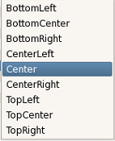
Figure 39 - Menu to select the inscription display area
An example of the menu to select the parameter to be used as an inscription (column “Inscription”) is given in Figure 40.
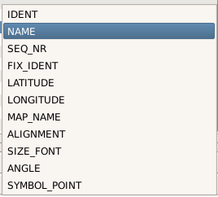
Figure 40 - Menu to select the inscription display area
In this menu the preferable option is “NAME”.
The parameters selected in the above described menus will be displayed in the respective columns.
An example of window “Control display” displayed upon selection of tab “Aeronavigation” is given in Figure 41.
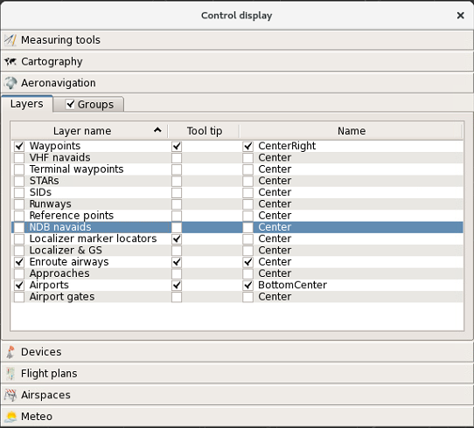
Figure 41 - Window “Control display» (tab “Aeronavigation”)
Using the tab, one may select the contents of aeronautical information displayed in the air situation window. The aeronautical information is received from specialized ANI centers and it may be supplemented by means of window «Configurator” at TCMS AWS.
The same as for vector mapping, aeronautical information may be displayed according to the following two options: by layers or by groups. In a similar manner, a group is a set of individual elements from various map layers (for example, a group for specific SID may include a set of graphical elements corresponding to the SID from layer AIRPORT SIDs, CRP designations from layer WAYPOINT, designations of radio navigation facilities from layer NDB NAVAIDS, etc.). If flag “√” is set in menu line “Groups”, the “group» option will be enabled. If there is no such flag, the “layer” option will be enabled. Figure 41 shows an example of the window displayed upon default selection of sub-tab “Layers”.
To display the required layer, click with the left mouse button on the check box in the beginning of column “Layer name”. If it is necessary to display a pop-up help for the layer, set flag “√” in the check box of column “Tool tip”. For layers with alphanumeric designations (inscriptions) specify (if not specified earlier) whether the layers will be displayed/not displayed as well as their position relative to the main element (for example, position of the CRP name relative to the CRP itself).
To show/hide an inscription, click with the left mouse button on the check box in column “Name”. The inscription display area shall be selected in the menu system. To call the menu, double click on field “Name” in the line containing description of the proper layer. After that button “” to call the menu appears. In this menu select the required parameter by clicking it with the left mouse button. There are 9 possible options to select the inscription display area: top left, top сenter, top right, center, center right, center left, bottom left, bottom center and bottom right.
An example of the window displayed upon selection of sub-tab “Groups” is given in Figure 42.
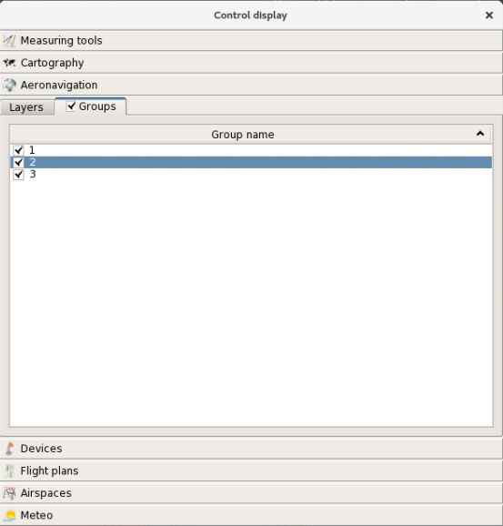
Figure 42 - Window “Control display” (sub-tab “Groups”)
To display a group of aeronautical information, select its designation in the group list by setting flag “√” in the beginning of the respective line. Herewith, it is necessary to set the display of respective layers in tab “Layers”.
An example of window “Control display” displayed upon selection of tab «Devices» is given in Figure 43.
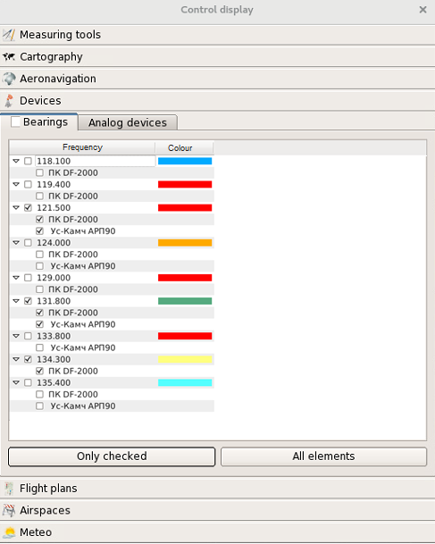
Figure 43 - Window “Control display”, tab «Devices»
This tab has two sub-tabs: “Bearing finders” and “Analog devices”.
Note - Sub-tab “Analog devices” is only used when the complex is interfaced with analog radars.
Figure 43 shows the window displayed upon selection of sub-tab “Bearings”. Using the sub-tab, one may select/cancel selection of radio communication frequency for direction finding, a direction finder, and set the display color of direction finding information for each selected frequency. To that end, set/remove flag “√” (by clicking with the left mouse button) in the respective fields (in the square in front of the designation of ADF and radio communication frequency). The display color is set in the special window called by clicking on column “Color» with the left mouse button. An example of window “Select color” is given in Figure 44.
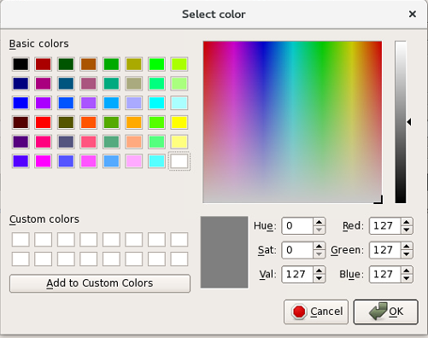
Figure 44 - Window “Select color”
Several color setting options are available in the window. If the required color or shade is available in field “Basic colors” or field “Custom colors”, left click on the respective color square in one of these fields. The selected color will be displayed within the rectangular-shaped display panel in the center at the bottom of the window. Then press button “ОК” at the bottom right section of the window.
If the required color or color shade is not available in fields “Basic colors” and “Custom colors”, select the proper color or shade by moving the cross-shaped or triangular cursor in color fields (in the right section of the window) using a mouse. The obtained color will be displayed at the bottom center section of the window within the rectangular-shaped display panel, and constituent parameters of the color will be displayed in the digital form in fields “Hue”, “Sat», “Val”, “Red”, “Green”, “Blue”. Then press button “ОК” at the bottom right section of the window.
The created color option may be saved for further use by pressing key “Add to Custom Colors”. Herewith, the color option will be added as the appropriate color square to field “Custom colors”.
Besides, the required color shade can be created by entering the appropriate digital values of color constituent parameters in the bottom right section of the window.
Button “Only checked» in tab «Devices» of window “Control display” is used to display information for selected radio communication frequencies only (the information is not displayed for non-selected ones), and button “All elements” is used to display information for all frequencies to be fixed. Aternative action buttons.
An example of window “Control display” displayed upon selection of sub-tab “Analog devices” is given in Figure 45.
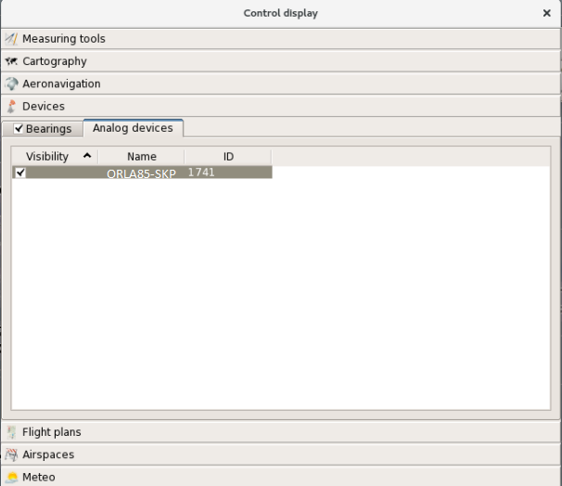
Figure 45 - Sub-tab “Analog devices”
Using the sub-tab, one may show/hide radar data received from analog sources, herewith, the above operations may be done for each source individually, if there are several sources available. The analog information display settings may be entered in functional window “Display settings” described in Section 2.5.
An example of window “Control display” displayed upon selection of tab “Flight plans” is given in Figure 46.

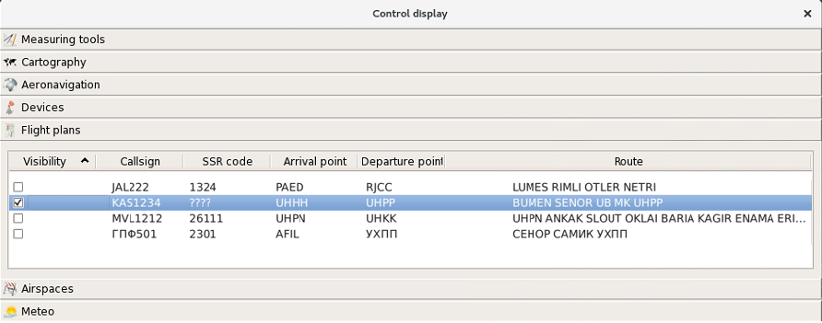
Figure 46 - Window “Control display” (tab “Flight plans”)
Using the tab, one may show/hide the routes displayed according to the plans stored in the current daily flight plan. The flight plan may include activated and non-activated plans, plans included in sector lists of active plans, and plans still not included in the lists. The essential data is transmitted from the planning subsystem of the complex ATC AS «Topaz». Each A/C shown in the tab corresponds to the respective information line containing the data on flight number, SSR code, departure airfield and destination airfield, flight route.
To call/clear the flight plan route for any flight, set/remove flag “√” (by clicking with the left mouse button) in column “Opacity” in the beginning of the respective information line.
Note – Using this option, one may call flight plan routes for A/C which still are not tracked by radars, and not included in the sector lists of active plans.
An example of window “Control display” displayed upon selection of tab «Airspaces” is given in Figure 47. This tab enables displaying/clearing from the display the zones used in the system during solution of functional control tasks. Including following airspaces: zones of minimum safe altitude “MSA”, radar data blanking zones “Blank”, controlled airspaces “Controlled», ASU restricted areas “Restrictive», airfield airspaces “Airport» and conflict zones “Safety». Each of above zones is assigned the respective sub-tab.
Note – Using window “Control display”, one may only show/hide such zones, but it is impossible to create zones, adjust parameters of the zones and control their operation.

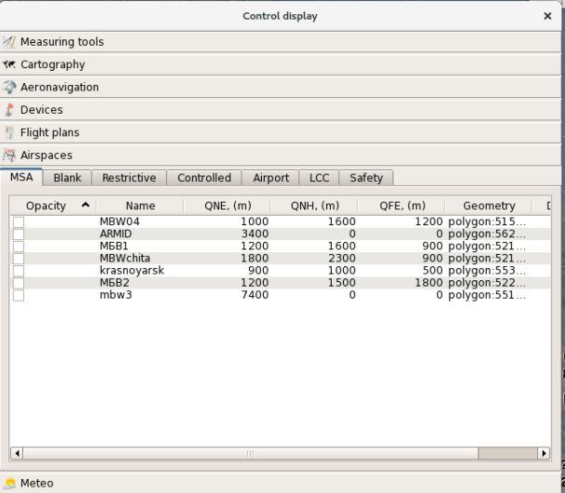
Figure 47 - Window “Control display» (tab «Airspaces”)
Figure 47 shows the window displayed upon selection of sub-tab “MSA”.
Using the tab, one may show/hide zones where the algorithms for detecting the situations when A/C descends below the minimum safe flight altitude (MSA) are effective. To that end, set/remove flag “√” (by clicking with the left mouse button) in the respective lines containing designations of MSA zones.
Figure 48 shows an example of the window displayed upon selection of sub-tab “Blank”.
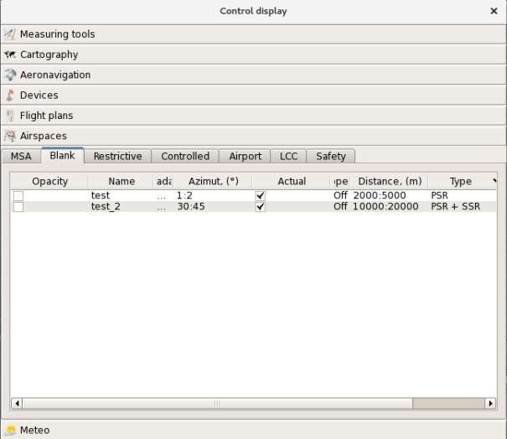
Figure 48 - Window “Control display” displayed upon selection of sub-tab “Blank”
Using the options of the sub-tab, one may show/hide graphic images of zones where the functions of processing the radar data from radar sources are prohibited or limited (to suppress continuous interference from the radar path and multipath propagation). Each blank is assigned the respective line in the informational part. To control display of blanks, set/remove flag “√” (by clicking with the left mouse button) in the respective lines in column “Opacity”.
An example of the window displayed upon selection of sub-tab “Controlled» is given in Figure 49.
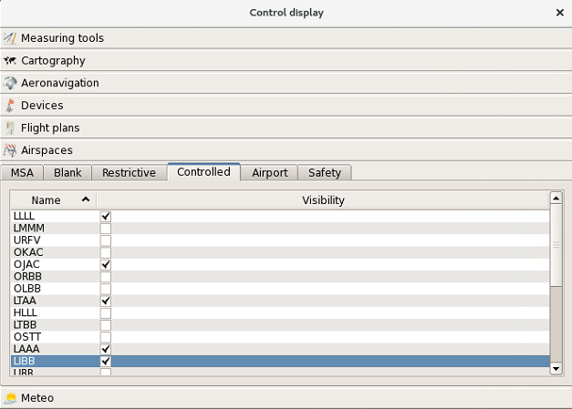
Figure 49 - Window “Control display» (tab «Airspaces”, sub-tab “Controlled”)
Using the tab, one may show/hide the boundaries of ATC zones (sectors) both in internal ATC areas and neighbouring ATC areas (neighbouring FIR areas). To that end, set/remove flag “√” (by clicking with the left mouse button) in the respective lines containing designations of air traffic control zones (sectors).
Note – Initially, the boundaries of ATC zones and sectors are taken from the set of aeronautical data received from CAICA or ASUP ATC AS, but, if necessary, the boundaries may be corrected in functional window «Configurator” at AWS of technical control and monitoring system.
An example of the window displayed upon selection of sub-tab “Restrictive” is given in Figure 50.
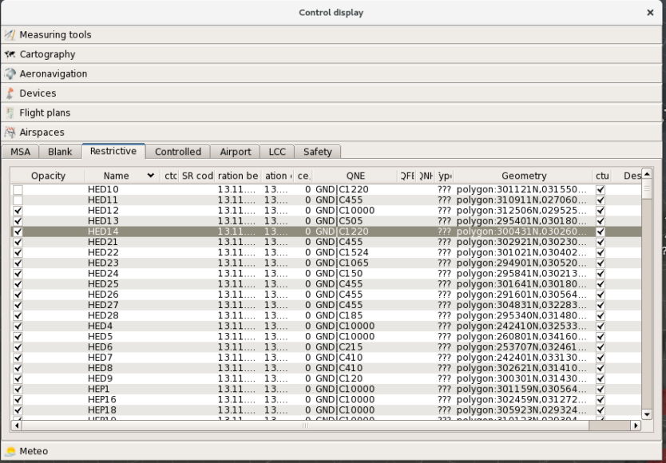
Figure 50 - Window “Control display” (sub-tab «Restrictive”)
Using the tap, one may show/hide airspace restricted areas in the air situation window. Such areas are used in the algorithms detecting the situations of A/C entry to ASU restricted areas. To control display of restricted areas, set/remove flag “√” (by clicking with the left mouse button) in the respective table lines.
Note – The restricted areas (represented by local and time modes as well as short-term restrictions) are transferred from the associated air traffic controllers’ AWS of air space use planning ATC AS (ASUP ATC AS).
The contents of information on restricted areas in window “Control display” correspond to the contents of information in window “Restrictive” (see Section 2.7). The functional features of window “Control display” consist in the option to show/hide “other’s” (not allocated to the sector by the flight operations director) and non-updated zones (areas) in the air situation window.
Each restriction is assigned the respective line in the informational part of the window. The line has two columns: «Name” (specifying the restriction name) and “Opacity” (to enter the flag of restriction display in ASW).
An example of window «Control display” displayed upon selection of sub-tab “Airport» is given in Figure 51.
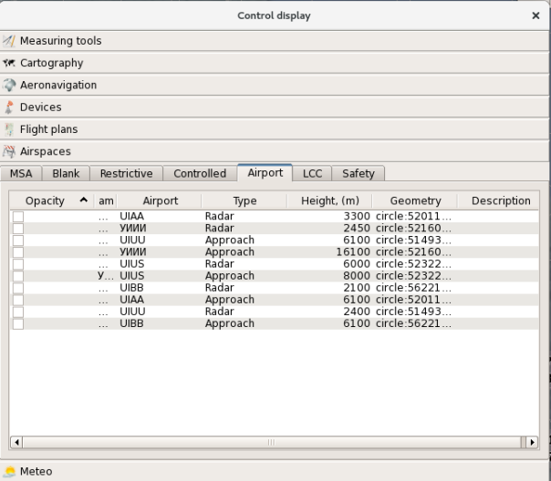
Figure 51 - Window “Control display” (sub-tab “Airport”)
Using the tab, one may show/hide the boundaries of airfield zones (approach and traffic circuit zones). These zones are used in the PCS detection algorithms as well as in algorithms intended to recalculate flight altitude based on airfield pressure. To that end, set/remove flag “√” (by clicking with the left mouse button) in the respective lines containing designations of airfield zones (in column “Opacity”).
An example of window “Control display” displayed upon selection of sub-tab “Safety” is given in Figure 52.
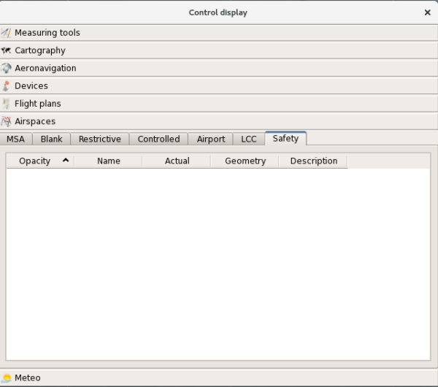
Figure 52 - Window “Control display” (sub-tab “Safety”)
Using the tab, one may show/hide the boundaries of the zones where the algorithms for detecting conflict situations are effective. Parameters of such zones are set in window «Configurator” at the AWS of technical control and monitoring system. Herewith, the zones «operate” no matter if their display is enabled/disabled at the complex AWS – conflict situations (flags “CA”, “STCA”, “PCS”, “MTC”, “MTAPW”, “APW”) are only displayed within the conflict zones. If conflict zones are not set, conflict situations are displayed in the entire airspace.
To show/hide conflict zones, set/remove flag “√” (by clicking with the left mouse button) in the respective lines containing zone designations in column “Opacity”.
An example of the window displayed upon selection of tab “Meteo” is given in Figure 53. Using the tab, one may show/hide graphic and text meteorological information in the air situation window. Such meteorological information is as follows: the information from weather radars, atmosphere sounding stations (balloon probes) processed in the weather sub-system, and the information received as the SIGMET-type weather reports.
This tab has two sub-tabs: “Phenomena” and “Airspaces». Figure 53 shows sub-tab “Phenomena”.
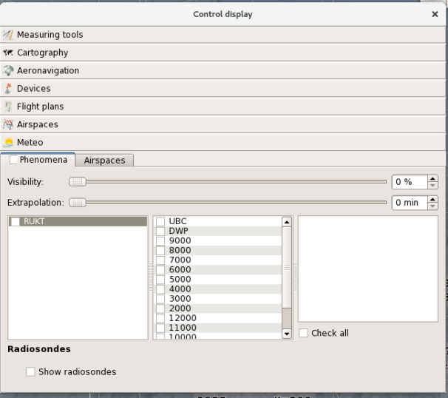
Figure 53 - Window “Control display” (tab “Meteo”)
Slide controls in the upper part of the sub-tab are intended to set the transparency level for displayed weather events zones (field “Visibility”) and extrapolation time for the current location of the zones (field “Extrapolation”). The options in the lower part of the sub-tab enable (by left clicking on the respective check boxes) selection of weather radars, altitude sections of WSRs, weather events types as well as showing/hiding the information on balloon probes.
Menu line “Check all” is intended to show or hide all weather events simultaneously.
Figure 54 shows sub-tab «Airspaces”.
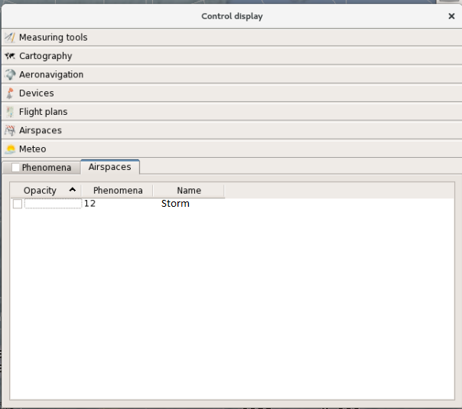
Figure 54 - Window “Control display” (tab “Meteo”)
The options for displaying window “Zoom-window” are set in the special display control window - window “Control display - zoom-window”. The window is called by pressing button in the right top section of window “Zoom». An example of the window is given in Figure 55.
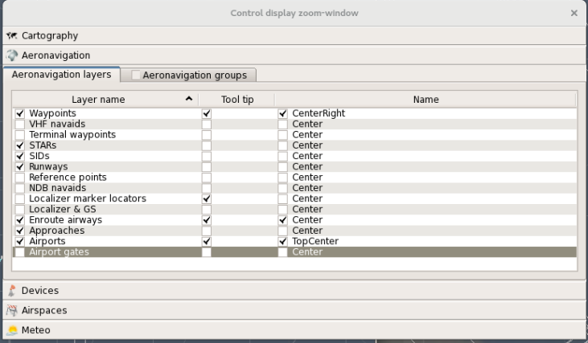
Figure 55 - Window “Control display zoom-window”
This window is the same as “Control display” window but displayed in a brief form. There are five tabs in the window: “Cartography”, “Aeronavigation”, “Devices”, «Airspaces” and “Meteo”. The control procedures are the same as the above procedures for the same-name tabs of window “Control display”.

Window “Aircraft toolbox”
The window is opened by left click on icon of the main menu. The window can be moved across the indicator screen and can be resized according to the set limits (the minimum window size is limited). An example of window “Aircraft settings” is given in Figure 56.
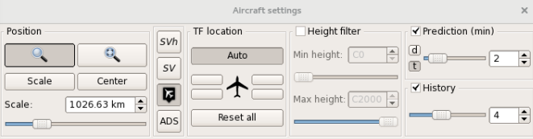
Figure 56 - Window “Aircraft settings”
Window “Aircraft settings”” is intended to set the options for information displayed in the air situation window (first of all, representation of the coordinate information on A/C being tracked):
- call the additional air situation window (“Show zoom-window”) – button ;
- set the airspace area to be displayed in the additional air situation window “Create zoom-window” – button ;
- select the airspace area to be zoomed in in the air situation window – button ;
- control the display scale in the air situation window – section “Scale” at the bottom left part of the window;
- set the special mode for viewing the data on flight altitude of “other’s” A/C – button ;
- enable/disable the TF general viewing mode – button ;
- enable/disable the display of “Show airplots” – button ;
- enable/disable automatic dependent surveillance – button ;

- cancel the image center offset in ASW (return of the center to the reference point) – button ;
- set the TF position relative to the A/C coordinate symbol – section «TF location»;
- reset all individual display settings for tracking forms – button “Reset all”;
- control the display of TFs and tracks in ASW using the altitude filter – section “Height filter”;
- set the value of extrapolation by time and range for extrapolated location vectors – section “Prediction (min)”/“Prediction (km)”;
- select the number of “traces” of A/C flight path – section “History”.
Buttons “”, “SVh”, “SV” and “Center” are direct-action buttons.
Momentary pressing of the first button displays coordinate symbols for targets (“plots”) not tracked by the complex, while repeated pressing clears the symbols from the display.
Momentary pressing of button “SV” clears all TFs, excluding “own” forms (i. e. TFs for A/C being under control within the sector), the forms displayed in sector-wise and/or individual viewing mode, in the mode of control takeover/handover and emergency and conflict situations indication. Herewith, the button is displayed as “pressed”. Repeated pressing of the button displays all tracking forms related to the tracks of aircraft located in the air situation window – the button is displayed as “released”.
Momentary pressing of button “SVh” displays a single-line form containing the data on current flight altitude, altitude variation tendency (if any) and the preset flight level (if the flight level value is specified in the form) for “other’s” A/C. Herewith, the button is displayed as “pressed». Repeated pressing of the button cancels this viewing mode – the button is displayed as “released”.
Note – Buttons “SVh” and “SV” are alternative action buttons, and when one button is “pressed”, the “pressed” state of the other button is cancelled.
Pressing of button “Center” resets the information displayed in ASW to such a state when the reference point of the ATC area entered in functional window “Display settings” is located in the center of the indicator screen. Usually, it is an ARP of the major airfield but other points (objects) of the ATC area may be used as well. All other buttons in window “Control display” are the buttons assigned to functions with arguments.
Button “Reset all” cancels all individual modes of tracks and TFs display in the air situation window including manual relocation (arbitrary movement) of TFs, extrapolation time or distance.

Scale setting
Scale may be selected in the range of 1 to 25,600 km (1–13,822 Nm) per an indicator screen side. There are several options for scale setting.
Scale may be set using a horizontal slider located in section “Scale” and moved by means of the mouse. Discrete incremental or decremental change in scale may be set by pressing buttons , located on the right of the display panel indicating digital values of the current scale above the slider, or using arrow keys (“”, “”, “” and “”) on the keyboard. Momentary pressing of an arrow key increments the current scale with the step of 100 km (“” and “”) or decrements it (“” and “”).
Note – The arrow keys may only be used when section “Scale” is active. To activate the section, press the left mouse button with the mouse cursor pointed over the section. The active state is indicated by dashed framing of the slide control field.
Any arbitrary value of scale may be set by entering the appropriate digital value right in the display panel , indicating digital values of scale. To that end, delete (or select the current value) and enter a new value (to overrun the old value).
The other way of scale setting is using a mouse with scroll wheel (“scroll”) functioning as a control element. In this case, to change scale press the scroll wheel and without releasing the wheel rotate it “away from oneself” (for scaling up) or “towards oneself» (for scaling down).
The scale in kilometers or nautical miles selected for ASW is indicated by a digital value displayed above the horizontal slider in display panel “Scale” and accompanied with the relevant letter designation (“km” or “miles”).

Center offset
The image center displayed in the air situation window is offset as follows. Move the mouse cursor to the ASW point designated as the offset center. Press the left mouse button and holding it pressed move the mouse to drag the image in the air situation window to the required direction. When the mouse button is released, the image in ASW will be fixed in the current position.
Pressing key “Center” in window “Aircraft settings” causes the reset to the position when the center of displayed radar data coincides with the reference point of the control area (the point is set in tab of window “Display settings”).

Extrapolation control
The extrapolation time for A/C extrapolated location vectors is set by means of the horizontal slider in section “Prediction (min)” of window “Aircraft toolbox” when button «t» in the section is pressed. Moving the slider to the left/to the right (point the mouse cursor over the slider, press the left mouse button, and move the mouse while holding the button pressed) increments or decrements the extrapolation time value in the range of 0 to 20 minutes. As a result, length of vectors in ASW for all A/C being tracked changes accordingly.
Incremental or decremental change in extrapolation time (with a 1-minute step) can be also set by pressing buttons , located to the right of the display panel indicating digital values of the current extrapolation time.
Any arbitrary value of extrapolation time may be set by entering the appropriate digital value right in the display panel , indicating digital values of extrapolation time. To that end, delete (or select the current value) and enter a new value.
Besides, when section “Prediction (min)” is active, one may change the values of extrapolation time using the arrow keys on the keyboard: “” (time decrement) or “” (time increment). To activate the section, press the left mouse button with the mouse cursor pointed over the section.
When value “0” is selected, the extrapolation vectors are cleared from the display.
The selected value of extrapolation time is shown by displaying the respective value to the right of the slider.
The range value for range vectors is set by means of the horizontal slider in display panel “Prediction (km)” or “Prediction (miles)” when button “d” in the right top section of window “Aircraft settings” is pressed.
Moving the slider to the left/to the right (point the mouse cursor over the slider, press the left mouse button, and move the mouse while holding the button pressed) increments or decrements the range value within 0 to 100 kilometers (0–53 nautical miles). As a result, length of vectors in ASW for all aircraft being tracked changes accordingly.
Incremental or decremental change in extrapolation distance (by 1 km or 1 nautical mile) can be also set by pressing buttons , located to the right of the display panel indicating digital values of the current extrapolation distance.
Any arbitrary value of extrapolation time may be set by entering the appropriate digital value right in the display panel, indicating digital values of extrapolation range. To that end, delete (or select the current value) and enter a new value.
Besides, when section “Prediction (km)” or “Prediction (miles)” is active, one may change the values of range using the arrow keys on the keyboard: “” (range decrement) or “” (range increment). To activate the section, press the left mouse button with the mouse cursor pointed over the section.
When value “0” is selected, the range vectors are cleared from the display.
The selected range value is shown by displaying the respective value to the right of the slider.

Setting the number of traces
The number of A/C flight path “traces” may be set in the range of 0 to 10 of previous scans from the control panel.
If value “0” is entered, the traces are cleared from the display.
The number of traces is set by means of the horizontal slider in section “History” of window “Aircraft toolbox”. Moving the slider to the left/to the right (point the mouse cursor over the slider, press the left mouse button, and move the mouse while holding the button pressed) increments or decrements the current number of traces. As a result, the number of history traces displayed in ASW for all A/C being tracked changes accordingly.
Discrete (with the step of 1) incremental or decremental change in the number of traces can be also set by pressing buttons , located to the right of the digital display panel.
Any arbitrary value of extrapolation time may be set by entering the appropriate digital value right in the display panel , indicating digital values of the number of traces. To that end, delete (or select the current value) and enter a new value.

Selection of the airspace to be zoomed in in ASW
To select an airspace area to be zoomed in in ASW, press key “Scale” in functional window “Aircraft toolbox”, and point the mouse cursor over the extreme point of the airspace area to be zoomed in. Then press the left mouse button and without releasing the button move the mouse to draw a rectangle within ASW that encloses the airspace area. In this case, the mouse cursor looks like a hand, and the drawn rectangle in ASW is highlighted in dotted lines. Upon releasing the left mouse button, the selected area will be expanded to the entire ASW field.

Altitude filter control
The altitude filter intended for displaying radar data in the air situation window is enabled/disabled with the left mouse button by clicking on menu line “Height filter” in the middle top section of window “Aircraft toolbox”. The enabled mode is indicated by the check mark in the beginning of the line.
Repeated clicking with the mouse clears the flag and cancels the altitude filter operation mode.
Operation range of the altitude filter is set by means of two slide controls: the upper slide control is intended to set the lower filtration limit “Min. height”, while the lower slide control sets the upper filtration limit “Max. height”. Discrete incremental or decremental change in the current value of filtration limit can also be set by pressing buttons , located to the right of the respective digital value designating the filtration limit. Besides, any arbitrary value of the upper or lower filtration limit may be set by entering the appropriate digital value right in the above display panels. To that end, delete (or select the current value) and enter a new value.
Altitude parameters are specified in tens of meters or hundreds of feet depending on the measurement system selected at the workstation.
When the altitude filter is enabled, coordinate information and tracking forms of the aircraft located outside the given altitude range due to current flight altitude are not displayed. Herewith, the altitude filter has no effect on A/C being tracked based on the information sent from PSR (A/C without SSR transponders). The filter also has no effect on the aircraft operated under conditions of an emergency situation or a conflict situation.

Window “Display settings”
The window is intended to set the display parameters for various types of information shown in the air situation window, such as color, size, type, transparency, etc. The window is called by pressing button in the main menu. An example of the window is given in Figure 57.
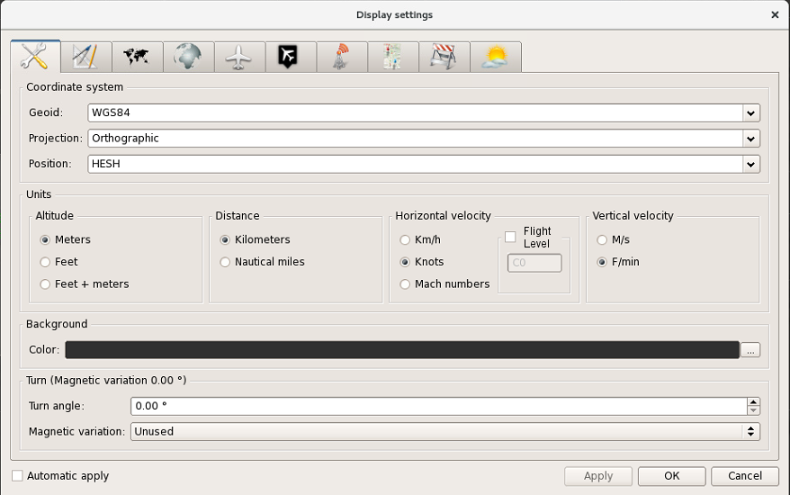
Figure 57 - Window “Display settings”
On top of the window there is a functional bar consisting of tab-type buttons and enabling selection of an information type for setting.
At the bottom (depending on a pressed tab-type button on the functional bar) the panel with elements intended for setting the relevant types of information in the air situation window is displayed.
In turn, the tab may consist of several sub-tabs. Each sub-tab opens the page (the setup panel) assigned to it.
At the bottom on the right there are executive buttons “Apply”, “OK” and “Cancel”. The first button initiates execution of the entered settings without closing window “Display settings”, the second button initiates execution of the entered settings and closes the window, and the third button closes the window without execution of the settings entered before pressing button “Apply”. Functional line “Automatic apply” enables setting of the automatic update of adjustable parameters without pressing the executive buttons (the so-called “online” mode). To set the above option, point the mouse cursor over the required line and click on the line with the left mouse button. Repeated clicking cancels the mode.

General parameters setting
Selection of tab-type button calls the set of options for setting general parameters of the information displayed in the air situation window. An example of the respective display is given in Figure 57.
Section “Coordinate system” contains the options for selecting the geodetic coordinate system (field “Geoid”), gnomonic projection (field “Projection”) and the reference point being a central one when radar data and mapping information are processed and displayed in the air situation window (field “Position”). Selection is made in the menu opened using button “” located in the right section of each field. One of three values “WGS84”, “PZ90» and “Spherical» may be selected in field “Geoid”. One of three values «Gauss–Krüger”, “Orthographic” and «Mercator» may be selected in field “Projection”. One of preset designations of reference points for the area may be selected in field “Position” (using window “Configurator”).
Section “Units” contains the options to select the proper measurement system at the workstation when displaying the data on:
- altitude (field “Altitude”);
- range (field “Distance”);
- ground speed (field “Horizontal velocity”);
- vertical speed (field “Vertical velocity”);
Selection is made by mouse-clicking on the respective designation. Altitude is expressed by the following units of measurement: meters, feet, meters+feet. For distance – kilometers, nautical miles. For ground speed – km/h, knots, Mach numbers. For vertical speed – m/s, feet. Selection affects the data displayed in forms, lists and display panels.
Besides, using section “Horizontal velocity” one may set the altitude limit above which A/C flight speed will be calculated in Mach numbers. If the mode is enabled, flag «√» is set before designation “Flight level”. To set the altitude limit, click on the display panel in field “Flight level”, and enter the required value from the numeric keyboard.
Note – The measurement system may also be selected in window “Current time” (see Section 2.2). Any options selected in window “Display settings” change the indication in the menu of window “Current time” accordingly, and vice versa.
Section “Background” contains the options on selection of the main background color for the air situation window. Field “Color” displays the currently selected background color of the air situation window (keep in mind that if the color of the raster geographical map is set for the air situation window, the color will be more prominent than the background color). To change the background color, press button . Pressing of the button displays window “Select color” (an example of the window is given in Figure 33, Section 2.3) intended for setting the background color for ASW.
Section “Turn (Magnetic variation...)” provides the options for setting the turn angle of the air situation image at workstations both by the magnetic variation relative to the selected reference point (for example, ARP of the major airfield), and by an arbitrary angle.
The option of turning by magnetic variation is mainly intended for air traffic controllers of aerodrome control canters and command ATC centers conventionally using radar and radio direction finding sources oriented relative to magnetic meridian. Besides, the option is provided to register magnetic variation in the aerodrome area without direct image turning. According to this option, the air situation is displayed relative to true north, and digital values of azimuth parameters in A/C tracking forms, measuring vector form and bearing form are entered taking into account magnetic variation.
The effective value of magnetic variation (entered to the system through functional window “Configurator”) in the reference point is specified in the header of section “Turn (Magnetic variation...)” (after phrase “Magnetic variation”).
The command to turn or to cancel turning by magnetic variation as well as magnetic variation recording in TF without making a turn are set in field “Magnetic variation» of the menu. The menu is called by pressing button in the right section of the field. The menu provides three options: “Used”, “Unused «, “Used for TF”:
To select the proper option, left click on the respective menu line. The selected mode is indicated in the middle section of field “Magnetic variation”.
Along with turning by magnetic variation, one may turn an image by an arbitrary angle. The turn angle value is entered in field “Turn angle”. One may set the proper turn angle by direct entry of the required value in the field using numerical keys of the keyboard or by decrementing/incrementing the current value of turn angle using buttons “▼” (“less”) “▲” (“more”) in the right section of the field.
Notes:
1. If both turning by an arbitrary angle and magnetic variation are set, the image is turned by a sum angle.
2. The functions of turning the image in ASW by magnetic variation and magnetic variation registering when displaying digital azimuth data in ASW are individual functions and are not applicable to other AWS.

Setting parameters of measuring tools (functions)
Selection of tab “General» 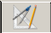 in the functional bar calls the set of options for setting parameters of the measuring tools (functions) for the air situation window. The tab principle is implemented. Figure 58 shows an example of the window displayed upon selection of tab “Geographical grid”.
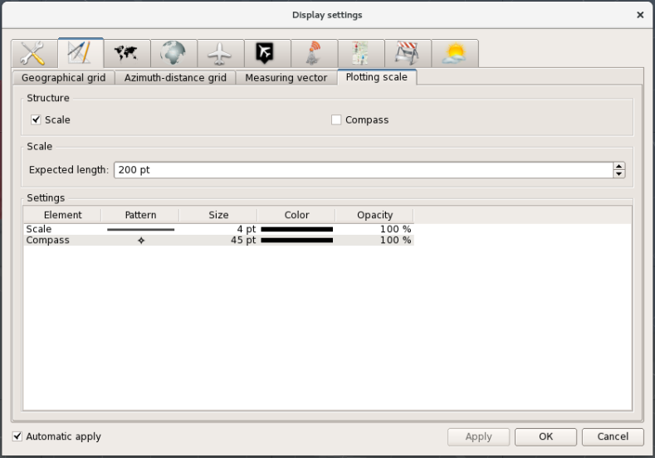
Figure 58 - Setting parameters of measuring tools
The top section of the tab, section «Structure” contains the functional elements to show/hide geographical grid lines (field “Geographical grid”), inscriptions near the grid lines at the edges of the screen (field “Labels”) and the help for the geographical grid (field «Tool tips”). Pop-up help giving the values of parallels and meridians is displayed when the mouse cursor is pointed over the respective geographical grid lines. To show/hide the required elements, left click on the respective field.
Below on the page there is a table for setting display parameters for geographical grid elements – lines and inscriptions. The following parameters are available: line type (column “Pattern”), element size in typographical points (column “Size”), color grade (column “Color”) and opacity level (column “Opacity”).
To change the line type, double left click on line “Grid”, column “Pattern”. After that button to call the menu with line types appears. In this menu select the appropriate line type (solid line, dotted line, dashed line, dash-dotted line, etc.) from the shown templates:

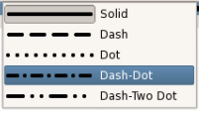

To set line size (thickness), double left click on column “Size”, and using arrow buttons increase or decrease the value expressed in typographical points (“pt”).
Column “Color” shows the current color that is used to display a geographical grid. To select another color, double click on the column to call window “Select color” intended to set the appropriate color for lines and inscriptions of the geographical grid.
Column “Opacity” shows the current opacity level of the displayed geographical grid elements (both for lines and inscriptions). To set another value, left click on column “Opacity”. After that the horizontal slider shown below appears in the column:

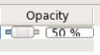

Moving the slider with the left mouse button, set the proper transparency level.
To select font type and size for inscriptions associated with the geographical grid, open the font selection window by double click with the left mouse button on line “Labels”, column “Size» or “Pattern”. The window is shown in Figure 59.
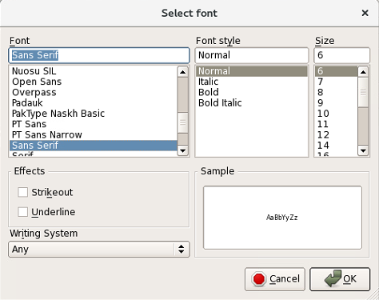
Figure 59 - Window “Select font”
Various options for font setting are available in the window. Select the font type in the list with scroll bar by a mouse click. One may select a style for each font: normal, italic, bold or a combination of both styles. Also, one may select a font size from the available list. By setting flag “√” in field “Effects”, one may set the appropriate text style: the text will be either crossed-out or underlined.
In list “Font” one may select the proper style from the available alphabets (languages). All changes made will be shown at once by the example given in window “Sample”. The changes will only take effect after pressing button «OK» or «Enter» on the keyboard. Upon pressing button “Cancel» all elements displayed on the screen remain unchanged. The font selection window will close.
The next tab “Azimuth-distance grid” of level 1 enables setting the method of azimuth-distance grid display in the air situation window. The view of the tab is given in Figure 60.
The upper section “Structure” provides the options to show/hide the azimuth-distance grid and the pop-up help. To that end, left click to set a check mark opposite to menu items “Azimuth-distance grid” and «Tool tips”.
The next section “Coordination system” enables setting the reference point “Reference points” for drawing the azimuth-distance grid (ARPs of major airfields of the area, major RPs, etc).
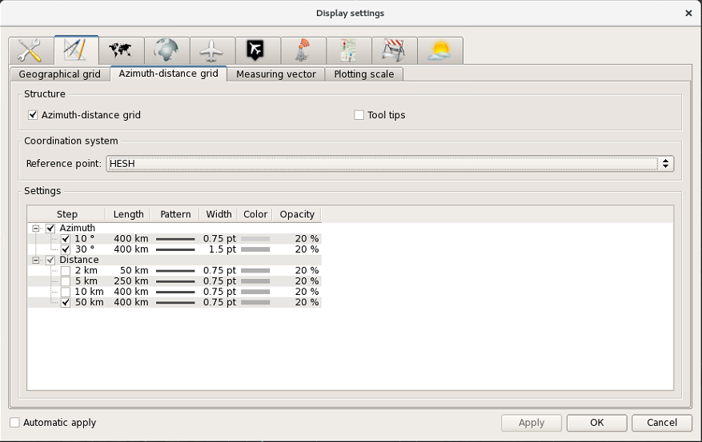 Figure 60 - Tab “Azimuth-distance grid”
Note – When another reference point is set in window “Display settings”, the reference point in window “Control display” changes automatically and vice versa.
Section “Settings” contains all possible display options for graphic elements of the grid. Values of line width, color, opacity and pattern are set individually for azimuth lines “Azimuth” and range rings “Distance”. One may enable the grid step in column “Step”. For azimuth the grid step is expressed in degrees (10° or 30°), for range the grid step is expressed in kilometers (2, 5, 10 or 50 km). To enable the step, left click on the respective lines within the column. Herewith, if menu line “Azimuth» or menu line “Distance” is clicked, all azimuth lines or range rings are selected at a time. The selected value is indicated with symbol “√”.
The settings in other columns are enabled by double clicking with the left mouse button, and in general they are similar to the above procedures with respect to the settings of geographical grid.
Provision is made to set the coverage of azimuth lines and range rings. Upon enabling the function, buttons appear in the right section of the field. Using the buttons, one can change (by increasing or decreasing) the current range value for the selected type of the azimuth-distance grid.
From column “Pattern” one may call the button intended for calling the menu containing the list of available line types. The appropriate line type may be selected from the list using the mouse.
From column “Width” one may call the buttons intended for changing the current values of thickness for lines and rings of the azimuth-distance grid.
From column “Color” one may call the standard color selection dialog box from which the proper color is selected.
From column “Opacity” one may call the slider to set transparency of the displayed azimuth-distance grid.
Besides, all numeric values can be edited. To that end, click on the required field with the mouse, and enter the data using the keyboard.
Using tab “Measuring vector” of level 1, one may enter display settings for the information shown in ASW while taking measurements by means of the measuring vector. The view of the tab is given in Figure 61.

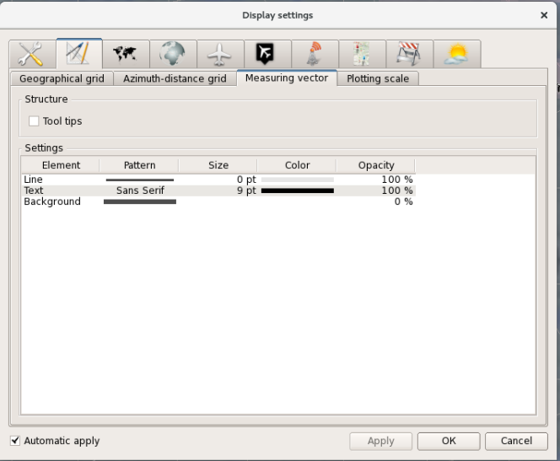
Figure 61 - Tab “Measuring vector”
Using section «Structure”, one may show/hide pop-up help. Section “Settings” shows the current values of display parameters for a line and a measuring vector form, as well as supports the following parameters adjustment options: line type and thickness, font type and size for a form, colors of a line and a form, opacity level of a line and a form, fill (cross-hatching) options, color and opacity of the form background color. To enable the adjustment functions, double click on the respective cell.
The next tab “Plotting scale” of level 1 is shown in Figure 62. Using the tab, one may set the display parameters for the graduated scale and compass in ASW.
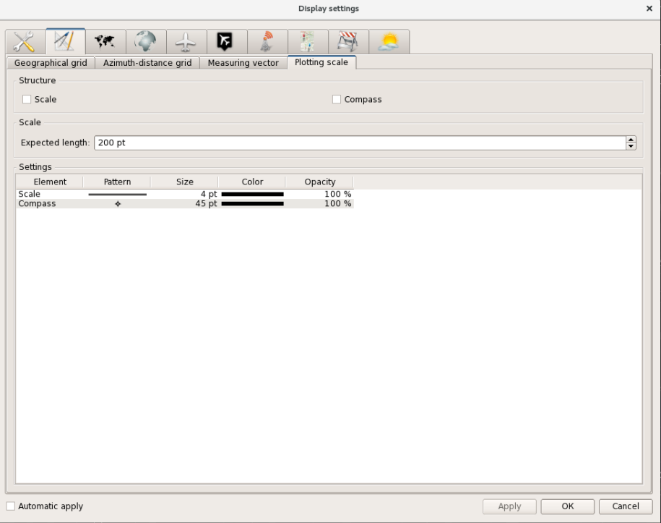
Figure 62 - Tab “Plotting scale” of level 1
Flag “√” is set or removed in upper section “Structure» by left clicking on the respective fields to show/hide the graduated scale (“Scale”) and the compass (“Compass»).
Parameter “Expected length” of the graduated scale, i. e. the length of this element in ASW, is set in section “Plotting scale” using arrows, or the parameter values may be entered from the keyboard.
Section “Settings” shows the current values of display parameters for a graduated scale and a compass, as well as supports the following parameters adjustment options, namely: line type, size (thickness), type and size of compass symbol, color and opacity both for the compass and for the graduated scale. The parameters settings are enabled by double clicking with the left mouse button when the mouse cursor is pointed over the respective field of section “Settings”.
Type and size of compass symbol are set in window “Select symbol” given in Figure 63.
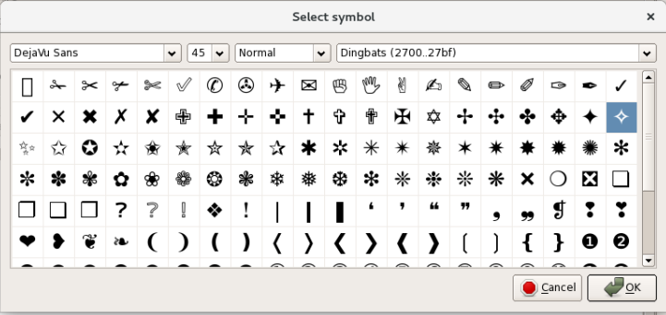
Figure 63 - Window “Select symbol”
A font type for the displayed compass symbol can be set in field “Font” of the window:
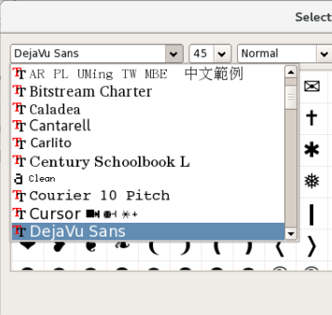
The appearance of a symbol can be set – the list of available symbols can be viewed by pressing the arrow in line “Symbol”. The example is given in Figure 64.
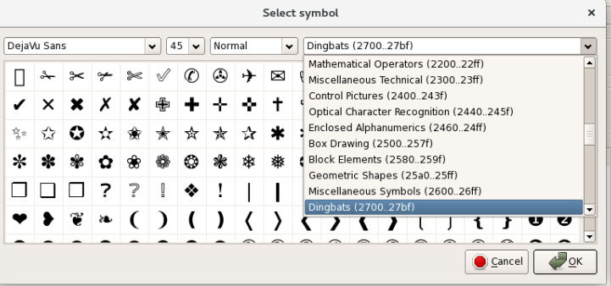
Figure 64 - Symbol selection

Mapping parameters setting
Selection of tab-type button  in the upper part of the window opens display setting options for mapping information. The appearance of the window is shown in Figure
65.
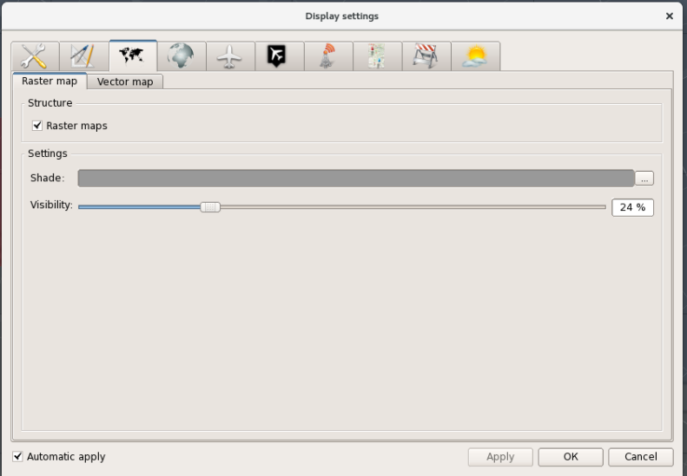
Figure 65 - Option “Cartography”
Two types of images are available for mapping data presentation. These are a raster image and a vector image whose settings are shown in tabs “Raster map” and “Vector map”, respectively. Tab “Raster map” is shown on the page.
Tab “Raster map” consists of 3 zones. The raster map (geographical map mount) can be shown/hidden by setting/removing check mark (flag) (“√”) in the check box of upper zone “Structure”. «Settings» area sets the parameters for raster map redrawing.
Zone “Settings” accommodates the fields for setting display parameters of a raster map. Line “Shade” shows the currently selected color of raster map, and special window “Select color” may be called from the line to select the proper color. To that end, press the three-point button in the right section of the line. An example of window “Select color” is given in Figure 66.
Figure 66 - Window “Select color”
Line “Visibility” with a slide control is intended to modify the rate of visibility (transparency) (in per cents) for a raster map displayed in ASW.
Vector mapping display settings are set on tab “Vector map”. An example of the tab is given in Figure 67.

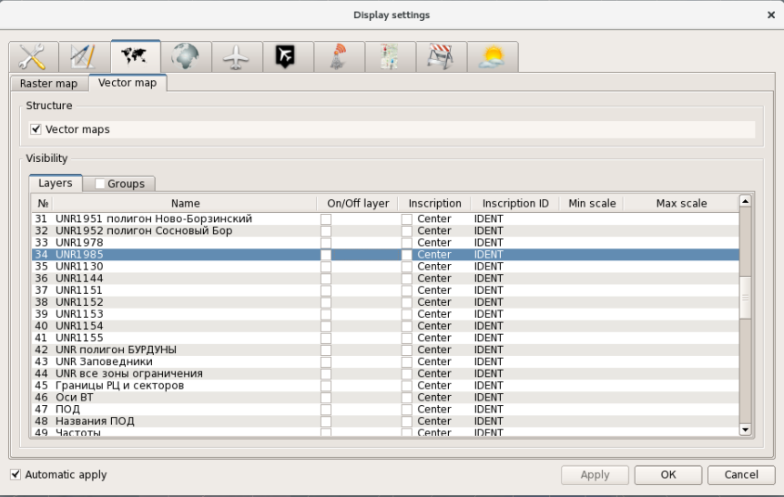
Figure 67 - Tab “Vector map” (sub-tab “Layers”)
Using the tab, one may set the air situation window display parameters for extra information (unique for the installation object mapping information which is missing in the basic aeronautical information received from specialized centers such as CAICA or the consolidated center of UATMS).
Such mapping information can be created (and saved as a special file) by Customer’s specialists who may use a standard graphic editor “MapInfo Professional” or “QuantumGIS”, or an integrated mapping editor used earlier in the previous versions of ATC AS “Topaz”. Then the information shall be loaded to the system (and further reformatted automatically) arranged at AWS of the specialist in charge of keeping mapping and aeronautical information in ATC AS.
The converted information will be grouped into a combination of map layers which can be used individually. Groups for vector mapping are created in advance using the integrated mapping editor for ATC AS “Topaz” just as well at the AWS of the specialist in charge of keeping mapping and aeronautical information in ATC AS.
Each layer is assigned a relevant line. The same as for window “Control display», one may set inscription display areas for alphanumeric designations on maps, and select the parameter to be used as an inscription from the associated data set. To that end, left click on field “Inscription» (if the inscription display area is to be set) or “Inscription ID” (if the inscription parameter is to be set) in the line containing description of the proper layer. After that button «» to call the menu appears. In this menu select the required parameter.
Columns “Min. scale” and “Max. scale” show the values of scale required for displaying the relevant mapping information in the air situation window (for example, to display the airfield layout the range of 1–5 km may be set, and the map will not be shown beyond limit values of the scale). Herewith, the above values cannot be modified, they are set in the “Topaz” special mapping editor.
This tab allows to set display elements for each layer. The setting procedure is as follows. The required line is selected by clicking with the left mouse button. Then the right mouse button is pressed while the mouse cursor is kept on the selected line. Display panel “Drawing” will appear. Then left click on the display panel. Special functional window “Display format of the layer” will appear. Examples of the interface are given in Figure 68.

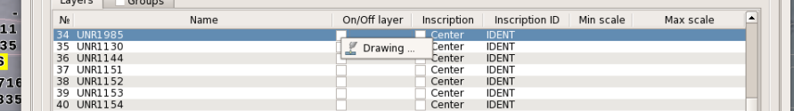

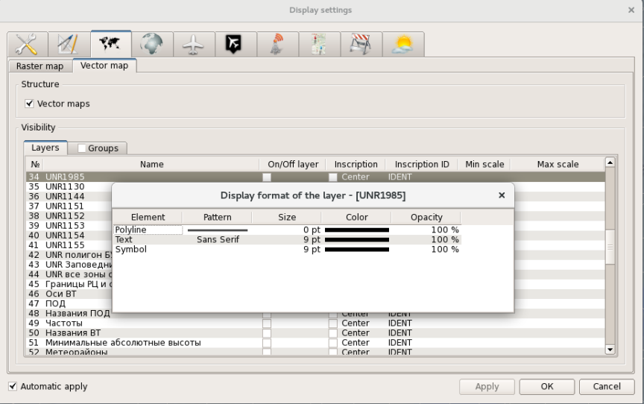
Figure 68 - Calling of window “Display format of the layer «
This window enables setting the display options for graphic elements of the selected map layer (line color, type and size , opacity level), size and type of font for alphanumerical elements (inscriptions) as well as the option of character representation for character elements. Each setting is enabled by double clicking on the respective field with the mouse and further selection of the proper option from the menu or in the special functional window.
The same as for window “Control display”, window “Display settings” enables setting the vector mapping display by layers and by groups. If flag “√” is set in menu line “Group”, the “group” display option will be enabled. If there is no such flag, the “layer” display option will be enabled. To select the display options for specific groups or layers, set checkmark /clear checkbox by clicking on the lines containing the names of groups or map layers, respectively, with the left mouse button.
Upon selection of a group, designations of layers included in the group will be displayed in the adjacent window on the right. If the proper layer is not selected (there is no flag “√” before the layer name), enable the layer display by left click on the check box. Also, one may go to tab “Layers» and set the display options for the layer in that tab.
Groups and layers in windows “Display settings” and “Control display” are selected synchronously, i.e. a selection made in one window results in automatic correction of the relevant parameters in the other window.
Figure 69 shows an example of the window displayed upon selection of tab “Groups”.
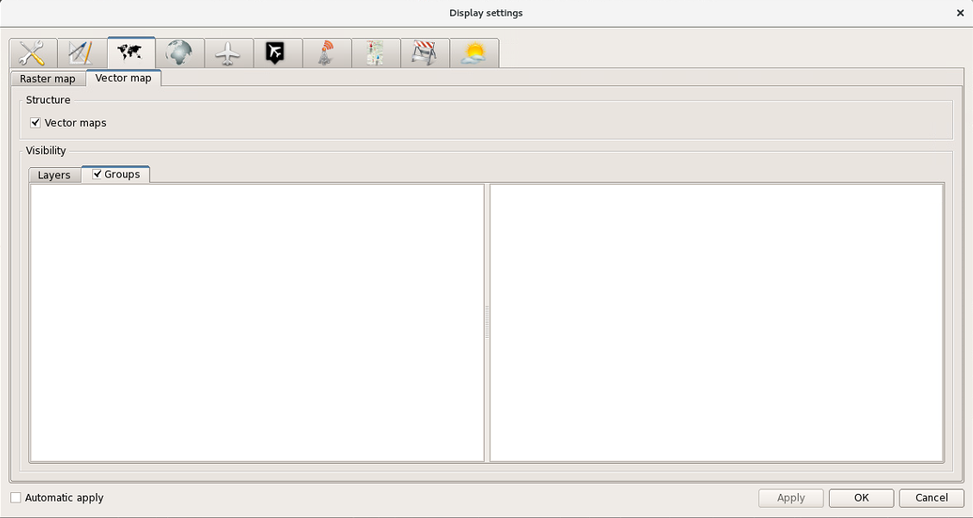
Figure 69 - Tab “Vector map» (option “Groups”)

Aeronautical data display setting
Display parameters for aeronautical data are set on the section-page opened upon clicking icon . The window appearance depends on the selected tab. An example of the window is given in Figure 70.
Aeronautical information may be displayed in ASW according to the following two options: by layers and by groups.
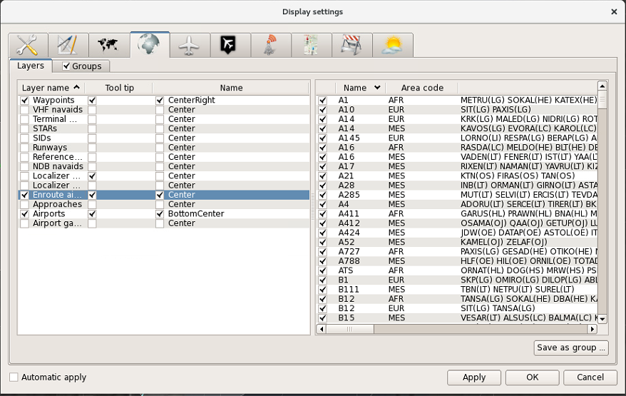
Figure 70 - Tab “Aeronavigation”
The intrasystem array of aeronautical information is divided into layers which are generally in line with the structure of aeronautical information (ANI) conventional for systems. It is planned to compile the array mainly on the basis of the aeronautical information package received from the aeronautical database (for example, from database “ARNAD”) in the Arinc 424 format as per the contract concluded with ANI competent authorities (such as CAICA). If there is an interface with ASUP ATC AS, aeronautical information will be sent from this system.
To facilitate handling the aeronautical information, provision is made for sense-groups which may contain both information from different layers and information extracted from one layer. For example, the aeronautical information received from CAICA contains layer “AIRPORT SIDS” which comprises the data on all standard departure trajectories for all airfields of Russia. On the basis of that data one may create individual groups referenced to the specific airfield, the specific point of departure from the airfield area and landing heading, for example, “SID BESTA 07D” or “SID KN 25A/25C”, and the groups may be supplemented with data from other layers, for example, with designations of marked and unmarked points from layers “TERMINAL NDB” and “WAYPOINT”.
Two options of mapping information display (by layers and by groups) are available for the user.
For selection by groups set flag “√” in header line “Groups”, and then set check marks (“√”) in the appropriate lines of the group list. Flag “√” is set by left click on the respective field.
If the check mark is not set in header line “Groups”, the “layer” display option for aeronautical information (tracks, CRPs, airfields, restricted areas, ATC areas and zones) in ASW shall be used. According to this option, check marks (“√”) shall be set in the appropriate lines containing designations of layers, and, if necessary, in the lines of respective elements being a part of each layer.
Figure 70 shows the appearance of the window with selected option “Layers”.
Tab “Layers” is divided into 2 parts. The left part includes the list of layers which can be used to display aeronautical data in the air situation window. Usually, the set of layers corresponds to aeronautical information types provided by ANI competent authorities (such as CAICA). It is possible to enable a pop-up help by setting a check mark in the respective check box.
Using column “Layer name”, one may show/hide the displayed elements and set the position of alphanumerical information (inscriptions) contained in the layer relative to the respective item (object). To show/hide an inscription, click with the left mouse button on the check box in column “Layer name”. To set a new position of inscriptions, double click with the left mouse button on the respective line. After that, button “” will be displayed on the right with the drop-down list of various positions wherein the proper position shall be selected. Keep in mind that the selected position will be effective for all inscriptions (names) of the editable layer.
Tab “Aeronavigation groups” (shown in Figure 71) is divided into 3 parts. The left part includes the list of earlier created groups. The middle part contains the list of layers related to the group selected in the left part. The right part is a set of elements from the layer selected in the middle part which were used when creating the group.

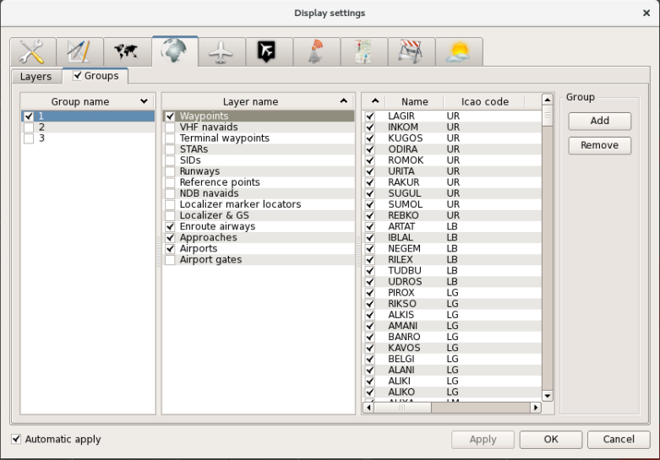
Figure 71 - Option “Aeronavigation groups”
One may add and delete groups at workstations provided they are assigned the rights of aeronautical information editing. The contents of mapping information displayed within a group can be promptly edited by setting or removing check marks in the check boxes of the middle part and right part of the tab. Buttons “Add” and “Remove” (arranged in the right section of the tab) are intended to add a new group or to delete the earlier created group. These functions are disabled and the above buttons are not available at workstations not assigned the rights of ANI editing (usually, air traffic controllers’ AWS are related to such workstations).
Each layer corresponds to an individual set of parameters for the elements included in the layer. Figure 70 gives the example of displayed tab when layer “Enroute airways” is active, as well as the set of tabular elements and parameters associated with the layer. Each track occupies one line in the right part of the tab, and comprises such parameters as airway name, area code and list of waypoints within the airway.
And if layer “Runways” is selected, each RW will be assigned with a single-line record containing data on RW name, a four-letter designation of airfield according to ICAO classification, coordinates (latitude and longitude), runway length and width, approach heading and RW threshold altitude above the sea level.

Setting A/C display parameters
To view and set parameters of A/C data display on the screen, select and press tab-type button .
In turn, the tab consists of tabs of level 2 (sub-tabs). Possible settings and appearance of the section-page depend on the tab selected in the upper part of the window.
The appearance of sub-tab “Aircraft” is shown in Figure 72.

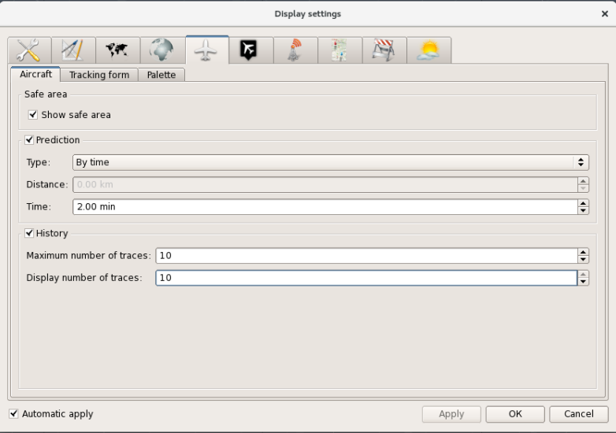
Figure 72 - Sub-tab “Aircraft”
This sub-tab is intended to show/hide the safety zone around the A/C tracks taking into account effective horizontal separation rules (10 km for area control center (ACC) and approach control units, and 5 or 10 km for airdrome control units depending on wake turbulence category of the leading A/C). The function is enabled by left clicking on line “Show safe area”. Flag in the beginning of the line indicates that safety zones are displayed. No flag indicates that the mode is off.
Note – Using window “Display settings”, one may set the mode of safety zones display by groups, the individual mode is set when calling the A/C coordinate symbol.
Section “History” sets the number of “traces” of A/C flight path – plots of the previous location of A/C relative to its current location based on two adjustable parameters: maximum possible value (line “Maximum number of traces”) and current number of traces (line “Display number of traces”).
The above mentioned parameters are modified using arrows in the right part of each line or by entering the proper value from the keyboard (before that remove or write down the previous parameter). These parameters provide synchronization with window “Aircraft toolbox”, and the value specified in line “Maximum number of traces” will be the upper limit for selection of A/C movement history through window “Aircraft toolbox”.
Section “Prediction” contains settings for A/C extrapolation vector. Using the section, one may set length of the vector that may designate predicted movement of A/C track in ASW.
One of two available extrapolation types may be selected: by distance and by time. To that end, using the arrows open the list shown in line “Type” (see Figure 73), and select the required type.
Figure 73 - Extrapolation type selection menu
Depending on the selection, the respective line becomes active: “By distance” or “By time”. Using the arrows (or by direct entry from the keyboard) one may set a numerical value in the lines: for range - in kilometers or nautical miles, for time - in minutes.
The appearance of sub-tab «Tracking form» is shown in Figure 74.
The sub-tab enables setting and defining the display parameters for a tracking form:
- the number of displayed TF lines;
- the contents of information given in the third and the fourth lines of TF;
- height filter settings;
- length of binding line;
- enabling/disabling the mode of TF positioning relative to the coordinate symbol (including enabling/disabling the automatic relocation function);
Several parameters to be edited in the window (height filter and mode of TF positioning relative to the flight direction) are synchronized with the parameters in window “Aircraft toolbox”. I. e. the values edited in the window are displayed in window “Aircraft toolbox” right after activation and vice versa.
To set the number of lines displayed in TF, select the required parameter in functional line “Count line” of section “Composition” by clicking with the left mouse button: “1”, “2”, “3” or “4”. The selected value is indicated by a point symbol set before the selected parameter.
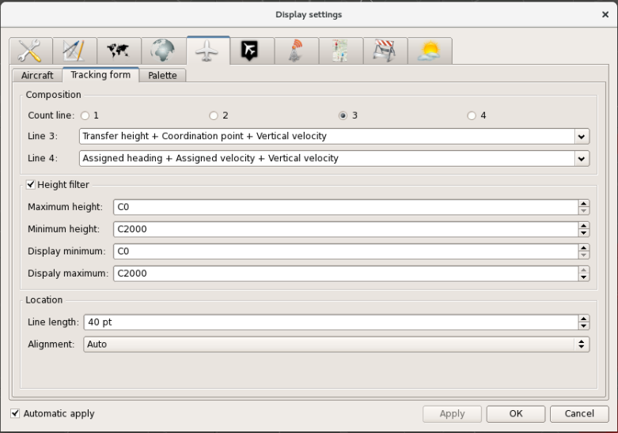
Figure 74 - Sub-tab «Tracking form»
The composition of data to be displayed in the third and fourth lines of TF is set by selection of the proper parameter in the special menu list opened by pressing button “▼” in the right section of field “Line 3” or field “Line 4”. An example of the menu is given in Figure 75. The menu list may be opened on the screen not in full, and the scroll bar is provided to select the proper option. The drop-down menu for the third line and the fourth line contains the same data.
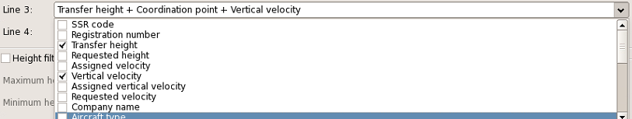
Figure 75 - Menu for data selection in the third and fourth lines
To show the required information in lines 3 and 4, select the check boxes next to the lines (by clicking with the left mouse button). In that way, the “set” of data displayed in the line is collected. Herewith, keep in mind that the set of data shall not exceed the number of character locations in the respective line.
Otherwise, the system message will be displayed:
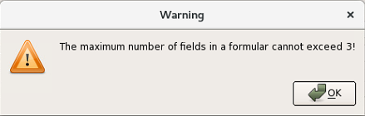
Figure 76 - System message warning on too many requested fields for TF line
The height filter is set in the next area. To enable the filter, set a check mark in line “Height filter», after that the lines where the filter parameters are specified become active. These are as follows: range of possible values (fields “Minimum height” and “Maximum height») and the range of filter current values (fields “Display minimum” and “Display maximum”). The values may be changed using arrows or by direct entry of the required values from the numeric keyboard (after clicking on the respective field with the mouse).
The specified values are synchronized with the respective parameters of the height filter in functional window “Aircraft toolbox”. Upon pressing executive keys “Apply” or “ОК» or right after selection of option “Automatic apply”, the preset values of the height filter change the respective parameters in window “Aircraft toolbox”. The reverse action takes effect in the same way – the values modified in window “Aircraft toolbox” change automatically in window “Display settings”.
“Location” area contains lines “Line length” and “Alignment”. Length of the binding line for TF is specified and, if necessary, edited in the first line using arrows or by direct entry of the required value in typographical points from the numeric keyboard. The current option of TF arrangement relative to the A/C coordinate symbol is shown and, if necessary, edited (through selection of the proper parameter from the menu called by pressing button “”). There are five options available: at the top right, at the top left, at the bottom right, at the bottom left and automatic. The latter option provides for automatic form relocation if overlapped.
Sub-tab “Palette” is given in Figure 77.

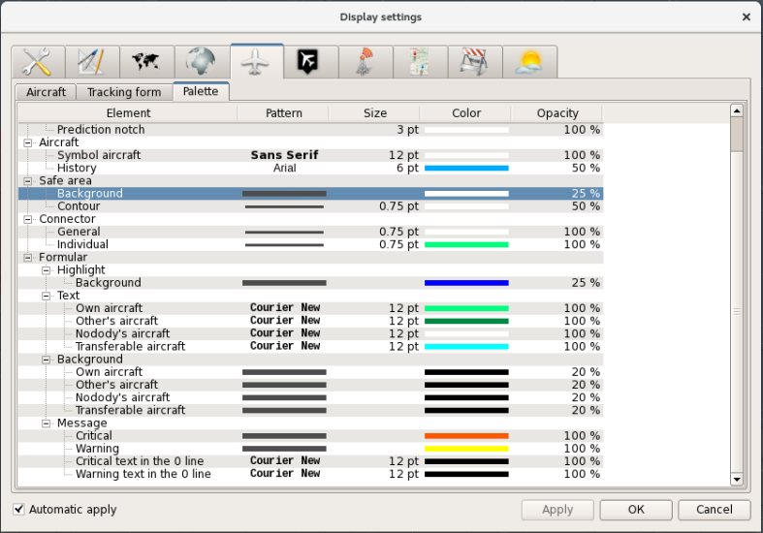
Figure 77 - Sub-tab “Palette”
The tab contains tabular values of current state as well as the options to set the display of various elements of tracking forms and track information for A/C being tracked. The list of adjustable elements is given in column “Element”. The adjustable parameters are available in columns “Pattern”, “Size”, “Color”, “Opacity”.
The parameters are set by clicking the respective table fields with the mouse button. When “linier” row in column “Pattern” are selected, button to call the menu with line types appears. In this menu select the appropriate line type (solid line, dotted line, dashed line, dash-dotted line, etc.) from the shown patterns. When “text” row in column “Pattern” are selected, functional window “Select font” is called. Using the window, one may set font type and size for various options of TFs display.
For “background” elements (for example, for a background mount of the form or a safe area) a fill type is selected in line “Pattern” (from solid fill to various cross-hatching options). The respective menu is shown in Figure 78.
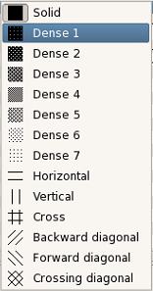
Figure 78 - Menu for line “Pattern”
To set line size (thickness), double left click on column “Size”, and using arrow buttons increase or decrease the value expressed in typographical points (“pt”). Double clicking on “text” lines of the same column calls window “Select font” (see the example in Figure 79) where one may change the size of font for TF and A/C symbols.
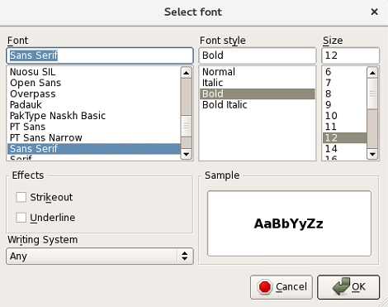
Figure 79 - Window “Select font”
Column “Color” shows the current color that is used to display a geographical grid. To select another color, double click on the column to call window “Select color” intended to set the appropriate color for lines and text elements of TF.
Column “Opacity” shows the current transparency level of the displayed geographical TF elements (both for lines and text elements). To set another value, left click on column “Opacity”. After that horizontal slider appears in the column. Moving the slider with the left mouse button, set the proper transparency level.

Setting display parameters for plots
To go to that page, select tab-type button 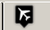. Visible parameters of plots are set at the page. An example of the displayed page is given in Figure 80.
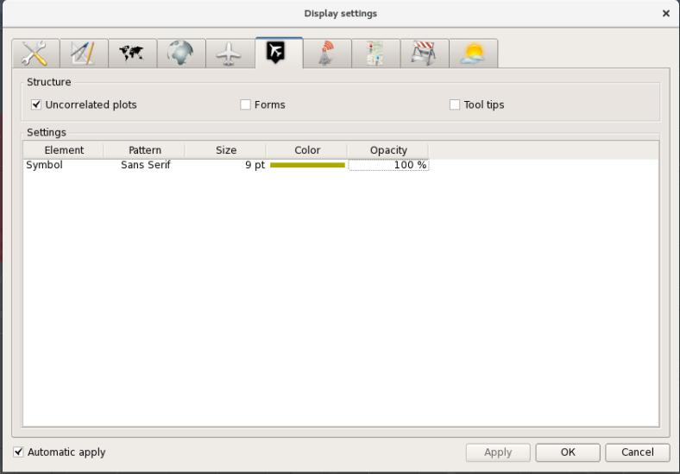
Figure 80 - Tab “Airplots”
«Structure» area contains the options to show/hide plots, forms and tool tips. To that end, using the mouse check marks are set/removed from check boxes next to options “Uncorrelated plots», “Forms» and «Tool tips”, respectively. Option “Uncorrelated plots” is synchronized with the similar option in window “Aircraft toolbox” – flag “√” set in line “Uncorrelated plots” automatically sets button in window “Aircraft toolbox” to the “pressed» state and vice versa.
The available setting mechanisms are enabled by double clicking on the respective table columns. The setting procedures are similar to those described in the previous sections. In this tab the adjustable parameters are size of the plot coordinate symbol (the symbols are not adjusted), color and opacity.
Double click on columns “Pattern” and “Size” calls window “Select font” that is mainly used to set the size of a coordinate symbol.

Setting of displayed data on ADF, analog devices and RW windows
To start setting the display parameters for ADF, radar data analog sources and RW occupancy display panel, press icon button 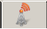. The page appearance depends on the specific tab. There are three tabs available.
The window with settings of ADF information display parameters is given in Figure 81.
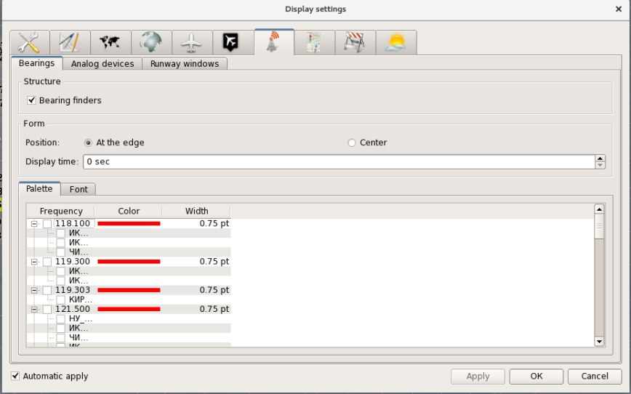
Figure 81 - Option «Devices», tab “Bearing finders”
The display mode for the general information on radio direction finders may be enabled/disabled in zone «Structure” by setting/removing the check mark in the check box. The radio buttons in zone «Form» are intended to set position of the bearing form: “At the edge” or “Center” (near the the ADF station location) and the time of the form display after the bearing line disappears. The time is set by incrementing or decrementing the current value using the “triangular” buttons in the right section of line “Display time” or by entering the required value using the keyboard.
The main field of the tab has two sub-tabs: “Palette” and “Font”.
Figure 81 shows the page displayed upon selection of sub-tab “Palette”. In this sub-tab frequencies and direction finders can be activated (column «Frequency”), and thickness of the bearing line “Size” and color of the line can be set “Color”).
To select (activate) direction finding frequency and ADF, click on the respective line. The selection made is indicated by the “check mark” symbol. Repeated selection of the field clears the symbol from the display and cancels the activation of frequency and ADF. Herewith, if the line containing the value of radio communication frequency is selected, all ADFs tuned to the frequency are selected at once. But if the line showing the ADF name is selected, only that ADF is selected.
To modify thickness of the bearing line, double click on column “Size”. After that, arrow buttons , intended to increase or decrease the current value will appear on the right of the column. Besides, the proper thickness can be set using the numeric keyboard.
Double click with the left mouse button or momentary pressing of the right mouse button on column “Color” calls the above described window “Select color”. Using the window one may change the current display color of direction finding information on the selected direction finding channel (on the selected radio communication frequency).
The font for displaying data in the bearing form can be selected in sub-tab “Font”. An example of the sub-tab is given in Figure 82.
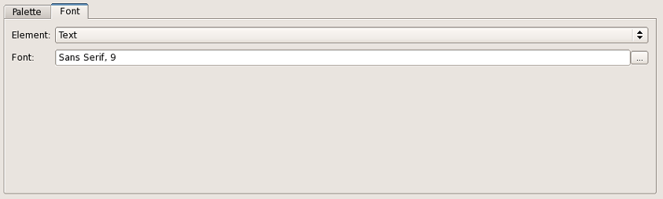
Figure 82 - Sub-tab “Font”
There are two functional lines in the sub-tab: “Element” and “Font”. An adjustable image element can be selected from line “Element”. But the line contains only one element – the form text. The font parameters (type, size, effects) for the bearing form are set in window “Select font”. The window is called by pressing button in the right section of line “Font”.
The next tab “Analog devices” of level 2 enables setting the display parameters for analog radar data in the air situation window. An example of the tab is given in Figure 83.

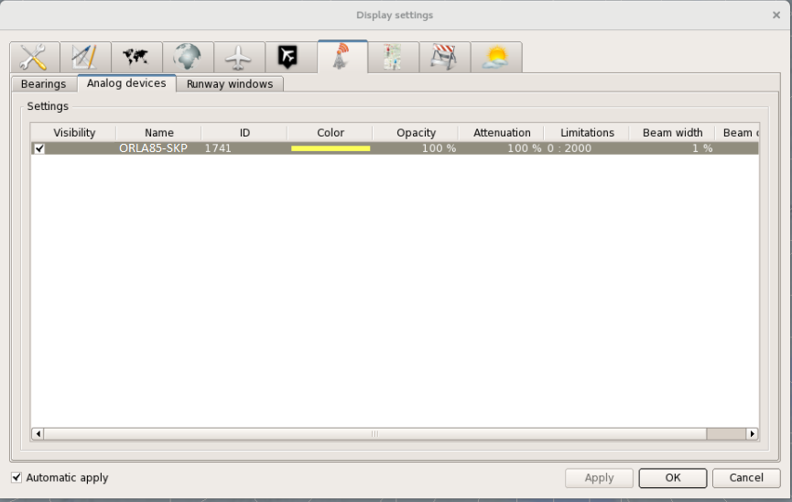
Figure 83 - Tab “Analog devices”
In section “Settings” one may set and adjust information display parameters individually for each source. The analog information display settings for any source are entered by left click on the line containing the source name and on column “Opacity”. Repeated clicking cancels the displayed information on the source.
The adjustable display parameters for analog RD sources are as follows:
- color of displayed analog plots and scanning beam (column “Color”);
- opacity of displayed plots (column “Opacity”);
- scan-wise fading degree of displayed analog plots (column “Attenuation”);
- the range limitations for displaying analog plots from the radar station point (column «Limitations”);
- scanning beam width (column “Beam width”);
- transparency of displayed scanning beam (column “Beam opacity”).
The parameters settings are enabled by double clicking with the left mouse button on respective fields of section “Settings”.
Note – When the fading degree is 0 %, coordinate analog plots for the previous scanning cycles (“traces”) are not deleted at all, and when the fading degree is 100 %, the plots are deleted completely.
The third tab “Runway windows” of level 2 enables setting the display parameters for RW occupancy display panel. An example of the tab is given in Figure 84.
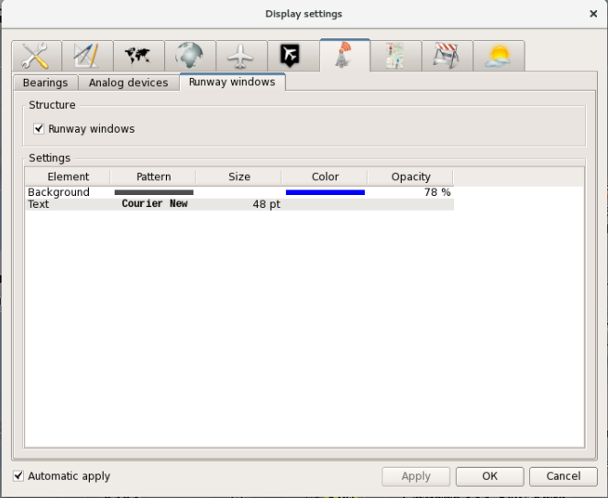
Figure 84 - “Runway windows”
The mode of RW occupancy window/windows (if there are several RWs at the airfield) display is enabled by setting flag “√” in the check box of line “Runway windows». But the essential condition for display of the RW occupancy window is selection of the required airfield and the operating runway in window «Airport” (see Section 2.6.7).
Such parameters as pattern, color and opacity for the background mount of the RW occupancy display panel as well as size and type of the font for RW occupancy designation may be set in field “Settings” of the main section of the tab.

Display settings for flight plan route
Pressing of tab-type button 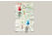 opens the window “Flight plans» to edit the display parameters of flight plan routes in the air situation window. The flight plan routes are called using the special procedures provided for sector lists of the situation indicator sub-system and for tab “Flight plans” in window “Control display” of the radar sub-system.
Besides, the setting parameters of the tab affect the display quality of flight plan routes called directly from TF (by clicking the designation of the next waypoint in the third line or the fourth line of the form or using the menu called upon selection of the A/C coordinate symbol or the free space available in the form).
The top section of the tab window accommodates section «Structure” intended to show/hide the pop-up help related to the flight plan route by clicking with the left mouse button on the check box of line «Tool tips”.
Note – The pop-up help showing the name of flight number is displayed when the mouse cursor is pointed over the flight plan route line.
An example of the window displayed upon selection of tab “Flight plans” is given in Figure 85.
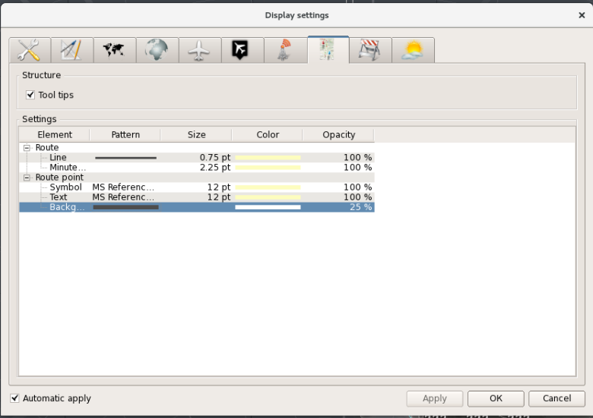
Figure 85 - Tab “Flight plans”
Section “Settings” given below shows the list of tabular elements related to presentation of the flight plan route in the air situation window as well as the current values of display parameters for such elements. Four elements are available: the flight plan route line, the minute notches on route (displayed as point symbols), symbol designations of route reference points (displayed as a triangle) forms next to reference points and background. The adjustable display parameters for them are as follows: line type, line size in typographical points, type and size of font for the form text, size of minute notches, color and opacity. The option for setting the parameters is called by double clicking with the mouse on the current value of the proper parameter in the respective field. Line type is selected from the menu opened using button “▼”. Type and size of font for the form text are set in window “Select font”, color is set in window “Select color”. Opacity level is adjusted using the slide control in column “Opacity”.

Setting display parameters for airspaces
To edit display parameters for airspaces press tab-type button . The window will have the appearance which may slightly vary depending on the selected sub-tab. In total, there are 7 sub-tabs which correspond to 7 zones: MSA, blank, restricted, controlled, airport airspaces, local area control airspaces (LCC) and safety airspaces.
Each sub-tab has sections “Structure” and “Settings”. In many respects, the settings will be identical for all zones.
The appearance of window “Display settings” with tab «Airspaces” and sub-tab “MSA” selected is given in Figure 86.
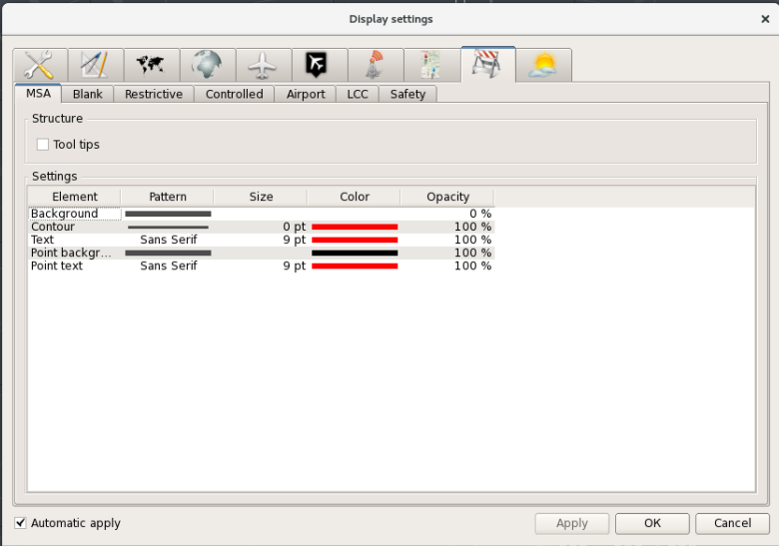
Figure 86 - Sub-tab “MSA”
The pop-up help for airspaces may be enabled/disabled in section «Structure” by clicking with the left mouse button on line «Tool tips”.
Section “Settings” shows current tabular values of various display parameters for airspaces graphic and text elements. The option for setting the parameters is called by double clicking with the left mouse button on the respective table field (where the line containing the element name crosses the column containing the parameter name). For MSA airspaces 5 elements are available: background (this is background area filling of the airspace), contour (the airspace boundaries in the horizontal plane), text containing the data on that airspace, the reference points background and the reference points text.
Note – The reference points are intended for dynamic editing the airspace boundaries right in the air situation window. Such editing is possible at the AWS with administrator’s rights, and usually the editing function is unavailable at air traffic controller’s AWS.
As regards the MSA airspaces, the following parameters may be set at the air traffic controller's AWS:
- type of airspace background filling (column “Pattern”, line “Background”);
- type of airspace contour (column “Pattern”, line “Contour”);
- thickness of airspace contour (column “Size», line “Contour”);
- type and size of font for the form text (columns “Pattern» and “Size”, line “Text”));
- color of displayed elements (column “Pattern”, all lines of the table);
- transparency of displayed elements (column “Opacity”, all lines of the table).
The appearance of the window displayed upon selection of sub-tab “Blank” is shown in Fig. 87.
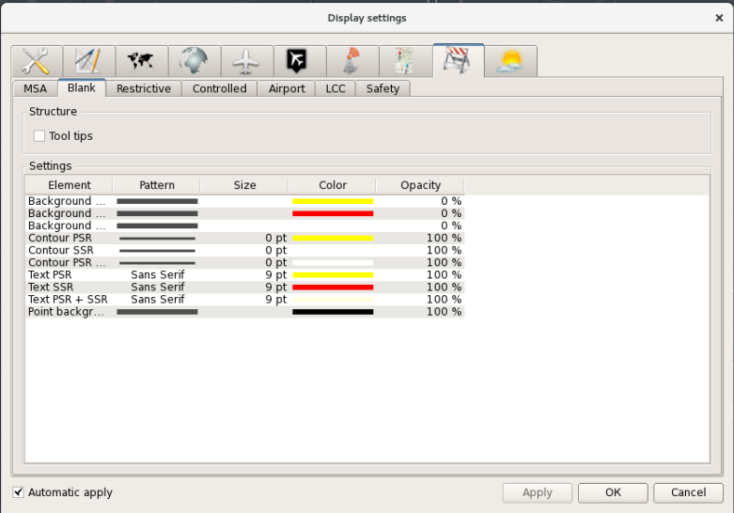
Figure 87 - Sub-tab “Blank”
This sub-tab contains more elements than the previous sub-tab due to that the airspaces for blanking the radar data from various sources (PSR, SSR, PSR+SSR) feature individual display settings. But the underlying setting principle is the same.
Fig. 88 shows sub-tab «Restrictive” intended for setting display parameters of restricted areas.
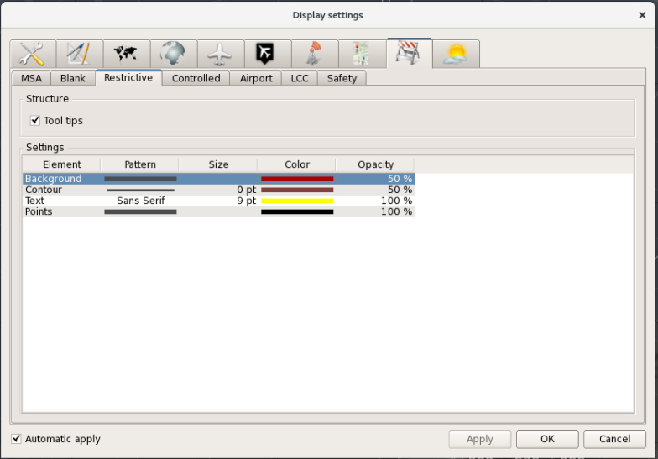
Figure 88 - Sub-tab «Restrictive”
Fig. 89 shows sub-tab “Controlled” intended for setting display parameters of control zones (ATC areas).
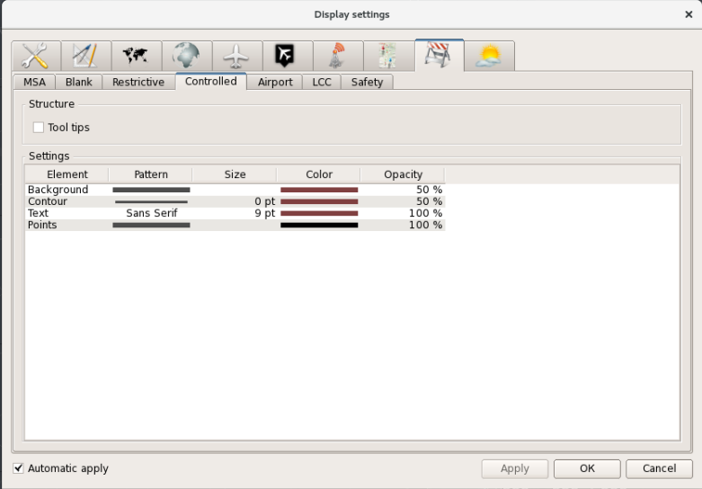
Figure 89 - Sub-tab “Controlled”
Fig. 90 shows sub-tab “Airport” intended for setting display parameters of airfield airspaces.
Note – Airfield airspaces are used in the algorithms intended to recalculate flight altitude and to detect potential conflict situations.
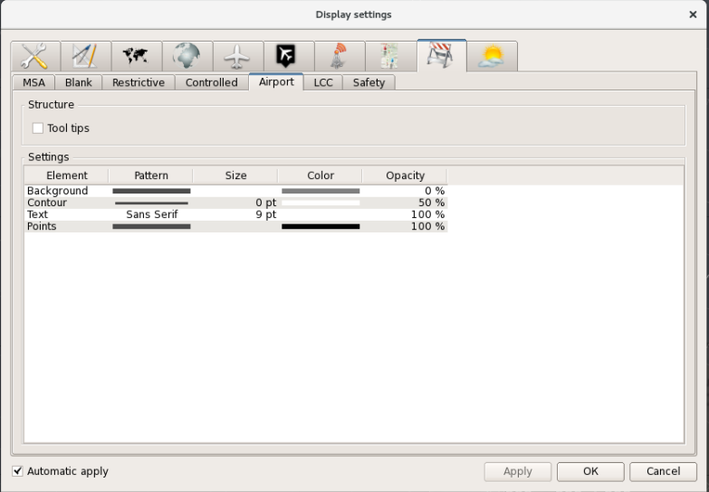
Figure 90 - Tab “Airport”
Figure 91 shows sub-tab “LCC” intended for setting display parameters of the Local Control Center.

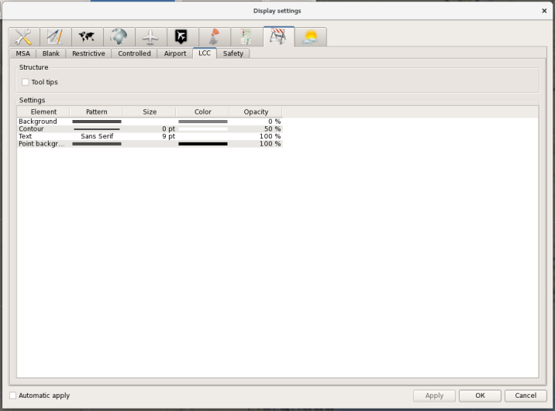
Figure 91 - Tab “LCC”
Figure 91 shows sub-tab “Safety” intended for setting display parameters of the airspaces where the algorithms for detecting conflict situations are effective.
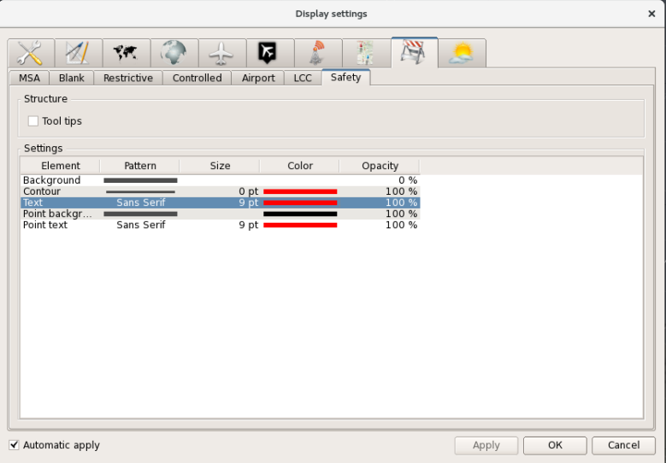
Figure 91 - Tab “Safety”

Setting display parameters for meteorological information
Select tab-type icon “Meteo» 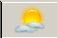to call the control elements for setting the display parameters of the meteorological information in ASW. The meteorological information shown in ASW includes graphic and text information (forms for zones) on dangerous weather events zones received from WSR, on launched radiosonde balloons and SIGMET messages.
The example of the information displayed upon selection of tab “Phenomena” and sub-tab “DWP” (dangerous weather phenomena) is given in Figure 92.
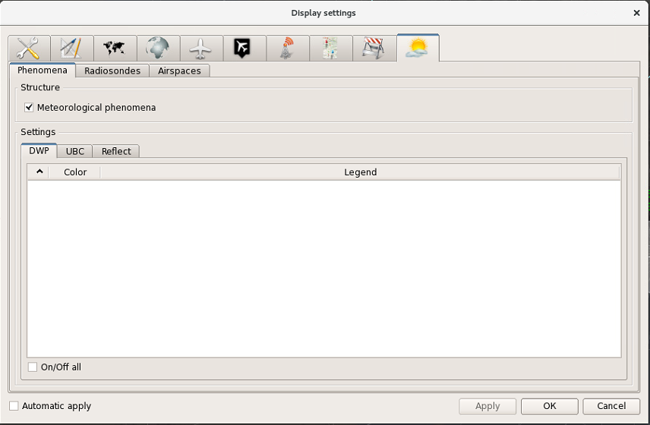
Figure 92 - Tab “Phenomena”, sub-tab “DWP”
The mode of weather events display in the air situation window is enabled by clicking with the left mouse button on the check box “Meteorological phenomena” within section «Structure”. As a result, a flag, i. e. a check mark will be set in the check box. Repeated clicking with the left mouse button will cancel the weather events display mode.
If a specific event from those listed in the tabulated form in section “Settings” is to be set, set a check mark in the check box located in the beginning of the respective line. Using the check box “On/Off”all” shown below, one may show or hide all weather events at a time.
The color selection box for the selected weather event is opened by double mouse click on the respective square in column “Color”.
An example of the window displayed upon selection of sub-tab “UBC” (upper border of cloud) is given in Figure 93.
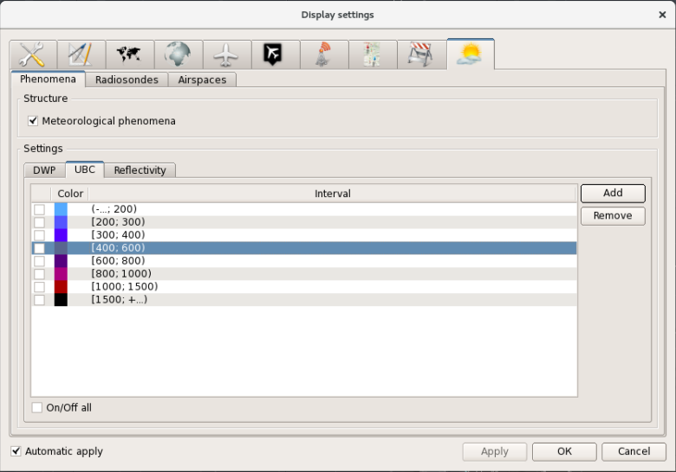
Figure 93 - Tab “Phenomena”, sub-tab “UBC”
To show/hide individual UBC elements (border of cloud by height), set or remove a check mark in the check boxes located in the beginning of the respective line. The line designates the interval (the altitude layer) the cloud top of a cloud segment shall fit into. For each altitude layer an appropriate color may be set, and the respective UBC element will be highlighted in that color in the air situation window. The color selection box is opened by double mouse click on the respective square in column “Color” to set the required color. The shared check box ““On/Off all” enables or disables all altitude layers.
To add a new layer, press button “Add”. A window will appear where one may set the upper limit for the altitude layer.
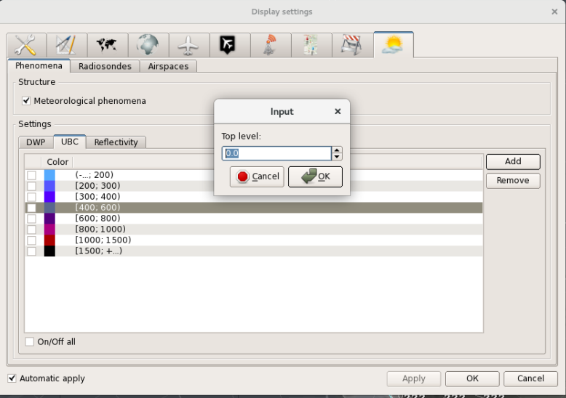
Figure 94 - New layer input window
A new element is added to the window by pressing button “ОК”. To delete the element, select it and then press button “Remove”.
An example of the window displayed upon selection of sub-tab “Reflectivity” is given in Figure 95.
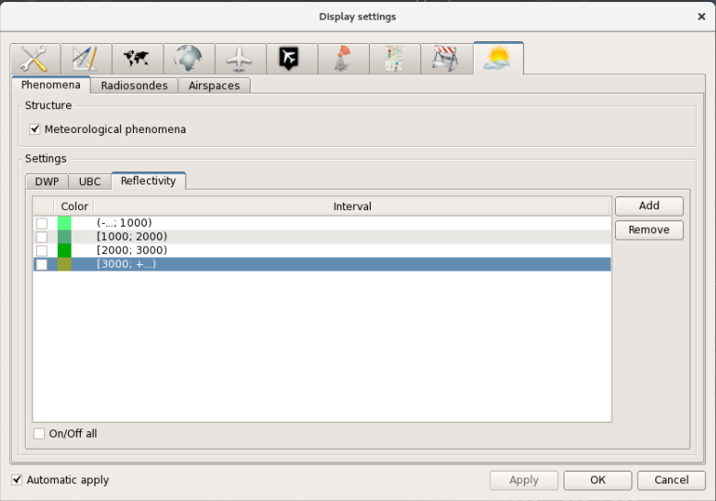
Figure 95 - Tab “Phenomena”, sub-tab “Reflectivity”
The listed elements are handled the same way as in tab “UBC”
An example of the window displayed upon selection of tab “Radiosondes” is given in Figure 96.
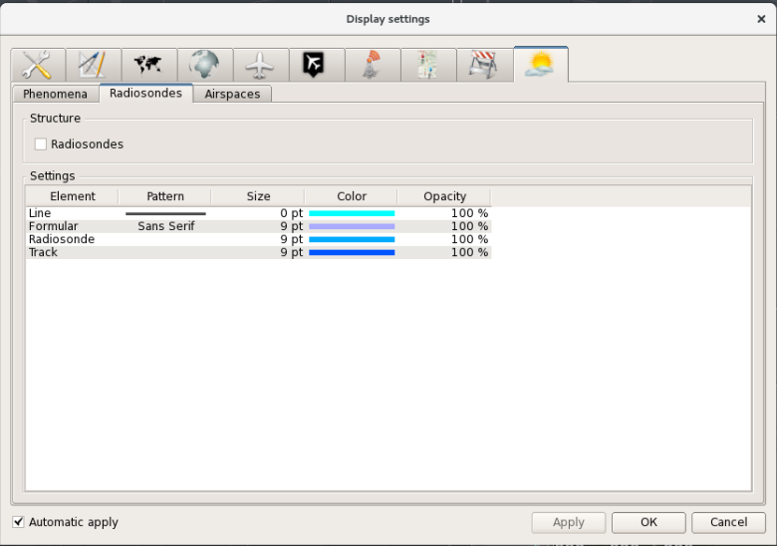
Figure 96 - Tab “Radiosondes”
The check box of field «Structure” is intended to show/hide the data on radiosondes displayed in ASW.
In section “Settings” one may enter the display settings for line (offset trajectory), form, symbol and track of radiosonde. One may set line type (solid line, dashed line, dotted line), line size, size and type of font for form, size of balloon probe and track symbols, display color for all elements. The setting procedure is initialized by double clicking on the respective field of the given section.
An example of the window displayed upon selection of tab «Airspaces” is given in Figure 97.
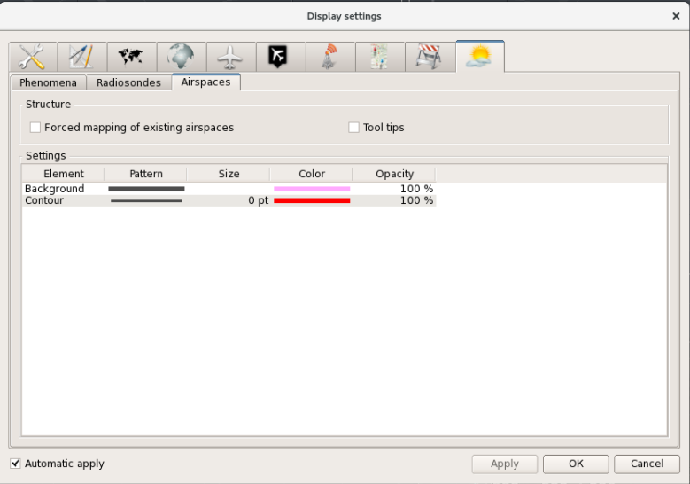
Figure 97 - Tab «Airspaces”
This tab enables display setting for the airspaces created on the basis of text SIGMET weather messages. The setting procedures are similar to those described in Section 2.5.9 for MSA airspaces, blanking zones, restricted flight areas, etc.

Display settings for window “Zoom”
Special functional window “Display settings zoom-window” is used for display setting. The window is called by pressing button in the right top section of window “Zoom”. An example of the window is given in Figure 98.
Actually, window “Display settings zoom-window” is a brief form of window “Display settings” for the main air situation window.
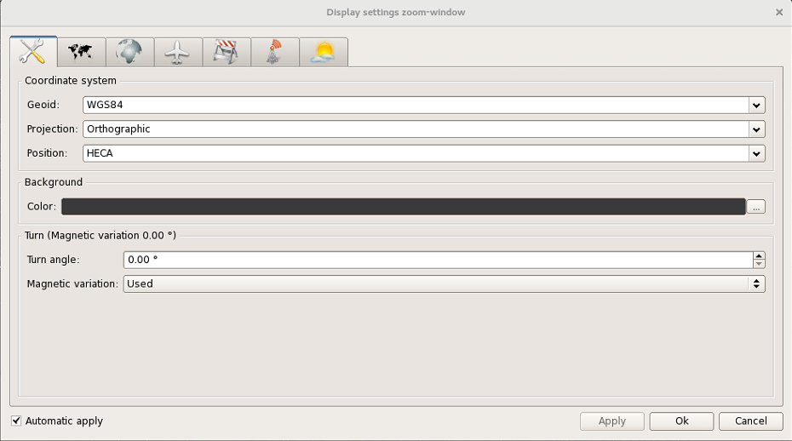
Figure 98 - Window “Display settings zoom-window”
The window has seven tabs intended for setting general display parameters, display parameters for mapping information, aeronautical information, information on A/C being tracked (tracking forms and tracks), information on airspaces, devices and meteorological phenomena display parameters. The way these tabs are presented and the procedures of display elements setting using the tabs are completely similar to those above described for window “Display settings”.

Auxiliary display control windows
Pressing of button in the main menu displays the menu containing the list of auxiliary windows including tabular list boxes. An example of the menu is given in Figure 99.
The enabled option for calling the respective window is indicated by symbol “√” in the beginning of the line.
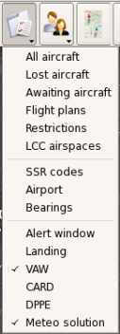
Figure 99 - List menu
This menu contains the following elements:
Line “All aircraft”– to show/hide table-based window “All aircraft”;
Line “Lost aircraft” – to show/hide table-based window “Lost aircraft”;
Line “Awaiting aircraft” – to show/hide table-based window “Awaiting aircraft”;
Line “Flight plans” – to show/hide table-based window “Flight plans”;
Line “Restrictions” – to show/hide table-based window “Restrictions”;
Line “LCC airspaces” - to show/hide table-based window on LCC airspaces pressure settings
Line “SSR codes” – to show/hide table-based window “SSR codes”;
Line «Airport” – to show/hide window «Airport”;
Line “Bearings” – to show/hide table-based window “Bearings” (see Section 2.1.4);
Line “Alert window” – to show/hide table-based window “Alert window”;
Line “Landing” – to show/hide landing glide slope and heading windows (see Section 2.1.10);
Line “VAW”-vertical assistance window – to show/hide vertical assistance window;
Line “CARD” - conflict and risk display” – to show/hide window “CARD”
Line “DPPE” – to show/hide window “DPPE”;
Line “Meteo solution”– to show/hide table-based window “Meteo solution”.

A/C list
When option “All aircraft” is selected, table-based window “All aircraft” appears. Window “All aircraft” contains the list of all A/C locked-on for radar tracking in the controlled airspace. An example of the window is given in Figure 100.
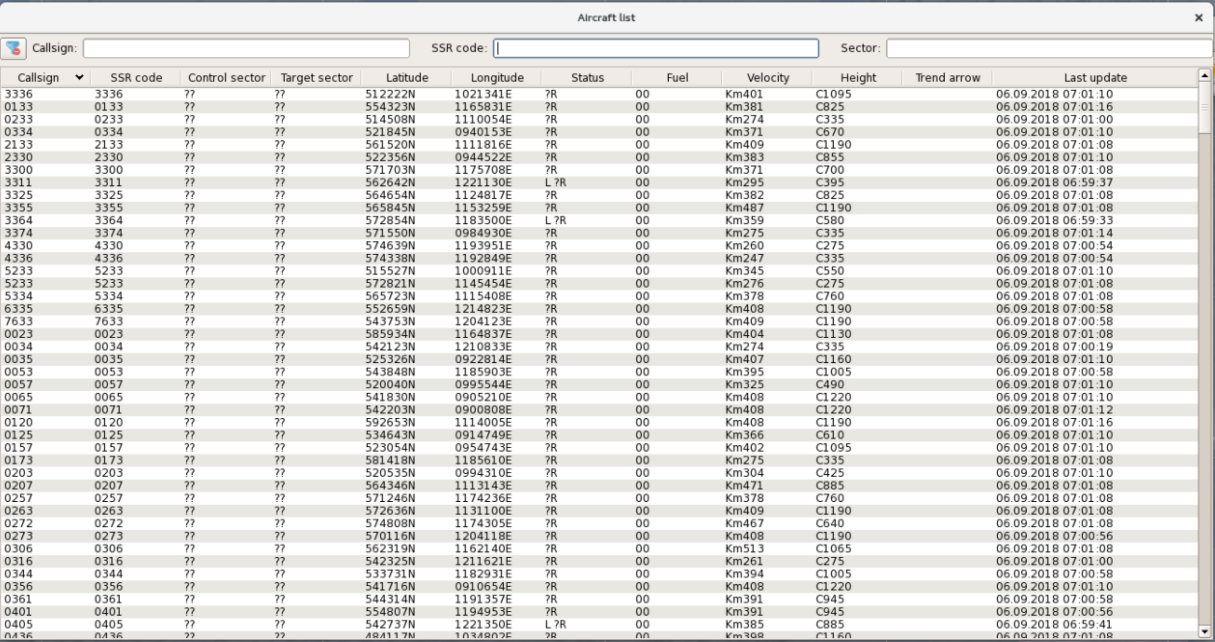
Figure 100 - Window “All aircraft”
Repeated selection of menu line “All aircraft” clears the same-name window from the display. The window can be also cleared by simultaneous pressing of keys “Alt” and “F4” on the keyboard.
The top section of the window accommodates 3 display panels for selection of a group of A/C (A/C filtration) by one of specified criteria.
Below is presented the tabular list of aircraft currently being under radar tracking in ATC AS. Each A/C is assigned an individual table line.
The following filtration options for the list of tracked A/C are provided:
- by call sign “Call sign”;
- by transponder code “SSR сode”;
- by control sector “Sector”.
To carry out filtering by one of above parameters, enter a letter or a digit that may be found in the required flight number, transponder code or designation of the control sector (not necessarily the initial letter or digit) to the respective display panel. In this case, all A/C whose callsign, transponder code or sector index contains the specified letter or digit will remain in the list. Figure 101 shows an example of selected A/C whose transponder code contains digit “33”.
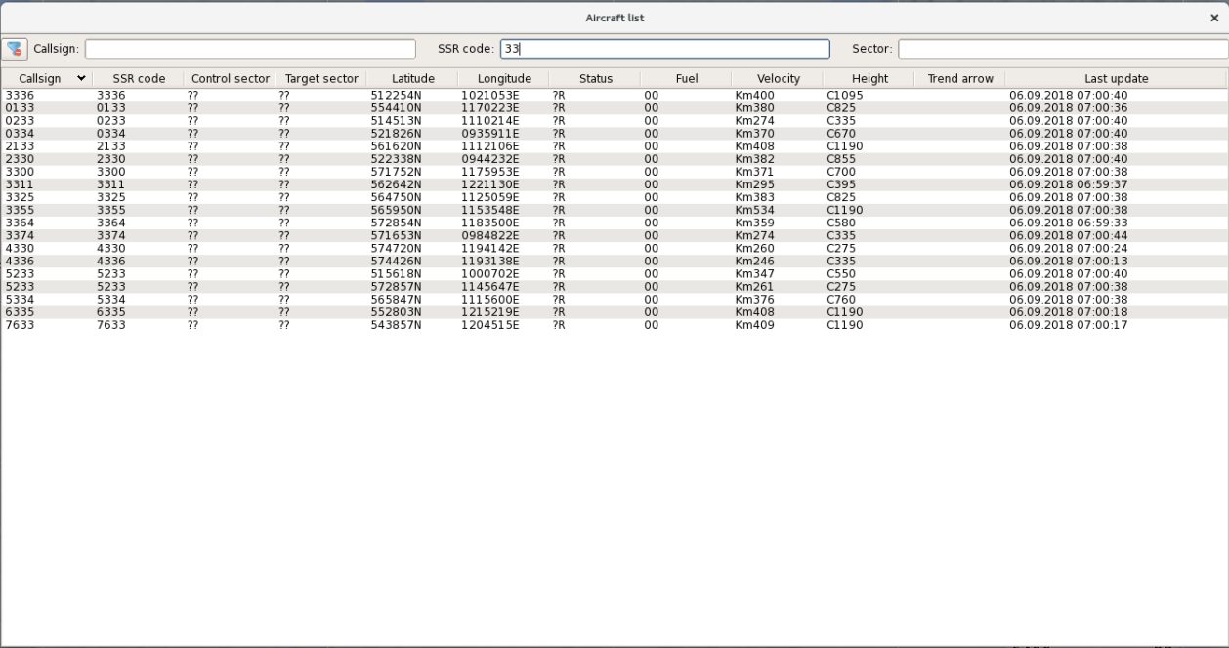
Figure 101 - Window “All aircraft” containing A/C selected by a SSR сode
If the second letter or a digit is further entered, only those A/C whose callsign, transponder code or sector index have the specified combination of symbols will remain in the list. The same is for entry of the third letter or digit and the next letters or digits.
The number of columns in the list is an adjustable parameter. To that end, point the mouse cursor over the functional line containing names of columns, and press the right mouse button. Special display panel containing names of columns will be displayed. An example of such display panel is given in Figure 102. Set flag “√” in any line to add the associated parameter to the A/C list. Repeated selection of the line deletes the above flag and the respective column from the A/C list.

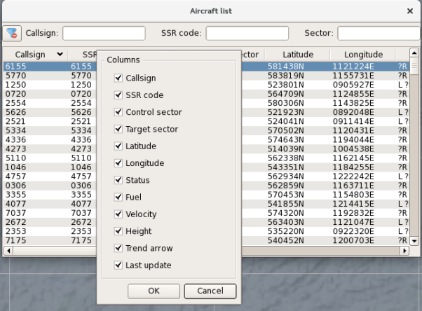

Figure 102 - Menu for setting window “All aircraft”
The list may comprise 12 columns maximum.
The A/C call sign (flight number) given in the flight plan or entered to TF using function “New Callsign” is specified in column “Callsign”.
The SSR transponder code (matching the aircraft number adopted in the native secondary radar system) is specified in column “SSR code”.
The current control sector for A/C is given in column “Control sector”.
Column “Target sector” specifies the adjacent control sector activated during manual or automatic control transfer.
Column “Latitude” specifies the current geographical coordinates of A/C (latitude).
Column “Longitude” specifies the current geographical coordinates of A/C (longitude).
Column “Status” contains flags “L” (tracking of A/C is lost, and A/C is included in the list of losses) and “R” (A/C is properly equipped to perform flights according to the RVSM rules). If A/C status is not clear as regards the RVSM rules (for example, a flight plan is missing for A/C), symbol “?R” is entered. If A/C is not properly equipped to perform flights according to the RVSM rules, the field is blank.
Column “Fuel” specifies remaining fuel if this information is received from the airborne transponder.
Column “Velocity” specifies current ground speed of A/C.
Column “Height” specifies current flight-level pressure altitude received from the airborne transponder (the standard one or the one based on airfield pressure when A/C is located within the take off and landing zone of the major airfield).
Column “Trend arrow” specifies the designation of flight altitude variation tendency. If A/C is climbing, the column shows inscription “Climb». If A/C is descending, the column shows inscription “Descent”.
Column “Last update” specifies the time of the last update of data on A/C.
From window “All aircraft” one may take over control of A/C, set a new callsign, transfer and take over control of A/C, change the RVSM status (in addition to similar procedures performed using TF).
To take over control of A/C, point the mouse cursor over field “Control sector”, and press the right mouse button. Display panel “Get control” will appear. Left click on the display panel. Designation of the sector will appear in the above mentioned field and in TF.
Note – Control takeover is only possible for A/C without control sector, i. e. with designation “??” in field “Control sector”.
To remove A/C from control, point the mouse cursor over the designation of the “own» sector in field “Control sector” (for “other’s” sectors the function is not active), and press the right mouse button. The two-line menu “Transfer control/Drop control”) will appear. Select line “Drop control” in this menu. The sector index will be cleared from this field and from TF.
To enter a new call sign, point the mouse cursor over field “Callsign”, and press the left mouse button – display panel “New” will appear, wherein enter the proper alphanumeric designation using the keyboard, and press key “Enter”. The entered value will be displayed in field “Callsign”, and in the first line of TF.
To transfer control, point the mouse cursor over field “Control sector” (the field shall contain the designation of the «own» sector otherwise it would be not possible to perform operations from the control panel), and press the right mouse button. The two-line menu «Transfer control/Drop control» will appear. Select line “Transfer control” in this menu. Window “Sector” showing designations of the ATC sectors will be displayed. In this menu select the required sector designation by double clicking with the mouse. As a result, the specified sector designation will be displayed in field “Target sector”, and TF will be changed over to the transfer mode with additional blinking mode at the air traffic controllers AWS that takes over control.
To take over control of A/C, point the mouse cursor over field “Control sector”, and press the right mouse button. Display panel “Get control” will appear. Left click on the display panel. The designation of “own” sector will be displayed in field “Control sector”, while field “Target sector” will show designation “??” and control transfer according to TF will be complete.
To set the RVSM flag for A/C, point the mouse cursor over field “Status”, and press the right mouse button. Display panel “Enable RVSM” will appear. Left click on the display panel. The indication in the above field and in TF will change accordingly.

Window “Lost aircraft”
The list of losses contains information on those A/C which were under control within the given sector (the given AWS) and for which radar tracking was lost and tracking according to function «Track by plan” is not used. An example of the displayed list of losses is given in Figure 103.
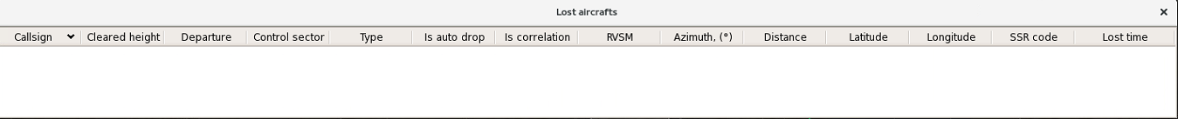
Figure 103 - Window “Lost aircraft”
The list of losses is displayed automatically provided it contains information at least on one A/C. The list cannot be cleared from the display if it contains data lines related to A/C. The blank list of losses can be displayed when the respective line in the list box menu is selected. The list can be automatically cleared from the display when data lines are automatically or manually removed from the list.
Note – When the radar path (including radar data sources, RD transmission channels and radar data processing module within the complex) operates normally, information on A/C is transferred from TF to the list of losses every 3–4 scanning cycles when no radar data is available. When the radar path operates abnormally (in case of its failures) (“hanging up” of the radar track) data is transferred in 3 minutes after the last updating of radar data on the track.
The list of losses contains information on “own” A/C, i. e. on A/C which were under control within the given sector, and whose TF showed the ID for the given sector at the moment when tracking failed.
The time of A/C data display in the list of losses may be limited – the line is automatically cleared from the display with the preset time interval after the A/C is added to the list of losses. But the air traffic controller may disable automatic clearing of the line from the control panel.
Note – The time of A/C data display in the list of losses is an adjustable system parameter, herewith an individual parameter may be set for each control sector. Individual settings may be entered from the AWS of the technical control and monitoring system.
Each information line of the list of losses displays the following data:
- A/C call sign (field “Callsign”);
- target flight altitude expressed in tens of meters or hundreds of feet (if altitudes are displayed in feet according to the workstation settings) with letter symbol “C” or “F”, respectively (field “Cleared height”);
- destination airport (field “Arrival point”);
- identifier of the current control sector (field “Control sector”);
- flag indicating the type of previous A/C radar tracking (field “Type” – if symbol “S” is set, A/C was tracked via the SSR channel, if symbol “P” is set, it indicates A/C tracking via the PSR channel, if symbol “A” is set, A/C was tracked according to the ADS information;
- flag indicating that automatic clearance of line by time is disabled (field “Auto”). If symbol “√” is set, automatic clearance of the line is disabled, if the field is blank, automatic clearance of the line is enabled;
- flag of previous correlation of plan information and radar data on A/C (field “Correlation”). If flag “√” is set, it indicates correlation of radar data and plan information, if the field is blank, there is no correlation;
- flag indicating that A/C is not fitted with the equipment essential for flight performance according to reduced vertical separation minimum (field “RVSM”). If the field is blank, it indicates that A/C is not fitted with the required equipment. If the field contains flag “R», the A/C is fitted with the equipment, if the field contains flag “?”, information on the equipment is missing;
- azimuth and range to A/C location relative to ARP at the moment when radar tracking is lost (range is expressed in kilometers with flag “m» or in nautical miles with flag “N” subject to the measurement system for the given parameter implemented at AWS) (fields “Azimuth” and “Distance”);
- geographical coordinates (latitude and longitude) of A/C location at the moment when radar tracking is lost (fields “Latitude” and “Longitude”);
- transponder code (field “SSR сode”);
- time of A/C being in the state of lost tracking expressed in minutes and seconds (field “Time since loss”).
The number of columns in the list (and the specific data in the list, respectively) is an adjustable parameter. To that end, point the mouse cursor over the functional line containing names of columns, and press the right mouse button. Special display panel containing names of columns will be displayed. Set flag “√” in the respective line to add the associated parameter to the list of losses. Repeated selection of the line deletes the above flag and the respective column from the A/C list.
The control functions associated with the list of losses can be activated through the functional menus called by clicking with the right mouse button when the mouse cursor is pointed over the respective field of the selected line in the list of losses. The following operations may be performed from the control panel: input of a new callsign, input of target altitude, setting/clearing of RVSM flag, input of the flag indicating that automatic clearance of the line in the list of losses is disabled, A/C control takeover and transfer, activation of function «Track by plan”, and the line referencing to the A/C track.

Window “Awaiting list”
The pending list shows the information on those A/C for which the air traffic controller does not consider it expedient to use TF, for example, due to continuous overlapping of the forms for A/C located within the pending zone. The list is generated manually from the control panel.
The air traffic controller can transfer TF on any A/C being under his control to the pending list. Herewith, the form is cleared from the display, and the number corresponding to the number of the information line included in the pending list is displayed next to the A/C coordinate symbol.
Note – In case any alarms (PCS, transmission of emergency signals via the SSR channel, entry to the prohibited zone) are to be issued for the A/C whose data is transferred to the pending list, the displayed TF are restored automatically (and highlighted in the appropriate color) provided that the line related to A/C remains in the pending list. When the emergency situation is eliminated, the TF disappears from the display.
Each line of the list displays the following information:
- the number corresponding to the number displayed next to the coordinate symbol of the A/C (field “№”);
- A/C call sign (field “Callsign”);
- SSR transponder code (field “SSR сode”);
- correlation flag with flight plan (field “Correlation”). If flag “√” is displayed, correlation occurs, if the field is blank, there is no correlation;
- flag indicating that A/C is fitted/not fitted with the equipment essential for flight performance according to RVSM rules (field “RVSM»). If A/C has the clearance to flight according to the RVSM rules, letter “R” is displayed in the field. If the field is blank, the A/C has no clearance to flight according to the rules, if symbol “?” is displayed, information on the A/C equipment is missing;
- current flight altitude expressed in tens of meters or hundreds of feet with letter symbol corresponding to the metric measurement system (“С”) or the foot measurement system (“F”) implemented at the AWS as well as the flag of flight altitude variation tendency (field “Height”);
- target flight altitude expressed in tens of meters or hundreds of feet with letter symbol corresponding to the metric measurement system (“С”) or the foot measurement system (“F”) implemented at the AWS (field “Cleared height”);
- destination airfield (field “Arrival point”);
- designation of the control sector (field “Control sector”);
An example of displayed window “Awaiting list” is given in Figure 104.
Figure 104 - Window “Awaiting list”
The number of columns in the table (and the specific data in the pending list, respectively) is an adjustable parameter. To that end, point the mouse cursor over the functional line containing names of columns, and press the right mouse button. Special display panel containing names of columns will be displayed. Set flag “√” in the respective line to add the associated parameter to the pending list. Repeated selection of the line deletes the above flag and the respective column from the table.
The control functions associated with the pending list can be activated through the functional menus called by clicking with the right mouse button when the mouse cursor is pointed over the respective field of the selected line in the pending list. The following operations may be performed from the control panel: input of a new callsign, input of target altitude, setting/clearing of RVSM flag, return to the TF display, A/C control takeover and transfer.

LCC airspaces pressure
LCC airspaces window contains a table with all zones of local control centers. For each zone, a height (H, QNE) corresponding to the standard atmospheric pressure of 760 mm Hg (1013 GPa) is set in window «Configurator». However, when flying under pressure normalized to sea level in a standard atmosphere (QNH), the controller enters the value of this pressure into the corresponding column of the table. In the last column, the altitude is recalculated according to QNH pressure (informative field).
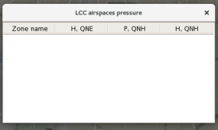
Figure 111 – Window “LCC airspaces pressure”

Window “SSR codes”
Window “SSR codes” is intended to monitor the use of codes provided for the ATC area.
The window is divided into 4 parts to display various types of secondary radar codes:
- local codes (to be used within the own area);
- transit codes (to be used within the respective coordinated SSR codes assignment zone – for example, in the territory of Russia);
- super-transit codes (to be used during flights on the global scale; there is no need to change the codes when crossing the border of Russia);
- forbidden codes (it is not recommended to use them under standard ATC situations).
Codes are entered or deleted using the configuration control window («Configurator”) at the AWS of technical control and monitoring system. Only the preliminary code occupancy may be set in the window.
The borders between cells can be shifted by means of the mouse.
Each code is assigned a relevant cell. The used code on the basis of which A/C with the same SSR code was detected in the controlled airspace is highlighted in green color. The code remains highlighted in color even after the respective A/C leaves the area provided that the A/C is within the coverage area of the radar facilities interfaced with ATC AS “Topaz”. The reserved codes are highlighted in grey or blue. The reservation function is enabled when the air traffic controller considers it necessary to mark this code as occupied before the A/C enters the zone or before the A/C leaves the zone. The reserved code is stored for 20 minutes (the time for a parameter adjusted in the off-line mode may be increased to 30 or 60 minutes).
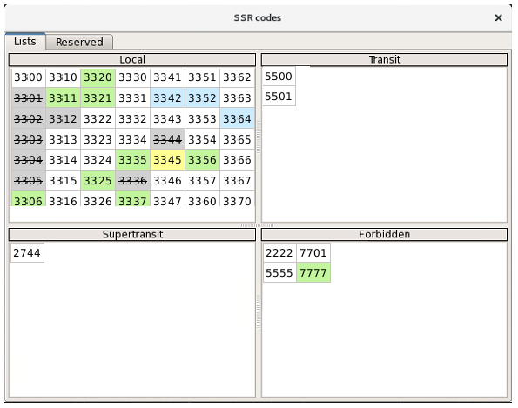
Figure 111 Window “SSR codes”
The codes reserved at the AWS are highlighted in blue. The codes reserved at another workstation are highlighted in grey. The code reservation function is executed as follows: point the mouse cursor over the required cell, and press the right mouse button. Display panel “Reserve” will appear. Left click the display panel. The reservation function is cancelled in a similar way, the only exception is that display panel “Unreserve” is used in this case. Herewith, reservation may only be cancelled for the codes reserved at this workstation.
Note – Codes can be reserved automatically, and cells in window “SSR codes” are filled with the appropriate color when the flight plan is activated and a “unoccupied” SSR code is entered to the ACT or ETD window (for the A/C leaving the zone).
The codes which initialized the algorithm for double codes detection in the controlled airspace are highlighted in yellow.
The indication of occupancy for the codes related to A/C which left the ATC area or to A/C whose associated radar data is lost remains on the screen for the next two hours after the radar tracking is lost. This a variable system parameter. Such indication consists in highlighting the cell background in grey color, and crossing out the code value, for example: 3317.
As for reserved codes, one may view the information on the AWS (sector) where the reservation procedure was completed, the time of the procedure execution and the time remaining until the code is changed to the “unoccupied» state. To that end, just point the mouse cursor over the cell containing the reserved code, after which the special display panel shown in Figure 112 will be displayed.
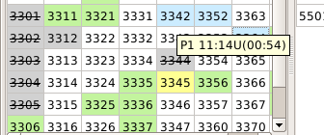
Figure 112 Display panel containing the data on the reserved code
Example: “Р1” – the sector where the code reservation procedure was completed, “11:14U” – time relative to UTC when the reservation procedure was performed, “(00:54)” – remaining time of the code keeping in the reserved state.
Besides, the information on reserved codes can be viewed in the tabular form. To that end, select tab-type button “Reserved” (see Figure 113).
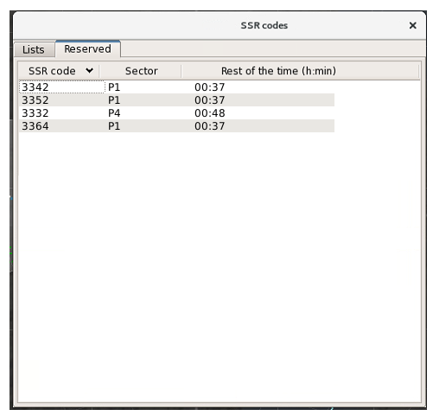
Figure 113 - Tab “Reserved”

Window “Airport information”
Window “Airport information” (also referred to as “display panel of airfield system parameters”) is used for continuous representing the current data on airfield pressure, transition flight level, operating RW (RWs) and the starting point of airfield pressure recalculation at the workstations (within the complex) supporting such function.
An example of the window is given in Figure 114.
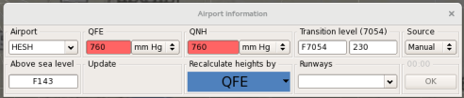
Figure 114 - Window “Airport information”

The display panel has the following fields:
«Airport” which shows a four-letter designation of the airfield whose parameters are viewed or edited;
“QFE” which shows current atmospheric pressure at the airfield level expressed in millimeters of mercury or hectopascals;
“QNH” which shows current atmospheric pressure at the airfield level normalized to the sea level and expressed in millimeters of mercury or hectopascals;
“Runways” which shows the designation of operating RW (RWs);
“Recalculate heights by” which shows the designation of pressure type (QFE or QNH), which is currently used to recalculate flight altitudes within the airfield zones below the transition flight level;
Update - if information on the last update is available it will be displayed in the corresponding field.
“Above sea level” – airfield altitude relative to the sea level in meters or feet depending on the measurement system implemented at the workstation;
“Transition level” which shows the current transition flight level in meters or feet relative to the standard pressure as well as the value of correction in meters or feet to calculate the starting point of flight altitude recalculation based on airfield pressure and recalculation of measurement system change altitude level (MSCAL) for the combined mode “Feet + meters” representing altitudes and flight levels. While calculating the above starting point and MSCAL, this correction is subtracted from the value of transition flight level. Besides, the header of this field (in parentheses) shows the value of transition flight level recalculated based on airfield pressure.
“Source” which allows to choose the source of pressure information:
- “Manual” - pressure value is entered manually;
- “Meteo” - pressure will be obtained automatically from the meteorological subsystem.
The right section of the display panel accommodates button “ОК” used to enter new values of airfield parameters to the system.
Notes
1. If the property of altitude representation in feet is set for AWS, the respective parameters are displayed in feet in fields “Transition level” and “Above sea level”, otherwise, the parameters are displayed in meters.
2. The values of transition flight level and the values of current flight altitudes received from A/C airborne transponders are recalculated in the system from standard pressure to airfield pressure according to the table of standard atmosphere. According to the table, 1 mm Hg corresponds to a variable value of altitude in the range of 11.2-12.2 meters for standard airfield zones.
3. Designations “QFE” or “QNH” displayed in field “Recalculate heights by” are highlighted in color. QFE is highlighted in blue, QNH is highlighted in green.
To view or modify the effective values of airfield parameters for an airfield entered to the system, press button in field «Airport” to call the menu containing the list of airfield designations, and select the required airfield in the menu. The parameters effective for the airfield (pressure, operating RW, transition flight level and the airfield altitude above the sea level) will be displayed in the relevant fields of the display panel.
To enter new values of airfield parameters for the selected airfield, click the relevant field of the display panel (“QFE”, “QNH”, “Runways” or “Transition level”, delete the old value and enter a new value of the respective parameter from the keyboard). To enter new values of airfield parameters to the system, press button “ОК». In this case, values of transition flight level shall be entered with an accuracy of up to 1 meter or 1 foot but not in tens of meters or hundreds of feet.
To modify the system of airfield pressure (“QFE” or “QNH”), which shall be used to recalculate flight altitude in the airfield zone below the transition flight level, press button “▼” in the right section of field “Recalculate heights by”. The two-line menu shown in Figure 115 will be displayed. The effective parameter is indicated by flag “√”. To select an alternative variant, click on the adjacent line with the left mouse button.
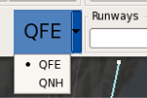
Figure 115 - Menu for selection of airfield pressure measurement system
The measurement system for airfield pressure values (millimeters of mercury or hectopascals) may be changed individually for QFE and QNH. To that end, press button “▼” in the required field. The two-line menu will be displayed: “mm Hg/hPa” where the required line is to be selected by clicking it with the left mouse button.
If atmospheric pressure is changed from QFE to QNH, the timer will start. An operator has 30 seconds to apply changes otherwise the pressure returns to QFE.
The RW occupancy display panel may be called or cleared from the airfield parameters display panel. To that end, press the right mouse button when the mouse cursor is pointed over field “Runway”. Display panel “Show runway windows” will appear. The example is given in Figure 116.
Calling of RW occupancy display panel
Figure 116
Repeated execution of the above procedure disables the RW occupancy display panel.

RW occupancy display panel
The RW occupancy display panel indicates occupancy or unoccupancy of RW at the major airfield of the area. The number of display panels corresponds to the number of RWs currently operated at the airfield which is specified in the aeronautical data on the respective airfield. Each display panel is a green inscription “RW№ vacated” or red inscription “RW№ occupied” subject to the flag entered from airdrome control tower (“Tower”) AWS or another air traffic controller’s AWS that supports such a function. Along with RW letter designation, the display panel shows the numeric designation of landing heading (the designation is extracted from the set of aeronautical data on the airfield; the data can be viewed in window “Display settings”). Font size and type, background color of the display panel and transparency of the display panel are set in functional window “Display settings”. The RW occupancy display panel may be displayed/not displayed at the workstation according to the settings available in window “Display settings” (tab «Devices», sub-tab “Runway windows”), and in window “Airport information” as described above.
An example of the display panel for one operating RW is given in Figure 117.
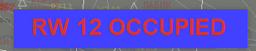
Figure 117 - RW occupancy display panel
An example of the display panel for two operating RWs at one airfield is given in Figure 118.
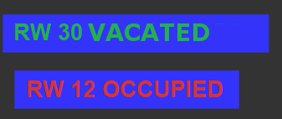
Figure 118 - Occupancy display panel for two RWs
Each display panel can be moved across the screen. To that end, point the mouse cursor over any letter or number in the relevant inscription, press the left mouse button and without releasing the button move the mouse to drag the display panel to the proper area of the indicator screen.
RW occupancy/unoccupancy may be promptly set by calling the relevant display panel. To that end, point the mouse cursor over the display panel with inscription “RW№ occupied” or “RW№ vacated”, and press the right mouse button. The special display panel with inscription “Set vacated” or “Set occupied” will appear subject to the current RW occupancy state. When the display panel is clicked with the left mouse button, the current RW occupancy state will be changed from “RW№ occupied” or “RW№ vacated” and vice versa. An example of the respective display is given in Figure 119.

Figure 119 - RW occupancy setting

Vertical assistance window
The window presents location of the selected A/C in the vertical plane and indicates a conflict situation (if there are any) with another A/C, or with one of allocated zones (for example, with the restricted flight area or with the MSA zone). To call the window, select functional line “Vertical assistance window” in the list box menu. An example of the window is given in Figure 120.
In this window the time scale is represented by the horizontal axis, while the altitude scale is represented by the vertical axis. The altitude scale is a flight level indicator according to the effective separation system. Altitude may be displayed in hundreds of feet or tens of meters subject to the measurement system implemented at the workstation. The time scale is adjusted in a part of the viewed range. The minimum value is 1 hour, the maximum value is 8 hours.
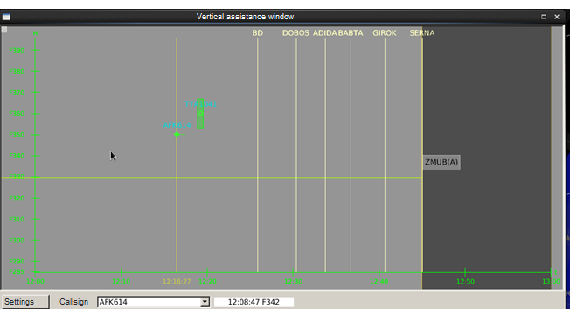Figure 120 - Vertical assistance window
For the altitude scale the options of scrolling and changing the scale are provided. For scrolling the scale, point the mouse cursor over the field of the altitude scale, press the left mouse button (the cursor takes on the appearance of a hand) and without releasing the button move the visible part of the scale to the required direction (up or down). Using the scroll wheel (“scroll”) with the left mouse button pressed, one may expand or shrink the altitude scale, i. e. change scale range.
There is button “Settings” at the bottom left part of the window. On the right of the button there is a field to select A/C for current viewing in the vertical section window (field “Callsign”) and a field to display the data on current position of the mouse cursor in the vertical assistance window. This is the data on time (in hours, minutes, seconds) and altitude. According to the example given in Figure 120, position of the arrow-shaped mouse cursor corresponds to time 12:08:47 and altitude of 34,200 feet.
The informational part of the window shows current time line, lines corresponding to location of the points (CRPs) along the flight route (for A/C referenced to the flight plan), horizontal or polygonal line corresponding to the planned flight path in the vertical area (for A/C referenced to the flight plan), track information on the selected A/C and on head-on A/C along its flight route, graphic images and names of prohibited zones, MSA zones, control zones and meteo zones along the flight route.
A/C tracks are designated with coordinate symbols appropriate for the air situation window. For a track of the selected A/C an extrapolation vector can be displayed a minute earlier. During level flight the vector has the horizontal direction. In climb or descent, the vector is drawn at an upward angle or at a downward angle, respectively. The track form displays its callsign (flight number). The airspace form shows the zone ID. Next to the A/C coordinate symbol its transponder code or callsign is displayed. A call sign is displayed provided that plan information and radar data on A/C are correlated or the call sign is specified using function “New Callsign”. For opposite-direction traffic the safety zone is displayed relative to the coordinate symbol taking into account the separation rules effective for A/C that makes it possible to decide if the selected A/C interferes the safety zone of the head-on A/C in the vertical plane.
Location of A/C in the vertical section window is determined based on the current flight altitude, and based on target flight altitude if the data on current flight altitude is missing. The procedure applies to the track according to the flight plan as well. If no data on current and target flight altitudes is available, the A/C track is displayed on the time scale.
Figure 121 shows an example of the displayed restricted flight area (MR121) along the flight route of the selected A/C (SAS276 in the given example).

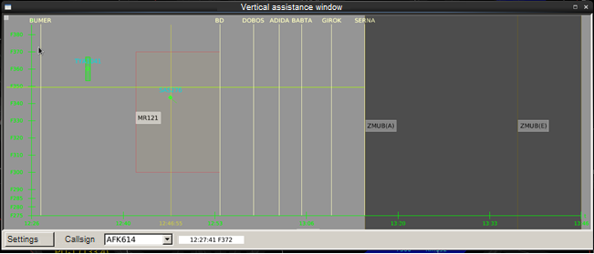
Figure 121 - Vertical assistance window showing the restricted flight area
The menu containing the list of A/C being tracked is opened by pressing button “▼” in field “Callsign”. The A/C to be viewed in the vertical assistance window is selected by clicking on the required line of the menu with the left mouse button. An example of the menu is given in Figure 122.
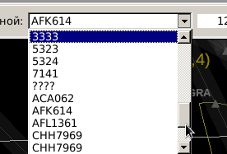
Figure 122 – Call sign selection menu
Only one A/C can be selected at a time.
Pressing of button “Settings” opens window “Display settings” shown in Figure 123.
The top section of the window, field “General”, accommodates the options to set background color of window “Vertical assistance window” using auxiliary window “Select color” called by pressing button .
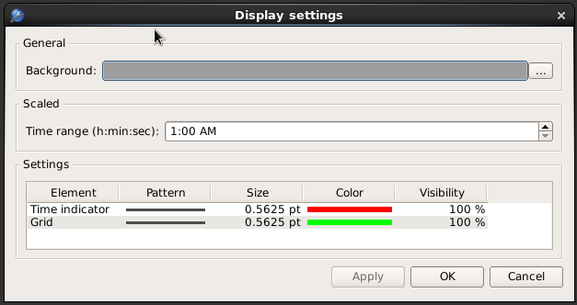Figure 123 - Window “Display settings”
Field “Scaled” provides the options to set a time span for the time scale. The required parameter is entered by deleting the old parameter and entering a new value from the numeric keyboard. Besides, the new time span can be set by increasing or decreasing the current value by means of buttons . The possible range of values is 1 to 8 hours.
Below in field “Settings” there are functional elements to set line type, size, color and opacity level for current time line (line “Time indicator”) and for time and altitude scales (line “Grid”).

Air traffic safety hazards window
The air traffic safety hazards window is the main window indicating availability of conflict situations in the controlled airspace. An example of the window is given in Figure 124.
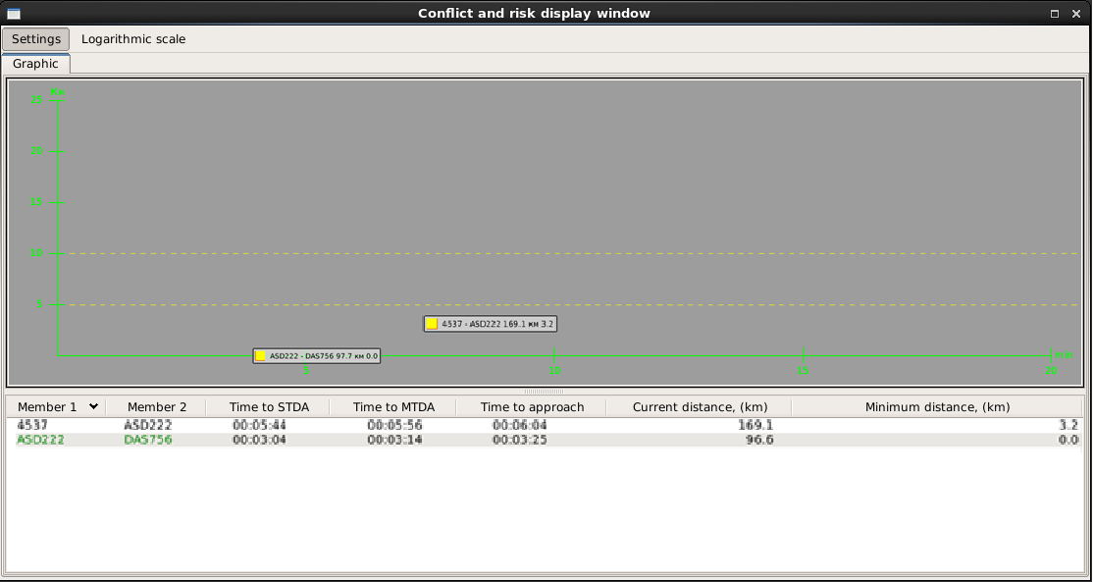
Figure 124 - Conflict and risk display window
The window has tab “Graphic”.
The window of tab “Graphic” is divided into two parts: the upper graphic part and the lower table part. The time scale of 0 to 20 minutes is displayed in the graphic part along axis X. The scale of minimum approach distance between the conflicting A/C is displayed along axis У. The conflict situation is shown on the curve as a yellow or red square and as a form containing brief data on the conflicting A/C. The form specifies flight numbers or SSR codes of the conflicting A/C, current distance between them and the minimum distance of predicted or actual approach of A/C expressed in kilometers or nautical miles. Yellow color is used before separation rules violation, and red color is used when the separation rules are violated. Position of the conflict indicator in the window depends on conflict situation hazard level:
– the shorter the minimum approach distance is, the lower the indicator is located;
- the less time before A/C collision remains, the greater is the indicator's shift to the left.
The window displays the horizontal lines corresponding to horizontal separation rules (10 and 5 km).
In the bottom table section each conflicting pair of A/C is assigned a table line specifying callsigns (transponder codes) of conflicting A/C (columns “Member 1» and “Member 2”), time interval before the separation rules are violated “Time to STCA”, time interval before a conflict situation arises “Time to CA”, time interval before reaching minimum approach distance “Time to approach”, current distance between A/C (“Current distance, (km)” or “Current distance, (nm)”) between A/C and minimum approach distance (“Minimum distance (km)”) or “Minimum distance (nm)”).
The window option with a logarithmic scale of distances may be called. To that end, press key “Logarithmic scale” in the top section of the window. An example of the displayed window is given in Figure 125. According to this option, along with variation of the window scale in terms of distance the display principle of conflict indicators is changed. The conflict indicator and the form are displayed in the top section of the window, while location of the conflict (its hazard level) is indicated using a red vector. Thus, that makes it possible to prevent frequent hops of the conflict forms when flight heading related to each of conflicting A/C and calculated based on radar data varies from scan to scan.
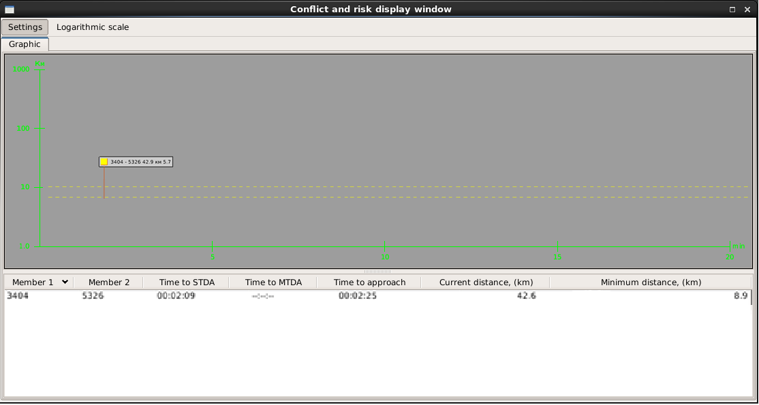Figure 125 - Air traffic safety hazards window with a logarithmic scale
In the top section of the window there is key “Settings”. Pressing of the key opens window “Display settings”. An example of the window is given in Figure 126.
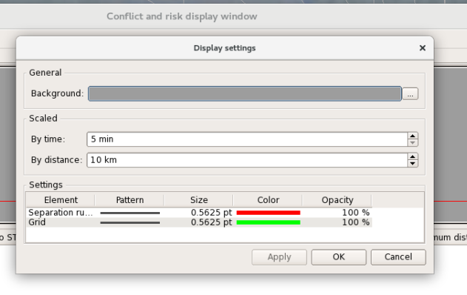
Figure 126 - Window “Display settings”
The top section of the window accommodates the functional elements for setting background color of the window (section “General”), setting the parameters of scaling by time and distance (section “Scaled”). Section “Settings” at the bottom of the window accommodates the functional elements to set line type, size, color and opacity level for vertical separation rules lines (line “Separation rules”) and for time and distance scales (line “Grid”). All setting procedures are similar to those described in Section 2.5.

Window “DPPE”
To call window «DPPE” press functional key “DPPE” in the list box menu. An example of the window is given in Figure 127.
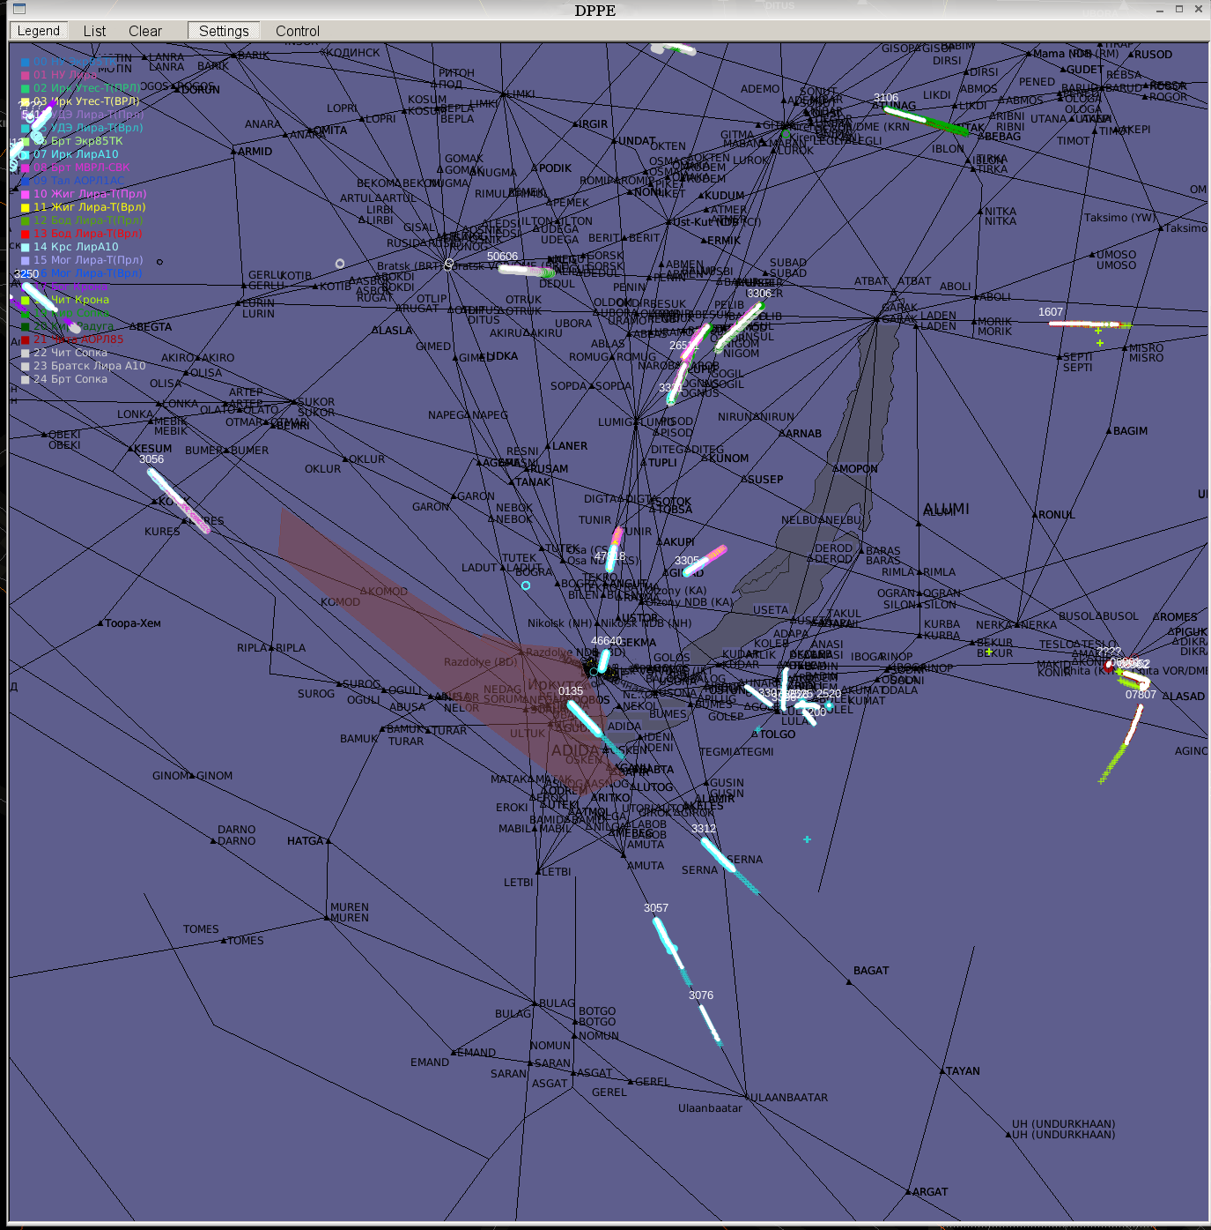
Figure 127 - Window “DPPE”
The window is intended to check digital radar data sent from the interfaced radar sources to the complex input. This window can be moved across the indicator screen field and resized.
Window “DPPE” displays coordinate information sent from all radars interfaced with the complex in the form of symbols. The coordinate data of the previous radar scans is shown on the screen for the preset time or since the last pressing of functional button “Clear”.
The coordinate information received from each radar is highlighted in appropriate color. The coordinate symbols’ display color assigned for each radar can be viewed in window “List” and in the special transparent display panel called by pressing button “Legend”.
The coordinate symbols used are associated with a type of radar data source (PSR, SSR, PSR + SSR).
Also, window “DPPE” displays the coordinate information obtained after secondary and tertiary processing the input radar data by the server of the “Topaz” system (“track” information). Again, the information is presented as point symbols which may be highlighted in color and marked with a prominent size.
A single-line form containing a SSR code or designation “????” for PSR tracks is displayed next to the “track” coordinate symbol for the current scan.
On top of the window there is a functional bar consisting of five buttons: “Settings”, “Control”, “Clear”, “Legend” and “List”. Button “Clear” clears the coordinate information displayed at the moment – screen clearing.
Pressing of button “Legend” in the left top corner of the informational part of window “DPPE” opens the transparent display panel showing the available options for color coding of the coordinate information received from radars connected to the complex. Repeated pressing of button “Legend” clears the above display panel from the screen. An example of the display panel is given in Figure 127.
Pressing of button “Control” calls window “Control display - DPPE”. An example of the window is given in Figure 128.
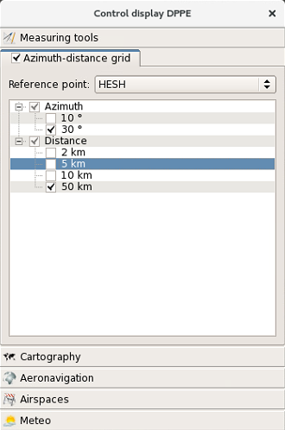
Figure 128 - Window “Control display - DPPE”
Using the window, one may show/hide azimuth-distance grid, mapping information, aeronautical information, and various zones (restricted flight areas, blanking zones, MSA zones, etc.). The working procedure for the window is similar to the procedures described in Section 2.3 for window “Control display” of the main air situation window.
Pressing of button “Settings» opens window “Display settings - DPPE” shown in Figure 129. Using the window, one may control the information displayed in window “DPPE”, including the displayed coordinate plots received from the interfaced radar sources. The window can be moved both within the space of window “DPPE” and in the area beyond the window on the screen of the main or auxiliary indicator of the workstation.
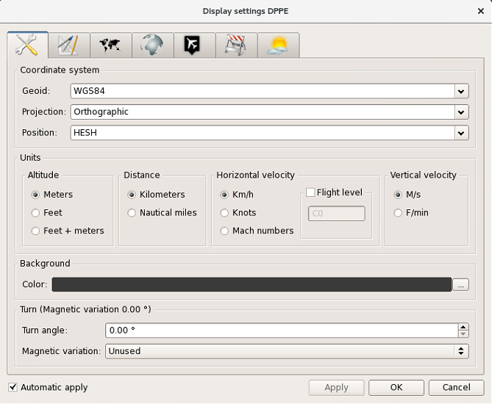
Figure 129 - Window “Display settings DPPE”
In general, the procedures of setting the required display options in window “DPPE” using this window are similar to those described in Section 2.5 relating to display settings of the air situation window.
It allows setting the required type of information displayed in window “DPPE” which may differ from the information displayed in the air situation window in terms of scale, center offset, the specific mapping information, azimuth-distance grid, background color of the window, displayed restricted flight areas, blanks, etc.
The specific feature of window “Display settings DPPE” is the option for individual setting of displayed plots received from interfaced radars, as well as tracks obtained after RD processing by the radar server. For that purpose, tab “Airplots” is used. An example of window “Display settings” displayed upon selection of tab “Airplots” is given in Figure 130.
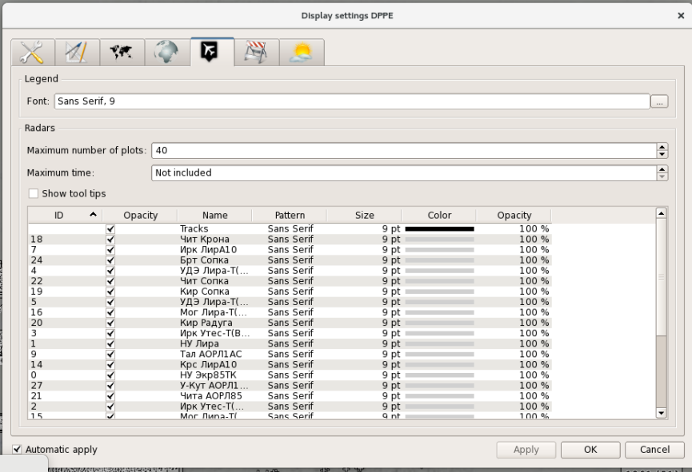Figure 130 - “Display settings DPPE”
Using field “Legend» of the window, one may set font size and type for transparent display panel showing the available options for color coding of the coordinate information received from radar.
Field “Radars” provides the options for setting the maximum number of displayed plots and maximum display time of coordinate information for each source in window “DPPE”. The number of plots is set by changing the current value in line “Maximum number of plots» using the “triangular” buttons (“” and “”) in the right section of the line (momentary pressing of each button increments or decrements the current value by 1). Besides, there is the option of direct entry of the required digital value to the line instead of the current value using the numeric keyboard. The maximum time of the coordinate information display in line “Maximum time” is set in a similar way. Coordinate plots are counted with reference to north plots received from each radar. The “maximum time” parameter is mainly intended for control of the ADS information display. Usually, this information is not based on the north plots. The maximum possible time value is 120 minutes. If an attempt is made to set a time value below 1 minute, parameter “Not included” is displayed. In this case, coordinate plots by time are not cleared.
At the bottom of field “Radars” there is the option to show/hide pop-up help displayed when the mouse cursor is pointed over a coordinate symbol from radar.
In the table section of window “Display setting” each radar interfaced with the complex is assigned a relevant line, and one line is reserved for the track information received from the radar server output.
To show/hide coordinate symbols from any source, set or remove flag “√” in column “Visibility» in the line assigned to the source by clicking with the left mouse button.
Flag “√” in line “Show tool tip” enables special pop-up help displayed when the mouse cursor is pointed over a coordinate symbol from any radar source shown in window “DPPE”.
Note – The pop-up help contains the data on number and type of the source, display time of the coordinate symbol as well as on its geographical coordinates.
For the selected source color, transparency and size of a coordinate symbol as well as font type and size for a form may be set.
The color is set using window “Set color” called by double clicking on column “Color» with the left mouse button. Transparency is set using the slide control displayed upon double clicking on column “Visibility” with the left mouse button. The size of a coordinate symbol as well as font type and size are set using window “Select font” called by double clicking on columns “Pattern” and “Size”.
The working procedure for the transparency slide control, windows “Select font” and “Select color” is similar to the options for setting the information displayed in the air situation window (see Section 2.5).
Herewith, the coordinate symbols displayed in window “DPPE” cannot be changed – only size, “stroke weight” and color can be changed. In general, the symbols are the same as those used for designation of plots in the air situation window (see Table 3 in Section 2.1.1). There is a specific feature – a symbol having the appearance of a filled circle is used for plots excluded from radar data processing. A point symbol is used for tracks.
An example of displayed coordinate symbols from various radars and coordinate symbol for a track in window «DPPE” is given in Figure 131.


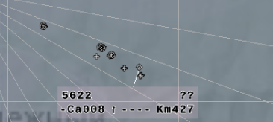
Figure 131 - Coordinate symbols displayed in window “DPPE”
Pressing of button “List” on the functional bar opens table-based window “Data from radar” shown in Figure 132.
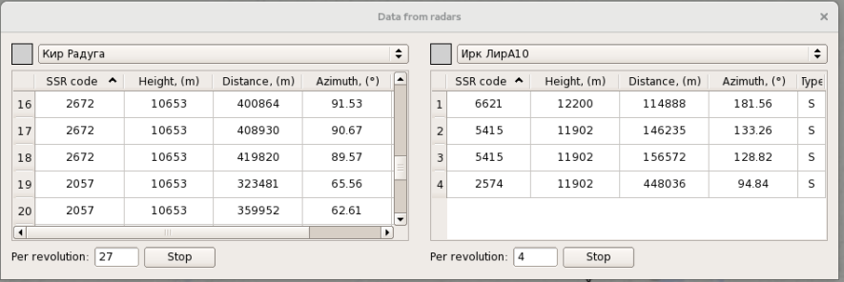Figure 132 - Window “Data from radar”
Highlighted background of the button indicates its active state. Repeated pressing of active button “List” clears window “Data from radars” from the display. The window can be moved both within the space of window “DPPE” and in the area beyond the window. The window can be promptly resized within the preset limits.
Information from two radars may be simultaneously displayed in window “Data from radars”. If more than two radars are interfaced, the information shall be viewed by choosing another radar data source.
The user may select the required radar data source for the left and/or right section of the window in the top section of the window in the radar selection field using the menu containing the list of interfaced radars which is opened by pressing button “”. Upon selection of the radar data source by clicking with the left mouse button, the user activates the lists of air targets whose data is received from the source. Besides, along with the source ID the radar selection field shows the color of coordinate plots received from the source and displayed in the main information field of window “DPPE”. The color is indicated as a filled square to the left or right of the radar selection field.
The lists of aircraft whose coordinate information is sent to the system input contain the following fields:
- SSR transponder code – column “SSR code”;
- current flight-level pressure altitude – column “Height, (m)”;
- range relative to the radar station point – column “Distance, (m);
- azimuth relative to the radar station point – column (“Azimuth, (º)”);
- flag of radar data type (column “Type”).
The flag of radar data type given in the list may take on the following values: “P” (data of the PSR channel), “S” (data of the SSR channel), “M” (merged data of SSR + PSR).
The display priority of data on air targets in the list when the window is called for the first time, and when radar data is being updated, is set based on the value of azimuth relative to the radar installation area. In the interval between data updates, pressing of header button “SSR» in the top left section of the table will sort information contained in the list based on a digital value of the transponder code. Upon pressing button “Height”, sorting is done based on a value of flight altitude.
If the full information from radar fails to fit into the fields allocated for the list, such information may be viewed completely using the scrolling function, i.e. by means of scroll bars which appear on the right and at the bottom of each table when any extra information is available.
Field “Per revolution» (which displays the number of plots received for the current scanning cycle of the radar) and functional button “Stop” are located at the bottom of the window under the list of aircraft.
Pressing of button “Stop” stops updating these fields of the list for detailed viewing. After detailed viewing of the data given in the list, data updating may be resumed by clicking functional button “Start” (displayed instead of activated button “Stop”).
Information on the selected radar is updated on signal “north” (or by a zero 30-degree plot) contained in codegrams which are transmitted from radar data primary processing equipment (DPPE) to RP.

Window “Alert window”
Window “Alert window» is intended to display tabular data on A/C for which conflict and off-normal situations requiring the air traffic controller’s attention have been detected. Such data includes conflicts arising between A/C, emergency warnings sent via the SSR channel (loss of radio communication, hijacking, distress), situations when A/C descends below the minimum safe altitude, enters prohibited zones, double SSR codes detected in the controlled airspace, deviation of the A/C flight path from the flight plan route above the preset limits, deviation from the preset flight level by more than 60 meters, availability of a conflict regarding flight plans between A/C and A/C and restricted flight areas.
An example of the displayed window is given in Figure 133.
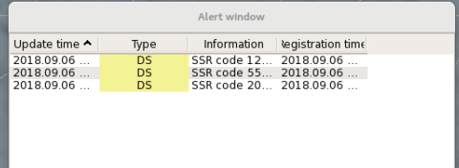
Figure 133 - Window “Alert window”
Information displayed in the window supplements the respective alerts in the air situation window using tracking forms.
If the window constant displaying is not set, the window appears automatically when any emergency or conflict situation arising during air traffic is detected. If no emergency and conflict events are detected for this scenario, the window is cleared from the display.
The options for an emergency-conflict situation display in window “Alert window” for all A/C or for “own” A/C only can be set for the workstation using window «Configurator” at the technician's AWS.
The window may be called manually by selection of line “Alert window” in the list menu. See the example in Figure 106 in the beginning of Section 2.6. Repeated selection of the line clears the window from the display provided that no emergency-conflict situation is indicated in the window.
In this window, each A/C participating in the event is assigned the relevant information line containing as follows:
- date (year, month, day) and time (hours, minutes, seconds) of the event start and the last data update;
- designation of event type (for example, “MSAW”, “PCS”, “STCA”, “CA”) assigned the respective background color depending on the event hazard level;
- information with event parameters (for example, A/C flight number, airborne transponder code and location (geographical coordinates).
The window may be moved across the indicator screen and resized.
From the special-purpose AWSs within the complex, for example, FOD AWS, the indication of an individual conflict situation or off-normal situation arising at the complex AWS (as displayed both in window «Alert window» and in the air situation window), for example, the indication of a conflict arising between A/C of the state aviation in the course of formation flights, may be cleared.
Proceed as follows: point the mouse cursor over the required information line in window “Alert window”, and press the right mouse button. Display panel “Ignore” will appear. Left click the display panel. The conflict situation in the given window and in the air situation window at all AWS of the complex will be cleared. To restore the cleared indication of the conflict situation or the emergency situation, left click on the free space of the window. Display panel “To reset the ignore” will appear. Left click the display panel.

Meteo solution
This window describes the current operating characteristics of the aerodrome. Meteorological minimum of the aerodrome is calculated depending on working conditions of an airport, the equipment used for the landing system, aerodrome lighting and radio equipment, terrain features and artificial obstacles. Complex receives information on A/C and pilot-in command minimums from the planned subsystem. If the meteorological minimum of the aerodrome is worse than the minimum of A/C and pilot-in command, then the system considers that the conditions of the aerodrome are not suitable for take-off or landing of the aircraft (the corresponding field is highlighted in yellow). If the meteorological minimum of the aerodrome is better than the minimum of A/C and pilot-in command, the approach or take-off can be performed (the corresponding field is highlighted green).

Control functions:

Measuring vector
Measuring vector is used for measuring distance as well as direct/reverse azimuth between:
- two points on the indicator screen;
- between two A/C;
- between A/C and a point on the indicator screen.
One may also take measurements using the “Measuring vector” function along a curved (multiple-vector) flight path.
The function can be executed by means of the mouse-type manipulator.
For short-time (occasional) measurement of azimuth and range between two arbitrary points and/or objects (A/C) on the screen, proceed as follows:
- point the mouse cursor over the first point or the coordinate symbol of the A/C being tracked (“track») in ASW, press button “Ctrl» on the keyboard, and press the left mouse button;
- move the mouse cursor to the second point or AC track (form) in ASW. When the mouse cursor is being moved, in the air situation window displayed are a straight line interconnecting the datum point (or A/C track) and the current point on the monitor screen, as well as a form containing the values of range and azimuth between these points;
- press the right mouse button in the final measurement point.
Note – Measurements from the A/C track can be started by clicking the A/C coordinate symbol with the left mouse button (without pressing button “Ctrl”).
If measurements take a long-time, the appropriate mode can be enabled by pressing button in the main menu. Further, just click the point or the A/C track with the left mouse button – the measurement process will be started.
Figure 134 shows the examples of the measuring vector displayed while taking measurements of relative position between two points in the air situation window.
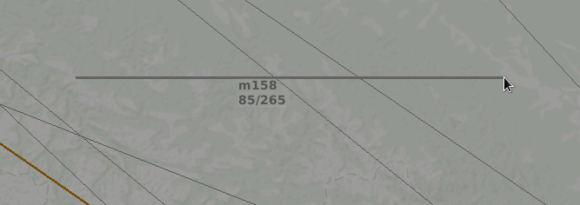
Figure 134 - Example of measuring vector displayed in ASW

2.1.1 The measuring vector form contains two, three or four data groups.
The form includes the following data:
– distance between objects in kilometers or nautical miles with letter symbol of the measurement system (“m” – a flag of the British measurement system (kilometers) and “N” – nautical miles);
– direct and reverse azimuths separated by slash “/”;
– time of A/C flight to the specified point (displayed when the A/C track is the initial measurement point);
– estimated altitude of A/C calculated based on current vertical flight speed in the final measurement point (displayed if A/C features flight altitude variation).
Move the measuring vector form in the air situation window. To that end, point the mouse cursor over the form, press the left mouse button and without releasing the button move the form to the proper area in ASW, and then release the button. In this case, the form will be displayed with a binding line drawn from the form to the middle of the measuring vector.
Depending on the mode preset in window “System parameters”, azimuth values are displayed relative to true or magnetic north.
For vectors connected with coordinate symbols of A/C being tracked, vector and digital values will be updated when position of the track is changed.
If the scale below 15 kilometers is selected in the air situation window, a higher measurement accuracy will be ensured. In this case, the format of the measuring vector form is changed as follows: in the beginning of the form letter symbol “М” is displayed, then follows the single-letter symbol of the measurement system enclosed in parentheses (“m” – kilometers or “N” – nautical miles), the value of distance is given in second decimal places of a kilometer (in tens of meters), or in nautical miles. For example, “М (м) 1.25 86/266”.
There is the option of multi-vector (along the curved flight path) measurements. The intermediate points are fixed by clicking with the left mouse button. In the final measurement point press the right mouse button (without pressing the left mouse button). As for the rest, the procedure is the same as for single-vector measurements. The form is displayed in the middle of the last vector, and it specifies quantity of the sections contained in the vector, total range for the curved flight path, direct/reverse azimuth for the last section and total flight time (if measurements are taken relative to the A/C).
Also, the simplified procedure of taking azimuth-range measurements relative to the points being the reference ones for the ATC sector (area) is provided. This procedure is set by selecting line “From the point of” in the two-line menu displayed by pressing button “” located next to button in the main menu. The menu has two lines: “From the point of” and “Marker”.
Selection of line “From the point of” displays the auxiliary menu containing the list of reference points for the area (which are set in the configuration control window). The major airfield reference point (ARP) is the mandatory point. Besides, the set of points may comprise positions of radars, RW thresholds, main CRPs of the sector or the control area. Usually, these points are used as reference points to draw range and azimuth plots and to count relative data on azimuth and range contained in TF.
To measure azimuth and range relative to any point from the list, proceed as follows:
- select the required line (press the left mouse button when the mouse cursor is pointed over this line of the list) – the line is highlighted in background color;
- move the mouse cursor to the air situation window – a vector originating from the specified reference point and ending in the point corresponding to the current position of the cursor will be drawn in ASW;
- point the mouse cursor over the measured object (the final measurement point) in ASW, and press the right mouse button;
To clear the measuring vector displayed in ASW, point the mouse cursor over the measuring vector form or over the symbol of initial or final measurement point, and press the right mouse button. That clears the vector from the display.

Measurement of geographical coordinates
To measure geographical coordinates of any object, in the air situation window select line “Marker” in the two-line menu called by pressing button “” (located next to button ) in the main menu, then move the mouse cursor to the required point in the air situation window. The two-line form connected with the mouse cursor through the binding line is displayed next to the mouse cursor. An example of the form is given in Figure 135.

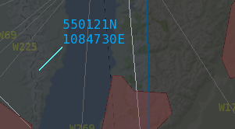
Figure 135 - Coordinate meter form
When the mouse cursor is moved across the screen, values of latitude and longitude contained in the form change in a dynamical fashion. The current position of the coordinate meter form is fixed by clicking with the left or right mouse button. Repeated clicking with the right mouse button clears the form from the display.
Besides, the current values of the mouse cursor coordinates (when the mouse cursor is within the air situation window) are displayed at the bottom of the current time display panel, if option “Show coordinates” is selected for the display panel.
An example of the displayed window is given in Figure 136.

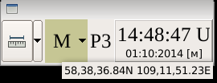
Figure 136 - Mouse coordinates displayed in the current time display panel

General viewing of TF
When button “SV” in window “Aircraft settings” is released, TFs are displayed for all A/C being tracked whose coordinate symbols are within the air situation window. These are both A/C under control and A/C not under control at any AWS (D) within the complex.
Pressing of the button clears all TFs excluding the TFs for “own” A/C and TFs in the emergency and conflict situations indication mode.
When button “SVh” is pressed (provided that button “SV”s released), single-line forms containing the data on current and target flight altitude are displayed for “other’s” A/C.

Manual relocation of TFs
In addition to the automatic relocation function for overlapped forms, there is the option of TFs manual relocation, i. e. the form can be moved using the control panel. Using the function, the air traffic controller may individually set position of TF relative to the respective coordinate symbol.
To execute the function, move the mouse cursor within the form to any location unoccupied by alphanumeric characters. The mouse cursor symbol changes – a “hand” is displayed instead of the arrow-shaped symbol. Press the left mouse button and without releasing the button move the form to the proper area in the air situation window, and then release the left mouse button. Such parameters as length and direction of the binding line are recorded for the form. Further, the form is moved with these parameters. The binding line of the manually relocated TF is highlighted in red.
To cancel execution of the TF manual relocation, point the mouse cursor over the A/C coordinate symbol or free space within the form, and double click with the left mouse button. Color highlighting of the binding line will stop. Then left or right click on an arbitrary point in the air situation window – the form will return to the standard position.
Besides, pressing of button “Reset all” in functional window “Aircraft toolbox” provides group cancelling of all individual settings related to TF position and display of the extrapolated location vector.

Individual viewing of TF
TF for the aircraft not controlled in the given sector and displayed only by a coordinate symbol or a coordinate symbol and an ID of the ATC “other’s» sector in ASW can be viewed as follows: point the mouse cursor over the A/C coordinate symbol. The selected form with the preset number of lines will be displayed.

Individual settings for TF
The system provides the option of setting individual display parameters for A/C being tracked (as opposed to general display parameters set in window “Display settings» and “Aircraft toolbox”). Including:
- setting of individual data contents in the third line and the fourth line of TF;
- displaying the safety zone around the A/C coordinate symbol;
- setting an individual extrapolation vector by time and range;
- transliteration of the data displayed in TF – changeover from the Cyrillic alphabet to the Latin alphabet and back;
- enabling/disabling the display of prompt “Transmit ACT” in the zero line of TF that indicates the necessity to send the conditions of A/C control transfer to the air traffic controller of the ATC neighbouring center (with which no automatic information exchange via the OLDI protocol has been established).
These options are set in the menu called by pressing the right mouse button when the mouse cursor is pointed over the A/C coordinate symbol or a free space within TF.
An example of the menu is given in Figure 137.
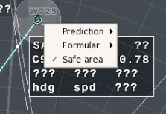
Figure 137 - Menu with TF individual setting options
Note – If the flight plan was not activated and plan information and radar data were not correlated for A/C, the menu contains only four lines: “Prediction”, “Form” and “Safe area”.
Line «Prediction” is intended for setting an individual vector by range or time. When the line is selected, display panels with the functional elements to control the extrapolation vector will be displayed. An example of the respective display is given in Figure 138.

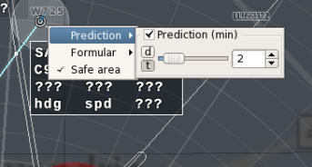
Figure 138 - Display panel for setting extrapolation value
A vector type is selected by pressing one of two buttons: “d” and “t”. Alternative action buttons – when one button is “pressed”, the other button is released. Values of range or extrapolation time span can be entered by one of the following three methods:
- by moving the slider using the left mouse button or by rotating the mouse wheel (scroll) to one or the other direction when the mouse cursor is pointed over the slider field;
- by entering the proper digital value in km or minutes from the numeric keyboard to the display panel in the right section of the auxiliary window;
- by incremental or decremental change in the current value of extrapolation vector using buttons .
The preset parameter takes effect immediately, pressing of any executive buttons is not required.
The settings window is cleared by left clicking on an arbitrary point in the air situation window.
For the given A/C an extrapolation vector will be displayed as related to the preset time or range interval irrespective of total extrapolation time or range effective for the air situation window (set in window “Aircraft toolbox”). An individual vector may be highlighted in the specific color (through the settings in window “Display settings”.
To set specific data for the third line and the fourth line of TF, select menu line «Form». A display panel with the functional elements to select specific data in the third line and the fourth line of TF will be displayed. An example of the respective display is given in Figure 139.
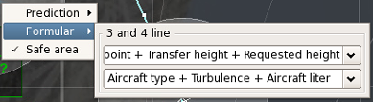
Figure 139 - Display panel to select the data in the third line and the fourth line of TF
Selection is made in the menu opened by pressing button “” in field “Line 3:” or field “Line 4:”. The menu items are the same as in the menu used to select the specific data in TF by means of window “Display settings”.
To display the safety zone around the A/C track, select line «Safe zone» in the menu. The line will display flag “√”, and a circle with a radius of 10 or 5 km will appear around the track subject to the horizontal separation rules effective for the A/C (with regard to the sector responsibility area and the A/C weight category). An example of the displayed zone is given in Figure 140. This zone will move together with the track.
Color, fill, transparency and line thickness for the safety zone are set in window “Display settings”. Repeated selection of line «Safe zone» in the menu clears the individual safety zone and flag “√” in the beginning of the line.
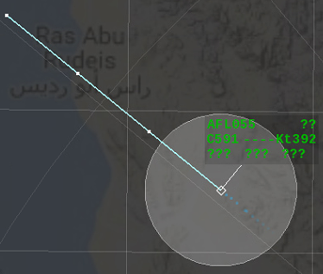
Figure 140 - Safety zone displayed in ASW

Duty takeover and individual display settings for AWS
For duty takeover by the air traffic controller press button in the main menu. The three-line menu shown in Figure 141 will be displayed.
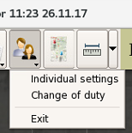
Figure 141 - User selection menu
Select line “Change of the duty” in this menu. The window shown in Figure 142 will be displayed.
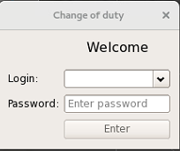
Figure 142 - Window «Change of duty»
By pressing the “triangular» button in field “Login” call the list of users of the own AWS. An example of the respective display is given in Figure 141.
Double click on the user name (on your surname) to set the AWS user. The selected surname will be displayed in field “Login”. Then enter a password in field “Password” and press button “Enter”. If the password is correct, the current time window will display the user name (the surname of the air traffic controller who takes over duty), time and date of duty takeover.
Note – Lists of air traffic controller s' surnames related to the workstations within the complex and passwords are set and corrected in window «Configurator” at the AWS of technical control and monitoring system.
If the password is incorrect, the warning system message will be displayed in window «Change of duty».
To work with individual display settings in the air situation window, select line «Individual settings” in the menu shown in Figure 141. The window shown in Figure 143 will be displayed.
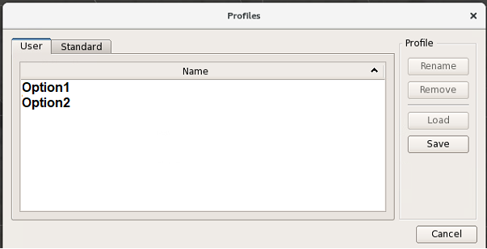
Figure 143 - Window “Profiles”
The window has two tabs: «User” and «Standard”. The first tab is intended to work with individual settings of the user. The second tab is intended to work with standard settings for all workstations (without the option of prompt modification of the settings by common users who are not granted system administrator's rights).
Figure 144 shows an example of the window displayed upon selection of tab “User”. If the air traffic controller has already set the options (individual display settings profiles), the list of settings will be displayed in field “Name” of the tab. If profiles have not been set, the field will be blank.
In order to set a new profile, enter the required display settings in the air situation window using windows “Aircraft toolbox”, “Control display” and “Display settings”. In particular, set the following parameters: scale and center offset, scope and contents of data in TF, composition and position of list boxes and auxiliary windows, color pattern of display elements, etc. Then press button «Save” in window “Profiles”.
The window shown in Figure 144 will be displayed to enter a new display profile designation.
Enter the proper alphanumeric designation in field «Name” of the window, and press button “OK”. This designation will appear in field “Name” of window “Profiles”.
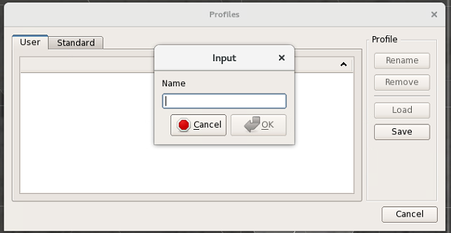
Figure 144 - Display profile designation input window
To load the earlier entered profile, select its designation in field «Name” of window “Profiles», and press button “Load”. A window for confirmation of the profile change with two options “Yes” and “No” will be displayed. If “Yes” is selected, the appropriate profile will be loaded.
To rename the earlier entered profile, select its designation in field “Name” of window “Profiles”, and press button «Rename”. Then enter a new name in window “Enter», and press button “OK”.
To delete the earlier entered profile, select its designation in field “Name” of window “Profiles”, and press button “Remove”. The window shown in Figure 145 will be displayed to confirm deletion.
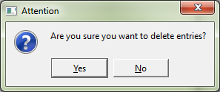
Figure 145 - Profiles
If “Yes” is selected, the selected profile will be deleted.
An example of window “Profiles» displayed upon selection of tab “Standard settings” is given in Figure 146.
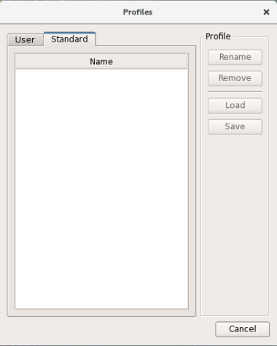
Figure 146 - Window “Profiles», tab “Standard”
To apply the required option, select the proper line in field «Name” by means of the mouse, and press button «Load”.
If line “Exit” is selected in the menu shown in Figure 141, the image in the air situation window will be locked, and the three-button menu with the following buttons will be displayed: “Block”, “Exit» and “Cancel”. An example of the respective display is given in Figure 147.
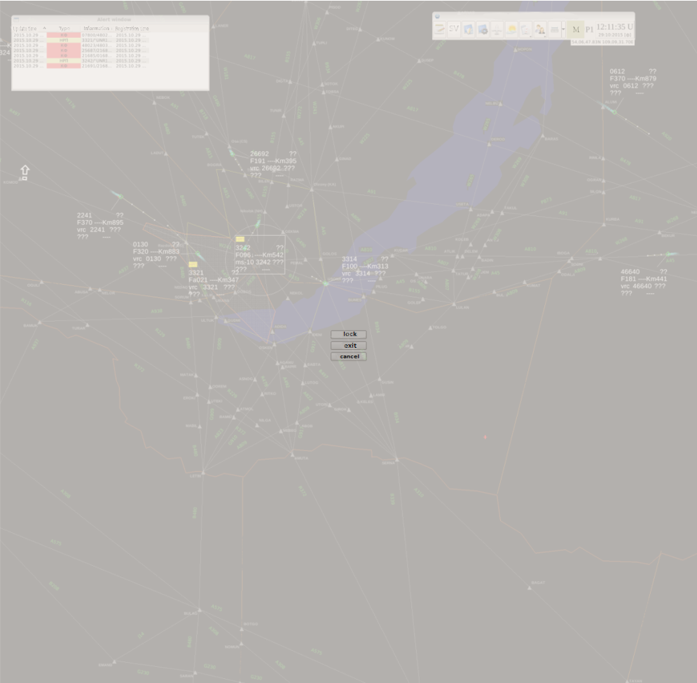
Figure 147 - Example of image locked in ASW
If button “Cancel” is pressed, the previous display mode preset for the air situation window will be restored.
If button “Block” is pressed, the workstation will be locked for execution of control functions. Herewith, the display panel shown in Figure 148 will appear.
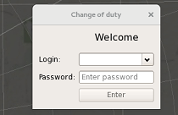
Figure 148 - Display panel for the function of image locking in ASW
The locking mode is enabled when the user leaves the workstation for a short time, or when the user wants to lock the access to the functions of his workstation for other users. To unlock AWS, enter a password in field “Password” and press button «Unblock”.
Button «Exit» is intended for the duty handover with the exit time recorded in the system log at the AWS of technical control and monitoring system. In this case, the window similar to that shown in Figure 143 is displayed wherein a password may be entered to change the user.

List of Abbreviations
A/C | Aircraft
ACC | Area Control Center
ADF | Automatic Direction Finder
ANI | Aeronautical Information
APW | Area Proximity Warning
ARP | Airport Reference Point
ASU | Air Space Use
ASUP ATC AS | Air Space Use Planning Air Traffic Control Automatic System
ASW | Air Situation Window
ATC AS | Air Traffic Control Automatic System
AWS | Automated Workstation
CAICA | Center of Aeronautical Information of Civil Aviation
CARD | Conflict and Risk Display
CNA | Code Not Assigned
CRP | Compulsory Reporting Point
CS | Conflict Situation
DPPE | Radar Data Primary Processing Equipment
DS | Double Squawk
DWP | Dangerous Weather Phenomena
ES | Emergency Situation
FACS | First Alert on Conflict Situation
FIR | Flight Information Region
FL | Flight Level
HJ | Highjacking
ID | Identifier
IFFR | Identification Friend-or-Foe Radar
MMA | Mismatch of Meteorological minimum and Airdrome minimum
MMP | Mismatch of Meteorological minimum and Pilot-in-command minimum
MSA | Minimum Safe Altitude
MSAW | Minimum Safe Altitude Warning
MSCAL | Measurement System Change Altitude Level
MTC | Medium Term Conflict
PCS | Potential Conflict Situation
PPCS | Preliminary Potential Conflict Situation
PSR | Primary Surveillance Radar
QFE | Current Values of Airfield Pressure
QNH | Pressure Normalized to the Sea Level
UERC | Unable to Establish Radio Contact
RD | Radar Data
RNP | Radio Navigation Point
RP | Radar Position
RVSM | Reduced Vertical Separation Minimum
RW | Runway
SID | Standard Instrument Departure
SIGMET | Significant Meteorological Information
SPI | Special Identification Position Pulse
SRV | Separation Rules Violation
SSR | Secondary Surveillance Radar
STAR | Standard Instrument Arrival
STCA | Short – Term Conflict Alert
TCMS | Technical Control and Monitoring System
TF | Tracking Form
TSC | Time Synchronization Complex
UAO | Unidentified Arial Object
UATMS | Unified Air Traffic Management System
UBC | Upper Border of Cloud
UTC | Universal Time Coordinated
VAW | Vertical Assistance Window
VSP | Variable System Parameter
WSR | Weather Surveillance Radar
CA | Conflict Alert
MTAPW | Medium Term Area Proximity Warning
DEV | Deviation by flight plan
FLB | Flight Level Bust

