Recording System AVIATOR for ATC Systems

Operation Manual

ЦИВР.462418.019-01 РЭ

Total sheets

Moscow

2017

**Table of Contents**

Introduction 5

1 Product Description and Operation 6

1.1 Product Purpose 6

1.1.1 Components of Recording System AVIATOR 9

1.1.2 Design and Operation 10

1.1.3 Used Measuring Equipment, Tools and Accessories 11

1.2 Description and Operation of product Components 11

1.2.1 Recording Station 12

1.2.2 Monitoring Workstation (MWS) 29

1.2.3 Radar Data Playback Workstation 30

2 Intended Use 32

2.1 Operational Limitations 32

2.2 Product preparation for Use 32

2.2.1 Visual Inspection Scope and Procedure 32

2.2.2 Rules and Procedure of product Preparation for Operation 33

2.2.3 Switching on of Recording System AVIATOR Hardware 33

2.3 Product Use 33

2.3.1 Procedure for Ensuring Serviceability of Recording System AVIATOR 33

2.3.2 Recording System AVIATOR Switching off Procedure 34

2.3.3 Operation of Recording System AVIATOR with Time Synchronization Complex "TSC TOPAZ" 34

2.3.4 Recording for Radio Sets Supporting ED-137 (Optional) 34

2.3.5 "VCCS TOPAZ" Interface for Remote Listening (Optional) 34

2.3.6 Recording of Monitor Screenshots 35

2.3.7 Radar Data (RD) Recording 35

3 Maintenance 36

3.1 General Instructions 36

3.2 Safety Precautions 36

3.3 Product Maintenance Procedure 37

3.3.1 Check of Grounding Wires for Secure Connection to Equipment Bodies and Grounding Bus 38

3.3.2 Check of Security of Detachable Connections and Units Fastening 38

3.3.3 Visual Inspection and Cleaning of PC System Units of Recording System AVIATOR 39

4 Routine Repair 40

4.1 Requirements to Repair 40

4.2 Methods of Repair 43

4.3 Failure Detection and Replacement of Board in AAU 43

5 Storage 46

5.1 Rules for product Placement in Storage and Removal from Storage 46

5.2 Storage Conditions 46

5.3 Methods of Disposal 46

5.4 Storage Periods 47

6 Transportation 48

6.1 Handling Procedure and Safety Precautions 48

Appendix A 49

Network Cards Bonding (Teaming) 49

Network routings 51

LAN switches 52

Diagnostics of Raid Controller and Disks 58

List of Abbreviations and Designations 61

Revision Record Sheet 63

# Introduction

The Operation Manual contains technical description of the recording system «AVIATOR», and information necessary for proper operation, routine repair, technical state assessment, transportation, storage of the product and its components.

Specialists, who have studied operational documentation for the system and its components, passed briefing in its use and knowledge check in safety rules in accordance with the Rules of technical operation of electrical consumers (RTOEC) and Rules of technical operation (RTO), and have at least category III access certificate for operation of electrical installations, are allowed to operate hardware components of recording system AVIATOR.

Operator of the product must be beware of the fire hazards which may be present at the connections of power circuits and electric circuits of electric power sources and consumers, in case of short circuit. Cut off power supply in case of fire. Suppression of initial fire is recommended to perform primarily by means of standard equipment using expedient means (canvas sheets, etc.)

Metal parts of the product component housings shall be effectively grounded.

# Product Description and Operation

## Product Purpose

Recording system AVIATOR is designed for recording voice and radar data and information from workstation monitors.

Recording system AVIATOR provides the following:

* continuous synchronous recording of air traffic controllers’ conversations via radio, internal and external control communication channels, in the online archive on hard disk drive and removable storage;
* continuous synchronous recording of digital radar data received at the input and taken off at the output of ATC AS servers, in the online archive on hard magnetic disk and removable storage;
* binding the recorded information to standard time signals, both from the internal timer and from the external time source (universal time system);
* visual and audio monitoring of the recording process, without interruption of the process;
* possibility of real-time listening of the voice information being recorded;
* possibility of at least 15 minutes overlapping of records in each recorded channel to allow exchanging a removable storage;
* synchronous playback of records within specific time interval and/or voice data channel number, using speakers or headset;
* synchronous playback of digital radar data from input or output of ATC AS servers, within specific time interval and/or channel number;
* operative control of the process of synchronous playback of voice and digital radar data, and workstation (WS) monitors with the functions of selecting voice information channel, time interval to be played back, playback stop, record rewinding forward and backward, fast and slow playback of recorded voice information;
* visual display of playback process status with indication of selected voice information channel and record time of played back fragment;
* individual adjustment of sound volume for each voice channel being played back;
* possibility of repetitive playback of specific fragment of record;
* possibility of exporting the audio records from the station's internal format to OGG or WAV files for listening under control of any operating system that supports such format, as well as exporting video images of workstation monitor screens to file formats OGV and WEBM (VP9);
* possibility of collection and processing of statistical information on the use and occupancy of communication channels, and printout of this information;
* possibility of recorded data retrieval by message starting date and time, number or designation of one or more channels, and also by the marker assigned at the time of recording (optional);
* possibility of synchronous playback of information on operations at the air traffic controller’s control panels (monitor screens).

Typical recording system AVIATOR is shown in Figure 1. A typical equipment rack consists of two server recorders, one Aviator Audio Unit (AAU). Digital Audio Units can be mounted near source (PBX or VCCS), and not presented in the diagram. VoIP LAN interfaces are connected directly to servers and do not require additional space in the rack. In case 6 hours or more of battery backup power is required, Recording System can be supplied with dedicated UPS Rack (in VCCS specifications), see Figure 1.

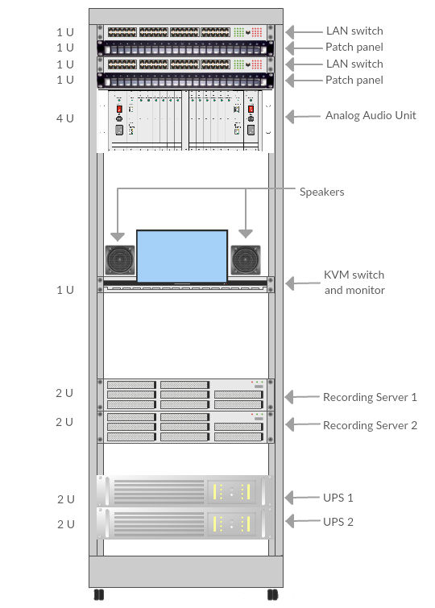

Figure 1 — Equipment rack

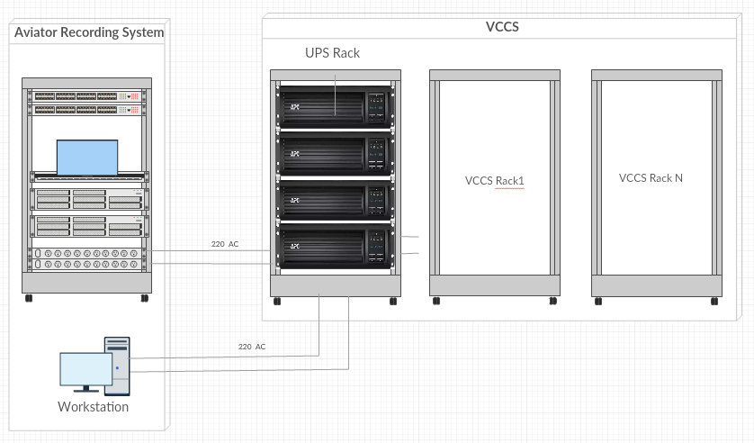

Figure 2 — Dedicated UPS rack

Basic specifications of the system are given in Table 1.

Table 1

System basic specifications

|  |  |
| --- | --- |
| Parameter | Value |
| System supply voltage, V | 220 +10 %, –15 % |
| Alternating current frequency, Hz | 50 +2 %, –2 % |
| Power consumption, VA | 1400, maximum |
| Duration of uninterruptable power supply, min. | 30, minimum |
| Number of recordable voice channels  (per AAU) | up to 192 |
| Number of AAU per sub-network, including redundancy | up to 14 |
| Typical number of recorded screens at LAN capacity of 100 Mbs | 100 |
| Data access time in case of playback from a removable storage recorded on a 192-channel recording station at a maximum channel capacity, with record time of 24.5 hours, maximum, and without initialization time of long-term data medium, s | 90, maximum |
| Mean time between failures, hours | 10,000, minimum |
| Mean time to recovery, hours | 0.5, maximum |
| Service life time, years | 12, minimum |
| Specified lifetime, hours | 80,000, minimum |
| Inherent noise of analog channel, minus dB | –60, maximum |

### Components of Recording System AVIATOR

Recording system AVIATOR has the following components:

* recording station;
* monitoring workstation (MWS);
* playback workstation (PWS);
* radar data playback workstation (RWS).

There is the possibility of combining the functionality of workstations depending on the Installation Project (for example, MP – monitoring + playback, MR – monitoring + radar, PR – playback+ radar, MPR – monitoring + playback + radar. An option of taking radar data from ATC AS of different manufacturer also may be considered)

Completeness of recording system AVIATOR as appropriate for each installation object is specified in log book ЦИВР.462418.019-01 ФО.

### Design and Operation

Connections of the system components are shown in the relevant connection diagram which is included in the detailed design package of the installation project.

The system has a distributed architecture and is implemented on the base of PCs interconnected with local area network (LAN) Fast Ethernet 10/100/1000 Mb/s (recommendations IEEE 802.3, 802.3u). The data transmission medium is twisted pair UTP Cat. 5. The system LAN is based on standard Fast Ethernet. The LAN is redundant for better reliability.

Playback of radar data is impossible without RWS, while the remote monitoring functions are performed by the voice playback client application software which is included in the scope of supply of recording system AVIATOR. The operating system applied is a Linux family system (Oracle).

The used security system is based on the security system of Linux operating systems, which prevents unauthorized access (UA) to data. Two main levels of access are available: administrator access and user access. UA protection is further provided by the hierarchy of authorization and functionality of recording system AVIATOR which corresponds to each specific user account and the account assignment to specific access group.

Voice information transmitted via voice communication channels and subjected to recording is received at AAU for analog-digital conversion and subsequent compression in accordance with recommendation G.726 CCITT at the rate of 16 or 32 kbit/s, G.711 CCITT at the rate of 64 kbit/s, or without compression at the rate of 128 kbit/s, depending on settings. Digitized and compressed information is sent to the recording servers and recorded in the online and long-term archives. Radar data on the air situation is received from the Air Traffic Management System (ATC AS) and the primary information processing equipment (PIPE). Recording system AVIATOR supports the option of interfacing with other RD sources. Such interface is implemented at the design stage. In case of interfacing with ATC AS, RD of two types is sent to the recording servers: air situation information from radar stations (normally with protocol Asterix SUR ET1/ST05-2000-STD02a-01), and RD transmitted by the radar server to the air traffic controllers’ workstations. Once received at the recording servers, the data is recorded in the online and long-term archives. Information from the online archive is sent to the respective AWSs of the system when requested by users.

Loss of LAN communication between the recording servers of recording system AVIATOR and "ATC AS TOPAZ" servers is acceptable for a maximum period of 3 seconds (with record in the system events log). Due to specific features of the implementation, this does not impact recording continuity of the received radar data.

The system is designed as several individual AWSs. The AWSs are interconnected on site by means of four-pair cable UTP cat. 5. Active network equipment is installed immediately in the recording station. Distribution frame cables for voice channels input and UTP cables cat. 5 from active equipment of ATC AS LAN (if any) are also connected to the recording station on site.

### Used Measuring Equipment, Tools and Accessories

Cable tester is used to measure power supply voltage, resistance of individual circuits, and for location of any cable breaks.

General purpose tools (tool kit) are intended for dismantling and installation of AWS and recording station components during repair operations.

Special tools are used for installation of LAN connectors RJ-45 and cross-connection of cables in patch panels.

## Description and Operation of product Components

### Recording Station

Recording station provides the following:

* recording of voice information from the connected voice frequency channels, digital radar data and screen views of workstation monitors ("ATC AS TOPAZ") in the online and long-term archive;
* serviceability monitoring of the system hardware;
* processing of user requests.
* Recording station consists of the following main components:
* patch panel;
* distribution frame;
* aviator audio unit (AAU);
* terminal switch;
* LAN hubs;
* supply line filter;
* fan panel;
* telecommunications rack 19";
* uninterruptible power supplies;
* recording servers.

Patch panel provides cross-connections for installation in 19" rack and input connection of voice communication lines from the air traffic controllers workstations to the recording station.

The distribution frame provides input and distribution of the communication lines used for recording. The distribution frame rack also accommodates protection devices (three-electrode gas discharge tubes), which (in combination with the incoming circuit protective devices in the digital processing boards of AAU) provide comprehensive overvoltage protection (up to 2 kV) of recording system AVIATOR. High potential protection of the building is provided by the operating company in compliance with the "Instruction for lightning protection of buildings and structures" РД 34.21.122-87. The rack is mounted on wall in the equipment room or in telecommunications room within the building (to be specified in the installation project). The list and a number of components of distribution cross-connection panel and distribution frame is given in Table 2, depending on the number of recorded voice frequency channels (including redundancy).

Table 2

Distribution cross-connection panel components and their quantity

|  |  |  |
| --- | --- | --- |
| Description | Number of channels | |
|  | 92 |
| Cross-connection panel, including: |  |  |
| Connecting strip with normally closed contacts LSA-PROFIL |  |  |
| 2/10, pairs marking 0…9 |  | 4 |
| Overvoltage protection box |  | 4 |
| Discharger 8×13, MC, 230 V, T |  | 92 |
| Structural elements for installation of connecting strips Krone in 19" rack |  |  |

Redundant AAU provides multiple-channel reception of the information to be recorded from the voice communication lines connected to the patch panel, its digitizing, compression and transmission of received data to the recording servers.

AAU is designed as crate 4U for installation in 19" rack. The AAU crate accommodates two motherboards (right and left motherboard).

Each motherboard provides for connection of the following components:

* 1 power interface module (MP);
* 1 control (switch) interface module (MC);
* Up to 6 interface modules (Mi) in particular: MA or ME.

Two types interface modules (Mi) can be installed in AAU:

* analog interface modules (MA). MA is designed for recording of up to 16 analog communication lines;
* flow E1 interface modules (ME). ME is intended to record one flow E1.

General view of AAU is shown in Figure 3.

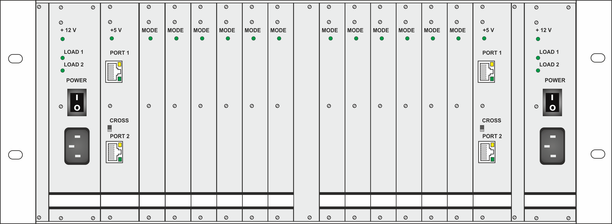

Figure 3 — General view of AAU

Front panels of AAU modules are shown in Figure 4.

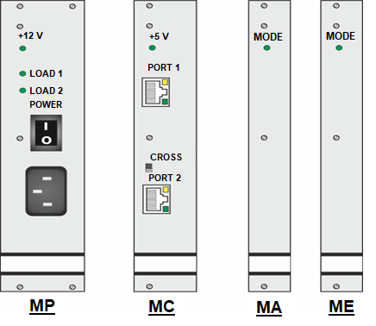

Figure 4 — Front panels of AAU modules

Power interface module. MP provides power supply to MC and Mi modules within AAU. Front panel of MP has a connector for connection to 220 V, 50 Hz primary power network. The AAU accommodates two motherboards (right and left motherboard). Power interface module (MP -1) connected to the same motherboard as modules MC -1 and Mi-1 is the main power source for the two modules. MP -1 is backup power source for modules MC -2 and Mi-2 connected to the other motherboard. MP is switched on by rocking switch "POWER". Indicator "+12 V" shall light up within about 2 seconds after switching on of MP. MP converts primary voltage into stabilized 12 VDC, which is supplied to the unit power supply lines (main and backup). Two MPs are installed in AAU. If one of the power interface modules fails, the other operating MP provides power supply for all unit modules. Motherboards within the unit are interconnected with bridge connections to implement the backup power supply system as shown in Figure 5.

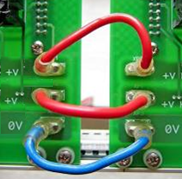

Figure 5 — Backup power supply bridge connections between AAU motherboards

Three indicators of the module operation modes are arranged on the MP front panel (Figure 4):

1. Indicator "+12 V" indicates supply of 12 VDC from MP to the unit power supply system;
2. Indicator "LOAD 1" indicates power supply to MP and Mi modules connected to the same motherboard as MP;
3. Indicator "LOAD 2" indicates power supply from MP to MC and Mi modules connected to the other motherboard.

"LOAD 1" is the main LOAD of MP -1, "LOAD 2" is the additional (backup) LOAD of MP -1. In the normal mode of operation of the two MPs in the unit, indicators "+12 V" and "LOAD 1" shall glow, and indicator "LOAD 2" shall not glow on both MPs.

In case of a failure or absence of a MP, the other MP provides power supply for all modules within the unit. In this case, all three indicators "+12 V", "LOAD 1" and "LOAD 2" shall glow on the single operating MP. Overall view of MP is shown in Figure 6.

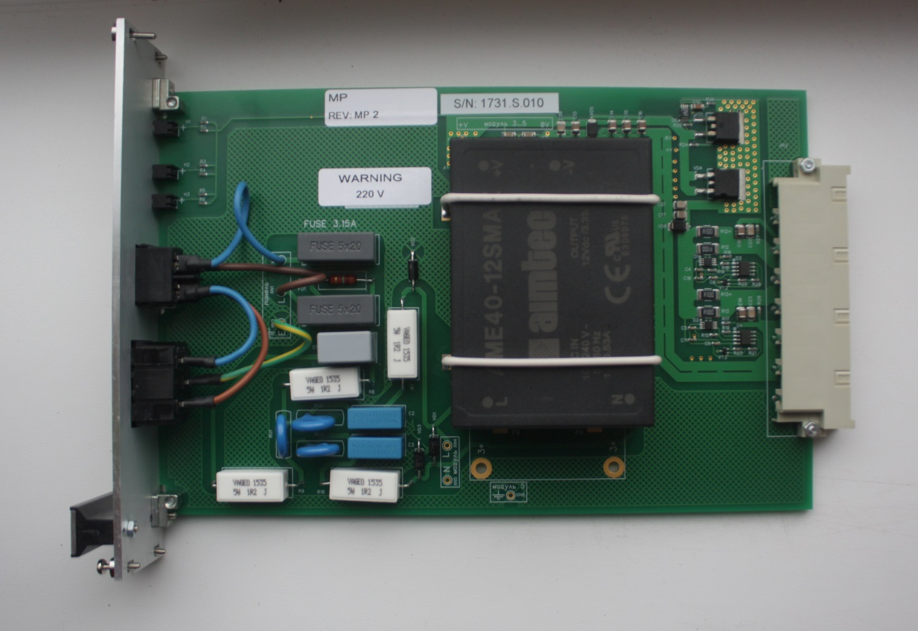

Figure 6 — Power interface module (MP)

Control interface module. MC is intended to transmit the processed data from Mi to the recording server. Standard arrangement of AAU includes two MCs. Each MC provides for connection of up to six Mis via the internal Ethernet network of the unit. MC is realized based on uncontrolled Ethernet switch with 8 ports. Six ports of the Ethernet switch are used for the unit internal connection. The Ethernet switch ports are connected to six Mis via AAU motherboard. Two Ethernet switch ports are connected to connectors RJ‑45 on the front panel of MC (refer to Figure 4) and intended for MC connection to external Ethernet network. The ports are marked as "PORT 1" and "PORT 2" on the MC front panel. "PORT 1" is intended for connection to external Ethernet network. "PORT 2" can be also used for connection to external Ethernet network. In addition, "PORT 2" can be connected to the internal unit Ethernet network for connection with similar port of the second MC (via AAU motherboard). Switching of port 2 between connector RJ-45 ("PORT 2") and motherboard ("CROSS") is provided by means of switch change over on the front panel of MC (refer to Figure 4). Structural connection diagram of two MC modules of AAU is shown in Figure 7.

1.tif

Figure 7 — Structural connection diagram of MC modules of AAU

MC modules can operate in AAU as two independent Ethernet switches. With this option, each MC transmits to connectors "PORT 1" and "PORT 2" the processed information from six Mis (connected to the respective MC). When switches of both MCs are set to position "CROSS", the control interface modules operate as one Ethernet switch with twelve internal unit ports connected to Mi1... Mi12 and two ports (connectors "PORT 1") for connection to external Ethernet network. With this arrangement, ports of the modules (MC1, MC2) are disconnected from connectors marked as "PORT 2" and connect MC1 and MC2 via the unit motherboards to form one internal Ethernet switch for the unit.

DIP switch is arranged on the MC board for assignment of unit number.

Reference table showing correspondence of DIP switch positions and unit number is provided near the DIP switch (on MC board). A fragment of MC board with DIP switch and unit numbers correspondence table is shown in Figure 8.

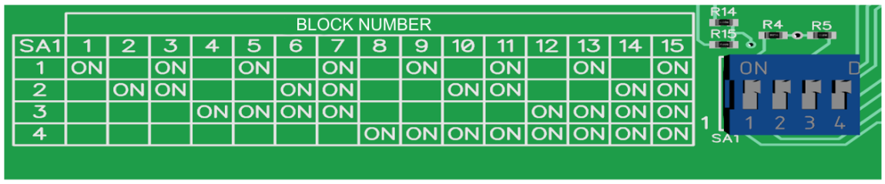

Figure 8 — Fragment of MC board with DIP switch and unit numbers correspondence table

Unit number is transmitted from MC to 6 Mis on the same motherboard (i.e. left motherboard "A" or right motherboard "B", refer to Figure 6). The unit number information is transmitted from MC to Mi by binary levels. In Mi potential levels are received at the "unit number sensors". After the sensors, information on the unit number is converted into the data communication format for Ethernet channel and transmitted to the data server. In normal operation mode each AAU unit is provided with two MCs. Unit number set on both MCs (using DIP switches) shall be the same. Up to 15 unit numbers can be initialized in one network.

Indicator "+5 V" on the MC front panel indicates voltage of 5 VDC which is supplied from DC-DC converter installed on the module board. Indicators on connectors: RJ-45 ("PORT 1", "PORT 2"). Two indicators are arranged on each connector: green and yellow. Glowing green indicator signals that the cable of external Ethernet channel is connected to MC port via the connector on the front panel.

If switches on both modules (MC1 and MC2) of AAU are set to position "CROSS", the green indicators on connectors "PORT 2" will glow, however connectors "PORT 2" on the modules front panels will be inactive. In this case, the indicators show that MC1 and MC2 ports are connected via the unit internal Ethernet network. Yellow indicators on connectors RJ-45 indicate a failure in the MC power supply system. The structure of AAU MC modules power supply is illustrated in Figure 9.

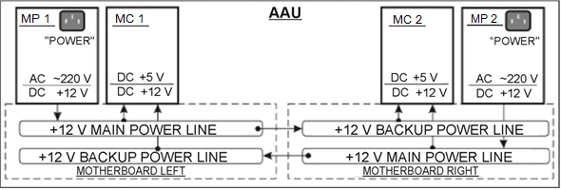

Figure 9 — Power supply diagram of unit MC modules

In normal operation mode, when MC is supplied with 12 VDC voltage from the main and backup power lines, yellow indicators do not glow. If 12 V voltage is not supplied through the main power line, yellow indicator glows on connector "PORT 1". If 12 V voltage is not supplied through the backup power line, yellow indicator glows on connector "PORT 2".

Overall view of MC is shown in Figure 10.

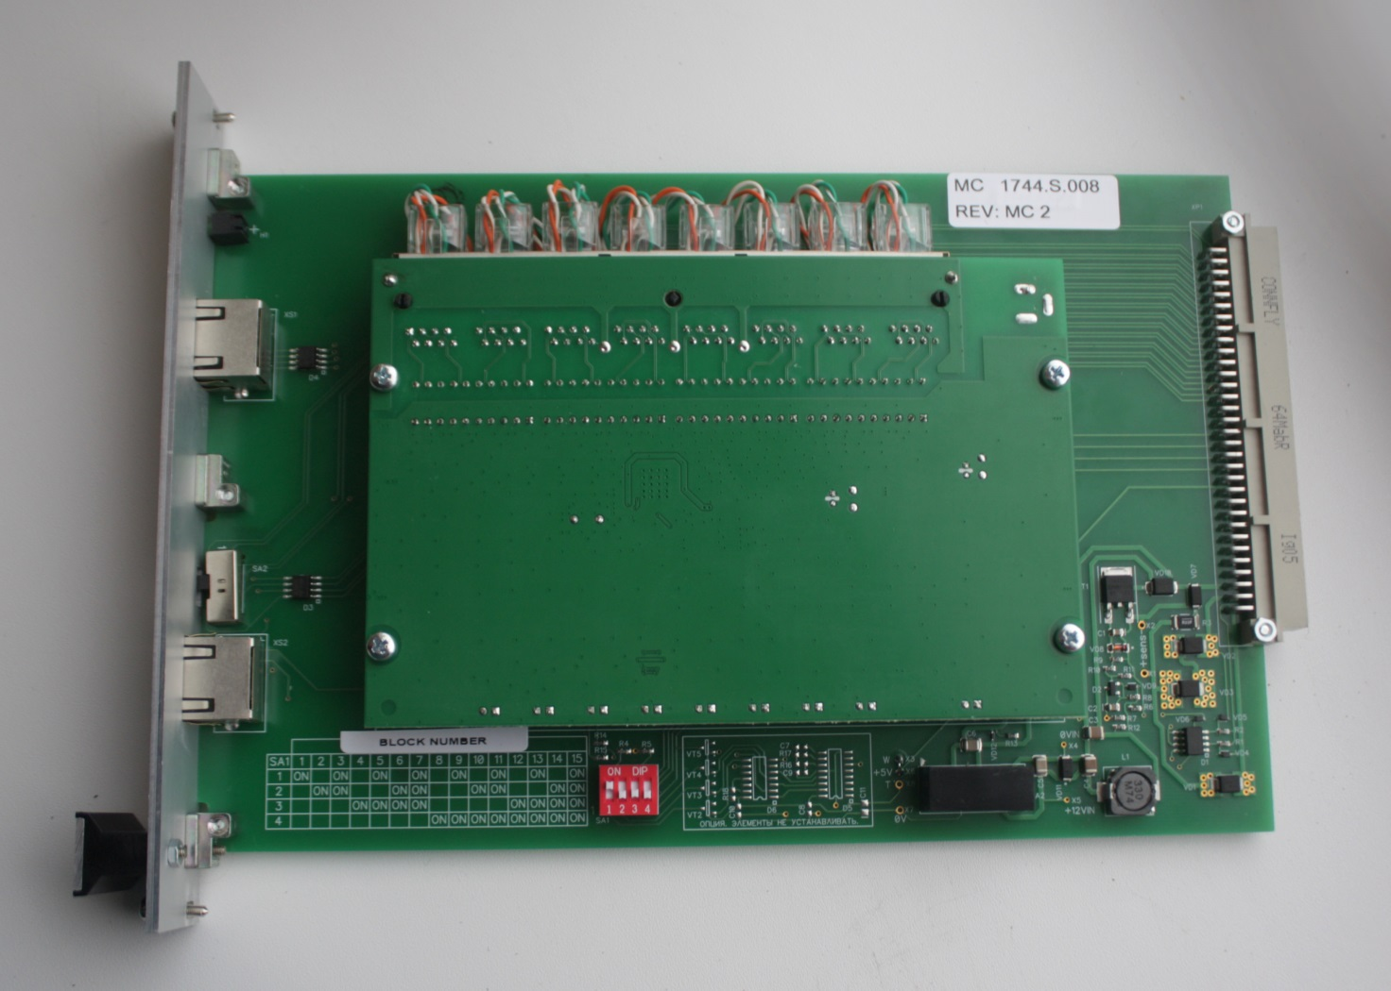

Figure 10 — Control interface module (MC)

Analog interface module. Analog interface module is intended for digitizing of analog (voice) signals from the analog lines and subsequent transmission of digitized signals via Ethernet network protocol to the recording server. MA can process signals from 16 analog lines and transmit them via Ethernet network. AAU can accommodate up to 12 analog modules. Each MA in AAU is connected with one of two MCs (installed in AAU) via internal unit Ethernet network. Digitized signals are transmitted from MA through the Ethernet network protocol via MC to the recording server. MA input circuits provide galvanic isolation of connected analog lines. MA input resistance for connected analog line is 1 MΩ, minimum, for alternating current and 2 MΩ, minimum, for direct current. MA input circuits are designed for up to 2 kV peak (pulse) overloads from connected analog lines, and for long-term overloading of up to 900 V. Frequency range of analog signals digitizing by "–3 dB" level is: 300 Hz...3400 Hz. Remote control of MA operation is provided through the same Ethernet channel as the one used for transmission of digitized signals from analog lines to the recording server.

MA modes are adjusted using special software – Technical Utility (TU). The utility provides interface for selection of analog signals digitizing method (codec type) and assignment of one of 16 available amplification factors for each of the 16 connected analog lines. The utility displays information on connected MAs: IP and MA addresses, unit number and number of slot where MA is installed in the unit, status (serviceability) of the main and backup power supply line of MA. The following technical tests of MA can be performed using the utility: Ethernet adapter test, watchdog timer test, and unit number sensor test. The utility can be used for reprogramming of MA via Ethernet channel.

MA power supply is provided from two power interface modules (MP) installed in the AAU. MP located in the same part of the unit with MA is the main power interface module for the MA. In normal mode, power is supplied to MA from the main MP. The second MP located in the other part of the unit is a backup power source for the MA. In case of a failure of the main MP, MA automatically switches over to power supply from the backup MP. Monitoring of module power supply system is provided in MA module. The module transmits information on the status of the MA power supply lines (main and backup) via Ethernet channel. Power capacity per one MA module is 1.5 W, maximum.

MA module consists of two assembly units: printed-circuit board with elements installed on it, and front panel. MA front panel is shown in Figure 4. Overall view of MA printed-circuit board with installed elements is shown in Figure 11.

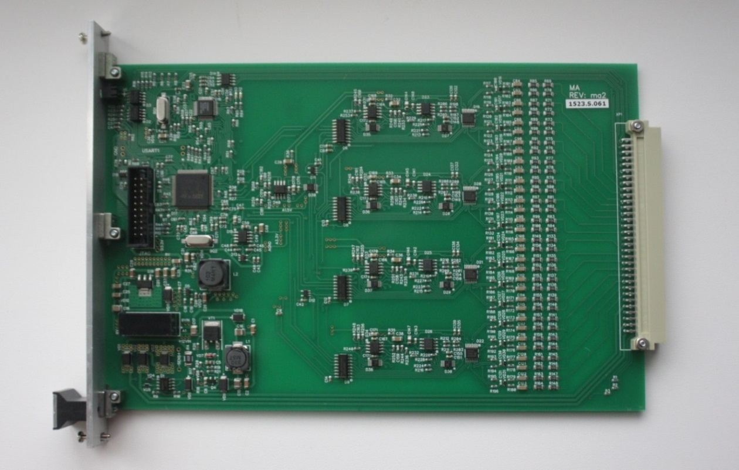

Figure 11 — MA module board

Structural diagram of MA is given in Figure 12. Analog signals received from lines are processed in four channels within the module. Up to 4 analog lines can be connected to each channel of MA. Signals from analog lines are sent to the channel input circuits. The input circuits provide galvanic isolation of analog lines from MA electronic components and protect the module against potential overvoltage originating from analog lines.

3.tif

Figure 12 — Structural diagram of MA module

Input circuits of MA channel function as frequency filter with bandpass   
(by level "–3 dB") of 300 Hz...3400 Hz. Having passed the input circuits, analog signals are received at multiplexer. Multiplexer successively switches signals from the four lines to the input of programmable amplifier (PA). PA operation is controlled by microcontroller. The microcontroller switches PA amplification factor depending on the line connected to PA input. Amplification factor for each line is set at the time of MA adjustment using the utility software. After PA signal from the channel is sent to another multiplexer for successive switching of outputs of two channels to the input of ADC integrated in the microcontroller. Two ADCs are used in the microcontroller: channels 1 and 2 are the group of channels switched with multiplexor to ADC1, while channels 3 and 4 are the group switched to ADC2. ADC1 and ADC2 operate in parallel, i.e. analog signals from the two groups of channels are simultaneously digitized in MA. Once analog signals are digitized, the data received from ADC are processed in microcontroller. Microcontroller also processes data from MA sensors. Microcontroller packs information from ADC and sensors into data packets and sends them to the Ethernet transceiver. The Ethernet transceiver converts the data packets received from the microcontroller to meet the requirements for data transmission via Ethernet channel.

Flow Е1 module (МЕ). ME is intended to record one flow E1.

The patch panel is fitted with symmetrically arranged couplers – passive sensors based on ferrite elements (Figure 13).

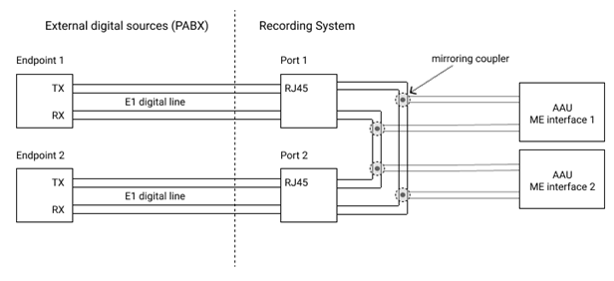

Figure 13 — Schematic diagram of flow E1 mirroring in recording system AVIATOR

Pulse signals taken from each flow E1 coupler are connected in the rack to two interface modules of flow E1 (ME) on AAU, what ensures system redundancy. With this arrangement the length of digital communication line between the stations is no way restricted by the recording system. Replacement of interface modules (ME) does not disrupt main flow E1 between the stations, and synchronization is not lost.

Generalized structural diagram of flow E1 recording is shown in Figure 14.

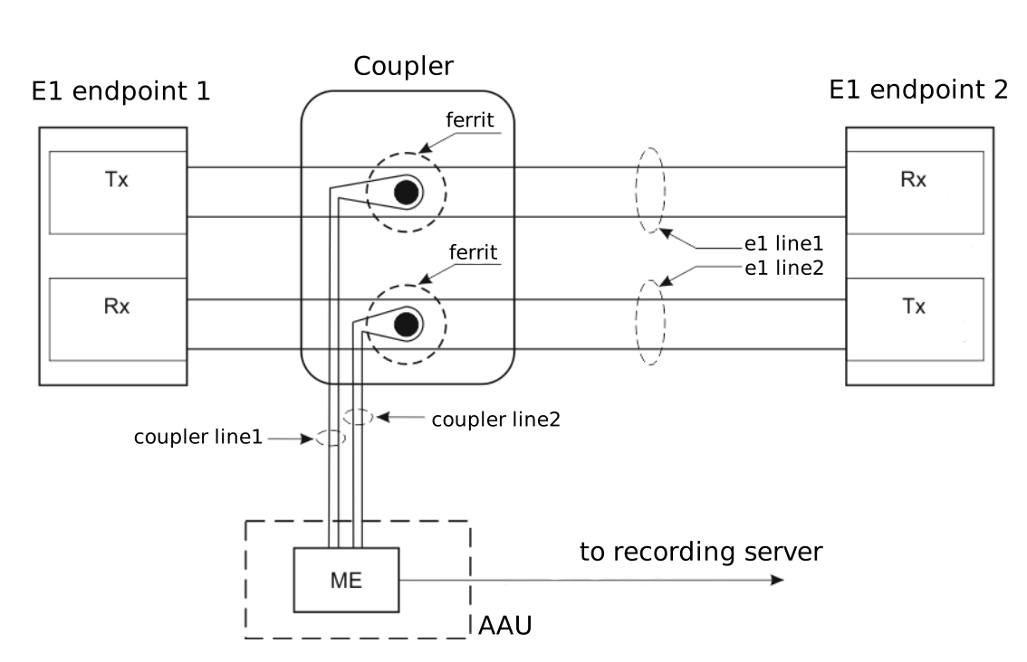

Figure 14 — Structural diagram of flow E1 recording

FL1, FL2 are communication lines of flow E1. CL1, CL2 are communication lines between the coupler and ME module.

The coupler provides noncontact monitoring of flow lines FL1, FL2 and matching with communication lines CL1, CL2 which transmit information to ME module. Overall view of the coupler and its installation on the patch panel are shown in Figure 15.

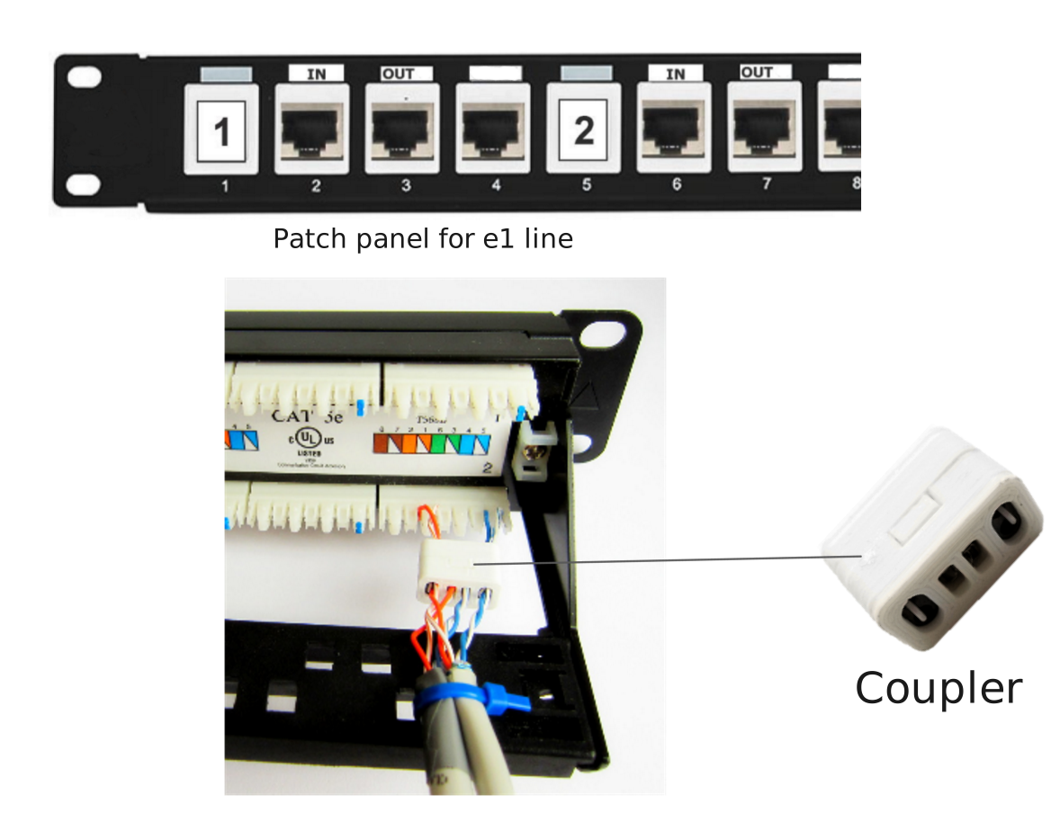

Figure 15 — Coupler

Specifications of the coupler:

Maximum length of CL lines (coupler – ME lines)………………………….…….. 100 m.

Operating ambient temperature range…………………………...…….–10 °С…+75 °С.

After the coupler signals are sent via lines CL1 and CL2 to ME module. ME module consists of two assembly units: printed-circuit board with elements installed on it, and front panel. ME front panel is shown in Figure 4. Overall view of ME printed-circuit board with installed elements is shown in Figure 16.

Sequences of reception and transmission pulses received at ME are amplified, processed and digitized, packed in protocol RTP/G.711 packets and transmitted to both servers of the recording system via redundant Ethernet lines. Each recording server records data from known good line and ME using the "source selection" algorithm (see Figure 16).

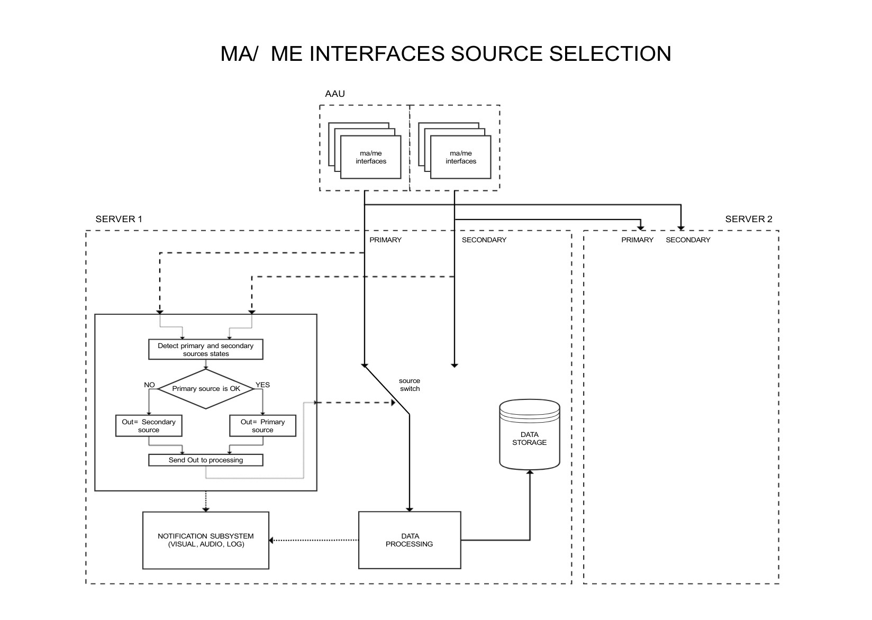

Figure 16 — "Source selection"

If a failure is detected, visual notification on the event is issued and a corresponding entry is made in the log. Continuous correct recording is ensured as long as at least one fault-free board and line are available.

If necessary, reserve capacity to increase the number of recorded flows is provided by installation of extra ME modules in AAU free slots and connection to lines E1 via pre-designed ports on the patch panel.

Recording server is a PC system unit (with processor Intel Core i3 or a later version) of industry standard 19". All controllers needed for connection of the required set of peripheral devices (monitor, keyboard, mouse manipulator, SATA), memory devices (HDD, DVD), redundant LAN adapter, disk storage (HDD) are integrated into the system unit. HDD capacity for the online archive depends on version of the recording station. Linux family operating system is installed on the server, as well as application software that supports the following functions:

* recording in online and long-term archives with reference to real time signals of the following data: voice information transmitted via VF channels, telephone subscriber lines, operative control communication channels; digital information sent via radar data communication channels from radar stations; digital radar data after secondary and tertiary processing which is transmitted to the air traffic controllers’ workstations; images from monitor screens at the air traffic controllers’ workstations (compressed video data flow);
* monitoring of the recording station hardware and network neighbourhood of the system;
* processing of user requests.

Uninterruptible power supply (UPS) unit protects consumers (PC system units, AAU, monitors, etc.) against voltage surges in 220 VAC power supply network. UPS also ensures automatic switching over to battery power supply within 2 to 4 ms in the event of mains voltage loss, and guarantees operation of the system hardware during 30 minutes from loss of mains power. UPS is based on maintenance-free sealed batteries. UPS has a control panel and light indicators. For more details on UPS operation refer to UPS User Manual.

LAN hubs are combined by hot swap pattern and ensure LAN operation on the basis of Fast Ethernet protocol. Data transmission between consumers is provided at the rate of 100/1000 Mbit/s, with the distance between them of 105 metres, maximum. Local network of the system is fully redundant: redundant switches, redundant data transmission lines, each AWS has two independent network inputs, so that sufficient level of reliability is ensured. Switches have an on-off toggle switch and light indicators of operation modes for each of the available LAN ports. For more details on the switch operation refer to Switch User Manual.

Monitor, keyboard and mouse manipulator are intended to provide operator interaction with an interface and are connected to one of the servers by means of KVM switch. Descriptions of the above mentioned products are given in the respective User Manuals. KVM switch is intended for electronic switching of input/output devices (mouse type manipulator and keyboard) between the recording servers. The switch has a light indicator of active server, which is connected to the input devices at any given time. For more details on operation of KVM switch refer to the respective User Manual.

Telecommunications rack 19" is intended for installation of the system components and for prevention of unauthorized access to components of the recording station. Two panels with fans and a temperature sensor are installed in the cabinet in order to maintain normal temperature for the system operation. Temperature settings in the rack can be adjusted by selecting desired temperature on the temperature sensor.

Supply line filter is intended for distribution of single-source power supply to various consumers, and is fitted with on-off toggle switch, power-on light indicator and 10 A safety fuse.

Fan panel with temperature sensor is intended for forced cooling of the recording station hardware in case of elevated operating temperature. Temperature sensor is located in the telecommunications rack in the place, which is most prone to heating; using the sensor it is possible to set threshold value of ambient air temperature, which will trigger automatic start of the fan.

Power supply splitter with in-line filter is intended for connection of all power consumers within the recording station to 220 VAC 50 Hz power supply network, and for protection of consumers (PC system units, AAU, monitors, etc.) against voltage surges in 220 VAC power supply network. The splitter has a light indicator of voltage supply and a 10 A safety fuse.

### Monitoring Workstation (MWS)

MWS is intended for system status monitoring and provides the following:

* remote monitoring of system components;
* timely warning of service personnel on any failures;
* point-to-point channel with any of the recording stations;
* playback of online archive from any of recording stations;
* processing of user requests.

MWS consists of the following components:

* workstation;
* monitor;
* keyboard;
* mouse manipulator;
* UPS;
* acoustic system and headset;
* connection cables set.

The workstation is a PC system unit (with processor Intel Core i3 or later versions) of industry standard 19" (desktop version is acceptable). All controllers needed for connection of the required set of peripheral devices (monitor, keyboard, and mouse), memory devices, and redundant LAN adapter are integrated into the system unit. Linux family operating system is installed on the workstation, as well as MWS application software (control panel) that supports the following functions:

* status monitoring of long-term archive;
* status monitoring of online archive;
* status monitoring of AAU;
* status monitoring of LAN;
* playback of information from online archive;
* arrangement of point-to-point channel;
* processing of user requests.

Acoustic system and headset are intended for conversion of electric signals into acoustic signals, and for power level adjustment during playback; therewith the headset is used for individual listening, so that no disturbance is caused to other persons nearby. When headset is used, acoustic system is off. Description of the acoustic system and headset is given in the User Manual for the respective product.

### Radar Data Playback Workstation

RWS is intended for playback of air situation information (RWS ЦИВР.468369.046).

RWS consists of the following components:

* workstation;
* monitor;
* keyboard;
* mouse manipulator;
* UPS;
* connection cables set.

The workstation is a PC system unit (with processor Intel Core i3 or later versions) of industry standard 19". All controllers needed for connection of the required set of peripheral devices (monitor, keyboard, and mouse), memory devices, and redundant LAN adapter are integrated into the system unit. Linux operating system is installed on the workstation.

UPS is intended to ensure normal operation of RWS in case of interruptions of mains power supply. Duration of RWS operation with power supply from UPS is defined by specific installation project. Description of UPS is given in UPS User Manual.

The connection cables set provides connection of all components in compliance with the connections diagram included in the installation project.

Synchronous playback is ensured by the hardware design and software of RWS and PWS.

# Intended Use

## Operational Limitations

Power supply for recording system AVIATOR shall be provided from alternating current network with frequency of 50 Hz ±2 % and voltage of 220 VAC +10 %, –15 %.

Allowable ambient parameters are listed in Table 3.

Table 3

|  |  |
| --- | --- |
| Parameter | Value |
| Ambient air temperature, °С | from +5 to +40 |
| Relative air humidity up to 90 % at a temperature of, °C | +25 |
| Atmospheric pressure, minimum, mm Hg | 430 |

## Product preparation for Use

### Visual Inspection Scope and Procedure

* Visually inspect recording system AVIATOR. No foreign objects may be present at the system workstations;
* Make sure that hardware of recording station, MWS, RWS has no mechanical damage.

IT IS PROHIBITED TO:

* Connect to PC any additional devices, which are not approved for use by the designer;
* Connect to system LAN any additional devices which are not approved for use by the designer.

Positions of the system components (recording station, MWS, RWS) shall comply with the site-specific installation project.

Make sure that no indication is present on the system hardware, and that all controls are switched off.

ATTENTION!

System operation is prohibited if any of the above requirements are not fulfilled.

### Rules and Procedure of product Preparation for Operation

Recording system AVIATOR readiness for operation is checked as follows:

* Make sure that the system equipment is isolated from power supply;
* Using cable tester check correctness and quality of cable connections of the system and its components in accordance with electrical connections diagrams ЦИВР.462418.019-01 Э4, ЦИВР.468369.039 Э4, ЦИВР.468369.046 Э4, ЦИВР.468369.047 Э4, ЦИВР.468369.048 Э4. When checking installation, make sure in particular that cables and harnesses bend circumferences are by more than three times larger than cable (harness) diameter;
* Check fastening security of the system hardware in the recording rack, MWS, RWS;
* Check system completeness in accordance with logbook ЦИВР.468418.019 ФО.

### Switching on of Recording System AVIATOR Hardware

Description of the system hardware switching on procedure is given in the instruction for product installation, start-up, adjustment and trial run.

## Product Use

### Procedure for Ensuring Serviceability of Recording System AVIATOR

Serviceability is checked by two methods:

* visual method: check of indication on the system hardware in compliance with the applicable operational documentation;
* remote method: using MWS hardware. Description of remote monitoring procedures is given in recording system AVIATOR software Operator Manual ЦИВР.00101-01 34 01.

### Recording System AVIATOR Switching off Procedure

Description of the system hardware switching off procedure is given in the instruction for product installation, start-up, adjustment and trial run (item 6.3.2).

### Operation of Recording System AVIATOR with Time Synchronization Complex "TSC TOPAZ"

All data sources are recorded using standard time marks. NTP protocol and related services are used to provide standard time for the system. Standard time marks are sourced from ATC AS connected to recording system AVIATOR via redundant LAN. For reliable operation, the recording system is tested with audio and visual warnings given and appropriate records made in the log.

### Recording for Radio Sets Supporting ED-137 (Optional)

Recording is performed in compliance with ED-137B. Radio sets connected to internal network of "VCCS TOPAZ" use their in-built remote monitoring functions to send audio data packets to servers of the recording system for processing and recording. Redundancy is provided by double VCCS network and redundant network of the recording system. If a failure is detected or recording with the recording system is impossible, visual and audio notification on the event is given and corresponding entry is made in the log. If radio sets are connected based on the hot swap pattern, continuous and correct recording is guaranteed as long as at least one fault-free radio set and LAN are available.

Reserve for connection of additional radio sets is only limited by capacity of LAN of "VCCS TOPAZ" and RS AVIATOR.

### "VCCS TOPAZ" Interface for Remote Listening (Optional)

VCCS has a linear input for reception of signal played back at PB ASW: two-wire symmetric line with Rin=600 Ω. Rated level of received signal is 0 dBm0 (0.775 V). Line output for signal transmission is provided at MWS or PWS of recording system AVIATOR: two-wire symmetric line. Rated level of transmitted signal is 0 dBm0 (0.775 V).

Communication line with recording system AVIATOR is accessed from VCDT of "VCCS TOPAZ", by pressing the designated direct access button.

A telephone communication device shall be arranged at operator's workstation of recording system AVIATOR (VCDT from "VCCS TOPAZ" set, analog telephone set of IP telephone connected to VCCS, or telephone set connected to PBX of ATC center).

Record listening procedure includes the following steps:

1) Air traffic controller sends to the operator of recording system AVIATOR details of the fragment of record to be played back.

2) Operator of recording system AVIATOR retrieves the required fragment and notifies the air traffic controller about readiness for playback.

3) Air traffic controller establishes communication with recording system AVIATOR and notifies the operator about readiness for listening.

4) Operator of recording system AVIATOR starts playback of the selected fragment.

5) Air traffic controller listens to the played-back fragment at VCDT of "VCCS TOPAZ" using the selected speaking devices.

### Recording of Monitor Screenshots

Monitor screenshots are sent from ATC AS to recording system AVIATOR via redundant LAN using standard RTP, RTPS protocols and H.264, MJPEG video encoding. Data from each ATC AS workstation are received at both servers of recording system AVIATOR for processing and recording. Failure of one ATC AS server and/or recording system server and LAN components will not result in loss of recorded data. For reliable operation, the recording system is tested with audio and visual warnings given and appropriate records made in the log

### Radar Data (RD) Recording

Radar data (RD) is sent from ATC AS to recording system AVIATOR via redundant LAN using ASTERIX protocols cat. 1, 2, 34, 48, 62. Failure of one ATC AS server and/or recording system server and LAN components will not result in loss of recorded data.

Reserve for connection of additional radar data sources is only limited by capacity of LAN of ATC AS and recording system AVIATOR.

# Maintenance

## General Instructions

Maintenance of the equipment is carried out as per technical description for the purchased products and this Operation Manual (ЦИВР.462418.019-1 РЭ). Maintenance is carried out by maintenance personnel. Responsibility for observance of the equipment operation rules and safety rules by maintenance personnel rests with manager of the site where the product is used, and in absence of manager – with shift supervisor (to be defined by local labour safety regulations). Consumables required for maintenance are listed in Table 4.

Table 4

List of consumables

|  |  |
| --- | --- |
| Material | Q-ty |
| Coarse calico* No. 6 ГОСТ 29298-92, m/year | 4 |
| Rectified industrial ethyl alcohol, grade "Экстра"* |  |
| ГОСТ 18300-87, l/year | 0.3 |
| *Consumables out of delivery scope | |

## Safety Precautions

In order to prevent potential accidents and damage of equipment, the following rules shall be followed:

* Adhere to the product equipment switching ON/OFF procedures;
* Check technical serviceability of the product components on a daily basis, at the start of shift;
* Apply special care when handling the monitors, as mechanical shock may break their screens into small fragments;

It is prohibited to:

* Leave switched on equipment unattended by maintenance personnel for more than one day;
* Touch and clean current-carrying parts;
* Eliminate detected failures, if that would not require contact with live current-carrying parts;
* Touch current-carrying parts in case of loss of voltage without having de-energized the equipment;
* Disconnect and connect live cables and harnesses.

## Product Maintenance Procedure

Product maintenance system includes the following maintenance operations:

* M-1 – line maintenance;
* M-2 – regular semi-annual maintenance.

Maintenance (M-1) is carried out on a daily basis by technical personnel of operating shift. Maintenance (M-2) is carried out by maintenance team personnel of the operating group. The number of personnel involved in maintenance operations is defined by the operations supervisor, depending on the scope and labour intensity of specific operations. Recommended manning of maintenance team is 3 persons, maximum.

Required labour input for repair and adjustment operations is defined each time based on technical state of the product and its components.

Maintenance of recording system AVIATOR shall be carried out according to Table 5.

Table 5

Maintenance of recording system AVIATOR

|  |  |  |  |
| --- | --- | --- | --- |
| Operation | Labour input for specific maintenance operations,  man-hour | | Required materials |
| M-1 | M-2 |
|  |  |  |  |
| Visual inspection of equipment | 0.3 | 0.3 |  |
|  |  |  |  |
| Grounding reliability check | – | 0.3 |  |
|  |  |  |  |
| Check and restoration of security of detachable connections and units fastening | – | 1.0 |  |
|  |  |  |  |
| Serviceability check of RS AVIATOR | 0.6 | 0.6 |  |
|  |  |  |  |
| Cleaning of PC system units |  | 0.7 |  |
|  |  |  |  |
| Completeness check of RS AVIATOR |  | 0.5 |  |
|  |  |  |  |
| Make records in tables: " product operation record" |  |  |  |
|  |  |  |  |
| "Maintenance Record", log book |  |  |  |
| ЦИВР.462418.019-01 ФО |  | 0.5 | ЦИВР.462418. 019-01 ФО |

### Check of Grounding Wires for Secure Connection to Equipment Bodies and Grounding Bus

If visual inspection of grounding wires connections is not possible, check the ground conductor circuit with cable tester. All walls and doors of the recording station rack and AWS panels shall be interconnected by ground conductors.

### Check of Security of Detachable Connections and Units Fastening

Check and if needed restore security of detachable connections and units fastening as follows:

* Check tightening of connector screw joints and tighten screws if needed;
* Check integrity of LAN connections by indication of LAN hubs and LAN adapters. If needed, check cables integrity with cable tester and restore connection by replacing connectors RJ-45 with spare ones from SPTA set, using special connector sealing tools.

### Visual Inspection and Cleaning of PC System Units of Recording System AVIATOR

For visual inspection and cleaning of PC system units of recording system AVIATOR observe the following procedure:

* Shut down the recording server (system unit) in accordance with the methodology described in the installation instruction;
* Open rear door of the recording station rack;
* Working from rear side of the recording station, disconnect LAN cables and 220 VAC 50 Hz power cable from the server, then unscrew two screws fastening the system unit cover;
* Carefully pull the unit out (against the stop) holding it by its front handles;
* Unscrew the remaining screws on the system unit cover and remove the cover;
* Clean the system unit from dust and wash the fan filter;
* Visually inspect fans for damage;
* Visually inspect internal connectors of the system unit for loose contact, check the connections by slightly pushing them;
* Re-install the system unit cover, fix it with screws, return the system unit to the initial position, connect LAN cables and power cable;
* Switch on the recording server;
* Repeat the operations for system units of MWS, PWS, RWS;
* On the second day visually inspect and clean the second recording server following the same procedure.

# Routine Repair

## Requirements to Repair

Routine repair of the product shall be carried out in line with instructions in this section and operational documentation for the components.

Operating company shall provide routine repair of the product when any failures described in this section are detected. In case of other failures, supplier's specialists shall be engaged for repair. Potential failures and methods of their elimination by operator's maintenance personnel are listed in Table 6. Operational documentation for the purchased products shall be also used for detection of failures. If recording servers are replaced, their software shall be installed or restored.

Table 6

| **Potential Failures and Troubleshooting Methods** | | | |  |
| --- | --- | --- | --- | --- |
| Description of failure and damage consequences | Possible causes | Instructions for identification of consequences of failure and damage to assembly unit (part) | Instructions for elimination of failure and damage consequences |
| 1 | 2 | 3 | 4 |
| At MWS status indicator of recording servers interconnection through LAN is shown in red | LAN cables break or damage, LAN hubs failure, LAN hubs are not switched on | Check if power supply to LAN hubs is switched on. Check hubs serviceability by their status indicators. Disconnect and check the cables | Replace faulty components |
| During playback with point-to-point channel at MWS, AAU boards monitoring indicator is shown in red in window "Monitoring" | AAU boards failure | Replace faulty boards | Check recording station serviceability according to the operator's manual |
| During playback of online archive or long-term archive at MWS, AAU boards monitoring indicator is shown in red in window "Playback of online or long-term archive" | Channel boards failure at the time of played-back fragment. Errors in online archive | Check recording station serviceability according to the operator's manual | Replace faulty boards |
| During play-back with point-to-point channel at MWS, common channel equipment indicator is shown in red in window "Monitoring" | Failure of timing board, power supply unit, AAU, or cable break between the recording device and PC | Check serviceability of the boards and power supply unit using their respective indicators, disconnect and check the cable | Replace faulty elements, check recording station serviceability according to the operator's manual |
| During playback of online archive or long-term archive at MWS, common channel equipment indicator is shown in red in window "Playback of online or long-term archive" | Failure of timing board, power supply unit, AAU, or cable break between the recording device and PC at the time of the played-back fragment | Check serviceability of the boards and power supply unit using their respective indicators, disconnect and check the cable | Replace faulty elements, check recording station serviceability according to the operator's manual |

## Methods of Repair

Repair is carried out by replacing faulty unit or board with spare one from SPTA. Description and characteristics of built-in monitoring systems diagnostic capabilities:

The recording system is equipped with built-in system for continuous monitoring of data recording to archives, functioning of AAU, and LAN state. Operator is warned on any failures by a sound signal on the recording station or MWS, after which the operator detects the failure cause through dialogue with system in accordance with Operator's Manual ЦИВР.00101-01 34 01.

Each AWS and recording station has the built-in system for continuous monitoring of hardware and software operation at the level of operating systems of servers and workstations. Operation records of servers and workstations are made in logs at the recording stations and can be accessed both on servers and at MWS or PWS (refer to Operator's Manual ЦИВР.00101-01 34-01).

AWS and recording station hardware have built-in continuous monitoring system, monitoring results are shown by indicators on front panels of the units. Functions of the indicators are described in Section 1 of the present Manual.

The following components can only be repaired in shop conditions:

* system unit;
* monitor;
* KVM switch;
* hub;
* fan panel with sensor;
* uninterruptible power supply;
* AAU;
* acoustic system.

## Failure Detection and Replacement of Board in AAU

Identify location of faulty board in MWS rack:

1. Select mode "Recording servers" in the right part of the program window (Figure 17).

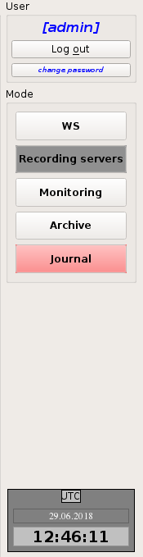

Figure 17 — Selection of mode "Recording servers"

1. In the left part of the program, select item "Audio Unit" in tab "Information" (Figure 18).

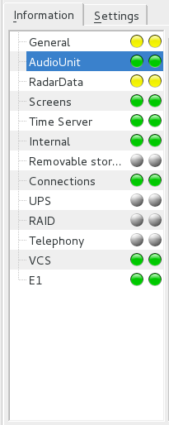

Figure 18 — Tab "Information". Selection of item "Audio Unit"

1. Identify the server with faulty board (faulty server is shown in red).
2. In the server identified according to the previous item, detect the AAU device with faulty board (the faulty device will be shown in red).
3. In the AAU identified according to the previous item, identify location of the faulty board (faulty board will be shown in red).
4. Remove the faulty board from the rack.
5. Replace the faulty board with an equivalent one from SPTA set.
6. Make sure that the board failure is not indicated any more at MWS (i.e. the respective server, unit and board are shown in green).
7. Check availability of signal in each channel of the replaced board (refer to Operator's Manual on "Monitoring").

# Storage

## Rules for product Placement in Storage and Removal from Storage

When the product is delivered to customer, the consignee shall check the cargo packages for damage to packaging and seals. Any cargo packages with damaged packaging and seals shall be opened by representatives of the consignee and carrier and checked against the list; any defect or deficiency found in the product shall be recorded in inspection report.

Product in the original packaging shall be placed in storage until arrival of the supplier's specialists for installation and start-up and adjustment works.

If the product is placed in storage after a period of operation, fulfil instructions in item 3.3.3 herein.

In case of storage for more than 6 months, open UPS packaging and charge the batteries as described in UPS user manual. After that store UPS in compliance with UPS user manual.

In case of long-term storage (for more than 12 months), open the packaging and fulfil instructions in item 3.3.3 herein.

At the product removal from storage, remove preservation grease with cleaning rags, unpack components and connectors.

During long-term storage (for more than 12 months) of SPTA set, unpack system unit of the set PC, connect it to the respective peripheral devices (monitor, keyboard and mouse manipulator), switch on power supply and leave switched-on for 24 hours. After 24 hours the system unit can be de-energized, disconnected from peripheral devices and packed for further storage.

## Storage Conditions

Product shall be stored in ventilated indoor premises in compliance with ГОСТ РВ 20.39.304-98, group 1.1.

## Methods of Disposal

Used UPS batteries shall be disposed of in compliance with UPS user manual.

## Storage Periods

Storage period is 12 months, minimum.

# Transportation

1. Requirements to product transportation and conditions at transportation.

The product shall be transported in manufacturer's packaging by railway, motor, water and air transport.

The product shall be transported in conditions, where it is not exposed to precipitation and direct sunlight, at the air temperature of –50 to +50 °С and relative humidity of 85 %, maximum, at 25 °С.

Shock and vibration over 4 g are not allowed at transportation.

1. Product preparation for transportation.

Product components shall be packed in the manufacturer's packaging. Boxes shall be marked with order numbers using tip marker or printed glued-on labels.

## Handling Procedure and Safety Precautions

Adhere to safety rules for LOAD handling operations.

Weight of individual boxes is larger than permitted for transportation as hand baggage. Boxes heavier than 100 kg shall be handled with power loading machines. Boxes with weight of 25 kg to 50 kg shall be carried by two persons, those with weight of 50 kg to 100 kg – by four persons. Use caution – monitors, UPS and system units of computers shall not be turned over, thrown and left exposed to precipitation.

# Appendix A

## Network Cards Bonding (Teaming)

The network operation mode used to provide redundancy of recording system AVIATOR channels is: bonding mode 1 (active-backup). Switches connection diagram is shown in the following diagram:

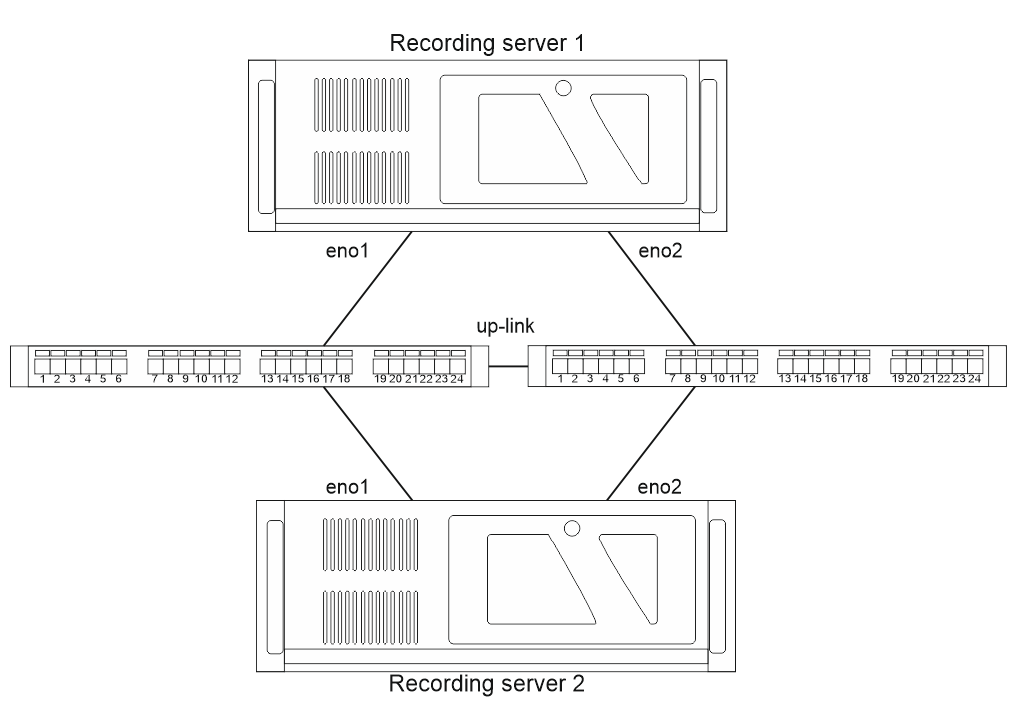

Server NetworkManager shall be disabled prior to network interface bonding setup adjustments.

**service NetworkManager stop**

**systemctl disable NetworkManager**

Command **ifconfig – a** is used to define which interfaces are connected to the switch. The number of input/output packets will change on them

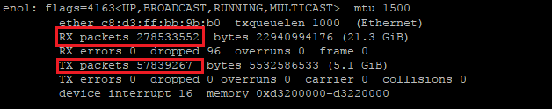

The following file parameters are entered at the time of network interfaces bonding:

**Ifcfg-eno1, Ifcfg-eno2** respectively

DEVICE=eth1

USERCTL=no

ONBOOT=yes

MASTER=bond0

SLAVE=yes

BOOTPROTO=none

TYPE=Ethernet

DEVICE=eth2

USERCTL=no

ONBOOT=yes

MASTER=bond0

SLAVE=yes

BOOTPROTO=none

TYPE=Ethernet

After that create file **ifcfg-bond0**

DEVICE=bond0

IPADDR=192.168.13.100

GATEWAY=192.168.13.1

NETMASK=255.255.255.0

DNS1=192.168.13.1

DNS2=192.168.13.2

ONBOOT=yes

BOOTPROTO=static

USERCTL=yes

BONDING_OPTS=”mode=1 miimon=100”

To apply the parameters, restart network connections with command:

**service network restart**

To check network serviceability, start command "ping" with the required number of echo requests and IP - address of any other active device within the network; when communication is available, disconnect cables from the switch one by one and make sure that no packets are lost. No packets shall be lost at steady network operation while command "ping" is running.

## Network routings

AAU operates in network via RFC 3927 (Dynamic Configuration of IPv4 Link-Local Addresses).

For network operation, routing shall be set up at the recording servers.

In folder **/etc/sysconfig/network-scripts/** create file **route-bond0** with the following parameters:

ADDRESS0=169.254.0.0

NETMASK0=255.255.0.0

GATEWAY0=

The parameters are applied upon restart of network connections with command:

**servie network restart**

Routing is checked with command:

**route**

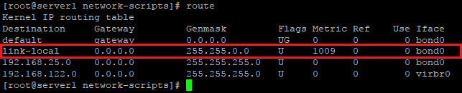

## LAN switches

Fail-safe operation of the network is ensured by provision of redundant communication lines. Switches that serve the scheme operate with protocol STP (Spaning Tree Protocol)

Initial setup of the switch is provided in Web browser via IP - address of the device. The address is specified on the sticker on the device rear panel.

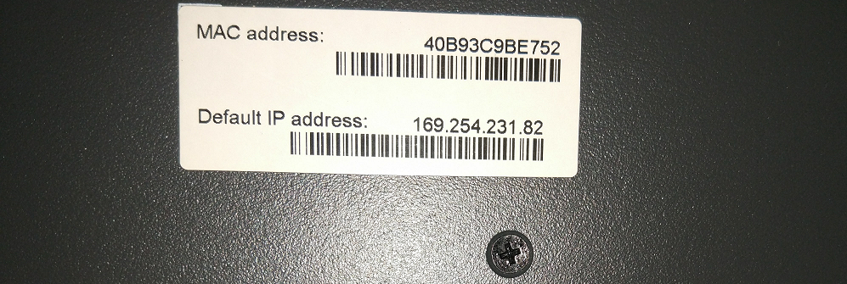

Login is **admin** with no password

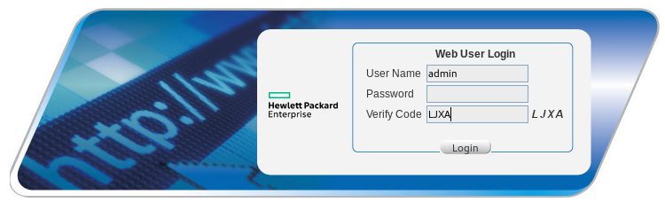

**After that Network -> MSTP**

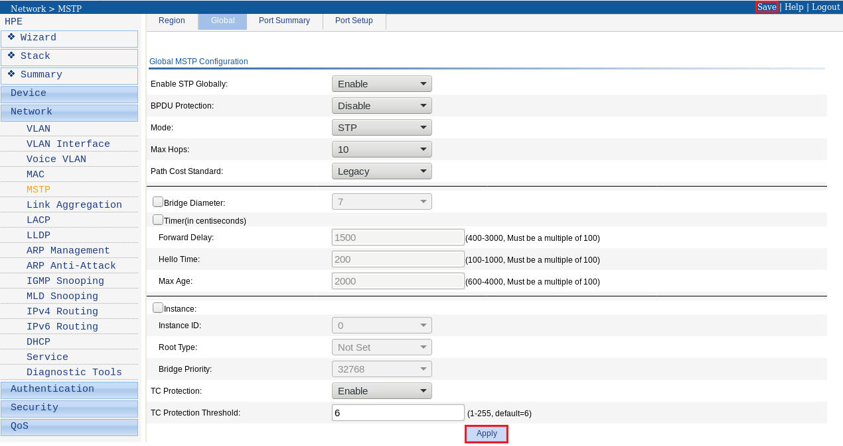

Click on "Apply" followed by "Save" to apply and save the configuration parameters.

The switching devices are controlled via protocols telnet and ssh.

To start them move to **Network -> Service**

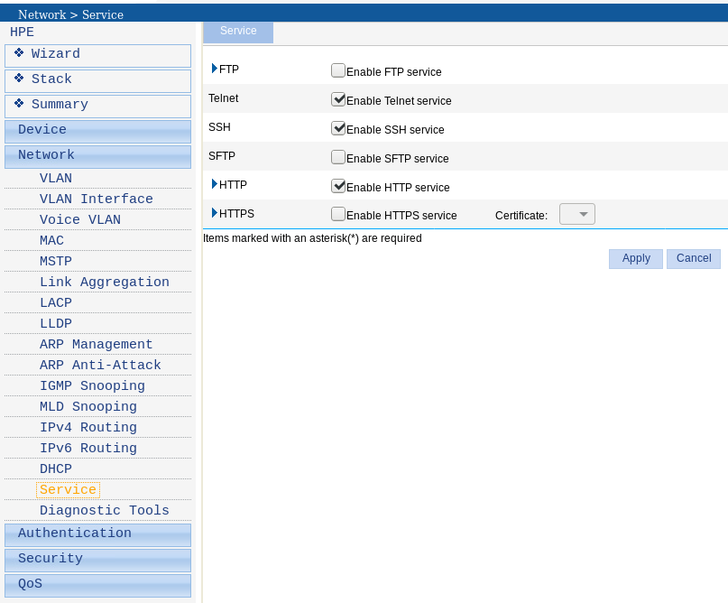

After that set authentication and password for account **admin**.

Move to **Authentication -> Users -> Modify**

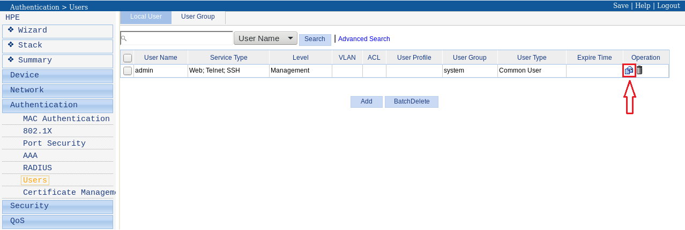

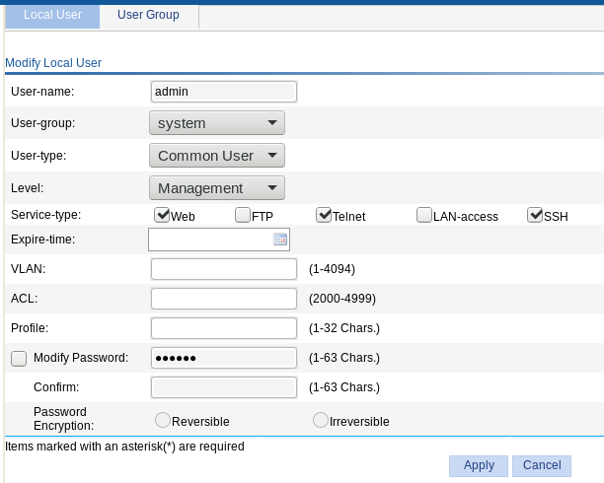

Here we can select the required user authentication and change the password.

To setup the device address in our sub-network, move to **Network -> Vlan Interface -> Modify**

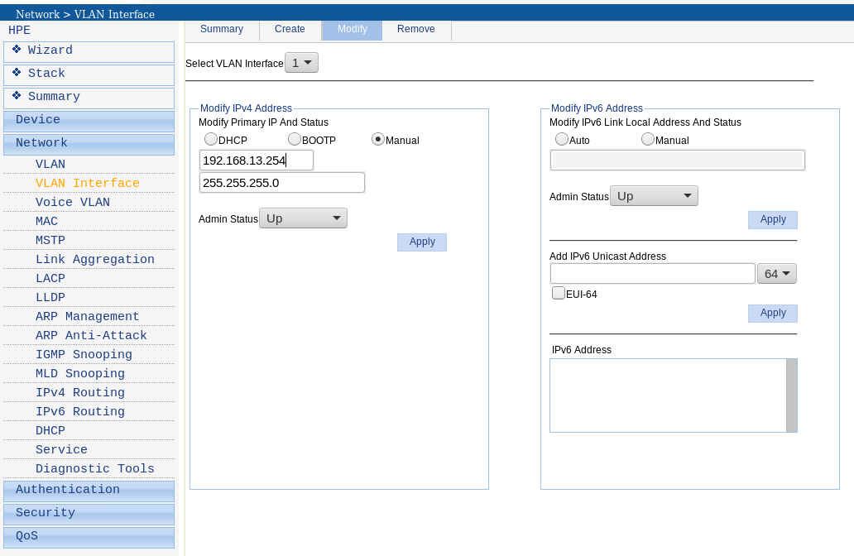

It is also possible to set up the switch using console cable through protocol telnet. For this purpose, execute the following commands:

1. Enable access to extended functions of command line

**_cmdline-mode on**

1. Enter password

**Jinhua1920unauthorized**

1. Proceed with configuration editing

**system-view**

1. Set parameter STP

**stp mode stp**

1. Enable STP

**stp enable**

1. Set IP address of the switch

**Interface Vlan-interface1**

**IP address 192.168.13.254**

1. Save configuration

**Save**

## Diagnostics of Raid Controller and Disks

Raid controller is checked for errors at restart of the server. Having started BIOS, press F9 and go to System Configuration.

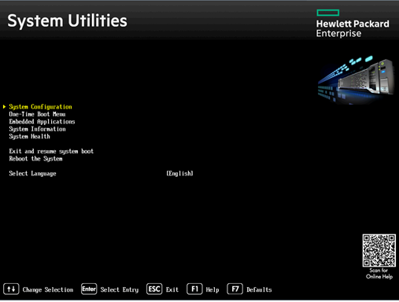

After that select Embedded Raid 1

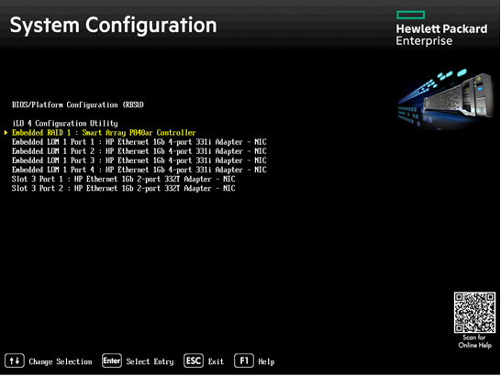

Then Exit and launch HP Smart Storage Administrator.

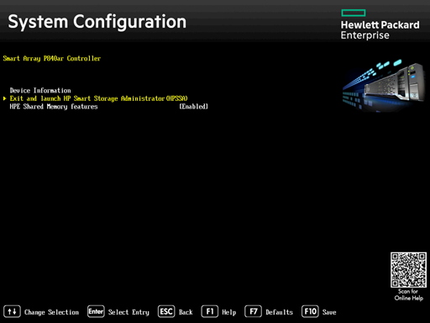

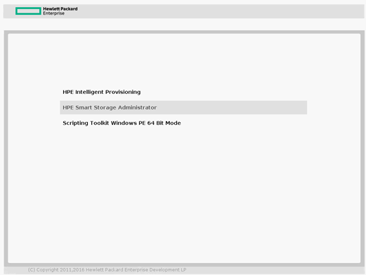

**For correct display of information, the monitor shall be connected to integral video card.**

Go to Smart array and make sure that no errors are present. In case of any errors, log files can be accessed in menu item View all status messages.

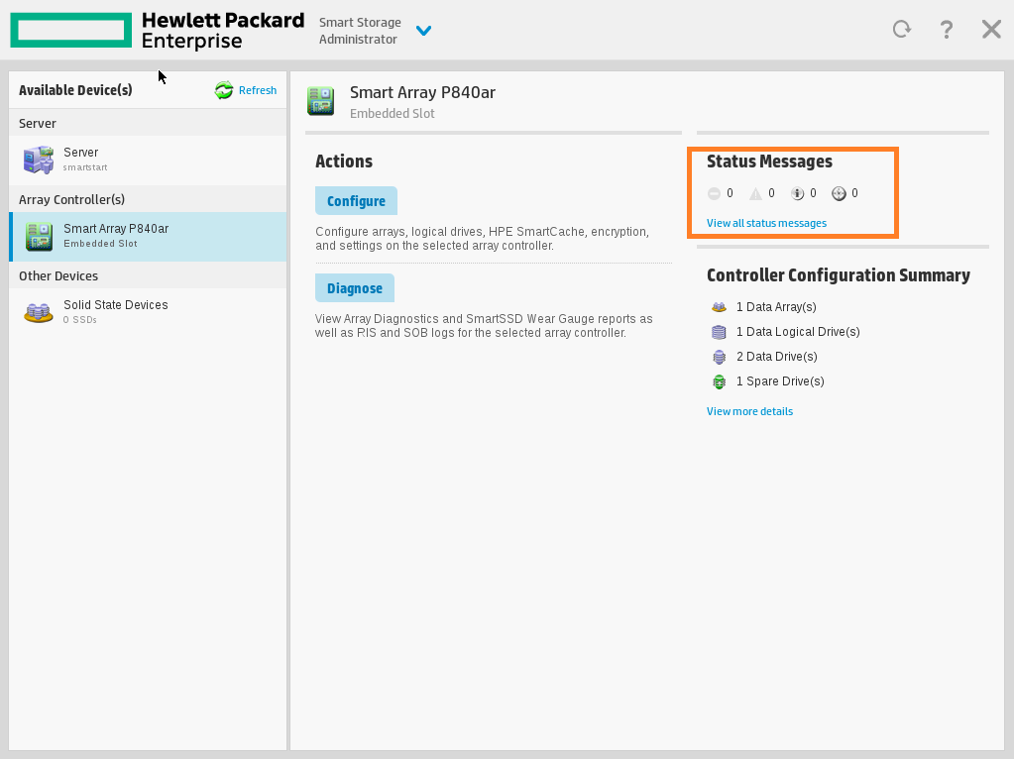

# List of Abbreviations and Designations

AAU – Aviator Audio Unit

ADC – Analog-Digital Converter

ATC – Air Traffic Control

ATC AS – Air Traffic Control Automated System

CL – Coupler lines – ME

DIP switch – dual inline plug switch

FL – Flow E1 lines

GLONASS – Global navigation satellite system

GPS – Global Positioning System

LAN – Local Area Network

LB – Log Book

LC – Local Computer

M – Maintenance

MA – Analog Interface Module

MC – Control Interface Module

ME – Flow E1 module

Mi – Interface module

MP – Power Interface Module

MWS – Monitoring Workstation

OD – Operational Documentation

OM – Operation Manual

PA – Programmable Amplifier

PBX of ATC center – Private Branch Exchange

PC – Personal Computer

Physical connection – Connection by means of cable lines laid and connected.

PIPE – Primary Information Processing Equipment

PWS – Playback Workstation

RAID – Redundant Array of Independent Disks

RD – Radar Data

ROCEI – Rules for Operation of Consumer Electrical Installations

RS – Recording System

RTO – Rules of Technical Operation

RWS – Radar Data Playback Workstation

SPTA – Spare Parts Tools and Accessories

SW – Software

TU – Technical Utility

UA – Unauthorized Access

UPS – Uninterruptible Power Supply

VCCS – Voice Communication and Control System

VCDT – Voice Communication Digital Terminal

VF – Voice Frequency

VI – Voice Information

WS – Workstation

# Revision Record Sheet

|  |  |  |  |  |  |  |  |  |  |
| --- | --- | --- | --- | --- | --- | --- | --- | --- | --- |
|  | Page numbers | | | | Total sheets in document | Doc. No. | Registration number of accompanying document and date | Sig. | Date |
| Changed | Superseded | New | Cancelled |
|  |  |  |  |  |  |  |  |  |  |
|  |  |  |  |  |  |  |  |  |  |
|  |  |  |  |  |  |  |  |  |  |
|  |  |  |  |  |  |  |  |  |  |
|  |  |  |  |  |  |  |  |  |  |
|  |  |  |  |  |  |  |  |  |  |
|  |  |  |  |  |  |  |  |  |  |
|  |  |  |  |  |  |  |  |  |  |
|  |  |  |  |  |  |  |  |  |  |
|  |  |  |  |  |  |  |  |  |  |
|  |  |  |  |  |  |  |  |  |  |
|  |  |  |  |  |  |  |  |  |  |
|  |  |  |  |  |  |  |  |  |  |
|  |  |  |  |  |  |  |  |  |  |
|  |  |  |  |  |  |  |  |  |  |
|  |  |  |  |  |  |  |  |  |  |
|  |  |  |  |  |  |  |  |  |  |
|  |  |  |  |  |  |  |  |  |  |
|  |  |  |  |  |  |  |  |  |  |
|  |  |  |  |  |  |  |  |  |  |