APPROVED
ЦИВР.00530-01 34 01 ЛУ

VOICE COMMUNICATION AND CONTROL SYSTEM
«VCCS Topaz»

VCDT Operator's Manual
ЦИВР.00530-01 34 01

Total sheets 115

2022
CONTENTS
Abbreviations and Definitions 4
1 Abstract 5
2 Interface Organization 5
2.1 Function Toolbar 6
2.2 Volume control 7
2.3 Active Field Area 8
3 Telephone Communication Functions 9
3.1 Direct Access Function 9
3.1.1 Simplex Communication 9
3.2 Function «Duplex» 10
3.2.1 Communication of «Half-duplex» type 11
3.3 Function «END» 12
3.4 Function «ANSWER» 13
3.5 Function «Connection Hold» 14
3.6 Function «Workstation Listening» 17
3.7 Function «Intrusion Call» 18
3.8 Function «Group (Circuit) Call» 19
3.9 «Indirect communication» 20
3.9.1 Incoming indirect calls 22
3.9.2 Call history 26
3.9.3 Phonebook 29
3.9.4 Functional code 32
3.9.5 Selection of external gateway 33
3.10 Function «Divert incoming calls» 34
3.11 Function «Conference» 36
3.12 Function of radio and telephone communication unification 38
3.13 Function «Automatic Redial» 39
3.14 Function «Calling a Group of Subscribers Before an Answered» 40
3.15 Function «PICKUP» 41
3.16 Function «Handset Lifting» 42
3.17 Function «Quick handset» 44
3.18 Function «DTMF dialing» 45
3.19 Function «Transfer Active Сalls» 46
3.20 Function «Priority Call» 47
3.21 Function «Divert incoming calls selective» 48
3.22 «Conference intrusion» function 50
4 Radio Communication Functions 51
4.1 Function «Basic Radio Set Control» 51
4.1.1 Best signal selection (BSS) 55
4.1.2 Radio channel standby mode 58
4.2 Function «Selective Call (SELCAL)» 60
4.3 Function «Retransmission» 63
4.4 Radio Parameters 65
4.4.1 Switching over between main and standby radio sets 66
4.4.2 Switching between standby channels 66
4.4.3 Squelch mode 66
4.4.4 Selflistening mode 67
4.4.5 SELCAL (Selective Call) 67
4.4.6 Remote radio set frequency tuning 68
4.5 Immediate initiation of squelch function 70
4.6 Redirecting Radio Frequencies to another VCDT 71
4.7 Radio Carrier Spacing mode 73
5 Special Functions 74
5.1 Selection of individual Speaking Device and Volume Control 74
5.1.1 General configuration of Speaking Devices 81
5.2 Acoustic Signals 83
5.3 Terminal Locking (Unlocking) 87
5.4 Short-Term Recording 88
5.4.1 Quick access to the last STR conversation playback 90
5.5 Emergency Volume 91
5.6 Quick headset 92
5.7 SPLIT mode 93
5.8 Acoustic signal control «Incoming call» 94
5.9 Two headsets mode 95
5.10 Roles 96
5.11 Update terminal configuration 98
5.12 Screensaver 100
5.13 Unattended working position 101
5.14 Terminal reserve mode 102
6 Service Functions 104
6.1 Tools 104
6.2 Generator 106
7 Emergency Notification System (ENS) 107
7.1 ENS purpose 107
7.2 Air traffic controllers terminal with the right to alert in an emergency (TA) 108
7.3 Reception and recording of alert signals reception acknowledgements (RF) 109
7.4 Air traffic controllers terminal without the right to generate an emergency alert signal (TNA) 112
Appendix A 113
Function codes 113
Revision Record Sheet 115

Abbreviations and Definitions

VAD | Voice Activity Detection
VCCS | Voice communication and control system
VCDT | Voice communication digital terminal
IMS | Inspection and management system
IME | Inspection and management equipment
TMCT | Technical monitoring and control terminal
PSTN | Public switched telephone network
LSC | Loudspeaker communication
DA | Direct access
SD | Speaking device
WS | Workstation
DTMF | Dual-Tone Multi-Frequency analog signal, used to dial a telephone number
HF | High frequency waves
VHF | Very high frequency waves
ACP | Area call panel
Rx | Reception
Tx | Transmission
RS | Radio set
BSS | Best signal selection
A/C | Aircraft
SELCAL | Selective calling system
STR | Short-term recording
PR | Permanent recording
PTT | Push-to-talk
ENS | Emergency notification system
TA | Air traffic controllers terminal with rights to alert to emergency situation
TNA | Air traffic controllers terminal without rights to generate emergency alert signal
RF | Reception and recording of alert signals reception acknowledgements
FB | Function button

1 Abstract
This User manual contains information regarding procedure for personnel operation with VCDT of system VCCS «Topaz». The document contains the description of user interface functions, which provide radio communication, telephone communication and use of special types of maintenance.
This Manual also contains short instructions, which allow familiarizing oneself and starting to operate VCDT of VCCS «Topaz» quickly. Summary instructions do not contain detailed description of all functional and system capabilities and describes only basic radio and telephony communication functions.
User Manual provides description of functional capabilities and operation procedure: description of user interface functions use.

2 Interface Organization
Description of procedure for operation with VCDT is given for standard VCDT configuration. The view of panels and displayed information are determined by the configuration of a given VCDT. Number, size and location of active field pages, number and location of buttons on the pages, color of buttons and inscription may be adjusted to the specific user requirements. All button inscriptions in this section are considered as an example.
1
Overall view of program window is shown in Figure 1.

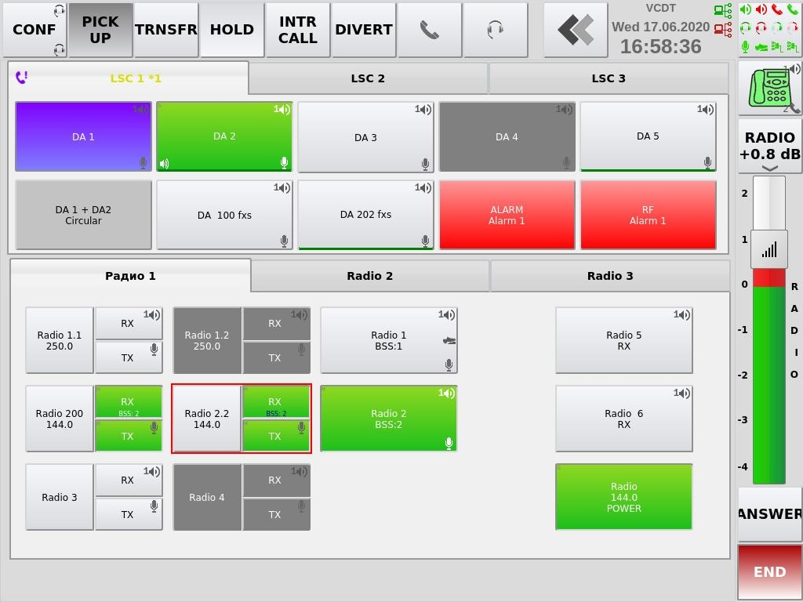
2
3
Figure 1 – Main program window
1 – Function toolbar; 2 – Volume control; 3 – Active field area

2.1 Function Toolbar
The toolbar consists of Main and Additional functional toolbars. Toolbar appearance is set up in IME (see item 5.5 «Functions», «IME Operator's Manual.ЦИВР.00531-01 34 01»).

The main toolbar is opened on VCDT when the latter is activated. An example of Main toolbar appearance is shown in Figure 2.

Figure 2 – Overall view of Main toolbar

An example of Additional toolbar appearance is shown in Figure 3.

Figure 3 – Overall view of Additional toolbar
 – Main toolbar is active;

 – Additional toolbar is active.

Also on the Function toolbar are:

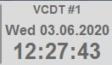 – the name of the system object configured on the IME, current date and time.

 – network interfaces status indicators. If the color of the pictogram is red, it means that there is no physical connection.

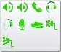 – button of SD selection and volume control. The current status of all speaking devices, set up on the terminal, are displayed on the button with icons. See item 5.1 «Selection of individual speaking device and volume control» of this manual.

2.2 Volume control
Radio/LSC volume control is located on the right – hand side of the program screen, see Figure 4.
The availability of the volume control and the button for switching communication types is determined by the presence of the «Main volume control is enabled» flag in the IME, see item 5.1.2.1 «Speaking devices», «IME Operator'sManual.ЦИВР.00531-01 34 01».

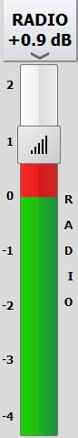 | 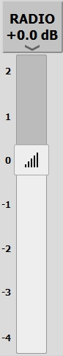
Figure 4 – Overall Radio/LSC volume control available | Figure 5 – Overall Radio/LSC volume control blocked

The type of communication is selected by pressing the button located above the volume control:

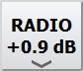 – communication type «RADIO» is selected;

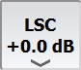 – communication type «LSC» is selected.

The position of volume control is saved in case of change of communication type and program restart.
The range of adjustment is from - 4 dB to 2 dB with increment of 0.1. The value of selected volume level is added to the value, which was set individually to this particular button, see item 5.1 «Selection of individual speaking device and volume control» of this Manual.

The volume control becomes red in dB gain area. To change the volume, touch the scale with cursor in any point of control bar. The control position will be set on the scale mark in the closest position to the touched point.
It is allowed to control volume by moving the control marker.

2.3 Active Field Area
The active field area consists of Telephone communication panel and Radio communication panel.

Telephone communication panel may consist of one or several pages with button of direct access to the subscribers. The subscriber name is indicated on each button, see Figure 6.

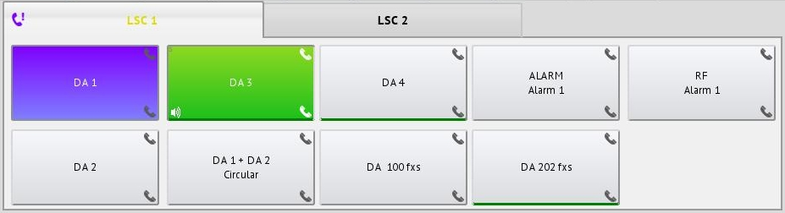
Figure 6 – Telephone communication panel

Radio communication panel may consist of one or several pages with radio communication buttons. The view of radio communication panel is shown in Figure 7.

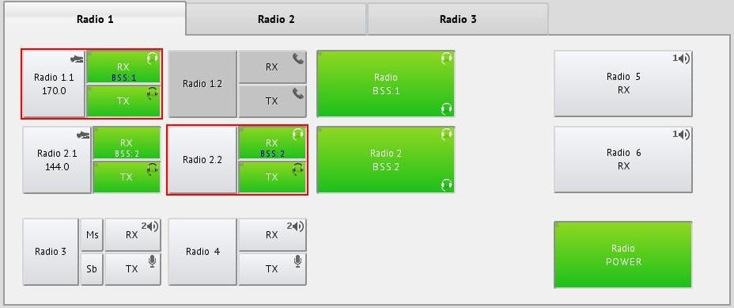
Figure 7 – Radio communication panel

3 Telephone Communication Functions

3.1 Direct Access Function
Direct access subscriber call and communication with him are established by using direct access (DA) buttons. The direct access buttons are located in VCDT active field area and may be additionally grouped into pages with tabs.
The procedures for subscriber call and communication are divided into three types: simplex, duplex and half-duplex.

3.1.1 Simplex Communication
This call type automatically connects the sound channel when a direct access button is pressed. Voice is transmitted to the called subscriber as long as the button is held down. The call is displayed on any workstation equipped with direct access button, intended for this purpose.
During outgoing call in simplex mode, only microphone is switched on (to transmit voice information), while the speaker unit is off.
During incoming call in simplex mode, only speaker unit is switched on (to listen to voice information), while the microphone is off.
Thus, simplex communication sessions are one-way.
In case the subscriber call buttons are configured for operation in the simplex mode, a called subscriber hears a caller voice without any actions on his part. In this case the subscriber call buttons operate in non-latching mode.

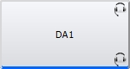 – incoming voice call is displayed on any workstation equipped with a button configured for it, for example «DA1 SIMPLEX».

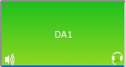 – to communicate with subscriber «DA1 SIMPLEX» press the button and, holding it down, transmit voice information.

– release the button to complete the communication session.

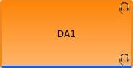 – subscriber busy indication «DA1».

3.2 Function «Duplex»
Standard (default) call with two-way path through-connection for both outgoing call and incoming call processing. It is most relevant for communication with public telephone network (PSTN).
Both subscribers can carry out voice communication in both directions at the same time.
In this mode, as a rule, subscriber call buttons operate in latching mode:

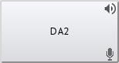 – incoming/outgoing call is displayed at any workstation, provided with a button, configured for it, for example «DA2».

 – to make/answer a call, press button «DA2», configured for this mode. Press «DA2» again to terminate a call/answer.

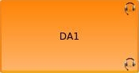 – subscriber busy indication «DA2».

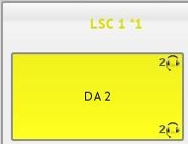 – incoming call indication. Button «DA2» and page name «LSC main» flash red/yellow. Next to the page name is the number of incoming calls waiting to be answered.

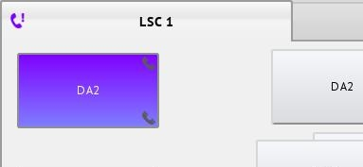 – missed call indication. Icon «Handset» and button «DA2» are violet.

In case the call button is set up for non-latching operation, the process of a call establishing is similar to mode «Simplex», see item 3.1.1 «Simplex Communication» of this Manual.

3.2.1 Communication of «Half-duplex» type
It is a modification of duplex communication. After the connection is established, the subscriber direct access button is switched to mode «Reception – Transmission» – when the button in not pressed, the playback device is connected to the sound channel, the microphone is disconnected, when it is pressed – the microphone is connected and the playback device is disconnected.

Button «END» on the function toolbar is used to terminate the connection.

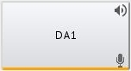 – the subscriber button is configured for communication type «Half-duplex».

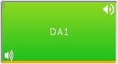– communication is established, button is not pressed, microphone listening mode is off.

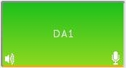 – communication is established, button is pressed, microphone is switched on, playback device is disconnected.

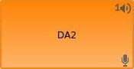 – subscriber busy indication «DA2».

3.3 Function «END»
The button «END» is used to terminate any active connection (including established and requested connections) and also for dropping the incoming call without answering it.
Any unanswered incoming call is dropped automatically if an answer isn’t given within a certain period of time (the corresponding waiting time is set by the Inspection and Management System.)
Function «END» terminates all ground connections in sequence, starting from the earliest connection (i.e. the last-coming one) up to the eldest connection (i.e. the first-coming one).

 – no active connections are available.

 – the active ground connections are available. One-time button presses one of the «youngest» last created active connection.

3.4 Function «ANSWER»
The button «ANSWER» is used to pick-up any incoming call (direct or indirect one). Incoming calls are picked-up on on-going basis. By single pressing the button, the eldest (first) call is picked up.

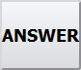

If there are held-on indirect calls, the button «ANSWER» is highlighted in green.

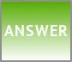

3.5 Function «Connection Hold»
«Connection Hold-on» function allows putting all the actual connections on hold. Also, it is possible to switch between two or more put on-hold calls by pressing the button «HOLD».
If the call is put on-hold by any other workstation, you should receive a special indication of the activation of this mode and sound.

 – hold function button. If there are no calls, the button has a dark-gray color. When the button is pressed, the «Action unavailable» acoustic signal is issued.

Do the following to put the active connection on-hold:

 – green button «DA1» indicates that there is available active connection at the current workstation.

 – press button «HOLD» to activate the function.

 – the button «DA1» indicates on-hold state. The «DA1» button flashes «blue/green».

– press button «HOLD» or the button «DA1» to return to the active connection.

– check if active connection is available at your workstation. Button «DA1» is green.

Switching between the active and held-on connections. Switching between the two connections is performed by putting one call on-hold while picking up another:

– there are two established connection at the current workstation: connection by «DA2» is active and connection by «DA1» is held-on - button «DA1» flashes «blue/green».

– press button «HOLD» for switching over.

 – both connection are switched over to held status. Buttons «DA1» and «DA2» are flashes «blue/green».

– press button «HOLD» or button «DA1» for switching over.

– button «DA2» remains on hold and flashes «blue/green». Button «DA1» indicates an active connection and highlighted in green.

– press button «HOLD» for switching over.

– both connections are switched over to held status. Buttons «DA1» and «DA2» are flashes «blue/green».

– press button «HOLD» or button «DA2» for switching over.

– connection «DA1» is put on hold, button flashes «blue/green». Button «DA2» indicates an active connection and highlighted in green.

To terminate both of the calls on-hold, press the button «END» twice.

3.6 Function «Workstation Listening»
This function allows listening to radio and telephone communication of other VCDT. Mutual listening by two subscribers to each other is prohibited. In case the listened subscriber is set up to the simplex call mode, switch off listening function at outgoing call to prevent «self-listening to own message».
There is a security mode, which does not allow to listen to this VCDT (the parameter is set from IME).

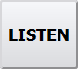 – button of listening mode activation.

 – listening activation mode is enabled.

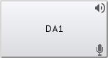 – select the workstation to listen to.
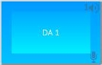 – listening is activated. All incoming to and outgoing information from the given workstation is listened. Button «DA1» is highlighted in turquoise. Press the button of listened subscriber, which is highlighted with turquoise, and activate the connection if it is necessary.

– connection to the listened subscriber is established. Button «DA1» is green. Press the green button of established connection with the subscriber, and to return to the function of listening of this subscriber. Button «DA1» is highlighted in turquoise again.

– press button «Listen» and select the listened subscriber to complete the listening function.

– listening is completed.

3.7 Function «Intrusion Call»
The function is intended to establish communication with VCDT operator, engaged in other communication.
The function is used in case when it is necessary for one VCDT (intruding – I-VCDT) to send urgent information to another VCDT (intruded – ID-VCDT) while ID-VCDT is engaged in conversation (via ground or radio communication).
In order to use this function, I-VCDT shall activate the intrusion mode and indicate the button for direct access to ID-VCDT In this case the button for direct access to ID-VCDT becomes a non-latching simplex call button regardless of its actual configuration. When the direct access button is released, the intruding call is terminated by I-VCDT.
If intrusion to ID-VCD is allowed, it receives the intrusion call (answers it automatically) and switches through the current receiving speaking device to data reception from the incoming call. At that sound from I-VCDT is switched through to
ID-VCDT only. There is no return sound channel. The subscriber, who is communicating with ID-VCDT operator at the moment, does not hear I-VCDT operator. In case ID-VCDT has a direct access button from I-VCDT, it indicates simplex voice call (with respective color). In this case a call from ID-VCDT can be terminated by pressing this button. This call from ID-VCDT can also be terminated by pressing button «END», which provides disconnection with the last established connection.
In case the mode of «locking of incoming ground communication during radio transmission» is activated in ID-VCDT, incoming call sound from I-VCDT is blocked, the priority call sound is played, but call indication remains.
In case intrusion is prohibited on ID-VCDT, the intrusion call, requested by I-VCDT, will be terminated by ID-VCDT without missed call indication.
In case the intrusion function is carried out onto not engaged in conversation ID-VCDT (freed), the call is still made as an intrusion with the only difference that a receiving intercommunication device is used for alerting from direct access button on I-VCDT. If such a button is not available, default receiving speaking device is used.

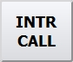 – button of intrusion mode activation.

 – intrusion activation mode is enabled.

– select a workstation, connection shall be established to.

 – an intrusion call is in progress, the button operates in the non-latching mode.

3.8 Function «Group (Circuit) Call»
Group call is a simultaneous call to all internal and/or external parties (subscribers), grouped in the simplex mode beforehand. The group may include up to 16 subscribers. This group is created on IME. The number of groups of a group call at one workstation is not limited.

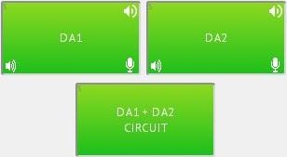
During conversation speaking devices, which are assigned to button «CIRCUIT», are used for all group subscribers (for SD assignment see item 5.1 «Selection of individual speaking device and volume control» of this Manual).

3.9 «Indirect communication»
The dial is used to dial indirect numbers.

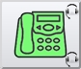 – button for opening/closing the indirect communication window.

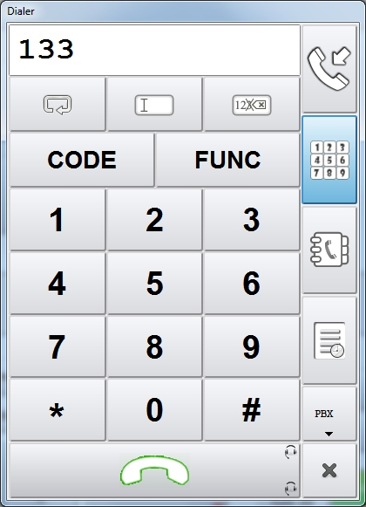
Figure 8 – Window «Dialer»
If the digits are pressed with established connection, they are sent to connection as DTMF codes.

 – dialing field;

 – redial button;

 – button «clear dialing field»;

 – button for deleting the last symbol in the dialing field;

 – activation of the functional button by entering a special code. For details refer to item 3.9.4 «Functional code» of this Manual;

 – an individual three-digit code to log out to the external gateway (line). For details refer to item 3.9.5 «Selection of external gateway » of this Manual;

 – button for opening incoming indirect call window;

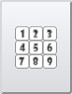 – button for opening a keypad;

 – phonebook opening button. The list of subscribers is formed in IME;

 – button for opening call history window;

 – output (external gateway) for dialing;

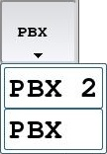 – selection of output (external gateway) for dialing;

 – subscriber call button.

3.9.1 Incoming indirect calls
Incoming calls are considered to be indirect in case a direct access button is not set up for the calling subscriber. By default all ground communication calls are also considered to be indirect.
Incoming indirect call window may be opened by pressing the respective button in the Dial or on the Additional toolbar.

 – button for opening incoming indirect call window in the Dial.

 – the bottom left corner shows the total number of calls in the queue.

– button for opening incoming indirect call window on the Additional toolbar. Second pressing of the button closes the window.

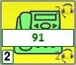 – incoming call. The button displays the first indirect caller waiting for a response. The bottom left corner shows the total number of calls in the queue.

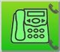 – active connection;

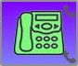 – unanswered call.
SD «Speaker unit» and «Microphone» are used for incoming indirect calls. For SD purpose see item 5.1 «Selection of individual speaking device and volume control» of this Manual.

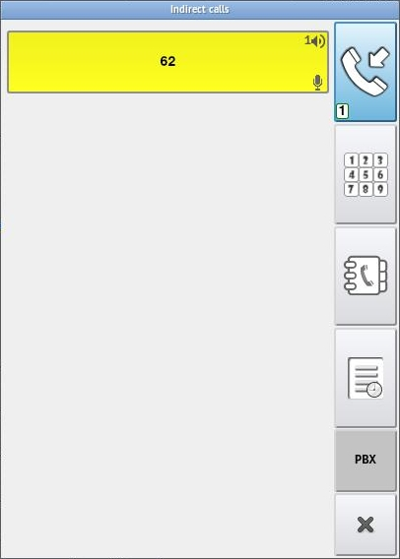
Figure 9 – Tab «Active», incoming calls
In case of incoming indirect call, information on the calling subscriber is displayed on the button. Subscriber data is taken from the phonebook if this one exists there.
The information only about the first call is displayed in the «general pick-up» line.

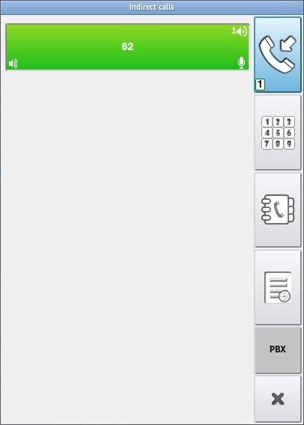
Figure 10 – Tab «Active», active connection
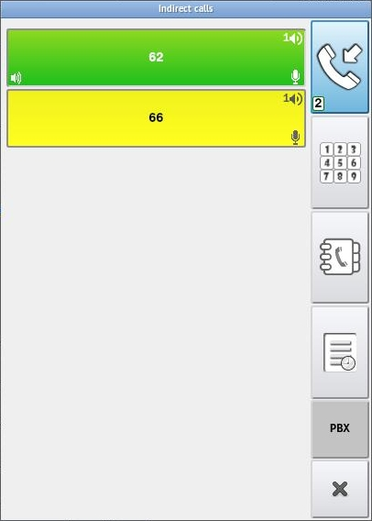
Figure 11 – Subscriber «62» during active conversation, subscriber «66» waits for an answer
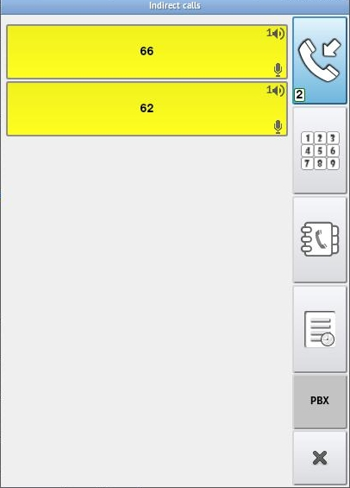
Figure 12 – Subscribers «66» and «62» wait for an answer

3.9.2 Call history
The user may view the call history on this tab. The history is limited to last 100 records.

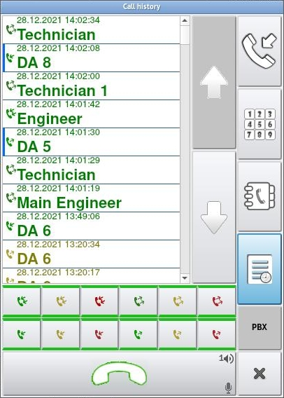
Figure 13 – Tab «History»
The history of each call is presented as follows: call type (answered, missed, declined), call time and calling subscriber name or address.
At the bottom of the window, there are buttons for filtering the call list.
The call history remembers the «simplex» call type and the next time the button is dialed, the button becomes «simplex». At the same time, in the history, «simplex» records are marked with a «blue» line.

Call type:

Answered outgoing call
Answered incoming call
Declined outgoing call
Declined incoming call
Missed outgoing call
Missed incoming call
Answered outgoing indirect call
Answered incoming indirect call
Declined outgoing indirect call
Declined incoming indirect call
Missed outgoing indirect call
Missed incoming indirect call

By default, all filter buttons are enabled. Leave only required filters by clicking on the appropriate button.

 – filter enabled.
 – filter disabled.

 – buttons for call list navigation.

 – subscriber dial button. When you click this button, it will display the name or address of the selected caller from the «Сall history» list.

 – subscriber call.

 – called subscriber has answered.

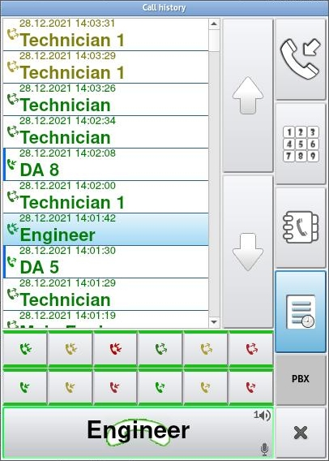
Figure 14 – Call to subscriber «Engineer». Number is selected from call history, subscriber call button is pressed
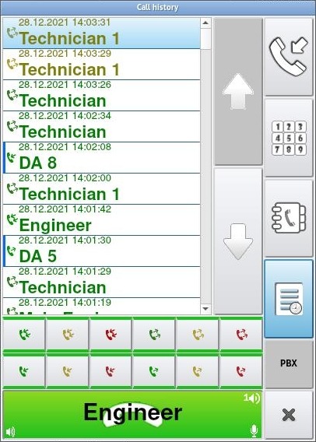
Figure 15 – Called subscriber has answered, subscriber call button is green

3.9.3 Phonebook
When the corresponding button is pressed, the phonebook window will be opened. The list of phonebook subscribers is created in IME (see item 5.6 «Phonebook», «IME Operator's Manual.ЦИВР.00531-01 34 01»).
The list of subscribers is formed in IME by groups, select the desired group from the list:

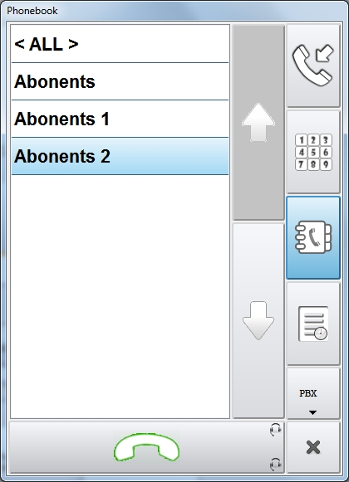
Figure 16 – Phonebook subscriber groups
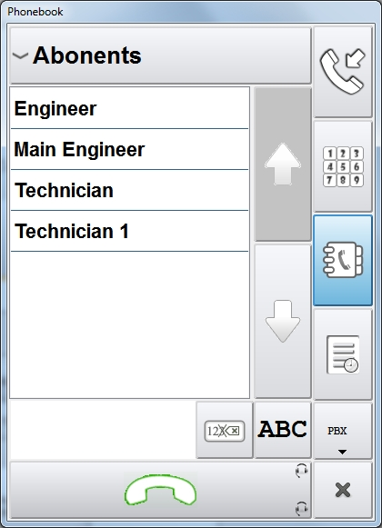
Figure 17 – List of phonebook subscribers of the selected group
 – button for deleting the last symbol in the filter field;

 – button for opening window «Keyboard» to look for phonebook subscriber.

– subscriber dial button. When you click this button, it will display the name or address of the selected dialer from the phonebook.

To search for a subscriber, open window «Keyboard» by pressing button «ABC» and then enter the required symbol for search in the filter field, see Figure 18.

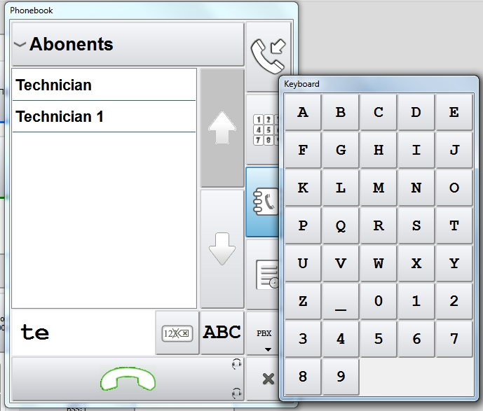
Figure 18 – Phonebook, window «Keyboard» is opened
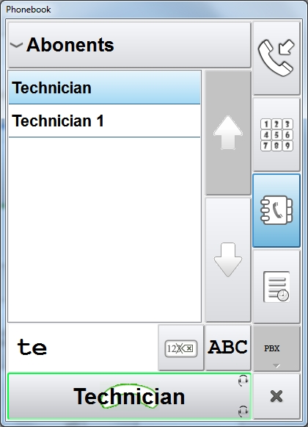
Figure 19 – Call to subscriber «Technician». Number is selected from the phonebook, subscriber call button is pressed

3.9.4 Functional code
In addition to calling out the desired function from the Main and Additional panels (see item 2.1 «Function Toolbar» of this Manual) there is a possibility to activate the required functional button by entering a special three-digit code. A list of functional codes is given in Appendix A of this Manual.
In IME these codes are indicated on the tab «Functional buttons» (see item 5.5 «Functions», «IME Operator’s Manual. ЦИВР.00531-01 34 01»).

- button of function activation by dialing a code on the telephone keyboard.

 - to activate a function, press the button «FUNC». The button will change the color from «grey» to «blue». Further, enter the code in the field of the number dialing on the keyboard to activate the function, for example, 006 «Priority call». The functional button «PRIO CALL» appears above the global volume control, this button is used in a standard mode.

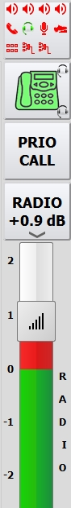

If you need to call out another functional button, press the button «FUNC» and enter a code, for example, 004 «Intrusion Call». The button «INTR CALL» appears instead of the button «PRIO CALL». In order to delete the functional button, you need to dial the code 000 on the keyboard. If the called button exists already on the panel (Main or Additional), it will not be moved anywhere, the indication on the created function button will work.

3.9.5 Selection of external gateway
In VCDT there is a possibility to check any telephone line by dialing an individual three-digit code. The code is dialed on the keyboard and makes it possible to access the line from any VCDT without specifying the availability of the gateway in the Connections editor (see item 5.2.2 «SIP routes», «IME Operator’s Manual. ЦИВР.00531-01 34 01»»).

- external gateway (line) access button by dialing an individual three-digit code.

 - to access an external gateway (line), press the button «CODE». The button will change the color from «grey» to «blue». Further, enter an individual code, for example, 863, in the field of number dialing on the keyboard. The code is set in the main system settings on the tab «External gateways» in the field «Access code» (see item 3.1.3 «External gateway setting», «IME Operator’s Manual. ЦИВР.00531-01 34 01»»).
If a gateway with such a code is found, its name is output on the button. In our example this gateway is PBX. Further, all calls will be made through this gateway. If the gateway with the indicated code is not found, an acoustic signal of an erroneous action is issued, and the button «CODE» flashes «red» for a while.

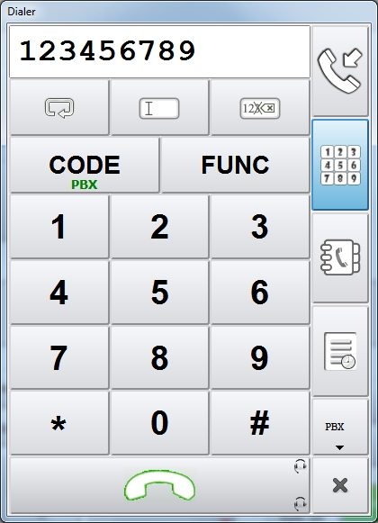

3.10 Function «Divert incoming calls»
This function is required to transfer all regular incoming calls via ground communication lines from the given terminal to the address of VCDT or any other communication network subscriber supporting call transfer.
Call transfer function is activated by pressing the functional button «DIVERT», the button «DA» (direct access) or by dialing an indirect communication number.
If transferred calls are coming to VCDT, call forwarding (repeated transfer) is possible. Back call transfer (back to the originator) is the only exception. Such calls are dropped.
If you try to set a forwarding that leads to «looping» (the subscriber can receive his own call), an acoustic signal about the invalid action will be issued. The LSC button will be highlighted in «red» for a while.

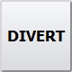 – if it is necessary to transmit a call from own workstation, press button «DIVERT» to activate the function. Transfer is deactivated by second pressing of button «DIVERT».

 – the button becomes green-blue.
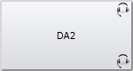 – select transfer target.
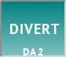 – the view of the button becomes the following – transferring to «DA2».
 – transferring from IME is activated.
In VCDT when you restart and update configurations, all call transferring settings will be saved and recovered including the group of selective call diversion (see item 3.21 of this Manual). In this case the state of the call transferring function is registered before it was activated from IME. This is necessary for subsequent recovery on command from IME (see item 12.4 «Call Transferring», the menu item «Return to original state», the instruction «IME Operator’s Manual. 00531-01 34 01»).

If the Screensaver function is enabled on the working position (see item 5.12 «Screensaver» of this manual), the message «DIVERT» will be added to the screen.

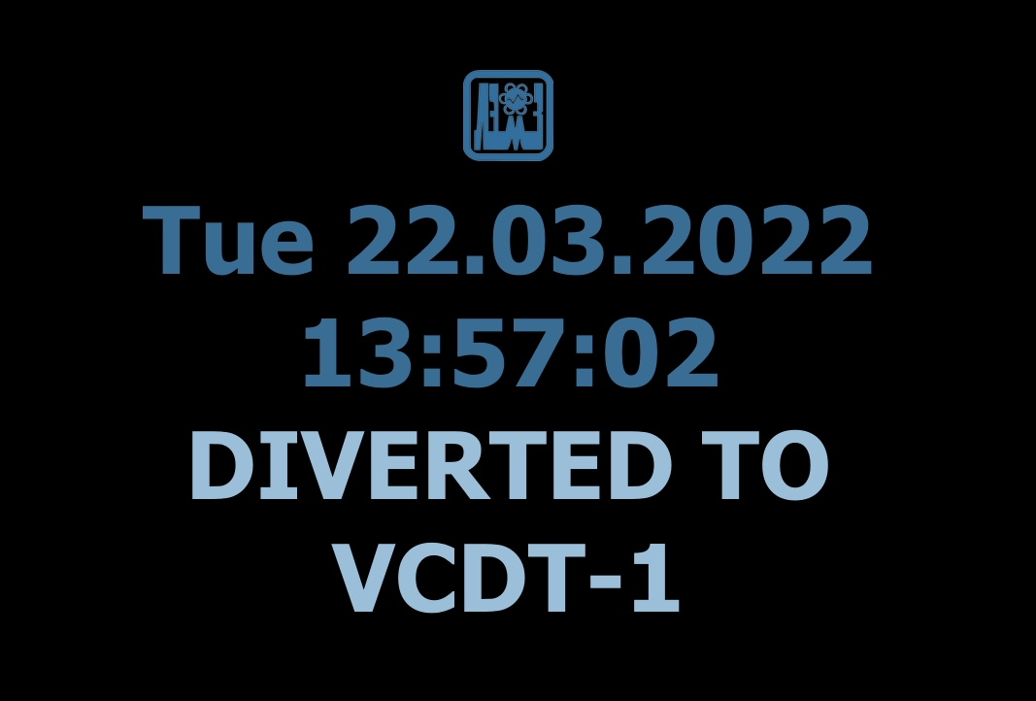
Figure 20 – Inscription «DIVERT» in case the «Screensaver» function is enabled

3.11 Function «Conference»
In conference call establishing takes part more than two (up to 16 subscribers) internal or external VCCS subscribers (DID, OREH, MARS, etc.).The number of conference call parties is set by the conference call initiator (he can add new subscribers and exclude the old ones).
Regardless of the type of called/receiving subscriber communication, communication type «duplex» will be set in the conference call mode.
Conference call initiator (the subscriber, who initiates the conference call mode) controls the conference call. He can complete operation using button «CONF» by another button pressing and holding it down for 2 second. Button «END» may be used to disconnect a subscriber, connected in the conference call mode, who was added first. Disconnection of any party may also be performed by pressing the button of active subscriber.
All other parties may leave conference call without affecting the others. All parties may put a conference call on hold at their workstations, while other parties remain connected.

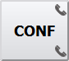 – create a conference call by pressing the button «CONF» and holding it down for 2 seconds;

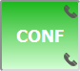 – button «CONF» is green, conference call is active;

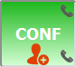 – graphical icon on the button shows that it is within the conference call parties inclusion mode. The conference call parties inclusion mode switches on as soon as a conference call is activated. Subsequently it is necessary to select the subscribersfor participationin the conference call. Exit from the conference call parties inclusion mode is carried out by a short pressing of the button «CONF»;

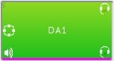 – conference member is indicated by green color of the corresponding subscriber button and display of the graphical iconat the left part of the button.

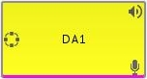 – an invitation to take part in a conference call looks like a standard call (yellow blinking of calling subscriber button) and availability of icon at the left part of the button.

Conference call can be carried out with a predetermined number of parties. The set of parties is selected in IME.

Assigned to button «CONF» speaking devices are used in the conference call mode (for SD assignment see item 5.1 «Selection of individual speaking device and volume control» of this Manual).

In case the conference call SD are not assigned, SD, selected in IME, will be used, see item 5.1.2.1«Speaking devices», «IME Operator's Manual.ЦИВР.00531-01 34 01».
The same SD will be used in case of incoming conference call.

3.12 Function of radio and telephone communication unification
Unification of radio and telephone communication (R+T) is the mode, in which the participants of established telephone connection can listen to incoming voice communication radio signal, at which time telephone communication is not transmitted on the air.

 – button for activation/deactivation of mode «R+T»;

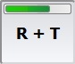 – to activate the mode, press and hold down button «R+T»;

 – mode «R+T» is activated;

 – to deactivate the mode, press and hold down button «R+T»;

 – short-term pressing of button «R+T» triggers a graphical icon indicating that the mode of Radio buttons selection for LSC transmission is active. Press button «R+T» for a short time again to deactivate the mode;

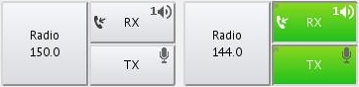 – buttons «Radio 150.0» and «Radio 144.0» are selected for LSC transmission, they are displayed as icon .

3.13 Function «Automatic Redial»
The automatic redial is return of the call (automatic redialing) in case the called subscriber is busy or the call is unanswered in telephone communication mode.

 – button for activation/deactivation of the automatic redial mode;

 – automatic redial mode is activated.

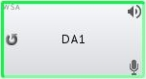 – automatic redial mode is displayed on button «LSC» as a respective icon. A subscriber will be automatically recalled in a period of time, set in IME (see item 5.1.2.2«LSC», field «Pause between recall attempts, seconds»), «IME Operator's Manual.ЦИВР.00531-01 34 01»).

3.14 Function «Calling a Group of Subscribers Before an Answered»

This function provides calling to group of subscribers before an incoming call is answered in the telephone communication mode. Subscribers call group is generated in IME (see item 5.3.2 «LSC button properties», field «Outgoing calls address», «IME Operator's Manual.ЦИВР.00531-01 34 01»).
When a button for group calling is pressed, a call comes to the first workstation in the call list. Subscriber's sequence number is displayed on the button.

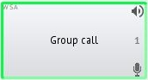

The call is automatically switched over to another workstation in the group in accordance with the selected sequence in case the subscriber is busy, incoming call is terminated using button «END» or upon expiry of specified period of time. Subscriber answer timeout is set in IME (see item 5.1.2.2 «LSC», field «Outgoing call answer timeout, seconds»), «IME Operator's Manual.ЦИВР.00531-01 34 01»).

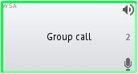

The call will be returned to the first workstation, if it is not answered by the last workstation in the call list. To complete a group call, cancel it from the calling VCDT or answer an incoming call at one of workstation, included in the call group.

3.15 Function «PICKUP»
Operation in the telephone communication mode provides call interception – a function, which allows answering incoming calls, waiting for an answer at another workstation.

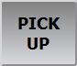 – button call interception.

Let’s consider the function operation algorithm using the following example. Direct access buttons «DA1» and «DA2» are set up on VCDT (VCDT3) (VCDT1 and VCDT2, respectively). Let’s make a call from VCDT2 to VCDT1, but do not answer it. Thus, an incoming call from VCDT2 to be answered is displayed on VCDT1. The «PICKUP» button is highlighted in yellow.

 – there are unanswered calls available to intercept.

Now use the call interception function to answer a call of another subscriber on VCDT3.
To do this, click the «PICKUP» button and in the window that opens, select the subscriber who has an incoming call waiting for a response:

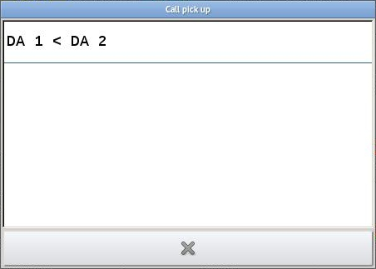

As a result, VCDT1 switches the incoming call to be answered to VCDT3, the call will be performed to the button «DA2», as the initial call originator is VCDT2:

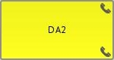 – the intercepted call is displayed as an incoming one from the initial call originator VCDT2 (on button «DA2»).

Answer the call as a usual incoming call:

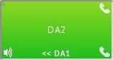 – the intercepted call is received with indication of call interception from VCDT1 (button «DA1»).
In case there are several incoming calls waiting to be answered on the interception target VCDT, only one call from the waiting queue will be processed on each use of INTERCEPTION function.

3.16 Function «Handset Lifting»

In case SD «Handset» with lifting/replacing detector is available, the algorithm of duplex calls processing, including conference call mode, is changed.
Depending on call type (incoming or outgoing) and status (to be answered or already answered), the «Handset» is automatically assigned as transceiver SD for this call at the time it is «lifted» or if it was already «lifted» before a call from VCDT was made. Besides, all calls, to which the handset was assigned, will be terminated when the handset is replaced.

Function «Handset lifting» processes calls in the following order:
- Incoming calls to be answered. The call is additionally answered.
- Active (answered) incoming calls.
- Outgoing calls to be answered.
- Active outgoing calls.

In case the «Handset» is already «lifted» prior to call origination, all duplex calls are automatically redirected to the «Handset».

Let’s consider an example of use of SD «Handset» with «lifting» detector.

Incoming calls to be answered

When the handset is lifted (call is answered), the assigned SD are switched over to the lifted handset on the subscriber call button «DA1», which is displayed by icon «Handset». After call termination SD are switched back from the handset to the initial values.

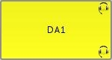 – incoming call to be answered. The handset status is «replaced»;

 – incoming call. The handset status is «lifted»;

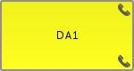 – incoming call to be answered. The handset status is «lifted»;

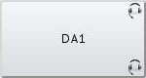 – subscriber disconnection. SDs return to the initial values.

Answered incoming calls/active outgoing calls

If the connection has already been established when the handset is lifted, the assigned SDs are switched over to the lifted handset. It is displayed as icon «Handset».

 – initial active call, handset status is «replaced». SDs, assigned to the button, are used.

– incoming call. The handset status is «lifted».

Outgoing calls to be answered

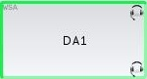 – outgoing call to be answered;

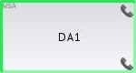 – outgoing call to be answered. The handset status is «lifted»;

– subscriber disconnection. SDs return to the initial values.

The call may be terminated as follows:
- by pressing button «END»;
- by pressing subscriber call button «DA1»;
- by replacing the handset.

3.17 Function «Quick handset»
The function allows quick selection of a handset for LSC. Radio communication remains working via the microphone and speaker units.

 – button for activation/deactivation of the «Quick handset» mode.

 – «Quick handset» mode is enabled. The button operates in latching mode, when activated the button color changes to green. Press the button again to return to the initial state. SDs for LSC become the last set before activation of the function «Quick handset».

3.18 Function «DTMF dialing»
The function allows additional DTMF dialing within active LSC connection. The configuration of this function is carried out in IME (see item 5.3.2 «LSC button properties», «IME Operator's Manual. ЦИВР.00531-01 34 01»).

There are two ways of usage:

- by specifying a predefined DTMF sequence - enter the required DTMF sequence (digits «0123456789*#») in the «Dial DTMF after outgoing call is answered» field. After the outgoing call is answered, the specified DTMF sequence will be sent to the established connection;
- by using the special DTMF dialer - set the flag «Open DTMF Dialer after outgoing call is answered» and the DTMF dialer will be opened after the outgoing call is answered, see Figure 25.

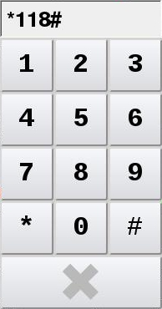
Figure 21 – DTMF dialer
All of the DTMF dialing methods can be applied both simultaneously and separately.

3.19 Function «Transfer Active Сalls»
Let’s consider the operation algorithm using the following example. Direct access buttons «DA1» and «DA3» are set up on VCDT (VCDT2) (VCDT1 and VCDT3, respectively). Let’s make a call from VCDT1 to VCDT2, but do not answer it. Thus, an incoming call from VCDT1 to be answered is displayed on VCDT2.
Now to transfer unanswered incoming call from VCDT2 to VCDT3, use call transferring function.

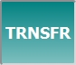 – press button «TRNSFR» to activate the function. After that select the button of LSC subscriber to be transferred.

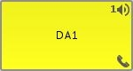 – selection of LSC subscriber, who is waiting for an answer. Button «DA1» blinks yellow.

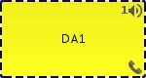 – LSC subscriber is selected for call transfer, button «DA1» is highlighted in dotted line.

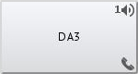 – selection of LSC subscriber, to whom the incoming call is transferred. The call is transferred to the selected subscriber, button «TRNSFR» is disabled.

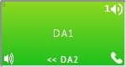 – the transferred call is received by VCDT3 with indication of call transfer from VCDT2 (button «DA2»).

3.20 Function «Priority Call»
The function «Priority Call» is similar to the «Intrusion call» function. A distinctive feature is the ability of the operator to interrupt the busyness of an internal or external subscriber by disconnecting the active connection of the desired busy subscriber using the function button «PRIO CALL» and make a call to this subscriber. Also, unlike intrusion, a priority call can be either simplex or duplex.
In an incoming duplex priority call, the indication on the direct call button will be highlighted alternately in «red/yellow».
The «Priority Call» function can be interrupted by the function «Intrusion call», i.e. intrusion takes precedence.

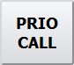 – button for priority call mode activation.

 – priority call mode is activated.

3.21 Function «Divert incoming calls selective»
Selective call diversion unlike regular divert function allows selection of one or more users from which incoming calls are required to be transferred.

 – button of selective call divert function activation/deactivation.

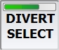 – activate the function by long pressing the «DIVERT SELECT» button. The button becomes colored, and the incoming caller(s) selection mode is enabled.

 – incoming caller(s) selection mode is enabled. In this mode, clicking on any «DA» button respectively adds or removes DA subscriber to/from selection. Corresponding icon on each selected «DA» button shows the user that particular subscriber is under selective call divert function:

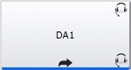

After incoming caller(s) selection is done, activate the mode of called (destination) party selection to which the call diversion will be performed. The mode is activated by a short press of the functional button.

 – the mode of called party selection is enabled. After that, click the desired «DA» button. The name of the called party will appear on the functional button.

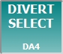 – diversion will be performed to the subscriber «DA4».

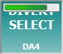 – a long press of the button disables the selective diversion function. The button becomes a gray «color». A short press resets to the mode of called party selection. It means, if the called party (destination) is not selected, the next short press will activate the caller(s) selection mode. In this way, you can cancel the previous selection and change the composition of the incoming caller(s) and the divert destination party.

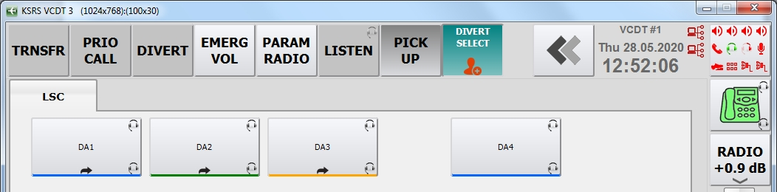
Figure 22 – Caller(s) selection mode is enabled. Subscribers «DA1», «DA2» and «DA3» were added to the group of subscribers to be diverted

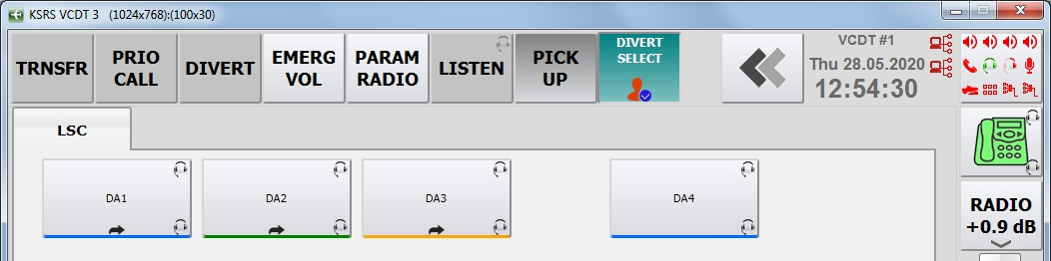
Figure 23 – Called party selection mode is enabled

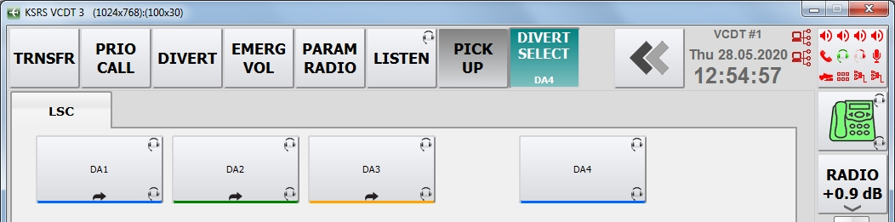
Figure 24 – Diversion of a group of subscribers «DA1», «DA2» and «DA3» will be carried out to the addressee «DA4»

If full call forwarding is enabled via the IME (see item 12.4 «Calls Transferring» «IME Operator's Manual.ЦИВР.00531-01 34 01»), active selective call forwarding to the VCDT will be automatically disabled. In the same way, call forwarding enabled via the IME will also be disabled if the full or selective forwarding function is activated on the VCDT itself.

3.22 «Conference intrusion» function
«Conference intrusion» function is designed for parallel operation of several VCDTs with telephone lines. For example, we make an outgoing call to an analog line from VCDT1.Consequently, if other VCDTs have an output to this analog channel, then it becomes busy. VCDT2 intrudes the busy analog channel without breaking VCDT1 connection. The intrusion is duplex. Thus, we create a conference call with three participants.

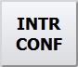 - on button for a conference intrusion mode.

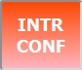 - conference intrusion mode is activated.

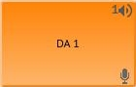 - the analog line is busy with a call from VCDT1, the button color is «orange».

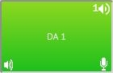 - VCDT2 became the participant of the conference, the button color is «green».

4 Radio Communication Functions

4.1 Function «Basic Radio Set Control»
The radio set is controlled using a three-button group: «Rx», «Tx» and PTT button.

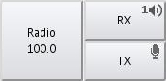

Button «Rx» is intended to connect speaking devices to the radio receiver output and visual indication of reception. The button operates in «latching» mode. In the initial state the speaking devices are disconnected from the radio receiver output.
Button «Tx» is intended to connect speaking devices to the radio transmitter input. The button operates in the «latching» mode. In the initial state the speaking devices are disconnected from the radio transmitter input.
TX button can be activated in two ways – by regular single click or by pressing and holding. А regular click is the default. Activation of the button by long pressing will work if the «TX button is activated by pressing and holding» option is set in the IME (see item 5.3.3 «Radio button properties», «IME Operator's Manual.ЦИВР.00531-01 34 01»).

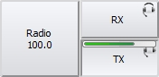 – activation of the TX button by long pressing. To deactivate an active (green) TX button, a long press is not required.

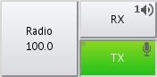 – the PTT button is intended to switch over the radio transmitter to «Radiation» mode and is used as visual indicator if radio transmitter operation mode. The button operates in «non-latching» mode. The button reacts to pressing only when button «Tx» is switched on. In the initial state the radio transmitter is set to the standby mode.

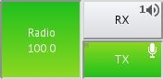 – if workstation configuration is correct the activation of PTT button result in changes button color to green. Green button color indicates that the respective radio transmitter is switched over to the «Radiation» mode. The PTT button priority is set up from IME.

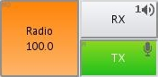 – in case the radio transmitter, which is controlled by this button, is used by another VCDT, the button color changes to orange and the button stops to react to pressing. In such a case, pressing the PTT button on the touch panel, or the PTT on the desk microphone holder, or PTT of hand microphone, or PTT of microphone headset triggers sound signal «Incorrect operation» to be given.

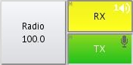 – when a voice signal is detected in the reception/transmission channels of radio set, the respective button blinks yellow.

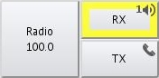 – if the button is inactive, then upon a voice signal is detected in the radio station's reception/transmission channels, it is highlighted with a yellow border. The presence of such a frame (indication) depends on the flag «VAD indication on inactive RX/TX buttons» (see item 5.3.3 «Radio button properties», «IME Operator's Manual. ЦИВР.00531-01 34 01»).

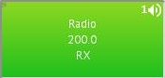 – only reception «Rx» mode is available for this radio set. Check box «Listening only» is selected (see item 5.3.3 «Radio button properties», «IME Operator's Manual.ЦИВР.00531-01 34 01»).

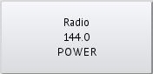 – radio set power supply control. Check box «Radio set power supply control» is selected (see item 5.3.3. «Radio button properties», «IME Operator's Manual.ЦИВР.00531-01 34 01»).
The button is grey – power supply is off.

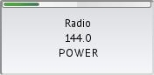 – press and hold down the button to switch on radio set power supply, at that the button color changes to green.

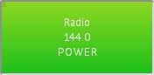 – the button is green, radio set power supply is switched on.

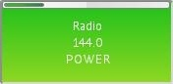 – press and hold down the button to switch off radio set power supply, at that the button color changes to grey.

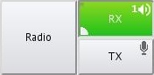 – check box «Reception priority» is selected (see item 5.3.3 «Radio button properties», «IME Operator's Manual.ЦИВР.00531-01 34 01»). A higher listening priority is assigned to one of the selected frequency channels. It is displayed on button «Rx» as a respective icon.
Higher listening priority icon
When the function of higher listening priority is activated, the ratio of change of non-priority RS volume may be set up (see item 5.1.2.3 «Radio communication», «IME Operator's Manual.ЦИВР.00531-01 34 01»).

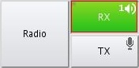 – check box «Complete reception disabling prohibited» is selected (see item 5.3.3 «Radio button properties», «IME Operator's Manual. ЦИВР.00531-01 34 01»). It is prohibited to disconnect the radio channel, used by one operator (air traffic controller) only, who is the only listener of this channel. It is displayed on button «Rx» as a red frame.
If the «Prohibit turning RX off (locally)» check box is selected, the «RX» button is highlighted with a red frame after the first activation and cannot be further disabled.

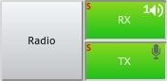 – in case of failure of the main channel, the operation on the reserve channel indicator will be displayed on the «Rx» button (the radio button must have channel reservation configured). At the same time, the presence or absence of the check box «Main/Reserve channel switch» does not affect the presence of the indicator (see item 5.3.3 «Radio button properties», «IME Operator's Manual. ЦИВР.00531-01 34 01»).
Operation icon on the backup channel

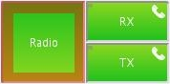 – when holding the PTT (mechanical or on-screen) longer than the specified time, a beep signal is played and a red border appears on the PTT button. The signal and the border will be repeated once per second until the PTT is released. The time is specified in the field «Indicate stuck PTT if active for specified time, in seconds» (see item 5.1.2.3 «Radio communication», «IME Operator's Manual. ЦИВР.00531-01 34 01»).

When a mechanical tangent is pressed in the absence of a RS with an active TX, the «Action unavailable» acoustic signal is issued.

4.1.1 Best signal selection (BSS)
Function «BSS» (best signal selection) from the group of radio sets is activated when a pre-configured button is pressed. Check box «BSS function control» is selected (see item 5.3.3 «Radio button properties», «IME Operator's Manual.ЦИВР.00531-01 34 01»).

Button «BSS» is intended for activation, deactivation and visual indication of special operation mode (mode «best signal selection») of radio set group. The button operates in «latching» mode.

In the initial state the button is shown in the released position, light grey.

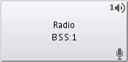

When the button is pressed, its color changes to green. At the same time all buttons «RX» of the radio sets, inside BSS group, are switched on. Green button color indicates that all group radio sets are switched on and connected to the workstation speaking devices. At that inscription «BSS» and indication of group number appears on «RX» buttons of radio sets, added into the group.

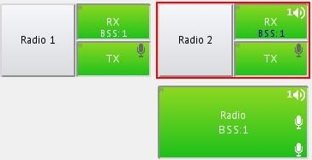
Figure 25 – Function of best signal selection for the radio set group is activated
The «RX» buttons of respective radio sets start to blink yellow upon the detection a carrier frequency by one or several radio sets of the group. At the same time indication (>BSS:1<), designating that VCDT has determined that the quality of received signal of this radio set is best and that the workstation speaking devices are connected to this very radio set, is displayed on one of buttons «RX». Visual indication – the button is marked with red frame.

An air traffic controller can activate/deactivate the best signal selection mode at any time and work with each radio set separately.

It is also possible to temporarily interrupt the automatic selection of the radio transmitter and set it manually. To do this, it is enough to briefly press the on-screen tangent on the corresponding Radio button. The indicator of manual transmitter selection is displayed as a red frame on the «TX» button, see Figure 26.

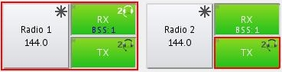
Figure 26 – Radio 1 is selected as the best receiving radio station, but Radio 2's transmitter is selected (manually) for transmission
To cancel manual selection and return to automatic selection, it is necessary to click the «TX» button marked with a red frame.

Check box «Support of BSS group priority increase» – enables/disables BSS function by long pressing of the button. Volume level of non-priority RS is set in decibels (see item 5.1.2.3 «Radio communication», «IME Operator's Manual.ЦИВР.00531-01 34 01»).
If the flag is not set, the method of activating/deactivating the BSS is determined by the parameter «BSS button is activated by pressing and holding» (see item 5.3.3 «Radio button properties», «IME Operator's Manual.ЦИВР.00531-01 34 01»).

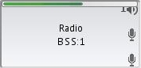 – enabling of BSS function by long pressing of the button.

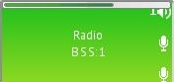 – disabling of BSS function by long pressing of the button.

Priority is switch on/off by short pressing.

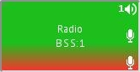 – visual indication of priority BSS group.

In case one mechanical PTT is assigned to several BSS groups at the same time and BSS priority is not used, then the PTT is activated on the PCT with the best signal in each of the groups, see Figure 27.

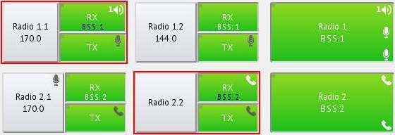
Figure 27
If one of the groups has priority mode enabled, then only the mechanical PTT is activated for the PCT from this group, see Figure 28.

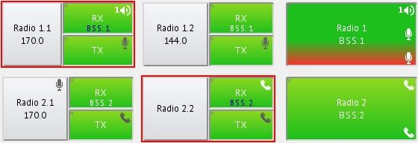
Figure 28
But if you select different mechanical PTTs for each of the groups, then each group will work on its own PTT, regardless of the priority mode on one of the groups.

4.1.2 Radio channel standby mode
The Radio button with channel standby mode is operated just as an ordinary Radio button described in 4.1. In addition to the main control buttons, the Radio button in this mode of operation can contain up to 4 additional buttons for forced switching between channels. These buttons also display availability status of each channel.
In case the connection with one channel is lost, the system automatically switches to the available channel. While this operation is performed, all active connections remain active, i.e. neither «RX» nor «TX» are interrupted.
If Radio button has two channels configured, the two additional buttons M/S appear on the button.
If the Radio button has more than two channels configured, the corresponding numbered buttons appear to switch between channels on the VCDT and display the availability status of each channel:

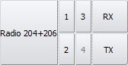

Possible states of the Radio button with channel standby mode (depending on the number of radio channels, there may be more options):

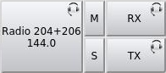 | – initial Radio button state.
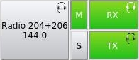 | – main channel is active, standby channel can be switched to.
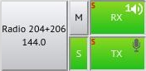 | – standby channel is active, main channel can be switched to. In the event of a failure of the main channel, the buttons «PX» and «TX» will display the indicator «S» of operation on the reserve channel.
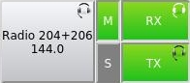 | – main channel is active, standby channel is unavailable and cannot be switched to.
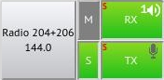 | – standby channel is active, main channel is unavailable and cannot be switched to.
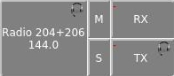 | – channels are unavailable, Radio button is completely disabled.
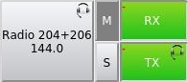 | – if there are no main channels, before transition to backup channels, the «–» indicator appears on the «RX» and «TX» buttons.

4.2 Function «Selective Call (SELCAL)»
System SELCAL consists of coder SELCAL, installed on the ground, system SELCAL control unit and system SELCAL decoder, installed on the aircraft. Each decoder SELCAL, installed onboard the aircraft, has its unique code. Decoder SELCAL is connected with HF and VHF radio channels of the aircraft. Upon reception of radio signal, the device gives a sound warning about it, and an active radio channel, via which transmission is carried out, is indicated on ACP panel in the crew cockpit.
Thanks to this system the crew does not have to monitor ACP state permanently.
SELCAL function is configured for each Radio button separately from IME, i.e. it is activated/deactivated for this Radio button. Radio button with enabled (but not active) SELCAL function looks as follows:

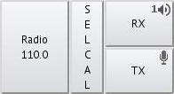
In order for this function to be active, it is necessary to activate «RX» and «TX», after which to activate SELCAL function it is necessary to press «SELCAL» button for a short time. The SELCAL button will turn «green» and the code dialing window will be automatically opened, see Figure 29.

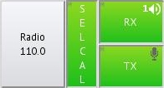

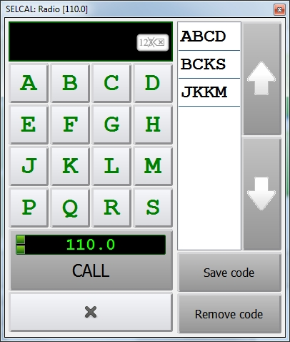
5
4
2
1
Figure 29 – Window of SELCAL code input
1 – List of previously called subscribers (history); 2 – Entered code field;
3
3 – Button «Call»; 4 – Letter tone input panel; 5 – Button «Close SELCAL window»

«History» – the list of previously called subscribers. When a code is selected from this list, the code is copied to the entered code field.

The «Save code» and «Remove code» buttons control the presence of the code in the list of typed ones.

«Entered code field» – it is used to display a code, which will be generated.

Button «Call» – button for generation of entered code tone signal in the radio facility. Call may be activated only when the whole code is entered (4 letters), button color shall be green:
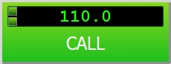
Figure 30
The call (sending the code) is made by briefly pressing the «Call» button. The SELCAL window remains open, you can continue working with the button in the normal mode. You can close the window by pressing the corresponding button (see Figure 29) or by pressing the «SELCAL» button again.

When the tone signal code is not entered or is entered incompletely, button «Call» is not active and is grey, i.e. tone signal generation is impossible:

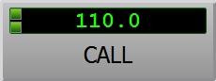
Figure 31
«Entered code field» – the SELCAL panel uses 16 tones from A to S, at that tones I, N, O are not used. Each tone is assigned with its «own frequency».
Rule of SELSAL code entry: the first letter of each pair shall precede the second one in the alphabet and letters shall not be repeated. Upon entry of the1st and the 3rd code symbols, the symbols, located on the panel above the entered one, including the last entered symbol, change their color from green to grey and can not be entered. But there are exceptions – when a grey symbol is held down for more than 5 seconds, the symbol is entered and a sound message of error signal, used on this VCDT, is issued. Upon entry of 2nd and 4th symbols, all symbols of the panel change their color to green.
According to Figure 32, the code is entered (dialed or selected from the list) and button «Call» is active.

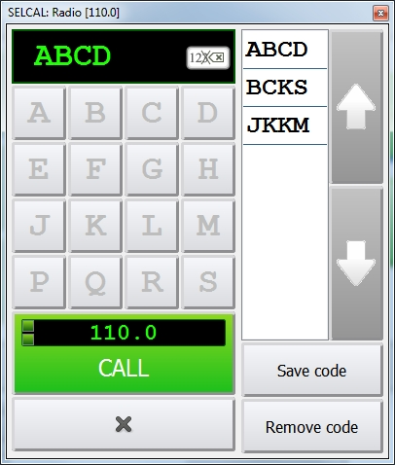
Figure 32 – Button «Call» is active

4.3 Function «Retransmission»
Radio channels grouping with possibility to retransmit voice signal from channel to channel in the radio communication mode. Only one such group can be created per VCDT.
Function «Retransmission» has two operation modes:
– full retransmission. Signals, transmitted by an air traffic controller and received via this radio set receiver, are retransmitted to all radio channels, included in the retransmission group;
– partial retransmission. During transmission via this radio set, the signal is retransmitted to all radio channels, included in the retransmission group.

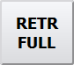 – retransmission mode button. The radio set selection mode is activated by short pressing of the button.

 – the radio set can be selected for including into the group in the full retransmission mode. Selection is carried out by pressing a respective Radio button. The button will look as follows:

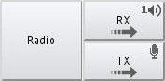 – full retransmission mode is selected for Radio button. «Rx» and «Tx» are not active.

When the required radio sets are selected, deactivate the selection mode by short pressing of button «FULL RETR».

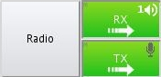 – full retransmission mode is selected for Radio button. «Rx» and «Tx» are active.

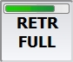 – switching over between full and partial retransmission modes is provided by long pressing of the button. By default, the button works in the full retransmission mode.

 – the radio set can be selected for including into the group in the partial retransmission mode. Selection is carried out by pressing a respective Radio button. The button will look as follows:

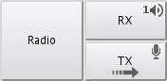 – partial retransmission mode is selected for Radio button. «Tx» is not active.

When the required radio sets are selected, deactivate the selection mode by short pressing of button «PARTIAL RETR».

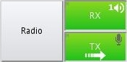 – partial retransmission mode is selected for Radio button. «Tx» is active.

4.4 Radio Parameters
«Radio Parameters» window has a possibility of Remote radio set frequency tuning that supports this function, to switch between the main and standby radio sets, if such a function is configured on this channel, and also to switch the squelch and selflistening modes.

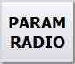 – button for opening window «Radio parameters».

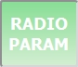 – the Radio button selection mode is activated.
After selecting the appropriate Radio button, the «Radio Parameters» window will be opened, see Figure 33.

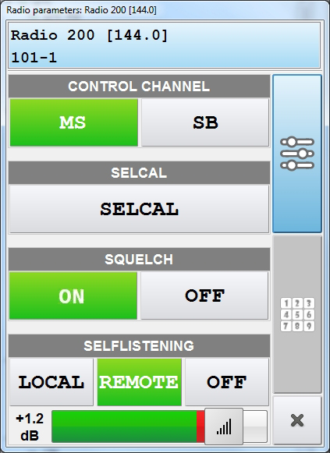
The button closing
«Radio Parameters»
The button opening Control Panel
The button opening Remote radio set frequency tuning
Figure 33 – Window «Radio parameters»
«Radio Parameters» window consists of a Control Panel and a Remote Radio Set Frequency Tuning Panel. The transition to the desired Panel is carried out by pressing the corresponding button.

4.4.1 Switching over between main and standby radio sets
On the Control Panel, using the «MS» and «SB» buttons, you can switch between the Main and Standby radio sets.
Select the desired mode by clicking on the corresponding button. The «green» color of the button determines the activity of the selected mode.

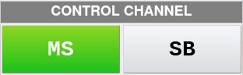

There is a possibility to switch between radio sets directly on the Radio button itself. The presence of «MS» and «SB» buttons on the Radio button depends on the presence of the «MS/SB switch» checkmark. The checkmark is set in the IME (see item 5.3.3 «Radio button Properties», «IME Operator's Manual 00531-01 34 01»).

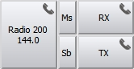

4.4.2 Switching between standby channels
Depending on the number of tuned channels on the Radio Button, the Control Panel will look like this:

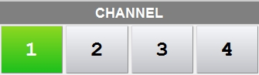

The Control Panel displays the availability status of each channel:

 – the channel is active, it is possible to switch to standby channels 2, 3, 4.

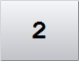 – the channel is not active.

4.4.3 Squelch mode

Squelch mode is activated/deactivated by pressing a button «ON»/«OFF»:



4.4.4 Selflistening mode

«Local selflistening» - when this mode is selected, selflistening is carried out through the gateway (for example, through LIU-A or LIU-Ds).

«Remote selflistening » - selflistening is carried out through the radio set.

Select selflistening mode by pressing the corresponding button. The «green» color of the button determines the activity of the selected mode.

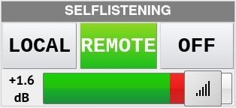
Selflistening volume control

Use the slider to increase or decrease the listening volume.

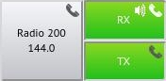 – selflistening mode is on. The corresponding icon appears on the Radio button.
Selflistening mode operation icon

4.4.5 SELCAL (Selective Call)

SELCAL for each Radio button is configured in IME (see item 4.2 of this manual). If the Radio button does not have a SELCAL button, then an alternative way to activate the selective call function is to press the «SELCAL» button. The button is located on the Control Panel.

 - SELCAL function is inactive, the button is «gray».

- SELCAL function active, «green» button.

4.4.6 Remote radio set frequency tuning

Clicking on the corresponding button will open the Remote Radio Set Frequency Tuning Panel, see Figure 34.

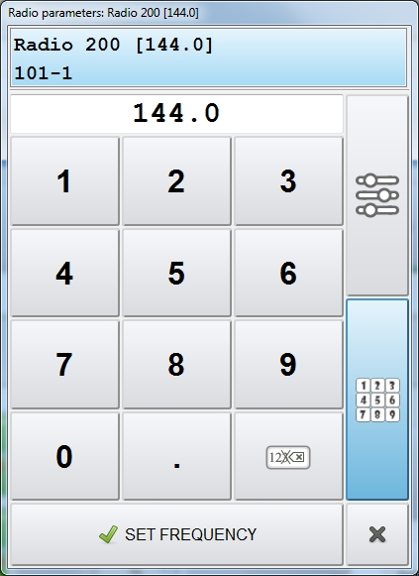
Figure 34 – Remote Radio Set Frequency Tuning Panel
Select the frequency to be changed. Use the numeric buttons to set the required value and press the «Set frequency» button, see Figure 35.

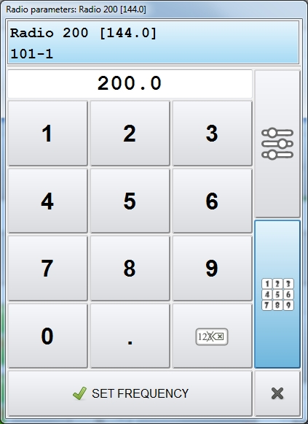
Figure 35 – Remote Radio Set Frequency Tuning Panel - setting the frequency
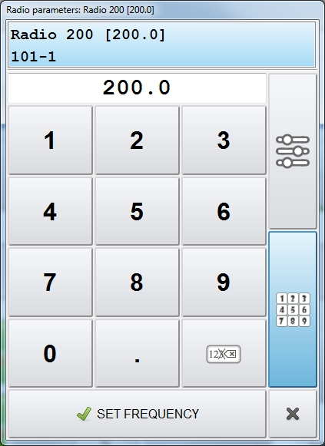
Figure 36 – Remote Radio Set Frequency Tuning Panel - frequency is set
VCDT transmits this frequency to the radio set. As a result, the value of new frequency is displayed at all workstations with access to this radio channel.

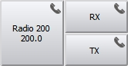

4.5 Immediate initiation of squelch function
The «Radio SQL» button is used for immediate squelch mode activation or deactivation.

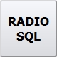 – button of squelch mode activation/deactivation.

Press «Radio SQL» button to turn the squelch on or off, the button appears yellow.

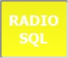 – the Radio button selection mode is activated to turn on/off the squelch.

Select the Radio button on which you want to activate or deactivate the squelch.

Depending on the initial state of the squelch activity, the Radio button will look like this:

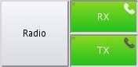 – the squelch mode is activated. There are no special indicators on the Radio button.

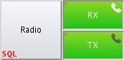 – the squelch mode is deactivated. An inscription «SQL» of red color appears on the Radio button.

4.6 Redirecting Radio Frequencies to another VCDT
To redirect the Radio to another VCDT, «DIVERT RADIO» button is used. To select the receiving VCDT, its direct access button is used.

Source VCDT operations

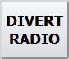 – button for switching on/off the Divert Radio Frequency mode button to another VCDT.

To enable the redirecting mode, press «DIVERT RADIO» button, the button will turn «green».

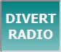 – the Divert Radio mode button is activated.

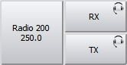 – select the Radio button for redirecting, for example, «Radio 200».

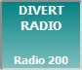 – the name of the selected Radio button will be displayed on the redirecting button. In this example, this is «Radio 200» button.

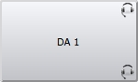 – then there is a need to select the LSC button. For redirecting, the first available address from the list of button addresses is selected, regardless of the state of the button itself.

In case of error or the other party refuses to initiate redirection the signal «Wrong action» will be issued and an information window is opened with the corresponding information.

Actions on destination VCDT
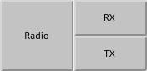 – for successful redirection, the configuration of the receiving VCDT should contain Radio buttons that are not tied to any radio channel. The color of these buttons is «gray».
When a request for redirection is received, a confirmation window will open at the receiving VCDT:

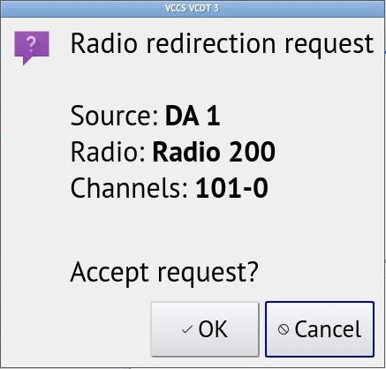

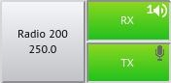 – the redirection is successful. This redirection will work until the configuration of the receiving VCDT is updated or until System Service or Graphical Interface is restarted.

4.7 Radio Carrier Spacing mode
«Radio Carrier Spacing» mode is used in conjunction with the BSS function. In this mode, reception is carried out by the best receiver, and transmission by all transmitters included in the group is carried out by a mechanical (or on-screen) PTT. This mode will work only for those Radio buttons where the «Carrier spacing» checkmark is set. The checkmark is set in the IME, see item 5.3.3 «Radio button Properties», «IME Operator's Manual 00531-01 34 01»).

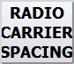 – button for switching on/off the «Radio Carrier spacing» mode.

To enable the carrier spacing mode, press «RADIO CARRIER SPACING» button, the button will turn «green».

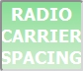 – the «Radio Carrier spacing» mode is activated for Radio communication.

5 Special Functions

5.1 Selection of individual Speaking Device and Volume Control
Volume can be adjusted separately for each radio set: reception and transmission. Volume can also be adjusted directly on the speaker units.

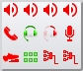 – button of speaking devices (SD) selection.

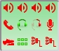 – the mode of button selection of speaking devices selection is activated.

The mode can be used for the button of the following type:
– «LSC»;
– «Radio»;
– «Conference call»;
– «Incoming indirect calls»;
– «Sound signals»;
– Dial opening button;
– Short-term recording (STR);
– «Listen».

Icons are displayed on the button in the following order:

– speaker units;
– handsets;
– headsets;
– right earpiece of stereo headset;
– microphones;
– pedals;
– multihab;
– line recording interfaces;
– button panel;
– encoder;
– speaking devices of unknown type.

The current status of all speaking devices, set up on the terminal, are displayed on the button with icons:

«Green» – speaking device is connected and ready for operation
«Red» – speaking device is unavailable (disconnected or faulty)
«Grey» – speaking device status is unknown

The setting window will be opened, when one of buttons is pressed.

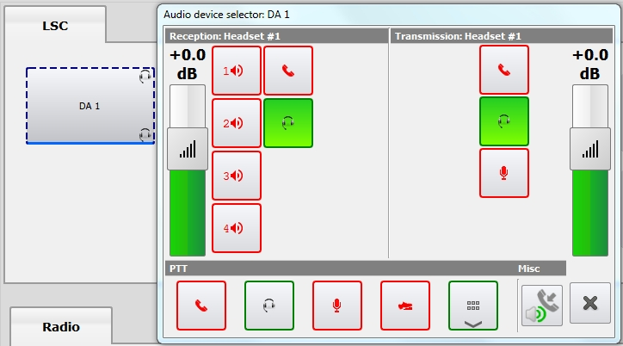
Figure 37 – Selection of speaking device for «LSC» button «DA1»
SD with PTT (one or several) can also be assigned to the selected Radio button. When hardware PTT is used, button «PTT» will be activated from assigned SD.

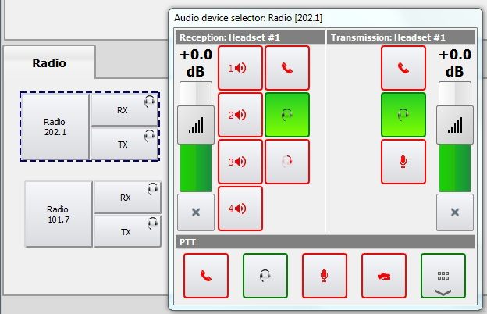
Figure 38 – Selection of speaking device for «Radio» button [202.1]

When selecting the device «Button panel», a list with its buttons to assign as PTT for the Radio button will be opened, see Figure 39.

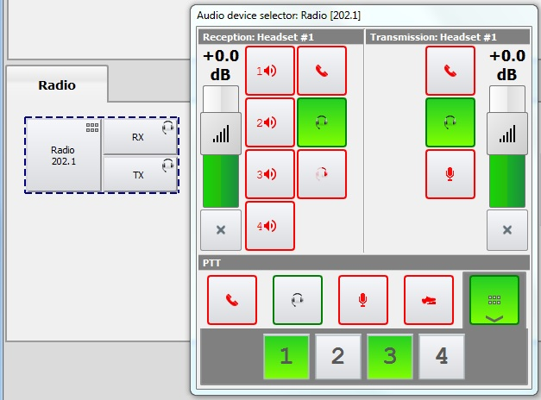
Figure 39 − Selection of SD with PTT «Button panel» for «Radio» button [202.1]
Each state of the Radio button on the button panel will correspond to the following color of the button:

«Red» | The gateway of the selected radio channel is disabled
«Orange» | The radio channel of the selected button is busy
«White» | The button is assigned to the radio channel and it is ready for operation
«Blue» | The radio channel is selected for monitoring (the button «Rx» is pressed only)
«Green» | The radio channel is selected for control (the buttons «Tx» and/or «Rx» are pressed)
«Bright green» | The PTT is activated
Flashing «Yellow» | The Voice Activation Detector (VAD) was triggered
No indication | The button is not assigned to the radio channel

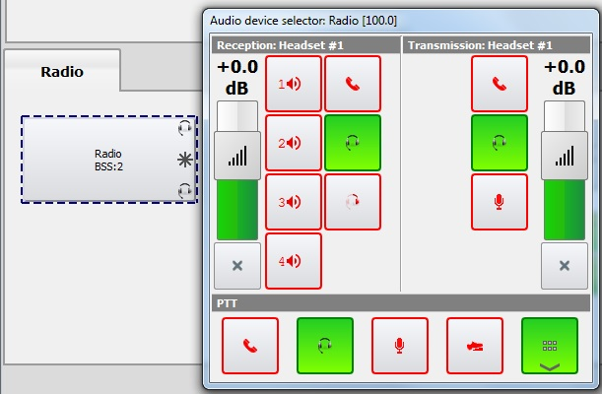
Figure 40 – Selection of speaking device for «Radio» button (BSS)

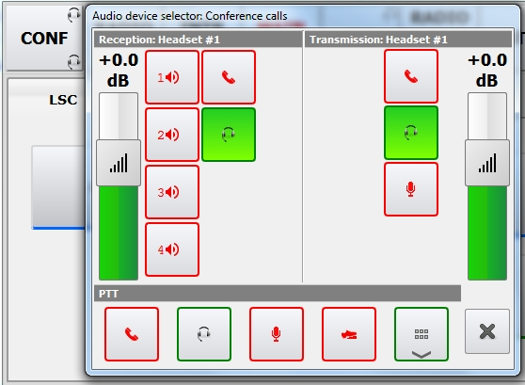
Figure 41 – Selection of speaking device for button «CONF» (Conference call)

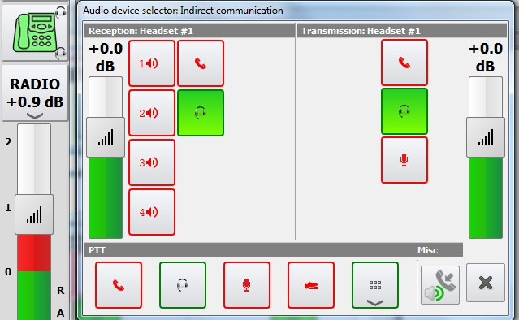
Figure 42 – Selection of speaking device for button «Indirect communication»

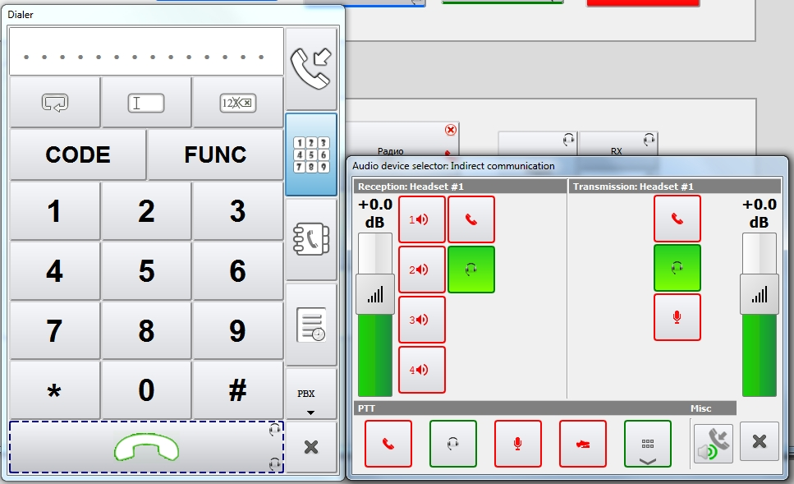
Figure 43 – Selection of speaking device for dial opening button
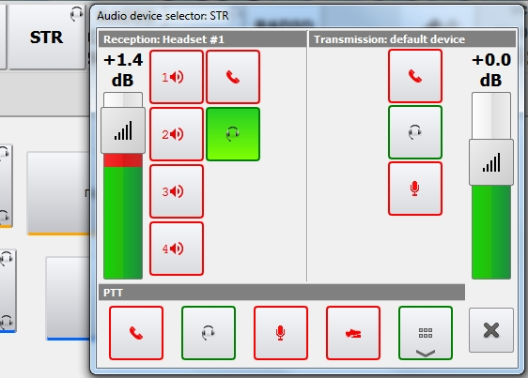
Figure 44 – Selection of speaking device for button «STR»
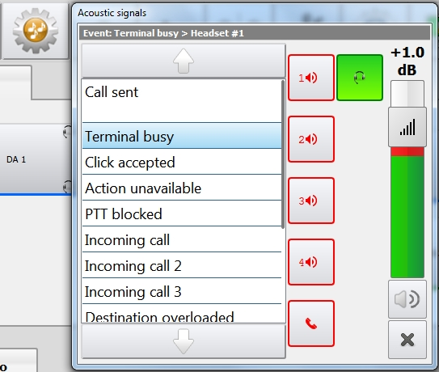
Figure 45 – Selection of speaking device for button
«Acoustic signals»

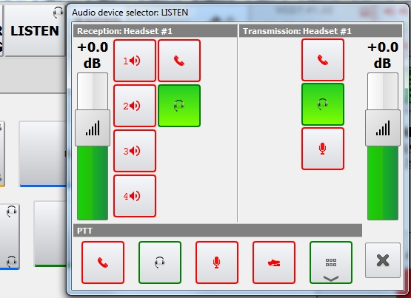
Figure 46 – Selection of speaking device for button «LISTEN»
 – respective speaking device is not connected to the terminal.
 – respective speaking device is connected, access for selection.

 – speaking device is selected for respective button («LSC», «Radio», «Conference», «Incoming indirect calls», dial opening button).
Speaking device volume level is set up using the respective buttons:

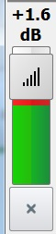
Volume control for SD
Button for window «SD selection» closing
Figure 47 – Setting of SD volume level
If check mark «Volume setting is prohibited» is selected, volume control is unavailable (see item 5.3.3 «Radio button properties», of «IME operator’s Manual. ЦИВР.00531-01 34 01»»).

5.1.1 General configuration of Speaking Devices

In addition to the individual one, there is a possibility of general configuration of the volume of speaking devices (reception or transmission) in the VCDT. The general setting of the SD volume is carried out on the Speaking devices Control panel, which opens by long pressing the SD selection button.

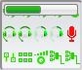 – opening the Speaking devices Control panel. The appearance of the panel is shown in Figure 48.

There are two ways to close the panel: long pressing of SD selection button or pressing of «SD configuration» window closing button (see Figure 48).

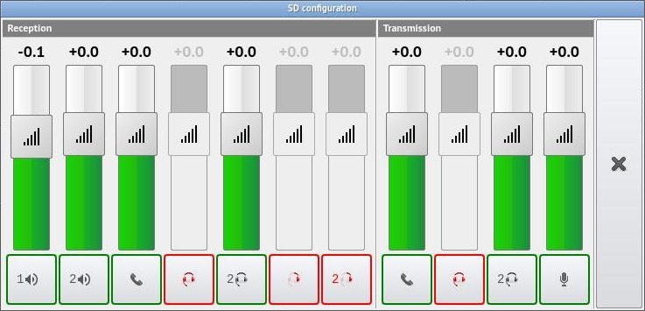
Button for window «SD configuration» closing

Figure 48 – Speaking devices Control panel

Buttons with SD icons located under volume control are used for quick check of set volume level. While the check function is active, the corresponding button will be highlighted in «green».
For devices, which are located on «Reception» panel, the generator signal is supplied to check the level. For the devices on «Transmission» panel turns on «Clay» mode, i.e. if device has both a speaker and a microphone (for example «Headset», «Handset»), then they are connected with each other, but if there is only a microphone («Table microphone» for example), then it will be connected with the default speaker.
The volume control sets the desired level.

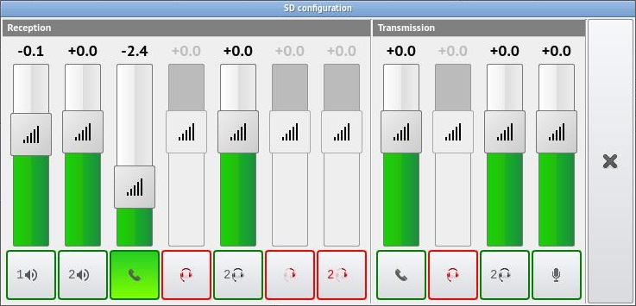
Figure 49 – Setting and checking the volume level of the selected SD

5.2 Acoustic Signals

 – button for opening/closing the window of sound signals settings. The icon of selected SD will be displayed on the button for opening/closing the window of sound signals settings only if one SD is assigned for all events.

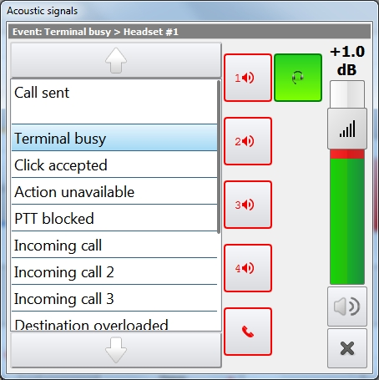
Button for window
«Sound signals» closing
Button for sound
signals list navigation
Figure 50 – Acoustic signals selection
The list of acoustic signals, which will be played by VCDT at specific events, is located at the left part of window «Acoustic signals». The buttons for selection of speaking device for sound signals playback are located in the right part.
Setting up acoustic signals is carried out in IME on the tab «Voice Events» (see item 5.4 «Voice Events», «IME Operator's Manual. ЦИВР.00531-01 34 01»).
A specific volume level in decibels is set up for each event, at that the speaking device remains common for all events.
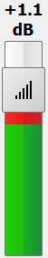
Volume control for the acoustic signal
Figure 51 – Setting of acoustic signal volume level
Sound alert can be switched off for events. Select an event name from the list and click the appropriate button:

 – sound alert mode is switched on;
 – sound alert mode is switched off. The mode is switched on/off by pressing the button.
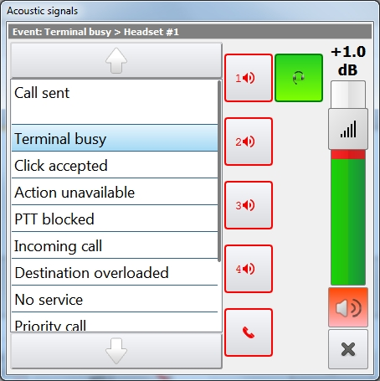
Figure 52 – Sound alert mode is switched off for event «Terminal busy»
For «Click accepted» event it is possible to control disconnection of sound alert separately for LSC buttons, Radio and other function buttons, see Figure 53.
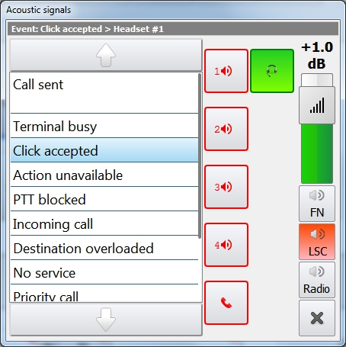
Figure 53 – Event «Click accepted», sound alert mode is switched off for LSC buttons
For «Incoming call» event, you can select one acoustic signal from several options, see Figure 54.
Select from the list the acoustic signal of an incoming call that you want to make the default signal when incoming calls are received and click the button with a check mark. The button will change the color to «green» and the selection will be saved. In this case, the acoustic signal that was previously set as the default signal is disabled.

 – «Incoming call X» acoustic signal is set as the default signal.

 – «Incoming call X» acoustic signal is not the default signal.
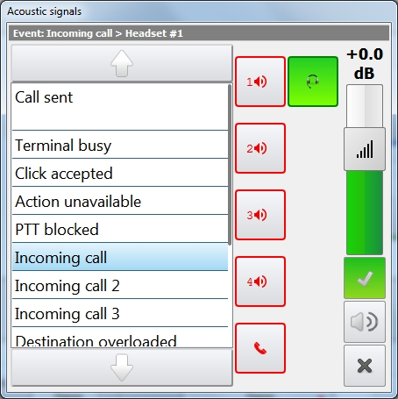
Figure 54 – «Incoming call» acoustic signal is set as the default signal

5.3 Terminal Locking (Unlocking)

 – button of terminal locking/unlocking on the toolbar.

 – locking is executed by pressing and holding down the button, mean while button color changes to red.

 – the terminal is locked.

 – to unlock the terminal by pressing and holding down the button, at that the button color changes to green – the terminal is unlocked.

5.4 Short-Term Recording
Short-term recording (STR) is test recording and listening to conversations of specific workstation. STR allows recording and playing back the communication session of workstation.

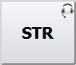 – button STR;

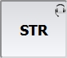 – STR is switched on.

The records are stored as cyclic buffer in the VCDT RAM (default storage time is 30 minutes, maximum storage time is 90 minutes). The list of records is saved until the terminal is rebooted or configuration is refreshed.
When button «STR» is pressed, the window with the same name will be open, see Figure 55.
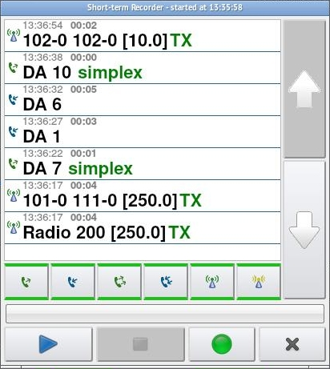
Figure 55 – Window STR
Each record is presented as follows:
– type of call;
– time of call;
– subscriber name;
– type of connection (simplex, duplex, half-duplex, reception, transmission).
Type of call:

Outgoing
Incoming
Incoming indirect
Outgoing indirect
Reception via radio
Transmission via radio

When a record from the list is selected, its playback starts automatically, see Figure 56. There will be no automatic playback of the record when a controller moves through the list of conversations using the buttons.

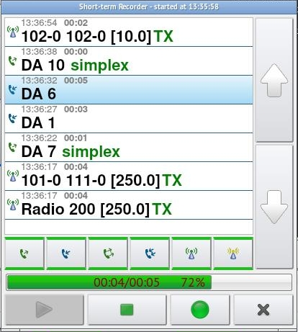
Button for conversation record list navigation
Figure 56 – Conversation record playback
Also, to listen to the selected recording, the corresponding buttons can be used.

 – button «Play conversation record»;

 – button «Stop conversation record;

 – button for activation/deactivation of STR mode.

The mode of workstation permanent recording (PR) can be set in IME. The recording process is activated automatically when the terminal is started and cannot be deactivated by the user. By default, cyclic records storage time is 10 minutes.

Conversation records can be filtered depending on their type, see Figure 57.

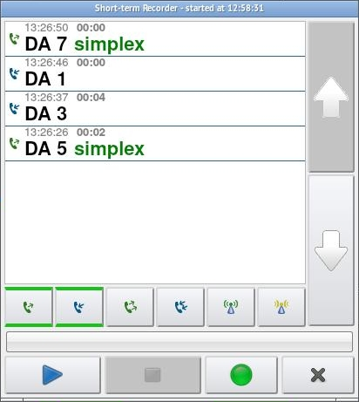
Figure 57 – The list of conversations is filtered by «Outgoing» type

5.4.1 Quick access to the last STR conversation playback

To quickly listen to the last STR conversation, use the «SAY AGAIN» button.

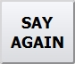 – last STR conversation listen button.
 – while the record is playing, the button becomes «green». Listening can be interrupted by pressing the «SAY AGAIN» button one more time.

5.5 Emergency Volume

VCDT allows using the emergency volume function.

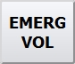 – button for activation/deactivation of emergency volume mode.
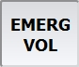 – press the button and hold it down to activate the emergency volume mode.
When button «EMERG VOL» is held down, the volume of all incoming calls (existing and new) is increased in VCDT by a selected value in dB.
By default the value is +4 dB.
It is set for each VCDT separately (see item 5.1.2.4 «Miscellaneous», «IME Operator's Manual.ЦИВР.00531-01 34 01»).

5.6 Quick headset
The function allows quick selection of a headset for all available communication of the current workstation.

 – button for activation/deactivation of the «Quick headset» mode.

 – «Quick headset» mode is enabled.
The button operates in latching mode, when activated the button color changes to green. Press the button again to return to the initial state. SDs for Radio and LSC become the last set before activation of the function «Quick headset».

If the «Ignore Quick headset mode» checkmark is set in the IME, then the quick headset function will not be applied to the button (Radio or LSC), see item 5.3.3 «Radio button Properties» of «IME Operator's Manual 00531-01 34 01).

5.7 SPLIT mode
«SPLIT» - the mode of immediate switching over of the VCDT buttons of each type (LSC, Radio, Telephone communication) to specific speaking devices.
 – button for activation/deactivation of «SPLIT» mode.
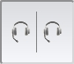 – «SPLIT» mode is enabled.
By default, SPLIT mode is deactivated. The individual Speaking Devices settings are used during operation, see item 5.1 «Selection of individual speaking device and volume control» of this manual.
While «SPLIT» mode activation, immediate switching over of the VCDT buttons of each type (LSC, Radio, Telephone communication) is carried out to specific speaking devices that are configured on the tab «Speaking devices» - «Speaking devices in SPLIT mode», see «IME Operator's Manual.ЦИВР.00531-01 34 01», item 5.1.2.1 «Speaking devices»). When «SPLIT» mode is enabled, individual setting of Speaking Devices is impossible.
While «SPLIT» function deactivation VCDT returns to the default operating mode.
When a stereo headset is connected at an air traffic controllers’ working position, a window is opened to confirm switching over of Speaking Devices buttons to the headset:

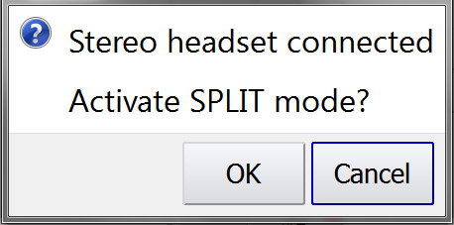
Figure 58 – «SPLIT» mode activation
If you select «OK», the «SPLIT» mode is activated. If you select «Cancel», the default operating mode remains. If the headset is not connected, the «SPLIT» mode will not be activated.

5.8 Acoustic signal control «Incoming call»
By default, the «Incoming call» acoustic signal is on. To quickly turn off the signal for all incoming calls, press the corresponding button, which is located on the function Toolbar (see item 2.1 of this manual).

 – button for turning on/off the «Incoming call» acoustic signal. The «Incoming call» acoustic signal is turned on.
The presence of this button in the SD selection window depends on the «Muting the incoming call acoustic signal is allowed» option (see item 5.1.2.1 «Speaking devices», «IME Operator's Manual.ЦИВР.00531-01 34 01»).

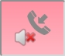 – «Incoming call» acoustic signal is muted. If you press the button again and there are unanswered incoming calls, the signal starts playing again.

Also, you can turn off/on the «Incoming call» acoustic signal directly on the LSC button: in the VCDT via the SD selection window or in the IME by setting the «Mute incoming call acoustic signal» flag (see item 5.3.2 «LSC button properties», «IME Operator's Manual. ЦИВР.00531-01 34 01»).
When the acoustic signal is switched off, an icon with a red handset appears on the button, see Figure 59.

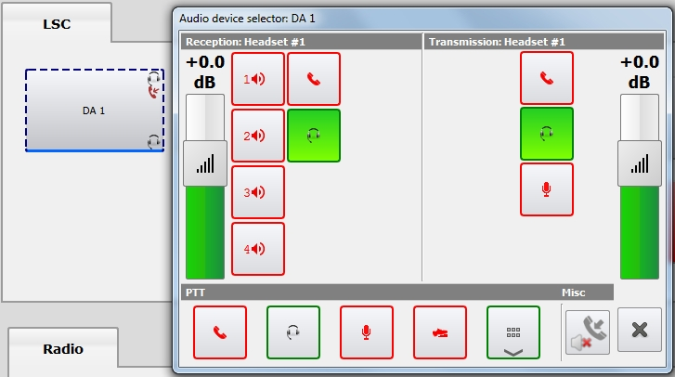
Figure 59 – Control of the acoustic signal «Incoming call» through the window «Audio device selector»

5.9 Two headsets mode
The function becomes available when there are two connected headsets and allows you to work with them in two different modes:
a) Routine duties mode: the first headset works with all radio communications, the second works with all telephone communications.
b) Training mode: both headsets work in parallel, but with different priorities for radio-telephony communications.
The first headset in this function is considered to be the one that has a lower number of the physical connection, that is, for example, from two headsets «Headset 2» and «Headset 3», «Headset 2» will be considered the first one.

 – button for «Two headsets mode» function activation/deactivation, initial state.

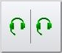 – the «Routine duties» mode is enabled. Two headsets will work separately (Radio and LSC). Accordingly, all the Radio buttons are rearranged to work with the first headset, all the LSC buttons - to work from the second headset. «A» mode is activated/deactivated by short pressing the button.

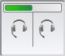 – the function switches to the «Training» mode by a long pressing of the button.

 – «Training» mode is enabled. In this mode, all incoming calls (radio and LSC) come to both headsets in parallel. By default, controller's microphone (the first headset) is active, so that controller is working both with radio communications and with the LSC. The instructor can intercept the PTT control since he has priority to go on the air. While he keeps holding the PTT button pressed on his own (second) headset - the instructor's microphone will be active. As soon as instructor releases PTT, the controller’s microphone will become active again.

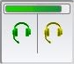 – subsequent long pressing of the functional button turns «b» mode off. By short pressing the button, you can quickly switch over to the «a» mode of operation.

5.10 Roles
Role is a configuration of a VCDT graphical user interface with a specific set of functional capabilities. The function «Roles» allows you to configure multiple interfaces on one VCDT. Interfaces (roles) are configured from the IMS, see item 5.3 «GUI Editor» of «IME Operator’s Manual. ЦИВР.00531-01 34 01».
The role that was selected in IMS, while saving the configuration, becomes the default role for VCDT. This default role can be changed in VCDT itself to any other role available in the configuration.
Click functional button «Tools» to open the window for changing the role. Select button «Switch role» in the opened window, see Figure 60.

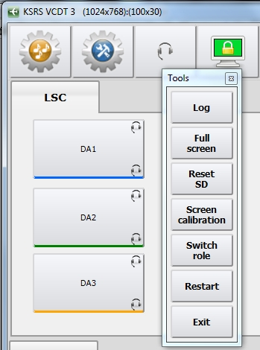
Figure 60 – Button selection «Switch role»
You need to select the desired role from the list of the «Role Selector» window. The name of the role that is currently loaded is highlighted in gray in the list, see Figure 61.

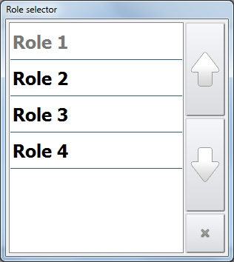
Figure 61 – Select a role from the list
Once the role is selected, the following window will immediately open:

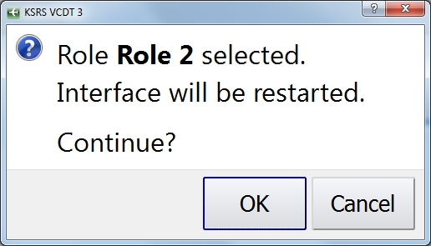
Figure 62 – Confirmation to use selected role

The GUI of the selected role will be displayed on the VCDT screen after restarting.

You can also change the role of VCDT remotely from IME, see item 5.3 «GUI Editor», «IME Operator's Manual.ЦИВР.00531-01 34 01». The role selected in IME will be uploaded without confirmation!

5.11 Update terminal configuration
Availability of functional button «Update Terminal Configuration» means that configuration files will be updated in VCDT only after confirmation by the operator. This function is configured from IME (see item 5.5 «Functions» of «IME Operator's Manual. ЦИВР.00531-01 34 01»).

 – button for terminal configuration updating.

The location of this button is fixed for VCDT that means it cannot be reconfigured, see Figure 63.

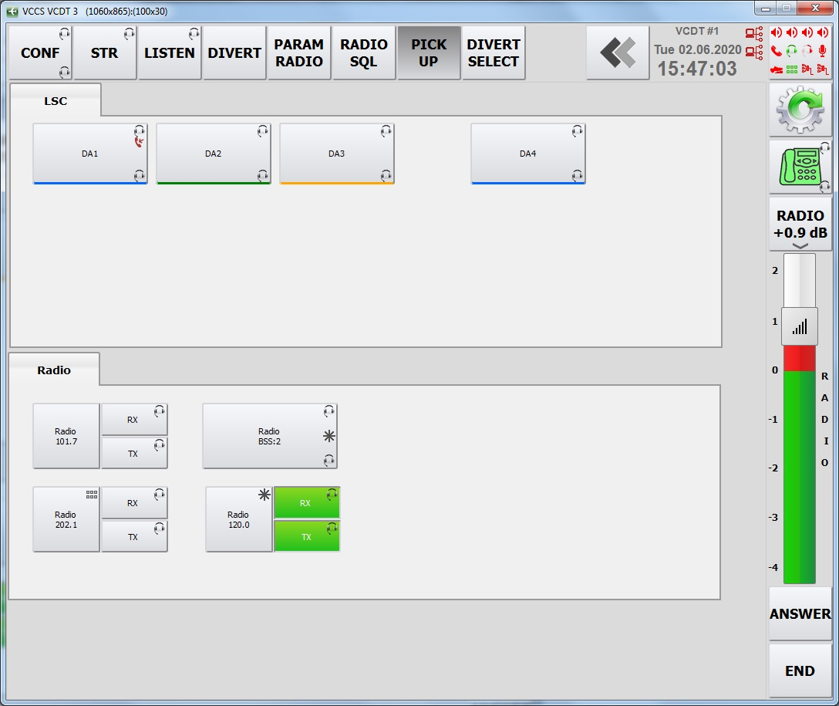
Figure 63 – Location of the terminal configuration update button

Clicking on the configuration update button will open a window with a confirmation question, see Figure 64.

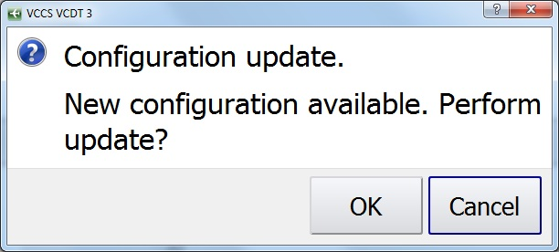
Figure 64 – Confirmation of the configuration update

Clicking on the button «Yes» will apply configuration waiting for update.

The configuration update will be carried out automatically in the VCDT even if there is a button for terminal configuration updating in the case of applying the menu item configuration update without confirmation, (see item 12.2 «Updating configuration (with confirmation)» of «IME Operator's Manual. ЦИВР.00531-01 34 01»).

5.12 Screensaver
«Screensaver» is a function of blanking the monitor screen when VCDT is idle, which is designed to reduce unproductive equipment deterioration. The presence of this function in VCDT, as well as the time after which the screen saver is turned on, is configured in IME (see item 5.1.2.4 «Miscellaneous», «IME Operator's Manual. ЦИВР.00531-01 34 01»).
«Screensaver» is not activated if there is a dialog on the screen asking to confirm something.
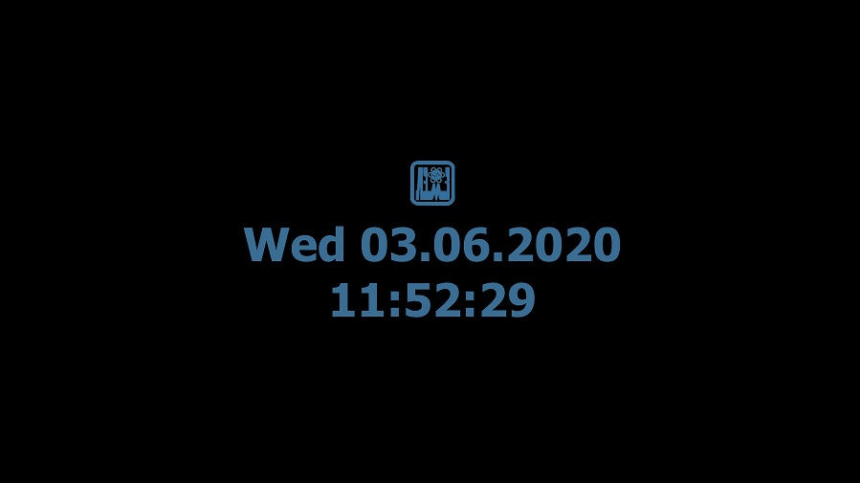
Figure 65 – «Screensaver» outer appearance

Disabling the «Screensaver» is performed by clicking on the screen or by PTT activation.
The «Screensaver» is disabled when the state of the LSC and Radio communication subscribers changes from «Available» to «Not available» and vice versa.
Also, the «Screensaver» can be disabled when there is an incoming LSC call and upon active reception from radio station (depending on the setting in IME, see item 5.1.2.4 «Miscellaneous», «IME Operator's Manual.ЦИВР.00531-01 34 01»).

5.13 Unattended working position
If all speaking devices with a microphone are turned off or failed, a semi-transparent red message «TERMINAL UNATTENDED» will appear on WP screen, see Figure 66.

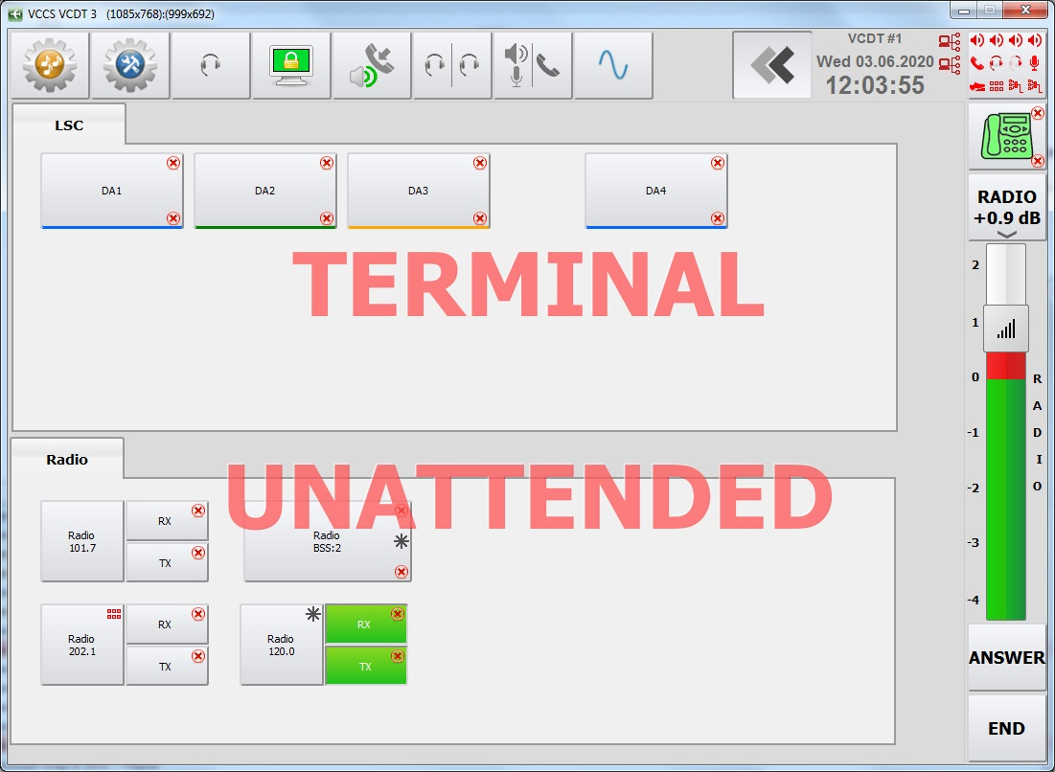
Figure 66 – Terminal with the inscription «TERMINAL UNATTENDED»
When the notification appears, the WP is not blocked, that is, the inscription does not prevent from pressing the buttons.
If the «Screensaver» function is enabled on the WP, an inscription «UNATTENDED» will be added to the screen in slightly brighter color than the main color, see Figure 67.

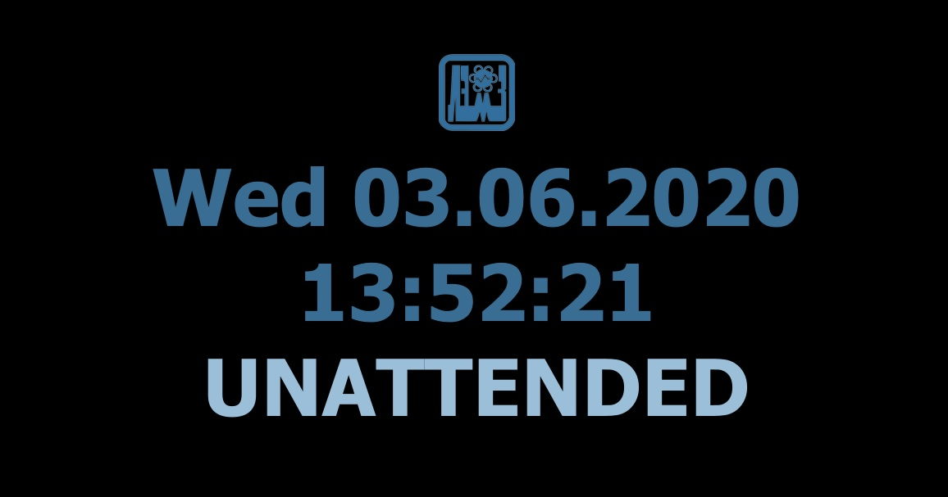
Figure 67 – Inscription «UNATTENDED» in case the «Screensaver» function is enabled

5.14 Terminal reserve mode
Terminals can be combined into reservation groups. In this group the terminals monitor the performance of other participants. If there is a problem with one of the terminals, then another terminal can take over its functions. The algorithm for setting up reservation groups is given in item 3.1.8 «VCDT reservation», «IME Operator’s Manual. ЦИВР.00531-01 34 01».
Each terminal in the group may have one of the following reservation statuses:

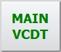 - the terminal is the Main one in the group. Full-function mode.

 - the terminal is Reserve. If there is a Main terminal in the group, all other terminals have a «Reserve» status. In this status the terminal rejects all incoming calls and stops listening to the Radio. At the same time, it can make outgoing calls over LSC and over the Radio. Depending on the settings, calls may get to the Main terminal in the group.

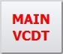 - an intermediate state during initialization or when updating the configuration. Full-function mode.

In the automatic mode the Main terminal in the group is selected on the basis of priority and physical availability of terminals in the network. When disconnecting the terminal (loss of connection with the terminal) in the group the selections occur, the Reserve terminal with the highest priority becomes the Main one.
The VCDT has a possibility to forcibly change the operating mode of any terminal in the group:

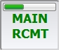 - activation of the Reserve mode is carried out by long pressing the button «MAIN VCDT».

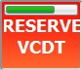 - to enter the Main mode, press and hold the button «RESERVE VCDT».

If there are only two terminals in the group, pressing the button can make the terminal both Main and Reserve. If there are more than two terminals, then the terminal can only be made the Main one.

If the Screensaver function is enabled, the inscription «RESERVE» will be added to the screen, see Figure 68.

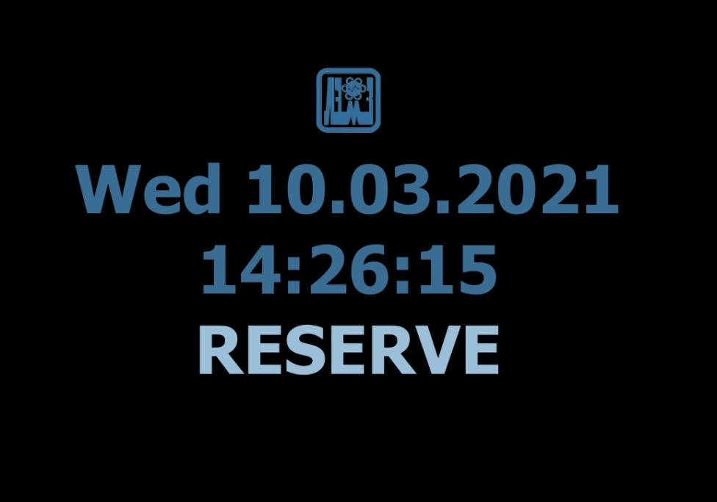
Figure 68 – The inscription «RESERVE» with the Screensaver function enabled
It is also possible to activate the standby mode in the VCDT remotely from the IME, see item 12.5 «Enabling the reserve mode» of «IME Operator's Manual. 00531-01 34 01». The activation of the reserve mode on the VCDT will be carried out without confirmation!

6 Service Functions

6.1 Tools

 – button for opening/closing window «Tools».

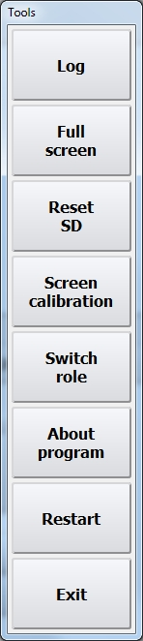

Button «Log» – opening of protocol window, see Figure 65.

Button «Full screen» – switching over VCDT to full screen mode.

Button «Reset SD» – reset of speaking devices, assigned by the user (see item 5.1 «Selection of speaking device and volume control» of this Manual), to settings, received from IME.

Button «Screen calibration» – start of system program of screen calibration.

Button «Switch role» – change the interface (role). For details, see item 5.10 «Roles» of this Manual.

Button «About program» – opening a window with information about the software version, see Figure 68.

Button «Restart» – restart of VCDT interface.

Button «Exit» – termination of VCDT interface operation.

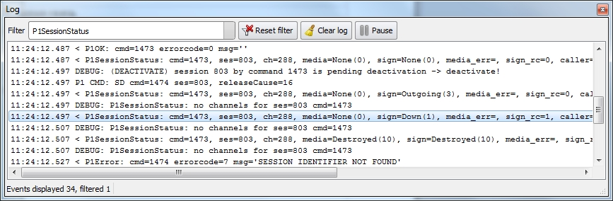
Figure 69 – Window «Log»

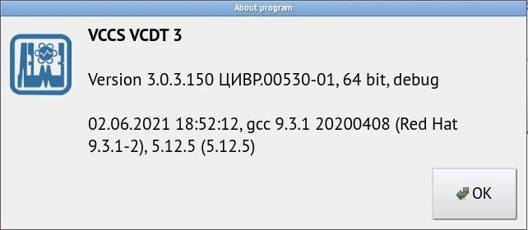
Figure 70 – Information window about the software version

6.2 Generator
This function provides continuous transmission of tone signal of given frequency to the channel to check speech path.
Generator activation button is arranged on the toolbar and operates just like the LISTENING function – first click the GENERATOR button, then choose the required «Radio» or «LSC» button, for which the generator shall be activated. By default, frequency 425 Hz is used in this function.
When you select a generator on the LSC simplex button or in Radio mode, the button will work with latching.

 – button for activation/deactivation of generator mode.

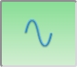 – generator operation mode is activated.

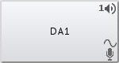 – generator is assigned to button «DA1». Sine wave symbol will appear on the button next to SD symbol.

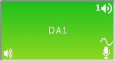 – connection is established, tone signal for speech path check is issued to the channel.

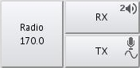 – generator is assigned to «Radio» button. Sine wave symbol will appear on the button next to SD symbol.

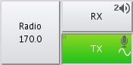 – button «Tx» is active. PTT is active, tone signal for speech path check is issued to the channel.

7 Emergency Notification System (ENS)

7.1 ENS purpose
Emergency notification system (ENS) is designed to create an emergency communications network on the basis of the current network of operative communication VCCS «Topaz» of an air traffic controllers shift in order to alert the airport's rescue team about the prerequisite to incident in a circular mode.
ENS allows:
- creating of several notification scheme;
- assigning of roles to each VCDT- transmission, reception or ignoring of alert signals and voice communication signals;
- assigning to one or several VCDT the role of the receiver of acknowledgments that the subscribers have received alert signals, including the initiator of emergency alert for the purpose of controlling;
- sending to each subscriber a special emergency alert signal, the duration of which can be changed by the settings in IME;
- transmitting voice information in a circular mode when the Emergency notification button is pressed;
- delivering audio and voice information to the line output for recording;
- displaying the reception of emergency alert signals by the blinking of indicating panel «ALARM!» on the subscriber's terminal, if technically possible;
- connection of an external acoustic and/or indicating panel of emergency notification.

ENS setting is executed from IME. The function of the Emergency notification button is selected by means of checkmarks (see item 5.3.5 «Emergency notification button properties», «IME Operator's manual. ЦИВР.00531-01 34 01»). Depending on selected checkbox in ENS, the terminals are divided into the following types:

- air traffic controllers terminal with the right to alert in an emergency (TA). The terminal is equipped with the button «ALARM», by pressing on that the controller sends a voice message on the air;

- Reception and recording of alert signals reception acknowledgements (RF). VCDT (DCP)is equipped by this function for the subscriber responsible for the transmission monitoring of emergency alerts. RF may be equipped both TA and TNA;

- air traffic controllers terminal without the right to generate an emergency alert signal (TNA). The terminal is intended for receiving an emergency alert signal from TA. The terminal becomes a TNA, if it is selected in the notification scheme (see item 10.1 «Notification scheme setup», «IMT Operator's manual. ЦИВР.00531-01 34 01»»).

7.2 Air traffic controllers terminal with the right to alert in an emergency (TA)

Air traffic controllers terminal with the right to alert in an emergency (TA) is equipped with the «ALARM» button of red color. The button is equipped with a progress bar, which protects against accidental pressing. The inscription on the button consists of the name of the button and the name of the notification scheme, in our example it is «ALARM» and «ALARM 1» respectively. The name of the button is indicated in IME, see item 5.3.5 «Emergency notification button properties» in the instruction manual of IME operator. ЦИВР.00531-01 34 01»». The name of notification scheme is specified in the item10.1 «Notification scheme setup», in the instruction manual of the operator. ЦИВР.00531-01 34 01»».
The controller sends a voice message on the air, when the button is pressed and held down. In this case, the TA buffers a voice message that is equal to the duration of the audible alarm for a subsequent sequential transmission of the audio and voice messages to the network in a circular mode. Also, the TA transmits a command to other terminals over the network about the transfer of subscribers of emergency alert to the «ALARM» mode (if the subscriber has a technical capability).

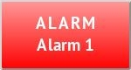 – the button of activation/deactivation of emergency alert mode.
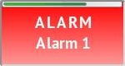 – press and hold the button to activate emergency alert mode, meanwhile the button color changes to green.
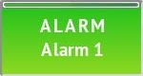 – emergency alert mode is activated. While the button is being held the recording of voice communication is in progress. Release the button to terminate the recording.

7.3 Reception and recording of alert signals reception acknowledgements (RF)

All subscribers of VCDT (DCP), responsible for controlling of emergency alert signals transmission, are equipped with the function of reception and recording of alert signals reception acknowledgements (RF).

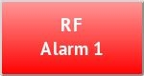 – the button of emergency alert signal transmission control.
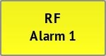 – the button starts blinking yellow, if there are any changes in subscriber state during alert signal reception.

When you press the button the window with a list of subscribers will be opened, from which it is expected to receive an acknowledgment of emergency alert signal. If TNA comes to the mode «ALARM», what means that equipment confirmed the reception «ALARM» signal, the line with subscriber name appears red see Figure 71.

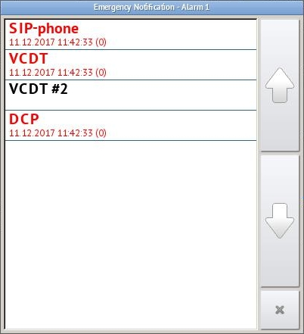
Figure 71 –The list of subscribers, from which it is expected to receive an acknowledgment of emergency alert signal. TNA is in «ALARM» mode
If a controller confirmed the reception of «ALARM» signal (by pressing blinking yellow display «ALARM» or by pressing the button «END»), the line with the subscriber name becomes green, see Figure 72.
The control list accommodates time of emergency alert signal reception and time of its confirmation by a subscriber (NOTIFICATION RECEIVE TIME\NOTIFICATION CONFIRM TIME). In brackets is indicated: for the moment of signal reception - the amount of time from the moment of signal formation on TA in sec. and for the moment of confirmation – how many seconds is passed from the moment of signal reception.
Black color of the line with subscriber name means that the subscriber has not received «ALARM» signal.

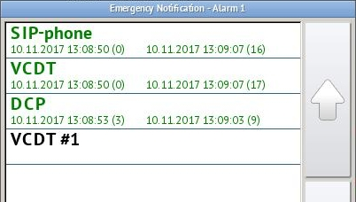
Figure 72 – The list of subscribers being confirmed emergency alert signal reception
If a subscriber does not answer the call or has not confirm receipt of a signal for a certain time, the call is automatically canceled by the TA. A line with the name of such a subscriber will be crossed out, see Figure 73. The waiting time for confirmation of a call is configured on IME (see item 10.1 «Notification scheme setup», parameter «Call confirmation timeout, in minutes» in the instruction manual of IME operator. ЦИВР.00531-01 34 01»).

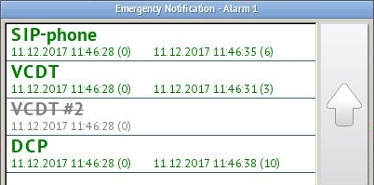
Figure 73 – VCDT #2 subscriber confirmation timeout

View the list of subscribers by pressing the control button of emergency alert signal transmission. Lines with subscribers’ names will be of black color.

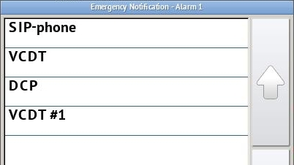
Figure 74 – The list of subscribers for emergency alert signal transmission control
VCDT\DCP and other subscribers of VCCS «Topaz», not added in emergency alert system, ignore the ALERT signal and do not switch over to the ALARM mode.

7.4 Air traffic controllers terminal without the right to generate an emergency alert signal (TNA)

Air traffic controllers terminal without the right to generate an emergency alert signal (TNA) is intended for alert signal reception from TN. In case of «ALARM» signal reception TNA comes to the «ALARM» mode - on the function panel switches on red blinking MESSAGE, see Figure 75. Alert sound signal and following voice alert from TA are played back through the loudspeaker.
Press onto the message (of the touch screen) or the button «END» (of the handset) for emergency alert signal reception confirmation. «ALARM» mode will be dropped.

Figure 75 – TNA in ALARM mode
After dropping of «ALARM» signal beneath the button of choosing of speaking devices appears the button of repetitive playback of emergency message, see Figure 76. You can listen to this voice message if necessary on TNA by pressing of the given button.

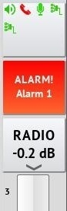
Figure 76 – The button of repetitive playback of emergency alert
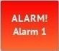 – the button of repetitive playback of emergency message.
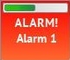 – press and hold down this button to close it and exit from emergency alert playback mode.

Appendix A

(reference)

Function codes

CODE | FUNCTION
002 | Autoredial
028 | GUI locking and unlocking
020 | Quick headset assignment
019 | Quick handset assignment
014 | Radio SQL mode toggle
004 | Intrusion call
005 | Intrusion call in conference mode
017 | Generator
025 | Radio parameters
030 | Tools
011 | Conference
023 | Short-term documenting
026 | Voice events configuration
027 | Mute Incoming Call signal
008 | Divert incoming calls
009 | Divert incoming calls (selective)
015 | Divert radio frequencies
010 | Transfer active calls
007 | Call interception
006 | Priority call
003 | Listening
024 | Say again
013 | R+T (Radio + Telephony integration)
022 | Two Headsets mode
016 | Radio carrier spacing
029 | VCDT reserve mode
012 | Retransmission
001 | Hold
021 | SPLIT mode
018 | Emergency volume

Revision Record Sheet

Rev. | Sheet (page) numbers |  |  |  | Total sheets (pages) in document | Doc. No. | Registration number of accompanying document and date | Signature | Date
 | revised | replaced | new | cancelled

