APPROVED

ЦИВР.00531-01 34 01 ЛУ

VOICE COMMUNICATION AND CONTROL SYSTEM
«VCCS Topaz»

IME Operator's Manual
ЦИВР.00531-01 34 01

Total sheets 314

2022
CONTENTS
Abbreviations and Definitions 6
1 Abstract 9
2 Getting Started 9
2.1 Interface Organization 11
3 System Settings 13
3.1 General system settings 13
3.1.1 TMCT Settings 14
3.1.2 SNMP Setting and VCDT logging 16
3.1.3 External Gateways Setting 18
3.1.4 Users Setting 20
3.1.5 Changing the color scheme 23
3.1.6 Extended 24
3.1.7 DB List 25
3.1.8 VCDT reservation 26
3.2 Network resources 28
3.3 Database configuration 30
4 System Objects 32
4.1 Creating a System Object 32
4.2 System Object Types 34
4.3 Replaceable units 36
4.4 Configuring System Object 40
4.5 Work with the scheme of the complex 42
4.5.1 Text adding 44
4.5.2 Logical grouping of objects 45
5 Voice Communication Digital Terminal (VCDT) 46
5.1 Main Settings 48
5.1.1 System parameters 49
5.1.2 Settings 49
5.1.2.1 Speaking devices 49
5.1.2.2 LSC 51
5.1.2.3 Radio communication 54
5.1.2.4 Miscellaneous 57
5.1.2.5 System settings 60
5.2 Connections 61
5.2.1 SIP endpoints 61
5.2.2 SIP routes 65
5.3 GUI Editor 66
5.3.1 Panel properties 75
5.3.2 LSC button properties 77
5.3.2.1 Speaking devices 83
5.3.2.2 Circular call setup 83
5.3.3 Radio button properties 84
5.3.3.1 Speaking devices 91
5.3.3.2 Linked radios 92
5.3.4 Radio button properties (Trainer) 93
5.3.5 Emergency notification button properties 98
5.3.6 Radio button properties (ED-137) 102
5.4 Voice Events 104
5.5 Functions 108
5.6 Phonebook 114
5.6.1 Phonebook import 116
6 Line Interface Unit Analog (LIU-A) 118
6.1 Main Parameters 119
6.1.1 Controller Module status 119
6.1.2 Global parameters 120
6.1.3 Network parameters 120
6.1.4 Interfaces 121
6.1.5 LI status 122
6.1.6 Channels 123
6.2 Internal route tables 130
6.3 Signalling Configuration 132
6.3.1 SSC signalling type 132
6.3.2 DTMF signalling type 132
6.3.3 LB signalling type 133
6.3.4 FXO signalling type 134
6.3.5 FXS signalling type 135
6.4 Reservation 136
7 Line Interface Unit Digital (LIU-D) and Line Interface Unit Analog (LIU-А v.2) 140
7.1 Setting of Web Interface 143
7.1.1 Page «Hardware info» 145
7.1.1.1 Section «Device information» 145
7.1.1.2 Section «Software information» 147
7.1.1.3 Section «Memory information» 147
7.1.1.4 Section «DSP information» 147
7.1.2 Page «System» 148
7.1.2.1 Section «Driver configuration» 148
7.1.2.2 Section «DSP setup» 150
7.1.2.3 Section «Network configuration» 152
7.1.3 Page «Configuration» 155
7.1.3.1 Section «Main settings» 155
7.1.3.2 Section «Boards configuration» 155
7.1.3.3 Section «SIP/PJ» 155
7.1.3.4 Section «RTSP/PJ» 157
7.1.3.5 Section «H323 configuration» 158
7.1.3.6 Section «E1 Trunks configuration» 158
7.1.3.7 Section «SS7 configuration» 160
7.1.3.8 Section «ISDN configuration» 161
7.1.3.9 Section «CAS configuration» 161
7.1.3.10 Section «Tone Signaling configuration» 162
7.1.3.11 Section «АК configuration» 163
7.1.3.12 Section «Redundancy» 164
7.1.3.13 Section «Emergency Phone configuration» 170
7.1.3.14 Settings of Section «LEMZGW configuration» for LIU-A v.2. LI settings 171
7.1.3.15 Save changes 185
7.1.4 Page Modems 186
7.1.5 Page «Routing» 186
7.1.5.1 Section «Main settings» 186
7.1.5.2 Section «Recorders» 187
7.1.5.3 Section «Signalling targets» 187
7.1.5.4 Section «AK targets» 191
7.1.5.5 Section «Patterns» 192
7.1.5.6 Section «Modem targets» 195
7.1.5.7 Section «Connections» 195
7.1.5.8 Section «Recorder patterns» 197
7.1.5.9 Section «Check patterns» 199
7.1.5.10 Button «Save changes» 199
7.1.6 Page «Statistics» 200
7.1.6.1 Section «Controller» for LUI-D 200
7.1.6.2 Section «Controller» for LIU-A v.2 203
7.1.7 Page «Syslog» 204
7.1.8 Page «Logout» 205
7.2 Channel Registration in the System 206
7.3 System configurations control 209
8 Emergency Communication Unit (ECU) 214
8.1 Main parameters 216
8.1.1 Status 216
8.1.2 Global parameters 217
8.1.2.1 Network configuration 217
8.2 Line interfaces and channels 218
8.2.1 Line interface 218
8.2.2 Line interface status 219
8.2.3 Channel 221
8.3 Line Switching Interfaces 225
8.4 Button Panels 226
8.5 Reservation 228
9 Briefing and Training System (BTS) 230
9.1 VCDT Training Configuration 230
9.2 Configuring BTS LIU-A 237
9.2.1 VOIP peers 237
9.2.2 Patterns 240
9.2.3 Files 241
10 Emergency Notification System Setting 242
10.1 Notification scheme setup 242
11 Monitoring System 245
11.1 Monitoring 249
11.2 Setting of Sound Event Alerting 253
11.2.1 Sound notification of failure and pre-failure status 254
11.3 VCDT Statistics 255
11.4 Logins 257
11.5 Emergency notification monitoring 259
11.6 VCDT Journal 260
11.7 Monitoring parameters 261
11.8 System objects monitoring 264
11.8.1 LIU-A and LIU-A v.2 monitoring 264
11.8.2 LIU-D monitoring 272
12 Remote VCDT Control 277
12.1 Updating Configuration 277
12.2 Updating Configuration without confirmation 278
12.3 Updating Training Configuration 279
12.4 Calls Transferring 280
12.5 Enabling the Reserve Mode 283
13 System Object Maintenance 284
14 DB Backup and Restore 285
14.1 File Manager 288
14.2 Emergency recovery of a corrupted database 290
14.2.1 Transaction limit exceeding 291
15 User Change 292
16 Power Supply Control 293
16.1 TMCT power control 293
16.2 Remote power control of system objects 294
16.2.1 Power management of all VCDTs 295
Appendix A 296
Setting of Printer Epson LX-350 296
Appendix B 299
Gain Parameters 299
Appendix C 300
Typical LIU-A v.2 configurations set up examples 300
Revision Record Sheet 314

Abbreviations and Definitions

AGC | Automatic gain control
ANI | Automatic number identifier
ATX | Automatic telephone exchange
BSS | Best signal selection
BTC LIU-A | Line interface unit analog for briefing and training system
BTS | Briefing and training system
CM | Controller module
CUPS | Common UNIX printing system
DA | Direct access
DB | Database
DC | Digital communication
DCP | Digital communication panel
DTMF | Dual-tone multi-frequency analog signal, used to dial telephone number
E&M | Analog telephone signalling standard (Ear and Mouth signaling)
ECPP | Emergency control phone panel
ECRP | Emergency control radio panel
ECU | Emergency communication unit
ENS | Emergency notification system
ENT | Emergency notification terminal
FLASH memory | Special type of non-volatile writable solid-state memory (Flash memory)
FXO | Analog interface of telephone exchange subscriber device (Foreign exchange Office)
FXS | Voice interface or port, emulating ATX interface extension, used to connect common analog telephone to multiplexer (Foreign Exchange Station)
FB | Function button
HSP | Hot standby protocol
IME | Inspection and management equipment
IMS | Inspection and management system
ISDN (Integrated Services Digital Network) | A digital network that allows to combine telephone and data services
ISUP (ISDN User Part) | User Part or ISUP is part of Signaling System N7, which is used to set up telephone calls in the public switched telephone network
LB | Local battery
LI | Line interface
LIA | Analog line interface
LID | Digital line interface
LIU-A | Line interface unit analog
LIU-D | Line interface unit digital
LSC | Loudspeaker communication
LSI | Line switching interface
MC | Microcontroller
PC | Personal computer
PhL | Physical line
PIATX | Private industrial automatic telephone exchange
PLD | Programmable logic device
PR | Permanent recording
PTT | Half-duplex voice communication standard with two-way radio interface and possibility to transmit a signal in one direction at a time (Push-to-talk)
RAM | Random access memory
RF | Reception and recording of alert signals reception acknowledgements
RRSC | Remote radio set control
RS | Radio set
RSC | Radio set control
RTP | Real-time transport protocol
Rx | Reception
SD | Speaking device
SELCAL | Selective calling system
SIP | Communications protocol, method of initiating and terminating user Internet session, including multimedia exchange (Session Initiation Protocol)
SIP signalling | Sting of exchange of special data, containing SIP protocol commands and parameters, determining media data transmission in media channel
SIP URI | SIP addressing scheme, used to call a subscriber via SIP
SNMP | Internet-standard protocol for devices control in IP networks based on TCP/UDP architectures (Simple Network Management Protocol)
SQL | Squelch
SSC | Subscriber selective call system
STR | Short-term recording
TA | Air traffic controllers terminal with rights to alert to emergency situation
TMCT | Technical monitoring and control terminal
TMCS | Technical monitoring and control server
TNA | Air traffic controllers terminal without rights to generate emergency alert signal
Tx | Transmission
UA (User Agent) | String name for identification in SIP-protocol
UPS | Uninterruptible power supply
URI | Uniform resource identifier
UTC | Universal time coordinated
VAD | Voice Activity Detection
VCCS | Voice communication and control system
VCDT | Voice communication digital terminal
VFCh | Voice frequency channel
WS | Workstation

1 Abstract

This document contains information regarding procedure for personnel operation with IME (Inspection and Management Equipment) program of system «VCCS Topaz». The document contains description of functions, which provide control of communication terminals, main and standby communication managers (modes of transmitter), system parameters settings, as well as settings for operation in Trainer mode.
IME is intended to monitor condition of communication terminals, active network equipment (switches, gateways) and control them during operation.
Inspection and management system (IMS) equipment is a redundant terminal, based on PC and special software.

2 Getting Started

Three access levels are used to work in IME: Administrator, Engineer and Technician.
Administrator (root) adds, deletes system objects, backs up and recovers DB, adds configuration, reboots the system, looks through the event log. Administrator also has access to configuration of editor settings.
Engineer updates configuration, reboots the system, looks through the event log. Engineer also has access to configuration editor settings.
Technician looks through the event log and has access to system object status data.
Two users are created in basic configuration of IME – Technician and Administrator.
By default IME is loaded with «Technician» access level (see Figure 1).

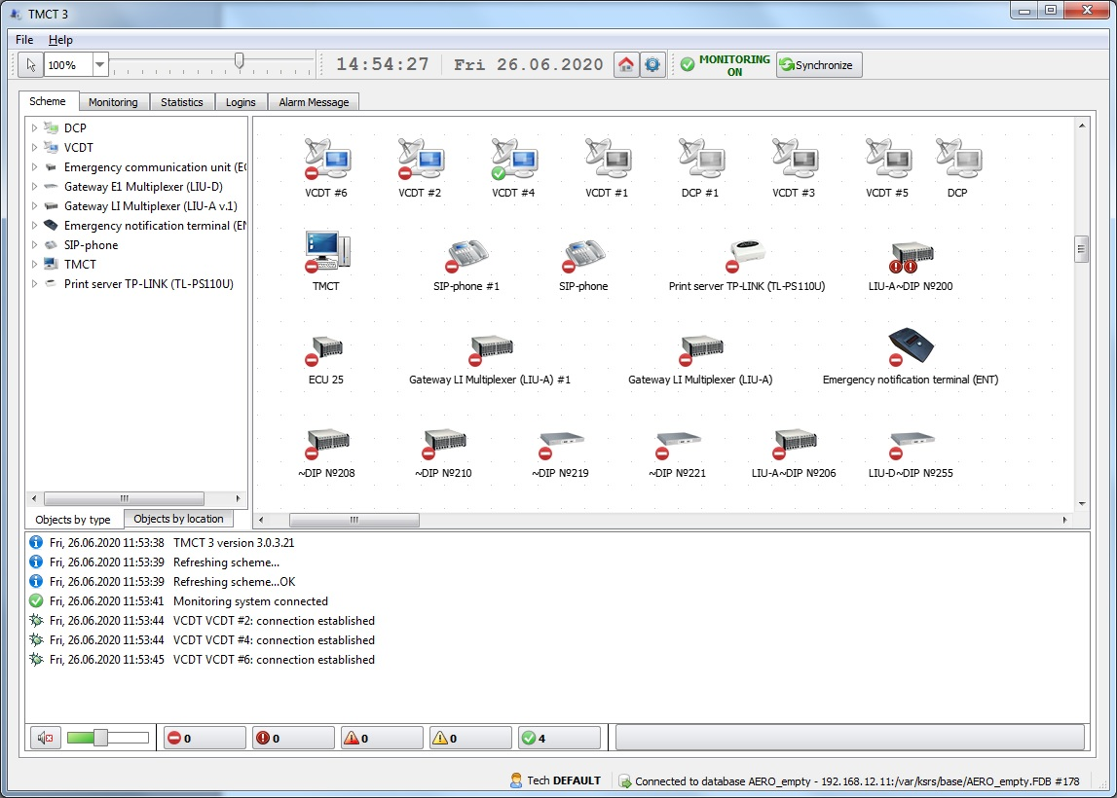
Figure 1 − IME loading by default
To configure IME, it is necessary to log in as an Administrator (root). For this purpose, select menu item «Change user», see Figure 2.

Figure 2 − Access level «Technician»

Enter «root» in field «User name» in the authorization window, there is no password. Select a database from the drop down list of «Database» field. Possible database states: - database connection is available; - database connection is unavailable.
In case of unavailability of the selected database, the same dialog will be shown with the possibility to select another database.

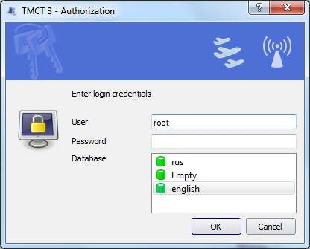
Figure 3 − User authorization as an Administrator (root)

When button «OK» is pressed, IME is loaded with enhanced functional capabilities.

To ensure safety, it is recommended to set a password for user «root» in tab «Users», see item 3.4 «Users Setting» of this Manual.

2.1 Interface Organization
Overall view of IME program window is shown in Figure 4.
1

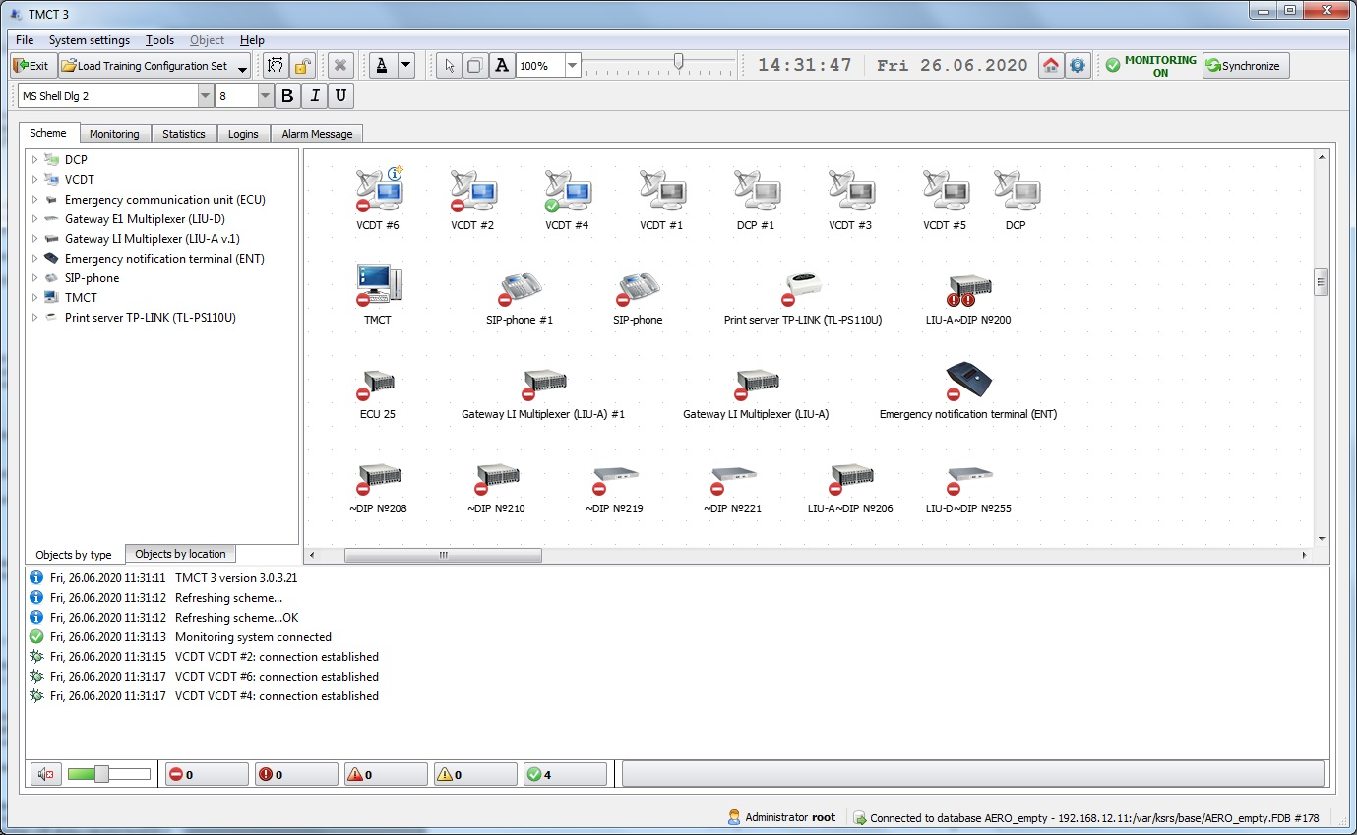
6
2
5
3
4
Figure 4 − Main program window

1 – Main menu bar. It contains such items as: «File», «System settings», «Tools», «Object», «Help». The set of menu items depends on the access level of authorized user.
When you select the «Help» menu item «About TMCT», a window with information about the software version will open:

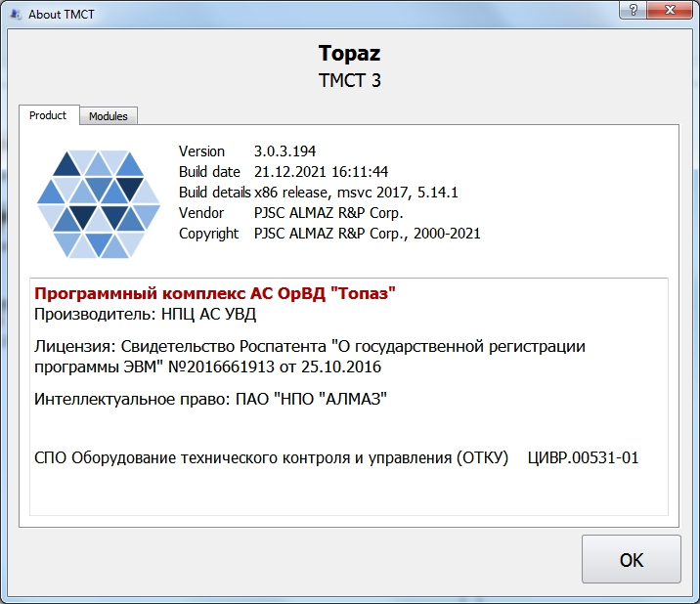

2 – Toolbar. The toolbar displays the current date, time (local or UTC, depending on the selected mode), the status indicator of the monitoring system (see item 11 «Monitoring System» of this manual).
In addition, the toolbar includes buttons that relate to working with the complex scheme (see item 4.5 «Work with the scheme of the complex» of this manual):

– local time indication mode is selected;

– UTC time indication mode is selected;

– monitoring system status indicator.

– system time and date changing. Clicking the button will open a window for changing the system time:

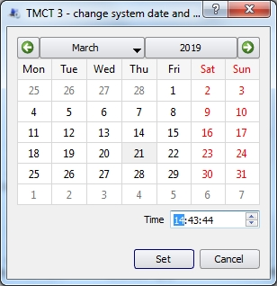

When clicking button , user terminates session, IME switches over to operation mode with access level «Technician».

3 – Active field area. It contains system objects the system consists of. The context menu may be used to update object configuration, enable readdressing, put for maintenance, reboot the system, delete an object, view and change object elements set, set up object parameters. Access to mentioned functions depends on the user access level.

4 – List of system objects by type or location. All system objects of the system are displayed as a list in tab «Scheme».

5 – System message window. A list of system operation messages is displayed in this window.

6 – Status bar. Authorized user access level and path to connected database are indicated in the bar.

3 System Settings

3.1 General system settings
To start setting up IMS, select main menu item «System settings», then «General», as per Figure 5.
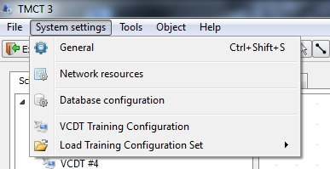
Figure 5 − Main menu, item «General»
The following tabs will be available in opened window «System settings» of IMS:
- «TMCT settings»;
- «Monitoring»;
- «External gateways»;
- «Users»;
- «Emergency Notification»;
- «Misc».
For Emergency notification system (ENS) settings see item 10 of this Manual.

3.1.1 TMCT Settings

To ensure correct indication of local time on the toolbar, select the required value in field «UTC and local time difference» in hours.
Check box «Enable Briefing and Training System (BTS) support» - determines the presence of «VCDT Training Configuration» and «Load Training Configuration Set» subitems in the «System settings» main menu item, which are required to work with the BTS.

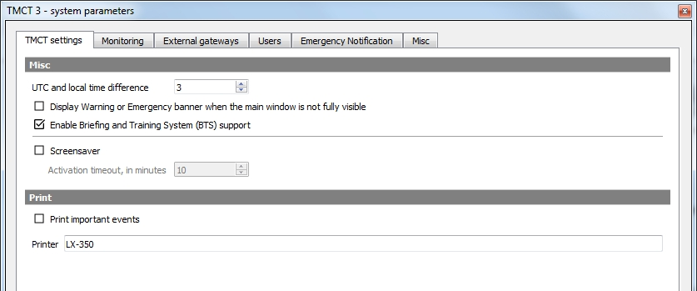
Figure 6 − System settings, tab «TMCT settings»
Check box «Display Warning or Emergency banner when the main window is not fully visible» - if this check box is set, the following banner will be displayed at the top of the screen when a system object is in configuration mode and upon message is received from the Monitoring System about an emergency or a malfunction:

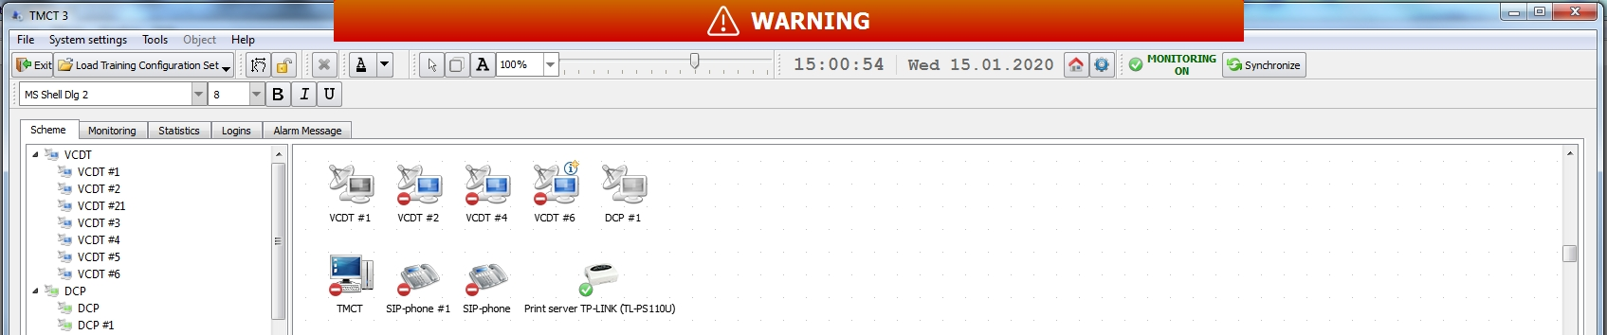
Figure 7 − Appearance of banner about warning existence
When system messages such as «Warning» and «Pre-Emergency status» appear, a banner with the word «WARNING» will be displayed. And when messages as «Failure» and «Unknown status» - a banner with the inscription «EMERGENCY». For more information, see item 11 of this manual.
When clicking on the banner, it is removed from the screen, the function «Acknowledge problem» (see item 11.2.1 of this manual) is not used in this case. The banner is only a visual indication of malfunctions and failures when the Complex Scheme occurs overlapped by a window, such as the system object editor window.

Check box «Screensaver» – the function of dimming the monitor screen when TMCT is idle, designed to reduce unproductive wear and tear of the equipment. If this check box is selected, the screensaver will be activated after the specified timeout when idle is detected. The default activation timeout is 10 minutes.
If it is necessary to print out important events, select an appropriate check box and specify the printer, which will be used to print out the events.
If the printer is local, the path to the local printer device must be specified in the «Printer» field, «/dev/usb/lp0» for example.
To support printing through CUPS, you need to specify the name of the CUPS printer, for example, «LX-350». To find the printer name, run the command: «lpstat -p -d».

It is recommended to set the required printer as the «default printer» with the command «lpoptions -d <printer name>».

For printer setting see Appendix A of this Manual.

3.1.2 SNMP Setting and VCDT logging

To inform VCCS monitoring system on the condition of separate VCCS system components, SNMP protocol is used.
Addresses of SNMP agent and event listeners are common for all system VCDT. These parameters are used in VCDT server.
«SNMP agent address» – local address of observation object is indicated as shown in Figure 8.
«SNMP receivers address list» – one or several addresses are indicated, that receive events from SNMP agents. Comma is used as a separator when several addresses are indicated.

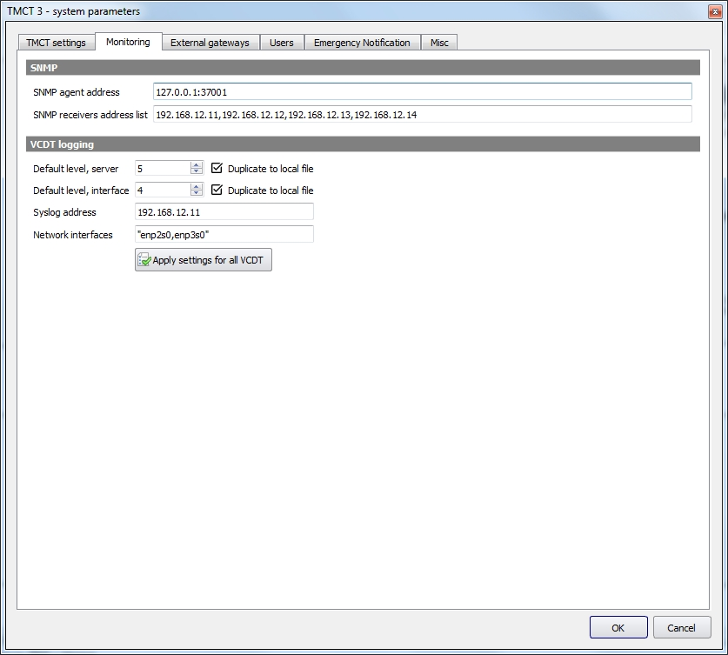
Figure 8 − System settings, tab «Monitoring»

The following parameters are used to configure VCDT logging.

«Default level, server» – server logging level. Valid value is from 0 to 7.

«Default level, interface» – graphical interface logging level. Valid value is from 0 to 7.

«Syslog address» – in case duplicating of BTC services operation logging is required, its address and Syslog server port are entered in this field.

Check box «Duplicate to local file» – if the flag is set, then logging (server and/or graphical interface) will be duplicated to a local file. If the flag is set and the «Syslog address» field is empty, logging will be carried out only to a local file.

«Network interfaces» – specifies the names of the network interfaces for monitoring. The default is "enp2s0, enp3s0".

– when you click on the button, the current logging settings will be applied to all VCDT, replacing their individual settings (see item 5.1.2.5 «System settings» of this Manual).
If the settings do not match, it may be necessary to update the VCDT configuration, which will be indicated by a corresponding information message.

– save the logging parameters of the DTC, with the exception of the parameters configured individually.

3.1.3 External Gateways Setting

The list of external gateways is set up in this tab. The list is used in VCDT «Indirect communication», for selection of output for number dialing see item 3.9 of «VCDT Operator's Manual. ЦИВР.00531-01 34 01».

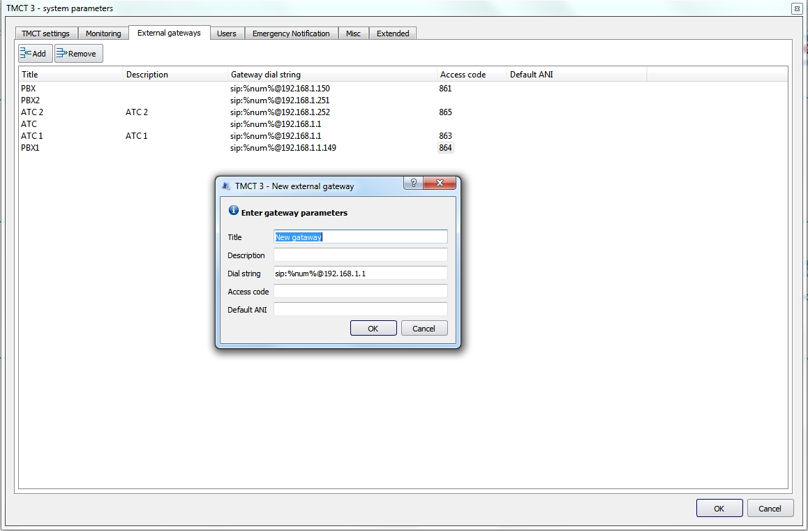
Figure 9 − System settings, tab «External gateways»
Field «Title» – the name of gateway shown on the button in VCDT «Indirect communication».
Field «Description» – description of the gateway.
Field «Dial string» – address of output to the gateway, it is indicated in SIP URI format. Macro "%num%" during dial to gateway is changed to a selected user number.

URI – uniform recourse identifier.

URI = <SCHEMA>:[<ADDR>@]<HOST>[:PORT]

where:

SCHEMA is addressing scheme (SIP or TEL);
ADDR is address;
HOSTis IP address or DNS name;
PORT isIP port (5060).

For example: sip:bloggs@212.123.1.213
sip:10@192.168.1.10

The field «Access code» is an individual three-digit code to access the external gateway. Dialing this code with the help of the button «CODE» on the dialer makes it possible to access a line from any VCDT without specifying the gateway availability in the Connections editor (see item 5.2.2 «SIP routes» of this Manual).

The field «Default ANI» - if ANI is not specified in the connection editor, in order to work correctly with the line, you can take ANI specified in the field «Default ANI».

Any of the gateway parameters («Title», «Description» or «Gateway dial string») can be changed. Double click mouse to activate the field in the line with the name of the parameter you want to change and enter the required information, see Figure 10.

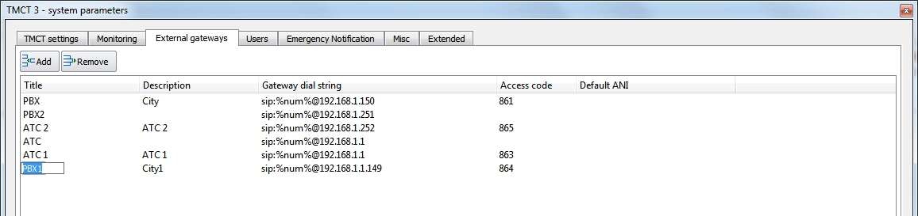
Figure 10 − Tab «External gateways», edit parameter

3.1.4 Users Setting

Tab «Users», available for Administrator only, is intended to form a list of users in IMS.

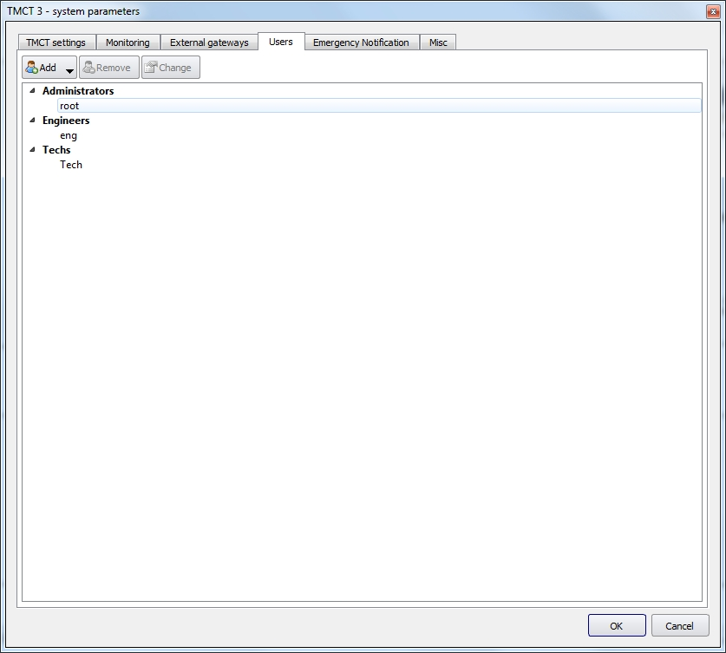
Figure 11 − System settings, tab «Users»

To add a new user, press button «Add».

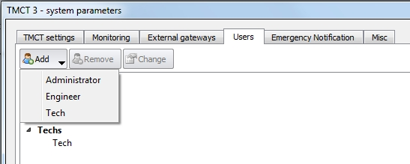
Figure 12 − Selection of user to be added
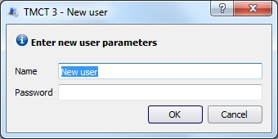
Figure 13 − Tab «Users», adding of new user

In the opened window specify new user name and password.

To change the user data, select a required line and press button «Change». Toolbar «User configuration» will be opened in the right part of the tab.

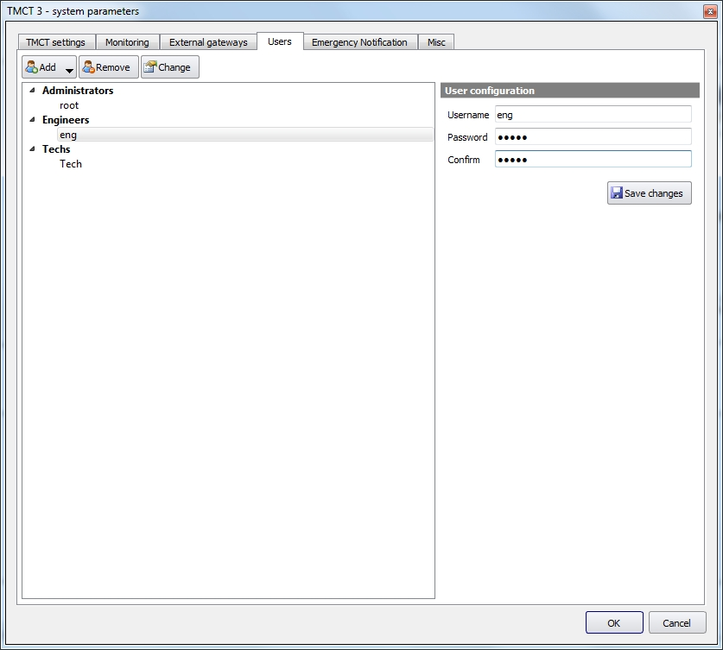
Figure 14 − Tab «Users», changing of user «Engineer» parameters

Upon making the required changes, press button «Save changes».

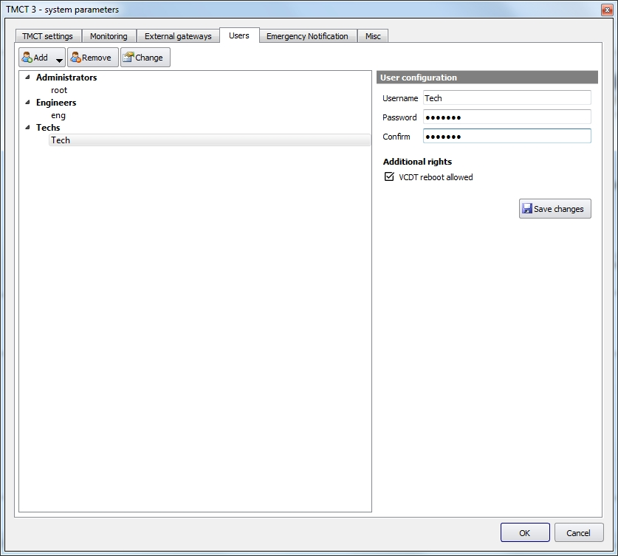
Figure 15 − Tab «Users», access level «Technician»
Each user has additional rights. When user «Technician» is selected, check box «VCDT reboot allowed» becomes available.

In case check box «VCDT reboot allowed» is active, when a system object is selected, reboot of VCDT graphic user interface, VCDT system service or controller module becomes available (see item 12 «Remote VCDT control» of this Manual).

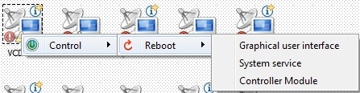
Figure 16 − Additional rights of user «Technician»

3.1.5 Changing the color scheme
The graphical interface of VCDT/DPC supports several color schemes. This setting allows you to select the default color scheme for all VCDTs, see Figure 17.
Personal scheme for a specific VCDT can be selected in the Main settings of VCDT configuration editor, see item 5.1.2.4 «Miscellaneous» of this Manual. Personal color scheme has a higher priority than the default color scheme.

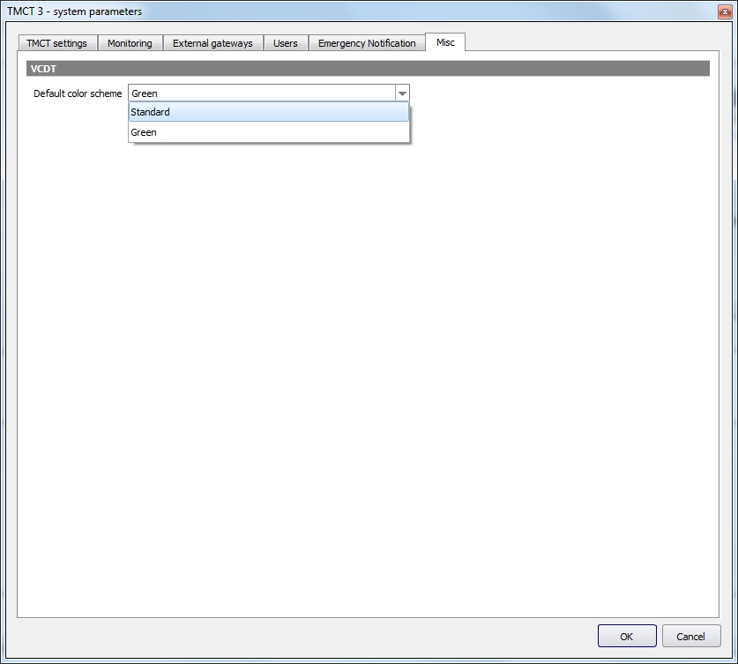
Figure 17 − Selecting the default color scheme

3.1.6 Extended
Settings on the tab «Extended» define the access to functions in IME interface. The list of functions divided by sections is presented in Figure 18.

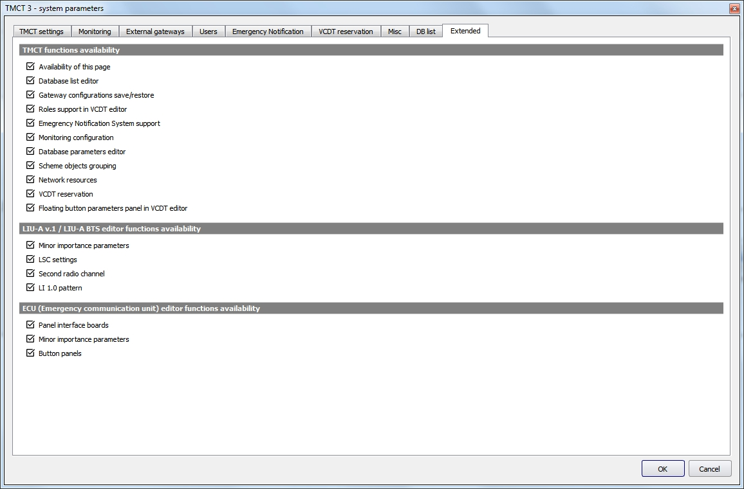
Figure 18 − Tab «Extended»
Use flags to control the presence/absence of access to functions in the appropriate sections.

3.1.7 DB List
The tab «DB List» displays the list of data bases that are available for selection in the window «Authorization» (see item 2 «Getting Started» of this Manual).

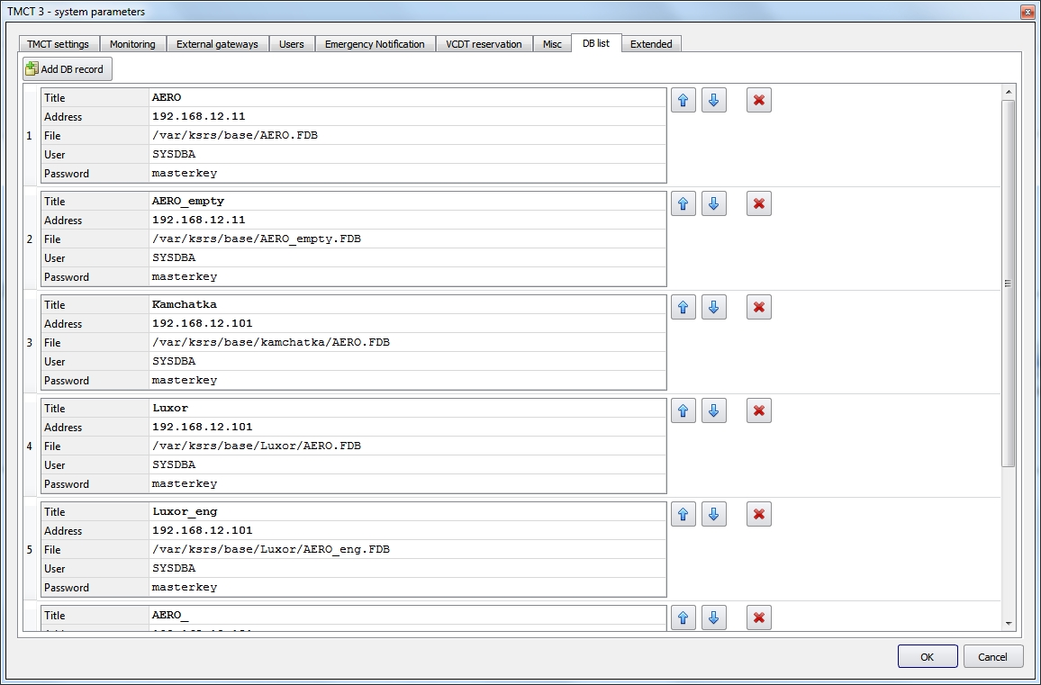
Figure 19 − Tab «DB list»
You can add a new DB to the list or delete the existing DB, edit parameters of the selected DB, change the position of DB in the list.

- add a new DB to the list.

- change a DB position in the list.

- delete a DB from the list.

The following parameters shall be specified for each DB: DB title, DB server address, the location of DB file, the user’s name and the password. The parameters are entered manually.

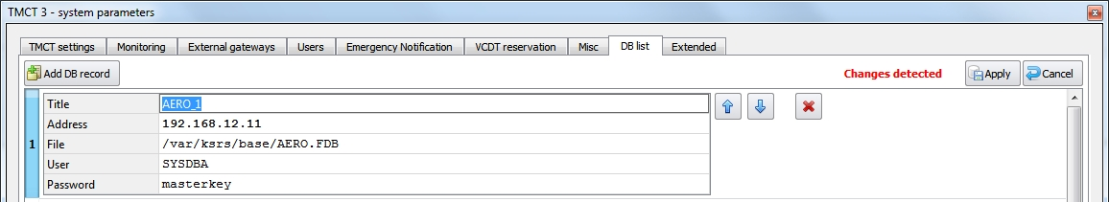
Figure 20 − DB parameters editing
Any of the abovementioned parameters may be changed if necessary. To do this, place the cursor in the desired line, the text will be highlighted in «blue» color, and then enter the changes.
When you make any changes, the buttons «Apply» and «Cancel» will appear at the top of the tab, see Figure 20. Press the appropriate button.

3.1.8 VCDT reservation
The description of VCDT reservation functions can be found in item 5.14 «Terminal reserve mode», «VCDT Operator’s Manual. ЦИВР.00530-01 34 01».

The screenshot of «VCDT Reservation» tab is given in Figure 22.

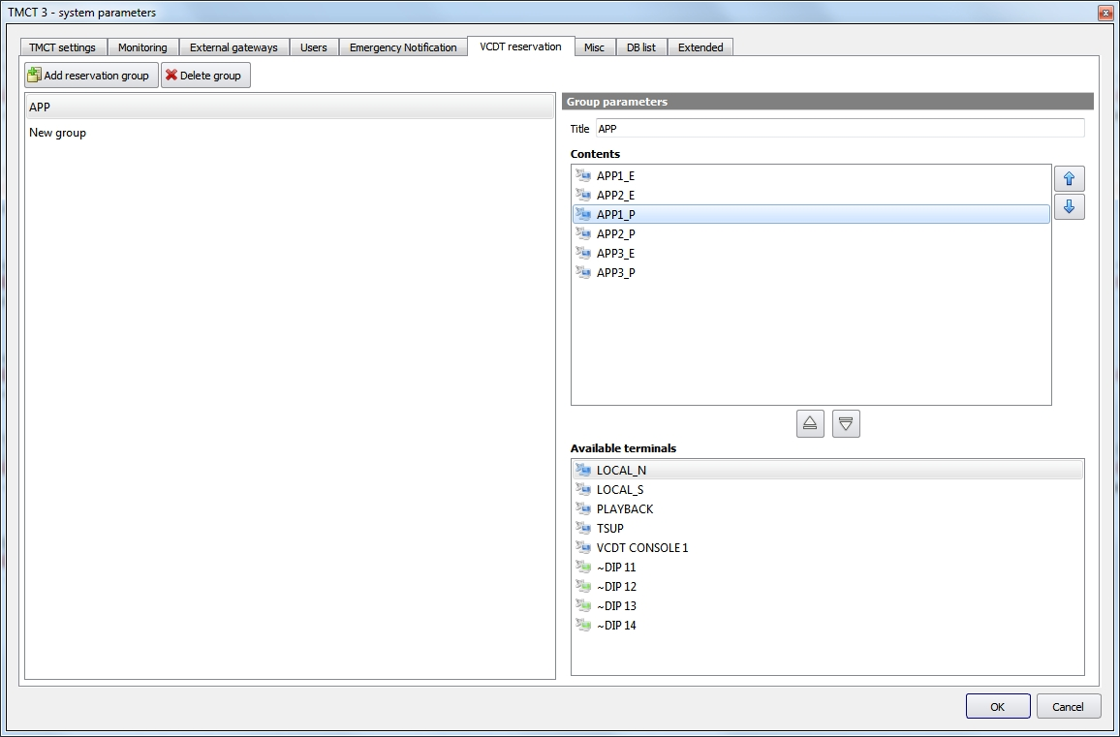
Figure 21 − «VCDT Reservation» tab
In the tab on the left there is a List of reservation groups, on the right there is a Panel of «Group parameters» and a List of «Available terminals».
In order to create a reservation group, press the button «Add reservation group». Enter the name of the group in the field «Title» on the Panel «Group parameters», the default value is «New group». Add reservation terminals to the list «Contents» from the list «Available terminals». Control the contents of the group using buttons to add/delete terminals to/from the reservation group. Set the priority of terminals in the reservation group using the corresponding buttons.

- add a reservation group to the list.

- delete a reservation group from the list.

- increase the terminal priority in the reservation group;
 - decrease the terminal priority in the reservation group.

- add a terminal to the reservation group;
- delete a terminal from the reservation group.

3.2 Network resources
Upon selection of the «Network resources» menu item, a window will be opened for available network resources configuring. By means of these resources you give the network subscribers description to which outgoing calls can be made or from which incoming calls can be made. For some system objects the resource can be created automatically (for example: VCDT, DCP, ENT, SIP-phone or LIU-A).
The window consists of a list of system objects, an object's resources displaying panel and a resource editing panel, see Figure 15.

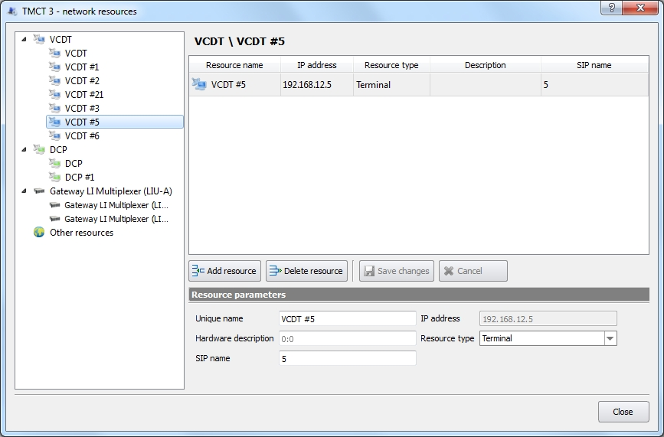
Resource editing panel
System objects list
Selected system objects resources displaying panel
Figure 22 − External view of the «Network resources» window
Resource parameters:

«Unique name» – name of the resource. This is the main parameter that will be used in the system when working with a resource.

«Hardware description» – a description of the resource related to the equipment. For example, if the resource type is «Trunk», then the hardware description 0:1 means: trunk number 0, timeslot in the trunk number 1. If the type of «Board», then the description of 1:2 means a board number 1, the channel number 2.

«SIP name» – SIP protocol contact name. For example, if the full sip address is «sip:98@192.168.1.98», then you need to specify 98 in this field.

«IP address» – the resource IP address. It usually coincides with the object address.

«Resource type» – select the required resource type from the drop-down list:
Terminal – VCDT or DCP type terminals;
SIP-phone – the final equipment, which works according to the sip-protocol;
Trunk – a group of digital channels;
Board – a group of analogue channels;
Agent – agent on the registrar.

While resources configuration, you can do the following:

– add resource to the list;

– remove a resource from the list;

– save resource parameter changes;

– cancel the last resource editing action.

3.3 Database configuration
Upon selection the «Database configuration» menu item, a window with adjustable database parameters will be opened. The window consists of a list of parameters and a panel for editing their values, see Figure 23.

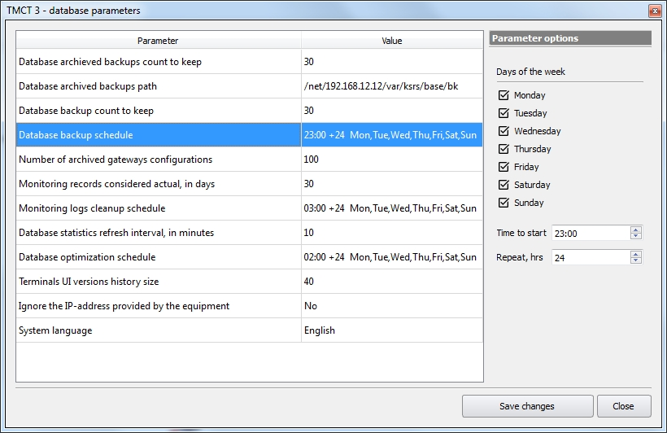
Parameter editing panel
Parameters list
Figure 23 − External view of the «Database Parameters» window
The following types of parameters are used for database operation:

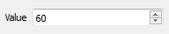 | Numeric value
 | String value
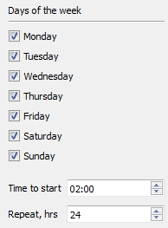 | Schedule. Parameters such as days of week, start time and repeat time in hours are specified.
Description of the parameters:

«Database archived backups count to keep» – as a result of automatic backups creation, the specified number of archived files will remain, the old files will be deleted.

«Database archived backups path» – after creation the archive files will be copied using the specified path.

«Database backup count to keep» – as a result of automatic backups creation, the specified number of backup files will remain, the old files will be deleted.

«Database backup schedule» – adjust the schedule of automatic DB backup’s creation.

«Number of archived gateways configurations» – as a result of creating of archived gateway configurations the specified number of archived files will remain; if the specified parameter is exceeded, older files will be deleted.
«Monitoring records considered actual, in days» – all records of protocols after a specified number of days will be considered obsolete.

«Monitoring logs cleanup schedule» – configure the schedule for deleting obsolete protocol logs.

«Database statistics refresh interval, in minutes» – specify the time in minutes to update the database statistics. The statistics are displayed in the window «Information: database status», see Figure 234 of this manual.

«Database optimization schedule» – configure the schedule to start optimizing of the internal database structures in this field. It is recommended to perform it regularly, especially after cleaning out the obsolete protocols.

«Terminals UI versions history size» – to reduce the volume of the database, you can limit the number of stored versions of terminal interfaces. The specified number is used for each system terminal (VCDT, DCP). Old versions are deleted.

«Ignore the IP-address provided by the equipment» – if the value is set to «Yes», then for system objects which can be configured automatically (support P7 Protocol), the free IP address will be taken from the range that is set during system objects types configuring (see item 4.1 «System object type adding and editing», «Monitoring system configuring» manual).
If the value is set to «No», the IP address suggested by the equipment will be applied.

«System language» – system language selection. After clicking the button «Save changes» and selecting the menu item «Restart GUI» (see item 16 «Power Supply Control» of this manual), the IME interface and monitoring system data will be displayed in selected language.

4 System Objects

4.1 Creating a System Object
A system object is a piece of equipment, which requires monitoring.

To create a new system object, open the context menu with right mouse button and select the required type of system object (system object types are set in DB), see Figure 24.

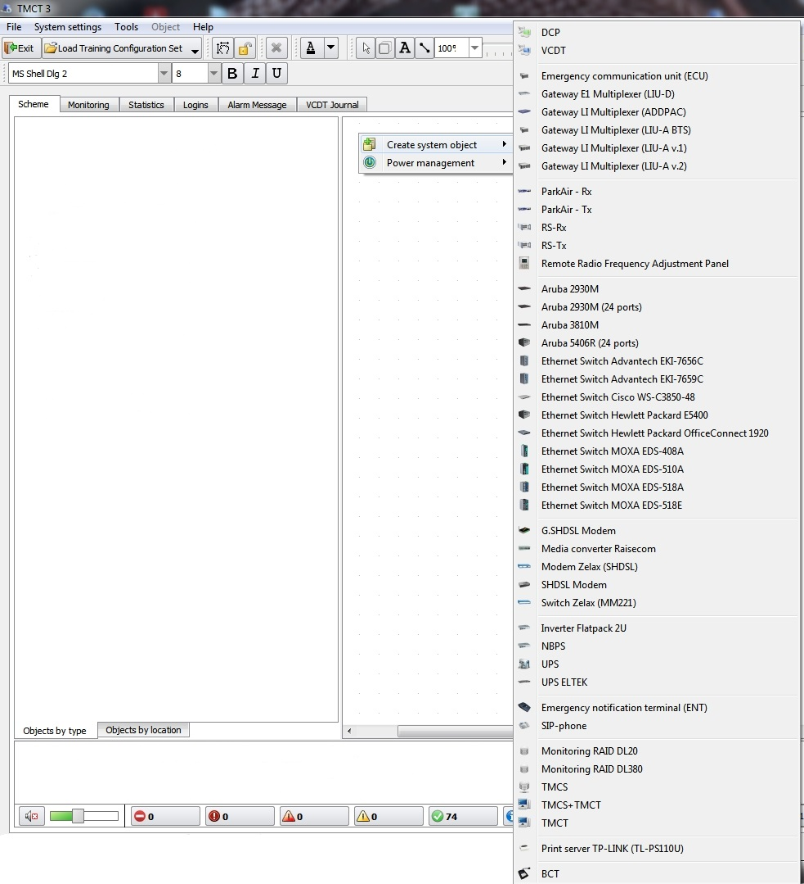
Figure 24 − System object creation

Upon selection of required element the following window appears:

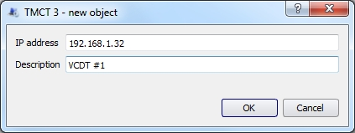
The window of new object adding is similar for all types of system objects.
Figure 25 − Adding a new object

System object address is indicated in field «IP address».

A newly created object will appear as an icon in the System scheme, see Figure 26.

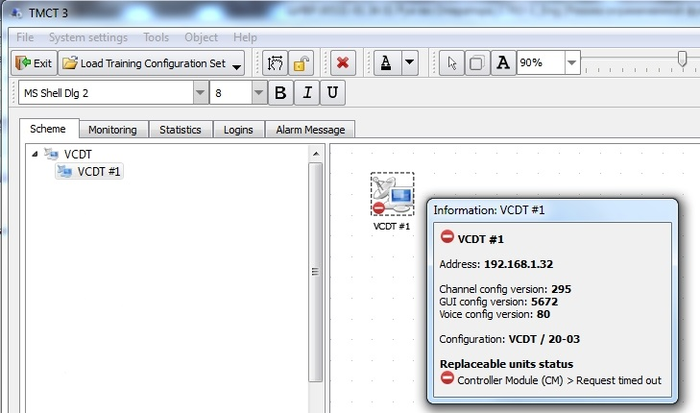
Figure 26 − Created object icon

4.2 System Object Types
VCDT – voice communication digital terminal – is an «operator-system» interface in a part of entry of commands to establish radio and telephone communication connections, enabling of additional functions and communication. It allows to establish voice communication connection, control the connection by enabling additional functions, carry out voice communication, provides visual and audio indication of connection status and stages of its establishing.

DCP – digital communication panel – is a version of VCDT in different equipment configuration.

TMCT – technical monitoring and control terminal – is intended to monitor condition of communication terminals, active network equipment (switches, gateways) and control them during operation.

TMCS – technical monitoring and control (supervision) server. Is a server of continuous monitoring of condition of communication terminals, active network equipment (switches, gateways) and storage of collected data.

TMCS+TMCT – a system object that combines the functionality of the terminal and the technical control server.

Gateway LI multiplexer (LIU-A) – multi-purpose line interface unit analog LIU-A – is intended:
- to control radio sets, connected to it via physical lines or standard voice frequency channels, upon commands transmitted depending on the type of DC or AC signals control line, and to transmit/receive LF signal to/from the radio set;
– to interface VCCS with loudspeaker equipment of air traffic controller communication via 2- and 4-wire physical lines or standard voice frequency channels with DC or AC signaling, or without signaling depending on the line type and type of interacting LSC equipment, and to transmit/receive LF signal to/from communication line. It may act both as individual equipment, intended for communication of only one VCCS subscriber, provided with VCDT, and common equipment, intended for communication of several VCCS subscribers, provided with VCDT.
Gateway LI multiplexer (LIU-A v.2) – multi-purpose line interface unit analog. It is an updated hardware and software platform for LIU-A.

Gateway LI multiplexer (LIU-A BTS) - universal analog unit of BLI-A line interfaces, which is intended for use as a part of the Briefing and Training system (BTS). Unlike BLI-A it does not require the presence of real equipment such as radio sets and simulates the work with this equipment.

Gateway E1 multiplexer (LIU-D) – multi-purpose line interface unit digital. LIU-D is a special-purpose multichannel telephone communication VoIP gateway with standard telephone interfaces. It is intended to interface «VCCS Topaz», in which VoIP protocols are used for voice data transmission, with conventional telephone communication networks and telephone systems via standard telephone interfaces.

Gateway LI multiplexer (ADDPAC) – multifunction VoIP gateway with simultaneous support of both analog voice interfaces and digital ones (E1/T1).

Remote Radio Frequency Adjustment Panel – the panel is used to change the frequency of the radio station, as well as to enable/disable the squelch mode on the radio station. All control of the radio station is carried out via the RS485 interface.

ParkAir – multi-mode digital radio station.

RS – multi-channel stationary radio station Rohde&Schwarz.

Ethernet switch – manageable industrial Ethernet switch with redundancy function.

UPS – uninterruptible power supply – is intended for power supply in case of short-term switching-off of the main power supply source, as well as for protection against existing interference in the mains, maintaining allowable parameters for the main source mains.

Inverter is continuous DC power supply source, based on the rectifier modules.

SHDSL modem is a modem, providing symmetrical duplex data transmission via a pair of copper conductors. It is intended to solve a last mile problem, connect remote segments of local Ethernet network and for connection o Internet.

Monitoring RAID – RAID array of several storage devices to store data being gathered by the Monitoring System.

Media converter – networking device that enables interconnection between networks or network devices with different speeds, operation types, modes and media types.

SIP-phone is a hardware or software telephone, which allows to make phone calls using VoIP technologies.

Emergency notification terminal (ENT) is a specialized terminal used in the Airport's Emergency notification System (ENS) and made in the fixed telephone format. The notification is carried out by transferring of the ENS call to the given terminal, when receiving it, an audio signal is sent to the speaker of the terminal with the simultaneous switch on of the indicating panel.

Emergency communication unit (ECU) is a centralized switch for the emergency communication system intended to provide the operation of the air traffic controller and technical personnel with radio sets and telephone communication facilities in case of complete or partial failure of the main VCCS communication system.

TP_LINK print server is a network device that allows using the connected office equipment (printer, scanner) by all users from a single local network.

BCT – button communication terminal.

4.3 Replaceable units
Each system object is created with a certain set of elements (replaceable units). Each system object type has its own list of possible replaceable units (controller module, headset, speaker, handset, etc.).
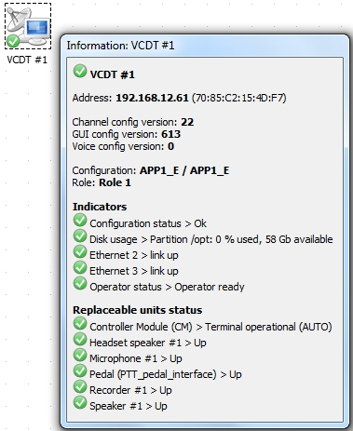
Figure 27 − Set of elements of «VCDT» system object
The list of elements, making up an object, may be changed. To edit the list of elements, open window «Object`s replaceable units» – open the context menu with the right mouse button and select item «Replaceable units».

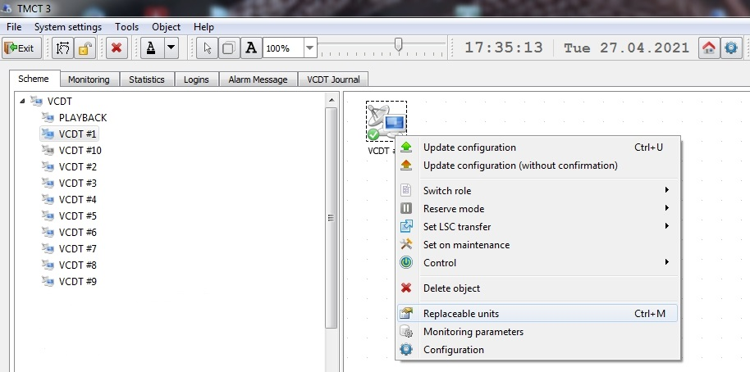
Figure 28 − System object menu
Window «Object`s replaceable units» consists of buttons, located in the upper part of the window, and a list of elements, see Figure 29.

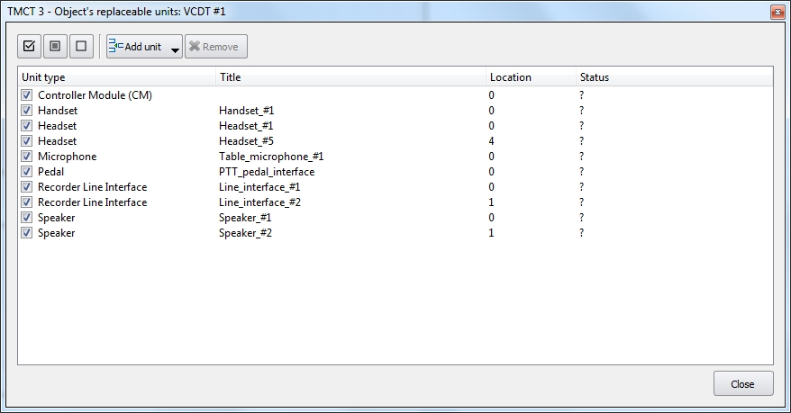
Figure 29 − Object`s replaceable units: VCDT

– add an element to configuration;

– delete an element from configuration.

Buttons for group control of the visibility of replacement elements:

- select all indicators from the list to be displayed in the window «Information»;

- select all indicators from the list to be displayed in the window «Information» if the indicator state is different from «normal» (failure, unknown status, pre-emergency status, etc);
- hide all indicators from the list to be displayed in the window «Information».

The list of elements has the following fields: «Unit type», «Title», «Location» and «Status». Field «Unit type» is editable. By default, this field indicates system names of elements, which if necessary can be changed. Open the window with a mouse double click to edit the name of element, see Figure 30.

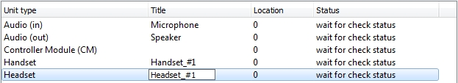
Figure 30 − Editing element name
To add an element to configuration, press button «Add unit» and select a required name from the drop-down list, see Figure 31.

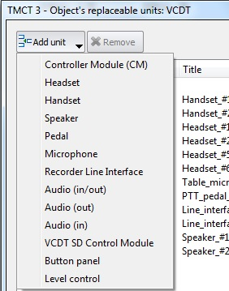
Figure 31 − List of elements available for adding (VCDT)

Peculiarities of «Audio» type elements setting
When setting up object elements of «Audio(in)», «Audio(out)», «Audio(in/out)» types, take into account that the following prefixes to the audio device names are provided to ensure correct indication of speaking devices, connected to the set-up ports:
«~audio-head~» – headset;
«~audio-hand~» – handset;
«~audio-speaker~» – speaker;
«~audio-mic~» – microphone.
«~audio-rec~CODEC» – external recording (used for system object of DCP type).
Thus, if name «~audio-head~Logitech» is assigned to an object element of «Audio(in/out)» type, it means that a headset is connected to port «Logitech».

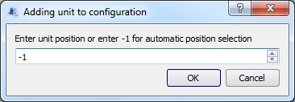
Figure 32 − Adding an element to configuration with position indication
Element numbering starts with «0» value. In case of «–1» value the system assigns a position number to the added element automatically.
When several object elements of «Audio(in)», «Audio(out)», «Audio(in/out)» types are added, start numbering with 0 up to the required number of elements –1. For example, if there are five elements, the numbering will be as follows: 0, 1, 2, 3, 4.
In case external recording is required for a system object of DCP type, start numbering of elements list from «Audio(out)~audio-rec~CODEC». For external recording two ~audio-rec~CODEC elements with appropriate numbers 0 and 1shall be available, see Figure 33.
When editing object’s replaceable unit of DCP type, take into account the following peculiarity: by default software automatic gain control (AGC) is switched off on receiving devices from sound cards). To switch on AGC, it is required to add a special attribute in the device name, for example: ~audio-mic~:AGC:PCH. In this case microphone AGC will be switched on, see Figure 33.

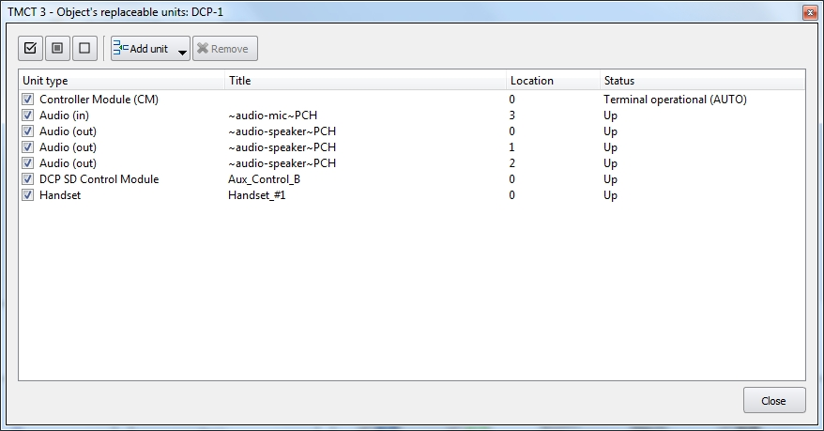
Figure 33 − Object`s replaceable units: DCP
An alternative way to turn on the AGC is to press the «Toggle AGC» button. This button is available for devices of the type «Audio (in)» and «Audio (in/out)». Place the cursor on the line with the name of the unit type you need and click the «Toggle AGC» button, see Figure 34. Pressing the button again disables AGC.

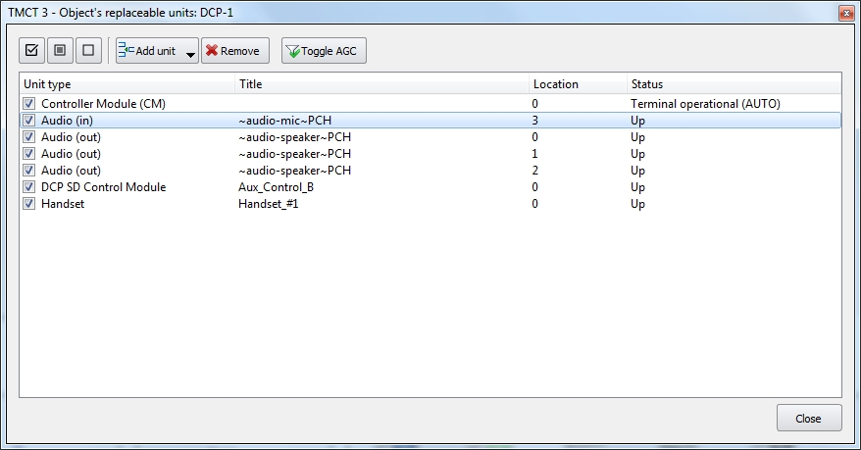
Figure 34 − Object`s replaceable units: DCP, toggle AGC

4.4 Configuring System Object
Each system object has its set of set-up parameters. Configuration editor is intended to set up system objects of VCDT and DCP type. For description of Editor operation see chapter 5 of this Manual.

Common Configuration editor is used to set up system objects of gateway E1 multiplexer, gateway LI multiplexer, Ethernet switch, inverter, UPS, modem, sip-phone type.
Let us take Ethernet switch Advantech EKI-7656С configuring as an example. Open the context menu with right mouse button and select item «Configuration».
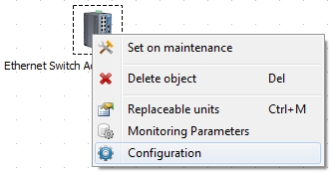
Figure 35 − Ethernet switch, context menu
The configuration editor consists of system object basic parameters and web browser, which is used for access to web interface for system object set-up, see Figure 36. Some system objects may not have a web browser.

System object basic parameters

Field «Type» – type of object in «VCCS Topaz». It is not editable.
Field «System ID» – identifier, given by the system automatically. It is not editable.
Field «Title» – object text description, given when it was created. If necessary, it may be changed.
Field «IP address» – object IP address, if necessary, it may be changed.

– check IP address for availability and request configuration.

MAC addresses table is next to the parameters. MAC address is an actual physical address of the network devices of the system object. A few MAC addresses divided by «,» sign can be indicated in the field «Additional addresses».

Web browser

The following buttons are located in the upper part of web browser window:

– «Go Back» return to the previous page;

– «Go Forward» go to the next page;

– «Reload page» refresh the page;

– zoom buttons. The scale is memorized separately for each IP address and restored when the editor is opened.

– clear cache and reload page;

– «Open in external browser».

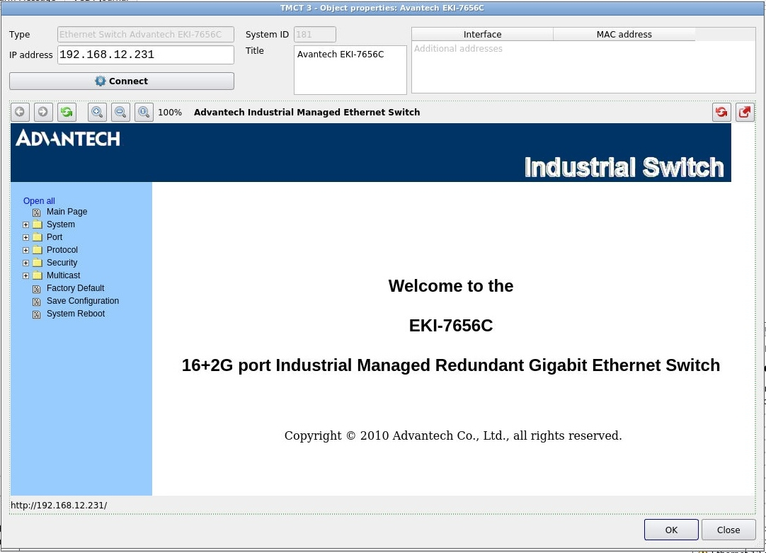
Web browser
System object basic parameters
Figure 36 − Configuration editor, Ethernet Switch Advantech EKI-7656С

4.5 Work with the scheme of the complex
The created system objects form the scheme of the «VCCS Topaz» complex. The scheme is located on a tab with the name «Scheme», see Figure 37.

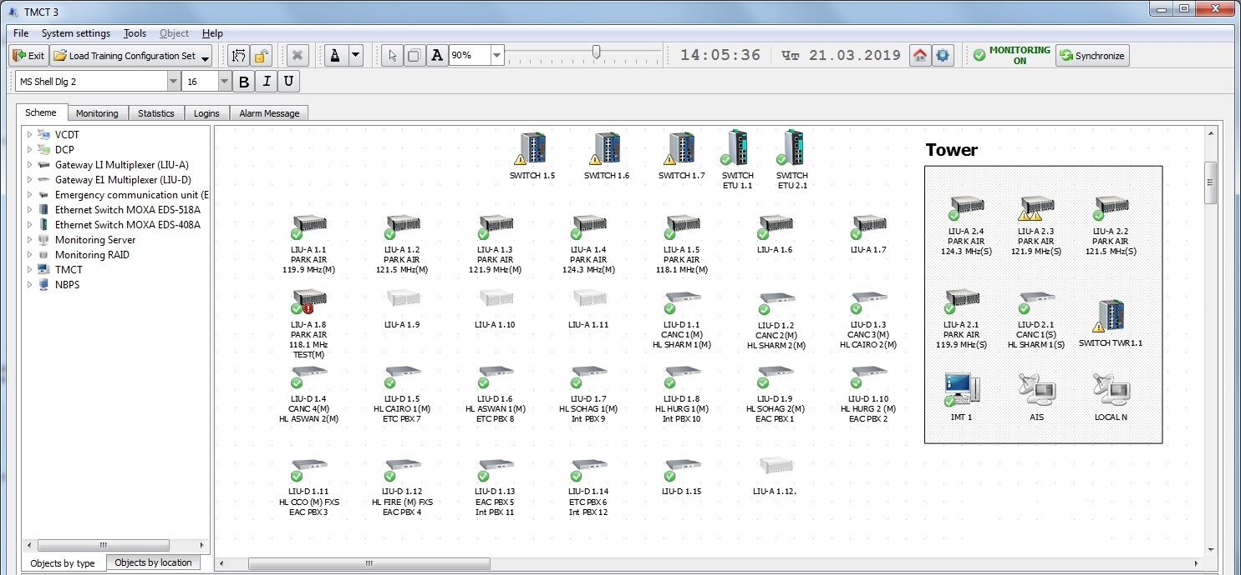
Figure 37 − The tab «Scheme»
All system objects of the complex are displayed in the form of a list, which is located on the left. Depending on the selected tag, system objects can be represented by type or location.

The toolbar contains buttons related to working with the scheme:

– switching over between «mouse» operation modes. If the button is pressed, the system structure is panned behind the free space between objects. If the button is not pressed, several objects can be selected in the system structure area;

– locking of objects movement in the active field area;

– movement of objects on the scheme is allowed;

– delete of selected object from the active field area;

– selection of several objects on the scheme;

– change the scale of displaying the scheme using percentages or by moving the scale bar slider.

Graphical indicators appear on the icon of the system object in the process of work that display various states of both the system object itself and its elements (monitoring system, call transfer, configuration update, editing the parameters of the system object by another user, etc.).

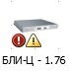
The state of the replacement units and indicators of the system object

«Last-listener of Radio Frequency» – VCDT / DCP is the only terminal on which listening to a radio channel is enabled



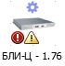
The system object is being edited by
another user

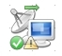
Call transfer is enabled


Configuration update is required

4.5.1 Text adding

The following buttons are used to add and edit text on the scheme:

– text adding.

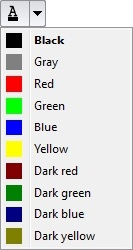 – text color changing.

– change the font, size and style of the text.

Clicking on the button for adding text leads in opening a window with a line where the text is entered, see Figure 38.

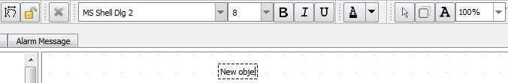
Figure 38 − Text entry window
Further, in the process of work, you can change the color or font of the text. For this purpose, highlight the text and pressing the corresponding buttons.

To delete a text object, call the context menu by means of right mouse button click and select item «Delete object»:

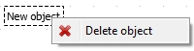
Figure 39 − Text object removal

4.5.2 Logical grouping of objects

– add rectangular borders.

Using the button for adding rectangular borders, it is possible to create rectangular objects for grouping other objects of the scheme according to some attribute, for example: building, room or server room.

 – resizing a rectangle is available when moving of system objects in the scheme is allowed.
 – «Title» is attached to a rectangle, text can be edited as a plain text object (see item 4.5.1 «Text adding» of this manual).
Objects are added and deleted to/from the rectangles by dragging and dropping actions. Rectangular objects can contain other rectangles. An example of grouping objects is shown in Figure 40.
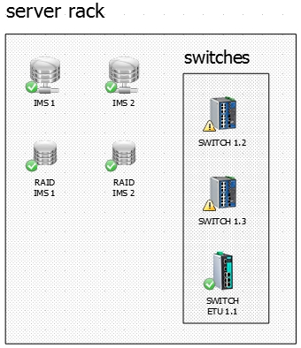
Figure 40 − Example of object grouping

5 Voice Communication Digital Terminal (VCDT)

Configuration editor is used to set up the parameters of system object of VCDT type.

To open the Editor, open the context menu with right mouse button and select item «Configuration».

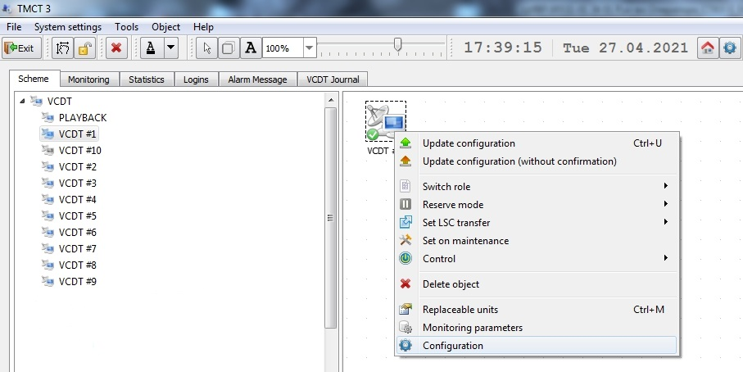
Figure 41 − VCDT system object menu

Configuration editor consist of the following tabs:

– «Main Settings»;

– «Connections»;

– «GUI Editor»;

– «Functions»;

– «Voice Events»;

– «Phonebook».

Each tab has its own set of parameters and buttons, whose description is given below. Overall view of the Editor is shown in Figure 42.

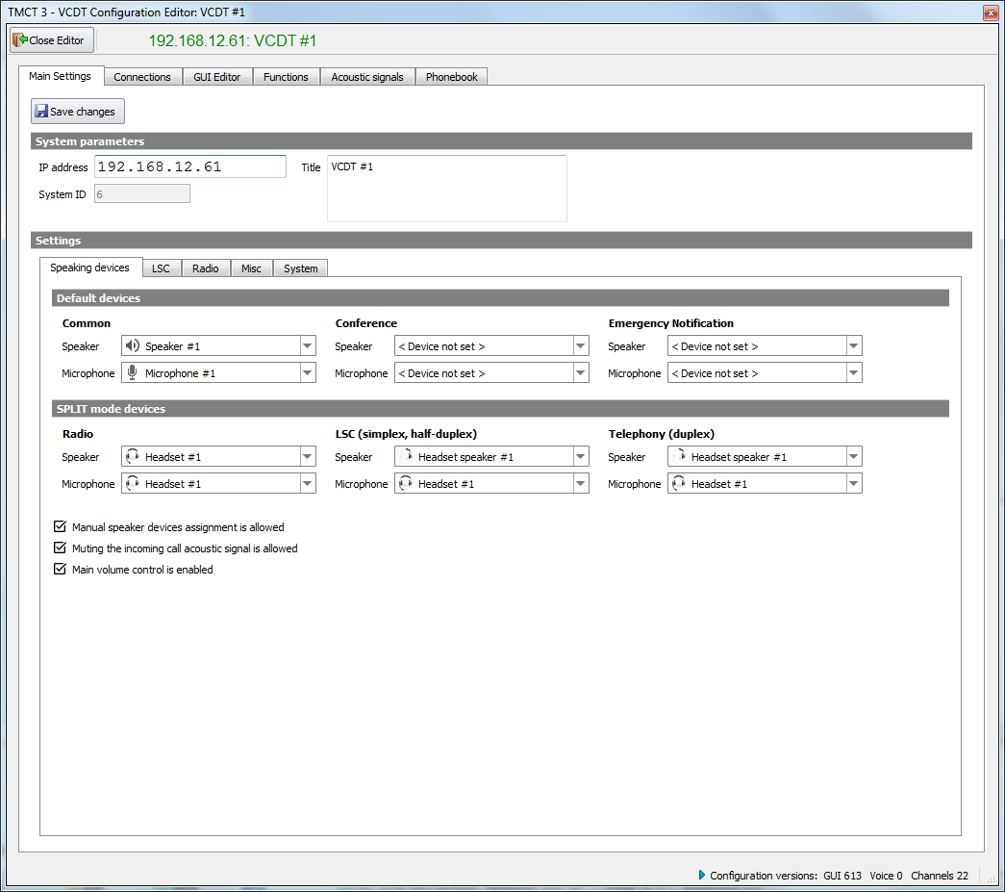
Figure 42 − Overall view of Configuration editor

5.1 Main Settings

The tab is used to setup System parameters, speaking devices (by default, in SPLIT mode), LSC parameters, Radio communication parameters.

– button for saving changes.

– settings have been changed, saving is required.

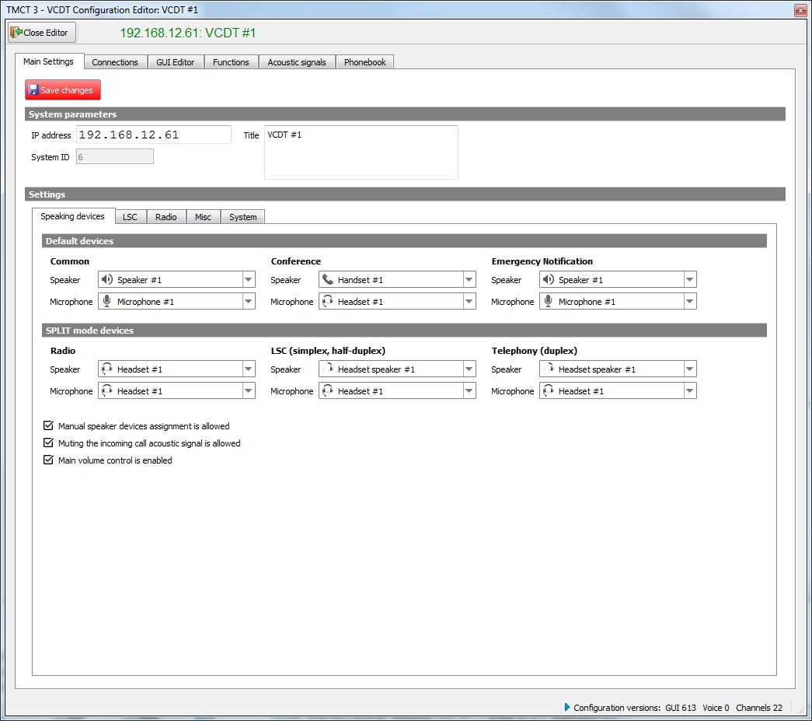
Figure 43 − Configuration editor, tab «Main settings»

5.1.1 System parameters

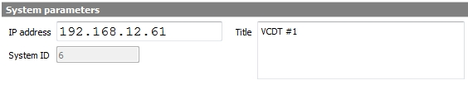
Figure 44 − Tab «Main Settings», System parameters

Field «System ID» – system object identifier, given by the system automatically.

Field «IP address» – system object IP address.

Field «Title» – system object name, indicated in the scheme.

5.1.2 Settings

5.1.2.1 Speaking devices

Speaking devices setting by default and for operation in SPLIT mode is performed on the tab «Speaking devices». SPLIT - the mode of immediate switching over of the VCDT buttons of each type (LSC, Radio, Telephone communication) to specific speaking devices.

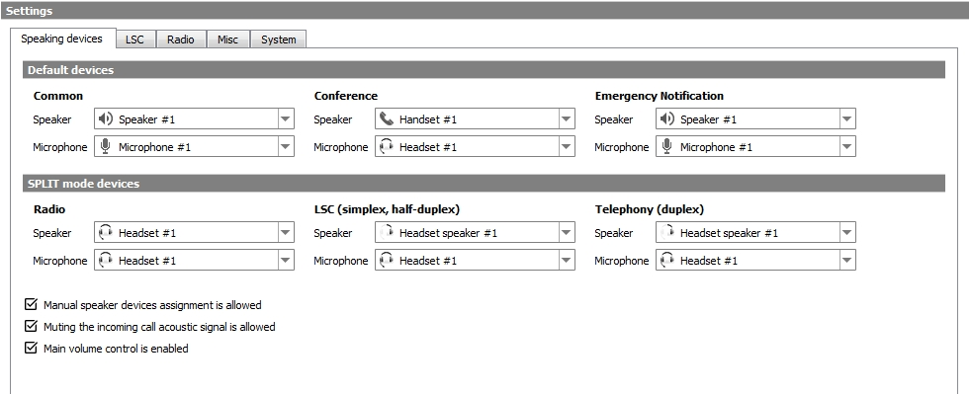
Figure 45 − Tab «Main Settings», Speaking devices
Default devices
«Common» – respective speaking devices will be used in case the devices, assigned to specific buttons, are not available.

«Conference» – in case conference call SD's are not assigned, common default devices will be used in VCDT.

«Emergency Notification» – certain speaking devices can be assigned for emergency notification:
«Speaker» – a device for TNA type terminal, which will be used to playback voice messages, received from TA;
«Microphone» – a device which, will be used to record voice message on TA.

SPLIT mode devices
Speaking devices are assigned for each type of buttons (LSC, Radio, Telephone communication) during operation in SPLIT mode.
Check box «Manual speaker devices assignment is allowed» – setting makes the function of speaking devices buttons reassigning available for VCDT operator on GUI buttons.

Check box «Muting the incoming call acoustic signal is allowed» – if the flag is set, the «Incoming call» acoustic signal on/off button will be available on the VCDT in the SD selection window, see item 5.8 ««Incoming call» acoustic signal control», «VCDT Operator's Manual. ЦИВР.00530-01 34 01».

Check box «Main volume control is enabled» – if the flag is not set, the main volume control and the button for switching communication types will be blocked for the operator on the VCDT, see item 2.2 «Volume control», «VCDT Operator's Manual. ЦИВР.00530-01 34 01».

5.1.2.2 LSC

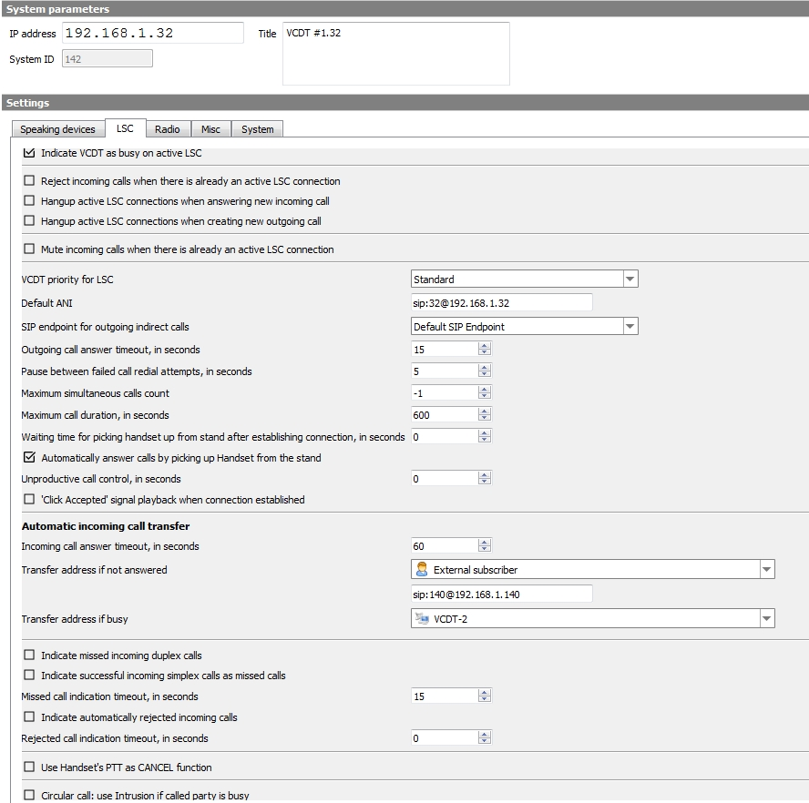
Figure 46 − Tab «Main Settings», LSC setting
«Indicate VCDT as busy on active LSC» – indicate on other terminals that considered VCDT is busy with a LSC communication (DA button on other terminals is orange).

«Reject incoming calls when there is already an active LSC connection» – if the checkmark is set, then regardless of the specified value in the field «Maximum simultaneous calls count», only one call will be processed. When a call arrives with a higher priority than the active one, the active call will be dropped. If the checkmark is not set, then the value specified in the field «Maximum simultaneous calls count» is applied. In this case, when a call with a higher priority arrives, the last call with a lower priority is terminated.

«Hangup active LSC connections when answering new incoming call» – all currently active LSC connections will be automatically terminated when answering a new incoming call.
«Hangup active LSC connections when creating new outgoing call» – all currently active LSC connections will be automatically terminated when creating a new outgoing call.

«Mute incoming calls when there is already an active LSC connection» – If the flag is set, then when busy on the LSC, the «Incoming Call» acoustic signal will not be played when incoming calls are received, i.e. any incoming call notification will be silent. The parameter is available only when the «Indicate VCDT as busy on active LSC» or «Reject incoming calls when there is already an active LSC connection» checkbox is set.

«VCDT priority for LSC» – select the priority value (standart, high or highest) from the drop-down list - this value will be used for outgoing connections. Emergency notification system calls have high priority.

Field «Default ANI» – if ANI is not assigned to a specific button, the value of this field is used. Line format: SIP URI.

«SIP endpoint for outgoing indirect calls» – name of connection, which will be used for outgoing indirect calls (see item 5.2.1 «SIP endpoints» of this Manual).

«Outgoing call answer timeout, seconds» – upon expiry of specified time an unanswered outgoing call will be cancelled.

«Pause between failed call redial attempts, in seconds» – time, upon the expiry of which a recall will be initiated, is set (used during automatic redial).

«Maximum simultaneous calls count» – maximum number of active calls is set («-1» by default unlimited). In case the specified value is exceeded, «Busy» response will be given to the incoming call. It does not affect listening, priority call and simplex modes. Calls, put on hold on this VCDT, are not considered active either.

«Maximum call duration, in seconds» – upon expiry of specified time active connections will be terminated. In case value «0» is set, active connections will never be terminated automatically.

«Waiting time for picking handset up from stand after establishing connection, in seconds» – if, after establishing a connection, the Handset remains on its stand for specified time, the connection will be forcibly interrupted. This function is only applied to those connections whose buttons have assigned the Handset with the lifting detector as a speaking device. The function is disabled when the parameter «0».

Check box «Automatically answer calls by picking up handset from the stand» – if the flag is set, then it will be enough to pick up the Handset from the stand to answer an incoming call.

«Unproductive call control, in seconds» – upon expiry of specified time the connection is automatically terminated in case there is no voice signal in the line. In case value «0» is set, active connections will not be terminated automatically when there is no voice signal.

Check box «`Click Accepted` signal playback when connection established» –the signal is given only if the connection is initiated by pressing a screen button.

Check box «Indicate missed incoming duplex calls» – unanswered incoming duplex calls will be displayed on the appropriate button in violet:

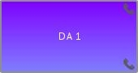

Check box «Indicate successful incoming simplex calls as missed calls» – completed incoming simplex calls will be displayed as missed incoming duplex calls (appropriate violet button).

«Missed call indication timeout, in seconds» – upon expiry of specified time indication of missed call on the button (violet) will be reset. In case value 0 is set, indication is reset with button «CANCEL» only. Indication is also reset by incoming call by using this button.

Check box «Indicate automatically rejected incoming calls». Automatically rejected incoming calls – calls that were rejected without the participation of the operator, for example, when such functions as «Reject incoming calls when there is already an active LSC connection», «Reject incoming LSC calls when PTT is active» are active.

«Rejected call indication timeout, in seconds» – set in seconds, after the specified time, the missed call indication on the button (violet) will be reset. If value «0», indication can be cancelled only by «CANCEL» button or by outgoing call.

Check box «Use handset`s PTT button as CANCEL function» – pressing of handset PTT will be equal to pressing screen button «CANCEL».

Check box «Circular call: use PRIORITY (INTRUSION) call if called party is busy» – when the check box is selected, circular calls will be made in mode Intrusion.

5.1.2.2.1 Automatic incoming call transfer

«Incoming call answer timeout, in seconds» – upon expiry of specified time an unanswered incoming call will be cancelled.

«Transfer address if not answered» – address, to which the call will be transferred, in case of reply absence from called subscriber. The address is selected from the drop-down list. If the desired address is not available in the list, select the value «External subscriber» and enter the address manually in the field that appears, see Figure 46. Line format: SIP URI.

«Transfer address if busy» – in case the subscriber is busy over LSC, or during transmission via RS, an address, to which the call will be transferred, is indicated. The address is selected from the drop-down list. If the desired address is not available in the list, select the value «External subscriber» and enter the address manually in the field that appears. Line format: SIP URI.
At that check box «Indicate VCDT as busy on active TX» shall be selected, see Figure 47.

5.1.2.3 Radio communication

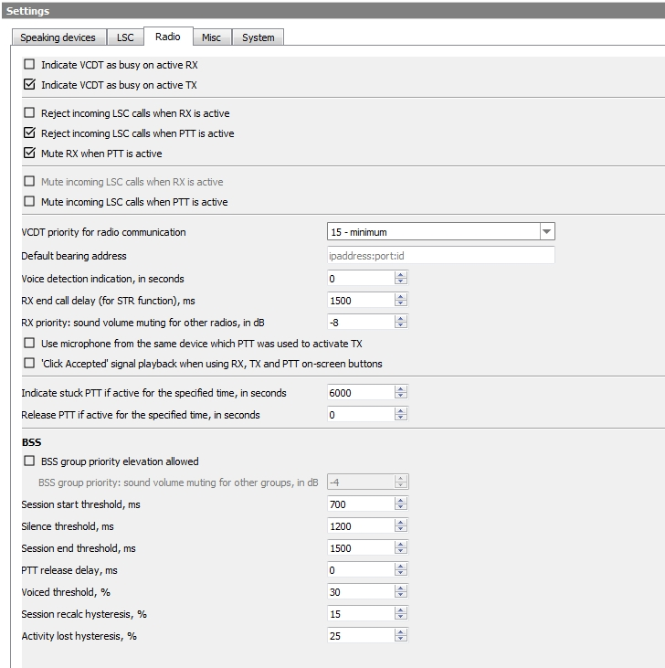
Figure 47 − Tab «Main Settings», Radio communication setting

Active reception – button Rx is green.

Check box «Indicate VCDT as busy on active RX» – display on other terminals, that this VCDT is engaged in radio communication (button DA on other terminals is orange with a red frame).

Active transmission – buttons Tx and PTT are green.

Check box «Indicate VCDT as busy on active TX» – display on other terminals, that this VCDT is engaged in radio communication (button DA on other terminals is orange with a red frame). In case the check box is selected, all incoming calls are displayed, at that ringing tone signal and automatic answer function are switched off.

Check box «Reject incoming LSC calls when RX is active» – all incoming calls will be rejected. When the lock flag is set, the corresponding indication is automatically activated.

Check box «Reject incoming LSC calls when PTT is active» – all incoming calls will be rejected. When the lock flag is set, the corresponding indication is automatically activated.

Check box «Mute RX when PTT is active» – parameter has three modes:
– checked. Block RX of all Radios;
– partially checked. Block RX only for the Radio, which TX is used at the moment;
– unchecked. Don`t block any RX.

«Mute incoming LSC calls when RX is active» – If the flag is set, the «Incoming Call» acoustic signal will not be played when incoming calls are received and any RX is active. The parameter is available only if the «Indicate VCDT as busy on active RX» flag is set.

«Mute incoming LSC calls when PTT is active» – If the flag is set, the «Incoming Call» acoustic signal will not be played when incoming calls are received and any PTT is active. The parameter is available only if the «Indicate VCDT as busy on active TX», «Reject incoming LSC calls when RX is active» or «Reject incoming LSC calls when PTT is active» flag is set.

«VCDT priority for radio communication» – the value of priority is selected from the drop-down list (from 0 to 15, 0 – maximum, 15 – minimum). The parameter is used when the users do not have their own set-up value of PTT priority to establish communication via Radio button (see description of field «PTT priority»).

«Default bearing address» – the terminal will send messages on frequency and status of used radio set PTT to the indicated address. The address of external bearing messages reception system is specified in the following format:
<IPaddress>:<Port>:<ID>, ID parameter (direction finding identifier) is not mandatory.
The parameter will be used only for those Radio buttons, whose own bearing address is not set up.

«Voice detection indication, in seconds» – time, during which buttons Rx and Tx will continue to display availability of voice (yellow blinking) after detector switching off.

«RX end call delay (for STR function), ms» – if there is no voice at the reception within the specified time (the voice detector doesn’t re-activate), the message is considered completed. The parameter is used to fine-tune the division of voice on reception to complete sentences. The parameter is set in milliseconds, the default value is 1500 ms.

«RX priority: sound volume muting for other radios, in dB» – the specified value will be added to the current volume level of non-priority RS at the moment voice appears in RS, whose parameter «Reception priority» is active. By default the value is equal to «–4».

Check box «Use microphone from the same device which PTT was used to activate TX» – if the check box is selected, the SD, used as a microphone for button Tx, will be changed promptly depending on the pressed mechanical PTT. In case transmission has been activated with PTT «Desk microphone», speak into the desk microphone, with PTT «Headset» – speak into the headset microphone.
At that SD, set for transmission, is ignored (see «VCDT Operator's Manual. ЦИВР.00531-01 34 01», item 5.1 «Selection of speaking device and volume control» or item 5.3.3 «Radio button properties» of this Manual).
In case the check box is not selected, the device, set in Radio button properties, is always used as a microphone regardless of which mechanical PTT was used to activate transmission.
This option is used only when several PTT's are assigned to Radio button at the same time.

Check box «`Click Accepted` signal playback when using RX, TX and PTT on-screen buttons» – the signal is given only if the connection is initiated by pressing screen buttons Rx, Tx and PTT.

«Indicate stuck PTT if active for specified time, in seconds» – if PTT is held more than the specified time, the warning sound will be played back along with the red border on the PTT button. If set to «0», this function will be turned off.

«Release PTT if active for the specified time, in seconds» – if PTT is being held more than the specified time, the warning sound will be played back one time and PTT will be automatically released. If set to «0», this function will be turned off.

Check box «BSS group priority elevation allowed» – if the check box is selected, BSS function is enabled/disabled by long pressing of the button. Priority is switched on/off by short pressing.
If the flag is not set, the method of activating/deactivating the BSS is determined by the parameter «BSS button is activated by pressing and holding» (see item 5.3.3 «Radio button properties» of this Manual).

«BSS group priority: sound volume muting for other groups, in dB» – the indicated value will be added to the current level of reception volume in non-priority BSS groups. By default the value is equal to «–4».

Parameters Session Start Threshold, Silence Threshold, Session End Threshold, PTT Release Delay, Voiced Threshold, Session Recalc Hysteresis, Activity Lost Hysteresis belong to fine BSS function adjustment.

5.1.2.4 Miscellaneous
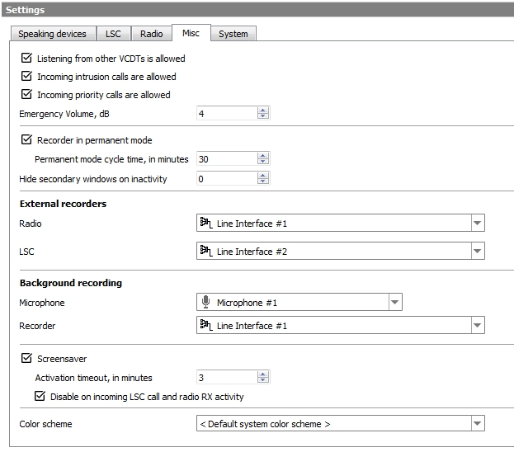
Figure 48 − Tab «Main Settings», Miscellaneous
Check box «Listening from other VCDTs is allowed» – other terminals may listen to this VCDT.

Check box «Incoming intrusion calls are allowed» – intrusion from other terminals is authorized on this VCDT.

Check box «Incoming priority calls are allowed» – accept priority calls at this VCDT.

«Emergency Volume, dB» – when button «Emerg Vol» is held down, volume of all incoming calls in VCDT is increased by the value indicated in the field. By default, the value is +4 dB.

Check box «Recorder in permanent mode» – if the check box is selected, recording process is activated automatically at terminal start and cannot be switched off by the user. By default, cyclic records storage time is 30 minutes. The possible range of values is from 5 to 90 minutes.

«Hide secondary windows on inactivity» – additional function windows (for example, «Dial» or «Incoming calls») will be automatically closed if they are not active for a specified period of time. Time is specified in seconds. In case value «0» is specified, automatic closing is disabled.
Check box «Screensaver» – the function of dimming the monitor screen when VCDT is idle, designed to reduce unproductive wear and tear of the equipment. If this check box is selected, the screensaver will be activated after the specified timeout when idle is detected. The default activation timeout is 10 minutes. The «Screen Saver» is not activated, if there is a dialog on the screen with a request to confirm something.

Check box «Disable on incoming LSC call and radio RX activity» – if this check box is selected, the screensaver will be deactivated when an LSC incoming call is received and on radio RX activity.

«Color scheme» – the graphical interface of VCDT supports several color schemes. This setting allows you to select a personal color scheme for a specific VCDT. A default color scheme can be selected for all VCDT systems, see item 3.1.5 «Changing the color scheme

5.1.2.4.1 External recording interfaces

External recording interfaces setting. Recording line or type of recording – RTP is selected from the drop-down list. Audio streaming is sent in the RTP protocol using G.711 A-law codec. When RTP is selected, field «RTP stream receivers» appears, see Figure 49.
Address is specified in one of two formats:

<Main IP>:<PORT>
or
<Main IP>:<PORT>,<Backup IP>:<PORT>

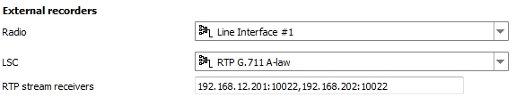

Figure 49 − External recording interfaces (VCDT)
In case a system object of DCP type includes «Audio(out)~audio-rec~CODEC» element type (see item 4.3 «Replaceable units» of this Manual), respective interface names will be displayed in the drop-down list, see Figure 50.
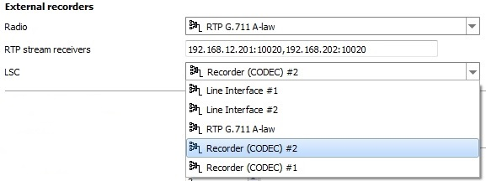

Figure 50 − External recording interfaces (DCP)

5.1.2.4.2 Background recording setup

In the «Microphone» field, select a device from the replaceable units (see item 4.3 of this Manual) that will be used as a background recording source.
Setting up background recording is carried out in the same way as setting up external recording interfaces: recording line or type of recording – RTP is selected from the drop-down list, see Figure 51. Audio streaming is sent in the RTP protocol using G.711 A-law codec. When RTP is selected, field «RTP stream receivers» appears. Address is specified in one of two formats:

<Main IP>:<PORT>
or
<Main IP>:<PORT>,<Backup IP>:<PORT>

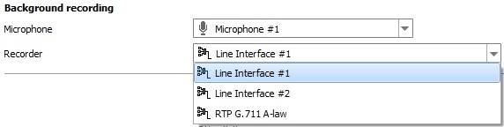
Figure 51 – Background recording setup

5.1.2.5 System settings

On the «System» tab, you can configure monitoring of VCDT and MAC addresses.

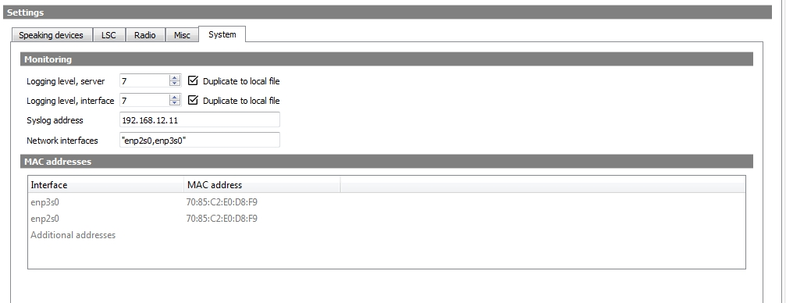
Figure 52 − Tab «Main Settings», System settings
Monitoring

The following parameters apply to setting monitoring for a specific VCDT.

«Logging level, server» – server logging level. Valid value is from 0 to 7.

«Logging level, interface» – graphical interface logging level. Valid value is from 0 to 7.

«Syslog address» – in case duplicating of BTC services operation logging is required, its address and Syslog server port are entered in this field.

Check box «Duplicate to local file» – if the flag is set, then logging (server and/or graphical interface) will be duplicated to a local file. If the flag is set and the «Syslog address» field is empty, logging will be carried out only to a local file.

«Network interfaces» – specifies the names of the network interfaces for monitoring. The default is "enp2s0, enp3s0".

MAC addresses

MAC address is an actual physical address of the network devices of the system object. A few MAC addresses divided by «,» sign can be indicated in the field «Additional addresses». Addresses unavailable for editing are determined automatically.

5.2 Connections

This tab is used to set up such parameters as SIP endpoints, SIP routes and availability of Radiostations.

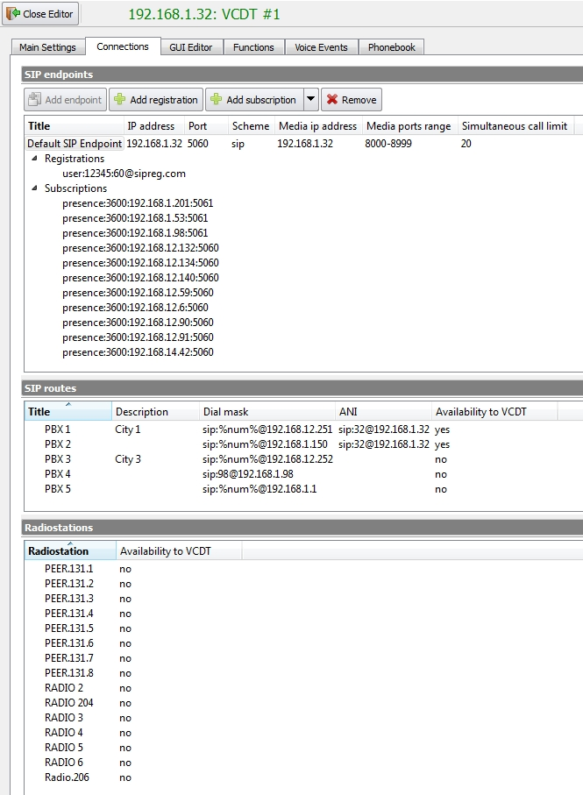
Figure 53 − Configuration editor, tab «Connections»

5.2.1 SIP endpoints

To connect to other terminals and subscribers, VCDT configuration implies one or several SIP endpoints. Today VCDT settings with several SIP connections are not used.
By default, SIP connection «Default SIP Endpoint» is created for VCDT, see Figure 54.

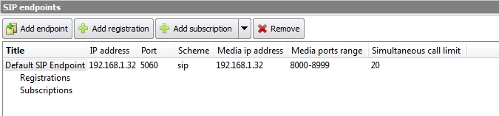
Figure 54 − Sip endpoints «Default SIP Endpoint»
SIP endpoints has the following parameters: IP address, Port, Scheme, Media ip address, Media ports range, and limit number of simultaneous calls.
Field «IP address» – local network address of signalling point. For example, «192.168.1.32:5060». By default the following value is used: «0.0.0.0:5060».
Field «Scheme» – scheme of addressing during outgoing calls. The possible values are: sip or tel. «Sip» is used by default.
Field «Media ip address» – local address, from which RTP sessions shall be created. If the parameter in not determined, a local address, using which signalling exchange is carried out, will be used.
Field «Media ports range» – the range of ports, via which RTP protocol exchange is carried out. The default value is «8000-8999».
Field «Simultaneous call limit» – the parameter indicates the number of outgoing registrations. If the parameter is not determined, the value is taken to be 0.
The above SIP connection parameters may be edited, if necessary.

To get information on the status of other terminals, subscription mechanism is used.
For example, to get information on the status of terminal with IP address, it is necessary to add a subscription by pressing button «Add subscription».

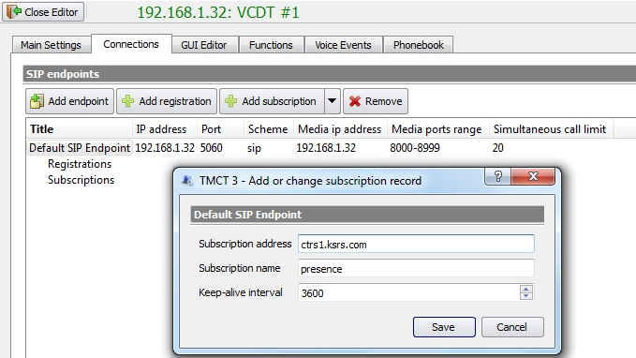
Figure 55 − Configuration editor, tab «Connections», adding a subscription

Field «Subscription address» – specify IP address of the terminal or name of the host, whose status information is required.

Field «Subscription name» – the name of subscription packet, usually it is «presence».

Field «Keep-alive interval» – subscription acknowledgement time, set in seconds. The minimum value is 30 seconds, the maximum value is 3600 seconds.

If it is necessary to add subscriptions for all VCDT's at once or for all LIU-A and LIU-D, press the drop-down menu button:
Drop-down menu button

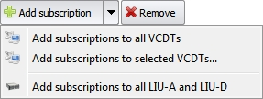
Figure 56 − Configuration editor, tab «Connections», adding subscriptions

If it is necessary to add subscriptions for given VCDT's, select item «Add subscriptions to selected VCDTs».
Window «VCDT selector» will be opened. Using checkboxes select the required VCDT, see Figure 57.

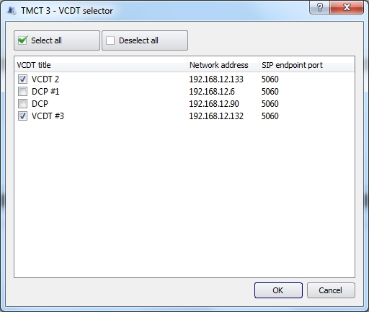
Figure 57 − Configuration editor, tab «Connections», adding subscriptions
for selected VCDTs

To register a terminal SIP endpoint with a gateway, add a registration record by pressing button «Add registration».
«Registration» is a subscription, which informs the registration record that the incoming calls to the indicated address («login») shall be sent to this SIP connection. The number of registration records is unlimited.

Field «Registrar address» – IP address or SIP registrar host name is indicated.
Field «Login» – name of registrar account.
Field «Password – account password.
Field «Keep-alive internal» – registration acknowledgement time, set in seconds. The minimum value is 30 seconds (it is recommended to set 60 seconds, minimum), the maximum value is 3600 seconds.

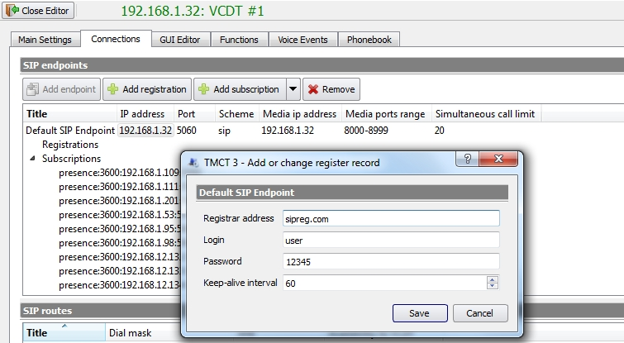
Figure 58 − Configuration editor, tab «Connections», adding registration

Used buttons
– add endpoint.

– add registration.

– add subscription;
– add subscriptions for all system VCDTs;
– add subscriptions for selected system VCDTs;
– add subscriptions for all LIU-A and LIU-D.

– delete SIP endpoint;
– delete registration;
– delete subscription.

5.2.2 SIP routes

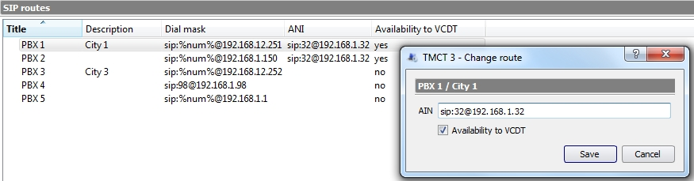
Figure 59 − Configuration editor, tab «Connections Editor», SIР routes

Fields «Title», «Description» and «Dial mask» – information is taken from the main settings, tab «External gateways», see item 3.3 «External gateways setting» of this Manual.
ANI and availability are set for each type of gateway. ANI is indicated in SIP URI format. In case check box «Availability to VCDT» is selected, this route is used in the dial of edited VCDT. The «Change route» window is opened by double mouse click.

5.3 GUI Editor

Tab «GUI Editor» is intended to configure VCDT (DCP) operating interface. Interface consist of LSC buttons, Radio and Radio (BTS) buttons, Alarm buttons.
In case setting up interface configuration the first time, GUI Editor appears in the way showed in Figure 60.

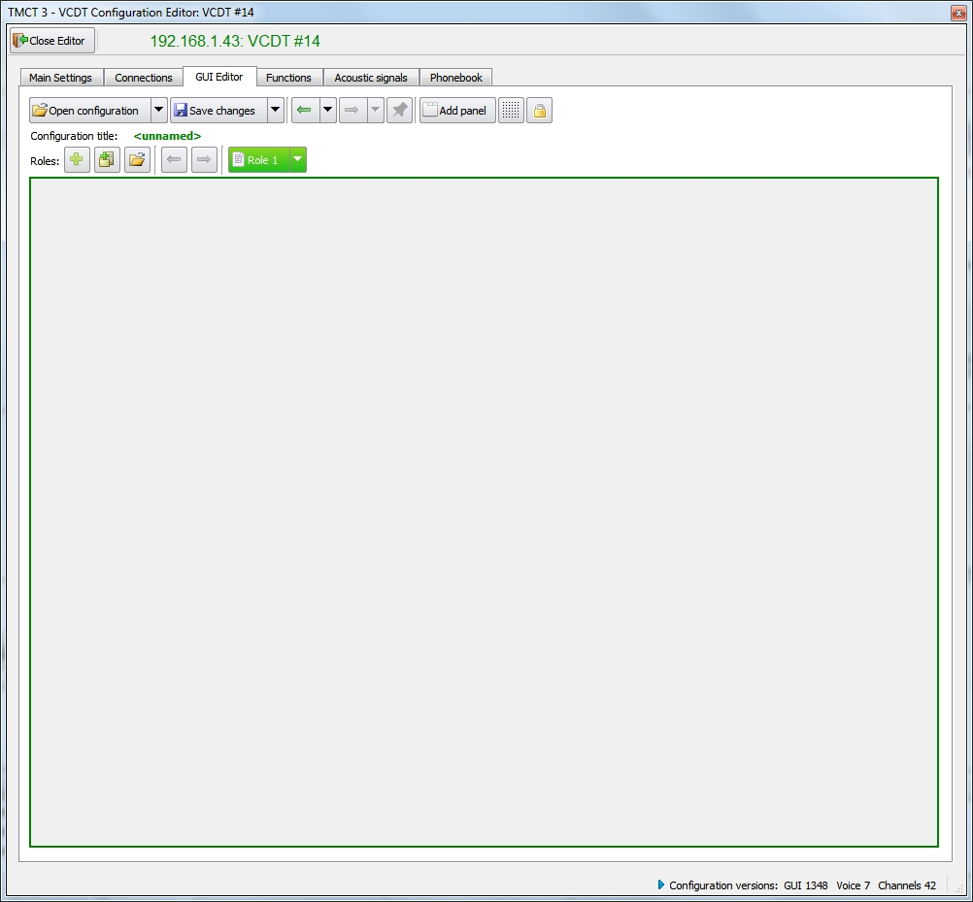
Figure 60 − Tab «GUI Editor», initial layout view when first time opened
The following buttons are located in the upper part of the Editor window:

– open VCDT configuration;
– open previous version of current configuration;
– open other VCDT configuration.

– save changes to interface;
– save configuration under a new name.
– settings have been changed, saving required.
– open the previous version of the configuration;
– open the next version of the configuration;
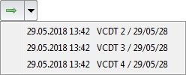 – to select a specific configuration, open the drop-down menu with a list of configurations by pressing the corresponding button. If there are more than 30 configurations available then the «ellipsis» indicator will be present at the end of the menu.

– configuration protection against automatic deletion is
enabled;
– configuration protection against automatic deletion is
disabled.

– add a new panel with tabs.

– align buttons to grid.

– lock movement and change of button size.

– add a role. Role is a VCDT (DCP) interface configuration
with a specific set of functional capabilities.

– add copy of active role.

– add roles from another configuration.

– move role higher in list.

– move role lower in list.

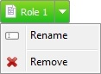 – rename role;
– remove role.

Opening configuration

To open the configuration of the VCDT interface click the button «Open configuration», see Figure 61.

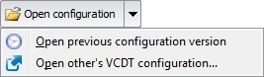
Drop-down menu button
Figure 61 − Tab «GUI Editor», drop-down menu button

In the window that opens, select the required VCDT interface configuration from the list provided, see Figure 62.

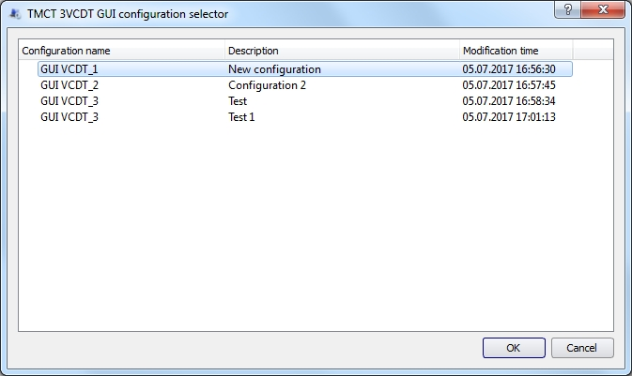
Figure 62 − Selecting VCDT interface configuration

If you need to open a previous version of the current configuration, click on the button to open the drop-down menu and select the menu item «Open previous configuration version». In the window that opens, select the name of VCDT from the list provided, see Figure 63.

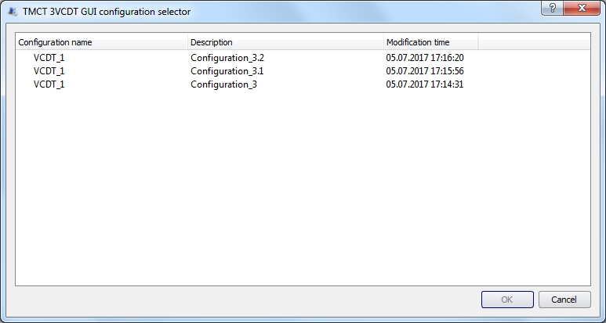
Figure 63 − Selecting previous version of current VCDT configuration

If you need to open the configuration of another VCDT, click on the button to call the drop-down menu, select the menu item «Open other’s VCDT configuration». In the window that opens, select the name of VCDT from the list provided, see Figure 64.

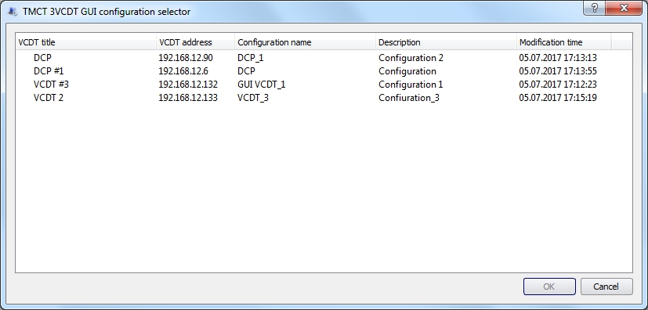
Figure 64 − Selecting other VCDT configuration
Saving configuration

When working with the configuration of the VCDT operating interface, it is possible to save the configuration under a new name. To do this, click the button to call the drop-down menu and select «Save configuration with a new name», see Figure 65.

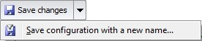
Drop-down menu button
Figure 65 − Tab «GUI Editor», drop-down menu button
In window «VCDT configuration saving» indicate new configuration parameters: configuration title and description, see Figure 66.

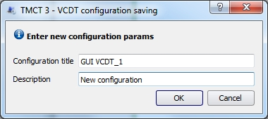
Figure 66 − Tab «GUI Editor», window of configuration saving under new name
Roles

Role allows you to configure multiple interfaces (roles) with a specific set of functional capabilities on a single VCDT (DCP).
At the top of the Editor window there is a Panel with a list of roles, as well as buttons that allow you to perform the following actions, see Figure 67:
– add a role. When you click on the button , the «Role» button will be added to the Panel. The role name is created automatically;
– add copy of active role. When you click on the button , a copy of the selected «Role» will be added to the Panel. The copy has the symbol «*» in the name. The button of the selected (active) role is «green»;

– move role higher or lower in list;

– add roles from another configuration. If you need to add one or more roles from another configuration, then click on the button. In the window that opens, select the desired VCDT interface configuration. After confirmation, a window with a list of roles will open. Select the desired roles and click «OK» to confirm.

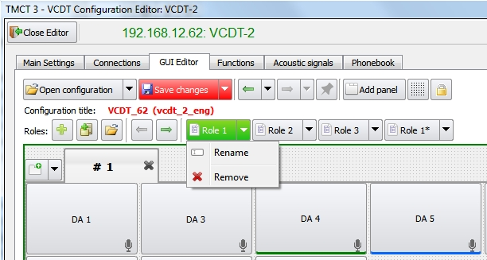
Figure 67 − Panel with a number of roles
When clicking on the button with the name of the role, we proceed to editing the parameters of this role. Each button has a drop-down menu with possible actions on the role – «Rename» or «Remove».
When you select the «Rename» menu item, a window for entering a new role name will open, see Figure 68. Enter the name and click the button OK.

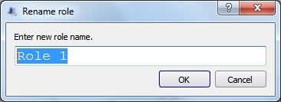
Figure 68 − Rename Role
If you select «Rename» after the clarifying question, the role will be deleted with all the settings.

The role that was opened in the Editor while saving the configuration becomes default VCDT role. In the future, the default role can be changed at VCDT itself to any other role available in the configuration, see item 5.10 «Roles», «VCDT Operator's Manual. ЦИВР.00531-01 34 01».

IME provides means for remote change of role on VCDT. To do this, select the terminal icon where you want to change the role, open the right click menu and select «Switch role», Figure 69. In the context menu, the role icon, which is highlighted in green, is available for changing.
The selected role will be uploaded to the VCDT without confirmation!

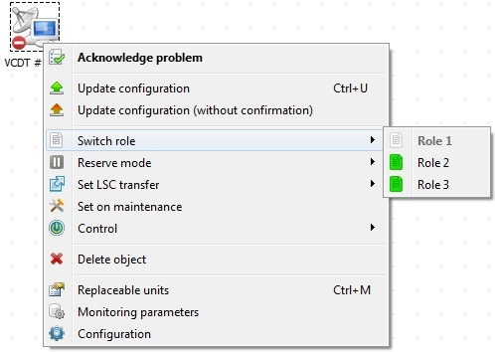
Figure 69 − Remote change of role on VCDT
Adding panels

For further work on configuring VCDT interface, you need to click the button «Add Panel». A panel will appear with editable page and LSC button, these parameters are set by default.

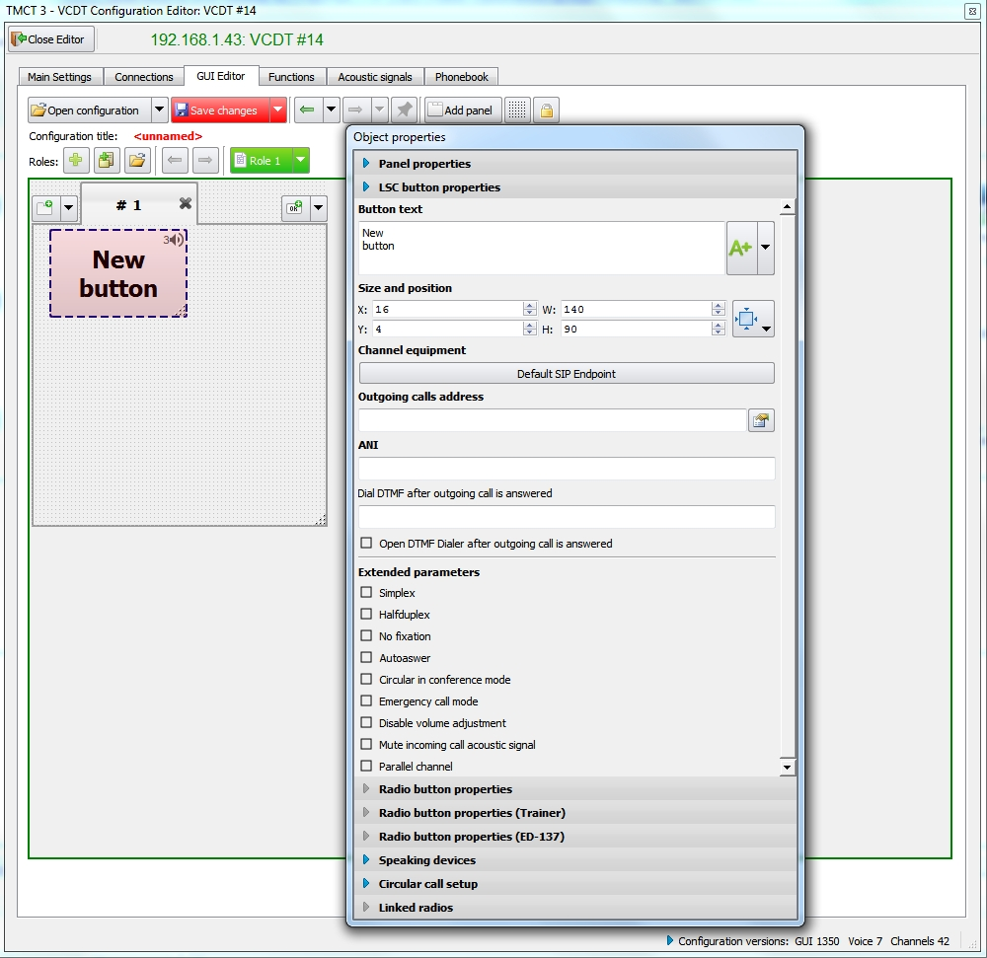
Figure 70 − «GUI Editor» tab, initial configuration of VCDT

By selecting the context menu item «Change size and position» and dragging the lower right corner of the panel, you can resize it, see Figure 71.
The location of the panel can be changed when the cursor «» appears. Panels can be placed horizontally or vertically.
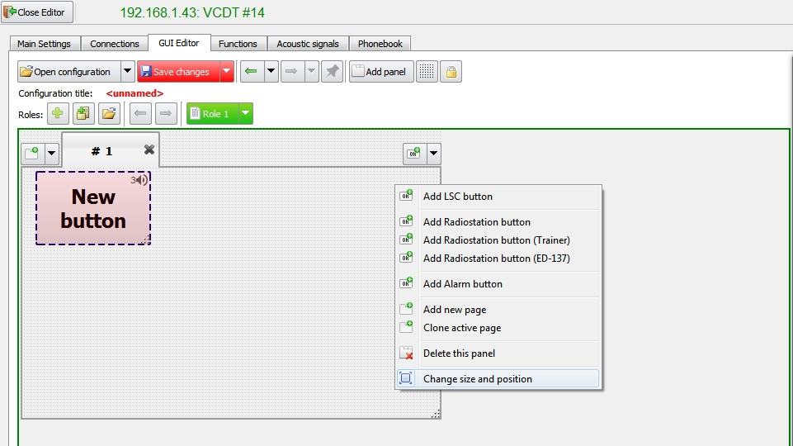
Resizing the panel
Figure 71 − «GUI Editor» tab, panel resizing

5.3.1 Panel properties

This tab displays the name and size of the page (panel), on which LSC buttons or Radio buttons are grouped according to certain criteria (purpose). The page title, its location and size can be changed by entering values ​​in the appropriate fields, see Figure 72.

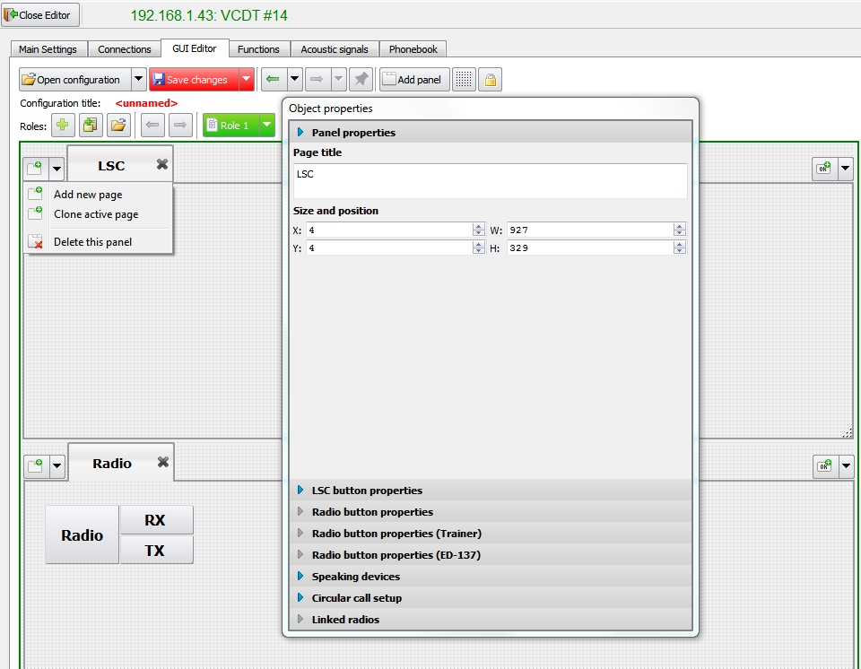
Toolbar
Figure 72 − «GUI Editor» tab, setting page parameters
The arrangement of tabs with the name of the pages on the panel is customizable. By default, tabs are located at the top of the panel. If necessary, this setting can be changed. Double-click on the tab name to call the window «Page properties» and in the field «Tabs position», select anoption «Bottom» from the drop-down list, see Figure 73.

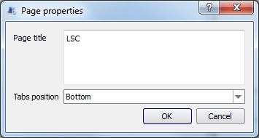
Figure 73 − Selecting the location of tabs
After confirmation, the tabs will be located at the bottom of the panel:

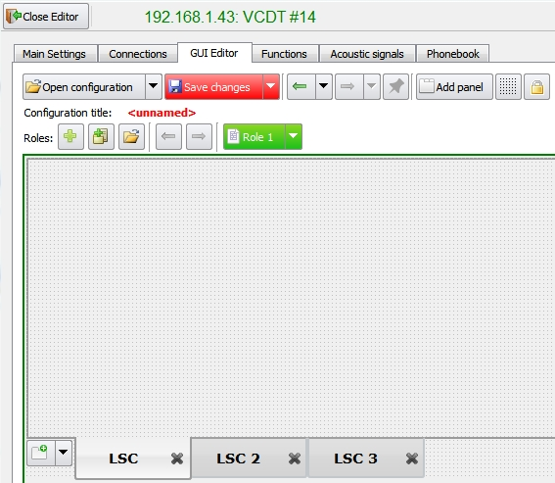
Figure 74 − Layout of tabs in the bottom of the panel
This tab indicates name and size of the page (toolbar), accommodating LSC buttons or Radio buttons, grouped by certain criteria (name).

5.3.2 LSC button properties

LSC button properties are set in the same-name tab, see Figure 75.

Specify the button name. Set button text font and style by pressing button «A+». If it is necessary to reset the font settings to default, select the respective check box, see Figure 75.

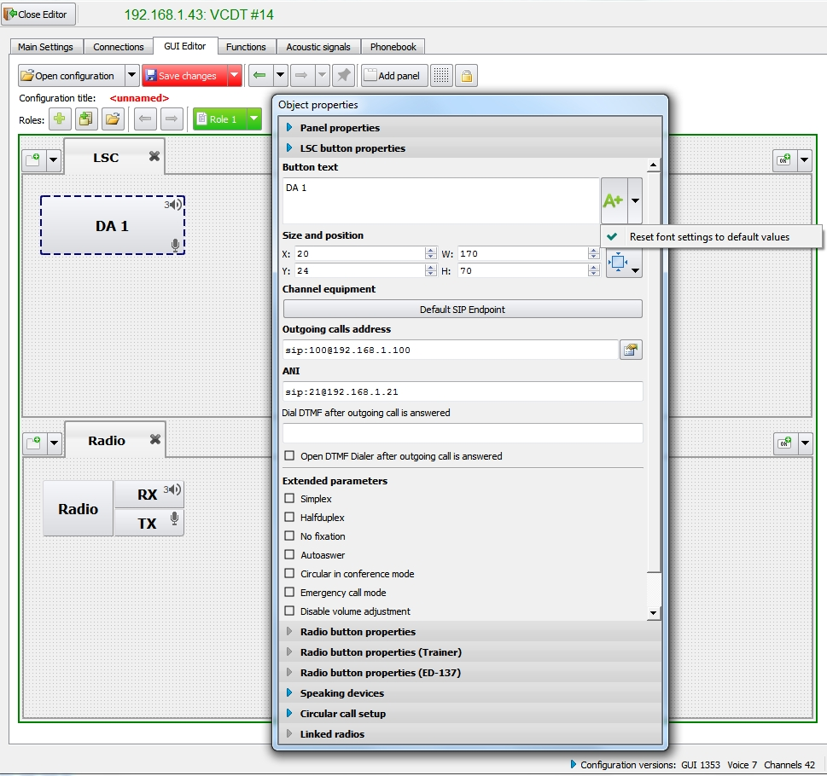
Figure 75 − Configuration editor, «GUI Editor», LSC button properties setting

Button size and position can also be set. Button size may be set manually or selected from the list, see Figure 76.

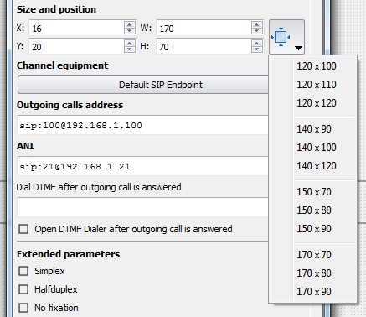
Figure 76 − Selecting LSC button size
The functions of button size and position changing, button copying and deleting are available in the context menu. When the copying function is selected, the button will be copied with all its parameters.

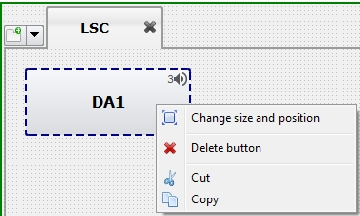
Figure 77 − Mode of LSC button size and position change

To add a new button select the respective menu item «Add LSC button»:

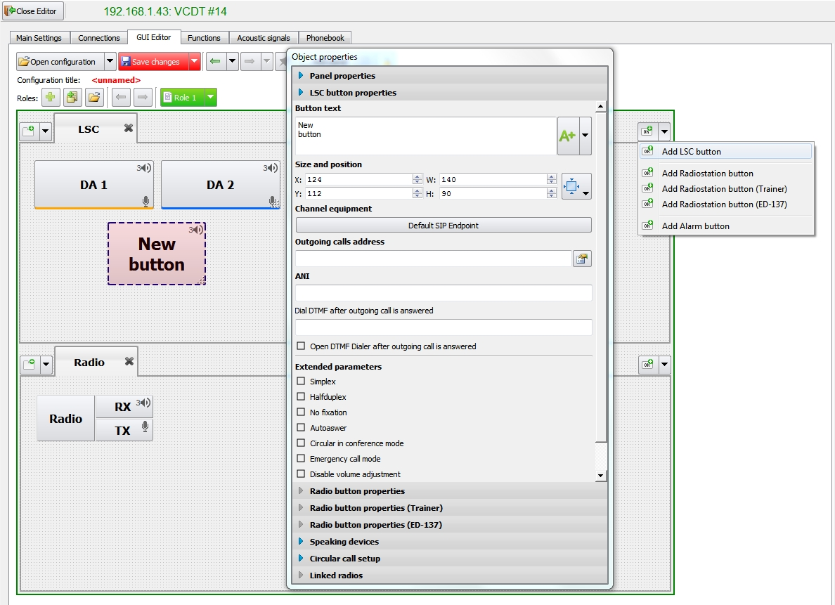
Figure 78 − Configuration editor, tab «GUI Editor», adding LSC button

«Channel equipment» – when the button is pressed, device selection window will be opened. The list of SIP endpoints is taken from the tab «Connections», see item 5.2.1 «SIP endpoints» of this Manual.

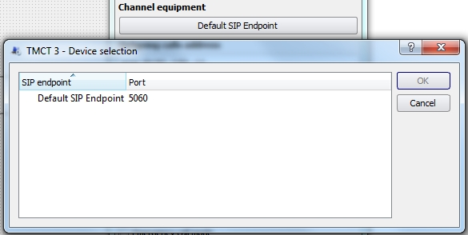
Figure 79 − Tab «GUI Editor», button LSC properties, selecting channel equipment
«Outgoing calls address» – the address of subscriber to be called is indicated in the field. Line format: SIP URI, see Figure 80.

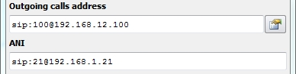
Network resources selection button

Figure 80 − Address of subscriber to be called and ANI
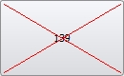 - in case of any inconsistencies in button's configuration (non-existent resource, incorrect address information in the «Outgoing calls address» or «ANI» field, etc.), the «LSC» button is marked with a red cross.

If it is necessary to use LSC button to call a group of subscribers before the incoming call is answered, indicate subscribers addresses through «,» in «Outgoing calls address».
When LSC button is pressed, the subscribers will be called in accordance with the set order. The time interval, after which the call is automatically switched over to the next subscriber, is set in field «Outgoing call answer timeout, seconds» (see item 5.1.2.2 «LSC» of this Manual).
To fill in the «Outgoing calls address» field, you can also use the list of resources by clicking the network resources selection button, see Figure 80. For network resources configuration see item 3.2 of this Manual.
In the window that opens, select a resource from the list of resources of the selected object and click «Add resource to list», see Figure 81.

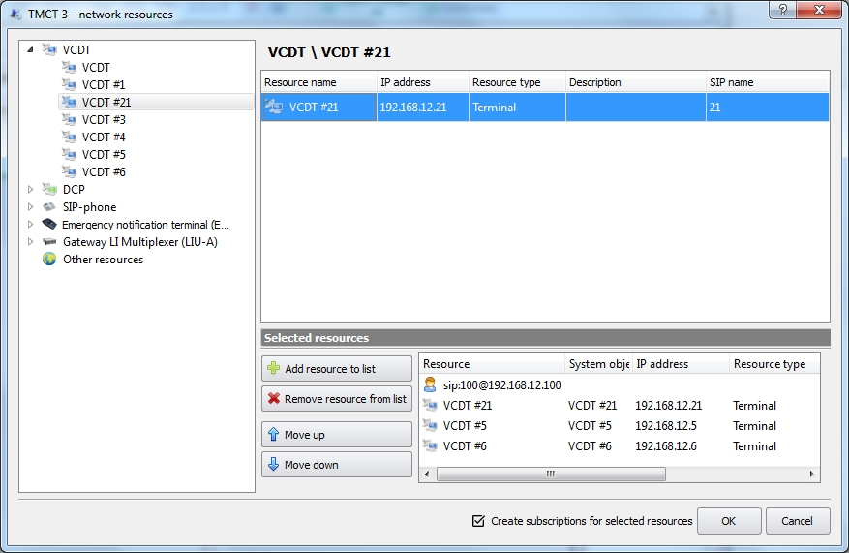
List of resources of the selected object

Figure 81 − Add a resource to the list
«Create subscriptions for selected resources» – if the check box is selected, subscriptions will be automatically added to all selected resources. Subscription – get information about the status of other terminals, see item 5.2.1 «SIP endpoints» of this Manual. Create a list of required resources and click «OK».

After clicking on the «OK», all resources from the selected list will be displayed in the «Outgoing calls address» field, see Figure 82.

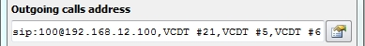
Figure 82 − Filling the address for outgoing calls field using the network resources selection button

«ANI» is indicated in SIP URI format. If this field is empty, value from field «Default ANI» is taken (see item 5.1.2.2 «LSC» of this Manual).

«Dial DTMF after outgoing call is answered» – after the outgoing call is answered, the specified DTMF sequence (digits «0123456789*#») will be sent to the channel.

«Open DTMF Dialer after outgoing call is answered» – after the outgoing call is answered, will be opened a small DTMF dialer.

Button operation mode is set using check boxes.

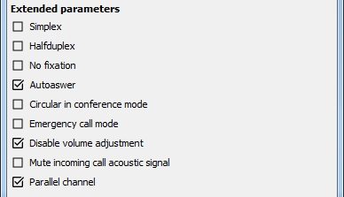
Figure 83 − Tab «GUI Editor», LSC button properties, selecting button operation mode

«Duplex» – standard (default) call with two-way path connection for both outgoing call and incoming call processing. In this mode, as a rule, subscriber call buttons operate in latching mode. In case the call button is set for non-latching operation, calling process is similar to «Simplex» mode.

«Simplex» – this mode uses voice instead of call signal to inform the called subscriber. The call is displayed on any workstation equipped with direct access DA keyboard, intended for this purpose.
During outgoing call in simplex mode, only microphone is switched on (to transmit voice information), while the speaker unit is off.
During incoming call in simplex mode, only speaker unit is switched on (to listen to voice information), while the microphone is off. Thus, simplex communication sessions are one-way.

«Halfduplex» – it is used for LSC buttons, during communication with which the speaking device is switch on only when the button is pressed.

«No fixation» – if the check box is selected, the connection remains active until the button is held down.

«Autoanswer» – if the check box is selected, when you receive a direct incoming call to this button, answer is performed without user assistance.

«Circular in conference mode» – if the check box and respective (subscribers) direct access buttons in tab «Circular call setup» (see below) are selected, the conference call will be made in the conference mode with predetermined number of subscribers.

«Emergency call mode» – if the check box is selected, the color of LSC button text changes to red, and in case the connection is successively established, an alert signal will be issued to the called subscriber. It works for both usual simplex, half-duplex and duplex LSC buttons and conference ones.



«Disable volume adjustment» – activating of check box in the window «Audio device selection» makes volume adjustment of speaking devices unavailable (see item 5.1 «Selection of speaking device and volume control», of «VCDT operator’s Manual.ЦИВР.00531-01 34 01).

«Mute incoming call acoustic signal» – if the check box is selected, the corresponding icon with a red handset appears on the button:

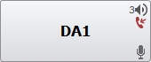

«Parallel channel» – with the set flag, when the button with an already active call (the button is «green» or blinking «yellow») receive second incoming call, this second call will be ignored. If the flag is not set, the «second» calls are rejected with the busy code or transferred to the address specified in the «Transfer address if busy» field (see item 5.1.2.2.1 «Automatic incoming call transfer» of this Manual).

5.3.2.1 Speaking devices

This tab is intended to select speaking devices to be used.

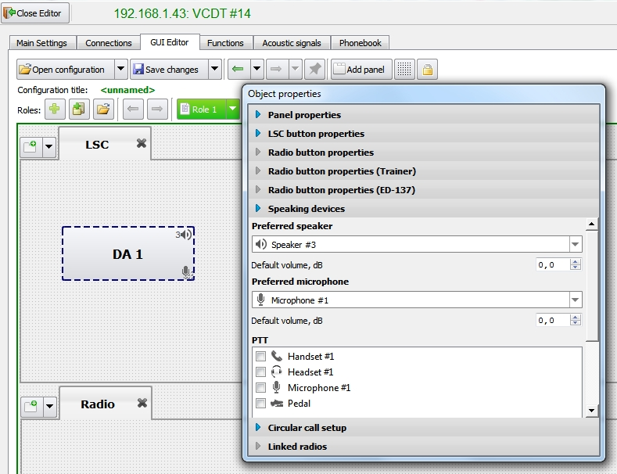
Figure 84 − Tab «GUI Editor», selecting speaking devices for LSC button
Speaker unit and microphone are selected from the drop-down list. In case «Default device» is selected in the field, the speaking device type will be taken from tab «Main settings», «Main default devices», see item 5.1.2.1 «Speaking devices» of this Manual.
Field «Default volume, dB» – the value determines the initial volume level on the LSC button.

5.3.2.2 Circular call setup

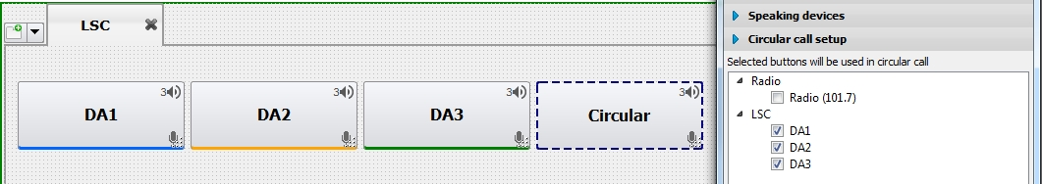
Figure 85 − Tab «GUI Editor», Circular call setup

Select those LSC buttons in the list, which will be used for circular call. Circular (group call) – simultaneous call to all internal and/or external parties (subscribers), grouped in the simplex mode beforehand. The group may include up to 16 subscribers.

5.3.3 Radio button properties

Setting of Radio button is similar to LSC setting: indicate button name, text font and style, position and size.
When setting Radio button, width of PTT button may be set by indicating the required value in field «PTT button width». When value «–1» is set, the width is calculated automatically.

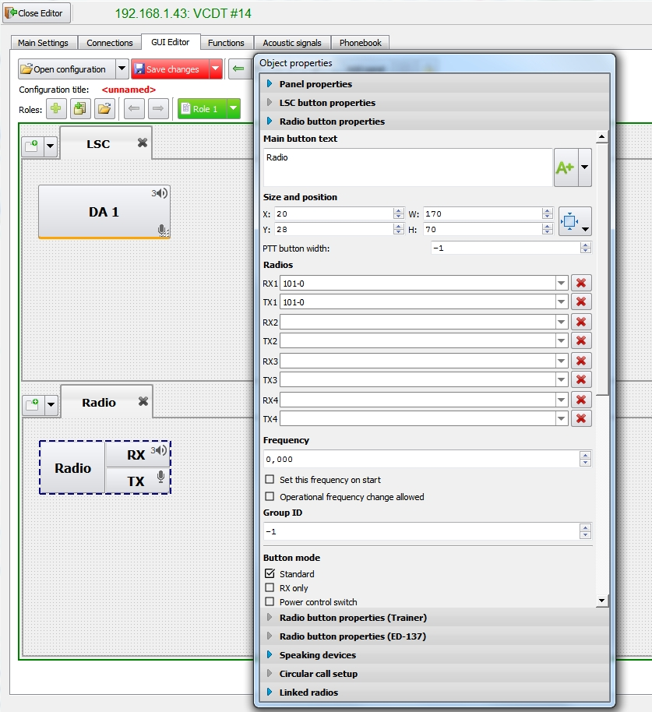
Figure 86 − Configuration editor, tab «GUI Editor», Radio button properties setting

«Radios» – one radio button can contain up to 4 control channels. Each channel can contain the same or different Radios, which are selected from the drop-down lists. Radios are set up in LIU-A. The frequency of the Radio can not be set, in this case, the frequency set in LIU-A will be used.

If Radio button has two channels configured, the two additional buttons M/S appear on the button.

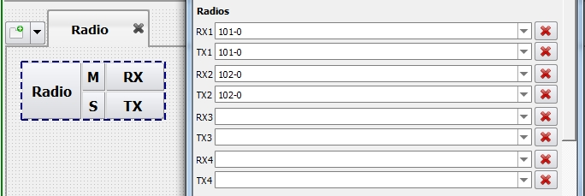
Figure 87 − Main/Reserve channel switch
If the Radio button has more than two channels configured, the corresponding numbered buttons appear to switch between channels on the VCDT and display the availability status of each channel:

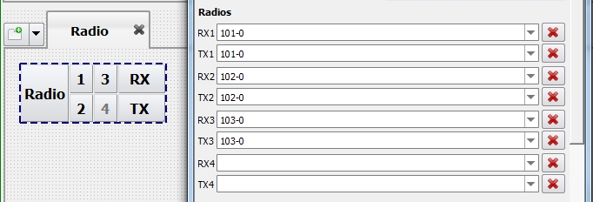
Figure 88 − Channel switch
To cancel the selection of a Radios, click the «Remove assignment» button and the link of the Radio button to the channel will be removed.

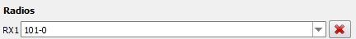
Button «Remove assignment»
Figure 89 − Button «Remove assignment»

Check box «Main/Reserve channel switch» – if the check box is cleared, the two additional M and S buttons in channel reservation mode will not be displayed, and the VCDT operator will not be able to switch channels manually.

Check box «Set this frequency on start» – if the check box is selected, frequency indicated in field «Frequency», is automatically set when VCDT is activated.
Check box «Operational frequency change allowed» – if the check box is selected, this RS is displayed in the radio set list in VCDT in window «Radio parameters» and is available for remote frequency tuning.

«Group ID» – identifier of the group of Radio buttons is specified, it is used during group operations with Radio buttons, for example, best signal selection (BSS).

«Standard» – if the check box is selected, Radio button operates in the standard mode.

«RX only» – if the check box is selected, only reception mode Rx becomes available for this radio set:
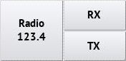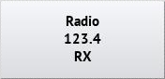

«Power control switch» – if the check box is selected, the radio set button is set to the power supply control mode:

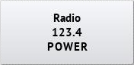

«BSS function switch» – if the check box is selected, the best signal selection function is activated for radio sets group. Radio button will look as follows:

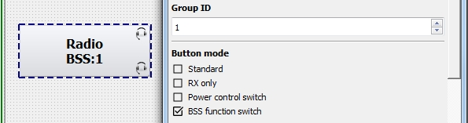
Figure 90 − Setting Radio button properties, selecting button
«BSS function switch» mode

«PTT button without fixation» – if the check box is selected, PTT of this radio set is active only when button PTT is held down.

Check box «TX button is activated by pressing and holding» – if the check box is selected, the TX button is activated by long pressing:

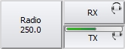
To deactivate the active PRD button, a long press is not required.

Check box «BSS button is activated by pressing and holding» - parameter is available when the «BSS function switch» operation mode of the button is selected. If the flag is set, the BSS is always activated by a long press. The method of activating BSS also depends on the parameter «The BSS button is activated by pressing and holding» (see item 5.1.2.3 «Radio communication» of this Manual).

Check box «VAD indication on inactive RX/TX buttons» – if check box is set, then upon the buttons are not active and the system detects a voice signal in Rx/Tx channels of radio station, respective button frame is highlighted in yellow. By default, the check box is enabled.

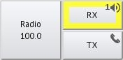

Check box «SELCAL enabled» – if the check box is selected, Radio button can open toolbar «SELCAL».

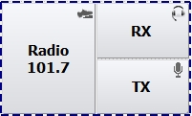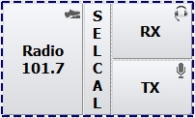

Select the required value of Radio set radiation class from the drop-down list for the time of SELCAL operation, if necessary, see Figure 91. When exiting in mode SELCAL, value, indicated in field «Normal mode class» is used.

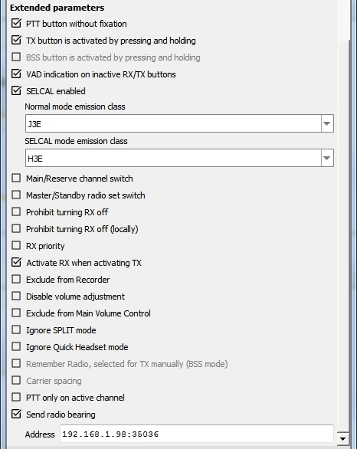
Figure 91 − Setting button Radio properties, selecting bearing message sending mode
Check box «Master/Standby radio set switch» – if the check box is selected, selector switch of master and standby radio sets is displayed in Radio button (configured in LIU-A).

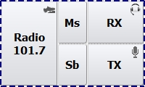

Check box «Prohibit turning RX off» – if the check box is selected, disabling of radio channel, used by one air traffic controllers only, is prohibited. The «RX» button is displayed with a red frame:

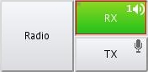

If VCDT / DCP is the only terminal on which listening to a radio channel is enabled, the «Last-listener of Radio Frequency» graphic indicator will appear on the system object icon:



Check box «Prohibit turning RX off (locally)» – mutually exclusive with «Prohibit turning RX off» option. When you enable the «Prohibit turning RX off (locally)» option, the «Prohibit turning RX off» option is automatically disabled and vice versa.
If the «Prohibit turning RX off (locally)» check box is set, then the «RX» button is highlighted with a red frame after the first activation and further «RX» deactivation is impossible.

Check box «RX priority» – if the check box is selected, higher listening priority is assigned to one of the frequency radio channels. A respective icon appears on the button:

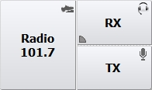
Higher listening priority icon

Check box «Activate RX when activating TX» – if the check box is selected, the TX button will be activated automatically when the RX button is activated.

Check box «Exclude from Recorder» – if the check box is selected, communication on this button is not included in short-term recording.

Check box «Disable volume adjustment» - activating of check box in the window «Audio device selection» makes volume adjustment of speaking devices unavailable (see item 5.1 «Selection of speaking device and volume control», of «VCDT operator’s Manual.ЦИВР.00531-01 34 01).

Check box «Exclude from Main Volume Control» – if the check box is selected, this button is not affected by general volume control.

Check box «Ignore SPLIT mode» – setting of check box means that speaking devices of the current button will not reassign during activation/deactivation of SPLIT mode (see item 5.1.2.1 «Speaking devices» of this Manual).
Check box «Ignore Quick Headset mode» - if the check box is selected, the quick headset mode will not be used on this button, see item 5.6 «Quick headset», of «VCDT operator’s Manual.ЦИВР.00531-01 34 01).

Check box «Remember Radio, selected for TX manually (BSS mode)» – this check box becomes available when you select the «BSS function switch» operation mode for the button (see above). If the checkbox is selected, pressing the on-screen PTT will memorize the selected Radio. With subsequent presses of the mechanical PTT, this particular Radio will be selected for transmission, and not the one that is currently active in the group.

Check box «Carrier spacing» – parameter is available when the «BSS function switch» operation mode of the button is selected. In this mode, reception is carried out by the best receiver, and transmission by all transmitters included in the group, by mechanical or individual PTT. The flag will only work if the carrier spacing mode for the radio is activated in the VCDT, see item 4.7 «Radio Carrier Spacing mode» of «VCDT operator’s Manual.ЦИВР.00531-01 34 01).

Check box «PTT only on active channel» – this parameter determines which channels to use when activating PTT. If the check box is selected, only one active TX channel will be used when the PTT is activated. In this case, the microphone will only broadcast to the active TX channel of the button. If there is no flag - all TX channels, when the microphone is transmitted, it is switched to all TX channels at once. Applies to multi-channel buttons.

Check box «Send radio bearing» – if the check box is selected, the terminal sends messages on used radio set frequency and PTT status to the indicated address (see Figure 91). The address of external bearing messages reception system is specified in the following format:
<IPaddress>:<Port>:<ID>, ID parameter (direction finding identifier) is not mandatory.

5.3.3.1 Speaking devices

This tab is intended to select speaking devices to be used. Speaker unit and microphone are selected from the drop-down list. In case «Default device» is indicated in the field, the speaking device type will be taken from tab «Main settings», «Main default devices», see item 5.1.2.1 «Speaking devices» of this Manual. The specified type of speaking device is displayed on the button as a corresponding icon, see Figure 92.

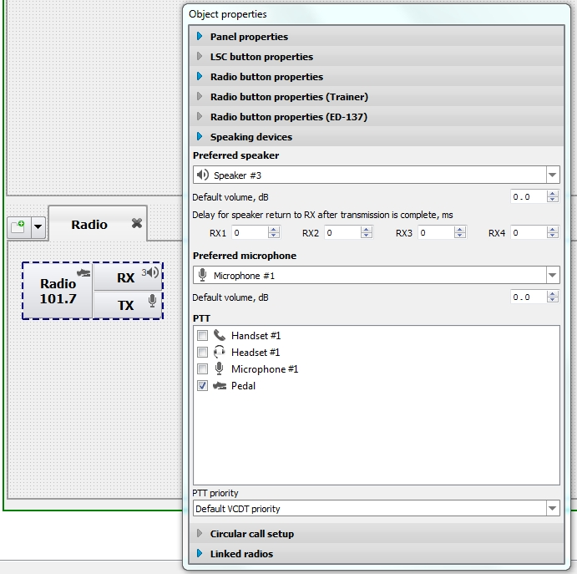
Figure 92 − Tab «GUI Editor», selecting speaking devices for Radio button

«Delay for speaker return to RX after transmission is complete, ms» - when using this setting, the speaker does not return to the RX immediately, but with the specified delay in ms. It is used in conjunction with the parameter «Mute RX when PTT is active» (see item 5.1.2.3 «Radio communication» of this Manual).

Several selected speaking devices are displayed as icon «↓», see Figure 93.

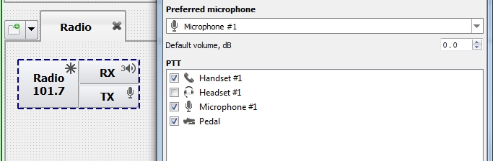
Figure 93 − Tab «GUI Editor», selecting several speaking devices for Radio button

Field «Default volume, dB» – the value determines the initial volume level on the Radio button.

Field «PTT priority» – priority access to the shared radio channels. The priority value is selected from the drop-down list: from 0 to 15, 0 is maximum value, 15 is minimum one. If «VCDT default priority» is indicated in the field, is taken the parameter «VCDT priority for radio communication» from tab «Radio communication», see item 5.1.2.3 of this Manual.
At that provided is the procedure for conflict resolution in case of PTT signal activation simultaneously by two or more operators with the same priority rights.

5.3.3.2 Linked radios

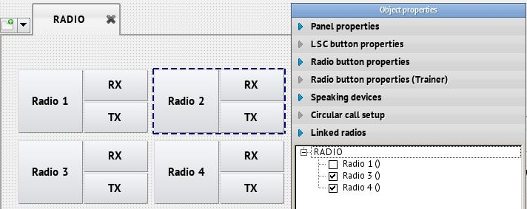
Figure 94 − Tab «GUI Editor», Linked radios
When any of buttons Rx or Tx of selected radio set is activated, all buttons Rx and Tx of the interfaced radio sets are deactivated automatically.

5.3.4 Radio button properties (Trainer)

Trainer Radio buttons emulates all functions of Radio button, working using the same protocol as LSC buttons. Buttons Rx and Tx operate in latching mode and have indication during sound transmission or reception (VAD). Button PTT is pressed without latching provided that button Тx is already pressed, communication is carried out in the simplex mode.
To add a button, select item «Add Radiostation button (Trainer)» from the drop-down menu, see Figure 95.

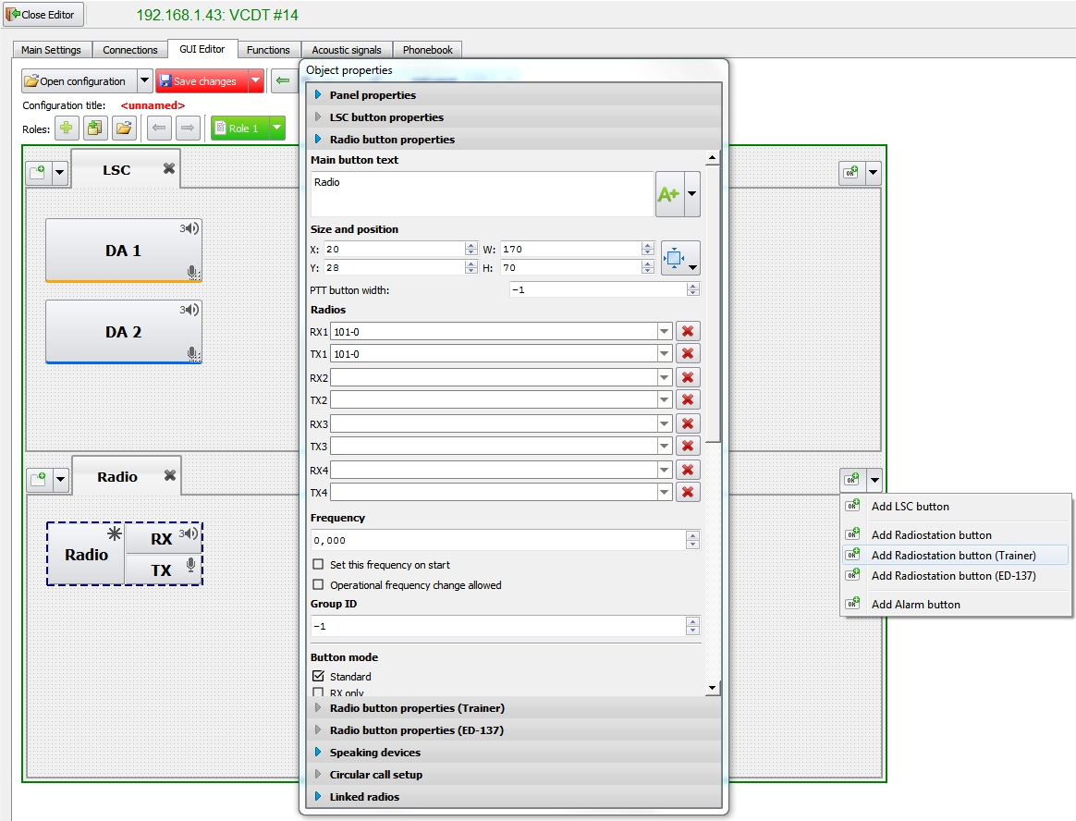
Figure 95 − Adding Trainer Radio button

Trainer Radio button with default parameters will appear on the page, see Figure 96.

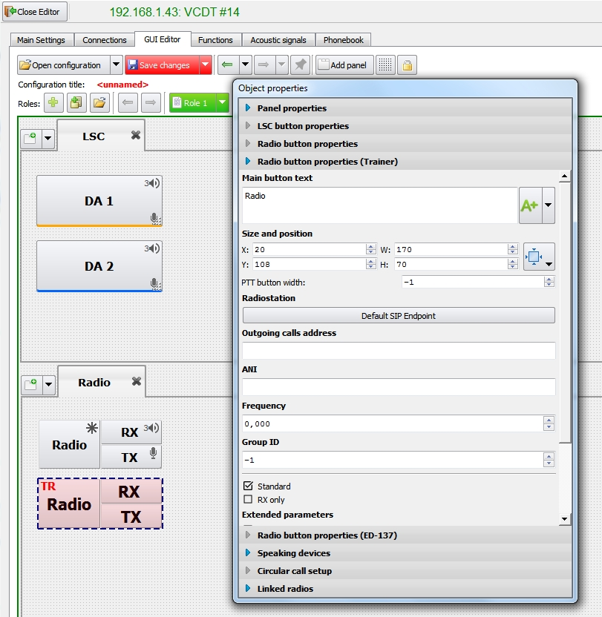
Figure 96 − Trainer Radio button, default parameters
Trainer Radio button setting: indicate button name, text font and style, position and size, select a radio set from the list (in this case, SIP connections), set its frequency manually.

When setting the button, width of PTT button may be set by indicating the required value in field «PTT button width». When value «–1» is set, the width is calculated automatically.

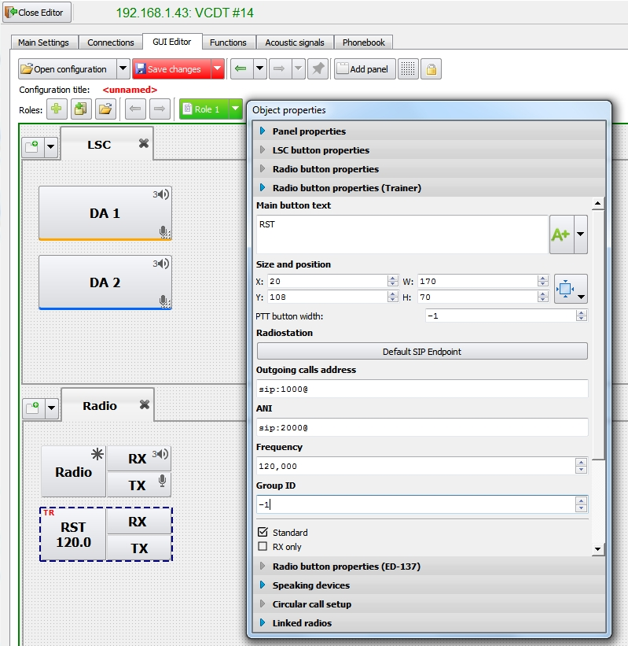
Figure 97 − Example of Trainer Radio button properties
«Outgoing calls address» – like LSC buttons, the address of subscriber to be called is indicated in the field. Line format: SIP URI.

«ANI» is indicated in SIP URI format. If this field is empty, value from field «Default ANI», tab «LSC» is taken (see item 5.1.2.2 «LSC» of this Manual).

Check box «Exclude from Recorder» – if the check box is selected, communication on this button is not included in short-term recording.

Check box «Disable volume adjustment» - activating of check box in the window «Audio device selection» makes volume adjustment of speaking devices unavailable (see item 5.1 «Selection of speaking device and volume control», of «VCDT operator’s Manual.ЦИВР.00531-01 34 01).

Check box «Exclude from Main Volume Control» – if the check box is selected, this button is not affected by general volume control.

Check box «Ignore SPLIT mode» – activating of this check box means that speaking devices of the current button will not reassign during activation/deactivation of SPLIT mode (see item 5.1.2.1 «Speaking devices» of this Manual).
«Send radio bearing» – if the check box is selected, the terminal sends messages on used radio set frequency and PTT status to the indicated address (see Figure 97). The address of external bearing messages reception system is specified in the following format:

<IP address>: <Port>:<ID>, ID parameter (direction finding identifier) is not mandatory.
If the address is specified in full format <IPaddress>:<Port>:<ID>, it completely replaces the address, indicated in the settings of Trainer Radio button, in the autonomous operation mode in VCDT equivalence table (see item 9.1 «VCDT Training Configuration» of this Manual).
If the address is specified in format <IPaddress>:<Port>, the button address is analysed to identify its ID. Thus, the address in Trainer Radio button can be specified using two variants only – <IPaddress>:<Port>:<ID>or <ID>.
If field «Send radio bearing» is empty, the value of field «Default bearing address» (see item 5.1.2.3 «Radio communication» of this Manual) is used in the standard VCDT operation mode and in integrated Complex mode.

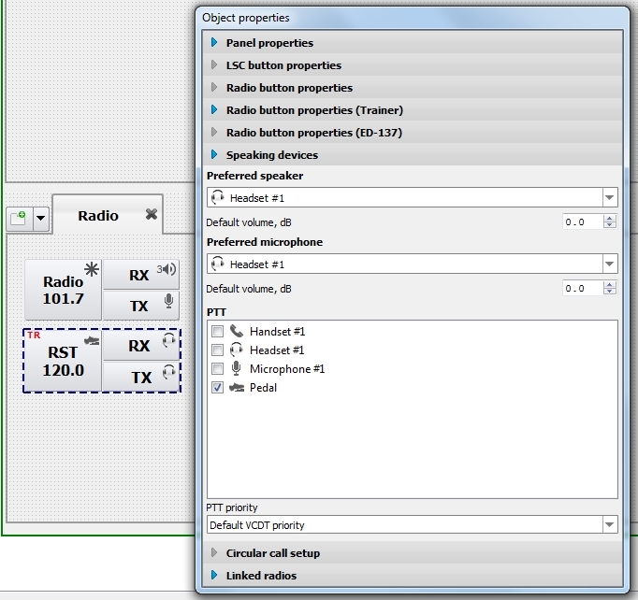
Figure 98 − Trainer Radio button, Speaking devices

5.3.4.1 Speaking devices

This tab is intended to select speaking devices to be used. Speaker unit and microphone are selected from the drop-down list. In case «Default device» is indicated in the field, the speaking device type will be taken from tab «Main settings», «Default devices» (see item 5.1.2.1 «Speaking devices» of this Manual).

The indicated type of speaking device is displayed on the button as a respective icon, see Figure 98. Several selected speaking devices are displayed as icon «↓», see Figure 99.

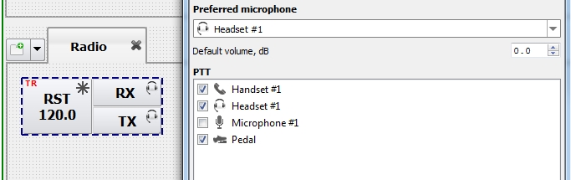
Figure 99 − Selecting several speaking devices for Trainer Radio button

Field «PTT priority» – priority access to the shared radio channels. The priority value is selected from the drop-down list: from 0 to 15, 0 is maximum value, 15 is minimum one. If «VCDT default priority» is indicated in the field, is taken the parameter «VCDT priority for radio communication» from tab «Radio» (see item 5.1.2.3 «Radio communication» of this Manual).
At that provided is the procedure for conflict resolution in case of PTT signal activation simultaneously by two or more operators with the same priorities.

5.3.5 Emergency notification button properties
To create emergency notification button, use «Add Alarm button» menu item, see Figure 100.
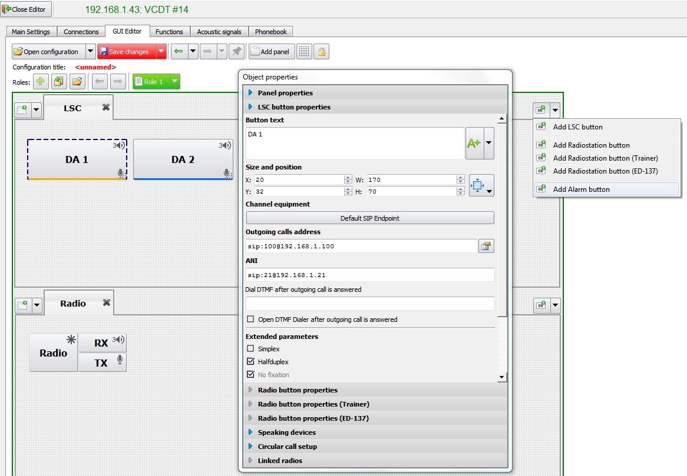
Figure 100 − Creating emergency notification button
New emergency button will be created on the current panel («LSC» page in our example) with the default parameters, see Figure 101.
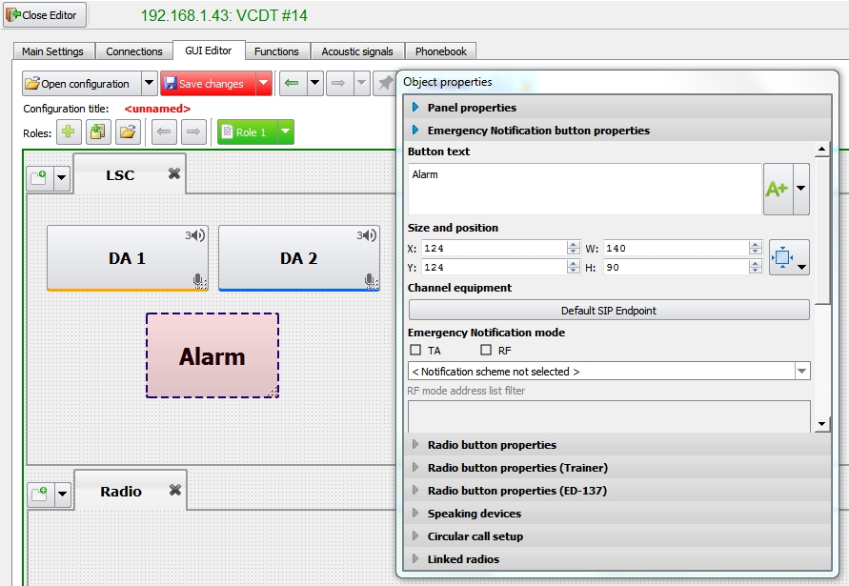
Figure 101 − Emergency notification button with the default parameters

Emergency notification mode

The functionality of LSC button is specified by means of check marks selected on ENS, see Figure 102. In TA mode, button is used to record voice message and start emergency notification procedure using the one of the preconfigured notification schemes, see item 7.2 «Air traffic controllers terminal with the right to alert in an emergency (TA)», «VCDT Operator's Manual. ЦИВР.00531-01 34 01».

In RF mode, button is used as an emergency notification events collector. It collects all of the notification data from subscribers (the moment when a subscriber received emergency signal, the moment when he starts listening to the voice message and when he has finished listening) and presents it in a popup window, see item 7.3 «Reception and recording of alert signals reception acknowledgements (RF)», «VCDT Operator's Manual. ЦИВР.00531-01 34 01».

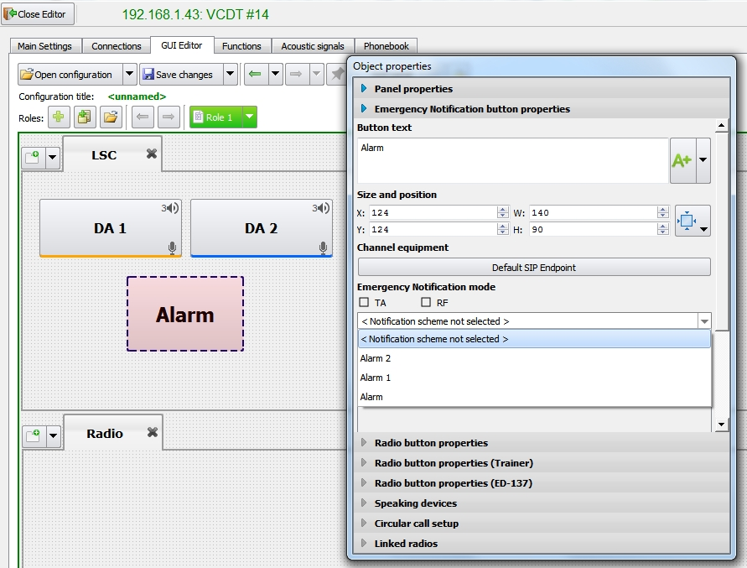
Figure 102 − Emergency notification mode selection

«Notification scheme» – Notification scheme from the «Emergency Notification» system settings, see 10.1 «Notification scheme setup».

In FP mode, an additional address filter becomes available, see Figure 103.

By default, this list contains all of the subscribers from the selected notification scheme. The corresponding checkbox must be cleared to exclude a subscriber from notification control.

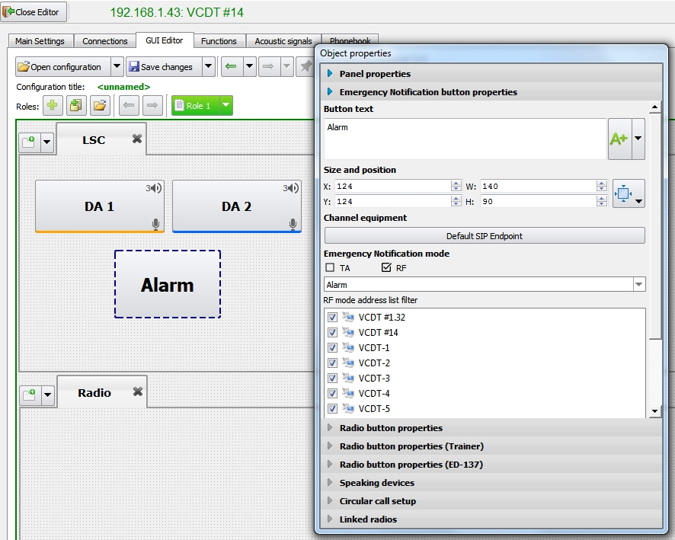
Figure 103 − RF notification mode address list filter

5.3.6 Radio button properties (ED-137)
The radio button is intended for radio stations that support the ED-137 protocol. To add a new button, select the appropriate menu item «Add Radiostation button (ED-137)», see figure 95.

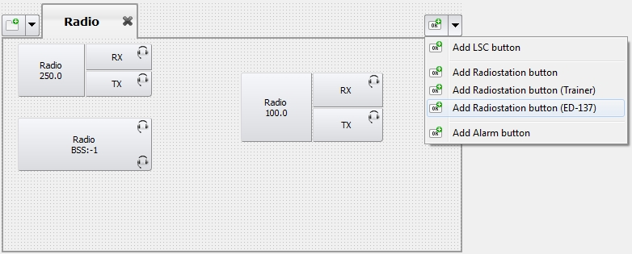
Figure 104 – Adding Radiostation button (ED-137)
When you add a button, the tab with its parameters is opened, see figure 96.

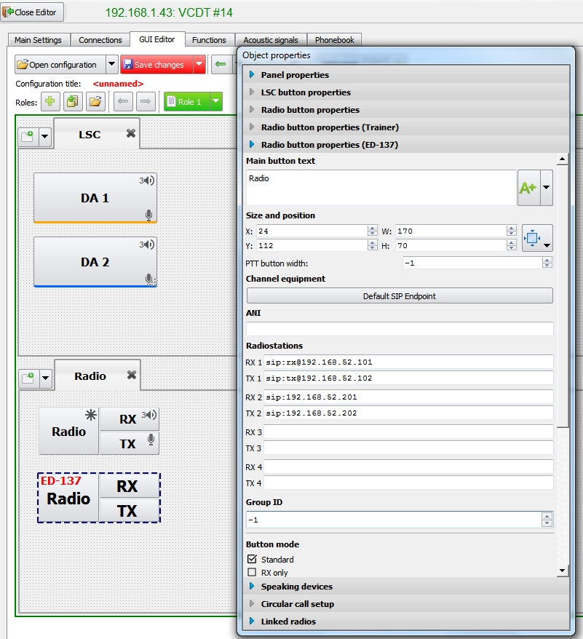
Figure 105 – Radio button (ED-137) properties
«Channel equipment» – when the button is pressed, device selection window will be opened. The list of SIP endpoints is taken from the tab «Connections», see item 5.2.1 «SIP endpoints» of this Manual.

«ANI» is indicated in SIP URI format. If this field is empty, value from field «Default ANI» is taken (see item 5.1.2.2 «LSC» of this Manual).

«Radiostations» – for each RX/TX the address of the radio station is set in SIP format. ED-137 Radio button allows you to configure up to 4 pairs of RX/TX.
The button is automatically engaged in the reservation of the configured radio stations. For example, if you lose communication with one transmitter, you will be switched to work with another.

The «Group ID», «Button mode», «Extended parameters» are similar to the parameters in the «Radio button», see item 5.3.3 «Radio button properties» of this Manual.

5.4 Voice Events
This tab is used to set up voice events configuration for VCDT. A sound file is assigned for each event.
Voice events are assigned for newly created VCDT by default. The overall view of the tab is shown in Figure 106.
The left part accommodates the list of voice events names, the right part – respective sound file. For files, assigned by default, only file description is displayed, file name is not displayed.

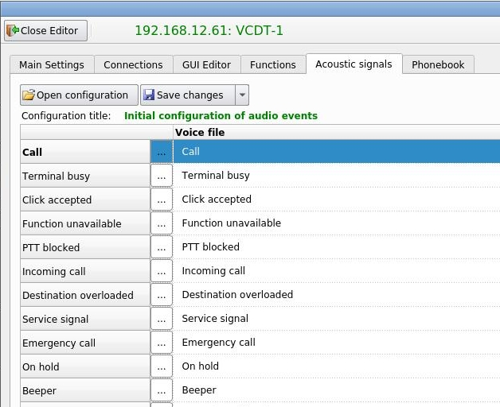

Name of voice event configuration
List of voice event names
Description of file for voice events, assigned by default
Figure 106 − Configuration editor, tab «Voice Events»

During operation the initial configuration of sound events may be changed. One or several sound files from the list may be replaced.

For this purpose proceed as follows:
– open window «Voice file selector» by pressing button ;
– upload a new file to the system by pressing button  (see Figure 107) and selecting a new voice file name (see Figure 108). If it is necessary to provide description of the selected voice file, by default it will contain file name, see Figure 109;
– confirm file selection by pressing «OK»;
– new uploaded voice file will appear in the list, see Figure 110.

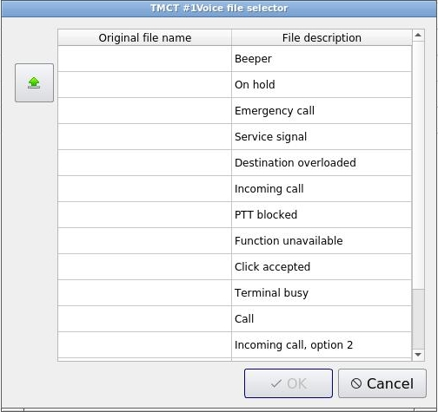
New file uploading
Figure 107 − Tab «Voice Events», uploading a new sound file

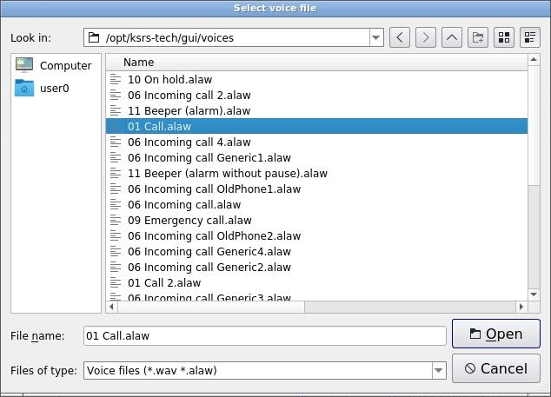
Figure 108 − Tab «Voice Events», selecting a new sound file

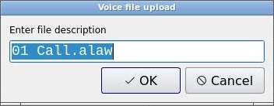
Figure 109 − Field for file description

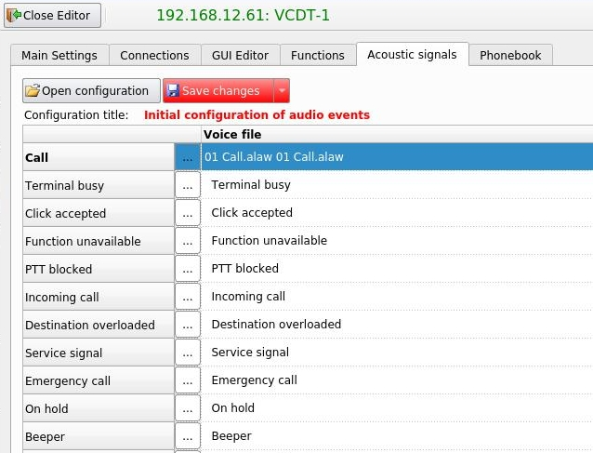
By default file description contains file name
File name
Figure 110 − Tab «Voice Events», new sound file is uploaded
Button «Save changes» allows to save changes under the existing voice configuration name or under a new name by pressing the drop-down menu button and selecting item «Save configuration with a new name».
If the sound configuration is saved under an existing name, then it will be applied to all VCDT that use it. If the VCDT requires individual adjustment of the sound configuration, then save it under a different (new) name after making changes.

– save changes of voice configuration;
– save voice configuration under a new name.
– settings have been changed, saving is required.

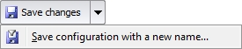
Drop-down menu button

– open sound events configuration.

When button «Open configuration» is pressed, the window with the list of existing saved VCDT sound configurations is opened, see Figure 111. Confirm the selection by pressing «OK» button.

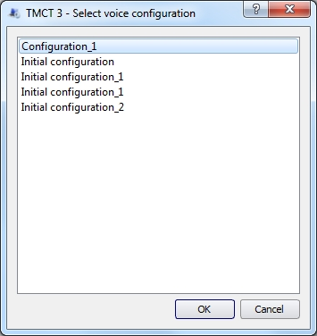
Figure 111 − Selecting voice configuration

5.5 Functions

This tab is used to set up Main and Additional VCDT Functional Toolbars. The main toolbar is opened on VCDT when it is activated.
The left part of the tab accommodates the list of available functions, the right part – configurable VCDT functional toolbars.
Availability of functions depends on the check boxes selection. Functions, selected in the list, are displayed on VCDT toolbar (main and additional). Functions, highlighted in grey color, are permanently displayed in VCDT.
There is a three-digit code next to the function name. Dialing of this functional code is carried out on the keyboard to activate the appropriate functional button in VCDT (see item 3.9.4 «Functional code», «VCDT Operator’s Manual. ЦТРС. ЦИВР.00531-01 34 01»).

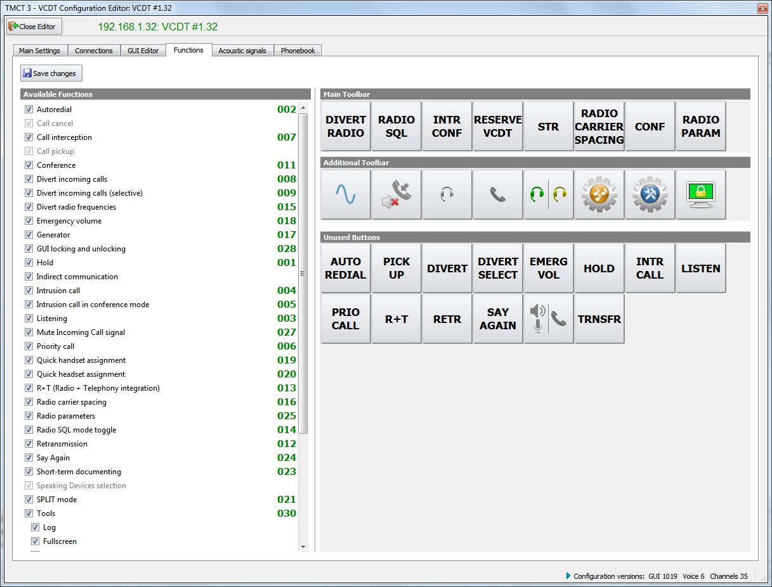
Figure 112 − Configuration editor, «Functions»
The number of functions of each toolbar is limited by 8 buttons. The toolbars are set up by dragging functional buttons to empty segments.

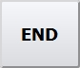 – termination of each current connection (existing or being established) as well as termination of unanswered incoming call.

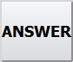 – answering to any incoming call (direct or indirect).

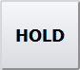 – putting all current connections on hold.

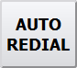 – automatic redial in case the called subscriber is busy or the call is unanswered in telephone communication mode.

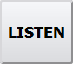 – listening to radio and telephone communication of other VCDT.

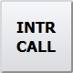 – establishment of communication with VCDT operator, engaged in other communication.

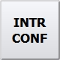 – intrusion call in conference mode. Parallel mode of operation of several VCDT with telephone lines.

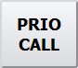 – priority call.

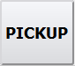 – answering to incoming calls to be answered on other workstation.

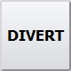 – divert incoming calls.

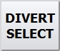 – divert incoming calls (selective).

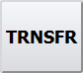 – redirection of all regular ground communication incoming calls from the terminal to other address: VCDT or other network subscriber, supporting readdressing.

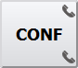 – conference communication.

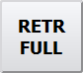 – radio channels grouping with possibility to retransmit voice signal from channel to channel in the radio communication mode.

 – combining of radio and telephone communication (R+T). In this mode the participants of established telephone connection can listen to incoming voice communication radio signal, at that telephone communication is not transmitted on the air.

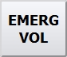 – when the button is held down, volume of all incoming calls is increased to the indicated dB value. By default, the value is +4 dB. It is set for each VCDT separately, see item of this Manual 5.1.2.4 «Miscellaneous», field «Emergency Volume».

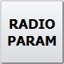 – remote frequency tuning for the radio set, supporting this function, switching over between main and standby radio set channels, activation of squelch mode.

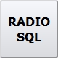 – operative RS squelch mode switching.

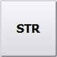 – short-term recording (STR). Test record and listening to conversations of separate workstation.

 – listen to the last STR conversation.

 – divert radio frequencies.

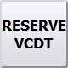 – VCDT reserve mode.

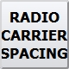 – radio carrier spacing.

 – SPLIT. Immediate switching over of the VCDT buttons of each type (LSC, Radio, Telephone communication) to specific speaking devices.

 – «Quick handset». The function allows quick selection of a handset for LSC. Radio communication remains working via the microphone and speaker units.

 – «Quick headset». The function allows quick selection of a headset for all available communication of the current workstation.

 – two headsets mode. There are two modes of operation of the button: 1) first headset works with all radio communications, and the second one with all telephone communications; 2) both headsets work in parallel (Training mode).

 – operative «Incoming call» signal mute.

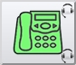 – indirect communication.

 – frequency generator. This function provides continuous transmission of tone signal of given frequency to the channel to check speech path.

 – audio signals setting.

 – terminal locking.

 – update terminal configuration. The location of the button on the VCDT is fixed and cannot be configured.

 – tools. When this functional button is selected, the window with the following buttons is opened in VCDT:

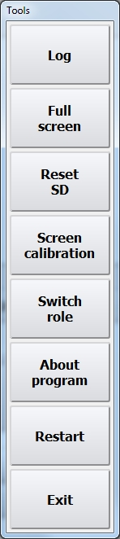
Button «Log» – opening of protocol window.
Button «Full screen» – switching over VCDT to full screen mode.

Button «Reset SD» – reset of speaking devices, assigned by the user, to settings, received from IME.

Button «Screen calibration» – launching of system program of screen calibration.

Button «Switch role» – change the interface (role).

Button «About program» – opening a window with information about the software version.

Button «Restart» – restart of VCDT interface.

Button «Exit» – termination of VCDT interface operation.

Buttons availability depends on the check boxes selected.

5.6 Phonebook

The list of subscriber numbers which will be used in the VCDT is configured on the «Phonebook» tab (see item 3.9 «Indirect communication», «VCDT Operator's Manual. ЦИВР.00531-01 34 01»).
The list of numbers of subscribers of the phonebook is formed by groups. To create one or several groups of subscribers, click on the appropriate button:

– add a new group to the phonebook;

– delete selected groups from the phonebook.

The list of created groups will be displayed at the top of the Phonebook tab, see Figure 113.

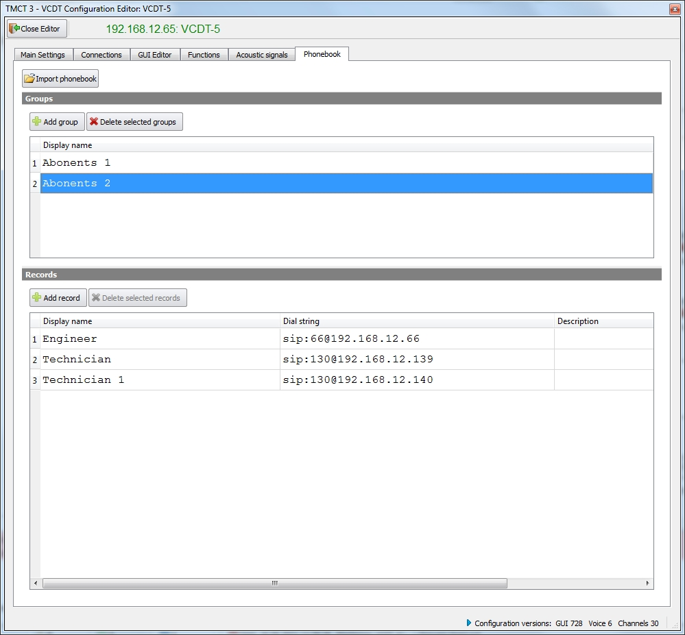
Figure 113 − Configuration editor, «Phonebook»

To add a new record to the selected subscriber group, click the button «Add record», and specify the required information in the appeared field, see Figure 114.

– add a new record to the group of subscribers.

– delete selected records from the subscriber group.

Each record contains a sequence number, display name, dialing string and comment to the record. The sequence number is set automatically by the system, the remaining fields are editable. The field «Description» is limited to 255 characters.

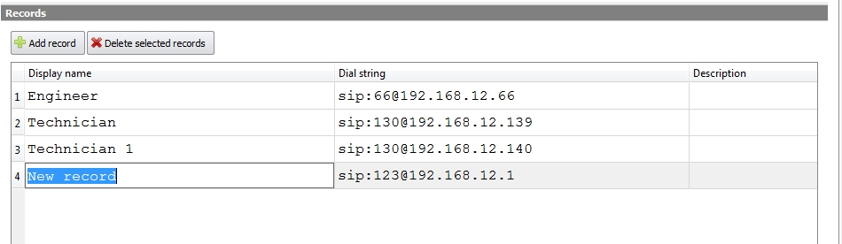
Figure 114 − Configuration editor, «Phonebook», adding a new note
The format of the dialing string is SIP URI, or, if an abbreviated number is indicated, then dialing will be performed using sip route selected in the Dialer (see item 5.2.2 «SIP Routes» of this Manual).
To select several records for deletion, hold down the key «Ctrl» and select the required lines by means of left-click of the «mouse» button, and then press delete button.

5.6.1 Phonebook import
At the top of the tab there is a button « Import phonebook », with the help of which one can import the data for VCDT phonebook. After clicking on the button, a window will open to select a file, see Figure 115.

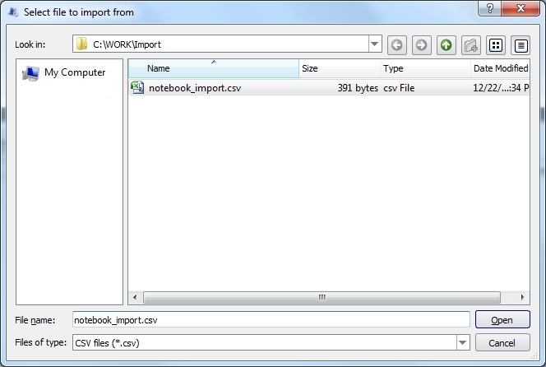
Figure 115 − File selection to import
Select a file, in our example it is notebook_import.csv, and press the button «Open».

The content of the imported file will appear in the window «Phonebook import», see Figure 116.

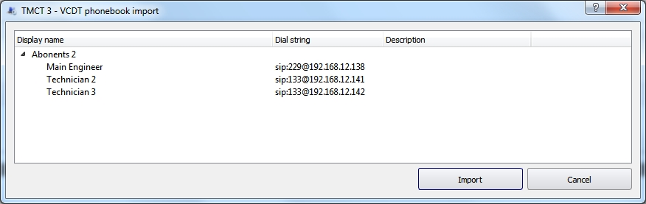
Figure 116 − Phonebook data import
After clicking on the button «Import phonebook» an information window will appear with the message about the result of the operation.
In case of successful importing, new records are placed at the end of the list, see Figure 117. If there are entries with the same name in the phonebook, they will be updated.

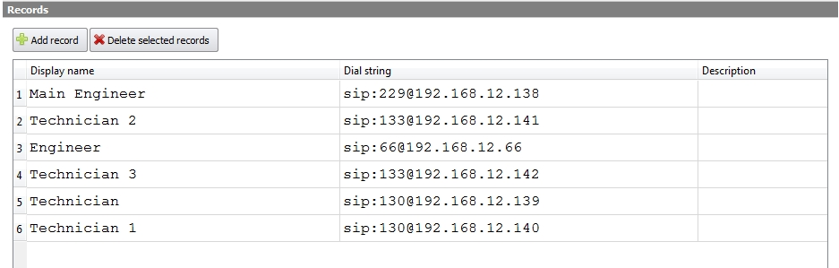
Figure 117 − Import of phonebook data is successful

File format for import

The file should be with the extension .CSV.

The following characters are used as a spacer: «;», «,» and «tabulation».

The mandatory first string of the file is as follows:
Group name; Group dial string; Group description; Display name; Dial string; Description

A file example is as follows:

6 Line Interface Unit Analog (LIU-A)

This item contains description of parameters, required to set up Line interface unit analog (LIU-A).
The upper part of the window accommodates the following fields and check boxes:
field «System ID» – system object identifier, given by the system automatically. The field is not editable;
field «Title» – system object name, indicated in the system structure. If necessary, it may be changed;
field «IP address» – system object IP address. If necessary, it may be changed;
check box «Current» – check box selection allows to view current LIU-A configuration;
check box «New» – check box selection allows to edit current LIU-A configuration. If necessary to save new configuration, press button «Apply configuration».

– check of availability of LIU-A at the indicated IP address and configuration query.

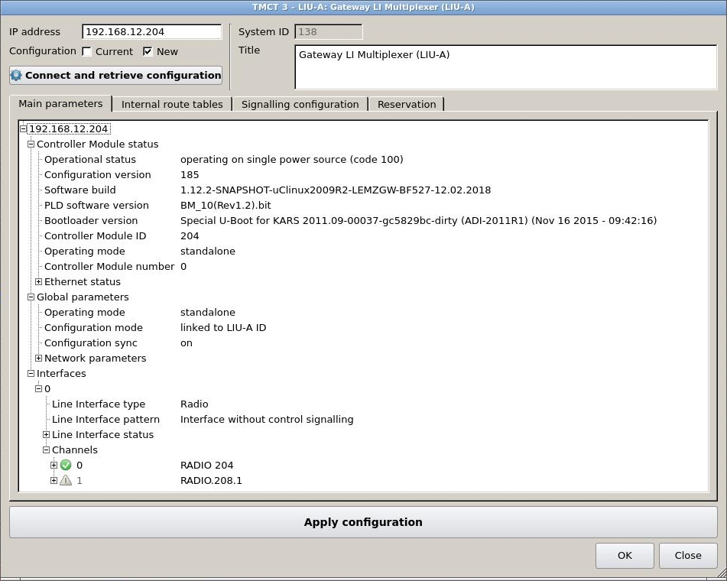
Figure 118 − LIU-A parameters
 – save new configuration LIU-A.

See description of operation with tabs «Main parameters», «Internal route tables», «Signalling configuration» and «Reservation» below.

6.1 Main Parameters
LIU-A parameters are displayed in this tab as a tree structure.

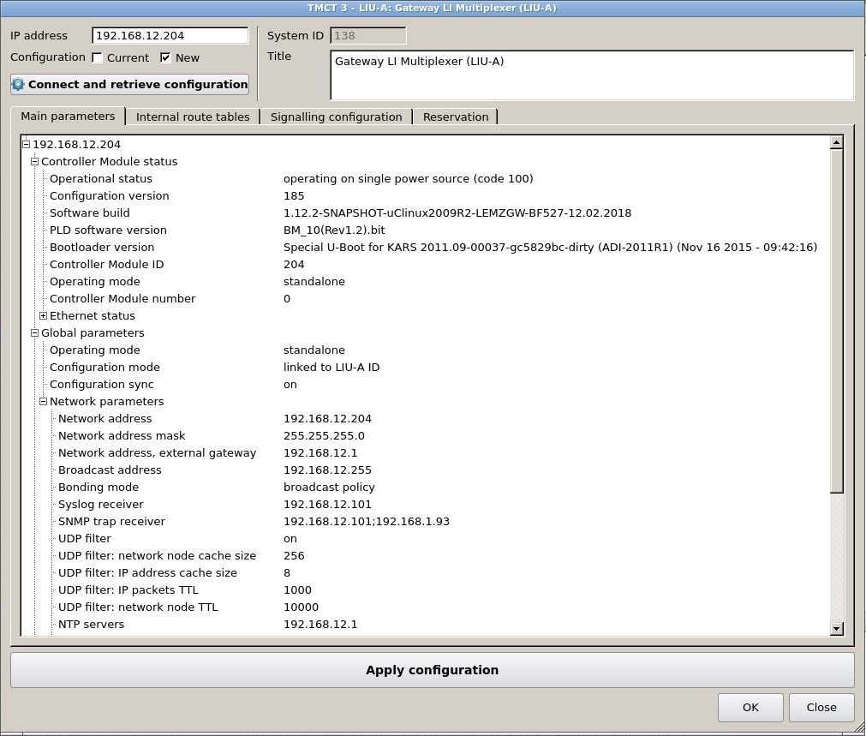
Figure 119 − LIU-A parameters, tab «Main parameters»

6.1.1 Controller Module status
When branch «Controller Module status» is opened, the current status is displayed. Non-editable fields are given for information only.
Operational status:
0XX – ready and operational (green);
000 – OK (code 000);
1XX – ready but has limitations (yellow);
100 – working on single power source (code100);
2XX – ready but almost reached limits (orange);
3XX – unserviceable, but monitoring is available (red);
300 – does not work (code 300);
4XX – unserviceable and monitoring is unavailable (dark red).

Configuration version – the configuration version number is displayed.
Software build – the version and time of the software build are displayed.
FPGA software version – the version of the FPGA software build is displayed.
Bootloader version – the bootloader version is displayed.
Controller Module ID – if the values of identifiers of all connected LI are identical, their value is set in this identifier, otherwise the value is –1.
Operating mode – the type of operation mode is displayed, set in the «Global parameters», see item 6.1.2 of this Manual.
Controller Module number – if the redundancy mode is set up in the gateway and two CM's are installed, this parameter determines CM number in the gateway. It may be equal to 0 or 1. CM numbering is similar to LI.

When branch «Ethernet status» is opened, the list of available interfaces and their status will be displayed:
1 – up;
2 – down;
3 – testing;
4 – unknown;
5 – dormant;
6 – not present;
7 – lower layer down.

6.1.2 Global parameters
Operating mode:0 – standalone;
1 – slave;
2 – master.
Configuration mode:
0 – linked to LIU-A ID;
1 – static configuration.
Configuration sync:
0 – off;
1 – on.

6.1.3 Network parameters
Network address – IP address of LIU-A.
Network address mask – subnet mask.
Network address external gateway – default IP address of router.
Broadcast address – address for broadcast packet transmission in the network.

Bonding mode:
-1 – disable bonding;
0 – round robin balance;
1 – active-backup mode;
2 – XOR policy balance;
3 – broadcast policy;
4 – 802.3ad dynamic link aggregation;
5 – adaptive transmit load balancing;
6 – adaptive load balancing.

Syslog receiver – IP address of server syslog.
SNMP trap receiver – IP address of SNMP agent, to which TRAP messages will be sent to UDP filter:
use module to filter redundant UDP traffic:
0 – off;
1 – on.
UDP filter: network node cache size – maximum size of peer history.
UDP filter: IP addresses cache size – maximum size of IP packet identifiers history.
UDP filter: IP packets TTL – «time to live» of IP packet in history, set in ms.
UDP filter: network node TTL – «time to live» of peer in history, set in ms.
NTP servers – list of IP addresses for NTP servers. Mark «;» is used as separator.
Configuration sync IP address white list – indicated is the list of IP addresses, mark «;» is used as separator. It is allowed to indicate a range of addresses, the first and the last addresses are separated with «-».
For example: 192.168.12.1;192.168.12.101-192.168.12.160. LIU-A will synchronize configuration with this server list. The list is used if parameter «Configuration sync» is activated. If the list is empty or does not contain any correct element, all available networks will be used as synchronization servers.

Configuration sync address black list – indicated is the list of IP addresses is indicated, mark «;» is used as separator. It is allowed to indicate a range of addresses, the first and the last addresses are separated with «-». For example: 192.168.12.20-192.168.12.30.
All addresses from this list will be ignored during configuration synchronization. The list is used if parameter «Configuration synchronization» is activated.
TOPAZ servers – the list of TOPAZ IP addresses, bearing messages will be sent to. Mark «;» is used as separator.

6.1.4 Interfaces
0 – sequence number of interface in LIU-A. It assumes a value from 0 to <number of interfaces>–1.

Line interface type:
0 – interface is disabled;
1 – Radio;
2 – LSC;
3 – Digital communication.

Line interface pattern – binary pattern, characterizes interface board operation. The pattern file is selected from the respective window, which is opened by double click, see Figure 120.

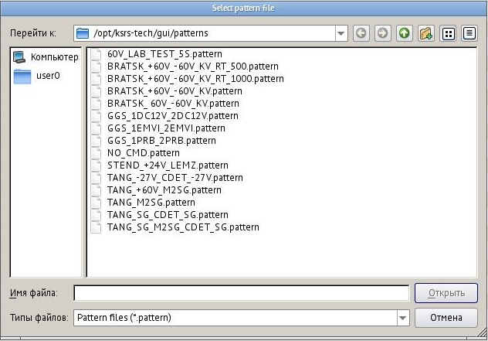
Figure 120 − Pattern file selection window

6.1.5 LI status
When branch «Line Interface status» is opened, the current LI status is displayed. Non-editable fields are given for information only.

Interface index number. It assumes a value from 0 to <number of interfaces>-1.

Line Interface ID. The gateway receives the identifier value from the line interface while its connection. The range of assumed values is from -1 to 255. In case of error or absence of LI, value -1 is selected.

Digital software version – software version in major.minor format.
Analog software version – software version in major.minor format.
Digital channels capacity – number of channels supporting LID.
Analog channels capacity – number of channels supporting LIA.
Interface status:
0XX – ready and operating (green);
000 – OK (code 000);
1XX – ready, limited functionality (yellow);
104 – ANALOG_INTERFACE_HARDWARE_ERROR. The ALI_HW_STATE package with the hardware error information will be received from the LIU-A;
105 – DIGITAL_INTERFACE_HARDWARE_ERROR. The
DLI_HW_STATE package with the hardware error information will be
received from the LIU-D;
2XX – ready but almost reached limits (orange);
3XX – unserviceable, but monitoring available (red);
300 –not working (code 300);
4XX – unserviceable and monitoring is unavailable (dark red);
400 – connection lost (code 400).

Boot loader version – in major.minor format.
FCPGA software version – in major.minor format.

CPU load – indicated in percent.

Power channel 1 fuse alarm:
0 – normal;
1 – alarm.

Power channel 2 fuse alarm:
0 – normal;
1 – alarm.

Channel 1 node 1 {PTT} alarm:
0 – normal;
1 – alarm.

Channel 2 node 1 {LSC1} alarm:
0 – normal;
1 – alarm.

Channel 1 node 2 {pattern} alarm:
0 – normal;
1 – alarm.

Channel 2 node 2 {LSC2} alarm:
0 – normal;
1 – alarm.

6.1.6 Channels

Sequence number of channel in the interface number X. It assumes a value from 0 to 7.

Answer mode for incoming call from network – the parameter is used for SIP signalling:
0 – ON_CONNECTION. Answer all incoming connections at once;
1 – ON_CALLING. Answer only if LI is operating and after sending the call to the line;
2 – ON_CALL. Answer if LI is operating and upon reception of acknowledgement that the call is answered in the line.

Answer mode for outgoing call to network – the parameter is used for SIP signalling. Describes when 'CALL' is sent to a line.
0 – ON_CONNECTION. Immediately after signalling session
setup;
1 – ON_CALLING. Immediately after remote party indicates 'ringing';
2 – ON_CALL. Immediately after media session setup.

Channel activity – the parameter value determines channel activity in the interface with number X, channel is active or interface is off:
0 – channel disabled;
1 – channel is active.

Channel pattern is a binary pattern that characterizes the channel operation in the interface board. The pattern file is selected from the corresponding window, which is called by double clicking the mouse. Default values – zero.

Common: channel type:
- – duplex;
- – simplex;
- – half-duplex.

Common: hang up if missing voice frames on receiver – parameter of SIP signalling:
0 – function disabled;
>0 – time in ms, if during the selected time there is no voice frames (packets) reception, CM terminates the call.

Common: logic type – LSC type, which corresponds to this channel of interface number X:
0 – no defined;
1 – 2-wire line. It is usual duplex channel with one reception line and one transmission line.
2 – 4-wire line. It is duplex channel, which consists of two 20-wire channels, but only reception is used in the minor channel, and only transmission in the major one.
Common: receiver delay – artificial delay during reception from the line, it is indicated in milliseconds, 1024, max.

Common: recorder mixer:
0 – off;
1 – on.

Common: signalling detector signal level – signal level for signalling detector in dB. It may assume a value within the range of –300...0. The parameter is related to SELCAL, DTMF signalling for Radio and LSC SSC.

Common: signalling level to voice level ratio – signal level for signalling detector in dB. It may assume a value within the range of –300...0. The parameter is related to SELCAL, DTMF signalling for Radio and LSC SSC.

Common: transmitter delay – artificial delay during transmission to the line, it is indicated in milliseconds, 1024, max.

Digital Comm: signalling type:
0 – off;

1 – ATS QSIG.

Gain: Automatic Gain Control for transmitter – the parameter value determines operation of automatic gain control for transmission to the line:
0 – off;

1 – on.

Gain: Automatic Gain Control for receiver – the parameter value determines operation of automatic gain control for reception from the line:
0 – off;

1 – on.

Gain: adjusting resistor RC – the parameter determines gain of preset resistor RC on this sub-channel. The range of possible values is from 0 to 255 (for values see Appendix B of this Manual). Negative value indicates that the parameter is not used.

Gain: adjusting resistor RR – the parameter determines gain of preset resistor RR on this channel. The range of possible values is from 0 to 255 (for values see Appendix B of this Manual). Negative value indicates that the parameter is not used.

Gain: reception – the parameter determines gain during reception on this channel. The range of possible values is from 0 to 255 (for values see Appendix B of this Manual). Negative value indicates that the parameter is not used.

Gain: recorder – the parameter determines gain of recording output on this channel. Gain is used for mixed reception and transmission data. The range of possible values is from 0 to 255 (for values see Appendix B of this Manual). Negative value indicates that the parameter is not used.

Gain: recorder additional – the parameter determines gain of recording output of reception only on this channel. Gain is used for auxiliary recording output, to which reception data are sent. The range of possible values is from 0 to 255 (for values see Appendix B of this Manual). Negative value indicates that the parameter is not used.

Gain: self-monitoring – the parameter determines gain during self-listening on this channel. The range of possible values is from 0 to 255 (for values see Appendix B of this Manual). Negative value indicates that the parameter is not used. Self-listening is relevant for 4-wire line only (Radio and 4-wire LSC). Negative value indicates that the parameter is not used.
Gain: transmission – the parameter determines gain during transmission on this channel. The range of possible values is from 0 to 255 (for values see Appendix B of this Manual). Negative value indicates that the parameter is not used.

LSC: call type – type of LSC call:
0 – no;
1 – DC, direct current control;
2 – tone, tone frequency control;
3 – voice, control by voice;
4 – FXO;
5 – FXS;
6 – MB call;
7 – SSC tone frequency control;
8 – DPU 60V;
9 – DPU А;
10 – DPU 60V with voice control;
11 – DC control;
12 – E&M with voice control.

LSC: channel signalling subtype: It takes the following values:
none - default value. This value shall be used if the channel
signaling subtype is not defined;
seize - this value is valid only for FXO, LB telephone signaling.
Pick up the phone to call.
tone - the value is valid only for FXO telephone signaling. Pick up
the phone to call and use tone mode to dial the number;
pulse - the value is valid only for FXO telephone signaling. Pick up
the phone to call and use pulse mode to dial the number.

LSC: echo canceller – the parameter value determines echo canceller operation:
0 – off;
1 – on.

Radio: BSS:
0 – off;
1 – on.

Radio: PTT over SQL priority – relative priority of PTT signal and SQL signal:
1 – PTT > SQL;
2 – PTT <SQL;
3 – PTT = SQL.
In case PTT priority is lower than SQL priority, during transmission (sending of PTT signal to LI) the receiver is not switched off, transmission is prohibited. In case PTT priority equal to SQL priority, during transmission (sending of PTT signal to LI) the receiver is not switched off, transmission and reception are carried out at the same time. In case PTT priority is higher than SQL priority, during transmission (sending of PTT signal to LI) the receiver is switched off, only transmission is available.

Radio: channel ID – channel ID from radio station’s setup.

Radio: channel frequency – radio set channel frequency (in MHz), it is transmitted to the line board when LIU-A is activated.

Radio: channel signalling subtype:
0 – default. Preferred value if channel subtype is not defined;
1 – Radiostation channel in gateway mode. Radio interface type channels only. This value corresponds to the default value for channels with Radio interface type;
2 – Radiostation channel in terminal mode. Radio interface type channels only. SQL signal used as PTT, and PTT used as SQL.

Radio: cross-listening in reservation – the inter-listening state for channels in the reservation group:
0 – off;
1 – on, based on the voice detector;
2 – on, based on PTT and SQL.
The default value is 0.

Radio: cross-listening threshold value – the parameter is used as a threshold value for the operation of the mutual listening algorithm. In the operation mode based on the voice detector, the value is interpreted as a threshold of comparison with a continuous voice duration for transmission. In the PTT-based operation mode and the presence of a carrier, the value is interpreted as a threshold of comparison with a continuous transmission duration. It is specified in milliseconds. The possible range is from 1 to 65535. The default value is 1000 ms.

Radio: emission class of radio station – the parameter is used to transmit voice and depends on the radio set type. It is transmitted to the line board when LIU-A is activated. In case the value is not configured, the value is considered to be taken from the radio set. Allowable values:
N0N – emission with modulated carrier;
J3E – sideband amplitude telephony with suppressed carrier;
НЗЕ – sideband amplitude telephony with full carrier;
R3E – sideband amplitude telephony with reduced carrier;
F1B – single-line frequency teletype;
G1B – single-line phase teletype;
A1B – amplitude teletype.

Radio: radiostation call type:
0 – not defined;
1 – SELCAL.

Radio: radiostation power on – energizing radio set at gateway activation:
0 – do not power on;
1 – power on.

Radio: radiostation type – type of radio set, corresponding to this channel of interface number X:
0 – control is disabled, channel do not support radiostation control;
1 – FAZAN-19;
2 – Polet;
3 – PP500 PIRS;
4 – FAZAN;
5 – SmartCross.

Radio: connection type:
0 – common point;
1 – dry switch relay;
65535 – unknown type.

Radio: receiver – receiver function status at activation:
0 – off;
1 – on.

Radio: remote control – radio set control (RSC) at activation:
– analog_local: local radio set control. LIA is responsible for control);
– digital_remote_tone_1020hz: remote radio set control using
1020 Hz tone frequency. LID is responsible for control;
– digital_remote_tp112: remote radio set control «PTT plus», version 1.1.2. LID is responsible for control;
– digital_remote_tone_2600hz: remote radio set control using 2600 Hz tone frequency. LID is responsible for control;
– digital_local_tone_1020hz: local radio set control using 1020 Hz tone frequency. LID is responsible for control;
– digital_local_tone_2175hz: local radio set control using 2175 Hz tone frequency. LID is responsible for control;
– digital_local_tone_2600hz: local radio set control using 2600 Hz tone frequency. LID is responsible for control;
– digital_local_tone_2700hz: local radio set control using 2700 Hz tone frequency. LID is responsible for control.

Tone control implies signal («PTT») control using tone frequency.

Radio: remote control mode – remote radio set control operation mode:
0 – controlled by local side;
1 – controlled by remote side.

Radio: remote endpoint radio channel number. Valid only if LI is configured as local manager end of RRSC. Interface number accept values from 0 to 7, and limited to channel capacity of LIA and LID.

Radio: remote endpoint radio interface number. Radiostation (interface) number on the remote endpoint. Valid only if LI is configured as local manager end of RRSC. Interface number accept values from 0 to interface count -1.

Radio: reservation – radio set redundancy mode:
0 – off;
1 – on.

Radio: runtime channel switch: radio set channel switching over during gateway operation using special commands in signalling:
0 – prohibited;
1 – allowed.
Radio: self-monitoring – status of self-listening function at activation:
0 – off;
1 – on.

Radio: squelch operation mode – it is transmitted to the line board when LIU-A is activated. It is transmitted to the line board when LIU-A is activated. In case the value is not configured, the value is considered to be taken from the radio set.
0 – not defined;
1 – off;
2 – on.

Radio: voice detection threshold – SNR threshold, determining availability of voice signal in the channel, indicated in decibels from–10dB to +10dB.

URI: reception – establishing of reception via a channel in the interface number X – data, received from the network or other channel, are switched to this channel. Allowable values:

SIP:number

RTP:port
RADIO:interface:channel
TABLE
For example, RTP:30000

URI: transmission – establishing of transmission from the channel in interface with number X – data received from the channels are transmitted to the network or other channel.
Allowable values:

SIP:number[@ip_address[:port]]

SIP:conf

SIP:reg
RTP:ip_address:port
RADIO:interface:channel,[RTP…]

TABLE
- SIP. If SIP is used, the address may look as follows, for example: SIP:1001@192.168.12.201:5000. In case it is necessary to establish a conference call with several subscribers, the list of receivers addresses shall be indicated separated by commas: SIP:1001@192.168.12.201:5000, SIP:2001@192.168.12.202 The maximum number of receivers is 4.
In case it is not necessary to indicate precise addresses of receivers, configuration SIP:conf or SIP:reg may be used. SIP:conf – establishing a conference call with registered peers; SIP:reg – call to all registered peers and establishing a session with the first one to answer.
- RTP. For RTP protocol both multicast and unicast of the address are allowed. For example, RTP:224.1.1.1:30000 or RTP:192.168.1.2:30002. As it is allowed to transmit to several receivers at once, their addresses shall be indicated separated by commas: RTP:192.168.1.2:30002,RTP:224.1.1.1:30000. The maximum number of receivers is 4.
- RADIO. If this channel belongs to radio interface, it operates in RRSC «remote end» mode, one of the channels, both voice and signalling will be switched to, shall be indicated as a value. For example, RADIO:3:0 means that all data, received by configured radio interface, will be switched to 3 interface and 0 channel. Unlike the previous configuration types, in case of RRSC only one receiver is allowed.
- TABLE. In case channel signalling implies its own addressing, it will be switched to URI from the table for this interface. The table search is run using two keys – channel number and Caller ID of channel signalling, see item 6.2 «Internal route tables» of this Manual. In case URI contains a list of values, the types of channels of all records shall be the same.

URI: transmission subscription – if SIP signalling is clearly indicated in URI, the gateway may subscribe to these URI, and if they are engaged, it may transmit engagement signal to the line provided that channel signalling supports it.

1 – on;
0 – off.

VAD: hang up on receiver silence – the parameter is used for LSC/DC signalling:
0 – function disabled;
>0 – time in ms, if during the selected time for reception voice is
not detected, CM terminates the call.

VAD: hang up on transmitter silence – the parameter is used for LSC/DC signalling:
0 – function disabled;
>0 – time in ms, if during the selected time for transmission voice
is not detected, CM terminates the call.

VAD: minimum threshold of exceeding signal/noise ratio – the minimum excess of voice over the noise in dB detected by the voice detector.

VAD: minimum voice duration in milliseconds – the minimum voice duration in milliseconds detected by the voice detector.

VAD: voice silence detection pause: duration of silence in milliseconds to detect no voice in channel.

6.2 Internal route tables

In case channel signalling implies its own addressing, that is the value of such channel parameters as «Transmission URI» and «Reception URI» in tab «Main parameters» is of value of TABLE, than switching is carried out to URI from the internal routing tables.

The table search is run using two keys – channel number and «Caller ID» of channel signalling. In case «Destination URI» contains a list of values, the types of channels of all records shall be the same.

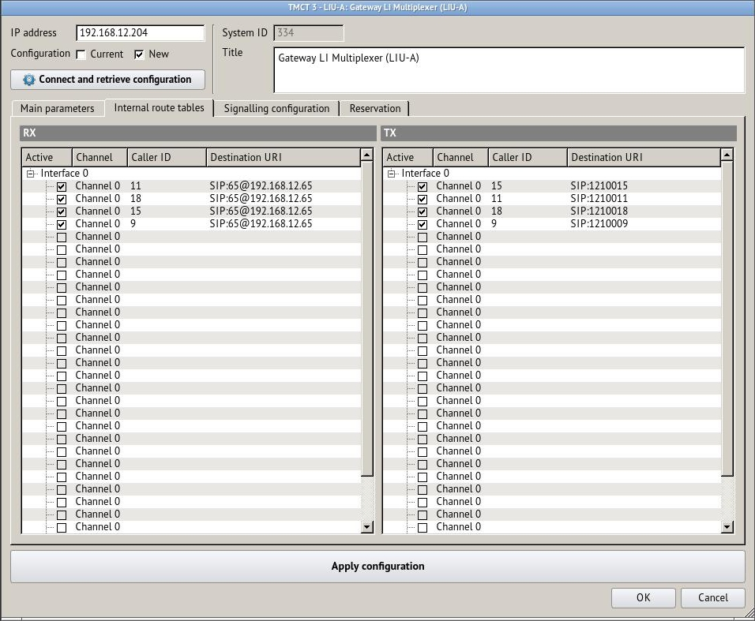
Figure 121 − «LIU-A parameters», tab «Internal route tables»
Parameter «Active» determines whether this record will be processed during search.
– recording is active;
– recording is not active.

The value of «Caller ID» depends on the type of channel signalling.

The allowable values of «Destination URI»: SIP:номер[@ip_адрес[:порт]]

If SIP is used, the address may look as follows, for example: SIP:1001@192.168.12.201

The internal routing tables may be used differently. For example, if parameter «Transmission URI» for a given channel is configured as «TABLE», then depending on URI from table «Transmission» the call was made to, such «Caller ID» will be transmitted on channel signalling.
And if parameter «Reception URI» for a given channel is configured as «TABLE», then depending on URI «Caller ID» received via channel signalling, URI is selected from table «Reception» for redirecting.
The size of the table is fixed and equals to 32 records.

6.3 Signalling Configuration

This tab is used to set up the parameters of SSC, DTMF, LB, FXO, FXS signalling.
Each table line describes signalling settings for a separate channel of respective interface.

6.3.1 SSC signalling type

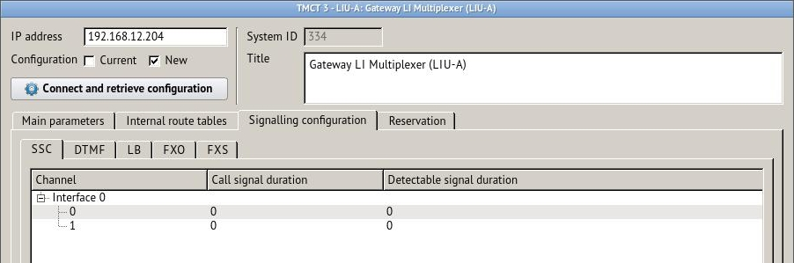
Figure 122 − SSC signalling parameters
«Channel» – sequence number of channel in the interface number X, signalling settings belong to. It assumes a value from 0 to 7.

«Call signal duration» – rated duration of call signal in milliseconds. Value 0 corresponds to default value (600 ms) in accordance with specifications for SSC. Allowable value is from 0 to 65535 ms. LID setting.

«Detectable signal duration» – rated duration of detected signal in ms. Value 0 corresponds to default value (600 ms) in accordance with specifications for SSC. Allowable value is from 0 to 65535 ms. LID setting.

6.3.2 DTMF signalling type

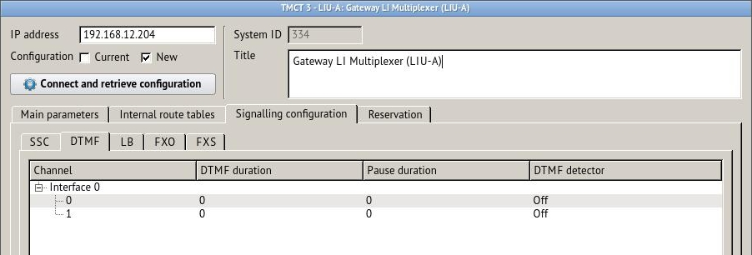
Figure 123 − DTMF signalling parameters
«Channel» – sequence number of channel in the interface number X, signalling settings belong to. It assumes a value from 0 to 7.

«DTMF duration» – duration of DTMF signal in milliseconds. Allowable value is from 0 to 65535 ms. LID setting.
«Pause duration» – duration of pause between two successive DTMF signals in milliseconds. Allowable value is from 0 to 65535 ms. LID setting.

«DTMF detector» – DTMF signalling detector: on/off, selected from the drop-down list, see Figure 124. LID setting.

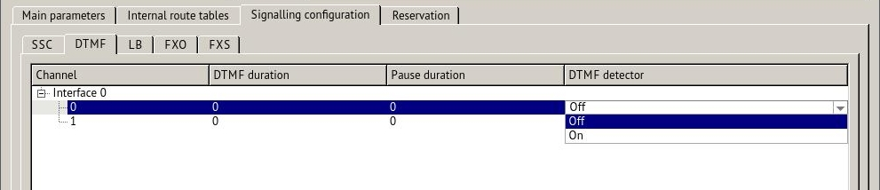
Figure 124 − Activation/deactivation of DTMF detector

6.3.3 LB signalling type

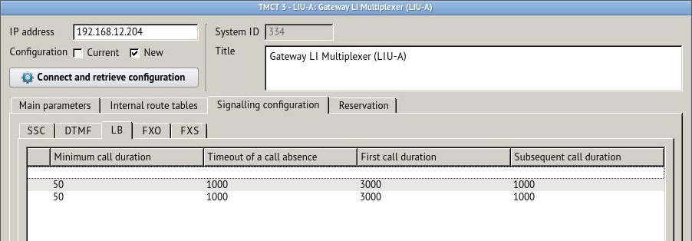
Figure 125 − LB signalling parameters
«Channel» – sequence number of channel in the interface number X, signalling settings belong to. It assumes a value from 0 to 7.

«Call format number» – inductor call format number (frequency/form/power). Allowable value is from 0 to 255. LIA setting.

«Minimum call duration» – minimum duration of inductor call in milliseconds. Allowable value is from 50 to 1000 ms. LIA setting.

«Timeout of a call absence» – timeout of inductor call absence in milliseconds. Allowable value is from 1000 to 65535 ms. LIA setting.

«First call duration» – duration of first inductor call in milliseconds. The first inductor call is made immediately after beginning of session between LIU-A and subscriber. Allowable value is from 0 to 65535 ms. MC setting.

«Subsequent call duration» – duration of next inductor call in milliseconds. The next inductor call is made during established session between LIU-A and subscriber. Allowable value is from 0 to 65535 ms. MC setting.

6.3.4 FXO signalling type

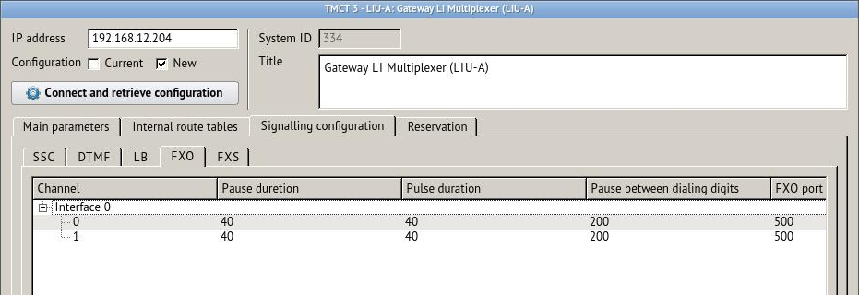
Figure 126 − FXO signalling parameters
«Channel» – sequence number of channel in the interface number X, signalling settings belong to. It assumes a value from 0 to 7.

«Pause duration» – duration of pause between dial pulses in milliseconds. Allowable value is from 30 to 255 ms. LIA setting.

«Pulse duration» – duration of dial pulses in milliseconds. Allowable value is from 30 to 255 ms. LIA setting.

«Pause between dialing digits» – indicated in milliseconds. Allowable value is from 200 to 2000 ms. LIA setting.

«FXO port reset duration» – indicated in milliseconds. Allowable value is from 200 to 2000 ms. LIA setting.

«FXO port seizure duration» – indicated in milliseconds. Allowable value is from 200 to 2000 ms. LIA setting.

«Minimum call duration» – minimum duration of inductor call is indicated in milliseconds. Allowable value is from 50 to 1000 ms. LIA setting.

«Timeout of a call absence» – inductor call absence is indicated in milliseconds. Allowable value is from 1000 to 65535 ms. LIA setting.

6.3.5 FXS signalling type

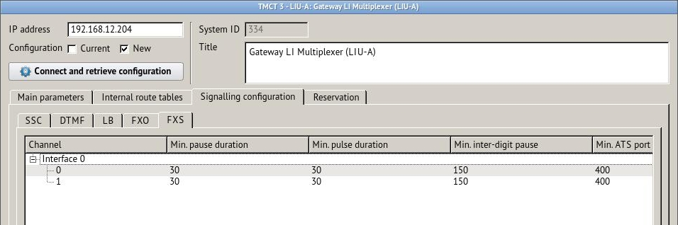
Figure 127 − FXS signalling parameters
«Channel» – sequence number of channel in the interface number X, signalling settings belong to. It assumes a value from 0 to 7.

«Min. pause duration» – minimum duration of pause between dial pulses in milliseconds. Allowable value is from 30 to 255 ms. LIA setting.

«Min. pulse duration» – minimum duration of dial pulses in milliseconds. Allowable value is from 30 to 255 ms. LIA setting.

«Min. inter-digit pause» – minimum inter digit pause, indicated in milliseconds. Allowable value is from 100 to 1000 ms. LIA setting.

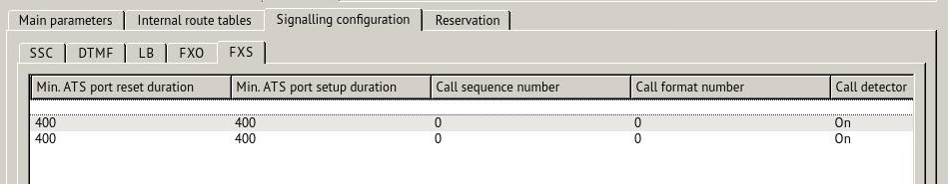
Figure 128 − FXS signalling parameters, continuation
«Min. ATS port reset duration» – indicated in milliseconds. Allowable value is from 200 to 2000 ms. LIA setting.

«Min. ATS port setup duration» – indicated in milliseconds. Allowable value is from 200 to 2000 ms. LIA setting.

«Call sequence number» – number of inductor call sequence (template). Allowable value is from 0 to 255. LIA setting.

«Call format number» – inductor call format number (frequency/form/power). Allowable value is from 0 to 255. LIA setting.

«Call detector» – on/off, selected from the drop-down list. LIA setting.

6.4 Reservation

Tab «Reservation» is intended for system redundancy settings and displaying of the current state of LIU-A resources.

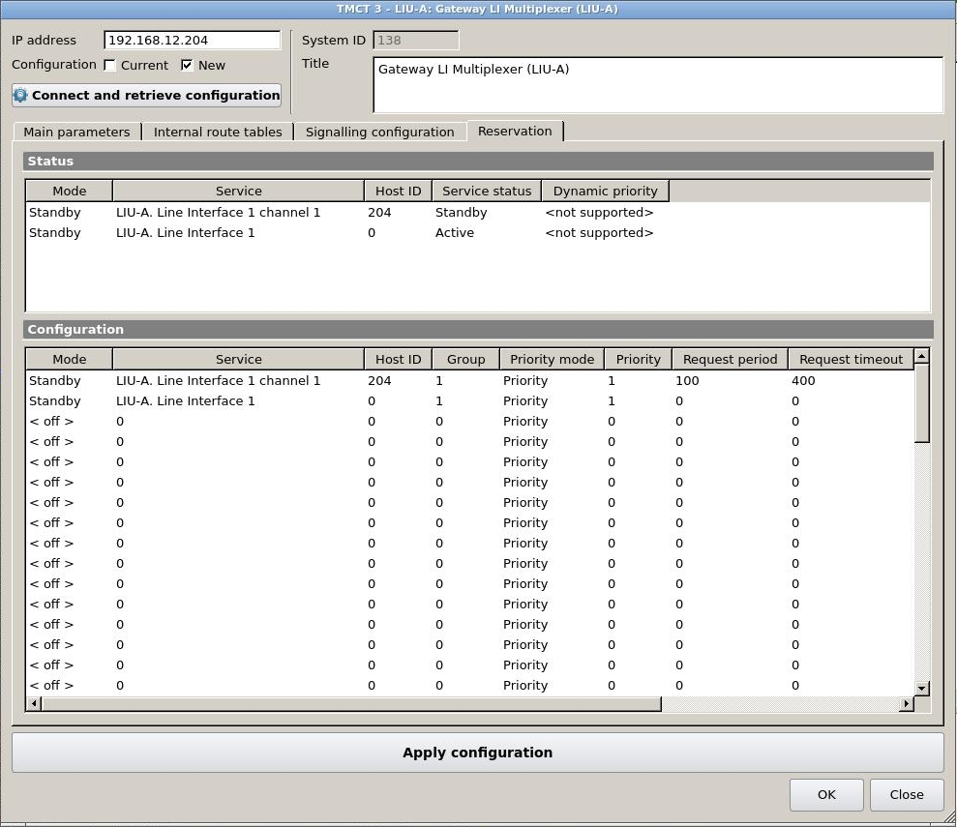
Figure 129 − Setting of reservation mode parameters of LIU-A resources
The current state of LIU-A resources is displayed in the upper part of the tab on the «Status» panel. The configuration of standby parameters is performed in the bottom part of the tab on the «Configuration» panel. When the setting is completed press button «Apply configuration».

«Mode» – record type is selected from the drop-down list:
off – record is not used;
Standby – record gives reservation of resource on the current LIU-A;
SmartCross – record is used in SmartCross configuration table.

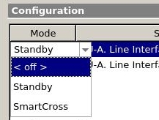
Figure 130 − «Mode», select a record type
«Service» – LIU-A resource selected for reservation. It is selected from drop-down list:
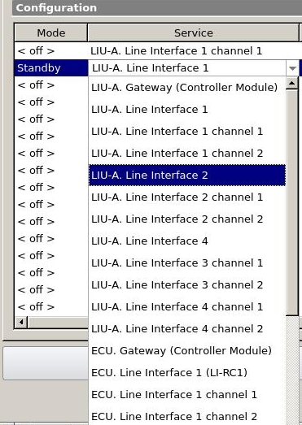
Figure 131 «Service» − The list of available LIU-A resources
The list of available LIU-A resources:
LIU-A. Gateway (MCU);
LIU-A. Line interface 1;
LIU-A. Line interface1 channel 1;
LIU-A. Line interface1 channel 2;
LIU-A. Line interface2;
LIU-A. Line interface2 channel 1;
LIU-A. Line interface2 channel 2;
LIU-A. Line interface3;
LIU-A. Line interface3 channel 1;
LIU-A. Line interface 3 channel 2;
LIU-A. Line interface4;
LIU-A. Line interface4 channel 1;
LIU-A. Line interface4 channel 2;
ECU. Gateway (MCU);
ECU. Line interface1 (LI-RC1);
ECU. Line interface1 channel1;
ECU. Line interface1 channel 2;
ECU. Line interface2 (LI-RC2);
ECU. Line interface2 channel 1;
ECU. Line interface2 channel 2;
ECU. Line interface3 (LI-RC3);
ECU. Line interface3 channel 1;
ECU. Line interface3 channel 2;
ECU. Line interface4 (LI-RC4);
ECU. Line interface4 channel 1;
ECU. Line interface4 channel 2;
ECU. Line interface5 (LI-RC5);
ECU. Line interface5 channel 1;
ECU. Line interface5 channel 2;
ECU. Line interface6 (LI-RC6);
ECU. Line interface6 channel 1;
ECU. Line interface6 channel 2;
ECU. Line interface7 (LI-RC7);
ECU. Line interface7 channel 1;
ECU. Line interface7 channel 2;
ECU. Line interface8 (LI-RC8);
ECU. Line interface8 channel 1;
ECU. Line interface8 channel 2.
«Host ID» – unique host identifier, assumes the value from 0 to0xFFFFFFFF.If «Standby» record type is used, 4 bits of LIU-A IP-address may act as host identifier. If «SmartCross» record type is used, host identifier can be any number.
«Group» – reservation group number, to which the resource belongs. It assumes the value from 0 to 255.
«Priority mode» – the mode of operation of the reservation algorithm, depending on the priority:
0 – «Priority». Service with a higher priority is always the main one. When a new properly functioning service with a higher priority appears in a group of reservation, it becomes the main one;
1 – «Standard». Minimum number of switching between services. The main service will not be changed, even when a new properly functioning service with higher priority appears in the reservation group.
The default value is 0.
«Priority» – static priority, assumes the value from 0 to 255.
«Request period» – time interval in ms, which is used by host to send messages. It assumes the value from 0 to 65535.
«Request timeout» – time interval in ms, during that host waits for a message. It assumes the value from 0 to 65535.

«Transport» – list of transport protocol address information for the reservation protocol. The entries in the list are separated by «;». Valid formats: UDP:IP_MULTICAST:PORT, CAN:ID, CAN:ID:REMOTE_ID, CAN:ID/MASK.
1. UDP. As a transport protocol, UDP is used. IP_MULTICAST – IP address of the multicast group. PORT is the receive and transmit port.
- CAN. All data in ASCII format HEX. For example, A1 or 12E:2FA or 123/7FF.

7 Line Interface Unit Digital (LIU-D) and Line Interface Unit Analog (LIU-А v.2)

This item contains information on parameters required to set up Line Interface Unit Digital (LIU-D) and Line Interface Unit Analog (LIU-А v.2).

LIU-А v.2 consists of a microcontroller board (MC) and a line interface (LI) board that are connected via a motherboard. At the moment LIU-А v.2 is composed of only one MC and one LI. Depending on the version, every LI board supports up to two radio channels and no less than two channels of LSC (loudspeaker communication/telephony). LI consists of two boards connected by a submodule that is an analog part of a line interface (LIA) and a digital part of a line interface (LID). The MC board incorporates 4 virtual DSPs and a virtual switching matrix. G.711 and Lin16 (PCM, 16 bit, 8 kHz) codecs support virtual DSPs.

The setting of LIU-D and LIU-A v.2 parameters is carried out in a web-interface and it has a similar structure. Most of the parameters are identical. Further, in the process of description of LIU-D and LIU-A v.2 setting, differences for each line interface unit will be provided.

When selecting one of the Line Interface Units, a parameter window will be opened. See Figure 132.

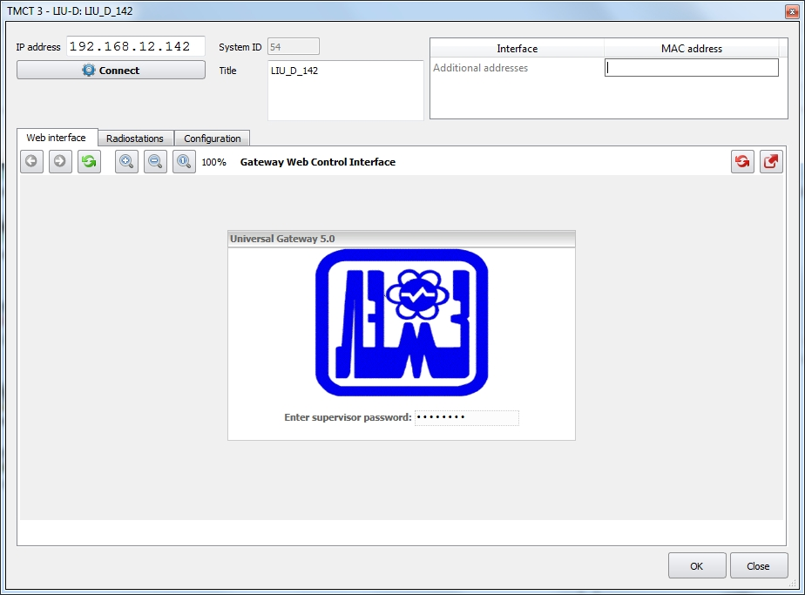
Figure 132 − Configuration editor, LIU-D (LIU-А v.2), password entry
At the top of the window the following fields are located:
Field «IP address» - IP address of the system object. It may be changed as necessary;
Field «Title» – a name of the system object, it is displayed in the scheme of the complex. It may be changed as necessary;
Field «System ID» – an identifier of the system object, it is assigned automatically. This field is not editable.

– when pressing this key, one can check the accessibility at the specified IP address and make a configuration request.

MAC addresses table is next to the parameters. MAC address is an actual physical address of the network devices of the system object. A few MAC addresses divided by «,» sign can be indicated in the field «Additional addresses».

On the «Web interface» tab during the connection a supervisor (supervisor/administrator) password entry window, a user «root», will be opened. To confirm the password, press key «Enter».
After the first successful login the entered password is saved on this TMCT and all subsequent authorizations will be carried out automatically.
In case the wrong password is entered, the following screen is displayed for 15 seconds (time countdown is shown in the lower right corner):

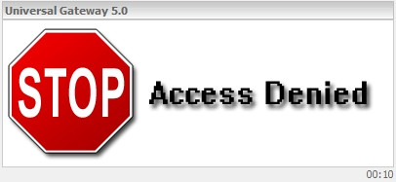
Figure 133 − Screen in case of a wrong password entry
After that the wrong password is reset and the initial screen is displayed. When the correct password is entered, a window with tabs appears, see Figure 134.

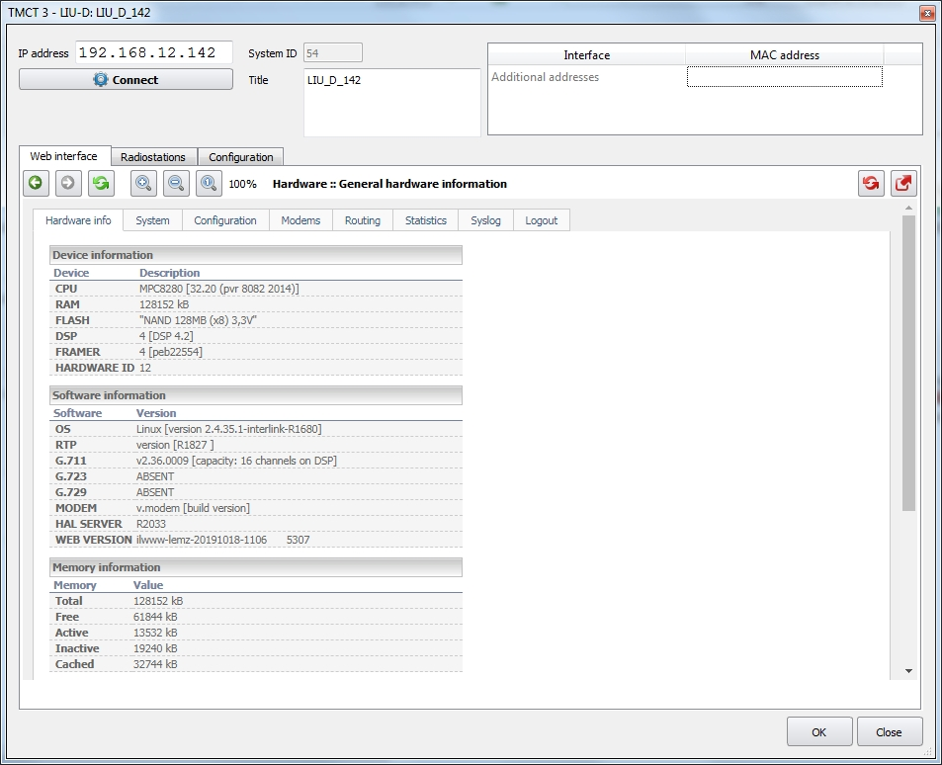
Figure 134 − Configuration editor, LIU-D (LIU-А v.2)
On the tab «Web interface» it is a user to configure gateway, controller software and router software via a single interface.

The «Radiostations» tab is used to register channels in the system, for detailed information see item 7.2 «Channel Registration in the System» of this Manual.

The «Configuration» tab is used to control system configurations. For detailed information see item 7.3 «System configurations control» of this Manual.

7.1 Setting of Web Interface

At any given time, the page with settings, selected by the user, is displayed in the main window:
«Hardware info» – information on available LIU-D (LIU-A v.2) resources, software component versions and RAM use.
«System» – IL software configuring. For LIU-A v.2 configuring the gateway and server software are used.
«Configurations» - controller software configuring.
«Modems» - modem pool configuring. This tab is not available for LIU-A v.2.
«Routing» - router software configuring.
«Statistics» - LIU-D (LIU-A v.2) use statistics.
«Syslog» - viewing of last information (last 500 records), registered locally in the system log Syslog.
«Logout» - a disconnection from http-server.

The tab pages are divided into logically isolated parts (sections), separated by a horizontal separator with a section name. For convenience of working with sections there is a possibility - to expand or - to collapse the section.
A section may contain one or several windows (or contain nothing at all) and command buttons. The section, located at the bottom of the page (with a thin solid line without a name as a divider) belongs to the page as a whole (page «Hardware info», which is completely informative, does not have such a section).

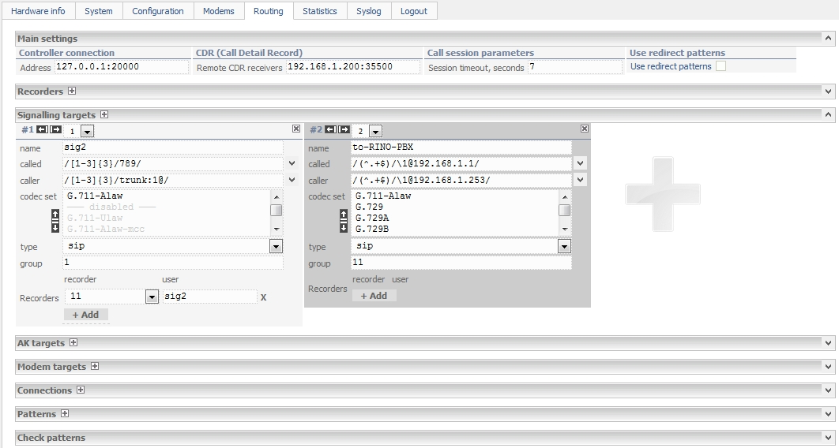
Figure 135 − LIU-D (LIU-A v.2) tabs
To create windows icon – add a window – may be arranged on the horizontal separator. One or several icons – add a child window and icon – close the window may be arranged on the window name toolbar. If there are several icons , when the cursor is pointed at the icon, a pop-up help with instructions on the type of window which will be added if a mouse left button is pressed, appears. The window has a button used to add a new record to the configuration.
The main elements inside the window are text fields (single or multi-line), drop-down lists, commands buttons and markers (check boxes). These elements do not have any specific features.
An additional element is an options list field with a priority and activity indicator. The field has a vertical scroll bar and horizontal separator between the list of active and disabled options. The active options are located in the upper part of the field above the separator and are shown in bold type. The upper most active option has the highest priority. To activate (or disable) an option, as well as to change the priority, use additional controls – arrows:
- up arrow (activation or increasing of the priority);
- down arrow (disabling or decreasing of the priority).
The option of moving in the list is selected with the cursor, the selected option is highlighted with a blue background. When you click on the arrow, the selected option is shifted to another position in the list:

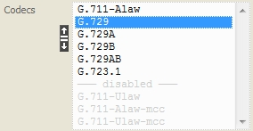

Use the arrows to change the priority of the window in the section. An alternative way to change the priority is a selection of the window sequence number from the drop-down list:
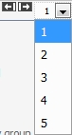

Note: if the new values are not saved during configuration before switching to another page, they will be lost since when you select a page the values are generated again based on the current configuration file values and system utilities output. The LIU-D parameters are saved by pressing the «Save changes» button.

The LIU-A v.2 parameters are saved by pressing the «Save» or «Save & Restart» buttons.

– changes saving.

– changes saving and reset of LIU-A v.2 software.

7.1.1 Page «Hardware info»

It is an information page and it displays summary data on LIU-D (LIU-A v.2) and available resources.
The information, provided on page «Hardware info», is intended mostly for manufacturer's support services. The data on LIU-D (LIU-A v.2) hardware components, available resources, key software module versions, RAM use are displayed on the page. The overall view of the page is shown in Figure 136.

7.1.1.1 Section «Device information»
Section «Device information» contains information on the main components of line interface units.
For LIU-D these components include: a telecommunication central processing unit (CPU), a random access (RAM) and a non-volatile (FLASH) memory, digital signal processors (DSP), a framer (FRAMER), a hardware identifier (HARDWARE ID).

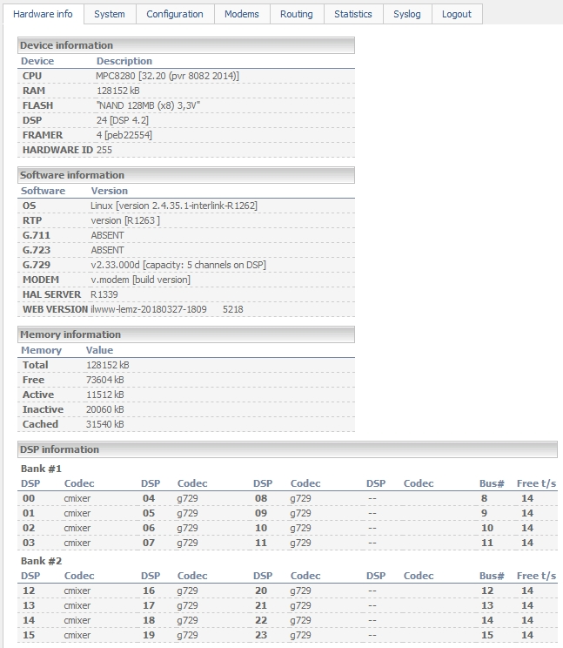
Figure 136 − Overall view of page «Hardware info» for LIU-D
For LIU-A v.2 BOARD NAME (a name of the board) component is present instead of the framer.

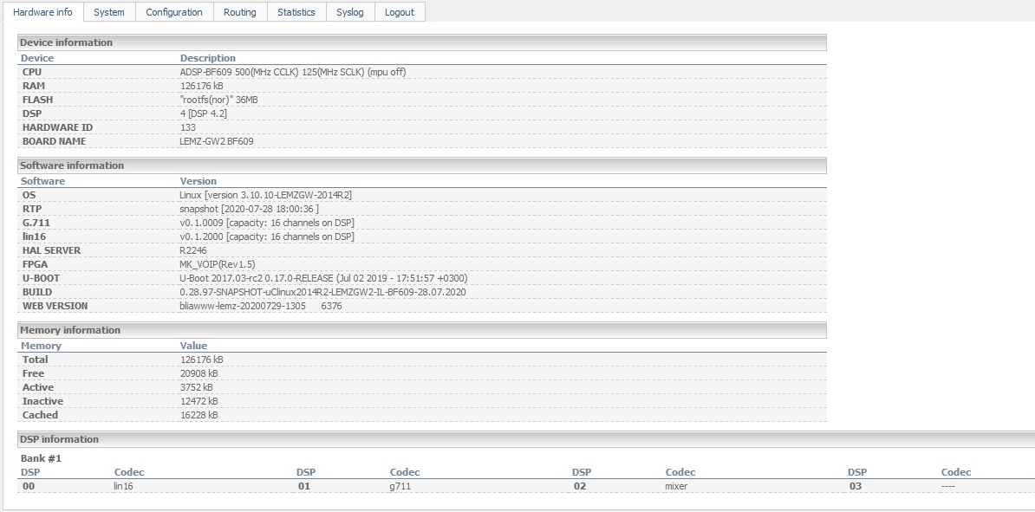
Figure 137 − Overall view of page «Hardware info» for LIU-А v.2
The data for the column «Description» are taken from a virtual file system /proc ОS Linux:

CPU - file /proc/cpuinfo
RAM - file /proc/meminfo
FLASH - file /proc/mtd
DSP - file /proc/dspmap
FRAMER - file /proc/driver/hdlc/peb22554
HARDWARE ID - file /var/monitoring/dip

BOARD NAME - file /proc/cpuinfo (for LIU-A v.2)

7.1.1.2 Section «Software information»
The section «Software information» contains information on key software components of a telecommunication central processing unit and DSP. They include: ОS Linux (OS), ОS driver kvoice (RTP), OS daemon server (HAL SERVER), signal processors software (G.711, G.729, G.723, MODEM).
For LIU-D (LIU-A v.2) the data for column «Version» are taken from the following sources:
OS - file /proc/version
RTP - file /proc/voice/version
G.711 - file /proc/voice/version
HAL SERVER - daemon launch result usr/local/sbin/server with key – version
WEB VERSION - the version of the web interface is generated automatically when
the release is built.

For LIU-D the data for column «Version» are taken from the following sources:
G.723 - file /proc/voice/version
G.729 - file /proc/voice/version
MODEM - file /proc/modem/version

For LIU-A v.2 the data for column «Version» are taken from the following sources:
Lin16 - file /proc/voice/version
FPGA - file /var/fpga-version
U-BOOT - file /var/u-boot-version
BUILD - file /var/version

7.1.1.3 Section «Memory information»
The section «Memory information» contains a standard information on RAM use in Linux OS of the board. It includes: a total memory volume in the system (Total), a memory not used by the system (Free), a used reserved memory (Active), an unused reserve memory (Inactive), a cached memory (Cached).
The data for column «Value» are taken from file /proc/meminfo.

7.1.1.4 Section «DSP information»
The section «DSP information» contains information on the software uploaded to DSP.

For LIU-D in accordance with the design DSP resources are divided between two hardware banks (Bank #1 and Bank #2). The information on the installed DSP modules and availability of uploaded software in DSP is displayed for each bank.

For LIU-А v.2 in accordance with the design DSP resources are located in a single hardware bank (Bank #1 for 4 DSPs). Since DSPs are virtual, they are always assumed to be present. There are 4 DSPs available in total. The information on the installed DSP modules and availability of uploaded software in DSP is displayed for each bank.

Column «DSP» contains a sequence number of a signal processor as a device, the column «Codec» – type (purpose) of uploaded software (in case of «----» software is not uploaded). For non-available (not installed) DSP column Codec is empty.

Column «Bus#» contains the number of bus, on which DSP is located.

Column «Free t/s» provides information on the number of free time slots in each bank bus.

7.1.2 Page «System»

Page «System» is intended to configure a board software and control gateway software loading process (file – /usr/local/etc/interlink.sh).

7.1.2.1 Section «Driver configuration»

Window «Drivers»

The window «Drivers» contains a complete list of drivers, which may be installed in the system. The main part of the drivers is enabled depending on the device specific purpose.
For LIU-D the window «Drivers» is as follows, see Figure 138.

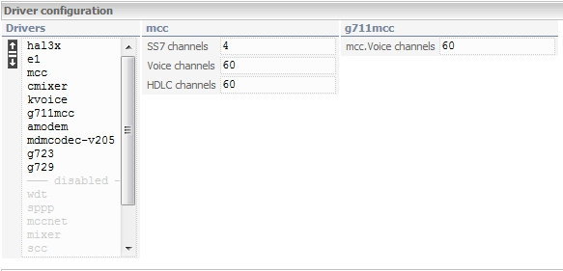
Figure 138 − Section «Driver configuration», window «Drivers» for LIU-D
A brief description of the drivers and recommendations on configuring is given below:

amodem - modem driver;
e1 - framer driver;
g711 - driver + DSP-code of codec G.711;
g711mcc - driver G.711 for mcc-controller;
g723 - driver + DSP-code of codec G.723.1;
g729 - driver + DSP-code of codec G.729ab;
hal3x - service driver, shall be always enabled;
hdlc - service driver, shall be disabled;
kvoice - service driver, shall be always enabled;
lapb - service driver, shall be disabled;
mcc - service driver, shall be always enabled;
mccnet - service driver, shall be disabled;
mdmcodec-v205 - modems DSP-code;
mixer - driver + DSP-code of conference call and DTMF decoder;
cmixer - driver + DSP- code of conference call and DTMF decoder + voice detector;
scc - service driver, shall be disabled;
sppp - service driver, shall be disabled;
wdt - service driver, shall be disabled.
For LIU-A v.2 the window «Drivers» is shown below, see Figure 130. In this window there is a list of drivers which are to be always enabled.

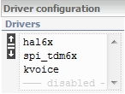
Figure 139 − Section «Driver configuration», window «Drivers» for LIU-A v.2

Window «mcc»

The window «mcc» is used to distribute the resources of the mcc controller of a telecommunication processor. All-in-all there are 128 channels of the mcc controller, which shall be distributed between a framer (double value from field «SS7 channels»), a voice channels pool («Voice channels») and a pool of HDLC controller channels («HDLC channels»).
The number of channels in field «SS7 channels» shall correspond to the total number of signal channels SS7/EDSS1 on the board (including standby ones).
The voice channels pool is reserved for codec G711mcc driver.
The pool of HDLC controller channels is intended to be used in the systems, including digital and analog subscriber line circuit boards. Two channels shall be reserved for each digital line circuit, one channel – for an analog circuit line.
A typical example of mcc channels reservation is given below:
SS7 channels = 4

Voice channels = 60
HDLC channels = 60

For LIU-A v.2 this window is not available.

Window «g711mcc»

The window «g711mcc» is used to assign previously reserved channels of the mcc controller voice pool to the driver of codec g711mcc (field «mcc. Voice channel»). The value in this field shall be less or equal to the number of channels in field «Voice channel» of window «mcc».

For LIU-A v.2 this window is not available.

7.1.2.2 Section «DSP setup»
The section is intended to configure the resources provided by DSP. For LIU-D this section is as follows:

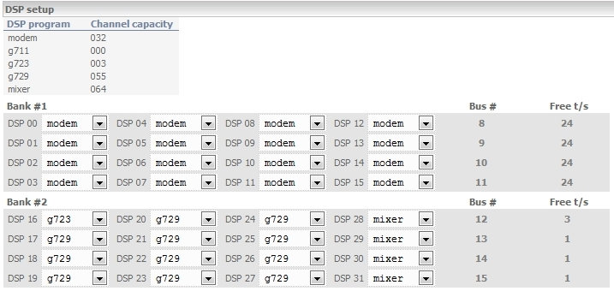
Figure 140 − Section «DSP setup» for LIU-D

Window Resources

The maximum number of channels («Channel capacity»), which may be served using the installed DSP software («DSP program»), is indicated in the information window of maximum amount of resources. For example:

DSP program Channel capacity
modem 032
g711 000
g723 003
g729 055
mixer 064

Warning! Resources, available at the moment of the startup, are indicated in the window.

In accordance with the design, DSP resources are divided between two hardware banks (Bank #1 and Bank #2).

The column «DSP» contains a sequence number of a signal processor as a device. Next to the DSP a drop-down list of DSP software is available for loading (when «----» is selected, software is not loaded to DSP). For the unavailable (not installed) DSP, the element of a drop-down list in the column «Codec» is locked.

Column «Bus#» contains the number of bus, on which DSP is located.
Column «Free t/s» provides information on the number of free time slots in each bank bus. If during attempted configuration (distribution of software between DSP) the limit of time slots is exceeded, a warning, highlighted in color, will appear in the column: negative number – number of time slots over the limit.
Warning! When installing DSP software, make sure you activated the appropriate driver in window «Drivers».
The section «DSP Setup» for LIU-A v.2 is shown below:
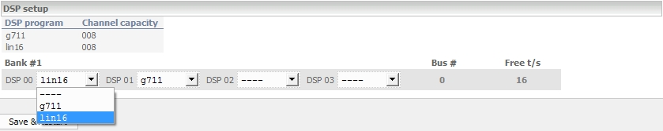
Figure 141 − Section «DSP setup» for LIU-А v.2

Window Resources

The maximum number of channels («Channel capacity»), which may be served using the installed DSP software («DSP program»), is indicated in the information window of maximum amount of resources. For example:

DSP program Channel capacity
g711 016
lin16 016
mixer 016

Warning! Resources, available at the moment of the startup, are indicated in the window.

According to the design the DSP resources are located in a single hardware bank (Bank #1 for 4 DSPs).
The field «DSP» contains a sequence number of a signal processor as a device. The DSP software available for loading is selected from a drop-down list (when «----» is selected, software is not loaded to DSP).

Warning! Since DSPs are virtual, the DSP functionality is available immediately, in particular, codecs Lin16, G711 and mixer.

7.1.2.3 Section «Network configuration»
This section is intended for network settings. For LIU-D and LIU-A v.2 the network setting parameters are similar.

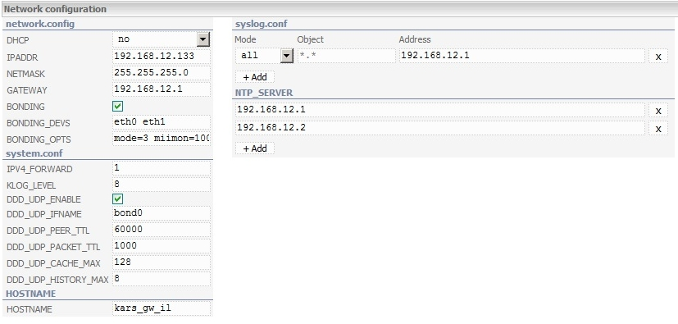
Figure 142 − Section «Network configuration» for LIU-D (LIU-А v.2)

Window «network.config»

Fields description intended for main network settings configuring:

«DHCP» – use of DHCP protocol for IP-address receiving. From a drop-down list «yes/no» may be chosen. By default, it is set to the value of «no». DHCP protocol – network protocol, that allows devices to receive IP-address automatically and other parameters necessary for operation in TCP/IP networks.

«IPADDR» – a static IP-address is indicated. It is used if the value DHCP «no» is set.

«NETMASK» – a sub network mask is specified. It is used if the value DHCP «no» is set.

«GATEWAY» – a default gateway IP-address. It is used if the value DHCP «no» is set.

«BONDING» – set a checkmark, if necessary to unite two physical network interfaces into one logical in order to provide the network fail-safety.

«BONDING_DEVS» – a list of network interfaces united into one logical (bond0). Network interfaces are divided by a space bar. The default value is «eth0 eth1», which is not recommended to change without coordination with a manufacturer.

«BONDING_OPTS» – a list of parameters of bonding interface. The default value is «mode=3 miimon=100», which is not recommended to change without coordination with a manufacturer.
«ALLMULTI» – enable or disable the all-multicast mode. Select «yes / no» from the drop-down list. If the mode is enabled, the interface will receive all multicast packets from the network.

Window «system.cong»

Additional settings of network filter are applied in case of network interfaces unification:
«IPV4_FORWARD» – a redirection of the 4-th version of IP-protocol packets:
1 – on;
0 – off.

«KLOG_LEVEL» – a logging level of kernel message.

«DDD_UDP_ENABLE» – an activation of duplicated packets filter:
no – the filter is off;
yes – the filter is on.
«DDD_UDP_IFNAME» – an interface name, where packet filtration will be carried out. The default value is «bond0».

«DDD_UDP_PEER_TTL» – a lifetime of UDP/ICMP connection in history (packet number).

«DDD_UDP_PACKET_TTL» – a lifetime of packet ID in a packet history of specific connection (packet number).

«DDD_UDP_CACHE_MAX» – a connection history size (number of connections).

«DDD_UDP_HISTORY_MAX» – a history size of identical packets.

Window «HOSTNAME»

«HOSTNAME» – in this field a text name of the host is specified.

Window «syslog.conf»

Use this window to configure a list of addresses for sending messages of the syslog server.
«Mode» – select the type of event logging setting from the drop-down list:
«all» – logging of all events;
«manual» – logging of events according to a given type.
«Object» – specify the type of event for logging in order of increasing severity, for example: debug, info, notice, warning, error, alert. When you select the setting type «all», the field is filled in automatically and cannot be edited.
«Address» – specify the IP - address of the message receiver. When using a non-standard port, it is specified in the address.

Window «NTP_SERVER»

Specify NTP server IP-address to synchronize the time in the NTP server window. If there are several such servers, the IP-addresses are listed in order of priority.

7.1.2.4 Section «Services startup»

In LIU-D (LIU-A v.2) the section «Services startup» is intended to control a software loading that determines a product operability.

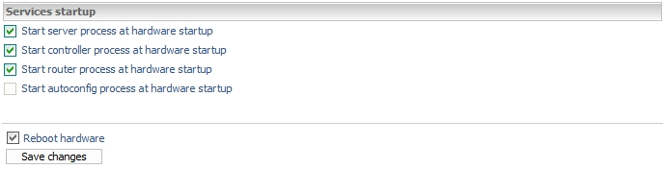
Figure 143 − Section «Services startup» for LIU-D
Check box «Start server process at hardware startup» in LIU-D (LIU-A v.2) equipment shall always be selected.
Check box «Start controller process at hardware startup» is not selected when the board is controlled by the external controller software.
Check box «Start router process at hardware startup» is not selected when an external product control interface is used. The check boxes are used during the equipment reboot.
Check box «Start autoconfig process at hardware startup» activation means that an automatic save and server configuration restore service will be started.
Check box «Reboot hardware» indicates, that the LIU-D software will be rebooted after the changes are saved.
In LIU-D pressing the key «Save changes» restarts the software.

In LIU-A v.2 pressing the key «Save & Restart» saves changes and restarts LIU-A v.2 software, see Figure 144.

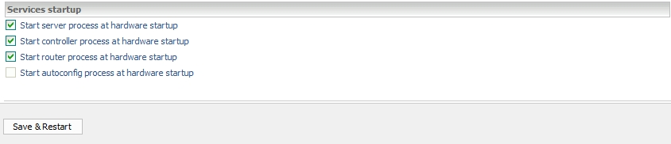
Figure 144 − Section «Services startup» for LIU-A v.2
Warning! In the current version the software changes will be applied only after the software is restarted. An animated screen saver appears on the screen while the software is being restarted:
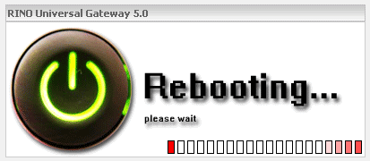
Figure 145 − Software rebooting
After the rebooting process is complete, it is necessary to repeat a login procedure described above.

7.1.3 Page «Configuration»

The page is intended to generate the control data of the controller software and set up the parameters of the controller software interaction with a server software (file – /usr/local/etc/controller.conf).

7.1.3.1 Section «Main settings»
The settings of this section may be changed only based on the manufacturer's recommendations.

For LIU-D the section «Main settings» is as follows:

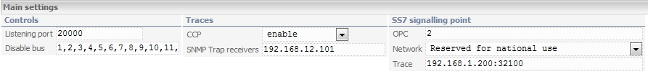
Figure 146 − Section «Main settings» for LIU-D

For LIU-A v.2 the section «Main settings» is as follows:

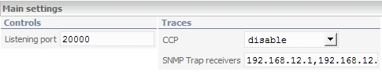
Figure 147 − Section «Main settings» for LIU-A v.2

7.1.3.2 Section «Boards configuration»

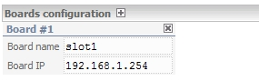
Figure 148 − Section «Boards configuration» for LIU-D (LIU-А v.2)

A symbolic name of the board is indicated in the field «Board name», its IP address – in the field «Board IP».

7.1.3.3 Section «SIP/PJ»
LIU-D and LIU-A v.2 act as UA in the network based on a SIP protocol. The SIP protocol v.2 is implemented in Line Interface Units.
For LIU-D the T.38 protocol (up to 5 channels T.38) is supported. When the voice data is transmitted, codecs G.711, G.729, G.723, based on DSP, may be used. It is not recommended to use codecs G711mcc. When the voice data is transmitted, codec G.711-A-law is used in LIU-A v.2.
The «SIP/PJ» section contains the basic settings of the SIP end. SIP signaling is used in LIU-A v.2 gateways in the LSC mode. In radio mode, SIP is only used for transmitting states through the SIP subscription mechanism.
In the field «Group» a group number for call routing is set. Default value is 10.
Field «Local Contact» is of use as a field «Contact» in the SIP packets. INVITE in SIP packet, for example. The default value is IL-254<sip:IL-254@192.168.12.254:5060>.
Usually an IP address is set depending on «HARDWARE ID». The field «Local Contact» is set depending on the IP address. For example, for the IP address 192.168.12.133, the value will be IL-133<sip:IL-133@192.168.12.133:5060>.
In the field «Log Level» a level of logging is set to SIP ends. The default value is 0.
In the field «PJ Trace Level» logging level in the PJSIP library is set. The default value is 0.
In the field «IO queue trace level» the logging level for receiving and transmitting of SIP packets is set. The default value is 0.
In the field «Local addr» the local IP address is set, which uses SIP ends to receive and transmit packets. The value of this field must match the value of «IPADDR» in the «Network configuration» window on the page «System». The default value is 192.168.12.254.
In the field «UDP port» a local UDP port is set which uses SIP-ending to receive packets. If the value is different from the default value, then the port value must also be changed in the field «Local Contact». The default value is 5060.

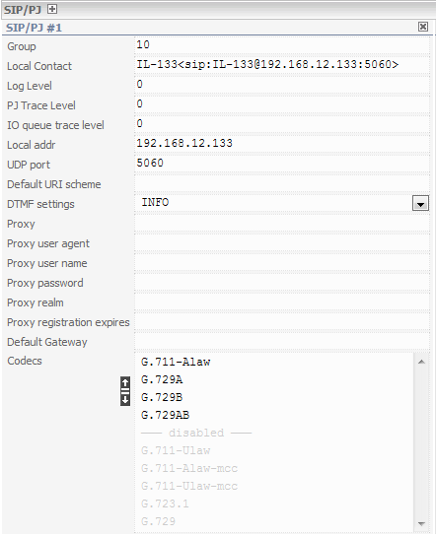
Figure 149 − Section «SIP/PJ» for LIU-D (LIU-А v.2)
Field «Default URI scheme» - a URI scheme in SIP-protocol, default is sip.
Field «DTMF setting» - the DTMF transmission method in a SIP protocol: INFO, In-band or RFC 2833.
Field «Proxy» – a proxy server address, for using a SIP proxy server or a Registrar.
Field «Proxy user agent» – a User Agent string for a proxy server.
Field «Proxy user name» – a user name for authorization on the proxy server.
Field «Proxy password» – the password for the above user.
Field «Proxy realm» – realm for authorization on a proxy server.
Field «Proxy registration expires» – the time in seconds to reregister automatically on the proxy server.
Field «Default Gateway» – a default signalling gateway IP address.
In the field «Codecs» select the codecs that the SIP termination can use. At the moment, the LIU-A v. 2 gateway supports only one codec from the list - this is G. 711-ALaw.

7.1.3.4 Section «RTSP/PJ»
This section’s settings are similar in LIU-D (LIU-А v.2).
The section «RTSP/PJ» contains the main RTSP ending settings. RTSP signaling is used in LIU-A v. 2 gateways for digital recording of radio and telephone calls in accordance with the specification ED-137 B.
RTSP signaling is not used as IP telephony signaling. Based on the above, the RTSP ending must be added and configured if digital recording is required. The main recording setting is located on the page «Routing».

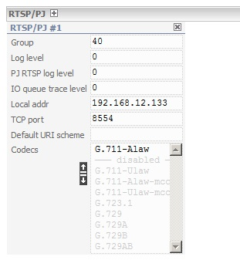
Figure 150 − Section «RTSP/PJ» for LIU-D (LIU-А v.2)
In the field «Group» a group number for calls routing. Due to the fact that the RTSP protocol is not used as a telephony call protocol, the group number is not currently used in any way. The default value is 40.
In the field «Log Level» a logging level to RTSP ending is set. The default value is 0.
In the field «PJ RTSP log level» a logging level in PJ RTSP library is set. The default value is 0.
In the field «IO queue trace level» a logging level for reception and transmission of RTSP packets. The default value is 0.
In the field «Local addr» a local IP address which uses RTSP endings for packets reception and transmission. The value of this field must match the value of «IPADDR» in the «Network configuration» window on the page «System» (see item 7.1.2.3 of this manual). The default value is 192.168.12.254.
In the field «TCP port» - a local TCP port is set, which uses RTSP endings for packets reception and transmission. Since the RTSP protocol is used only for recording, that is, the RTSP ending is created in the RTSP UAC client mode, therefore, the local tcp port is not used in any way, but it is mandatory to specify. The default value is 554.
Field «Default URI scheme» - a URI scheme, the default value is «an empty line».
In the field «Codecs» the codecs that the RTSP ending can use are selected. At the moment, the LIU-A v. 2 gateway supports only one codec from the list - this is G. 711-ALaw.

7.1.3.5 Section «H323 configuration»
This section is intended for LIU-D only. LIU-D acts as a gateway in the network based on H.323 protocol stack without a multi-endpoint connection controller (terminal Type=60). The product is compatible with the most widespread versions of H.323 protocol stack (v2-v4).
To minimize the time of connection establishing, Fast Connect (Fast Start) procedure may be used. The encapsulation of H.245 messages (H245 tunneling) is not used at the moment.
T.38 protocol (up to 5 channels T.38) is supported.
When the voice data is transmitted, codecs G.711, G.729, G.723, based on DSP, may be used. It is not recommended to use codecs G711mcc.
Window «Terminal #» allows to specify personal settings for a specific network point.

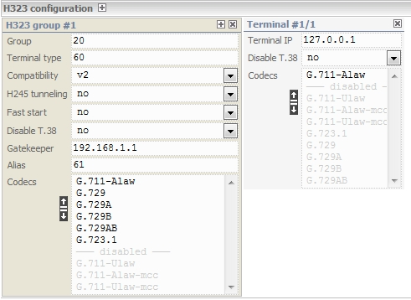
Figure 151 − Section «H323 configuration» for LIU-D

7.1.3.6 Section «E1 Trunks configuration»
This section is intended for LIU-D only. E1 interface configuring consists of referencing of the interface to the board, assigning a unique identifier to each interface within the board, assigning a unique identifier to each interface within the product, selection of signaling system and assigning a group identifier, based on which call routing in the product is carried out.
The interfaces are configured after the gateway board that the interfaces belong to is configured.
A synchronization source is selected depending on the product switching circuit. In case the circuit does not imply the use of E1 interfaces or partner PBX is not a part of network (an internal private or public network) and cannot act as a synchronization source, the built-in synchronization source (mode «free run») is used. Otherwise, a synchronization sequence is taken from the E1 interface reception path, selected during configuring. The interface is selected using its unique (within the product) identifier.
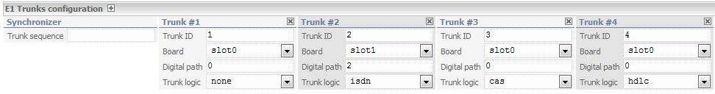
Figure 152 − Section «E1 Trunks configuration» for LIU-D
EDSS1 configuring consists of selection of network side, that means the role of LIU-D for PBX (or other device), connected to this E1 interface – a part of the network or a terminal unit.

Field «Synchronizer» – the selection of E1 interface (Trunk sequence) to extract a synchronization signal from E1 reception path in case an external synchronization source is used. It is filled in with a parameter Trunk ID value.
Field «Trunk ID» – a unique interface identifier within the product (controller). In theory, it assumes a value from 1 to N×4, where N is the number of Interlink boards.
Field «Board» – Interlink board identifier (parameter slot1, slot2, …) within the controller.
Field «Digital path» – E1 interface identifier within each Interlink (Board).
Field «Trunk logic» – the type of signaling used in E1 interface is selected from the drop-down list:
cas – channel-associated signaling using protocols r 1.5, r2, e_and_m (parameter Cas type);
isdn – DSS-1 signaling protocol of ISDN digital network;
ss7 – protocol «common signaling channel No. 7». If this signaling type is selected, go to section «SS7 Configuration» to set up the respective parameters, see item 7.1.3.7 «Section SS7 configuration» of this Manual.
hdlc – a high-level data link protocol used for connection with ECPP (an emergency communication phone panel).

7.1.3.7 Section «SS7 configuration»
This section is intended for LIU-D only. SS7 configuring consists in assigning an address of signaling point (OPC code), DPC code (codes), configuring link sets, setting signaling links and ISUP sub-system parameters.
A signaling point address (OPC) is provided by an appropriate state authority. The number and configuration of link sets is determined by a scheme and conditions of connection to the operator network. Marks of signaling links SLC and codes of DPC destinations are determined by the connecting network operator.
ISUP parameters are selected as agreed with the operator. Channel identification code CIC determines the number of a speaking channel between two sets (five least-significant bits indicate the timeslot, the other ones – E1 number). Timeslots, used as signaling channels, are excluded from speaking channels.
In case the signaling type ss7 is selected in field «Trunk logic» (see item 7.1.3.6 «Section E1 Trunks configuration» of this Manual), set up the parameters of this signaling.

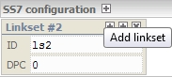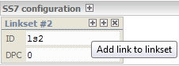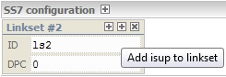
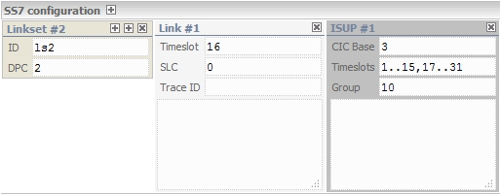
Figure 153 − Section «SS7 configuration» for LIU-D
To create a linkset, press button «Add linkset».

«Linkset» – a link identifier, it is assigned automatically when a link adding button is pressed (Add linkset).
Field «DPC» – a destination point signaling code in the network.

«Link#N» – a description of link N:
Field «Trunk» - a trunk ID is selected from a drop-down list. A trunk ID corresponds to the given Link.
Field «Timeslot» – a channel timeslot of E1 interface signaling;
Field «SLC» – a link code (from 1 to 16).
Field «Trace ID» – an integer-value link identifier (value from 0 to 65535).

«ISUP» – a description of ss7 application part parameters:
Field «Trunk» - a trunk ID is selected from a drop-down list. A trunk ID corresponds to the given ISUP.
Field «CIC Base» – a conditional identifier of initial voice channel timeslots (usually starts with 0).Field «Timeslots» – voice channel timeslots of E1 interface. For a stream with link in the first channel timeslot: 2..31.
Field «Group» – an interface identifier to search for route of router service.

7.1.3.8 Section «ISDN configuration»
This section is used for signaling ISDN settings, used only in LIU-D.

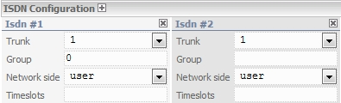
Figure 154 − Section «ISDN configuration» for LIU-D
Field «Trunk» – a trunk ID is selectable from a drop-down list. A trunk ID corresponds to the given ISDN.
Field «Group» – an interface identificator for a route search (field «group») of a router service. The field is available upon signaling ISDN selection (field «Trunk logic»).
Field «Network side» – a network termination side. Values «network» or «user» are selectable from a drop-down list.
Field «Timeslots» – interface E1 «voice» channel intervals. The number of timeslots available for users is between 0 and 31 depending on signaling, most often 30 (timeslot 0 is reserved for service information, slot 16 is recommended for service information but not mandatory). Slots from 1 to 31 can be used for voice and data transmission correspondingly. ISDN format is 1…15, 17…31.

7.1.3.9 Section «CAS configuration»
This section is used for signaling CAS settings, used only in LIU-D.

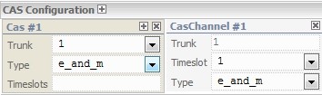
Figure 155 − Section «CAS configuration» for LIU-D
Field «Trunk» – a trunk ID is selectable from a drop-down list. A trunk ID corresponds to the given CAS.
Field «Type» – a signaling type of CAS, selectable from r1.5, r2 or e_and_m drop-down lists.
Field «Timeslots» – interface E1 «voice» channel intervals. CAS format is 1…15, 17…31. Window «CASChannel#» for a specific channel settings will be added if icon «» is pressed:
field «Trunk» – a number of a trunk, the value is taken from the window «Cas#» (Field «Trunk»). No editing is possible;
field «Timeslot» – a timeslot number. It is selectable from a drop-down list, values from 1 to 15 and from 17 to 31. The default value is the first one available from the range, which had no previous settings;
field «Type» – a signaling type. The default value is indicated from «Сas#» window (Field «Type»). A user redefines a logics type by default.

7.1.3.10 Section «Tone Signaling configuration»
This section is used for voice frequency channels settings, it is used only in LIU-D.

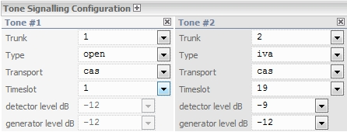
Figure 156 − Section «Tone Signaling configuration» for LIU-D
Field «Trunk» – a tunk’s ID. It is selectable from the list of trunks with «CAS» logics type. This parameter is obligatory.
Field «Type» – a voice frequency signaling type («open», «iva»). The default value is «open». The parameter is obligatory.
Field «Transport» – a transport type. The default value is «cas». The parameter is not subject to edit.
Field «Timeslot» – a timeslot number for the selected signaling type. It is selectable from the list of vacant timeslots (from 1 to 15 and from 17 to 31). The parameter is obligatory.
Field «rx gain dB» is the gain on reception from the TDM for the end in dB. Values from -9 to +24 dB, increment 3. The default value is 0.
Field «vad_voice_th_msec» is the minimum speech duration in milliseconds detected by the voice detector. It can take a value from 0 to 10000. The default value is 80.
Field «vad_silence_th_msec» – the duration of the pause in milliseconds that determines the absence of voice in the channel. It can take a value from 0 to 10000. The default value is 700.
Field «vad_e_th_dB» is the minimum excess of speech over noise detected by the voice detector. Specified in dB, it can take a value from 0 to 90. The default value is 30.
Field «name» is the name of the voice frequency channel.

If a tone signaling type «iva» is selected in «Type» field, two parameters become available for the settings:
field «detector level dB» – a level of detected IVA signals from the line in dB. The values range from -33 to 0 in -3 increments. The default value is -12;
field «generator level dB» – a level of generated IVA signals into the line in dB. The values range from -33 to 0 in -3 increments. The default value is -12.

7.1.3.11 Section «АК configuration»
This section is intended for multi-operated interface boards configuring. The section is intended for LIU-D only.

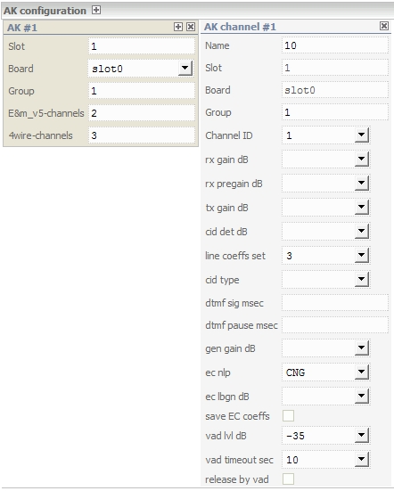
Figure 157− Section «АК configuration» for LIU-D
Window «AK»

Field «Slot» – the number of multi-operated interface board mounting position
Field «Board» – see item 7.1.3.6 of this Manual.
Field «Group» – see item 7.1.3.8 of this Manual.
Field «E&m_v5-channels» – a comma-separated list of channels, which are used as E&M (from 4 to 7). Channels that are not in this list will be used as FXO. Channels from 0 to 3 are always used as FXS.
Field «4wire-channels» – a comma-separated list of 4-wire channels. Channels that are not in this list will be used as 2-wire channels. Channels from 0 to 3 are always used as 2-wire channels.

Window «AK channel»

Field «Name» – the name of the AK channel.
Field «Slot» – the slot number where the corresponding AK board is inserted. The field is filled in automatically when the setting window is added, it is not editable (the value is taken from the settings of the corresponding AK board).
Field «Board» – the symbol name of the board. The field is filled in automatically when the setting is added, it is not editable (the value is taken from the settings of the corresponding AK board).
Field «Group» – a signaling group, which includes the channel to search for route of router service.
Field «Channel ID» – a channel identifier on the board.
Field «rx gain dB» – a gain of the channel for reception in dB. Valid values ​​are from -45 to +45.
Field «rx pregain dB» is the parameter of preamplification in dB. Acceptable values are from -20 to +20 dB.
Field «tx gain dB» – a gain of the channel for transmission in dB. Valid values ​​are from -45 to +45.
Field «cid det dB» – a signal amplification from the line upon «Caller ID» detection in dB. Valid values ​​are from -45 to 45.
Field «line coeffs set» – the adjustment coefficients for the line characteristics. Accepted values ​​are from 0 to 17.
Field «cid type» – «Caller ID» type, selected from the drop-down list. Accepted values ​​are: none (0), FskBellcore (1), DTMF (2). The value may not be specified.
Field «dtmf sig msec» – the length of the DTMF signal sent to the line. It is specified in milliseconds, values ​​from 0 to 6000. The value may not be specified.
Field «dtmf pause msec» – pause duration between DTMF signals sent to the line. It is specified in milliseconds, values ​​from 0 to 6000. The value may not be specified.
Field «gen gain dB» – the level of the generated CID and DTMF signals in dB. Values ​​from -45 to +45. The value may not be specified.
Field «ec_nlp» – a type of the residual echo suppression in the echo suppressor. Acceptable values of none (0), CNG (1), CLIP (2). A default value is CNG.
Field «ec_lbgn» – the level of the comfort noise generated in dB. The values are from -40 to -100 dB. The value may not be specified.
Checkmark «save EC coeffs» - save the echo suppressor coefficients. After saving coefficients or if the page is rebooted, the checkmark will be cleared.
Field «vad lvl dB» – a threshold level of VAD for reception in dB. The maximum value is -5, the minimum value -45, increment 5. A default value is -30 dB.
Field «vad timeout sec» – a channel release timeout when there is no voice to receive according to VAD in seconds. The maximum value is 30, the minimum value is 3, increment 1. A default value is 10 seconds.
Checkmark «release by vad» – if the checkmark is set, the channel will be cleared when there is no voice to receive according to VAD.

7.1.3.12 Section «Redundancy»

In LIU-D (LIU-A v.2) this section is intended for Redundancy configuring. The redundancy is based on the own HSP protocol. The essence of redundancy is the constant monitoring and management of services in order to maintain them in a working state in the event of a failure of a part of the equipment. Services of the same type can be combined into a single group. Services from the same reservation group exchange information about their state, and the main service is selected.
Host – PC, СM or MC that implements HSP.
Service – an abstraction provided by the host. It can be a communication channel, LI, etc. All services are typified and have a well-defined tree-structured hierarchy. The host can also be considered as a root service.
Main Service – a service that is currently in use and is active.
Standby service – a main redundant service. If the main service fails, it becomes the main one.
Standby group – services that are united into one general group for reservation.

The reservation service in LIU-D can be:
E1/Trunk radio channel. When reserving a radio channel, the following scheme is used. The standby group includes radio channels (in general, three). This may be LIU-A v.2 radio channels. There may be several radio stations, there may be one per channel, or there may be one for all channels. The main thing is that all radio stations operate on the same frequency, and reserve one frequency. Reception and transmission is carried out only through the «main» channel, and the «stand by» channels do not transmit or receive anything. Also, radio channels exchange information about the PTT busyness using the HSP protocol.
Subscriber line circuit board channel (AK). When reserving the AK channel, the following scheme is used. The standby group includes AK channels (in general, three). The physical line connects to all channels. However, communication is carried out only through the «main» channel, and the «stand by» channels are transferred to a state in which they do not affect the physical line, and the influence of the line is ignored.
Controller. When the controller is reserved, the entire server is reserved. When reserving a LIU-D, the following scheme is used. The standby group includes two LIU-Ds (in general, three). All LIU-D have the router, controller, and server applications running. The controller on each of the LIU-D is connected to all servers, to the local one and to the other from the standby group. But to be more precise, at any given time, only the «main» controller is connected to the servers, and the «standby» one is not. The stand by controller breaks the connection. Monitoring also goes through the main controller.

The reservation service in LIU-A v. 2 can be:
The radio channel. When reserving a radio channel, the following scheme is used. The standby group includes radio channels (in general, three). These may also be LIU-D radio channels. There may be several radio stations, there may be one per channel, or there may be one for all channels. The main thing is that all radio stations operate on the same frequency, and reserve the same frequency. Reception and transmission is carried out only through the «main» channel. Reception and transmission on the «stand by» channels occur according to the «standby_mode» parameter. Also, radio channels exchange information about the PTT busyness using the HSP protocol.
Controller. Reserving the controller is similar to LIU-D.

Controllers that manage the resources of the reserved services according to the redundancy protocol periodically exchange their states using various messages. UDP is used as the transport protocol. Multicast is used for multicast packet transmission. Multicast group by default 224.0.0.2. Usually the IP address and port correlate with the group ID, for example:
group = 7
224.254.12.7:35007
group = 55
224.254.12.55:35055.

There is its own section for each service, see Figure 158.

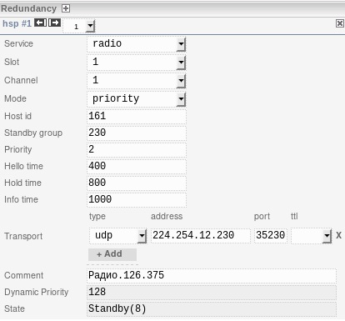
Figure 158 − Section «Redundancy» for LIU-D
For LIU-A v.2, the «Redundancy» section is as follows:
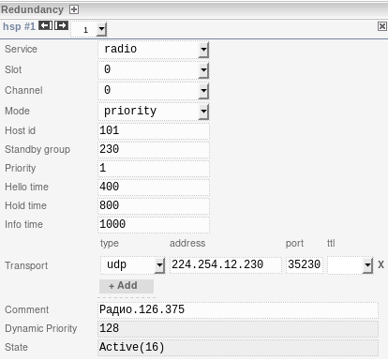
Figure 159 − Section «Redundancy» for LIU-A v.2
In the field «Service» the service to be redundant is selected. Possible options for LIU-D:
«controller» – reservation of the whole LIU-D (controller);
«ak» – reservation of the AK channel;
«radio» – E1/Trunk radio channel reservation.
Possible options for LIU-A v.2:
«controller» – reservation of the whole LIU-A v.2 (controller);
«radio» – radio channel reservation.
Possible values for LIU-D:
from 0 to 15 – for the AK channel. The value of this field should be taken from the field «Slot» in the AK channel settings in the section «AK configuration»;
from 1 to 4 – for the E1/Trunk radio channel. The value of this field is taken from the «cas.trunk.no» in the settings of the corresponding static connection in the section «Connection».

Possible values for LIU-A v. 2:
0 – for the radio channel. The value of this field should be taken from the field «e2m.board.no» in the settings of the corresponding static connection in the section «Connection». Since there is only one LI in LIU-A v.2, then there is only one possible value.
The field «Channel» is the channel number or the time slot number, depending on the type of gateway and the type of service.

Possible values for LIU-D:
from 0 to 7 – for the AK channel;
from 1 to 15 and from 17 to 31 – for the E1/Trunk radio channel. The value of this field should be taken from the «cas.trunk.timeslot» field in the settings of the corresponding static connection in the section «Connection».

Possible values for LIU-A v.2:
from 0 to 1 - for the radio channel. The value of this field should be taken from the field «e2m.board.channel» in the settings of the corresponding static connection in the section «Connection».

Field «Mode» – mode of operation. The mode can be as follows:
- «standard» - «standard» mode, this is the main mode of operation. The key point of this mode is the principle of switching the service from the «Standby» state to the «Active» state. Namely, if any service has become the main one, then the service in the «standard» mode cannot become the main one, even if it has a higher priority.
- «priority» - «priority» mode, this is the second mode of operation. The key point of this mode, as well as in the «standard» mode, is the principle of switching the service from the «Standby» state to the «Active» state. Namely, if the service has a higher priority than the main service, and it has a «priority» mode of operation, then this service can become the main one.
- «passive» - «passive» mode, this is the third mode of operation. The key point of this mode is that the state of the service does not change above the «Listen» state. That is, this service does not participate in the reservation, it only receives and transmits the «Info» message. This mode is typical for emergency radio channels that do not participate in reservation, but only exchange the information on PTT state.
Field «Host id» – the host identifier, must be unique within the standby group. Valid values are from 0 to 4294967295. Usually, the host ID is «HARDWARE ID».
Field «Standby group» – the number of the standby group. Valid values ​​are from 0 to 255.
Field «Priority» – static priority.
Field «Dynamic Priority» dynamic priority. The static priority is set before the reservation algorithm starts. The dynamic priority changes during its operation. It is necessary in order to change the priority of various services depending on any external factors. The «Priority» field is used to select the main service and the standby service: 0 – for selection the highest priority, 255 – the lowest priority. When selecting a new main service, it is selected with the highest priority. First, the dynamic priorities are compared, if they are equal, the static priorities are compared. If both dynamic and static priorities are equal, then a service with a higher host ID is selected. Further, the priority may be implied from both priorities.
Field «Hello time» – a request time. This is the time interval in milliseconds within space of which the service sends «Hello» messages notifying all the services in the standby group that this service is active and in working order. The default value is 1000.
Field «Hold time» – the waiting period. This is the time interval in milliseconds, during which the service expects to receive «Hello» messages from the main and standby services. If the main or standby service does not receive the «Hello» packets during the «Hold time", then this service is considered not working and can be superseded. The default value is 3000.
Field «Info time» – the time period for the «Info» message in milliseconds. The «Info» message is sent periodically in all states, starting with «Listen». For radio channels, it transmits the PTT busy status. The default value is 10000.
Field «Transport»:
«type» – specify the type of transport protocol. Currently, only the UDP protocol is supported;
«addr» – specify the address in the format IP_MULTICAST;
«port» – specify the port, the default value is 35000.
«ttl» – the period of the lifetime of a data packet. This is the numeric value from 0 to 255, the field may be empty. In LIU-A v.2 when you select the «can» protocol, the parameter «ttl» will not be available.
Field «Comment» – the field for entering a comment, it is filled in if necessary.
Field «Dynamic Priority» – dynamic priority, a number from 0 to 255.
Field «State» – state of the service. Possible values:
- «Initial(0)» – initial state. The service is in this state if the hardware does not work properly or has not yet been initialized.
- «Listen(2)» – standby group monitoring state. This is the state in which the service only accepts «Hello» messages, but does not transmit anything other than the «Info» message.
- «Speak(4)» – communication state within standby group. The service periodically sends «Hello» messages. In this state, the service participates in the selection of the stand by and main service.
- «Standby(8)» – standby service state. In this state, the service periodically sends «Hello» messages. A standby group can only have one standby service at a time. This service is ready to replace the main service at any time.
- «Active(16)» – main service state. In this state, the service periodically sends «Hello» messages. A standby group can only have one main service at a time.

Example of setting up a reservation of a radio channel. There are three gateways:
1. LIU-A v2. «Main». IP=192.168.12.101, HardwareID=101, one radio channel.
2. LIU-D. «Stand by». IP=192.168.12.161, HardwareID=161, 10 radio channels.
3. LIU-A v2. «Emergency». IP=192.168.13.1, HardwareID=1, one radio channel.
All three channels are connected to three different «radio stations» operating on the same frequency. The «Main» and «Stand by» gateways are in the same network, and the «Emergency» one is behind the router. Therefore, the transport is configured with ttl=2, so that the router can transfer multicast traffic.

Parameter | Main | Standby | Emergency
Service | radio | radio | radio
Slot | 0 | 1 | 0
Channel | 0 | 1 | 0
Mode | standard | standard | passive
Host id | 101 | 161 | 1
Standby group | 7 | 7 | 7
Priority | 1 | 2 | 3
Hello time | 400 | 400 | 400
Hold time | 800 | 800 | 800
Info time | 1000 | 1000 | 1000
Transport | udp:224.254.1.7:35007:2 | udp:224.254.1.7:35007:2 | udp:224.254.1.7:35007:2
Dynamic Priority | 128 | 128 | 128
State | Active(16) | Standby(8) | Listen(2)

Since all channels in the standby group are radio channels, the values of «Service» for all channels correspond to «radio». The «Slot» and «Channel» settings were taken from the respective channels. The «Mode» is selected as «standard» on the «Main» and «Stand by» channels. «Main» and «Stand by» agree among themselves which of them is the main and which is the stand by. The «emergency» channel works in parallel, so it has a «passive» mode. The indentifier «Host id» is selected to be unique in the context of the standby group. The «Standby group» is common to all channels. The parameter «Priority» is selected according to the roles. The optimal value of «Hello time» at the moment is 400 ms. This parameter is to have the same value for all services within the group. The optimal value of «Hold time» is a value at least twice as large as «Hello time». This parameter must have the same value for all services within the group. The «Info time» parameter is set to 1000 ms, it makes no sense to set less than this value, only more. The transport must have the same value for all services within the group.

7.1.3.13 Section «Emergency Phone configuration»
In LIU-D this section is intended for setting up the ECPP and each phone channel separately. The section is intended for LIU-D only.

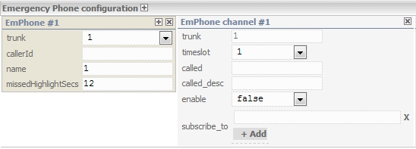
Figure 160 − Section «Emergency Phone configuration» for LIU-D

Window «EmPhone»

The following parameters are used to configure the ECPP.
Field «trunk» – specifies the trunk number to which ECPP is connected (a mandatory parameter). The drop-down list is formed from the trunks that were configured in the «E1 Trunks configuration» section.
Field «callerId» – the number that will be issued in the caller field when called from the ECPP (Caller ID of the emergency telephone). It is a string of numbers. The parameter is optional.
Field «name» indicates the name of the ECPP.
Field «missedHighlightSecs» – the duration of the missed call indication in seconds, the default value is 15 seconds. Valid values ​​are from 0 and above.
Field «Hdlc timeslot» – for ECPP the value is «31».
Field «Hdlc address» – for ECPP the value is «0x1111».

Window «EmPhone channel»

A channel (button) setting is done in the «EmPhone channel» window.
Field «trunk» – the number of the trunk to which ECPP is connected. The value is taken from the «EmPhone» window, the field is not editable.
Field «timeslot» – the timeslot number an emergency telephone button associated with (a mandatory parameter). It takes values ​​from 1 to 17, value 16 is invalid.
Field «called» is the number that will be output in the called field when you call from the button. It is a string of numbers. The parameter is optional.
Field «called-desc» – a string description of the called subscriber when called from the button. It is a string of characters. The parameter is optional.
Field «enable» – a parameter that determines the availability of the button. Select «true» (available) or «false» (not available) from the drop-down list. The parameter is optional.
Field «subscribe_to» – a parameter that determines the subscription to the system resource. It is a string of characters. The parameter is optional.

7.1.3.14 Settings of Section «LEMZGW configuration» for LIU-A v.2. LI settings

In LIU-A v.2 the section «LEMZGW configuration» is intended for the LI parameters setting.
At the moment, the gateway supports three versions of LI (the LI version is determined by the LIA version):
1. LI 1.0 (LIA 1. xx). LI version 1.0 can work in radio mode and in LSC mode. In radio mode, LI 1.0 supports one four-wire channel. In LSC mode, LI 1.0 supports either one four-wire channel or two two-wire channels. In LSC mode, LI 1.0 supports tone signaling and telephone signaling with a voltage range. The logic of operation and voltage are determined by the type of signaling and the LI pattern.
2. LI-T 1.0 (LIA-T 1.xx). LI-T version 1.0 can only work in LSC mode. The LI-T 1.0 supports either one four-wire channel or two two-wire channels. In the LSC mode, LI-T supports telephone signaling with a voltage in the range from -60 to +60V. The logic of operation and voltage are determined only by the type of signaling, patterns are not used in the LI-T.
3. LI 2.0 (LIA 2.xx). LI version 2.0 can work in radio mode and in LSC mode. In radio mode, LI 2.0 supports up to two four-wire channels. In LSC mode, LI 2.0 supports up to two channels in two-wire or four-wire mode. In LSC mode, LI supports only tone signaling. The logic of operation is determined by the type of signaling and the LI pattern.
The window «Lemzgw #1» contains the LI settings. Since the LIU-A v.2 gateway works with one LI only, there is only one LI configuration window.

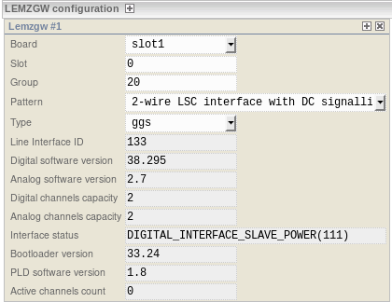
Figure 161 − Section «LEMZGW configuration» for LIU-А v.2 LI settings
Figure 161 shows the LI settings window. The fields with a gray background color correspond to the states and statuses of the LI and are read-only fields.
In the field «Board», select the name of the server to which LI is logically connected (i.e., the server running on the host to which LI is physically connected). For LIU-A v.2, the server, controller, and router are running on the same host. Therefore, there is no need to change the default value «slot1».
In the field «Slot», select the sequence number of the LI. Since the LIU-A v.2 gateway works with only one LI, there is no need to change the value of this field. The default value is 0.
In the field «Group», select the group number for calls routing. At the moment, the group number is not used in any way. The default value is 20.
In the field «Pattern», select one pattern from the list of available patterns 1.0. The list contains the file names, the files themselves are located in the /usr/local/etc/patterns/en directory and have the extension *.pattern. The selected pattern is used to configure LI 1.0.
A list of all the patterns and the logic of LI work:
- «2-wire LSC interface with DC signalling (-24V)» – two-wire LSC interface with direct current signaling (PRB) - 24V;
- «2-wire LSC interface with DC signalling (12V)» – two-wire LSC interface with 12V direct current signaling;
- «3-wire LSC interface with control via one separate pair (dry contact, E&M)» – three-wire LSC interface with separate pair control (dry contact, E&M);
- «4-wire interface with control of phantom signalling of frame potential» – four-wire interface with phantom signaling control via frame potential;
- «4-wire interface with control of phantom signalling with voltage of +24V» – four-wire interface with +24V phantom signaling control;
- «4-wire interface with control of phantom signalling with voltage of +30V» – four-wire interface with +30V phantom signaling control;
- «4-wire interface with control of phantom signalling with voltage of +60V (SWITCH ON RADIO SET pulse 1000ms)» – four-wire interface with +60 V phantom signaling control (RS ON pulse 1000ms);
- «4-wire interface with control of phantom signalling with voltage of +60V (SWITCH ON RADIO SET pulse 500ms)» – four-wire interface with +60 V phantom signaling control (RS ON 500 ms pulse);
- «4-wire interface with control of phantom signalling with voltage of -27V» – four-wire interface with phantom signaling control -27V;
- «6-wire interface with control of frame potential via one separate pair» – six-wire interface with phantom signaling control via frame potential on a separate pair;
- «6-wire interface with control of phantom signalling and frame potential via one separate pair» – six-wire interface with phantom signaling control via frame potential and frame potential control on a separate pair;
- «6-wire interface with control of phantom signalling with voltage of 60V and frame potential via one separate pair» – six-wire interface with +60V phantom signaling control and frame potential control via a separate pair;
- «6-Wire Int. Tangenta +24v M2» – six-wire interface with +24V PTT control via a separate pair;
- «8-wire interface with control of frame potential via two separate pairs interface without control signal» – eight-wire interface with frame potential control via two separate pairs;
- «Interface without control signalling» – interface without a control signal. If one of the digital (tone) signaling is configured in the LI, then you are to select this pattern.
In the field «Type», select LI type. There are two possible options:
- «radio» - radio line interface;
- «ggs» - LSC line interface.
Field «Line Interface ID» contains the value «HARDWARE ID». Physically, the dip-switch is located on the cross-board. LI reads it and then passes it to the MC.
Field «Digital software version» – LID software version in «major.minor» format.
Field «Analog software version» – LIA software version in «major.minor» format.
Field «Digital channels capacity» – number of channels which LID supports.
Field «Analog channels capacity» – number of channels which LIA supports.
Field «Interface status» contains the state of the line interface. In the LIU-A and LIU-A v.2 monitoring, this state corresponds to the state of the system element general-purpose LI board (LI).
Field «Bootloader version» contains the LID bootloader version in the «major.minor» format.
Field «PLD software version» contains LID FPGA software version in the «major.minor» format.
Field «Active channels count» contains the number of active LI channels. This state corresponds to the state of the «Channel Activity (LI 1)» indicator in the LIU-A v.2 monitoring.

LI setting in LSC mode

After selecting the type of LI signaling, you can add channels for this particular LI. The «GGS Channel» windows contain the LSC channel settings. LI supports up to two LSC channels, respectively, there can be no more than two «GGS channel» windows.
Conventionally, all the LSC channel parameters can be divided into four groups:
1. Channel name.
2. Statuses. This is the «STATUS» section. All fields in this section have a grayer background color, which means that these fields are read-only. This section contains the various LSC channel statuses and states.
3. Basic settings. This is the «MAIN SETTINGS» section. This section contains the main channel parameters.
4. Other settings. These are the «GAIN» and «OTHER SETTINGS» sections. The «GAIN» section contains the channel gain parameters. The «OTHER SETTINGS» section contains all the other settings.

Field «name» contains the particular channel name (alias). The name is not used anywhere else and has only an informative function.
Field «Channel status» contains the channel status. In the LIU-A and LIU-A v.2 monitoring, this state corresponds to the state of one of the indicators «LI 1 channel 1» or «LI 1 channel 2».
Field «Call status» contains this particular channel call status. Possible values:
«free» – the line is free, there is no call;
«busy» – the line is busy, the line signals that it is engaged;
«out-call» – outgoing call to the line (in LI);
«in-call» – incoming call from the line (from LI).
Field «group» contains the group number. Due to the fact that most of the types of LSC calls (signallings) do not have any address or number information, switching is carried out by the group number. Therefore, this parameter is required and very important for LSC channel configuring.
Field «channel» contains the channel number. Possible values are 0 or 1.
Field «pattern» - select one pattern from the list of available patterns 2.0. The list contains the file names, the files themselves are located in the directory /usr/local/etc/patterns/en and have the extension *.pattern2. The selected pattern is used to configure LI 2.0 channel. A list of all the patterns and the logic of LI operation:
- «4-Wire Int. Tangenta +27v Phantom-SG» – battery controlled PTT switch +27V relatively SG (signal ground) via phantom (transmission pair);
- «5-Wire Int. Tangenta fantom-SG» – SG (signal ground) potential controlled PTT switch via phantom (transmission pair);
- «6-Wire Int. Tangenta +27v M-SG» – battery controlled PTT switch +27V relatively SG (signal ground) through a separate wire (signal «M»);
- «6-Wire Int. Tangenta dry-conact M-SG + fantom-SG» – SG (signal ground) potential controlled PTT switch via the phantom (transmission pair) and via a separate wire («M» signal) simultaneously;
- «6-Wire Int. Tangenta dry-conact M-SG» – SG (signal ground) potential controlled PTT switch through a separate wire (signal «M»);
- «6-Wire Int. Tangenta dry-conact M-SG Squelch E-SG» – SG (signal ground) potential controlled PTT switch through a separate wire (signal «M»). Carrier detection is determined by the SG (signal ground) potential supply through a separate wire (signal «E»);
- «6-Wire Int. Tangenta dry-conact M-SG + fantom-SG Squelch E-SG + fantom-SG» – SG (signal ground) potential controlled PTT switch through the phantom (transmission pair) and through a separate wire (signal «M») simultaneously. Carrier detection is determined by the SG (signal ground) potential supply through a separate wire (signal «E») and through the phantom (reception pair) simultaneously;
- «Interface without control signalling» – interface without control signal. If one of the digital (tone) signallings is configured in LI 2.0, then you select this pattern.
In the field «wire», select the type of connection. Possible values:
«2-wire» – two-wire channel;
«4-wire» – a four-wire channel.

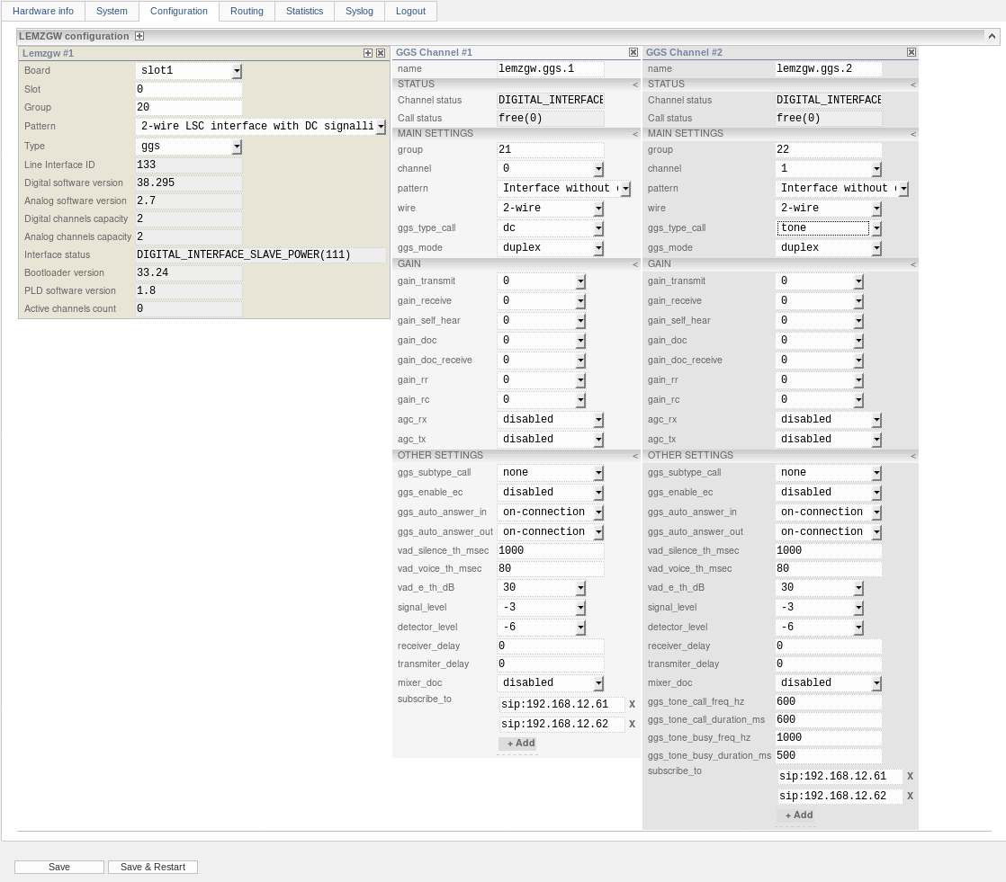
Figure 162 − LI settings in LSC mode
For LI 1.0 and LI-T 1.0 the following configurations are possible:

№ | Description | Parameter  «channel» | Parameter «wire» | Parameter  «channel» | Parameter  «wire»
1 | One two-wire channel | 0 | 2-wire
2 | Two two-wire channels | 0 | 2-wire | 1 | 2-wire
3 | One two-wire channel | 0 | 4-wire

Configuration options with two channels of different connection type, when one channel is two-wire and the other one - four-wire for the LI 1.0 and LI-T 1.0 boards is not allowed. In this case, only the channel with the number «0» will be configured, and the channel with the number «1» will be ignored.
In LSC mode, LI 2.0 supports up to two channels in two-wire or four-wire mode. If you exclude the option of setting up LI without channels, then all 8 combinations of channel settings are possible.
In the field «ggs_type_call», the call type is configured. In LSC mode, LI supports the following call types:
1. «Direct current (DC) control» – this signaling type can work on two-wire and four-wire channels. The logic of work and voltage are determined by the LI pattern. This call type is only supported by LI 1.0.
2. «Voice frequency control (Tone)» – this signalling type can work on two-wire and four-wire channels. Incoming and outgoing calls are made by generating a voice frequency. The call release (busyness) is determined by the voice frequency detector from the line. The busyness transmission is carried out by generating a voice frequency to the line. The signalling parameters are set for each channel separately. The amplitude of voice frequencies is set in the field «signal_level» in dB. The frequency detector trigger threshold is set in «detector_level» in dB. The call tone frequency is set in the field «ggs_tone_call_freq_hz» in Hz. The duration of the call tone is set in the field «ggs_tone_call_duration_ms» in milliseconds. The call release / busyness frequency is set in the field «ggs_tone_busy_freq_hz» in Hz. The duration of the call release / busyness tone is set in the field «ggs_tone_busy_duration_ms» in milliseconds. This type of call is supported in LI 1.0 and 2.0.
3. «Voice actuated control» – this signaling type can work on two-wire and four-wire channels. Both reception and transmission are activated by the presence of a voice in the line. The presence of a voice is determined by the VAD (voice activity detector) settings. Namely «vad_silence_th_msec», «vad_voice_th_msec», «vad_e_th_dB». This type of call is supported in LI 1.0 and 2.0.
4. «FXO Telephony» – this type of signaling can only work on two-wire channels. This call type is supported only in LI-T 1.0. The dialing (call) type is configured in the «ggs_subtype_call» parameter. The time parameters are configurable, but not available in the web interface:
«PulseMake» – the pause duration between the dial pulses in milliseconds. The possible range of values is from 30 to 255. The default value is 40.
«PulseBreak» – the dial pulses duration in milliseconds. The possible range of values is from 30 to 255. The default value is 40.
«PulsePause» – inter-digit pause in milliseconds. The possible range of values is from 200 to 2000. The default value is 200.
«Flash» – the duration of the PBX port reset in milliseconds. The possible range of values is from 200 to 2000. The default value is 500.
«Seize» – the duration of the PBX port seizing in milliseconds. The possible range of values is from 200 to 2000. The default value is 500.
«RingDet» – the minimum duration of an inductor call in milliseconds. The possible range of values is from 50 to 1000. The default value is 50.
«RingOff» – the inductor call absence timeout, in milliseconds. The possible range of values is from 1000 to 65535. The default value is 1000.
5. «FXS Telephony» – this type of signaling is not supported.
6. «MB Call» – this type of signaling can only work on two-wire channels. This type of call is supported only in LI-T 1.0. The call type is configured in the «ggs_subtype_call» parameter. Time parameters are configurable, but not available in the web interface:
«RingForm» – the inductor call format number (frequency/form/capacity). The possible range of values is from 0 to 255. The default value is 0.
«RingDet» – the inductor call minimum duration in milliseconds. The possible range of values is from 50 to 1000. The default value is 50.
«RingOff» – the inductor call absence timeout in milliseconds. The possible range of values is from 1000 to 65535. The default value is 1000.
«RingFirst» – the first inductor call duration, in milliseconds. The first inductor call is sent immediately after the session is raised between the LIU-A and the subscriber. The possible range of values is from 0 to 65535. The default value is 3000.
«RingNext» – the successive inductor call duration in milliseconds. The next inductor call is sent during the already established session between the LIU-A and the subscriber. The next call is implemented through the busy symbol transfer (flash/#) from the subscriber to the LIU-A. The possible range of values is from 0 to 65535. The default value is 1000.
7. «IVA Voice Frequency Control (IVA)» – this signaling type can work on two-wire and four-wire channels. An incoming and outgoing call is made by generating one of nineteen pairs of voice frequencies. The voice frequencies amplitude is set in the field «signal_level» in dB. The frequency pulse detector trigger threshold is set in «detector_level» in dB. This call type is supported in LI1.0 and 2.0. Time parameters are configurable, but not available in the web interface:
«TransInterval» - the call signal nominal duration in milliseconds. The possible range of values is from 0 to 65535. The default value is 600.
«DetectInterval» – the detected signal nominal duration in milliseconds. The possible range of values is from 0 to 65535. The default value is 600.
8. «DPU 60V (DPU60)» – this signaling type can work on two-wire and four-wire channels. This call type is only supported by LI-T 1.0.
9. «DPU A (DPUA)» – this signaling type can work on two-wire and four-wire channels. This call type is only supported by LI-T 1.0.
10. «DPU 60V and voice control (DPUVI)» – this signaling type can work on two-wire and four-wire channels. This call type is only supported by LI-T 1.0.
11. «PRB Direct Current Control (PRB)» – this signaling type can work on two-wire and four-wire channels. The operation and voltage logic are determined by the LI pattern. This call type is only supported by LI 1.0.
12. «E&M and Voice Control (EMVI)» – this signaling type can work on two-wire and four-wire channels. The operation and voltage logic are determined by the LI pattern. This call type is only supported by LI 1.0.
In the field «ggs_mode», the channel operation mode is selected. Possible values:
«simplex» – simplex mode;
«duplex» – duplex mode.
The selected channel operation mode is implemented in the LID, where all sound processing takes place. The default value is «duplex».
In the field «gain_transmit», the transmission gain is selected. Units of measurement - dB. The possible range of values is from -45 to 39. The default value is 0.
In the field «gain_receive», the reception gain is selected. Units of measurement - dB. The possible range of values is from -45 to 39. The default value is 0.
In the field «gain_self_hear», the self-listening gain is selected. Units of measurement - dB. The possible range of values is from -60 to 24. The default value is 0.
In the field «gain_doc», the recording output gain (the first recording channel) is selected. Units of measurement - dB. The possible range of values is from -45 to 39. The default value is 0.
In the field «gain_doc_receive», the receive-only recording output gain (the second recording channel) is selected. Units of measurement - dB. The possible range of values is from -45 to 39. The default value is 0.
In the field «gain_rr», select the tuning resistor gain RR. The possible range of values is from -127 to 128. The default value is 0.
In the field «gain.rc», select the tuning resistor gain RC. The possible range of values is from -127 to 128. The default value is 0.
In the field «agc_rx», the reception AGC is configured. It can take the value «disabled» (off), «ali» (enabled on the LIA) and «dli» (enabled on the LID on the codec). The default value is «disabled».
In the field «agc_tx», the transmission AGC is configured. It can take the value «disabled» (off) or «enabled» (on). The default value is «disabled».
In the field «ggs_subtype_call», the GGS channel signaling subtype is configured. It can take the following values:
1) «none» is the default value. If the signaling subtype is not defined for the channel, then this value is used;
2) «seize» – the value is relevant only for FXO telephone signaling, MB. To make a call, you only need to «pick up the handset»;
3) «tone» – the value is relevant only for FXO telephone signaling. To make a call, you need to «pick up the handset», and to dial the number, use the tone mode;
4) «pulse» – the value is only relevant for FXO telephone signaling. To make a call, you need to «pick up the handset», and to dial the number, use the pulse mode.
The default value is «none».
In the field «ggs_enable_ec», the echo canceller operation is configured. It can take the value «disabled» (off) or «enabled» (on). The default value is «disabled». It makes sense to activate the echo canceller on two-wire channels, for such channels it helps to deal with linear echo. It is unable to handle the acoustic echo.
In the field «ggs_auto_answer_in», the mode of an incoming call answering operation from the network to the line is configured. It can take the following values:
1) «on-connection» – answer all incoming connections at once;
2) «on-calling» – answer if the line is working and after call sending to the line;
3) «on-call» – answer if the line is working and after receiving confirmation that the call was answered in the line.
For example, if the LSC channel is configured in the «Voice frequency control (Tone)» or «IVA Tone Control (IVA)» mode, and the parameter «ggs_auto_answer_in» is set to «on-connection». The corresponding button is configured on the VCDT. Then, during a call from the VCDT LSC channel, you can hear a tone signal on the VCDT, which is transmitted to the line. If on the contrary, there is no need to hear the tone signal, then it is enough to set the parameter «ggs_auto_answer_in» to «on-call». The default value is «on-connection».
In the field «ggs_auto_answer_out», the outgoing call response mode from the line to the network is configured. This parameter describes the conditions under which the «CALL» state is transmitted to the line, signaling a successful call completion. It can take the following values:
1) «on-connection» – answer immediately after raising the signalling session;
2) «on-calling» – answer immediately after the remote subscriber has started signaling about incoming call (ringing);
3) «on-call» – answer immediately after raising the media session.
For example, if the LSC channel is configured in the «Direct Current Control (DC)» mode. The parameter «ggs_auto_answer_out» is set to «on-call». The corresponding button without auto-answer is configured on the VCDT. Then, during a call from the LSC channel to the VCDT, the successful call completion signaling will be transmitted to the line only after the answer at the VCDT. The default value is «on-connection».
In the field «vad_silence_th_msec», the duration of the pause in milliseconds is set to determine the absence of voice in the channel. It can take a value from 0 to 10000. The default value is 1000.
The field «vad_voice_th_msec», the minimum speech duration in milliseconds detected by the voice detector is set. It can take a value from 0 to 10000. The default value is 80.
In the field «vad_e_th_dB», the minimum speech excess over noise detected by the voice detector is set. Specified in dB, it can take a value from 0 to 90. The default value is 30.

All three parameters «vad_silence_th_msec», «vad_voice_th_msec» and «vad_e_th_dB» are responsible for the VAD operation. The VAD operation algorithm is as follows. The sound is processed in frames of 8 msec. For each frame, the attribute is determined whether this frame refers to voice or noise. To form this attribute, the parameter «vad_e_th_dB» is important. It determines how much the voice level estimate in the frame must exceed the noise level estimate in dB in order for the frame to be considered voice. In other words, the higher the value of the parameter «vad_e_th_dB», the greater the signal-to-noise ratio in the frame must be in order for the frame to be considered voice.
The algorithm considers that the signal has a voice as soon as it meets a continuous sequence of voice frames with a duration of at least «vad_voice_th_msec» (i.e., if we set the parameter «vad_voice_th_msec» to 50 msec, the algorithm will issue an active VAD as soon as it meets at least 7 consecutive voice frames (7 *8 = 56 msec)).
The algorithm considers that the voice has stopped in the signal as soon as it encounters a continuous sequence of non-voice frames (in which the sign of the voice presence in the frame is inactive) with a duration of at least «vad_silence_th_msec» (i.e., if we set the parameter «vad_silence_th_msec» to 600 msec, the algorithm will issue an inactive VAD as soon as it encounters at least 75 non-voice frames in a row (75 * 8 = 600msec)).
In the field «signal_level», the signaling signal level is set relative to the voice signal level in dB. It can take a value from -45 to 45. The default value is -3. The value of this parameter is used as the signaling amplitude in channels with the call type «Voice frequency control (Tone)» and «IVA Tone Control».
In the field «detector_level», the signal level for the signaling detector in dB is set. It can take a value from -90 to 0. The default value is -6. The value of this parameter is used as the threshold for triggering the signaling detector in channels with the call type «Voice frequency control (Tone)» and «IVA Tone Control». Transmission lines can significantly weaken and garble the signal. Therefore, for the tone signaling receiver/detector normal operation of the, it is recommended to set the value of «detector_level» to -14. If the detector is working, you can increase the threshold in increments of 3 dB, if the detector is not working, then reduce it.
In the field «receiver_delay», the reception voice delay is set in milliseconds. It can take a value from 0 to 2500. The default value is 0.
In the field «transmiter_delay», the transmission voice delay in milliseconds is set. It can take a value from 0 to 2500. The default value is 0.
In the field «mixer_doc», you can configure the mode of recording mixer operation. It can take the following values:
«disabled» – the recording mixer is disabled;
«enabled» – the recording mixer is enabled.
The default value is «disabled». The recording mixer only works in LI 1.0 in radio mode.
In the field «ggs_tone_call_freq_hz», the call tone frequency in Hz is set. It can take a value from 300 to 3400. The default value is 600.
In the field «ggs_tone_call_duration_ms», the call tone duration in milliseconds is set. It can take a value from 0 to 3000. The default value is 600.
In the field «ggs_tone_busy_freq_hz», the cancel/busy tone frequency in Hz is set. It can take a value from 300 to 3400. The default value is 1000.
In the field «ggs_tone_busy_duration_ms», the cancel/busy tone duration in milliseconds is set. It can take a value from 0 to 3000. The default value is 500.
The parameters «ggs_tone_call_freq_hz», «ggs_tone_call_duration_ms», «ggs_tone_busy_freq_hz» and «ggs_tone_busy_duration_ms» are specific only for the channel with the signaling type «Voice frequency control (Tone)». Therefore, they become available only when the «Voice frequency control (Tone)» call type is selected. For a normal tone call, the default settings are used:
«ggs_tone_call_freq_hz» – 600 Hz;
«ggs_tone_call_duration_ms» – 600 ms;
«ggs_tone_busy_freq_hz» – 1000 Hz;
«ggs_tone_busy_duration_ms» – 500 ms.
To call DJH1 device, use the settings:
«ggs_tone_call_freq_hz» – 600 Hz;
«ggs_tone_call_duration_ms» – 1000 ms;
«ggs_tone_busy_freq_hz» – 1000 Hz;
«ggs_tone_busy_duration_ms» – 500 ms.
In the fields «subscribe_to», the SIP URIs of the called VCDT (subscribers) are configured. LIU-A v. 2 subscribes to these SIP URIs, and if they are busy, transmits the busyness to the line, provided that the channel signaling supports this. If more than one subscription is set up, the busyness is determined by the «OR» principle. Busyness is transferred to the line if at least one of the subscriptions is occupied. For example, there is busy state is in the «Direct Current Control (DC)» signaling.

LI setting in Radio mode

After selecting the LI signaling type, you can add channels for this LI. The «Radio Channel» windows contain the radio channel settings. LI 2.0 supports up to two radio channels, so there can be no more than two «Radio Channel» windows. Conventionally, all the parameters of the radio channel can be divided into four groups:
1. Channel name.
2. Statuses. This is «STATUS» section. All fields in this section have a gray background color, which means that these fields are read-only. This section contains various statuses and radio channel states.
3. Basic settings. This is «BASIC SETTINGS» section. This section contains the main parameters of the channel.
4. Other settings. These are the following sections:
«REDUNDANCY» – redundancy operation parameters.
«GAIN» – channel gain parameters.
«BSS» – the «Best Signal Selection (BSS)» algorithm parameters.
«REMOTE CONTROL» – parameters of the radio station control via communication line.
«REMOTE CONTROL VIA RS 232/485» – radio station control operation parameters via the serial interface.
«OTHER SETTINGS» – this section contains all other parameters.
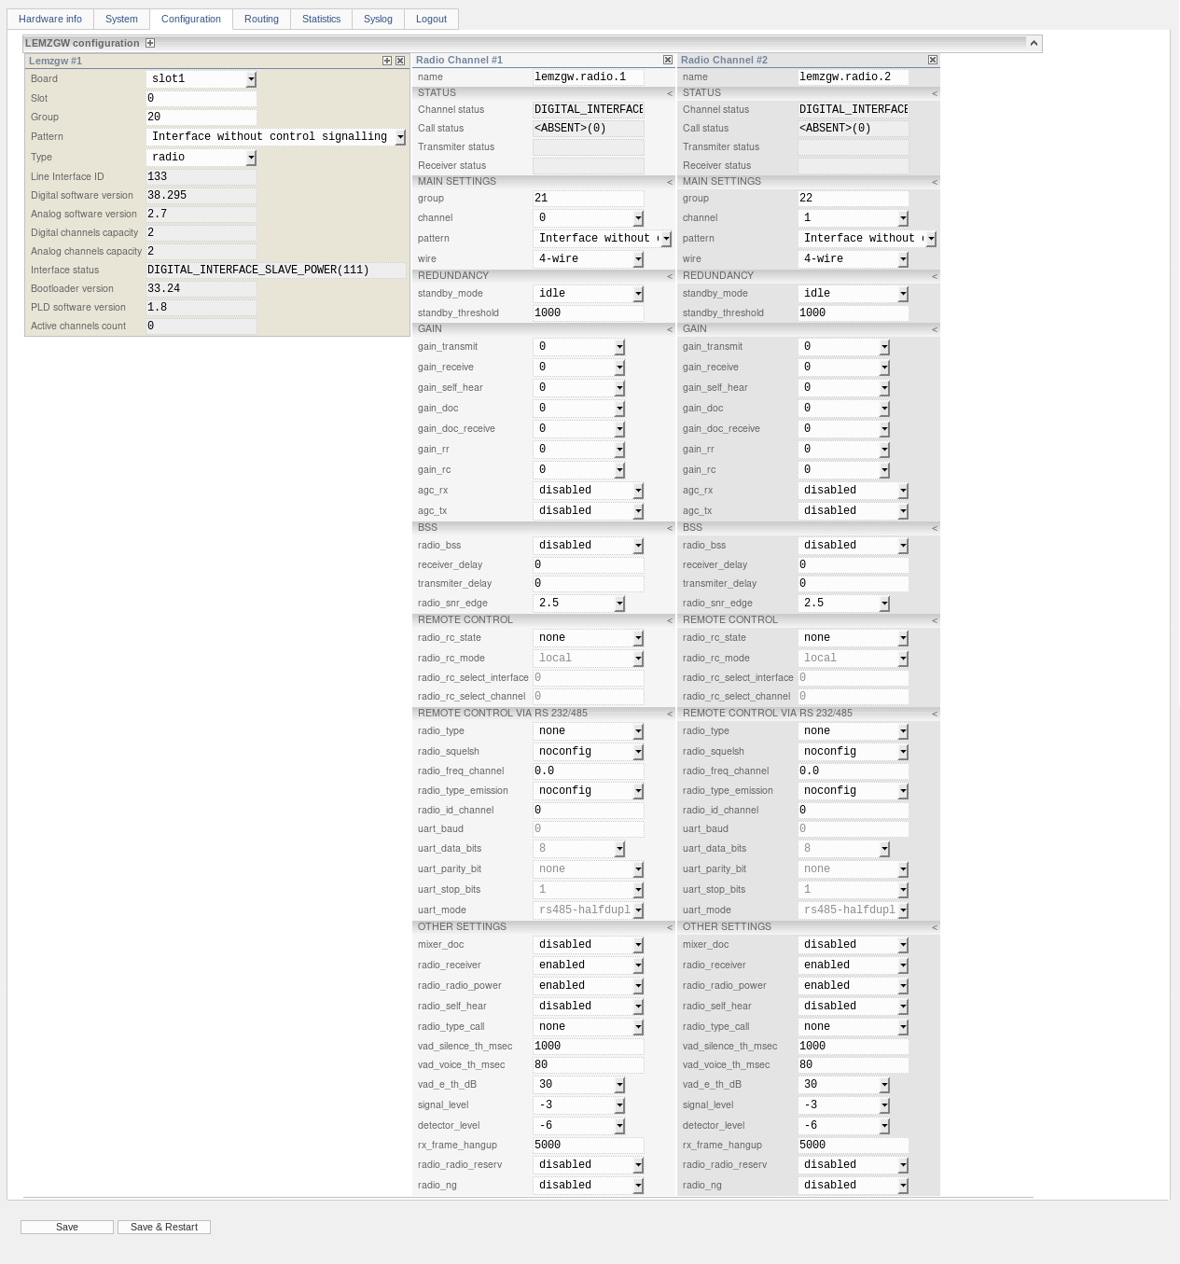
Figure 163 − Radio Mode LI settings
The «name» field contains the name (alias) for this channel. The name is not used anywhere and has only an informative function.
The «Channel status» field contains the status of this channel. In LIU-A and LIU-A v.2 monitoring this state corresponds to the state of one of the indicators «LI 1 channel 1» or «LI 1 channel 2».
The «Call status» field contains the call status of this channel. Possible values are:
ABSENT – none of the checkmarks are set.
PTT – PTT is pressed, transmission status.
SQL – carrier detect signal, receive status.
RxVAD – a voice detector has been triggered.
For a channel, all states are independent of each other and can occur simultaneously, so they will be listed and separated by the «|» symbol. For example, «<ABSENT> (0)», «PTT (1)», or «RxVAD | SQL (6)».
The «Transmiter status» field contains the transmitter status of this channel. This state is available in the web interface only when redundancy is configured for the radio channel and one of the «loop-check» modes is selected as a standby_mode. In LIU-A and LIU-A v.2 monitoring this state corresponds to the state of one of the indicators: «LI transmitter 1 channel 1» and «LI transmitter 1 channel 2».
The «Receiver status» field contains the receiver status of this channel. This state is available in the web interface only when redundancy is configured for the radio channel and one of the «loop-check» modes is selected as the standby_mode. In LIU-A and LIU-A v.2 monitoring this state corresponds to the state of one of the indicators: «LI receiver 1 channel 1» and «LI receiver 1 channel 2».
The group number is configured in the «group» field. Typically, the radio channel is switched with RTP over a static connection, which is configured on «Routing» page in the «Connections» section. Switching occurs according to the specified LI and channel identifiers, and not according to the group number. Although this parameter is not used, it is required.
The channel number is configured in the «channel» field. Possible values ​​are 0 or 1.
In the «pattern» field, one pattern is selected from the list of available 2.0 patterns. The list of patterns is exactly the same as the list of patterns for LSC channel.
In the «wire» field, the conduction type is selected. Possible values are:
«4-wire» is a four-wire channel.
The «standby_mode» field is used to select the standby mode. If a channel is in a reservation group, then in general it can be either «main» or «standby». The redundancy operating mode describes the actions that take place when the status of the backup changes. Possible values:
«Idle» – if the channel changed its state and became «standby», then do nothing;
«Sound-off» – if the channel changed its state and became «standby», then the sound for transmission to the line is turned off;
«Call-off» – if the channel has changed its state and has become «standby», then the sound for transmission to the line is turned off, and the call is canceled (PTT is released);
«Loop-check-vad» – if the channel has changed state and became «standby», then the sound for transmission to the line is turned off, and the call is canceled (PTT is released). Also, when choosing the «main» receiver/transmitter, a listening algorithm based on a voice detector is used.
«Loop-check-ptt-sql» – if the channel has changed state and has become «standby», then the sound for transmission to the line is turned off, and the call is canceled (is released). Also, when the «main» receiver / transmitter is selected, a listening algorithm based on PTT and carrier presence is used. The default value for this parameter is «idle».
In the «standby_threshold» field, the Standby Threshold parameter is adjusted. The parameter is used as a threshold value for the listening algorithm operation. It can take a value from 0 to 65535. The default value is 1000.
The settings in the «GAIN» section completely coincide with the settings of the LCS channel.
In the «radio_bss» field, the state of BSS function «Best Signal Selection (BSS)» is configured. It can be «disabled» or «enabled». The default is «disabled».
In the «receiver_delay» field, the voice delay is configured to receive it in milliseconds. It can take a value from 0 to 2500. The default value is 0.
In the «transmiter_delay» field, the voice transmission delay is configured in milliseconds. It can take a value from 0 to 2500. The default value is 0.
In the «radio_snr_edge» field, SNR (signal-to-noise ratio) threshold is set, which determines the presence of a speech signal in the channel. It is indicated in dB, the possible values range ​​is from -10 to +10. The default is 2.5. This parameter refers to the settings for BSS algorithm.
In the «radio_rc_state» field, the type of radio station control (RSCT) over communication lines is configured. It can take the following values:
«none» – control over communication lines is disabled, control is performed according to the pattern;
«analog_local» – local control of the radio station, LIA is responsible for the control;
«digital_remote_tone_1020» – remote control of the radio station with a voice frequency of 1020 Hz, LID is responsible for the control;
«digital_remote_tp112» – remote control of the radio station «Tangenta Plus» version 1.1.2, LID is responsible for control;
«digital_remote_tone_2600» – remote control of the radio station with a voice frequency of 2600Hz, LID is responsible for the control;
«digital_local_tone_1020» – local control of the radio station with a voice frequency of 1020 Hz, LID is responsible for the control;
«digital_local_tone_2600» – local control of the radio station with a voice frequency of 2600 Hz, LID is responsible for the control;
«digital_local_tone_2700» – local control of the radio station with a voice frequency of 2700 Hz, LID is responsible for control.
«digital_local_tone_2175» – local control of the radio station with a voice frequency of 2175 Hz, LID is responsible for the control.
Tone control involves controlling the push-to-talk signal using a voice frequency.
If the value of the parameter «radio_rc_state» is different from «none», then «radio_rc_mode», «radio_rc_select_interface» and «radio_rc_select_channel» become available for editing.
In the «radio_rc_mode» field, the operating mode of the radio station control is configured. Remote control implies that there is «controller» and «controlled». The «manager» is the one who controls and sends commands, the local ending. «Controlled» is the one who is controlled, the one who executes the commands, the remote ending. The operating mode determines the role of the channel in remote control; it can take on the value:
«Local» – «controller».
«Remote» – «controlled».
The default is «local».
In the «radio_rc_select_interface» field, the number of the interface (radio station) at the remote end is configured. The value is relevant provided that the LI is configured as the local/near end of the RRSC. Integer> = 0. The default value is 0. The value is valid provided that the LI is configured as a local end. And the type of radio control must have a value of one of «digital_remote_xxx».
In the «radio_rc_select_channel» field, the channel (radio station) number at the remote end is configured. Integer> = 0. The default value is 0. The value is valid provided that the LI is configured as a local end. And the type of radio control must have a value of one of «digital_remote_xxx».
In the «radio_type» field, the type of controlled radio station or device is configured. Can take values:
«none» – control is disabled;
«fazan19» – radio station Fazan-19;
«polet» – radio station Flight;
«pp500» – radio station PP500;
«fazan» – radio station Fazan;
«smartcross» – SmartCross device (SC-16X3L).
The default is «none». If a value other than none is specified in the «radio_type» field, then the parameters become available for editing.
In the «uart_baud» field, the baud rate for the serial interface is configured. Integer> = 0. The default is 0. Typical speeds are 75, 110, 300, 1200, 2400, 4800, 9600, 19200, 38400, 57600, and 115200.
In the «uart_data_bits» field, the size of the data symbol in bits is set. An integer from 5 to 9. The default is 8.
Use of the parity bit is configured in the «uart_parity_bit» field. It can take the value:
«none» – do not use the parity bit;
«even» – the parity bit is even;
«odd» – odd parity bit.
The default is «none».
The «uart_stop_bits» field is used to set the number of stop bits. An integer from 1 to 2. The default is 1.
In the «uart_mode» field, the operating mode of the serial interface is configured. It can take the value:
«rs485-halfduplex» – reception/transmission of control commands via RS-485 interface in half-duplex mode;
«rs485-fullduplex» – reception/transmission of control commands via RS-485 interface in full duplex mode;
«rs232» – reception/transmission of control commands via RS-232 interface in full duplex mode.
The default is «rs485-halfduplex».
For example, if «radio_type» is «fazan» or «fazan19», then the default parameters can be set as follows:
«uart_baud» – 115200;
«uart_data_bits» – 8;
«uart_parity_bit» – «none»;
«uart_stop_bits» – 2;
«uart_mode» – «rs485-halfduplex».
If «radio_type» is «polet» or «pp500», then the default parameters can be set as follows:
«uart_baud» – 9600;
«uart_data_bits» – 8;
«uart_parity_bit» – «none»;
«uart_stop_bits» – 1;
«uart_mode» - «rs485-halfduplex».
If «radio_type» is «smartcross», then the default parameters can be set as follows:
«uart_baud» – 115200;
«uart_data_bits» – 8;
«uart_parity_bit» – «none»;
«uart_stop_bits» – 1;
«uart_mode» – «rs485-fullduplex».

Some radios allow you to control themself by means of commands received via a serial interface.
In the «radio_freq_channel» field, the frequency of the radio station's channel is set in MHz. The command to change the frequency is transmitted to the radio station, immediately after establishing a connection with it via the serial interface. The possible range of values is from 0 to 500.0. The default value is 144.0. If set to 0, it means that the value will be read from the radio station.
In the «radio_id_channel»field – the radio station's channel ID (number). The command to change the channel is transmitted to the radio station, immediately after establishing a connection with it via the serial interface. The possible range of values is from 0 to 65535. The default value is 0. If set to 0, it means that the value will be read from the radio station.
In the «radio_squelsh» field, the noise canceller operation mode is set. It can take the following values:
«noconfig» – not configured;
«disabled» – the noise canceller is disabled;
«enabled» – the noise canceller is enabled.
The default value is «noconfig». If «noconfig» is selected, it means that the value will be read from the radio station.
In the «radio_type_emission» field, the radio station's emission class is configured. It can take the following values:
«noconfig» – the parameter is not used;
«N0N» – radiation with a modulated carrier;
«J3E» – single-band amplitude telephony with suppressed carrier;
«NZE» – single-band amplitude telephony with full carrier;
«R3E» – single-band amplitude telephony with a weakened carrier;
«F1B» – single - channel frequency teletype;
«G1B» – single-channel phase teletype;
«A1B» – amplitude teletype.
The default value is «noconfig». If «noconfig» is selected, it means that the value will be read from the radio station.
In the «mixer_doc» field, you can configure the mode of recording mixer operation. The recording mixer only works in LI 1.0 in radio mode. It can take the following values:
«disabled» -–the recording mixer is disabled. This means that the TX signal will be output to the first recording channel, and the RX signal will be output to the second recording channel;
«enabled» – the recording mixer is enabled. This means that the mixed RX+TX signal will be output to the first recording channel, and RX signal - in the second recording channel.
The default value is «disabled».
In the «radio_receiver» field, the radio station reception control is configured. It can take the following values:
«disabled» – reception is disabled. This means that the LI does not let in the reception sound from the radio station to the MC;
«enabled» – reception is enabled. This means that LI is passing the reception sound from the radio station to the MC.
The default value is «enabled».
In the «radio_radio_power» field, the radio station power control is configured. LI has the ability to control the power supply to the radio station. It can take the following values:
«disabled» – power is off;
«enabled» – power is on.
The default value is «enabled».
In the «radio_self_hear» field, self-listening control is configured. For the radio channel in LI, you can enable self-listening. This means that the transmission will be mixed with the reception, thus you can check the passage of the sound to LIA and back. It can take the following values:
«disabled» – self-listening is disabled;
«enabled» – self-listening is enabled.
The default value is «disabled».
In the «radio_radio_reserv» field, the radio station reservation control is configured. LI has the ability to control, via a dedicated line, the switching between the main and standby radio stations. It can take the following values:
«disabled» – disable the transition signal to the standby radio station;
«enabled» – send a transition signal to the standby radio station.
The default value is «disabled».
In the «radio_type_call» field, the call type by the radio station is configured. It can take the following values:
«none» – no additional call type is used for this channel;
«selcal» – a selective call «SELCAL».
The selective call operation principle is as follows: after the radio station has started transmitting, a sequence of tones is transmitted to the air.
The default value is «none».
The parameters «vad_silence_th_msec», «vad_voice_th_msec» and «vad_e_th_dB» are described in the LSC channel.
In the «signal_level» field, the signaling signal level relative to the voice signal level is set in dB. It can take a value from -45 to 45. The default value is -3. The value of this parameter is used as the signaling amplitude in the channel with remote control and in the channel with a selective call «SELCAL».
In the «detector_level» field, the signal level for the signaling detector is set in dB. It can take a value from -90 to 0. The default value is -6. The value of this parameter is used as the threshold for signaling detector triggering in remote-controlled channels.
In the «rx_frame_hangup» field, cancel is configured if there are no voice frames (RTP packets) to receive from the network. If there are no RTP packets from VCDT within the specified time in milliseconds, then the call (PTT) is rejected. It can take a value from 0 to 65535. A value of 0 means that the function is disabled. The default value is 5000.
In the «radio_ng» field, the noise reduction function is configured. Noise reduction works as follows: if there is no sound/voice in the line, active noise cancellation is activated. If a sound/voice appears, the noise cancellation is disabled. It can take the following values:
«disabled» – disable noise cancellation;
«enabled» – enable noise cancellation.
The default value is «disabled».

7.1.3.15 Save changes
In LIU-D changes are saved by setting the appropriate check marks and pressing the key «Save changes».

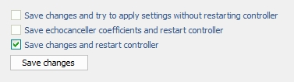
Figure 164 − Saving changes in LIU-D
The check mark «Save changes and try to apply setting without restarting controller» – save changes and try to apply them without restarting the controller.
The check mark «Save echocanceller coefficients and restart controller» – save echo canceller coefficients and restart the controller. If this check mark is set and the button «Save changes» is pressed, the user will save coefficients of those channels that have the check mark «Save EC coeff» set, see item 7.1.3.11 «AK configuration» of this Manual.
The check mark «Save changes and restart controller» - save changes and restart the controller.

In LIU-A v.2 changes are saved by pressing the keys «Save» or «Save & Restart».

7.1.4 Page Modems

The page «Modems» is intended to configure fax modems support. This setting is only available for LIU-D.

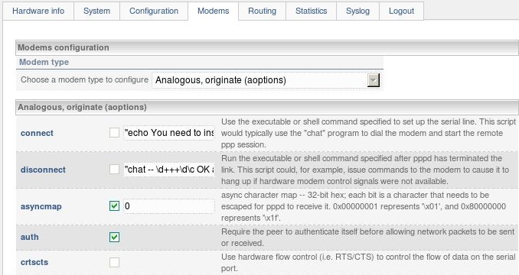
Figure 165 − Page «Modems» for LIU-D

7.1.5 Page «Routing»

In LIU-D and LIU-A v.2 this page is intended to form the routing information of router software and set parameters of the router software interaction with the controller software (file – /usr/local/etc/router.conf).
The Router is designed for autonomous call routing. The Controller provides the operation of all communication channels which enter into the system and interaction with the router according to the scheme «client-server» via port 20000 (client-router, server-controller).
There are always two main components in the router – a signalling target and a pattern. Any incoming call is checked for correspondence to patterns in order of their location. a number of parameters, of which the pattern consists, are checked for matching and, in case of coincidence, the call is transmitted to target, which displays the specific interface (a communication channel) of the system. The Pattern only checks, but does not change the parameters of the incoming call. The Target determines the parameters of the outcoming call and can (and usually should) change the parameters of the incoming call before the call is converted to outcoming through the specified interface (channel).

7.1.5.1 Section «Main settings»
The section «Main settings» in LUI-D and LIU-A v.2 is as follows:

Figure 166 − Section «Main settings» for LIU-D (LIU-A v.2)
In the parameter «Address» the IP-address and the port for connection with controller software are specified.
In the parameter «Remote CDR receivers» the IP-address and the port for connection with the offline billing software are specified.
The parameter «Session timeout, seconds» defines the waiting time for the route information for router software.
The parameter «Use redirect patterns» - if the check mark is set, on command to redirect the call there will be implemented the logic for selecting the first appropriate pattern and an immediate start-up of its execution. If the check mark is not available, an attempt to redirect the call will be made as it is without routing, generating a call to the network that requested to redirect it.

7.1.5.2 Section «Recorders»
Section «Recorders» in LIU-D and LIU-A v.2 is used for recording parameters settings, see Figure 167.

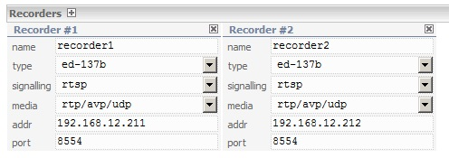
Figure 167 − Section «Recorders» for LIU-D (LIU-A v.2)
Field «name» – a recording server name, must not contain space. The default value is «empty line».
Field «type» – a recording server type. The default value is the first on the list «ed-137b».
Field «signaling» – a signaling type. The default value is the first on the list «rtsp».
Field «media» – a media type. The default value is the first on the list «rtp/avp/udp».
Field «addr» – recording server IP address. The default value is «empty line».
Field «port» – a recording server port. The default value is «empty line».

7.1.5.3 Section «Signalling targets»
In LIU-D and LIU-A v.2 this section is intended to generate outcoming call parameters (address data of a called subscriber, information on a calling subscriber, codec selection preferences) and indicate the route in accordance with the group number. It is recommended to determine all routes prior to operation with section «Patterns» of this page.

Field «name» shall contain the name of the route.
Field «called» generates an address from the address information received by the gateway. The address is generated using the regular expressions specified in the field.
Field «caller» generates information about the caller. The information is formed using regular expressions similarly to the field «called».
Field «codec set» is not used in LIU-D. Currently only one codec G.711 is supported in LIU-A v.2.
Field «type» is intended for specifying the parameters of the target protocol (sip, isdn, ss7, cas-hdlc). For LIU-A v.2 the value is sip. Each protocol type has its own settings:
«sip»
Field «subject» – the purpose of the call. Select the appropriate value from the drop-down list: «IA call», «DA/IDA call», «monitoring», «A/G monitoring», «G/G monitoring». The default value is «DA/IDA call»;
field «priority» – the priority of the call. From the drop-down list, select the appropriate value: «emergency» (distress), «urgent» (important), «normal» (ordinary), «non-urgent» (unimportant). The default value is «non-urgent»;
field «media service» – restrictions on the type of media environment. The following values are available: «simplex», «duplex», «limited». The default value is «none».
«isdn»
isdn.cg.typeofnumber – Calling Party Number (CGNUM) TypeOfNumber (caller subscriber number type);
isdn.cg.plan – CGNUM NumeringPlanIdentification (caller subscriber number plan type indicator);
isdn.cg.screeningind – CGNUM ScreeningIndicator (caller network authentication indicator);
isdn.cd.typeofnumber – Called Party Number (CDNUM) TypeOfNumber (caller subscriber number type);
isdn.cd.plan – CDNUM NumeringPlanIdentification (caller subscriber number plan type indicator);
isdn.cd.screeningind – CDNUM ScreeningIndicator (caller network authentication indicator).

«ss7»
ss7.cg.category – calling category (caller subscriber category);
ss7.cg.nature – calling nature of address (caller address type indicator);
ss7.cg.inetwork – calling network type (caller network type indicator);
ss7.cg.plan – calling numbering plan (caller subscriber number plan type indicator);
ss7.cd.nature – called nature of address (callee address type indicator);
ss7.cd.plan – called numbering plan (called subscriber number plan type indicator).

The «group» field displays the parameter «Group» (the page «Configuration», item 7.1.3 of this manual) of the target interface, i. e. identifies it. It should not be empty (see Figure 168).

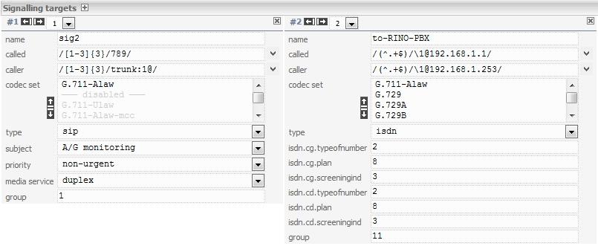
Figure 168 − Section «Signalling targets» for LIU-D (LIU-A v.2)
Fields «called» and «caller» are synthesizers of numbers. Their empty value lets the input value pass to the output without any changes. These field strings are made as a set of several elements, tied by certain rules. Rules for connecting the elements of an expression in a string.
1. First you specify an element that selects some part from the incoming sequence. This is a regular expression that works for finding a match. This is followed by the element being replaced by that part of the incoming sequence that matched with the first element. The symbol «/» acts as element separator.

Example 1 (see Figure 169):
- an expression of the following form is given in the «called» field: «/[1-3]{3}/789/»;
- the field «inexp» (incoming sequence) looks like: «123456»;
- in the field «result» we will get the value: «789456».

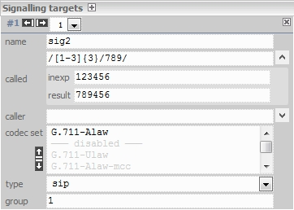
Figure 169 − Section «Signaling targets», Example 1
If the expression «[1-3] {3}//» is specified in the field «called», then the «result» field will be «456».

Example 2 (see Figure 170):
- an expression of the following form is given in the field «called»: «/[1-3]{3}/trunk:1@/»;
- the field «inexp» (incoming sequence) has the form: «1234»;
- in the «result» field we will get the value: «trunk:1@4».

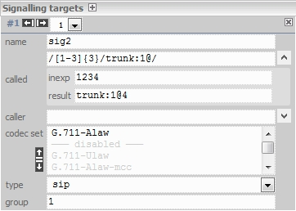
Figure 170 − Section «Signalling targets», Example 2
2. Fragments of a string with elements can be placed sequentially through a «space».

Example 3 (see Figure 171):
- an expression of the following form is given in the field «called»: «/[1-3]{3}/78/ /[4-6]{3}/ 09/»;
- the field «inexp» (incoming sequence) looks like: «123456»;
- in the field «result» we will get the value: «7809».

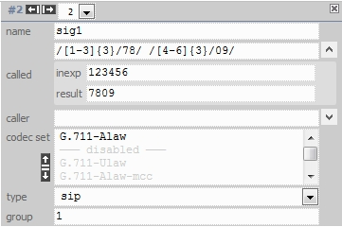
Figure 171 − Section «Signaling targets», Example 3
3. The part of the incoming sequence enclosed in parentheses can be stored in the variable (1-9), and then substituted into the resulting expression by the symbol «\».

Example 4 (see Figure 172):
- an expression of the following form is given in the field «called»: «/(.*)trunk:[1-7]{1}@/\1/»;
- the field «inexp» (incoming sequence) has the form: «199trunk:1@qwerty»;
- in the «result» field we will get the value: «199qwerty», that is, «199» is stored in the variable «1».

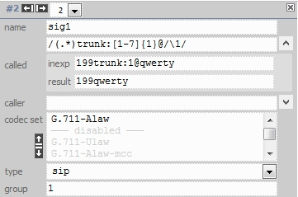
Figure 172 − Section «Signalling targets», Example 4
4. There is a special kind of variables: I, C, R, F, G. They are convenient to be used for substitution of specific call parameters into the resulting sequence.
The specification of variables:
«I» – an IP-address of the calling subscriber;
«C» – the number of the called subscriber (or the number to be used for call transfer function);
«R» – the number of the calling subscriber;
«F» – the number from which the call was transferred;
«G» – a group number of the channel from which the call came.

Example 5 (see Figure 173):
Call parameters at the input: called «123», caller «456».
The expression specified in the field «called»: «/.*/\R/» will yield the result «456».

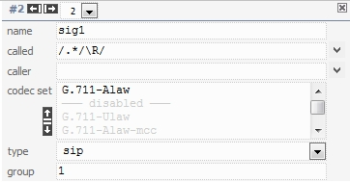
Figure 173 − Section «Signalling targets», Example 5

7.1.5.4 Section «AK targets»
In LIU-D the section «AK targets» is intended to configure analog subscriber sets (multipurpose interface boards).

Field «name» determines a «telephone» number of AK.
Field «slot» determines the number of AK board slot.
Field «channel» determines the number of the channel on AK board.
Field «incoming caller id» is a constant, assigned when an incoming call is made.
Field «outcoming caller id» is a regular expression used at outgoing calls to generate a «caller id» in the case of fxs;
Field «called» is a regular expression used at the outgoing call to generate the called number in the case of fxo.

When an incoming call is made via the appropriate channel, the parameter «caller id» is added to the call and then the call is processed in Patterns. But in the case of fxo, the incoming «caller id» (if it available) takes precedence (see Figure 174).

Figure 174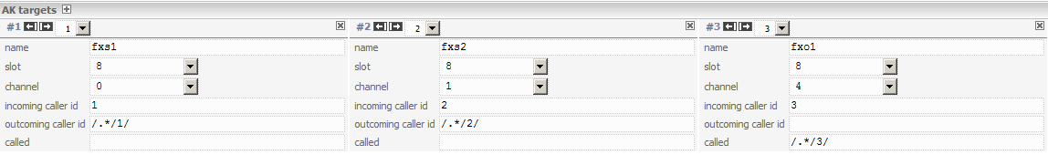 − Section «АК targets» for LIU-D
In LIU-A v.2 the section «LEMZGW targets» is intended to configure the LI boards, see Figure 175.

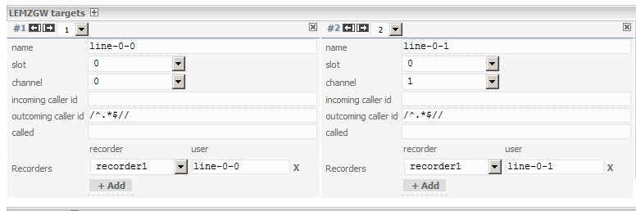
Figure 175 − Section «LEMZGW targets» for LIU-A v.2
Field «name» determines a «telephone» number of the LI.
Field «slot» determines a slot number of the LI board.
Field «channel» determines a channel number of the LI board.
See above the description of fields «incoming caller id», «outcoming caller id» and «called».

7.1.5.5 Section «Patterns»
In LIU-D and LIU-A v.2 section «Patterns» is intended to select a path for incoming call routing. The selection is made by comparing received by gateway an address sequence with some sample (a template, a pattern). The comparison with the pattern is carried out successively (i.e. starting with Pattern #1, then with Pattern #2 and so on until the match, or until all patterns are done). If no suitable pattern is found for an address sequence, the incoming call will be terminated with a message on the absence of route. The comparison is carried out until the first match.

Field «called» determines the pattern for comparison with the received address information. The pattern is a regular expression.
Field «caller» analyses information on the calling subscriber, it operates similarly to field «called». It represents a regular expression.
Field «group» determines the identifier of interface, via which the call is received, it may be empty. It represents a regular expression.
Field «targets» determines the route in case the address information matched the pattern. All available routes, configured before, are shown as a drop-down list.
Filed «type», from the drop-down list one of the following values ​​is selected:
native – routing by a target name;
called – routing by a number: search for the target with the name of the incoming number;
reject – a rejection with code 21 is generated (Q.850 – the route is unavailable);

Field «routing timeout» – waiting for a response from PABX (a gateway) after outgoing dialing out the number, in seconds, when this value equals to «0», waiting is infinite.

Field «answer timeout» – waiting for the «answer» signal from PABX (a gateway) after dialing out the number, in seconds, at a value of «0», the timeout is infinite.

Field «routing timeout» – waiting for a response from PABX (gateway) after outgoing dialing out the number, in seconds, when this value equals to «0», waiting is infinite.
Field «dial timeout» – delay of dialing the number via the interface of the selected target, in seconds, with a value of «0» there is no delay.
Field «vad timeout» - a time in seconds after expiration of which the connection will be released if there is no conversation.
Fields «called», «caller» and «group» are filters through which the incoming sequence is being passed. If the value is empty, it is assumed that the filter is disabled.
Examples: «^$» – an empty number, «.*» – any number, «^1[0-5,7]{1}$» – numbers 10-15 and 17.
It should be noted that if the regular expression matches only a part of the incoming sequence, then it will all be considered matched.

Example:
the incoming sequence has the form «123456789», pattern «456789» – there will be a coincidence, and if the pattern «^ 456789», it will not happen (see Figure 176).
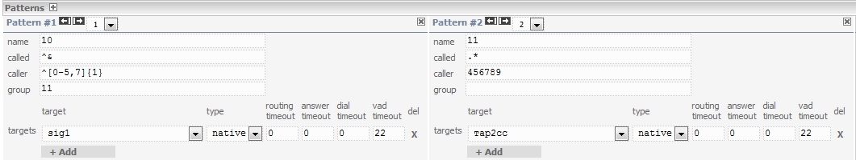
Figure 176 − Section «Patterns» for LIU-D (LIU -А v.2), Examples

7.1.5.5.1 Examples of setting the incoming call routing

An example of setting an incoming call routing will be considered over several routes at once or in succession. Several signalling targets are shown in Figure 177, in particular we are interested in targets with names sip131, sip132 and sip133.

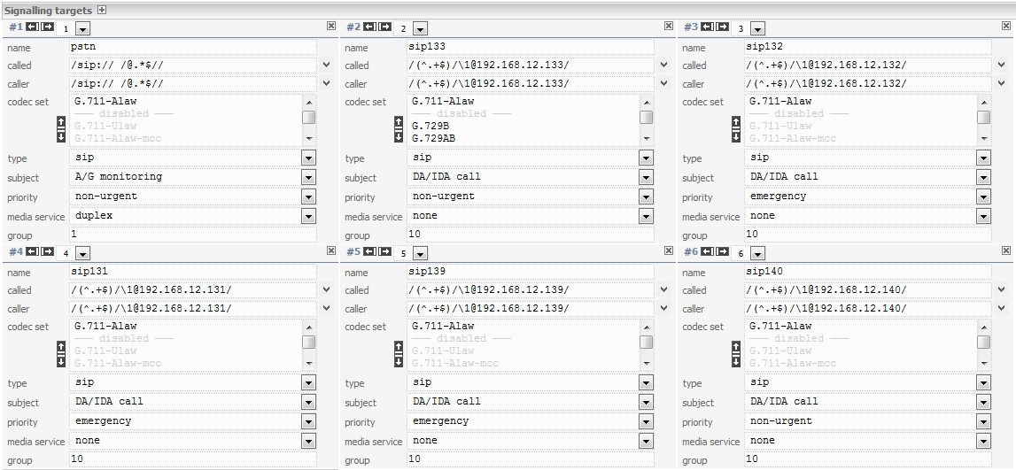
Figure 177 − Section «Signalling targets»: sip131, sip132, sip133
Setting of an incoming call routing over three routes at once with the answer timeout of 10 seconds (an answer timeout = 10), until the first subscriber to answer or upon expiry of an answering interval is shown in Figure 178.
In this example three routes are determined if the field «targets», this pattern will be used in case the address information matches the pattern (field «called»). If necessary, the answer timeout may be changed for different routes.

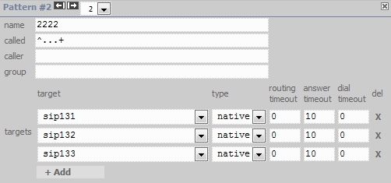
Figure 178 − Setting of incoming call routing over three routes at once for LIU-D
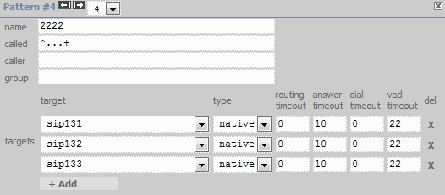
Figure 179 − Setting of incoming call routing over three routes at once for LIU-А v.2
Consider an example of incoming call routing over three routes, but with a successive use.
The route sip131 (answer timeout = 10, dial timeout = 0), will be used first, a call without a waiting interval, an answer timeout is 10 seconds.
After that the route sip132 with the dial timeout of 10 seconds and the answer timeout of 10 seconds will be used, upon expiry of these timeouts, the route sip133 is used.
Route sip133 has timeout of 20 seconds, with answer timeout of 10 seconds, upon expiry of which the call is terminated if there is no answer.

If there was an answer over one of the routes, the next routes are not used.
The timeout may be changed optionally, the essential point is that if the dial routes are to be used successively, it is necessary to comply with a specific formula: a dial timeout of the next route shall be equal to the time of an answer timeout + a dial timeout of the previous route.

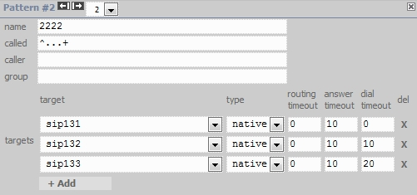
Figure 180 − Setting of incoming call routing over three routes with a successive use for LIU-D

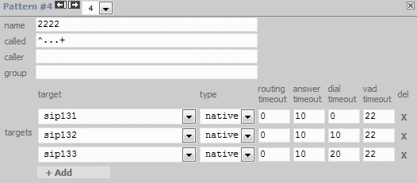
Figure 181 − Setting of incoming call routing over three routes with a successive use for LIU-A v.2

7.1.5.6 Section «Modem targets»
Section «Modem targets» is intended to configure modem terminations of LIU-D.
For LIU-A v.2 this section is missing.

7.1.5.7 Section «Connections»
For LIU-D and LIU-A v.2 this section is intended to set up a terminal connection with radio stations. The parameters, selected in the section, are displayed in tab «Radiostations», see item 7.2 «Channel Registration in the System» of this Manual.

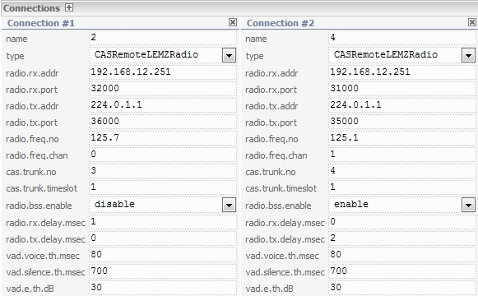
Figure 182 − Section «Connections» for LIU-D

Field «name» – a connection name.

Field «type» – a radio station type, selected from the drop-down list.

Field «radio.rx.addr» – an IP address of the receiver.

Field «radio.rx.port» – a port.
Field «radio.tx.addr» – an IP address of the transmitter.

Field «radio.tx.port» – a port.
Field «radio.freq.no» – frequency in MHz.
Field «radio.freq.chan» – a channel number in Radio station.

Values, indicated in fields «cas.trunk.no» and «cas.trunk.timeslot», are taken from the section «E1 Trunks configuration» (Trunk ID and Timeslots, respectively), see item 7.1.3.6 «Section E1 Trunks configuration» of this Manual.

Field «radio.bss.enable» – the BSS function state when enabled. It may have the value «disabled» (off) or «enabled» (on). The default value is «disabled».
Field «radio.rx.delay.msec» – a voice delay during reception in milliseconds. It may have the value from 0 to 2000. The default value is 0.
Field «radio.tx.delay.msec» – a voice delay during transmission in milliseconds. It may have the value from 0 to 2000. The default value is 0.
Field «vad_voice_th_msec» – the minimum speech duration in milliseconds detected by the voice detector. It can take a value from 0 to 10000. The default value is 80.
Field «vad_silence_th_msec» – the duration of the pause in milliseconds that determines the absence of voice in the channel. It can take a value from 0 to 10000. The default value is 700.
Field «vad_e_th_dB» – the minimum excess of voice over noise detected by the voice detector. Specified in dB, it can take a value from 0 to 90. The default value is 30.

In LIU-A v.2 the section «Connection» is as follows:

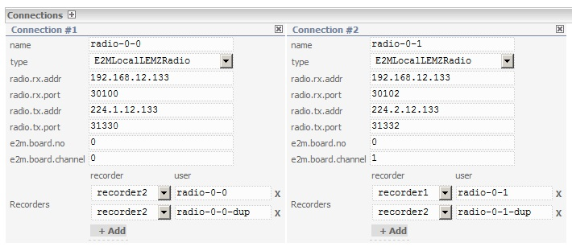
Figure 183 − Section «Connections» for LIU-A v.2

Field «type» – the type of Radio Station «E2MLocalLEMZRadio».
Field «e2m.board.no» – a board number, an integer >=0. The default value is 0. The value of this field corresponds to the value of the «slot» field (see item 7.1.3.14 «Setting of section «LEMZGW configuration»» for LIU-A v.2»» of this Manual, window «Radio Channel»).

Field «e2m.board.channel» – a channel number, an integer >=0. The default value is 0. The value of this field corresponds to the value of the «channel» field (see item 7.1.3.14 «Setting of section «LEMZGW configuration»» for LIU-A v.2»» of this Manual, window «Radio Channel»).
See above the description of fields «radio.rx.addr», «radio.rx.port», «radio.tx.addr», «radio.tx.port».

7.1.5.8 Section «Recorder patterns»
For LIU-D and LIU-A v.2 this section is intended to set up parameters for recording.

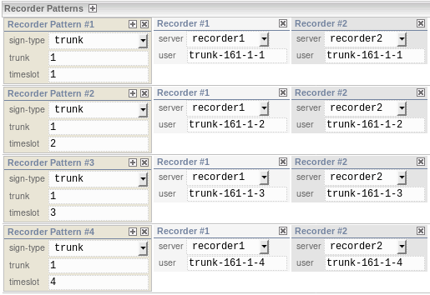
Figure 184 − Section «Recorder patterns» for LIU-D
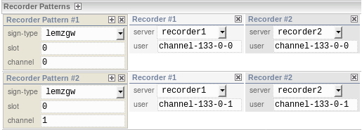
Figure 185 − Section «Recorder patterns» for (LIU-A v.2)
In LIU-D and LIU-A v.2, the «Recorder Patterns» section is used to select the address where and how the session will be recorded. Due to the fact that the session consists of two endings (incoming and outgoing), two patterns are selected at the first stage, for each end. The choice is made by comparing the address information received by the router with a certain sample (template, pattern). The comparison with the sample is made sequentially (that is, first with «Recorder Pattern #1», then with «Recorder Pattern #2», and so on either until the match or until the end of the samples).
The comparison is made before the first match. Ultimately, there may be three outcomes:
1. No pattern was found, either for the incoming or outgoing ending. In this case, the session will not be recorded.
2. One pattern was found, either for the incoming or outgoing ending. In this case, the session will be recorded on the corresponding servers specified in the pattern.
3. Two patterns were found, both for the incoming (PatternIn) and for the outgoing (PatternOut) ending. In this case, a higher priority pattern is selected. The priority is determined primarily by the type:
«ak» – AK channel, priority - 1;
«lemzgw» – LEMZGW channel, priority - 2;
«trunk» – E1/Trunk timeslot, priority - 3;
«sip» – SIP signaling, priority - 4.
A lower absolute value has a higher priority. If the priorities are equal, then the first one is selected by the number in the list of patterns. As a result, the session will be recorded on the corresponding servers specified in the selected pattern.

The «sign-type» field - the signaling type, selected from the drop-down list. The following types of signalings are available for LIU-D:
«ak» – AK channel;
«trunk» – E1/Trunk timeslot;
«sip» – SIP signaling.
For LIU-Av.2:
«lemzgw» – LEMZGW channel;
«sip» – SIP signaling.
Each signaling type has its own signaling parameters. For «ak» and «lemzgw» signalings, the signaling parameters are the slot number and the channel number. Regular expressions are entered in the corresponding fields for comparison:
«slot» – a regular expression for the slot number;
«channel» – a regular expression for the channel number.
For «trunk» signaling, the signaling parameters are the trunk number and the time slot number. In the corresponding fields, enter regular expressions for comparison:
«trunk» – a regular expression for the trunk number;
«timeslot» – a regular expression for the time slot number.
For «sip» signaling, the signaling parameters are the number of the called party and the number of the calling party. Regular expressions are entered in the corresponding fields for comparison:
«caller» – a regular expression for the called subscriber number;
«called» – a regular expression for the caller subscriber number.
The «Recorder» window is used to configure the recording address information.
In the «server» field, select the recording server name from the drop-down list. The name is set in the «name» field, see item 7.1.5.2 of the section «Recorders» of this manual. The default value is the first in the list.
The user name is configured in the field «user». If the name does not contain special characters, it is used as it is. Otherwise, it is interpreted as a number synthesizer, like the «called» field in «Singnalling targets».
The «user» and «server» pair is used to create a recording session with the «user@server» parameters and the corresponding signaling, the parameters of which are specified in the settings «Recorders» for this server.

7.1.5.9 Section «Check patterns»
The section «Check patterns» is intended to verify that the routing settings are correct. The algorithm for working with the section is the same in LIU-D and LIU-A v.2.
Depending on the input data enter the required values in the fields «called», «caller» or «group».

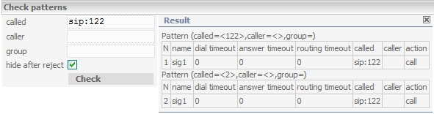
Figure 186 − Section «Check patterns» for LIU-D (LIU-A v.2)
When you click on the button «Check», the «Result» window will appear with information according to the specified parameters. If the check mark «hide after reject» is set, then after targets with the «reject» type are done, information in the window «Result» will not be output.

7.1.5.10 Button «Save changes»
In LIU-D the button «Save changes» is used to save changes made to the configuration file router.conf, and to send the signal to the router daemon about the need to reread the configuration file.

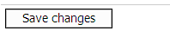
Figure 187 − Saving the changes in LIU-D

In LIU-A v.2 the button «Save» is used to save changes made to the configuration file router.conf. When you click on the button «Save & Restart», the signal is sent to the router daemon about the need to reread the configuration file.

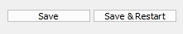
Figure 188 − Saving the changes in LIU-A v.2

7.1.6 Page «Statistics»

In LIU-D and LIU-A v.2 the page «Statistics» contains data on the current distribution of resources and network side statistics with channels (telephone network) switching.
Note: if necessary, statistics of a data transmission network is gathered using the utility tcpdump. To analyze the gathered data, programs Hammer Call Analyzer and Wire Shark may be used.

7.1.6.1 Section «Controller» for LUI-D
Controller version R0754 – the line contains a controller software version, the first letter {Test Release} indicates the type of software: T – a test, R – a release software version.
Controller started: 10/08/2015 00:00:53 uptime 20 days 00:00 – the date and time of the controller software start, the number of days, hours and minutes from the moment of the last loading.

Statistics created: 30/08/2015 00:00:54 - the time of statistics page creation.

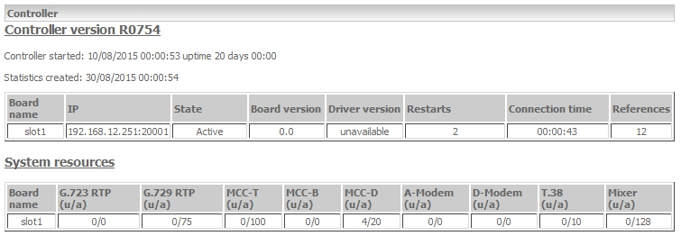
Figure 189 − Section «Controller» in LIU-D

Table «Board»

The Table «Board» contains information on LIU-D boards. Parameters: «Board name», «IP», «State», «Board version», «Driver version», «Restarts», «Connection time», «References».
«Board name» – a board name.
«IP» – an IP address and IL software control port on the board.
«State» – a board state at the time of interrogation.
«Board version» – a board version.
«Driver version» – a driver version.
«Restarts» – a board restarts counter from the time of the controller software start.
«Connection time» – the time of continuous interaction of IL software and controller software.

Table «System resources»

Parameters: «Board name», «G.723 RTP (u/a)», «G.729 RTP (u/a)», «MCC-T (u/a)», «MCC-B (u/a)», «MCC-D (u/a)», «A-Modem (u/a)», «D-Modem (u/a)», «T.38 (u/a)», «Mixer (u/a)».
«Board name» – a board name
«G.723 RTP (u/a)» – the number of codecs G.723 (used/available).
«G.729 RTP (u/a)» – the number of codecs G.729 (used/available).
«MCC-T (u/a)» – the number of voice channels G.711mcc (used/available).
«MCC-B (u/a)» – the number of voice channels assigned for ISDN-BRI sets (used/available).
«MCC-D (u/a)» – the number of channels assigned for board control and for signalling links of ISDN-PRI (used/available).
«A-Modem (u/a)» – the number of analog modems (used/available).
«D-Modem (u/a)» – the number of digital modems (used/available).
«T.38 (u/a)» – the number of T.38 channels (used/available).
«Mixer (u/a)» – the number of G.711 channels (used/available).

Table «Е1 trunks»

The parameters: «ID», «Board name», «Digital path», «Status», «Clock source», «Slip alarm», «Basic frame alarm», «Carrier alarm», «AIS alarm», «RAI alarm», «Watch».
«ID» – a system-unique trunk identifier.
«Board name» – a name of board the trunk belongs to.
«Digital path» – a board-unique trunk identifier.
«Status» – {SYNC, CL}
«Clock source» – {*, -} – an attribute, indicating whether a trunk is a synchronization sequence source.
«Slip alarm» – a slip error.
«Basic frame alarm» – an alignment error.
«Carrier alarm» – a carrier error.
«AIS alarm» – an indication of input signal loss.
«RAI alarm» – a remote alarm indication.
«Watch» – an indication whether the trunk status as a potential synchronization sequence source during backup is monitored.

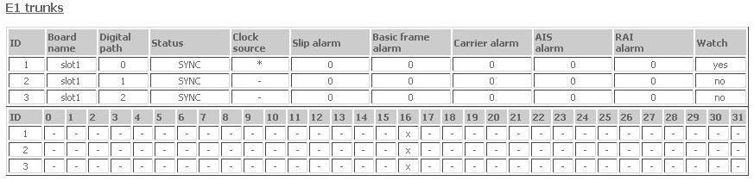
Figure 190 − Table «E1 trunks» in LIU-D

Table «ISDN brief statistics»

The parameters: «trunk», «group», «side», «status», «restarts», «timeslots (u/a)», «calls», «unsuccessful calls», «T303», «T304», «T308», «T310», «T313».
«trunk» – a system-unique trunk identifier.
«group» – a group identifier.
«side» – a network side.
«status» – {Multiple frame established, Awaiting establishment}.
«restarts» – the number of restarts.
«timeslots (u/a)» – the number of timeslots: used (u)/ available(a).
«calls» – a total number of calls.
«T303» – the value of timer T303 operation counter. The timer purpose: an interval between the transmission of SETUP and the reception of ALERT, CONNECT, CALL_PROCEEDING, SETUP_ACKNOWLEDGE or RELEASE_COMPLETE.
The value of T303 = 4 s.
«T304» – a value of timer T304 operation counter. The timer purpose: an interval between the reception of SETUP_ACKNOWLEDGE and the transmission of message INFORMATION (during the transmission of the address data in the overlapping mode) and the reception of message ALERT, CONNECT or CALL_PROCEEDING.
The value of T304 = 15 s.
«T308» – the value of the timer T308 operation counter. The timer purpose: an interval between the transmission of the message RELEASE and the reception of the message RELEASE_COMPLETE or RELEASE.
The value of T308 = 4 s.
«T310» – the value of the timer T310 operation counter. The timer purpose: an interval between the reception of the message CALL_PROCEEDING and the reception of one of messages ALERT, CONNECT, PROGRESS or DISCONNECT.
The value of T310 > 40 s.
«T313» – the value of the timer T313 operation counter. The timer purpose: a time interval between the transmission of the message CONNECT and the reception of the message CONNECT_ACKNOWLEDGE.
The value of T313 = 4 s.

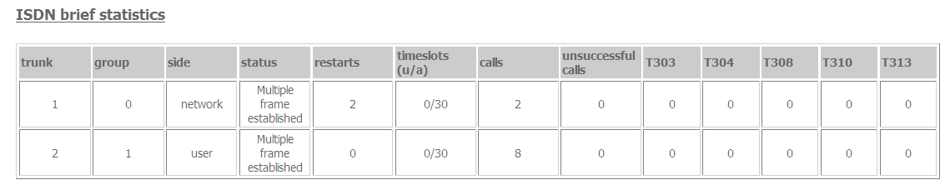
Figure 191 − Table «ISDN brief statistics» in LIU-D

Table «ISDN detailed statistics»

group=0 trunk=1 – the string indicates the number of trunk and trunk group identity.

Parameters: «id», «timeslot», «call state», «node state», «isdn state», «call reference», «E1 timeslot», «call waiting», «calls».

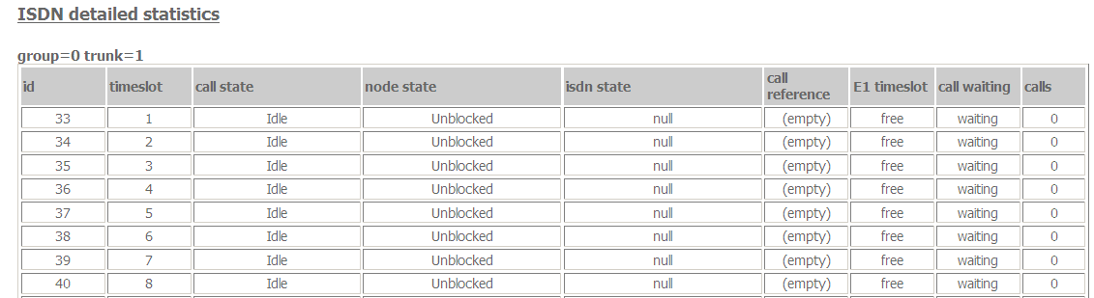
Figure 192 − Table «ISDN detailed statistics» in LIU-D

Table «SS7 detailed statistics»

If there are no SS7 trunks in the system, only headers are given instead of tables «SS7 detailed statistics» and «ISUP detailed statistics».

Table «ISUP detailed statistics»

Parameters: «id», «timeslot», «call state», «node state», «ss7 state», «E1 timeslot».

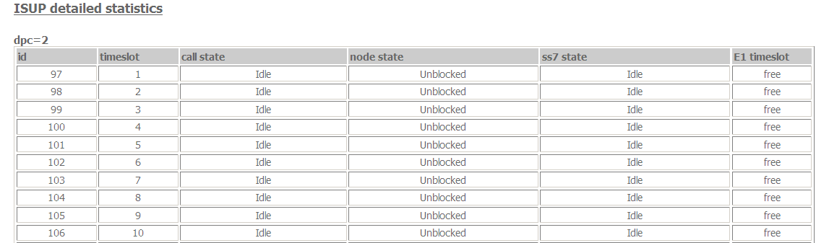
Figure 193 − Table «ISUP detailed statistics» in LIU-D

7.1.6.2 Section «Controller» for LIU-A v.2
«Controller version» – the string contains the controller software version, the first letter {Test|Release} means the type of software T– test, R – a working version of the software.
«Controller started:» – a date and time of the controller software start, hours and minutes since the last upload.

«Statistics created:» – the time of the statistics page creation.

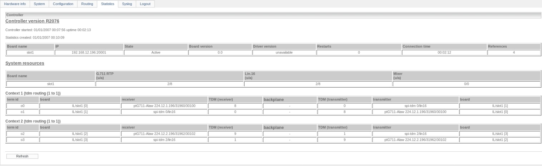
Figure 194 − Section «Controller» in LIU-A v.2

Table «Board»

The table «Board» contains the information on LIU-A v.2 boards. Parameters: «Board name», «IP» «State», «Board version», «Driver version», «Restarts», «Connection time», «References».
«Board name» – a board name.
«IP» – an IP-address and a control port of server software.
«State» – a board state at the moment of interrogation.
«Board version» – a board version. Currently these values are not changed, they are specified.
«Driver version» – a driver version. Currently these values are not changed, they are specified.
«Restarts» - a counter of board restarts from the moment of a controller software start.
«Connection time» – the time of the continuous server software interaction with the controller software.
«References» – the number of slots used on the board.

Table «System resources»

Parameters: «Board name», «G.711 RTP (u/a)», «Lin.16 (u/a)», «Mixer (u/a)».
«Board name» - a board name.
«G.711 RTP (u/a)» - the number of codecs G.711 (used/available).
«Lin.16 (u/a)» - the number of codecs Lin.16 (used/available).
«Mixer (u/a)» - the number of mixers (used/available ).

Table «Context 1»

The table of connections is presented by the following parameters:

«term id» - a connection identifier.

«board» - a board (a server) name of the connection receiver. It is taken from «Board Configuration»→ «Board 1»→«Board Name».

«receiver» - a type of the receiver slot and connection parameters.

«TDM (receiver)» - the time-slot number of the receiver of connection.

«TDM (transmitter)» - the time-slot number of the transmitter of connection.

«transmitter» - a slot type of the transmitter and connection parameters.

«board» - a board (a server) name of the connection transmitter. It is taken from «Board Configuration»→ «Board 1»→«Board Name».

7.1.7 Page «Syslog»

In LIU-D and LIU-A v.2 the page «Syslog» is intended to be used by the manufacturer's support service. By default, both local logging-in and logging in external host are disabled. The used configuration of system Syslog is given in directory /etc in file syslog.conf.
When the local logging-in is disabled, page Syslog looks as follows:

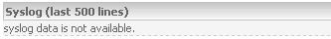

Attention! Enabling of local logging-in in syslog (logging-in in file var/log/messages) without the consent of support service may lead to RAM shortage and, thus, the degradation of the device performance.
The state of Syslog at the moment of a browser connection to http server is displayed on the page. The page is not reloaded automatically. To reload the data manually, button «Refresh» is used.
When local logging-in is enabled, page Syslog looks as follows:

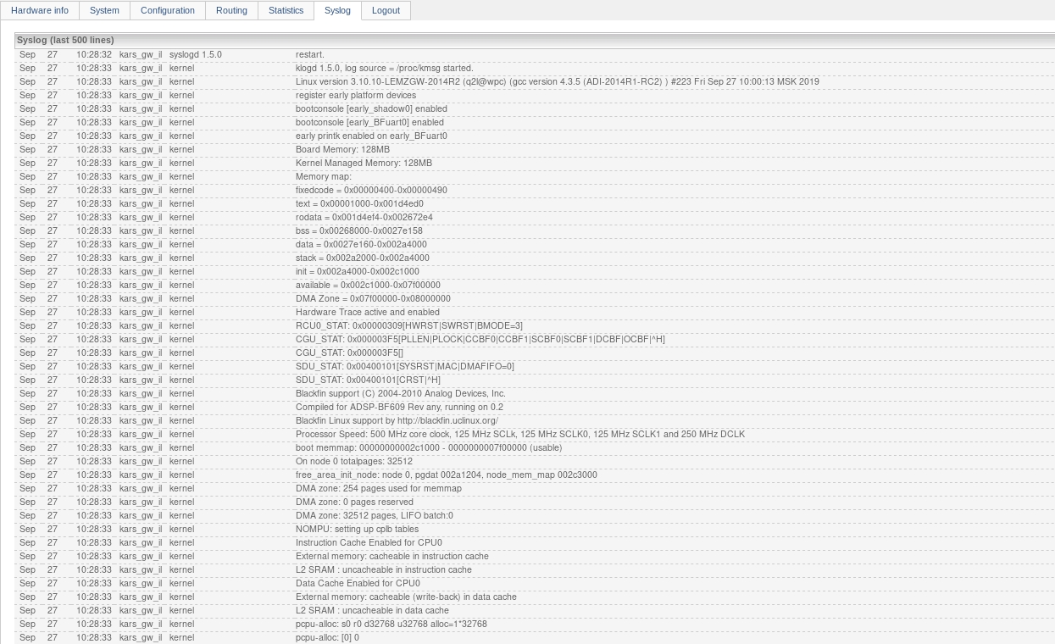
Figure 195 − Page «Syslog» for LIU-D (LIU-А v.2)

7.1.8 Page «Logout»

When tab «Logout» is selected, the user is disconnected from http server.

7.2 Channel Registration in the System

After the web interface is set up, it is necessary to go to the tab «Radio stations» to register the channels in the system.
In LIU-D and LIU-A v.2 the algorithm of channels registration is the same. The appearance of the tab is shown in Figure 196.
The upper part of the tab accommodates button «Check parameters», when it is being pressed, a request is made to LIU-D (LIU-A v.2) to receive an updated list of radio stations.

– reception of an updated list of radio stations.

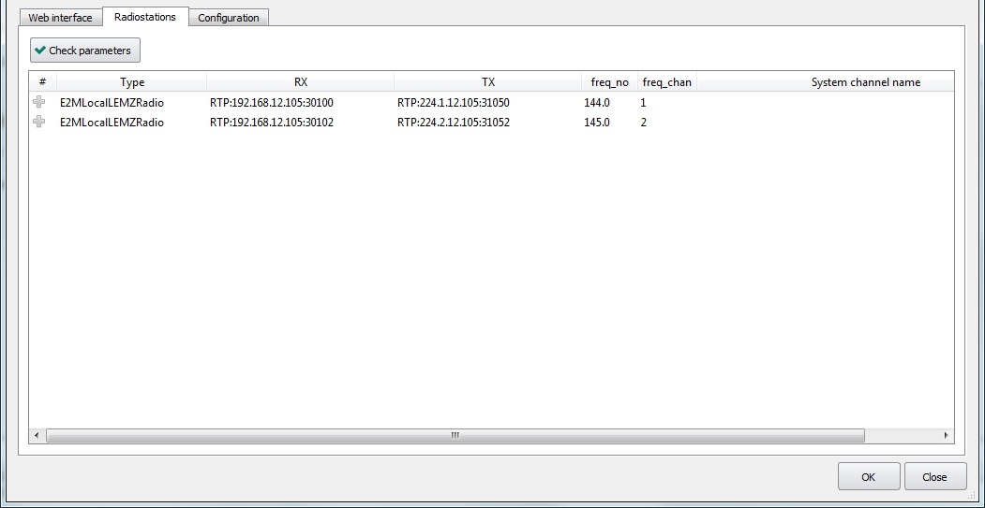
Figure 196 − Tab «Radio stations» for LIU-D (LIU-А v.2), the overall view
The list of radio stations (channels) with specified parameters is displayed in the tab.
For LIU-D the parameters are taken from section «Connections», see item 7.1.5.7 of this Manual.
For LIU-A v.2 the parameters «Type», «RX» and «TX» are taken from the section «Connections» (see item 7.1.5.7 of this Manual). For displaying parameters «freq_no» and «freq_chan», the values from fields «radio_freq_channel» and «radio_id_channel» are taken respectively (see item 7.1.3.14 of «Section «LEMZGW configuration»», window «Radio Channel»).
The channel is registered in the system under its name. Indicate the channel name in field «System channel name», for example, Radio 144.0, see Figure 197.

Figure 197 − Tab «Radio stations», entering channel name
After quitting the field, the status of channel Radio 144.0 is automatically changed to «Registered in system», see Figure 198.

Figure 198 − Tab «Radio stations», channel Radio 144.0 is registered in the system

Channel status:

Channel is not registered in the system
Channel is registered in the system

An alternative method of channel registering is to open the context menu with right mouse button and select item «Register channel», see Figure 199.

Figure 199 − Tab «Radio stations», registering a channel
If a user attempts to register a channel without name, the name will be assigned to the channel automatically in the following format: RADIO.HOSTID.LICHANNEL, see Figure 200.
The field with automatically assigned name is editable.

Figure 200 − Registering a channel with automatically assigned name RADIO LI2(2ch) - 105 145.0

To delete channel registration from the system, select a required line, open the context menu and select item «Unregister channel»).

Figure 201 − Deleting channel registration from the system

The registered channels are displayed in the list of radio sets, see Figure 202. In this example, these are channels with names Radio 144.0 and RADIO LI2(2ch) - 105 145.0.

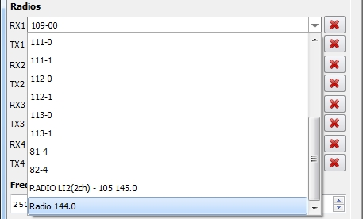
Figure 202 − Registered channels with names Radio 144.0 and RADIO LI2(2ch) - 105 145.0
List «Radiostation» consists of the radio set channels, which are set up in the system objects of LIU-A, BTC LIU-A, LIU-D type.

7.3 System configurations control

In LIU-D and LIU-A v.2 on the tab «Configuration» the control of the system configurations is carried out. In LIU-D and LIU-A v.2 the tabs are identical. The parameters description and the algorithm of the work with configurations is provided below.
The tab consists of panels («Filter», «Current configuration», «Archived configurations» and «System configurations» - it depends on the filter parameters) and control buttons, see Figure 203.

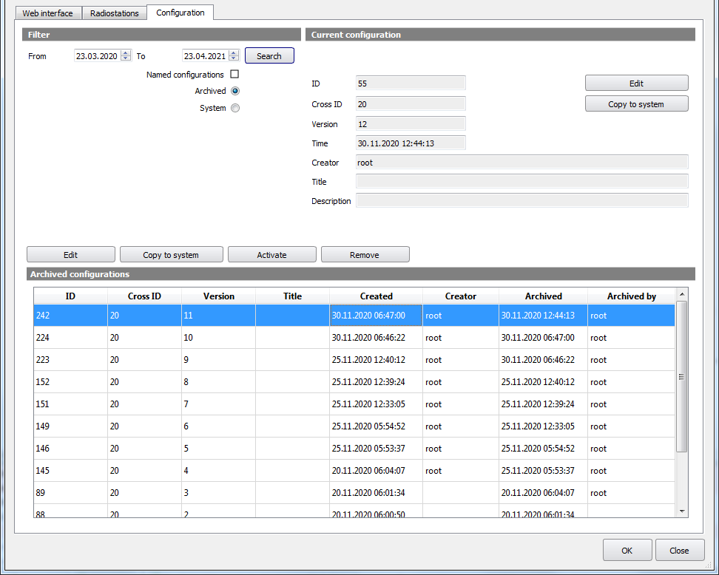
Figure 203 − Tab «Configuration» for LIU-D (LIU-A v.2)

Panel «Current configuration»

The panel «Current configuration» displays the parameters of the configuration that is used at the gateway at the moment. Only «Title» and «Description» parameters of all current configuration parameters are editable. These fields are empty by default.
In order to input changes, you need to press the button «Edit». In the opened window you need to indicate the necessary information in the fields «Title» and «Description», see Figure 204.

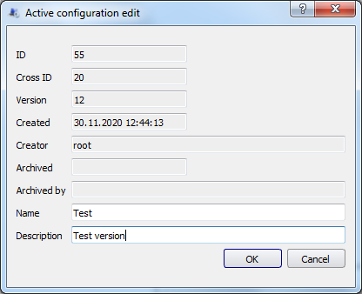
Figure 204 − Window of editing the current configuration parameters

The used buttons on the panel of «Current configuration» are as follows:

– edit the parameters of the current configuration.

– copy the current configuration to the list of system configurations.

Panel «Filter»

The appropriate filter parameters for configurations are set on the panel «Filter»:
- date, a desired time period is specified;
- an option «Archived» or «System» is selected.
- a flag «Named configurations» is set, if you need to search configurations by the name.

– filtering configurations on the basis of given parameters.

After clicking the button «Search» a list of configurations by the specified filter will be displayed at the bottom of the window («Archived» or «System» configurations).

Panel «Archived configurations»

The archived configurations on the panel are presented as a list of the appropriate parameters, see Figure 205.
The names of users are displayed in the fields «Creator» and «Archived by».

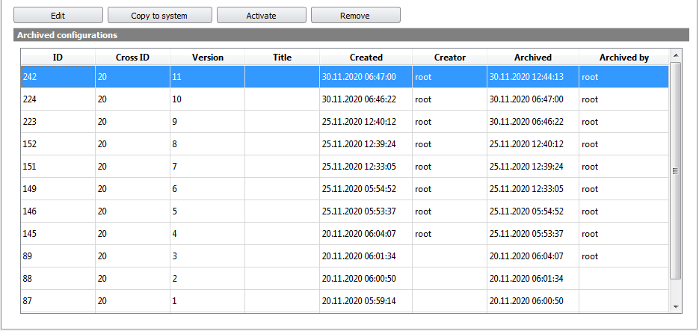
Figure 205 − Panel «Archived configurations»
The number of archived configurations without a name is defined by the parameter «Number of archived gateways configurations» (item 3.3 «Database Configuration» of this Manual), see Figure 206.
The number of the named configurations is unlimited. Archived configurations may be applied to a specific system object.

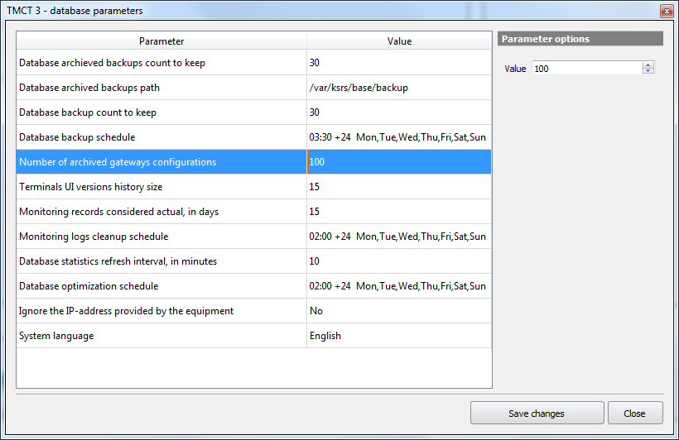
Figure 206 − Parameter «Number of archived gateway configurations»
Above the panel «Archived configurations» the buttons are located for performing the following actions:

– to edit the parameters of the archived configuration. Only «Title» and «Description» of all archived configuration parameters are editable. You need to select a desired configuration and click the button «Edit». In the opened window in fields «Title» and «Description» you need to specify the required information. The button «ОK» - saving changes.

– to copy an archived configuration to a list of system configurations. You need to select the required configuration from the list and click the button «Copy to system». The selected archived configuration will be copied to the list of system configurations.

– to make an archived configuration active (current). You need to select the required configuration from the list and click the button «Activate». When you click the button «Activate», after confirmation, the selected archived configuration becomes the current one and its parameters display in the panel «Current configuration». This increases the version number of the current configuration by one.

– to remove an archived configuration. You need to select the required configuration from the list and click the button «Remove». After confirmation the selected archived configuration will be deleted from the list without possibility to restore.

Panel «System configuration»

The system configurations are provided as a list of appropriate parameters in the panel, see Figure 207. The parameters of system and archived configurations are the same. The only difference is the presence of «IP address» parameter.
The number of the system configurations is unlimited. The system configurations are available for all system objects of the selected type.

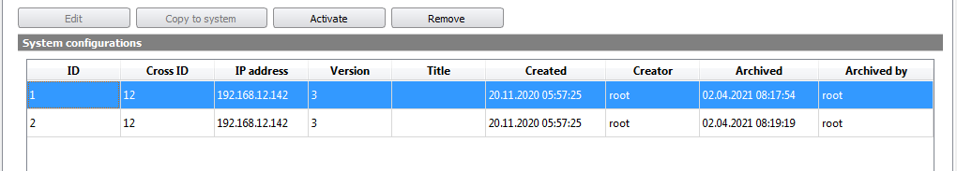
Figure 207 − Panel «System configurations»
The system configurations have only options «Activate» or «Remove», unlike the archived configurations.

– to make a system configuration active (current). You need to select the required configuration from the list and click the button «Activate». When you click the button «Activate», after confirmation, the selected system configuration becomes the current one and its parameters display in the panel «Current configuration». This increases the version number of the current configuration by one.

– to remove a system configuration. You need to select the required configuration from the list and click the button «Remove». After confirmation the selected system configuration will be deleted from the list without possibility to restore.

8 Emergency Communication Unit (ECU)

Emergency Communication Unit (ECU) - a centralized switch for the emergency communication system intended to provide the work of the ATC and technical personnel with radio and telephone communication facilities in case of complete or partial main VCCS communication system failure.

This item contains a description of the parameters required to configure the ECU.

The upper part of the window accommodates the following fields and check boxes:
field «System ID» – system object identifier, given by the system automatically. The field is not editable;
field «Title» – system object name, indicated in the system structure. If necessary, it may be changed;
field «IP address» – system object IP address. If necessary, it may be changed;
check box «Current» – check box selection allows to view current ECU configuration;
check box «New» – check box selection allows to edit current ECU configuration. If necessary to save new configuration, press button «Apply configuration».

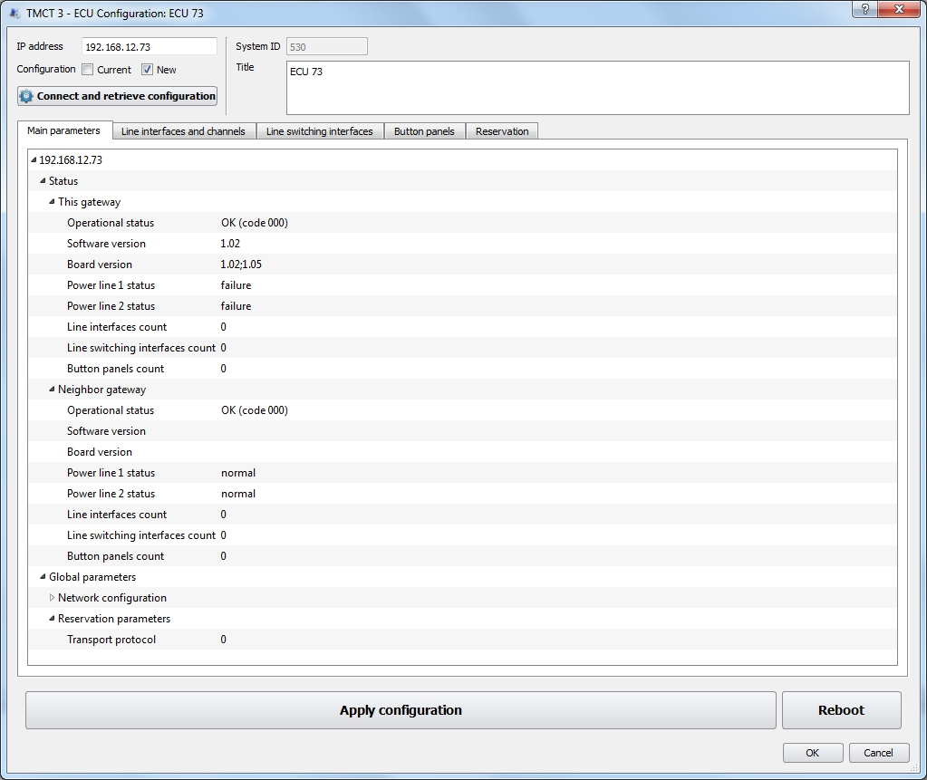
Figure 208 − ECU parameters

– check of availability of ECU at the indicated IP address and configuration query.

 – to save the new ECU configuration.

 – to apply new configuration and reboot the ECU.

Operation description with the tabs «Main parameters», «Line interfaces and channels», «Line switching interfaces», «Button panels» and «Reservation» see below.

8.1 Main parameters

On this tab, the ECU parameters are displayed in the form of a tree structure.

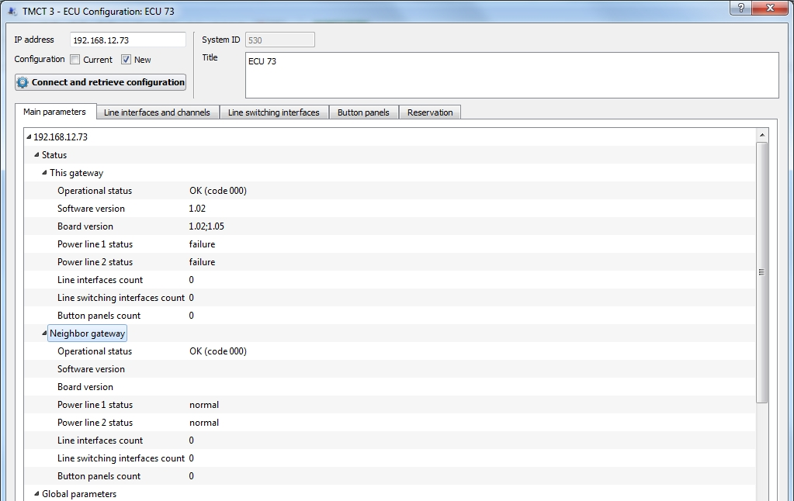
Figure 209 − ECU parameters, tab «Main parameters»

8.1.1 Status

When branch «Status» is opened, the current status of the given and remote gateway is displayed. Non-editable fields are given for information only.

Operational status:
0XX – ready and operational (green);
000 – OK (code 000);
1XX – ready but has limitations (yellow);
100 – working on single power source (code100);
2XX – ready but almost reached limits (orange);
3XX – unserviceable, but monitoring is available (red);
300 – does not work (code 300);
4XX – unserviceable and monitoring is unavailable (dark red).

Software version – ECU gateway software version.

Board version – ECU gateway board version.

Power line 1 status:
0 – normal;
1 – failure.

Power line 2 status:
0 – normal;
1 – failure.

Line interfaces count – the number of LIs served by the ECU gateway.

Line switching interfaces count – the number of LCs served by the ECU gateway.

Button panels count – the number of push-button panels serviced by the ECU gateway.

8.1.2 Global parameters

8.1.2.1 Network configuration

IP address – ECU gateway IP address.

Network mask – subnet mask.

Gateway address – address of the network gateway.

SNMP trap receivers – list of SNMP agents IP addresses, separated by a «;» (semicolon), to which the TRAP messages will be sent.

Syslog server address – IP address of the server for the purpose of syslog messages sending.

Crate address – the address of the crate in which this ECU is located. In case of an error, «-1» will be displayed.

Crate position – the position of the gateway in the crate 1 or 2. If there is an error, «-1» will be displayed.

8.2 Line interfaces and channels

The tab displays the current status of each available LI and a set of parameters for LI and its channels configuring.

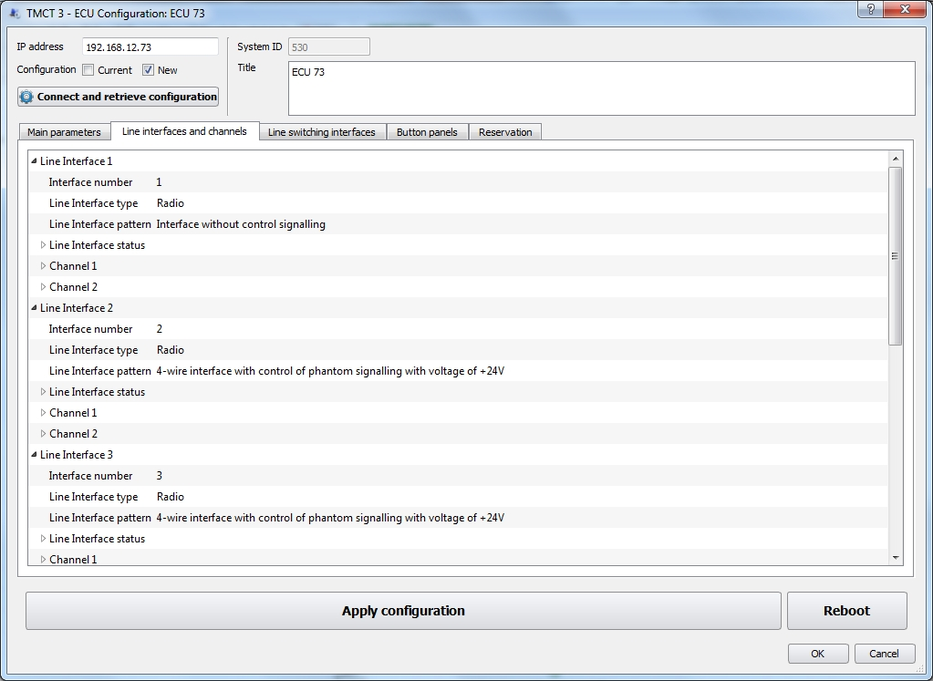
Figure 210 − ECU parameters, tab «Line interfaces and channels»

8.2.1 Line interface

As an example, consider the description of the settings of Line Interface 1, see Figure 210.

Interface number – the sequence number value of the interface in the ECU. The field is not editable.

Line interface type:
0 – the line interface is not used;
1 – Radio.

Line interface pattern – a binary pattern that characterizes the operation of the interface board. The pattern file is selected from the corresponding window, which is called by double-clicking, see Figure 211.

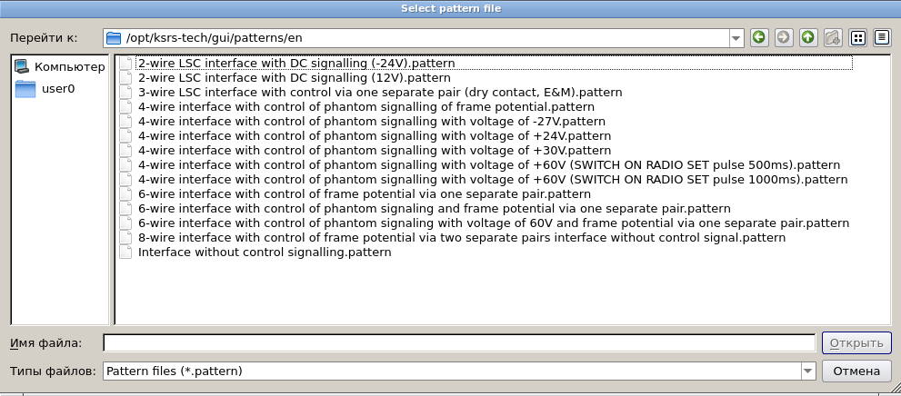
Figure 211 − Pattern file selection window

8.2.2 Line interface status

The current LI status is displayed while the branch «Line interface status» opening. The fields are not editable, they are given for information only.

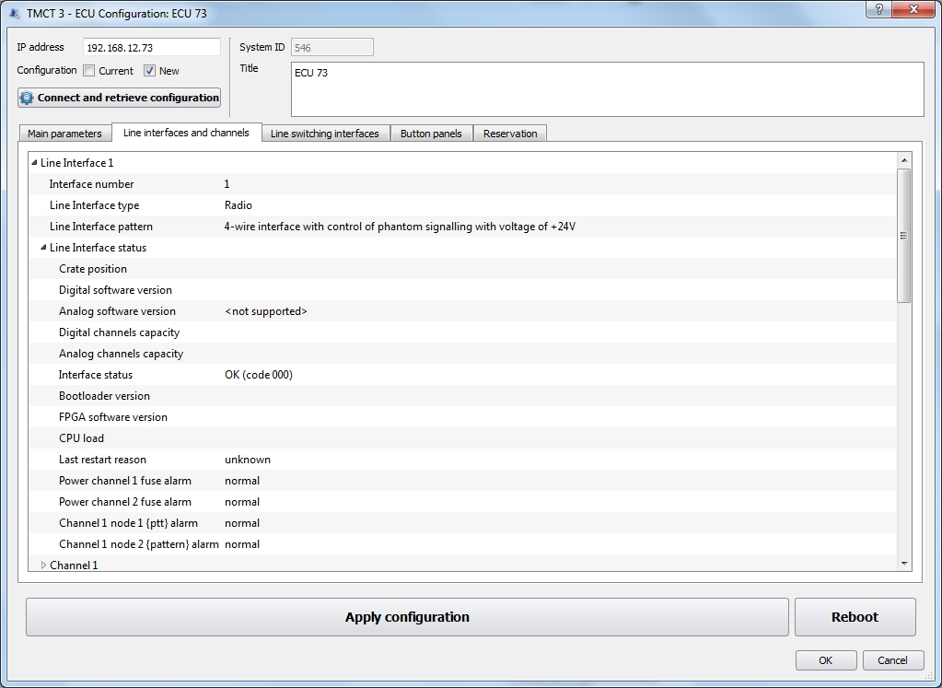
Figure 212 − Tab «Line interfaces and Channels», LI status
Crate position – board position within the crate.

Digital software version – software version in major.minor format.

Analog software version – software version in major.minor format.

Digital channels capacity – number of channels supporting LIU-D.

Analog channels capacity – number of channels supporting LIU-A.

Interface status:
0XX – ready and operating (green);
000 – OK (code 000);
1XX – ready, limited functionality (yellow);
104 – ANALOG_INTERFACE_HARDWARE_ERROR. The
ALI_HW_STATE package with the hardware error information will be
received from the LIU-A.
105 – DIGITAL_INTERFACE_HARDWARE_ERROR. The
DLI_HW_STATE package with the hardware error information will be
received from the LIU-D.
2XX – ready but almost reached limits (orange);
3XX – unserviceable, but monitoring available (red);
300 –not working (code 300);
4XX – unserviceable and monitoring is unavailable (dark red);
400 – connection to LI is not established (code 400).

Bootloader version – in major.minor format.

FPGA software version – in major.minor format.

CPU load – indicated in percent.

Last restart reason:

0 – unknown;

1 – loss of communication;

2 – internal error;

3 – incorrect configuration;

4 – gateway command;

5 – synchronization error.

Power channel 1 fuse alarm:
0 – normal;
1 – alarm.

Power channel 2 fuse alarm:
0 – normal;
1 – alarm.

Channel 1 node 1 {ptt} alarm:
0 – normal;
1 – alarm.

Channel 2 node 1 {pattern} alarm:
0 – normal;
1 – alarm.

8.2.3 Channel

As an example, consider the description of Channel 1 settings, see Figure 213:

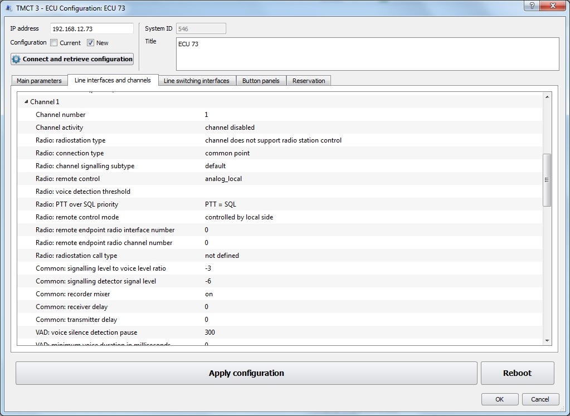
Figure 213 − Tab «Interfaces and channels»
Channel number – the channel sequence number value in the interface.

Channel activity – the parameter value determines channel activity in the interface, channel is on or off:
0 – channel disabled;
1 – channel is active.

Radio: radiostation type – type of radio set, corresponding to the given interface channel:
0 – channel does not support radiostation control;
1 – FAZAN-19;
2 – Polet;
3 – PP500 PIRS;
4 – FAZAN (R2, R5, R8, P2, Rx);
5 – SmartCross.

Radio: connection type:
0 – common point;
1 – dry switch relay;
65535 – unknown.
Radio: channel signalling subtype:
0 – default. Preferred value if no channel subtype defined;
1 – Radio interface type channels only. Radiostation channel operates in gateway mode. This value corresponds to the default value for channels with Radio interface type;
2 – Radio interface type channels only. Radiostation channel operates in terminal mode. SQL signal used as PTT, and PTT used as SQL.

Radio: remote control – radio set control (RSC) at activation:
– analog_local: local radio set control. LIA is responsible for control;
– digital_remote_tone_1020hz: remote radio set control using 1020 Hz tone frequency. LID is responsible for control;
– digital_remote_tp112: remote radio set control «PTT plus», version 1.1.2. LID is responsible for control;
– digital_remote_tone_2600hz: remote radio set control using 2600 Hz tone frequency. LID is responsible for control;
– digital_local_tone_1020hz: local radio set control using 1020 Hz tone frequency. LID is responsible for control;
– digital_local_tone_2175hz: local radio set control using 2175 Hz tone frequency. LID is responsible for control;
– digital_local_tone_2600hz: local radio set control using 2600 Hz tone frequency. LID is responsible for control;
– digital_local_tone_2700hz: local radio set control using 2700 Hz tone frequency. LID is responsible for control.

Tone control implies signal («PTT») control using tone frequency.

Radio: voice detection threshold – SNR threshold, determining availability of voice signal in the channel, indicated in decibels from–10dB to +10dB.

Radio: PTT over SQL priority – relative priority of PTT signal and SQL signal:
1 – PTT > SQL;
2 – PTT <SQL;
3 – PTT = SQL.
In case PTT priority is lower than SQL priority, during transmission (sending of PTT signal to LI) the receiver is not switched off, transmission is prohibited. In case PTT priority equal to SQL priority, during transmission (sending of PTT signal to LI) the receiver is not switched off, transmission and reception are carried out at the same time. In case PTT priority is higher than SQL priority, during transmission (sending of PTT signal to LI) the receiver is switched off, only transmission is available.

Radio: remote control mode – remote radio set control operation mode:
0 – controlled by local side;
1 – controlled by remote side.

Radio: remote endpoint radio interface number: the value is valid provided that the LI is configured as the local / near end of the RRSC. The interface number takes the value from 0 to the number of interfaces -1.

Radio: remote endpoint radio channel number: the value is valid provided that the LI is configured as the local/near end of the RRSC. The channel number of the interface takes the value in the range 0..7 and does not exceed the supported number of LIU-A and the LIU-D channels.

Radio: radiostation call type:
0 – undefined (no call type defined for this channel or this
parameter is not used);
1 – SELCAL.

Common: signaling level to voice level ratio – signal level for the signalling detector in dB. It can take a value in the range -300..0. The parameter refers to the SELCAL, DTMF signalling for Radio and LSC SSC.

Common: signaling detector signal level – the signal level for the signalling detector in dB. It can take a value in the range -300..0. The parameter refers to the SELCAL, DTMF signalling for Radio and LSC SSC.

Common: recorder mixer:
0 – disabled;
1 – enabled.

Common: receiver delay – artificial delay during reception from the line, it is indicated in milliseconds, 1024, max.

Common: transmitter delay – artificial delay during transmission to the line, it is indicated in milliseconds, 1024, max.

VAD: voice silence detection pause – the length of the pause in milliseconds, over which the detector determines the absence of voice in the channel.

VAD: minimum voice duration in milliseconds – the minimum speech duration in milliseconds detected by the voice detector.

VAD: minimum threshold exceeding signal/noise ratio – the minimum excess of speech over the noise in dB detected by the voice detector.

Gain: reception – the parameter determines gain during reception on this channel. The range of possible values is from 0 to 255 (for values see Appendix B of this Manual). Negative value indicates that the parameter is not used.

Gain: transmission – the parameter determines gain during transmission on this channel. The range of possible values is from 0 to 255 (for values see Appendix B of this Manual). Negative value indicates that the parameter is not used.

Gain: self-monitoring – the parameter determines gain during self-listening on this channel. The range of possible values is from 0 to 255 (for values see Appendix B of this Manual). Negative value indicates that the parameter is not used. Self-listening is relevant for 4-wire line only (Radio and 4-wire LSC). Negative value indicates that the parameter is not used.

Gain: adjusting resistor RR – the parameter determines gain of preset resistor RR on this channel. The range of possible values is from 0 to 255 (for values see Appendix B of this Manual). Negative value indicates that the parameter is not used.

Gain: adjusting resistor RC – the parameter determines gain of preset resistor RC on this sub-channel. The range of possible values is from 0 to 255 (for values see Appendix B of this Manual). Negative value indicates that the parameter is not used.

Gain: recorder – the parameter determines gain of recording output on this channel. Gain is used for mixed reception and transmission data. The range of possible values is from 0 to 255 (for values see Appendix B of this Manual). Negative value indicates that the parameter is not used.

Gain: recorder additional – the parameter determines gain of recording output of reception only on this channel. Gain is used for auxiliary recording output, to which reception data are sent. The range of possible values is from 0 to 255 (for values see Appendix B of this Manual). Negative value indicates that the parameter is not used.

Gain: Automatic Gain Control for receiver – the parameter value determines operation of automatic gain control for reception from the line:
0 – off;

1 – on.

Gain: Automatic Gain Control for transmitter – the parameter value determines operation of automatic gain control for transmission to the line:
0 – off;

1 – on.

8.3 Line Switching Interfaces

This tab is intended for setting and displaying of the current LSI status.

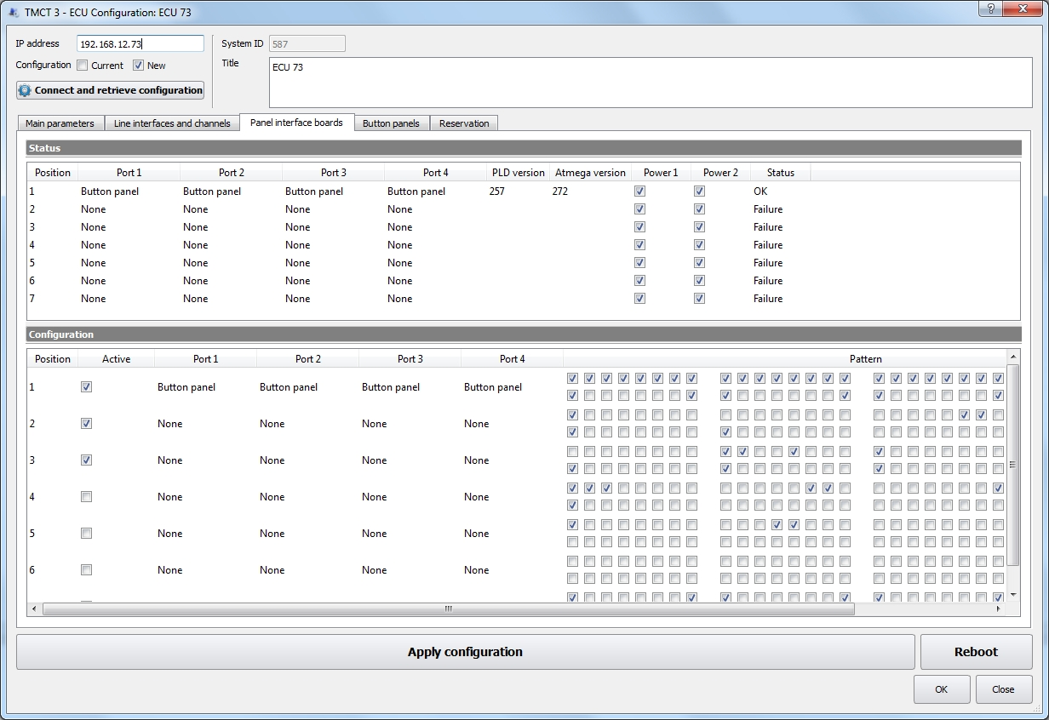
Figure 214 − The tab «Line switching interfaces»
The current status of the LSI is displayed at the top of the tab «Line switching interfaces» in the «Status» panel – the position in the crate, the status of the ports, the LSI activity (on or off), the FPGA and Atmega firmware versions, availability of the configuration and power supply for the first and second channels, the LSI status code.

LSI parameters are adjusted at the bottom of the tab in the «Configuration» panel.

«Position» – the LSI position in the crate.

«Active» – LSI status:
0 – LSI is off, checkmark is absent;
1 – LSI is on, checkmark is set.

«Port» – the type of port. Select the type of port from the drop-down list: disabled, the button panel cable.

«Pattern Size» – the size of the binary configuration pattern. The field is not editable.

«Pattern» – binary pattern for low-level LSI configuration. It is presented in the form of four button panels with 16 buttons.

When the configuration is complete, click the button «Apply configuration».

8.4 Button Panels

This tab is used to configure and display the current status of the Button panels. At the top of the tab in the «Status» panel, the current status of the Button panels is displayed:
«LSI position» – the LSI position in the crate.

«LSI port» – the LSI port to which the panel is connected.

«PLD version» – PLD firmware version.

«Atmega 1 version» – firmware version of the first Atmel Atmega chip.

«Atmega 2 version» – firmware version of the second Atmel Atmega chip.

«Active» – the state of the Button panel, working or on standby.

«Microphone» – panel microphone status.

«Power 1» – power availability on the first channel.

«Power 2» – power availability on the second channel.

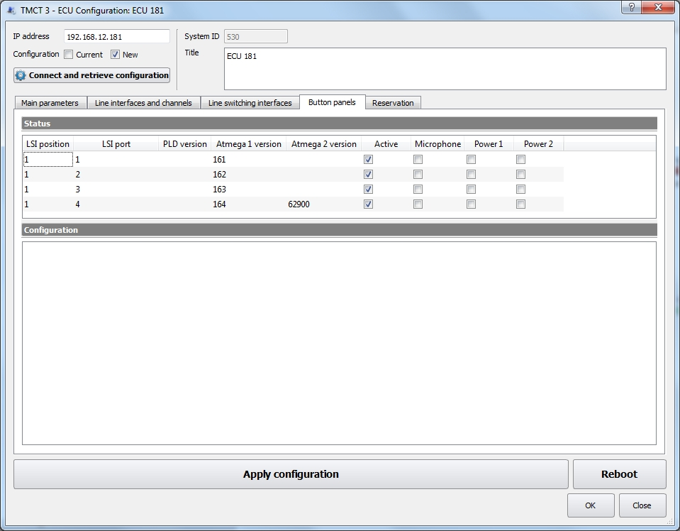
Figure 215 − Tab «Button panels»

LSI parameters are adjusted at the bottom of the tab in the «Configuration» panel.

«LSI position» – the LSI position in the crate.

«LSI port» – the LSI port to which the panel is connected.

«Active» – the state of the Button panel. If the checkmark is set the panel is enabled, if the checkmark is not present the panel is turned off.

«Pattern Size» – the size of the binary configuration pattern. The field is not editable.

«Pattern» – binary pattern for low-level configuration of the Button panel.

When the configuration is complete, click the button «Apply configuration».

8.5 Reservation

This tab is used to configure the reservation and display the current status of the ECU resources.
The current status of the ECU resources is displayed at the top of the tab in the «Status» panel:

«Service» – reserved service (resource).

«Host ID» – unique numeric host identifier in the HSP protocol.

«Service status» in the HSP protocol:
0 – «Initial», initial status;
1 – «Learn», learning status;
2 – «Listen», reservation group monitoring status;
4 – «Speak», the status of communication with the reservation group;
8 – «Standby», the status of the standby service;
16 – «Active», the status of the main service.
If we consider the status in the context of «main/standby», then the «Active» state is «main», and all other statuses are «standby».

«Dynamic priority» – the dynamic priority of the service, it takes values ​​from 0 to 255.

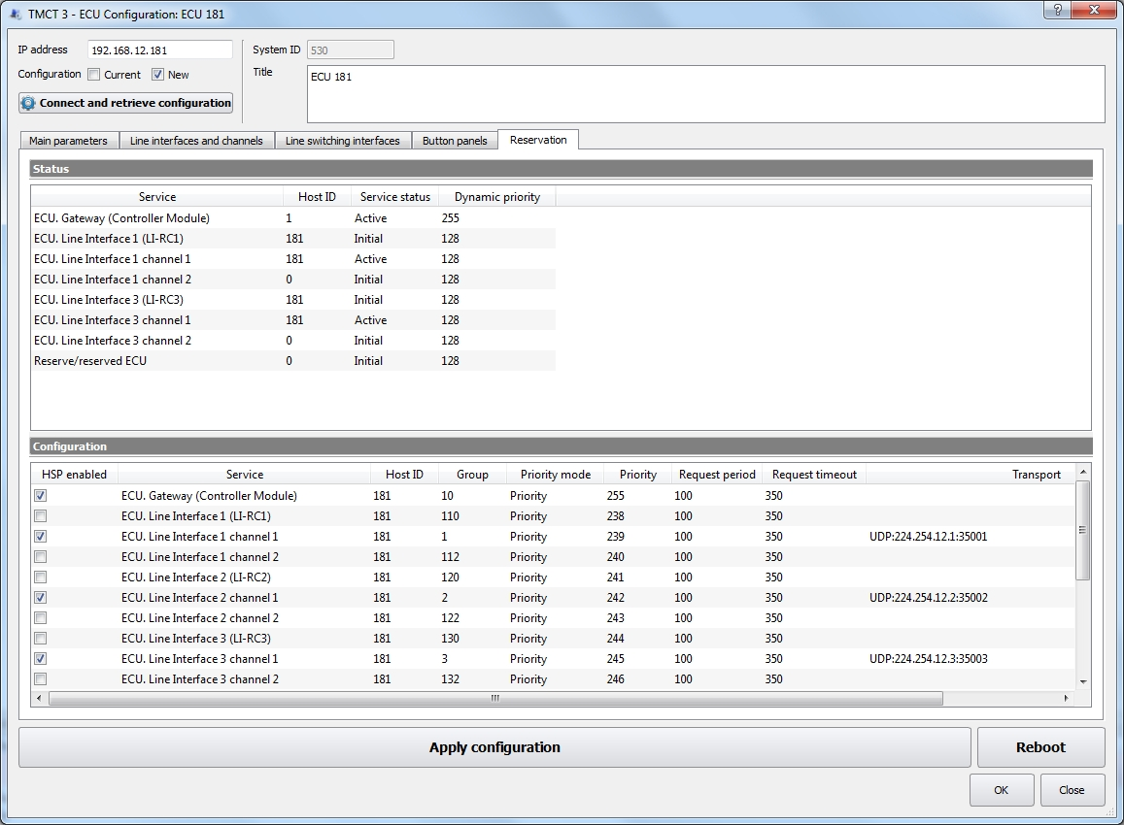
Figure 216 − The «Reservation» tab
Configuration of the reservation settings is performed at the bottom of the tab in the «Configuration» panel.

«HSP enabled» – the status of this service: whether the HSP is enabled or not is determined by the presence or absence of a check mark. Valid values ​​are:
0 – disabled;
1 – enabled.

«Service» – reserved service (resource).

«Host ID» – unique host identifier, it can take values ​​from 0 to 0xFFFFFFFF. If the record type is «Standby», then 4 bytes of the IP-address of the ECU can be used as the host ID. If the record type is SmartCross, then the host ID can be any.

«Group» – the number of the reservation group in the HSP protocol. The reservation group to which the service belongs. It takes a value between 0 and 255.

«Priority mode» – the mode of operation of the reservation algorithm, depending on the priority:
0 – «Priority». Service with a higher priority is always the main one. When a new properly functioning service with a higher priority appears in a group of reservation, it becomes the main one;
1 – «Standard». Minimum number of switching between services. The main service will not be changed, even when a new properly functioning service with higher priority appears in the reservation group.
The default value is 0.

«Priority» – the static priority of the service. It takes a value between 0 and 255.

«Request period» – the interval of message sending in milliseconds by the host. It takes a value between 0 and 65535.

«Request timeout» – the interval in milliseconds during which the host waits for the message. It takes a value between 0 and 65535.

«Transport» – list of transport protocol address information for the reservation protocol. The entries in the list are separated by «;». Valid formats: UDP:IP_MULTICAST:PORT, CAN:ID, CAN:ID:REMOTE_ID, CAN:ID/MASK.
1. UDP. As a transport protocol, UDP is used. IP_MULTICAST – IP address of the multicast group. PORT is the receive and transmit port.
- CAN. All data in ASCII format HEX. For example, A1 or 12E:2FA or 123/7FF.

9 Briefing and Training System (BTS)

Instructors carry out air traffic controllers (dispatchers) training in the standalone and complex mode.
In the standalone training mode, dispatcher's WP 1 and instructor's WP 1 are connected to each other only. Connection is provided only between these two WS's using button Radio (Trainer).
In the complex mode, at least two dispatchers and two instructors carry out operations. Dispatchers communicate via LSC communication with each other, and not with the instructor (as in the standalone mode). In this case the instructor acts as a pilot and external LSC subscribers, at that the instructors hear communications of their dispatchers.
Each dispatcher works at his workstation (WS) with its unique configuration. Training configuration is exactly the same as WS of each dispatcher. Instructor's task is to simulate standard and abnormal situations, which may take place during dispatcher’s work.

9.1 VCDT Training Configuration

According to the type of WS, all VCDT are divided into «Instructor» and «Dispatcher». WS type is set at the stage of system object creation (see item 4.1 «Creating a System Object» of this Manual).

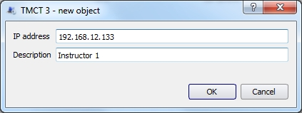
Figure 217 − Creating a new system object
The text description of VCDT name must contain keyword «Instr» or «Disp», which determines the type of WS – «Instructor» or «Dispatcher».

Operation mode selection and updating training workstation’s configurations are carried out in the window, which is opened by selecting menu item «VCDT Training configuration», see Figure 218.

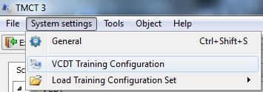
Figure 218 − Menu item «VCDT Training configuration»

When the menu item is selected, the window, whose overall view is shown in Figure 219, will be opened.

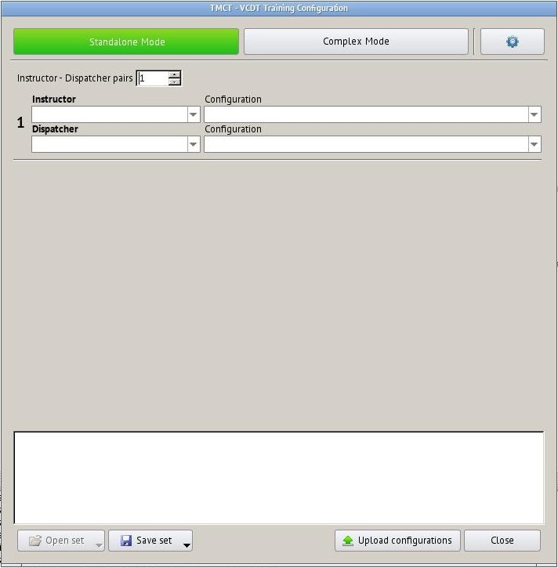
Figure 219 − Overall view of window «VCDT Trainer configuration»
Buttons for selecting configuration updating modes – «Standalone» or «Complex» are located in the upper part of the window. Button for access to the page of setting with different parameters, facilitating VCDT selection and configuration for their updating, is located in the right part.

The number of pairs, which is required for operation, is indicated in field «Instructor – Dispatcher pairs».

In the standalone mode the minimum number of assigned pairs is 1, in the complex mode – 2. The maximum number of pairs in both modes is 9.

VCDT, to which configuration shall be set, is selected from drop-down list «Instructor», the selection is made from all available system’s VCDTs of indicated type. WS configuration for respective VCDT is selected from drop-down list «Configuration», the selection is made from all available system configurations, see Figure 220.
VCDT, to which configuration shall be set, is selected from drop-down list «Dispatcher», the selection is made from all available system VCDT of indicated type. WS configuration for respective VCDT is selected from drop-down list «Configuration», the selection is made from all available system configurations, see Figure 220.

If there are two configurations with the same name, for example, «Standalone Instr AC» and «Standalone Disp AC», when one of them is selected for this WS, the second one is selected automatically.

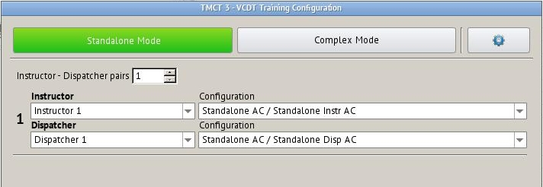
Figure 220 − Selecting configuration
To upload the selected configurations to the selected VCDT, press button «Upload configurations». Detailed information on the progress of updating will be displayed in the protocol window, see Figure 221.

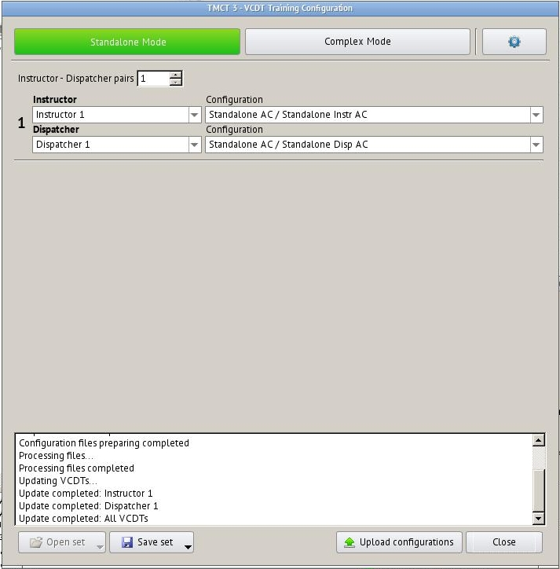
Figure 221 − Uploading current configuration
The selected VCDT and their configurations can be saved as a named set to be used again. Press button «Save set», select item «Save as». Specify the name in the title entry field and press «OK»:

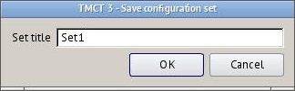
Figure 222 − Saving configuration

To load a previously saved set of configurations to the window, press button «Open set» and select the required set by its name.

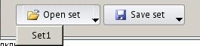
Figure 223 − Opening configurations set
After that, the list of VCDT and their configurations is loaded in the window. To apply the selected set, press button «Upload configurations».

Alternative method of configurations set uploading is to use menu item «Load Training Configuration Set», see Figure 224.
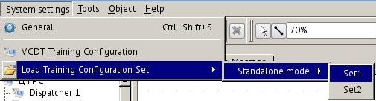
Figure 224 − Alternative method of configurations set opening

Select a respective mode and configurations set name. Window «VCDT Training Configuration» with the selected set will be opened. To apply it, press button «Upload configurations».

The saved set may be deleted by holding down key «Shift» while it is selected.

To save a configurations set under other existing name, press button «Save set» and select an existing name (in this example, Set1).

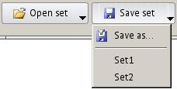
Figure 225 − Saving another configurations set under existing name

In case of positive answer, another configurations set will be saved under name Set1.
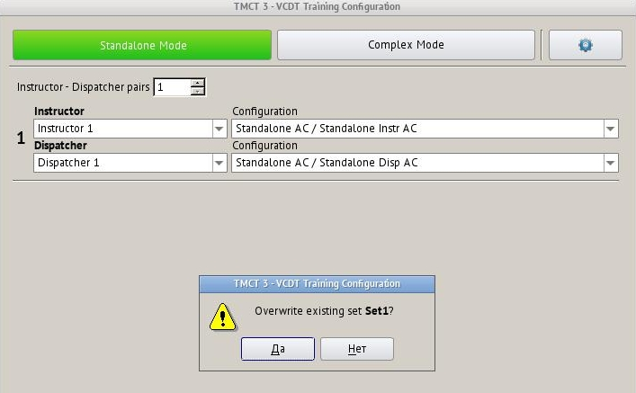
Figure 226 − Saving another configurations set under name Set1
VCDT equivalence table may be used to facilitate selection of configurations of «Instructor» and «Dispatcher» WS.
To open the equivalence table, press the button located in the upper right part of the window, see Figure 227.

Select Instructor's VCDT and respective Dispatcher's VCDT from the drop-down list.
For the standalone mode the address of external bearing messages reception system is specified in the following format:
<IPaddress>:<Port>:<ID>, ID parameter (direction finding identifier)is not mandatory.
In case the address is specified in the Equivalence table in format <IPaddress>:<Port>:<ID>, it completely replaces the address, indicated in the settings of button Radio (Trainer), see item 5.3.4 «Radio button properties (Trainer)» of this Manual.
If the address is specified in format <IPaddress>:<Port>, the button address is analyzed to calculate its ID.
Thus, the address in Radio (Trainer) button can be specified using two variants only – <IPaddress>:<Port>:<ID>or <ID>.

For the complex mode, the value, specified in field «Default bearing address» is used (see item 5.1.2.3 «Radio communication» of this Manual).

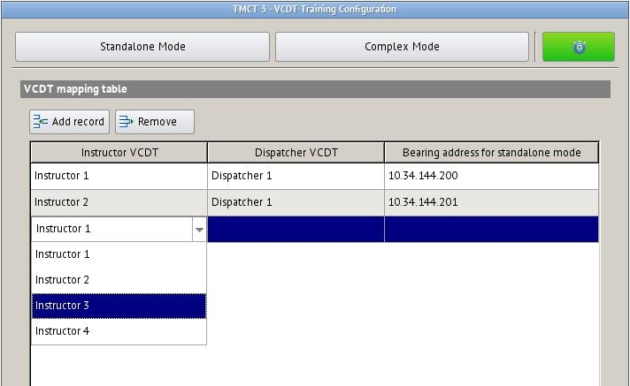
Figure 227 − VCDT equivalence table

For example, when Instructor 1 VCDT «Instructor 1» is selected on the standalone mode page, «Dispatcher 1» is selected automatically in the Dispatcher VCDT field in accordance with the Table, see Figure 228.

Figure 228 − Automatic equivalent selection

9.2 Configuring BTS LIU-A

Protocol of configuring and monitoring of LIU-A (Line interface unit analog) and BTS «Topaz» (Briefing and training system) LIU-A.
This item contains the description of tabs «VOIP peers», «Patterns» and «Files». Description of parameters of tabs «Main Parameters» and «Signalling Configuration» is given in items 6.1 and 6.3 of this Manual.

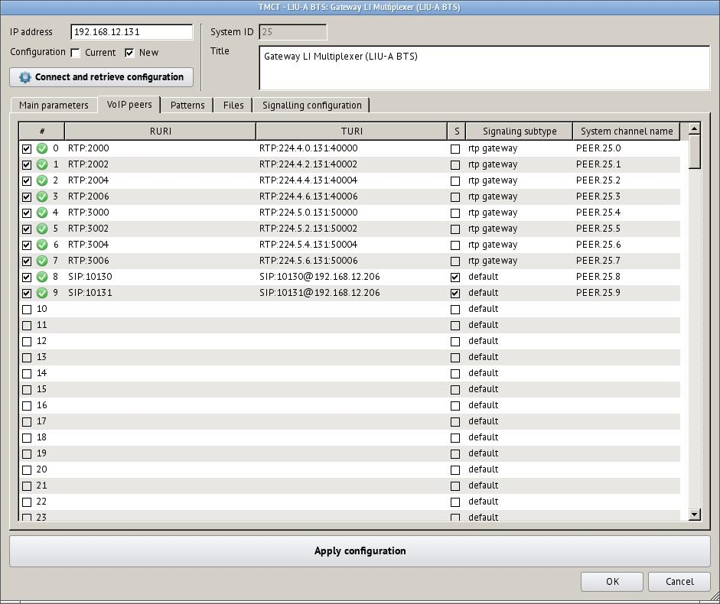
Figure 229 − BTS LIU-A parameters, tab «VOIP peers»

9.2.1 VOIP peers

The parameter value determines VoIP peer activity. In case the peer is on, it will be taken into account during analysis of switching pattern table (tab «Patterns»).

1 – on;
0 – off.
Sequence number of VoIP peer. It assumes a value from 0 to 255.

RURI

URI for establishing incoming call to LIU-A using one of VoIP protocols.
SIP:number | RTP:port
For example: RTP:30000 or SIP:240
- SIP:number.This value corresponds to simplex call via SIP. Signalling control using the subscription mechanism SUBSCRIBE/NOTIFY. Number in the SIP signalling can be both a usual number for SIP (SIP:300) and contain set expressions.
- RTP:port. This value corresponds to simplex call via extended RTP protocol. The port number is also used as SIP number to transmit signalling using the subscription mechanism SUBSCRIBE/NOTIFY.
If LIU-A IP address is 192.168.12.240 and the value of one of LIU-A VoIP peers in field RURI is SIP:240, to call this peer using SIP protocol, called URI on the calling side (when it is called) shall be SIP:240@192.168.12.240.
If LIU-A IP address is 192.168.12.240 and the value of one of LIU-A VoIP peers in field RURI is RTP:30000, to call this peer using extended RTP protocol, called URI on the calling side (when it is called) shall be RTP:192.168.12.240:30000.
Further call switching is carried out in accordance with the switching pattern table (tab «Patterns»).

TURI

URI for establishing outgoing call from LIU-A using one of VoIP protocols. Allowable values:

SIP:number[@ip_address[:port]] | RTP:ip_address:,[RTP…]
- SIP. If SIP is used, the address may look as follows, for example: SIP:1001@192.168.12.201:5000. In case it is necessary to establish a conference call with several subscribers, the list of receivers addresses shall be indicated separated by commas: SIP:1001@192.168.12.201:5000, SIP:2001@192.168.12.202. The maximum number of receivers is 4. Number in the SIP signalling can be both a usual number for SIP and contain set expressions.
- RTP. For RTP protocol both multicast and unicast of the address are allowed. For example: RTP:224.1.1.1:30000 or RTP:192.168.1.2:30002. As it is allowed to transmit to several receivers at once, their addresses shall be indicated separated by commas: RTP:192.168.1.2:30002,RTP:224.1.1.1:30000. The maximum number of receivers is 4.
In case URI contains a list of values, the types of channels of all records shall be the same.

Control over subscriptions

If SIP signalling is clearly indicated in TURI, LIU-A may subscribe to these URI, and if they are engaged, it may transmit engagement signal to the calling channel provided that calling channel signalling supports it.

1 – switch on subscriptions;
0 – switch off subscriptions.

Signalling subtype:
0 – default. Default value. In case the subtype of
signalling is not determined for the channel, this value shall be used;

1 – radio_gateway. The value is relevant for channels with
RTP signalling type. RTP channel operates in the gateway mode. This
value also corresponds to the default value for channels
with RTP signalling type;

2 – radio_workstation. The value is relevant for channels with
RTP signalling type. RTP channel operates in the workstation
mode. Signal SQL is used as PTT, while PTT – as SQL;

3 – rtp_gateway. The value is relevant for channels with
RTP signalling type. RTP operates in rtp_gateway mode and cab be
switched to another RTP channel in rtp_gateway mode. At that
reception will be switched to transmission, and transmission to reception.

Name of VCES channel

The name of VCES channel is indicated. The list of these channels will be indicated in field «Radiostation» (see item 5.3.3 «Radio button properties» of this Manual).

Set expressions formation principles

The set expressions for incoming calls may have the following values:
- «T» (one letter) – designates any number of digits.
- «T..T» (N letters) – designates that the number of digits shall be equal to N.
For example: SIP:1TT. All three-digit numbers, starting with 1, correspond to this pattern.

The set expressions for outgoing calls may have the following values:
(CALLED:L:C) – returns last L symbols of field «Called», if the length of «Called» 1 is less than L, the number is supplemented with L-1 symbols C from the left.
(CALLED:L) – returns (CALLED:L:0).
(CALLED) – returns field «Called» as it is.
{CALLED:S:L} – returns first L symbols of field «Called» starting with symbol number S. Symbols numbering starts with 0.
{CALLED:S} – returns {CALLED:S:L}, where L is the length of field «Called».
{CALLED} – returns field «Called» as it is.

The number may contain one pattern only.
For example, if the value of RURI is «SIP:1(CALLED:3)@192.168.12.61», and Called is equal to «12», after substitution it will be «SIP:1012@192.168.12.61».

9.2.2 Patterns

The switching pattern table is used to route the incoming calls. If an incoming call is received in the channel, there is the first active record for this channel in the pattern table, its fields «Called» and «Caller» coincide with the values of this incoming call. If such a record is found, the call is switched to the outgoing channel.
Fields «Called» and «Caller» are filled in differently for different channels during incoming call. In general case, field «Called» indicates the number of party being called without any additional signalling data. In general case, field «Caller» indicates the number of caller without any additional signalling data.
The parameter value determines the record activity. In case the record is active, it will be taken into account during analysis of switching pattern table:
1 – on;
0 – off.
Sequence number of record. It assumes a value from 0 to 255.

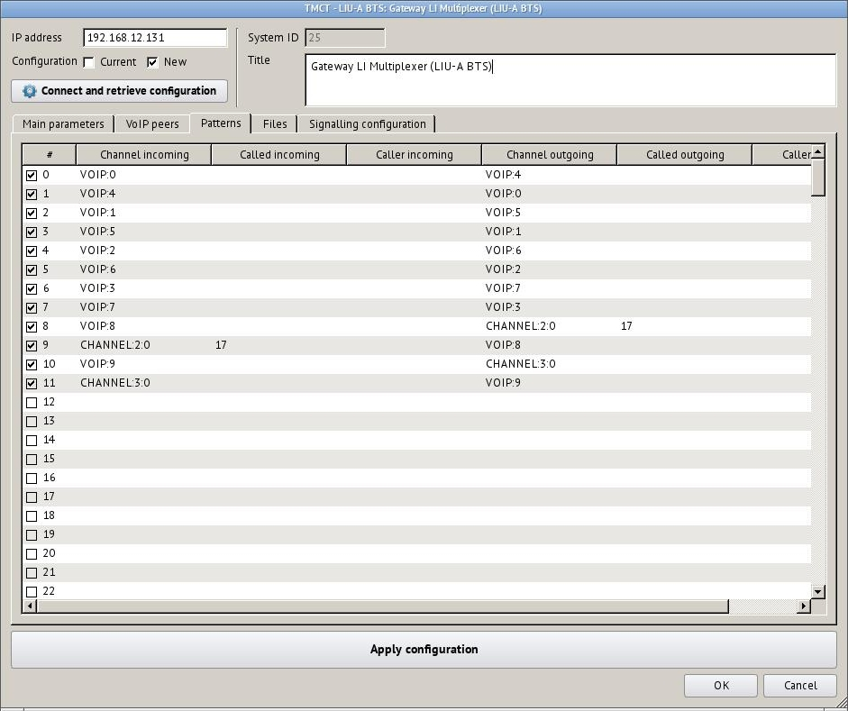
Figure 230 − BTS LIU-A parameters, tab «Patterns»

Channel incoming

The name of the channel an incoming call is made to. The following values are allowable:
«VOIP:N» – this value corresponds to the peer number N from VoIP peers table;
«CHANNEL:I:C» – this value corresponds to the channel number C of interface number I;
«FILE:N» – this value corresponds to a sound file number N from sound file table;
«» – an empty channel name will be ignored.

Called incoming

If this field is not empty, it will be compared to field «Called» of incoming call.

Caller incoming

If this field is not empty, it will be compared to field «Caller» of incoming call.

Channel outgoing
The name of the channel an incoming call will be switched to. The following values are allowable:
«VOIP:N» – this value corresponds to the peer number N from VoIP peers table;
«CHANNEL:I:C» – this value corresponds to the channel number C of interface number I;
«FILE:N» – this value corresponds to a sound file number N from sound file table;
«» – an empty channel name indicates that the call will be terminated.

Called outgoing

If this field is not empty, field «Called» of outgoing call will be substituted with this value.

Caller outgoing

If this field is not empty, field «Caller» of outgoing call will be substituted with this value.

9.2.3 Files

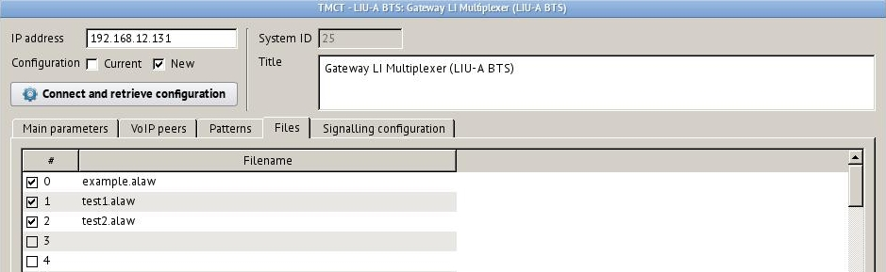
Figure 231 − BTS LIU-A parameters, tab «Files»
The parameter value determines the sound file activity. If the file is on, it may be used in the pattern table.
1 – on;
0 – off.

Sequence number of sound file. It assumes a value from 0 to 255.

Filename

Path to the file relative to the directory, where media files are stored.

10 Emergency Notification System Setting

The Emergency Notification System (ENS) is intended to create emergency communication network based on the used operational communication network of VCCS to warn the airport rescue team on the prerequisite for flight accident.

10.1 Notification scheme setup
Emergency notification schemes are configured on «Emergency Notification» tab in «System parameters» window, Figure 232. «System parameters» window can be opened by selecting main menu items «System settings»\«General».

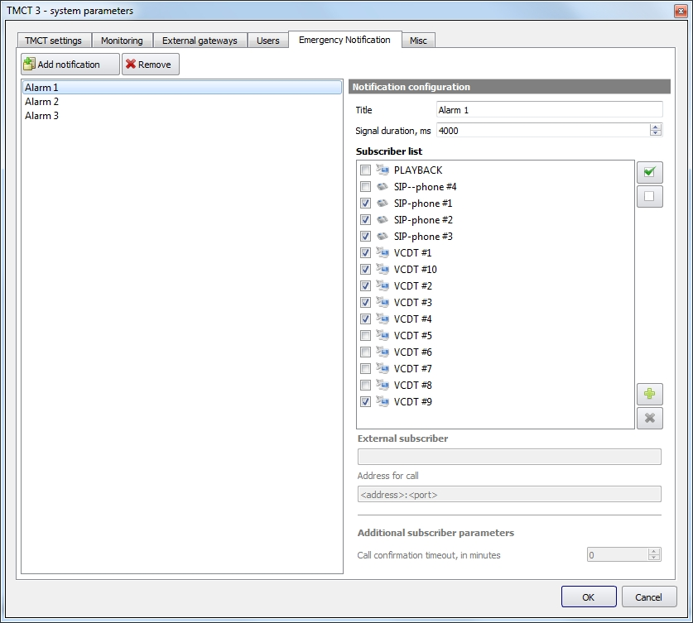
Notification scheme parameters оповещения»
Notification scheme list
Figure 232 − «Emergency Notification» setup page

Setup page contains the list of notification scheme sand the configuration panel for the selected scheme. The main list management buttons are:

– create and add new notification scheme to the list;

– completely remove selected scheme from system.

Scheme parameters

«Title» – scheme title.

«Signal duration, ms» – alarm signal playback duration. This alarm signal is played to a subscriber before voice message.
At the moment, «Beeper» voice event is used as an alarm signal (see 5.4 «Voice Events»). If the «Beeper» audio file is longer than this value, it’s playback will be interrupted. If the «Beeper» audio file is shorter than this value, it’s playback will be looped until «Signal duration» time runs out. If this value is set to «-1», then «Beeper» audio file will be played one time entirely from start to end.

Notification subscribers are selected in «Subscriber list». This list contains all VCDT, DCP and SIP-phones. External subscribers can be added manually.

– check all subscribers in list;

– clear all check marks.

If you need to add any external subscriber to the notification list, click the «Add external subscriber» button.

– add an external subscriber to the notification list;

– remove an external subscriber from the notification list.

Enter subscriber name and an address in the edit fields «External subscriber» and «Address for call». Subscriber’s address has a SIP URI format.

The name of the newly added external subscriber (in our example it is «Engineer») will be placed at the end of the list, see Figure 233.

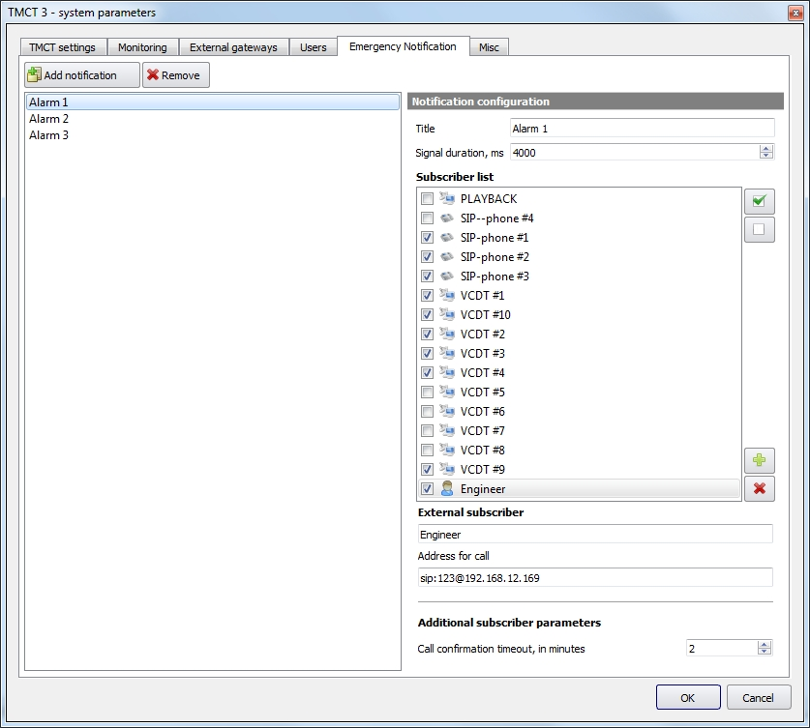
Figure 233 − «Emergency Notification» setup page, external subscriber edit

Additional subscriber parameters

«Call confirmation timeout, in minutes» – this field specifies the timeout to confirm the emergency notification call by subscribers, in minutes. If the call is not answered or confirmed by a subscriber in the specified time, it will be cancelled by the originating side with the appropriate log entry.
Default value is 0, i.e. no timeout and the calls are never cancelled automatically.

11 Monitoring System

The monitoring system (of equipment condition) is a set of procedures, which allows to get information on the current technical condition of the equipment (measurements of object status, including their switching on/off, change of configuration) based on the results of measurements of selected parameters and monitoring of equipment operation.

The monitoring system status indicator is located on the toolbar. Possible state are:

− the monitoring system is active, the state of work «Normal»;

− the monitoring system is in the state of performing any service operation, for example, creating a database backup. The indicator blinks green;

− the monitoring system is not available.

Clicking on the indicator will open an information window showing the current status of the database and monitoring collector, see Figure 234.

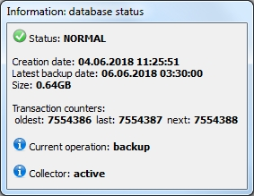
Figure 234 − Monitoring system, database status and collector
The monitoring collector is a subsystem of the TMCT, which is responsible for the relevance of system objects' indicators and replacement elements in the TMCT database.
The possible states of the collector:
– initializing;
– active, standby mode disabled;
– active;
– standby synchronization;
– standby.
If the collector is configured to use standby protocol and currently is in active mode, the «Synchronize» button will appear next to the monitoring system status indicator. The standby mode is set when you configure the collector. The database backup takes place once per hour on a timer and notifies the reservation group of the need to update.

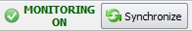 − when you click on the button, the process of forced database synchronization will be started (to save current changes to the database). If the collector is already in synchronization, the forced synchronization process will be postponed.
Monitoring system information is displayed in the form of system messages and graphical indication of object status.

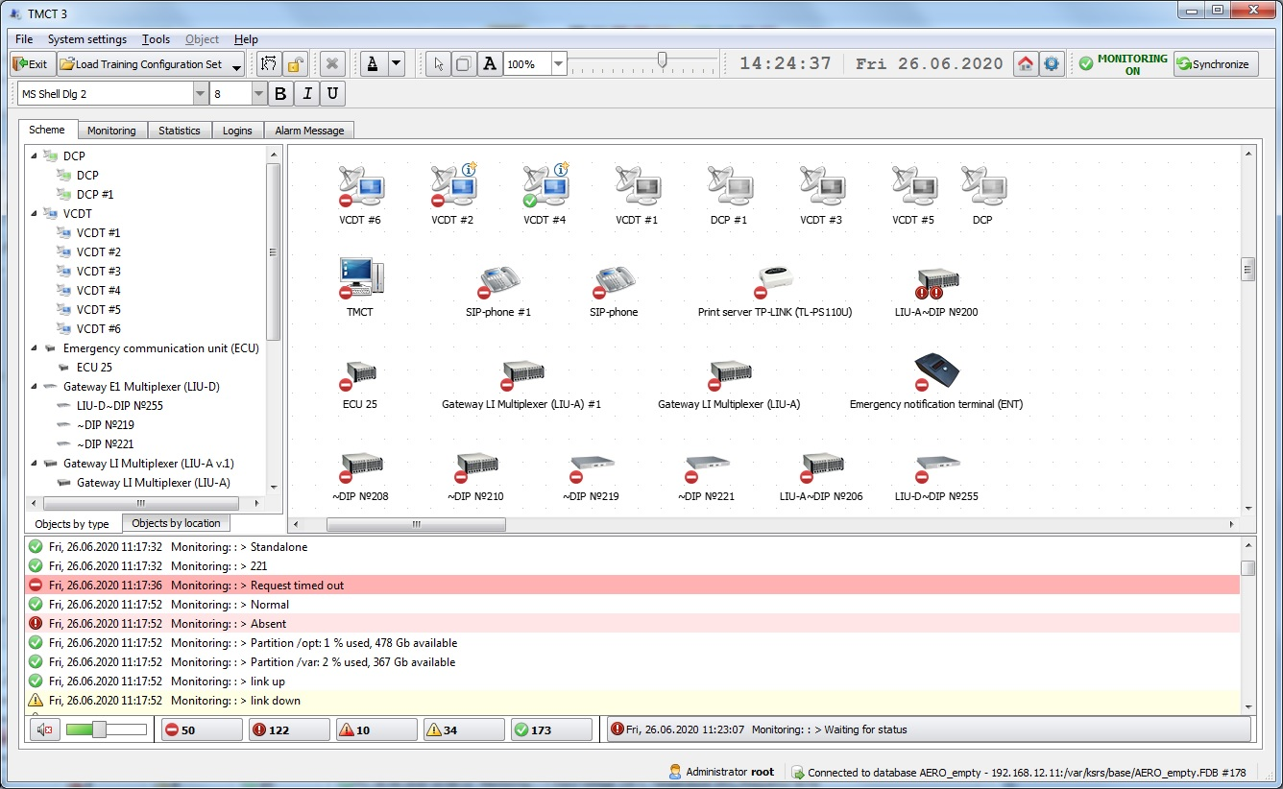
System messages
Information line
Graphical display
of system objects
Figure 235 − Monitoring system, system messages

The information line displays the last current message from the system message window.
All monitoring system messages are divided into the following types:

Failure | Major system disturbance
Unknown status | Also considered an emergency situation
Pre-emergency status | The monitoring object may pass to emergency condition
Warning | Events, after which VCCS may be operated without limitations
Normal | Monitoring object is in the normal operating condition

It is possible to set a filter on the output of the current system messages. To enable the filter, select the type of system messages whose display you want to disable and click the appropriate button:

- filtering system messages of this type is enabled. Pressing the button again disables the filter.

- filtering system messages of this type is disabled.
Enabling/disabling the filter does not affect the recording of system messages to the monitoring journal.
There are the following types of information (the monitoring log does not get):

Debugging messages
Other information messages

An event record (system message) contains the following information (see Figure 235):
– message type;
– time;
– device type;
– device;
– monitoring object;
– message content.

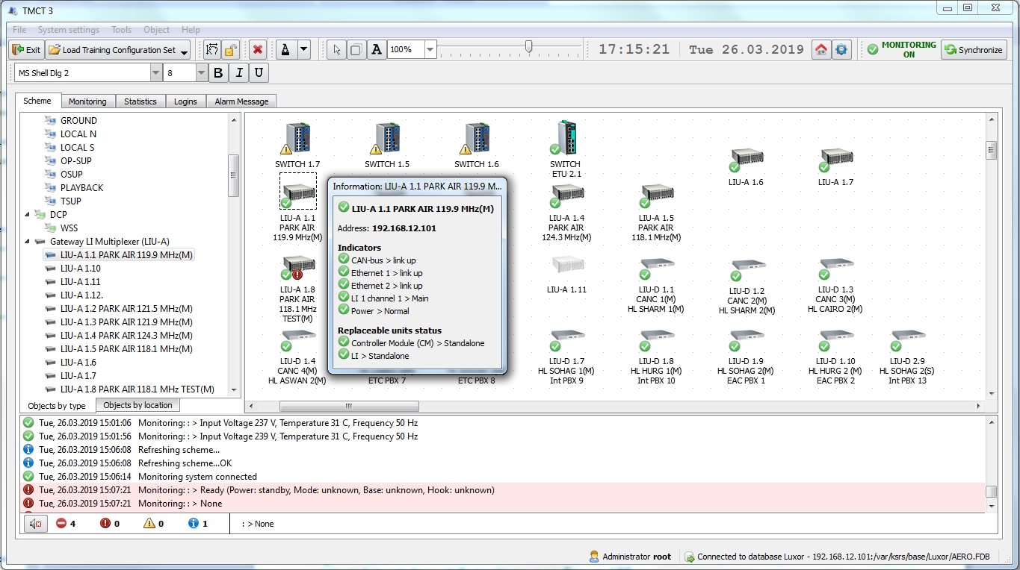
Figure 236 − Monitoring system, graphical indication of object status
The system object status is displayed on its icon in the form of respective indicator: normal status, failure, unknown status, pre-failure status, warning and information (description is given above). Detailed information on the status of selected system object elements may be viewed in window «Information», see Figure 236.
During operation, visibility of object indicators may be controlled, see item 11.7 «Monitoring parameters» of this Manual.

In case the status of Controller Module is unknown, all indicators and other replaceable elements from the object are hidden until CM status is normal again, see Figure 237.

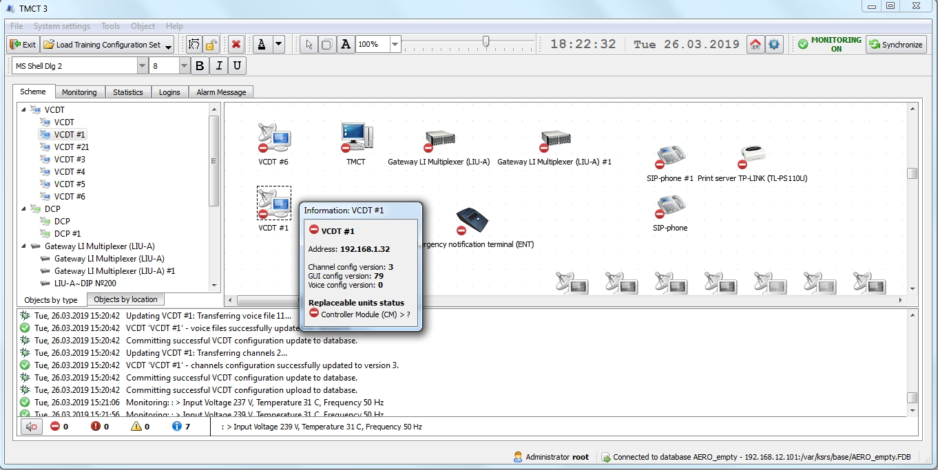
Figure 237 − Monitoring system, unknown CM status

11.1 Monitoring
Monitoring log is intended to view system messages. The tab consists of panel «Filter», panel «Message» and List of events. Buttons «Refresh», «Filtering» and «Print» are located in the upper part of the tab, see Figure 238.

– refresh the current list of messages;

– hide/show panel «Filter».

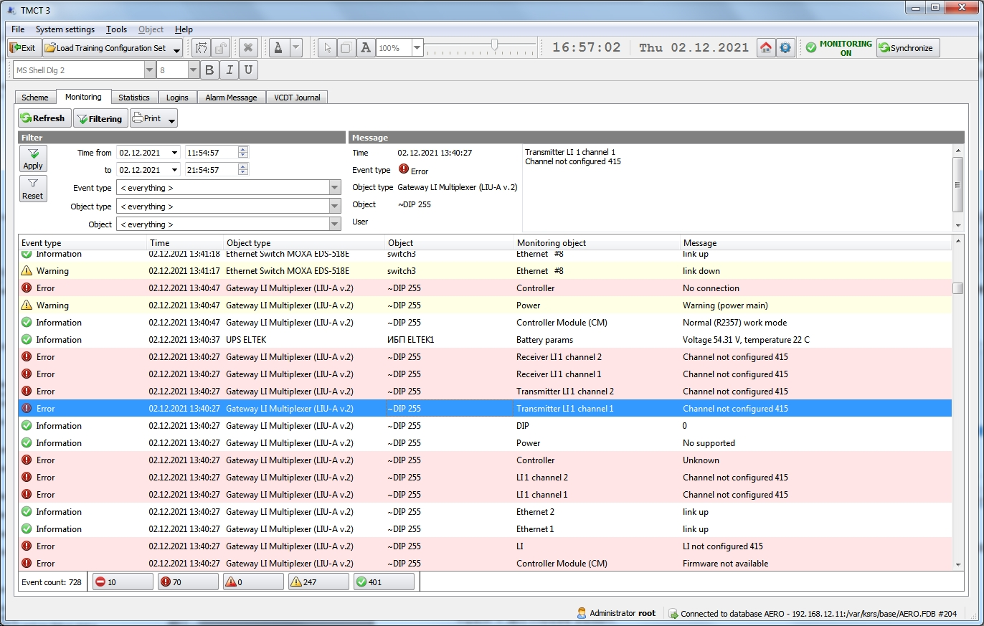
Panel «Filter»
List of events
Panel «Message»
Figure 238 − Tab «Monitoring»
In the Monitoring log it is possible to select the records that need to be printed. Records can be selected using the following key combinations:
«Shift» + «↑»,«↓»;
«Shift» + left mouse button;
«Ctrl» + left mouse button.

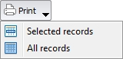 – print all records or records selected in the list.

If no printer is specified, the «Print» button will not be displayed! (see item 3.1.1 «TMCT Settings» of this manual).
The list of messages may be filtered by such parameters as time, type of event, type of device and specific device. Filtering parameters are set on «Filter» panel, see Figure 239.

 – filtering of messages by selected criteria;

 – reset filter parameters.

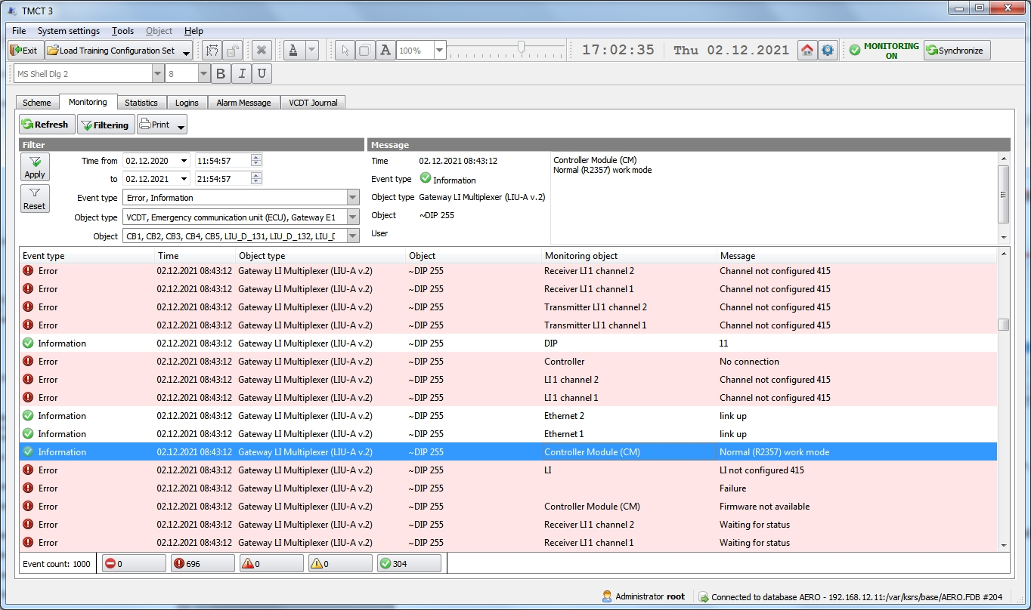
Figure 239 − Tab «Monitoring», filtering messages by selected criteria

Information of the event, selected from the list, is displayed on panel «Message», see Figure 239.

When USB flash drive appears in the system, button «Export» appears on tab «Monitoring» next to button «Filtering», see Figure 240.

– export of Monitoring log (all records or selected) in .csv format to the selected USB flash drive.

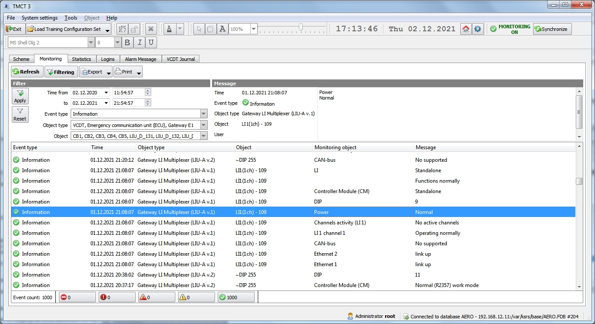
Figure 240 − Tab «Monitoring», button «Export»

In case USB flash drive is connected prior to TMCT start, the device is not detected!

To export the Monitoring log:
− press button «Export»
− select the USB flash drive;
− select the «Export here» drop-down menu item.
− select the «All records» or «Selected records» drop-down menu item. If you want to export the selected records, select the desired messages from the list of events before clicking the «Export» button.

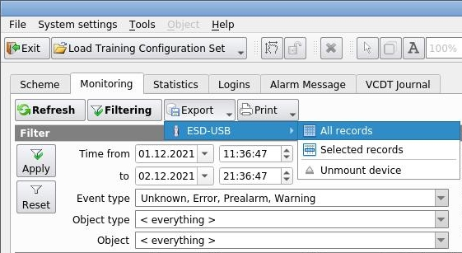
Figure 241 − Tab «Monitoring», selecting USB flash drive
Before exporting the Monitoring log, a window will be opened requesting the name of the resulting file. If the name is not specified, it will be generated automatically, see Figure 242.

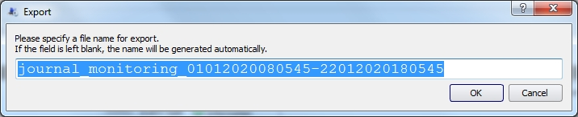
Figure 242 − Monitoring, request a file name for export

In case the log is exported successfully, a respective information message is displayed, the file is exported in .csv format, see Figure 243.

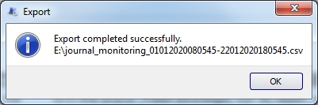
Figure 243 − Monitoring, export completed

To safely remove the USB flash drive, use the «Unmount device» drop-down menu item.

11.2 Setting of Sound Event Alerting
Specific sound alerting can be assigned to each type of monitoring system messages.
The on/off button is at the bottom of the window:

– all sound alerts are switched on.

– all sound alerts are off.

– sound alerts volume control.

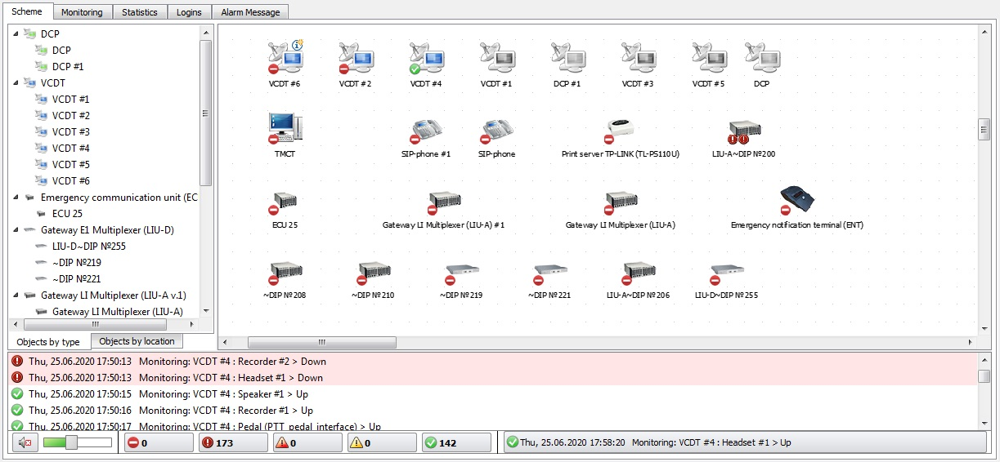
Figure 244 − Monitoring system, alerting

.wav files shall be located in folder \Sounds.

Message type | File name
- Failure | error.wav
- Unknown status | emergency.wav
- Pre-emergency status | alarm.wav
- Warning | warning.wav

11.2.1 Sound notification of failure and pre-failure status
In case of any failure and pre-failure situation, a sound signal is activated on the IME. Each type of event has its own sound signal, see item 11.2 of this manual. Among all failures, the most urgent problem is selected to trigger an alarm.
The sound signal is played until the accident is eliminated, or until the fault is confirmed manually. Manual alarm confirmation is performed by selecting the menu item «Acknowledge problem», see Figure 245.

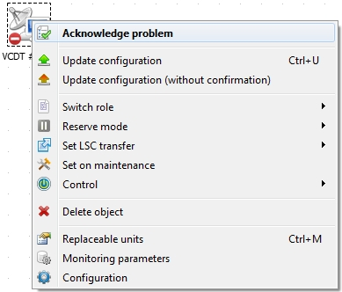
Figure 245 − Manual problem confirmation
The problem acknowledgement is displayed on the tab «Monitoring» with the corresponding entry indicating the user and the type of equipment affected, see Figure 246.

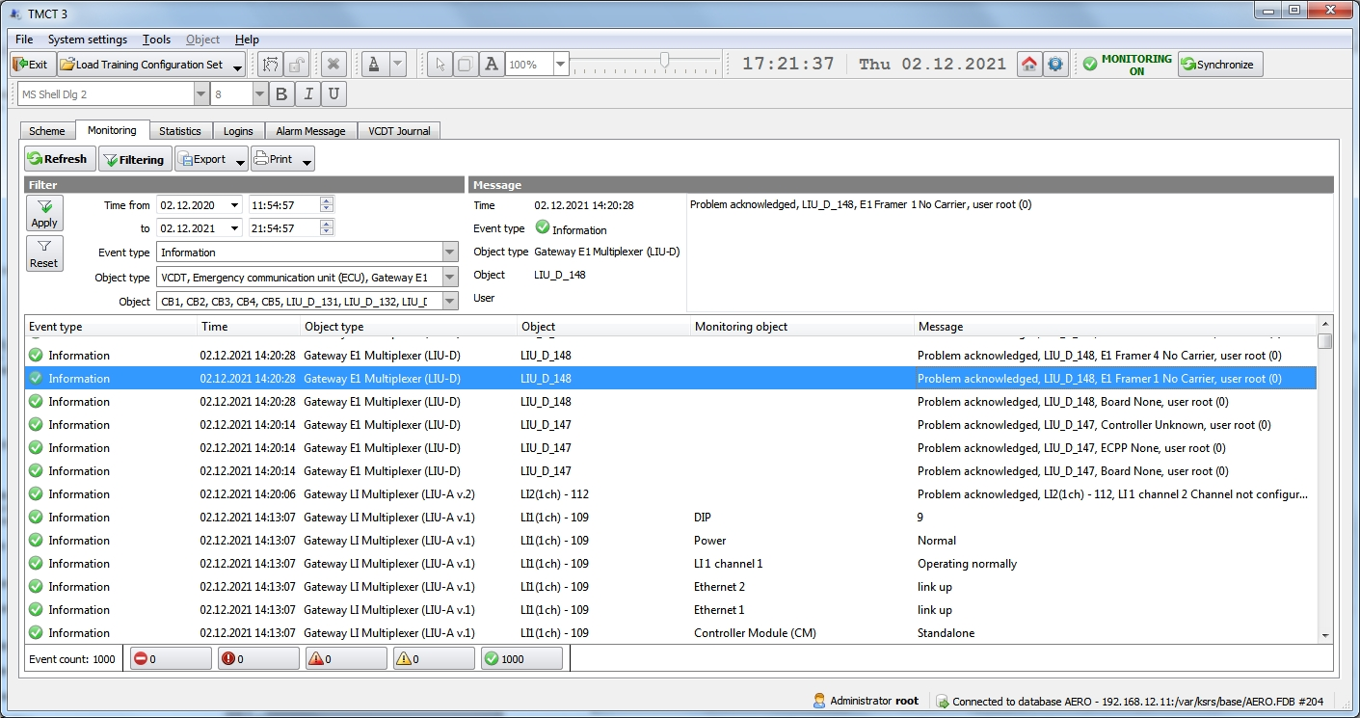
Figure 246 − Informational entry about failure acknowledgement

11.3 VCDT Statistics
Tab «Statistics» is intended to view information on workstation and communication channel loading.

– refresh current list of messages;

– delete all statistics permanently.

Tab «Statistics» consists of panel «Filter», information panel «Load by channel» and List of messages.

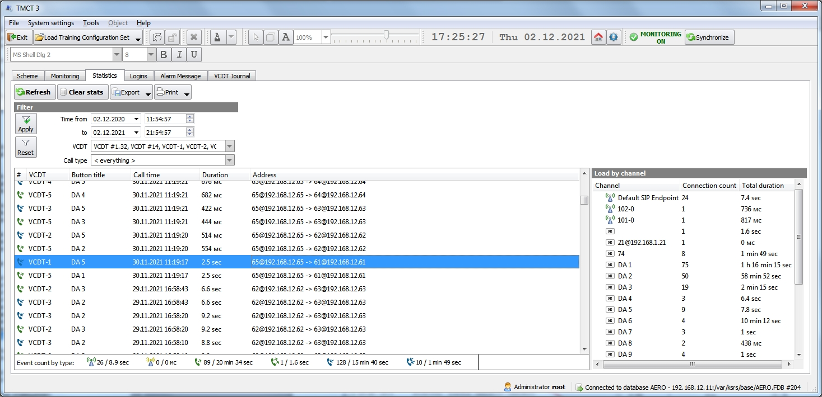
Panel «Filter»
Information panel
«Load by channel»
List of messages
Figure 247 − Tab «Statistics»
To view required information, select the required filters on panel «Filter»: time, VCDT name (one or several), type of call (one or several).

Type of call:

Transmission via radio
Reception via radio
Outgoing
Outgoing indirect
Incoming
Incoming indirect

– filtering of messages by selected criteria;

– reset filter parameters.
When USB flash drive appears in the system, button «Export» appears on tab «Statistics» next to button «Clear stats», see Figure 248.

– export of VCDT statistics (all records or selected) in .csv format to the selected USB flash drive.

In case USB flash drive is connected prior to TMCT start, the device is not detected!

To export the Statistics:
− press button «Export»
− select the USB flash drive;
− select the «Export here» drop-down menu item.
− select the «All records» or «Selected records» drop-down menu item. If you want to export the selected records, select the desired messages from the list of events before clicking the «Export» button.

To safely remove the USB flash drive, use the « Unmount device» drop-down menu item.

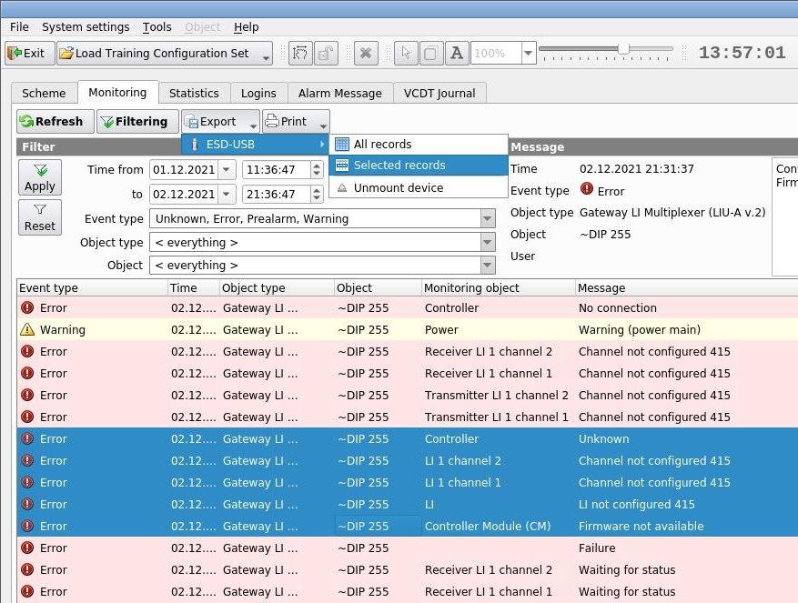
Figure 248 − Tab «Statistics», button «Export»
Before exporting the Statistics, a window will be opened requesting the name of the resulting file. If the name is not specified, it will be generated automatically.
In case the log is exported successfully, a respective information message is displayed, the file is exported in .csv format.

11.4 Logins

Tab «Logins» is intended to view authorized IME users sessions.

– refresh the current list of messages.

Tab «Logins» consists of panel «Filter» and List of authorized users. If necessary, select filter by time.

– filtering of authorized users by selected criteria.

– reset filter parameters.

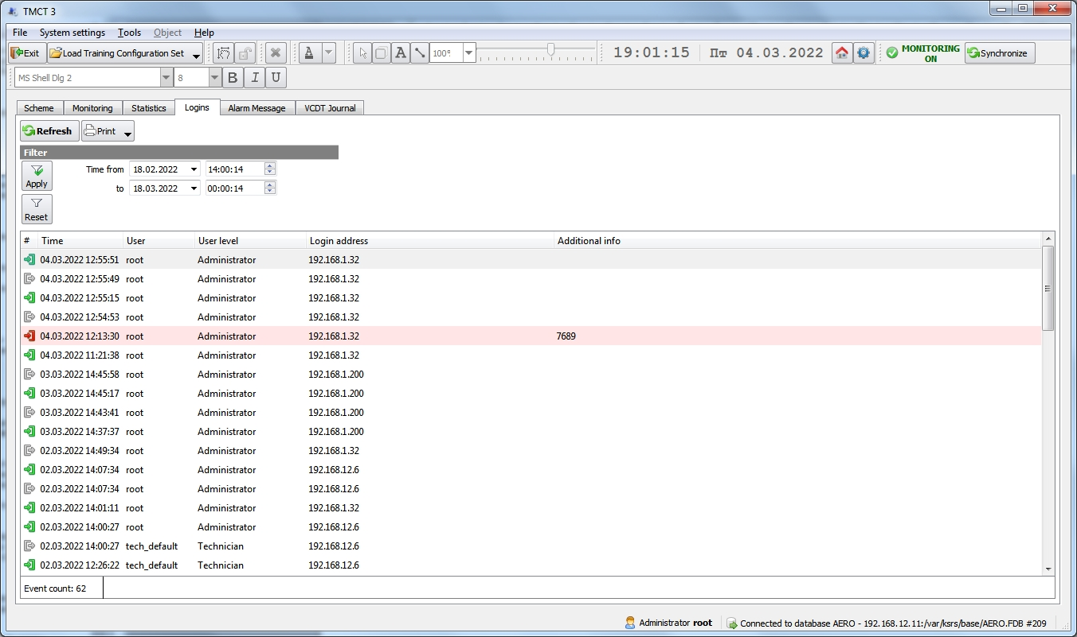
Panel «Filter»
List of authorizationsof users
Figure 249 − Tab «Logins»
Authorization status:

Beginning of user session
Completion of user session
Attempt of authorization with wrong data

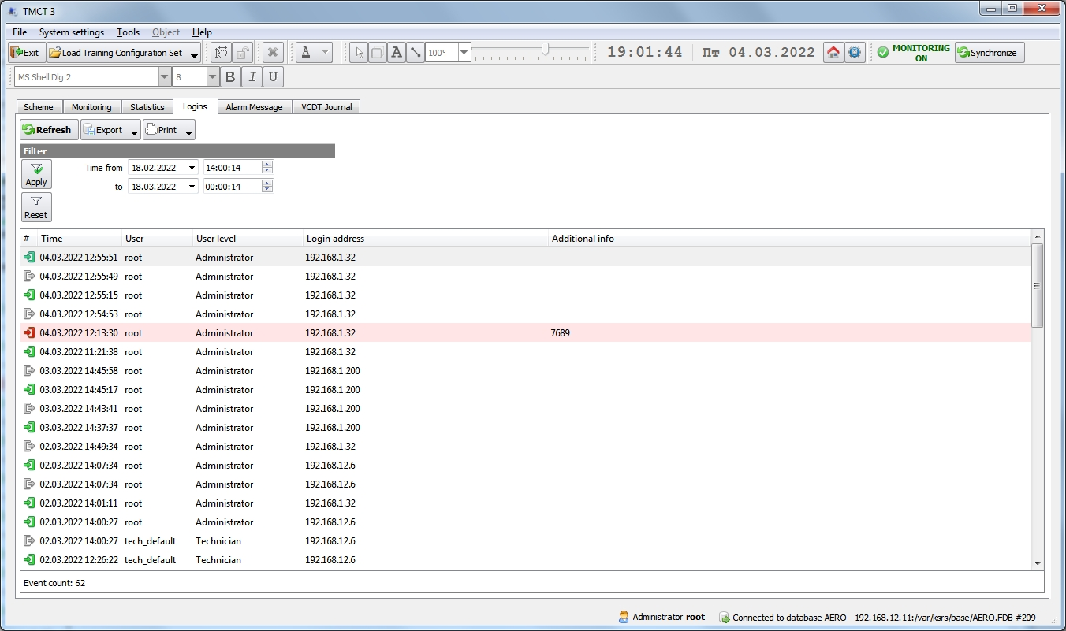
Figure 250 − Tab «Logins», button «Export»
When USB flash drive appears in the system, button «Export» appears on tab «Logins» next to button «Refresh».

– export of Logins (all records or selected) in .csv format to the selected USB flash drive.

In case USB flash drive is connected prior to TMCT start, the device is not detected!

To export the logins:
− press button «Export»
− select the USB flash drive;
− select the «Export here» drop-down menu item.
− select the «All records» or «Selected records» drop-down menu item. If you want to export the selected records, select the desired messages from the list of events before clicking the «Export» button.

To safely remove the USB flash drive, use the «Eject device» drop-down menu item.

Before exporting the Logins, a window will be opened requesting the name of the resulting file. If the name is not specified, it will be generated automatically.

In case the logins is exported successfully, a respective information message is displayed, the file is exported in .csv format.

11.5 Emergency notification monitoring

«Alarm Message» tab of the main interface is used to monitor emergency notification statuses system wide.

– refresh data.

– apply filter panel settings.

– reset filter panel to default values and refresh data.

«Alarm Message» page consists of the Filter panel and the notifications list, see Figure 251. For the notification schemes setup see chapter 10.1 of this manual.

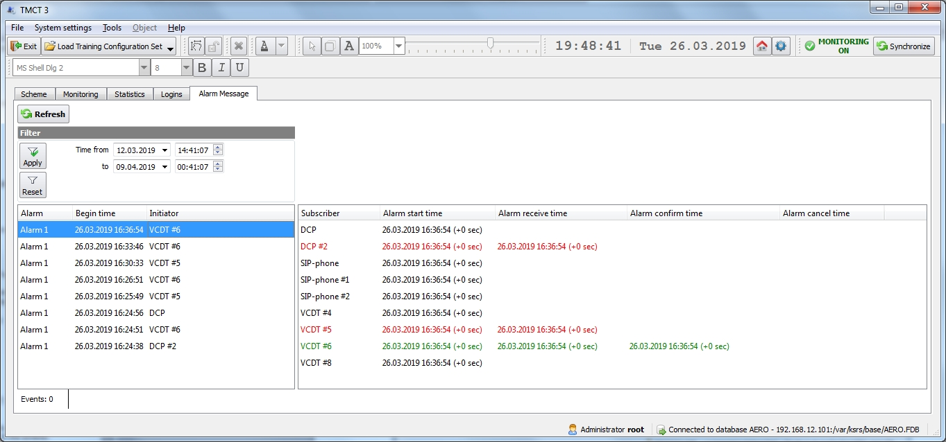
Activated notification schemes list
Selected notification scheme subscribers’ statuses
Filter panel
Figure 251 − «Alarm message» tab
Each of the activated notification schemes contains the following information:
– scheme title;
– notification start time;
– notification initiator (a VCDT title usually).

When selecting a scheme from the list, its subscribers are displayed on the right panel, see Figure 251. Each table entry contains the following information:
– subscriber’s name;
– notification start time;
– notification receive time (when a subscriber actually received the notification call);
– notification confirm time (when a subscriber has confirmed that the notification voice message was listened to).

In addition, the notification statuses are color-coded:

VCDT 90 | Grey – notification created, waiting for subscriber’s answer
VCDT 90 | Red – notification was received by subscriber and notification voice message is being listened to
VCDT 90 | Green – subscriber has confirmed the notification

11.6 VCDT Journal
The «VCDT Journal» tab is intended for viewing such actions of the dispatcher as: using all functions, changing the SD on each button, individually adjusting the volume for each button, enabling/disabling the TX and RX buttons, using the general volume control, cyclic forwarding creation attempt.
To view the necessary information, set the appropriate filters on the «Filter» panel: time, name of the VCDT (one or more) and type of event.

– refresh the current list of dispatcher actions.

– filtering dispatcher's actions according to the specified criteria.

– reset filter parameters.

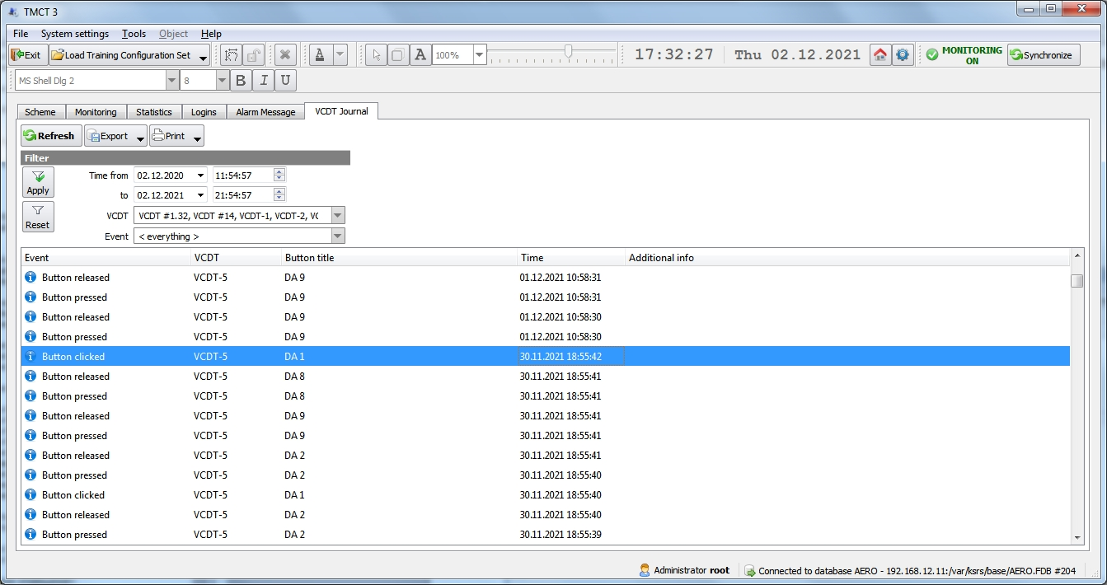
Figure 252 − «VCDT Journal» tab
The algorithm of actions for working with the «Export» and «Print» buttons is similar to that described in item 11.1 «Monitoring» of this manual.

11.7 Monitoring parameters
Visibility of some system objects indicators may be controlled using menu item «Monitoring parameters». The context menu is opened with right mouse button.

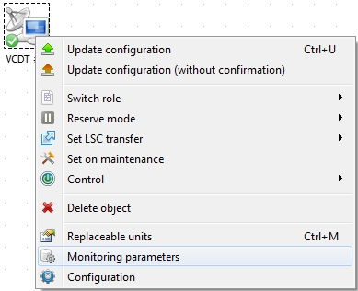
Figure 253 − Monitoring parameters
When menu item «Monitoring parameters» is selected, window «Monitoring configuration of system object» with tab «Indicators» will be opened, see Figure 254.

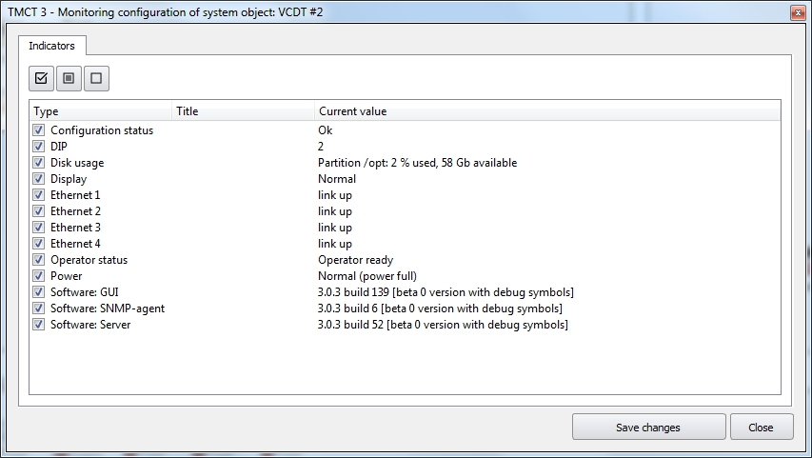
Figure 254 − Parameters of system object VCDT monitoring
The default tab displays all types of indicators of the system object and their current value.

In the upper part of the tab, there are buttons that are used for group control of the visibility of indicators:

- select all indicators from the list to be displayed in the window «Information»;

- select all indicators from the list to be displayed in the window «Information» if the indicator state is different from «normal» (failure, unknown status, pre-emergency status, etc);
- hide all indicators from the list to be displayed in the window «Information».

The name of the indicator is predefined, but if necessary, it can be replaced with an arbitrary name. Use double click to activate the field in the line with the name of the indicator you want to change. Specify a different name for the indicator, see Figure 255. Let's take system object «VCDT» as an example.

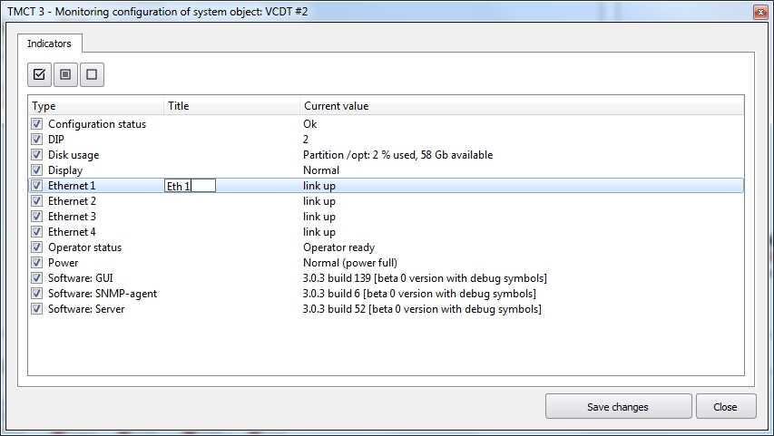
Figure 255 − Entering an arbitrary name of the indicator
Leave the names of only those indicators, which shall be displayed in window «Information», in the list.

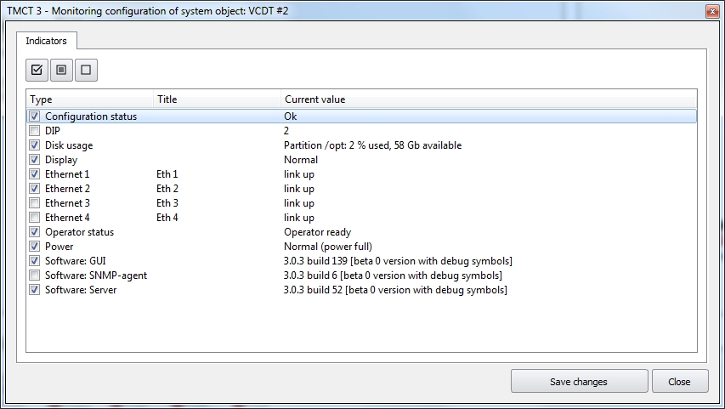
Figure 256 − System object VCDT, selecting indicators to be displayed in window Information»
The «Information» window will display an arbitrary indicator name, if it was specified, and the system name will be hidden, see Figure 257.

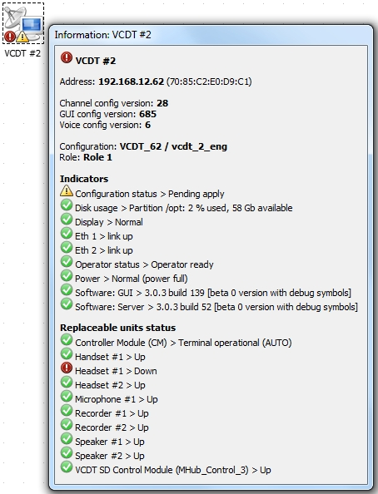
Figure 257 − Displaying selected indicators in window «Information»

11.8 System objects monitoring

11.8.1 LIU-A and LIU-A v.2 monitoring
As the most of system objects, LIU-A supports the capability to monitor its own state, the state of component elements as well as the state of indicators. LIU-A and LIU-A v.2 gateways have the same hardware platform, but different application software. Therefore, the composition of both gateways is identical.
The LI gateway multiplexer (LIU-A and LIU-A v.2) consists of two elements (see Figure 258):
- Controller Module (CМ).
- Line Interface board (LI) UNIVERSAL.

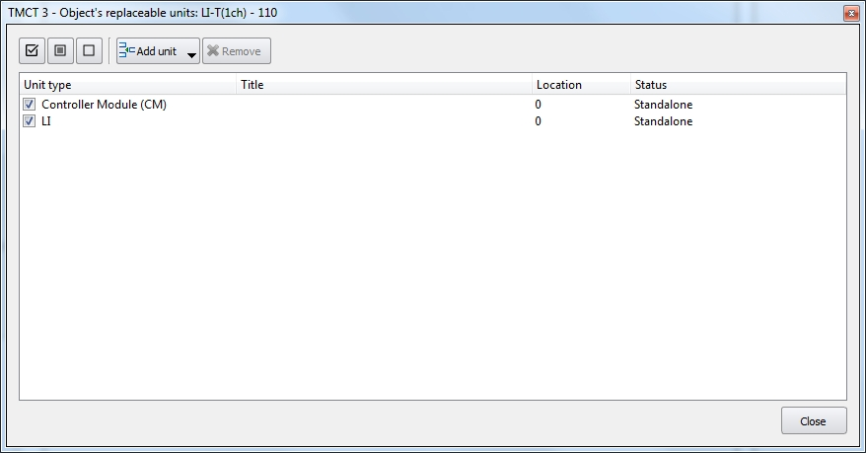
Figure 258 − LIU-A (LIU-A v.2) system object composition
The CM and LI are connected to a single mother-board through which they communicate. The LI is connected to physical communication lines, it is responsible for the reception and transmission, signalling processing, control and management of communication lines. The LI board consists of two boards of line interface analog part (LIA) and line interface digital part (LID) which are connected by a mezzanine. The CM is responsible for configuring, control and managing of LI and itself.

The CM of LIU-A may have the following states:

«Standalone» | The CM works normally.
«Main» | The CM works normally. The CM is in the standby group and it is «Main».
«Standby» | The CM works normally. The CM is in the standby group and it is «Standby».
«Works from a single power source» | The gateway works from a single power source.
«Not ready» | The gateway does not work. Either there is no communication with one of the LIs or there is a problem with reading DIP gateway ID.
The CM may have two states in LIU-А v.2:

«Normal ($VER) work mode» | The CM is available via SNMP and it responds to requests. To be more precise, upon request from IMS, the CM returns the value of the software version in the correct format. For instance, «Normal (R2033) work mode». The software version in Russian version is not displayed.
«Firmware not available» | The CM is not available via SNMP.

The LI status is identical for LIU-A and LIU-A v.2. For LIU-A v.2 the status of LI is also duplicated in the web-interface and can be found in the section «LEMZGW configuration», window «Lemzgw», field «Interface status» (see Figure 161 of this Manual).

LI may have the following states:

«Standalone» | The LI works normally. In web-interface the value of «Interface status» - OK(0).
«Main» | The LI works normally. The LI is in the standby group and it is «Main». In web-interface the value of «Interface status» - OK_ACTIVE (1).
«Standby» | The LI works normally. The LI is in the standby group and it is «Standby». In web-interface the value of «Interface status» - OK_STANDBY (2).
«Analog interface hardware error» | From LIA the packet ALI_HW_STATE with the information on analog interface hardware error is received.  In web-interface the value of «Interface status» - ANALOG_INTERFACE_HARDWARE_ERROR(104).
«Digital interface hardware error» | From LID the packet DLI_HW_STATE with the information on digital interface hardware error is received.  In web-interface the value of «Interface status» - DIGITAL_INTERFACE_HARDWARE_ERROR(105).
«Digital interface break line» | One of the LID channels do not work. Digital interface break line is detected.  In web-interface the value of «Interface status» - DIGITAL_INTERFACE_BREAK_LINE(106).
«Works from a main power source» | From LID the packet DLI_HW_STATE is received with the information that LI only works from a main power source.  In web-interface the value of «Interface status» - DIGITAL_INTERFACE_HARDWARE_MASTER_POWER(110).
«Works from a standby power source» | From LID the packet DLI_HW_STATE is received with the information that LI only works from a standby power source.  In web-interface the value of «Interface status» - DIGITAL_INTERFACE_HARDWARE_SLAVE_POWER(111).
«Not ready» | This state is set for LI at the time of the attempt to transit from the state NOT_CONNECTION to the state OK (the transition of configuration to LI). Either this state is set for LI at the time of the attempt to transit from the state OK to the state NOT_CONNECTION (reset of connection with LI). In web-interface the value of «Interface status» - NOT_WORK(300).
«No connection» | The connection between CM and LI is not set.  In web-interface the value of «Interface status» - NOT_CONNECTION(400).
«No connection, analog interface and MK» | There is no connection between LIA and CM.  In web-interface the value of «Interface status» -NOT_CONNECTION_ALI_MK(401).
«No connection, digital interface and MK» | There is no connection between LID and CM.  In web-interface the value of «Interface status»  - NOT_CONNECTION_DLI_MK(402).
«No connection, MK and analog interface» | There is no connection between CM and LIA.  In web-interface the value of «Interface status»  - NOT_CONNECTION_MK_ALI(403).
«No connection, MK and digital interface» | There is no connection between CM and LID.  In web-interface the value of «Interface status»  - NOT_CONNECTION_MK_DLI(404).
«Incorrect configuration, digital interface» | Incorrect configuration of LID.  In web-interface the value of «Interface status» - DLI_BAD_CONFIG(405).
«Incorrect configuration, analog interface» | Incorrect configuration of LIA.  In web-interface the value of «Interface status» - ALI_BAD_CONFIG(406).
«DIP keys mismatch, line interfaces» | DIP keys of line interfaces are different.  In web-interface the value of «Interface status» - BAD_ID(407).
«DIP key of analog interface changed value» | DIP key of analog interface changed the value.  In web-interface the value of «Interface status» - ALI_BAD_ID(408).
«DIP key of digital interface changed value» | DIP key of digital interface changed the value.  In web-interface the value of «Interface status» - DLI_BAD_ID(409).
«LI reboot on command from MK» | LI reboot on command from MK.  In web-interface the value of «Interface status» - MK_RESET_CONNECTION(410).
«LI reboot on command from analog interface» | LI reboot on command from analog interface.  In web-interface the value of «Interface status» - ALI_RESET_CONNECTION(411).
«LI reboot on command from digital interface» | LI reboot on command from digital interface.  In web-interface the value of «Interface status» - DLI_RESET_CONNECTION(412).
«LI reboot due to analog interface hardware error» | LI reboot due to analog interface hardware error.  In web-interface the value of «Interface status» - ALI_HW_FAULT(413).
«LI reboot due to digital interface hardware error» | LI reboot due to digital interface hardware error.  In web-interface the value of «Interface status» - DLI_HW_FAULT(414).
«LI not configured» | LI not configured.  In web-interface the value of «Interface status» - NO_CONFIG(415).

The LIU gateway supports the following list of indicators:

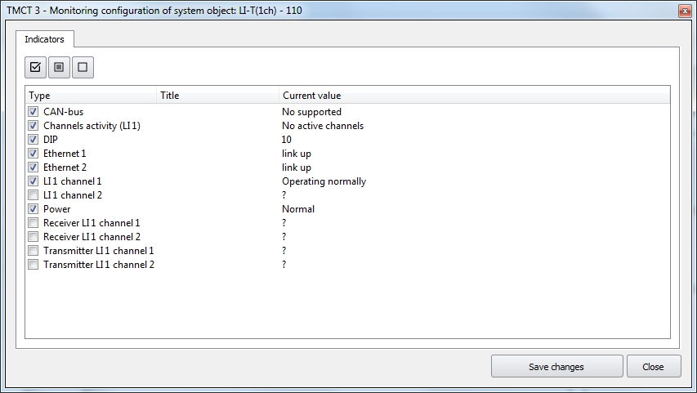
Figure 259 − Layout of LIU-A system object indicators
The possible states of indicators are as follows:

«CAN-bus» | The status of the CAN-bus. The bus is used to connect two gateways combined in a reserve group.
«DIP» | The hardware ID of the gateway, the value of which is set on the 8-bit DIP-switch that is physically located on the cross-board. Acceptable values are from 0 to 255.
«Channels activity (LI 1)» | The indicator of the total number of active channels/sessions in LI 1.
«LI 1 channel 1» | The status of channel 1 of line interface 1.
«LI 1 channel 2» | The status of channel 2 of line interface 1.
«Transmitter LI 1 channel 1» | The status of the channel 1 transmitter of line interface 1.  The values of this indicator are relevant in the case of using radio channel reservation in the mode of «Loop check».
«Transmitter LI 1 channel 2» | The status of the channel 2 transmitter of line interface 1.  The values of this indicator are relevant in the case of using radio channel reservation in the mode of «Loop check».
«Ethernet 1» | The status of network port Eth1.
«Ethernet 2» | The status of network port Eth2.
«Receiver LI 1 channel 1» | The status of the channel 1 receiver of line interface 1.  The values of this indicator are relevant in the case of using radio channel reservation in the mode of «Loop check».
«Receiver LI 1 channel 2» | The status of the channel 2 receiver of line interface 1.  The values of this indicator are relevant in the case of using radio channel reservation in the mode of «Loop check».
«Power» | The gateway has a redundant Power source, the indicator «Power source» shows the status of power supplies.

The example of the status of indicators, CM and LI board in LIU-A display is shown in Figure 260.

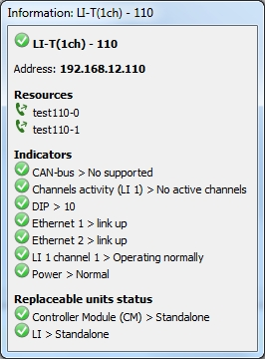
Figure 260 − Status of indicators, CM and LI board in LIU-A

The LIU-A v.2 gateway supports exactly the same indicators as LIU-A gateway. Additionally, the following list of indicators is given below:

«Channels activity CM» | The indicator of total number of active channels/sessions for the whole gateway.
«Controller» | The status of controller application.

The «DIP» indicator has the numeric value from 0 to 255.

«Channels activity (LI 1)» indicator shows the total number of active channels/sessions in LI 1. If LI is configured in the mode of loudspeaker communication, the activity refers to an incoming or outcoming call. If LI is configured in Radio mode, the activity refers to Push-to-Talk (PTT) or carrier detect signal (SQL) or the signal from the voice detector to reception.
It can have the following values:
- «No active channels». In case there is no one active channel/session.
- «1, Active channel». In case there is only one active channel/session.
- «N, Active channels». In case there is N active channels/sessions (more than one).

«Channels activity CM» indicator shows the total number of active sessions in the whole gateway (a session is a logical connection between two signalling endings). If LI is configured in the mode of loudspeaker communication, the session is created and terminated together with the call. If LI is configured in Radio mode, the session is raised immediately at the start of CM and does not end.
It can have the following values:
- «No active channels». In case there is no one active session.
- «Active channels». In case there is at least one active session.

«Controller» indicator shows the status of the controller application. The status of the controller is displayed in a separate indicator because among its main functions, it is responsible for the reservation.
It can have the following values:
- «Unknown». At the start the status of the controller is unknown therefore the value «Unknown» is set.
- «Standalone». The controller works normally provided that reservation is not enabled in the controller.
- «Main». The controller works normally. The controller belongs to the reservation group and it is «Main».
- «Standby». The controller works normally. The controller belongs to the reservation group and it is «Standby».
- «No connection». There is no connection between the controller and the server.
- «Nor running». The controller application is not running.

«Power» indicator displays the status of power sources. Depending of the hardware version of the board, the CM may or may not support the power supply control.
In LIU-A it can have the following values:
- «No supported». CM does not support the power support control.
- «Normal». Both power sources are included.
- «Works from a main power source». The standby power source is disconnected
- «Works from a standby power source». The main power source is disconnected.

In LIU-A v.2 it can have the following values:
- «No supported». CM does not support the power support control.
- «Normal (power full)». Both power sources are connected.
- «Warning (power main)». The reserve power source is disconnected.
- «Warning (power reserve)». The main power source id disconnected.

«LI 1 channel 1» and «LI 1 channel 2» indicators display the status of channels 1 of line interface 1. In LIU-А v.2 the state of the channel is also duplicated in web-interface, it can be found in section «LEMZGW Configuration», window «Radio channel», field «Channel status» (see Figure 161 of this Manual).
Indicators may have the following values:
- «Operating normally». The channel operates normally. In web-interface the value of «Channel status» - OK(0).
- «Main». The channel operates normally. The channel is in the reservation group and it is «Main. In web-interface the value of «Channel status» - OK_ACTIVE (1).
- «Standby». The channel operates normally. The channel is in the reservation group and it is «Standby». In web-interface the value of «Channel status» - OK_STANDBY (2).
- «Device timeout response». The timeout for waiting for a response from a digital device via the control channel has been exceeded. In web-interface the value of «Channel status» - DEVICE_TIMEOUT_RESPONSE(100).
- «Device protocol error». A protocol error signal from the digital device was received via the control channel. In web-interface the value of «Channel status» - DEVICE_PROTOCOL_ERROR(101).
- «Device hardware error». A hardware error signal from the digital device was received via the control channel. In web-interface the value of «Channel status» - DEVICE_HARDWARE_ERROR(102).
- «Input error». Input data to control a digital device is not correct. In web-interface the value of «Channel status» - INPUT_ERROR(103).
- «Analog interface hardware error». The packet ALI_HW_STATE with information on the analog interface hardware error from LIA was received. In web-interface the value of «Channel status» - ANALOG_INTERFACE_HARDWARE_ERROR(104).
- «Digital interface hardware error». The packet DLI_HW_STATE with information on the digital interface hardware error from LID was received. In web-interface the value of «Channel status» - DIGITAL_INTERFACE_HARDWARE_ERROR(105).
- «Digital interface break line». The channel does not work. The digital interface break line was detected. In web-interface the value of «Channel status» - DIGITAL_INTERFACE_BREAK_LINE(106).
- «Works from a main power source». From LID the packet DLI_HW_STATE was received with the information that LI works only from a main power source.
In web-interface the value of «Channel status» - DIGITAL_INTERFACE_HARDWARE_MASTER_POWER(110).
- «Works from a standby power source». From LID the packet DLI_HW_STATE was received with the information that LI works only from a standby power source.
In web-interface the value of «Channel status» - DIGITAL_INTERFACE_HARDWARE_SLAVE_POWER(111).
- «Channel does not work». The channel does not work. In web-interface the value of «Channel status» - NOT_WORK(300).
- «No connection». The connection between CM and LI is not set. In web-interface the value of «Channel status» - NOT_CONNECTION(400).
«Channel not configured». The channel is not configured. In web-interface the value of «Channel status» - NO_CONFIG(415).

«Ethernet 1» and «Ethernet 2» indicators display the status of two network interfaces. The indicators may have the following values:
«Status link unknown». At the start the status of the network interface is unknown, so the value «Status link unknown» is set;
«link up». The network interface is connected and works normally;
«link down». The network interface is not connected;
«link testing». The network interface is in testing mode;
«link dormant». The network interface enters a sleep mode;
«link not present»;
«link lower layer down».

«CAN-bus» indicator displays the status of CAN-bus. It can have exactly the same values as network interface indicators and another one:
«No supported». This means that physically there is no CAN-bus on the CM board or the device driver is not set.

«Transmitter LI 1 channel 1» and « Transmitter LI 1 channel 2» indicators display the status of channel transmitter of line interface 1.
In LIU-A v.2 the status of the channel transmitter is also duplicated in web-interface. It can be found in section «LEMZGW Configuration», window «Radio channel», field «Transmitter status» (see Figure 161 of this Manual).
It may have the following values:
- «Operating normally». The transmitter works normally. In web-interface the value of «Transmitter status» - OK(0).
- «Main». The transmitter works normally. The transmitter is in the reservation group and it is «Main». In web-interface the value of «Transmitter status» - OK_ACTIVE (1).
- «Standby». The transmitter works normally. The transmitter is in the reservation group and it is «Standby». In web-interface the value of«Transmitter status» - OK_STANDBY (2).
- «Transmitter does not work». The transmitter does not work. In web-interface the value of «Transmitter status» - NOT_WORK(300).
- «No connection». The connection with the transmitter is not set. In web-interface the value of «Transmitter status» - NOT_CONNECTION(400).
- «Channel not configured». The channel is not configured to work with the transmitter. In web-interface the value of «Transmitter status» - NO_CONFIG(415).

«Receiver LI 1 channel 1» and «Receiver LI 1 channel 2» indicators display the status of channels receiver of line interface 1.
In LIU-A v.2 the status of the channel receiver is also duplicated in web-interface, it can be found in section «LEMZGW Configuration», window «Radio Channel», field «Receiver status (see Figure 161 of this Manual).
It may have the following values:
- «Operating normally». The receiver works normally. In web-interface the value of «Receiver status» - OK(0).
- «Main». The receiver works normally. The receiver is in the reservation group and it is «Main». In web-interface the value of «Receiver status» - OK_ACTIVE (1).
- «Standby». The receiver works normally. The receiver is in the reservation group and it is «Standby». In web-interface the value of «Receiver status» - OK_STANDBY (2).
- «Receiver does not work». The receiver does not work. In web-interface the value of «Receiver status» - NOT_WORK(300).
- «No connection». The connection with the receiver is not set. In web-interface the value of «Receiver status» - NOT_CONNECTION(400).
«Channel not configured». The channel is not configured to work with the receiver. In web-interface the value of «Receiver status» - NO_CONFIG(415).

11.8.2 LIU-D monitoring
The gateway multiplexer of LI (LIU-D), as well as LIU-A, supports the monitoring capability of its status, the status of component elements as well as indicator statuses.
LIU-D may consist of several elements (see Figure 261):
- Controller Module (CM).
- Board.
- ECPP. Emergency phone.

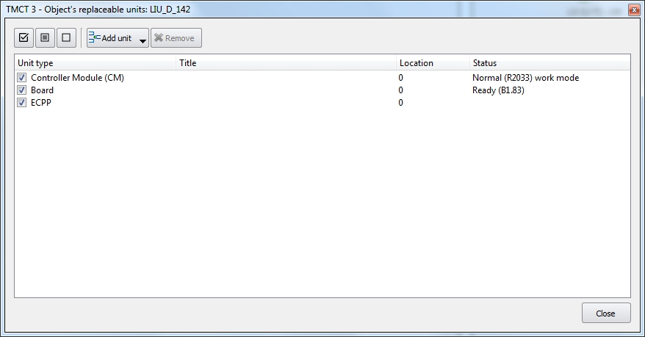
Figure 261 − LIU-D system object layout
There are various versions of layout and various «Boards». Up to 20 «Boards» can be connected to a single cross-board. The emergency phone is connected via interface E1, so the number of connected emergency phones is limited to the number of interfaces Е1 in the crate. At the same time, each CM board contains 4 interfaces E1 on its platform.

The CM may have the following states:

«Normal ($VER) work mode » | The CM is available via SNMP and responses to requests. To be more precise, upon request from IMS, the CM returns the value of the software version in the correct format. For instance, «Normal (R2033) work mode». In Cyrillic variant the software version is not displayed.
«Firmware not available » | The CM is not available via SNMP protocol.

The board may have the following states:

«None» | The board was not found in the system and block configuration.
«Waiting resources ($VER)» | In this state bus resources are expected to be busy to work with the AK board. After the CM loses the communication with the board for any reason, the board always goes to this state. It is in this state the bus is busy.
«Waiting board ($VER)» | The connection to the board has not been established yet, and a response to the board version request is expected. Once the response with the version is received, it is considered that the connection is established and the board goes to the status «Ready». Since this is an intermediate state in which the board persists for a very short time, the IMS terminal is not notified of it in the current implementation.
«Ready ($VER)» | The connection between the CM and the board was established successfully, the configuration was applied, the board is working normally. $VER is the software version of the board. For example, «Ready (B1.83)». The version is read from the board when the connection between the board and CM was first established.

ECPP. Emergency connection phone may have the following states:

«None» | There is no connection with the phone and its status is unknown.
«Not configured (Power: $POWER, Mode: $MODE, Base: $BASE, Hook: $HOOK)» | The phone connection was restarted but the configuration has not been applied yet. Since this is an intermediate state in which the phone persists for a very short time, the IMS terminal is not notified of it in the current implementation.
«Ready (Power: $POWER, Mode: $MODE, Base: $BASE, Hook: $HOOK)» | The phone was configured and it is ready to work.

Where $POWER is the status of the power supply and it may have the following values:
- «unknown» - the power is not available, the states of power supply modules is unknown;
- «standby» - the phone is powered only by the standby power module (main power module failure);
- «main» - the phone is powered only by the main power module (standby power module failure);
- «full» - both power modules work normally.

Where $ MODE is an operation mode and it may have the following values:
- «unknown» - the phone connection is not established, as a result its operation mode is unknown;
- «active» - the phone works normally when its button panel is active;
- «sleep» - the phone is put into the sleep mode by the switch next to the button panel.

Where $BASE is a base status and it may have the following values:
- «unknown» - the phone connection is not established, as a result its base status is unknown;
- «connected» - the base works normally;
- «disconnected» - the base is disconnected.

Where $HOOK is a hook status and it may have the following values:
- «unknown» - the phone connection is not established, as a result the handset status is unknown;
- «connected» - the emergency phone handset is connected and works normally;
- «disconnected» - the emergency phone handset is disconnected and unable to work.
The example of the emergency phone status is «Ready (Power: full, Mode: active, Base: connected, Hook: connected)».

The LIU-D gateway supports the following list of indicators:

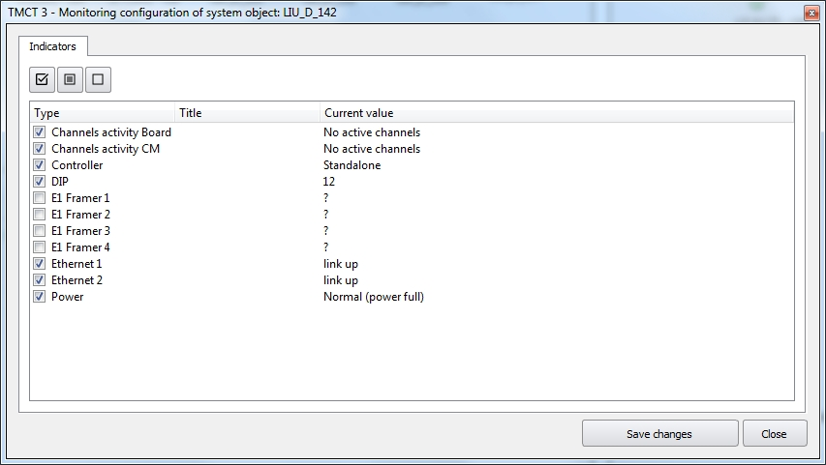
Figure 262 − List of LIU-D system objects indicators
The LIU-D gateway supports the following list of indicators:

«DIP» | Hardware gateway ID the value of which is set on the 8-bit DIP-switch that is physically located on the cross-board. Aссeptable values are from 0 to 255.
«E1 Framer 1» | Status E1 Port №1.
«E1 Framer 2» | Status E1 Port №2.
«E1 Framer 3» | Status E1 Port №3.
«E1 Framer 4» | Status E1 Port №4.
«Channels activity Board» | An indicator of the total number of active channels/sessions on AK board.
«Channels activity CM» | An indicator of the total number of active channels/sessions on the whole gateway.
«Controller» | Status of controller application.
«Ethernet 1» | Status of the network port Eth1.
«Ethernet 2» | Status of the network port Eth2.
«Power» | The gateway has a redundant power supply, the indicator «Power source» displays the state of power sources.

«Controller» indicator shows the status of the controller application. The status of the controller is displayed in a separate indicator because in addition to the main functions, it is responsible for the reservation. It may have the followings values:
- «Unknown». At the start the status of the controller is unknown, so the value «Unknown» is set.
- «Standalone». The controller works normally provided that the reservation is not enabled in the controller.
- «Main». The controller works normally. The controller is in the reservation group and it is «Main».
- «Standby». The controller works normally. The controller is in the reservation group and it is «Standby».
- «No connection». No connection between the controller and the server.
- «Not running». The controller application is not running.

«DIP» indicator has the numeric values from 0 to 255.

«E1 Framer 1», «E1 Framer 2», «E1 Framer 3» and «E1 Framer 4» indicators display the status of four Ports E1.
The indicators may have the following values:
- «No Carrier». There is a constant logical zero on the receiving line.
- «AIS». Alarm Indication Signal. There are errors in the bitstream.
- «FAS Loss». Loss of Frame Alignment. Error of frame synchronization.
- «RAI». Receive Remote Alarm. There is an error on the remote ending.
- «Synchronized». Normal work of Framer.

«Ethernet 1» and «Ethernet 2» indicators display the status of two network interfaces. The indicators may have the following values:
«Status link unknown». At the start the status of the network interface is unknown, so the value «Status link unknown» is set.
«Link up». The network interface is connected and it works normally.
«Link down». The network interface is not connected.
«Link testing». The network interface is in the testing mode.
«Link dormant». The network interface entered the standby mode.
«Link not present».
«Link lower layer down».

«Power» indicator displays the status of power sources. Depending on the hardware version of board, the CM may or may not have power support.
It may have the following values:
- «No supported». The CM does not support power monitoring.
- «Normal (power full)». Both power sources are ON.
- «Warning (power main)». The standby power source is OFF.
- «Warning (power reserve)». The main power source is OFF.

«Channels activity Board» shows the total number of active sessions on AK board (a session means a logical connection between two signalling endings). It may have the following values:
- «No active channels». In case there is no single active session.
- «Active channels». In case there is at least one active session.

«Channels activity CM» indicator shows the total number of active sessions through the whole gateway (a session means a logical connection between two signalling endings). It may have the following values:
- «No active channels». In case there is no single active session.
- «Active channels». In case there is at least one active session.
The example of displaying the status of indicators and LIU-D elements is given in Figure 263.

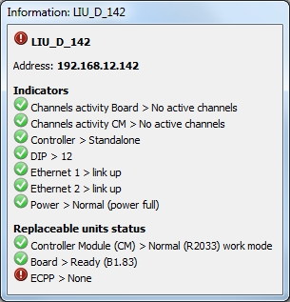
Figure 263 − Status of indicators, CM, Board and ECPP in LIU-D

12 Remote VCDT Control

12.1 Updating Configuration
Necessity to update VCDT configuration is displayed by blinking indicator on VCDT icon. Open the context menu with right mouse button and select item «Update configuration».
If the functional button «Update terminal configuration» is enabled (see item 5.5 «Functions» of this manual), VCDT configuration files will be updated after confirmation by the operator (see item 5.11 «Update terminal configuration» of the «VCDT Operator's Manual. ЦИВР.00531-01 34 01»).
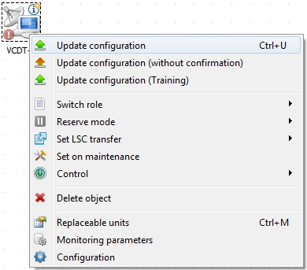

Figure 264 − Updating configuration
Information on required updating and configuration status is displayed in window «Information»:
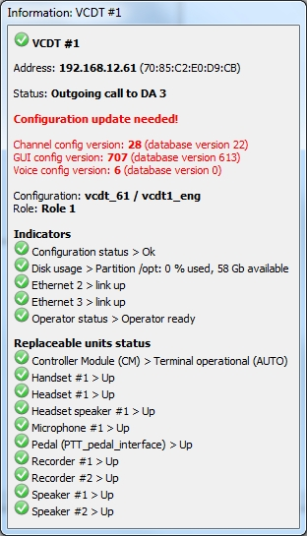
Figure 265 − Window «Information»

12.2 Updating Configuration without confirmation
To update the VCDT configuration without operator's confirmation, the «Update configuration (without confirmation)» menu item is used, see Figure 266.

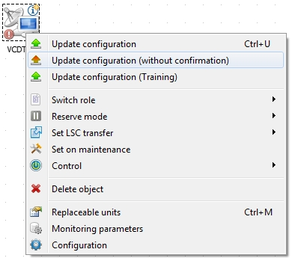
Figure 266 – Updating configuration without confirmation
The configuration update will occur automatically even if the «Terminal configuration update» functional button is present in the VCDT (see item 5.11 «Update terminal configuration» of the «VCDT Operator's Manual. ЦИВР.00531-01 34 01»).

12.3 Updating Training Configuration
An important aspect of Training operation is quick change of configuration on WS group. Open the context menu with right mouse button and select item «Update configuration (Training)».
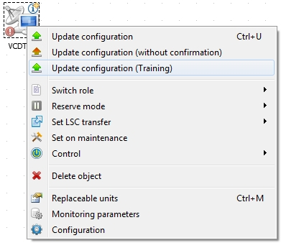

Figure 267 − Updating (Training) configuration
WS configurations are updated in window «VCDT Training configuration». For operation in this window see item 9.1 «VCDT Training configuration» of this Manual.

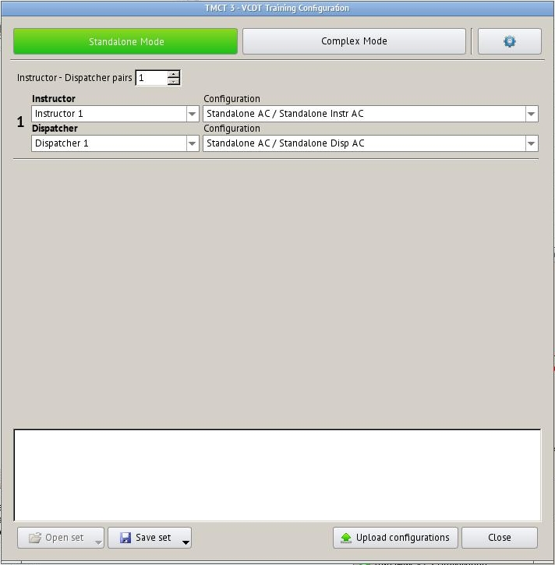

Figure 268 − Window «VCDT Training configuration»

12.4 Calls Transferring
The function is required to transfer all regular ground communication incoming calls from the terminal to other address: VCDT or other network subscriber, supporting transferring.
IME allows to carry out transferring remotely. To enable the function, select menu item «Set LSC transfer», and then the required VCDT from the displayed list.

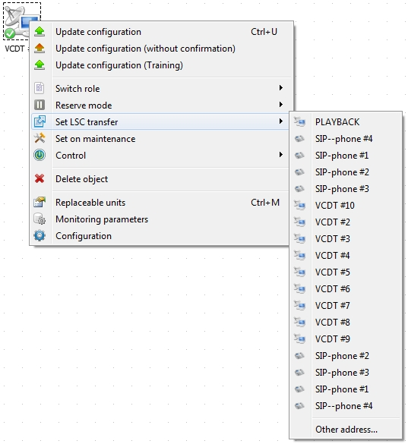

Figure 269 − Enabling transferring function
If there is no required VCDT in the list, select menu item «Other address» and enter an address for transferring.

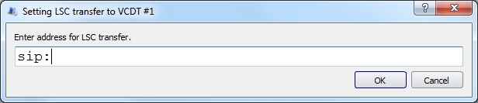

Figure 270 − Setting transferring
Transferring activation is indicated visually as a green arrow on the system object icon.
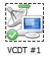
A line in the system object information window also indicates transferring activation:

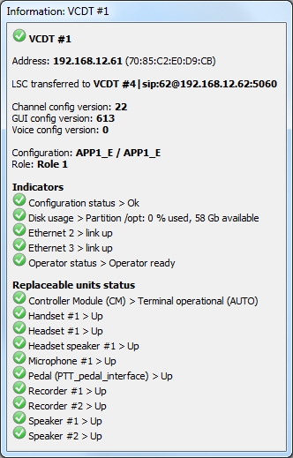

Figure 271 − System object information window: transferring is on
Transferring is switched off by selecting menu item «Cancel transfer».

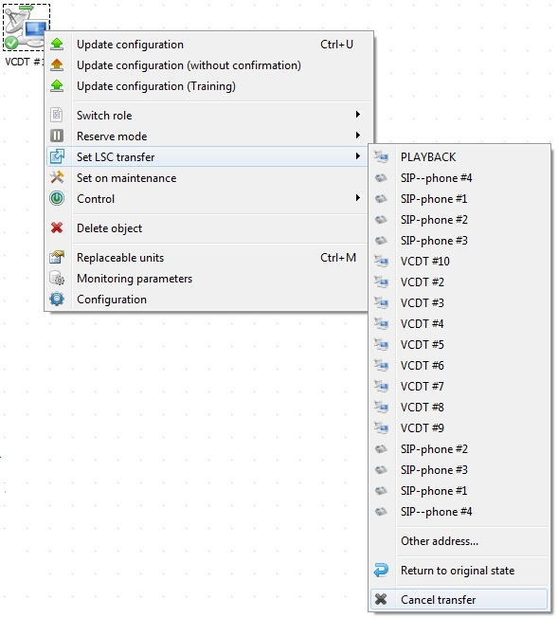

Figure 272 − Switching off transferring
Selecting the menu item «Return original state» allows you to return to the forwarding setting of the VCDT itself, that is, to what it was before you turned on the forwarding from TMCT.

12.5 Enabling the Reserve Mode
The presence of the «Reserve Mode» function allows to determine an operation mode (Reserve or Main) of the working position in the VCDT. The reserve working position is fully functional except for the capability to receive incoming calls.
For remote activation of the Reserve Mode, select the VCDT where it is necessary to switch on the Reserve Mode, open the context menu, select the menu item «Reserve Mode»→«Activate», see Figure 273.

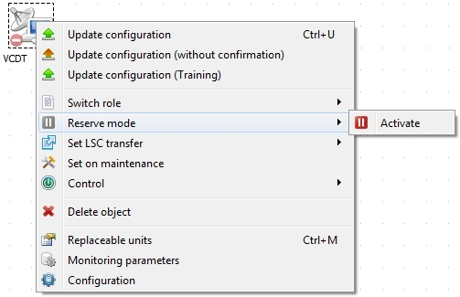
Figure 273 − Enabling the Reserve Mode of the terminal
The Reserve Mode of the VCDT will be activated without confirmation!

In order to deactivate the Reserve Mode, select the required VCDT, open the context menu, select the menu item «Reserve Mode»→«Deactivate», see Figure 274.

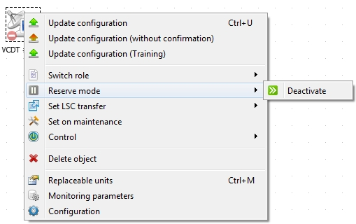
Figure 274 − Disabling the Reserve Mode of the terminal

13 System Object Maintenance

In case of maintenance and/or remedial works of VCCS «Topaz», the system object maintenance may be initiated.
For this purpose select the required system object, open the context menu with right mouse button and select item «Set on maintenance», see Figure 275.

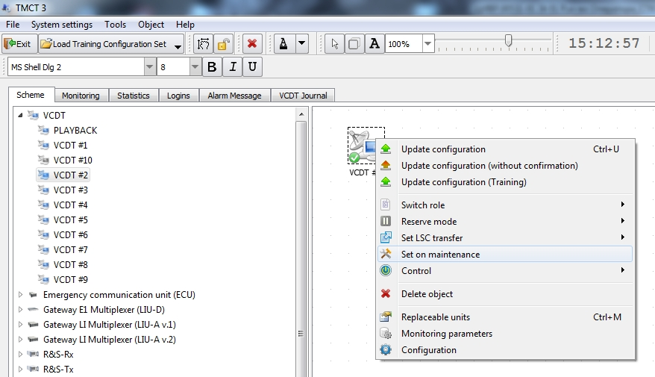

Figure 275 − Initiation of object maintenance
After initiation of maintenance, the object icon becomes light grey, see Figure 276, while the object is disconnected from the monitoring system.

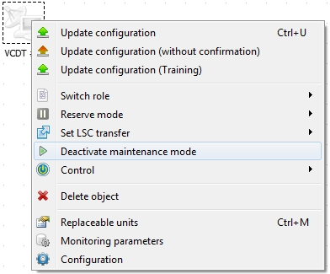

Figure 276 − Object removal form maintenance
To cancel the maintenance mode, select context menu item «Deactivate maintenance mode».

14 DB Backup and Restore

To perform a database data backup, perform the following actions:

1. Select the menu item File → Database tools → Backup, see Figure 277.

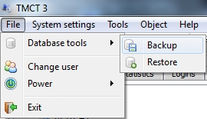

Figure 277 − DB backup
2. In the window that will be opened, on the «Database backup» tab the field «Operation after successful backup completion», select the required action from the drop-down list, see Figure 278.

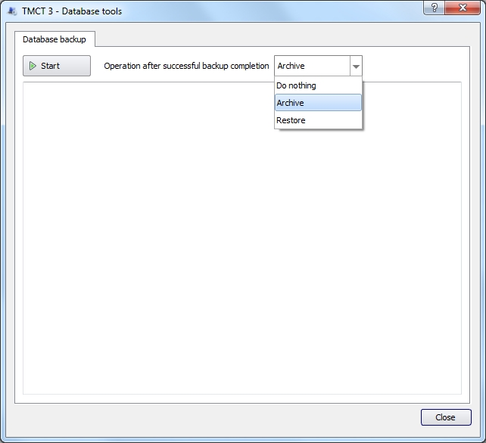

Figure 278 − Selecting of an operation after creating a database backup

«Do nothing» – no actions will be taken with backup copy of the database after its creation;
«Archive» – after creating a database backup copy, it will be archived and the archive will be copied using the specified path, see item 3.3 of this manual, parameter «Database archived backups path».
«Restore» – after a database backup copy is created, the process of its restoration will be started immediately (database regeneration).

3. To execute the database backup, click the button «Start». Information about the process will be displayed on the tab «Database backup», see Figure 279.

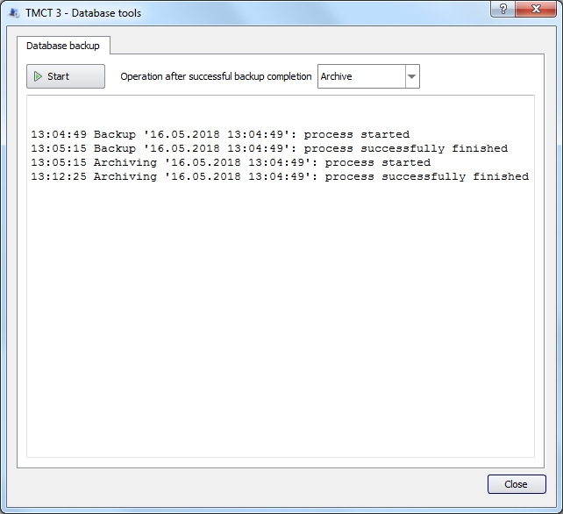
Figure 279 − Information on the progress of the database backup process

After the backup is completed, the backup file can be moved (to another computer or to a CD).
To perform a database data restoration from backup copy, perform the following actions:

1. Select the menu item File → Database tools → Restore.

2. In the «Database tools» window, on the «Database restore» tab, select the required file:
– source file of the database backup copy;
– a packed backup file of the database.

3. Click the «Restore database from selected copy» button. Information about the progress of the restoration process will be displayed at the bottom of the window, see Figure 280.

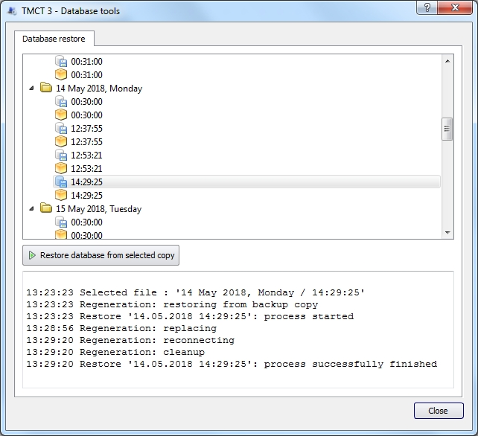
Figure 280 − Database restore from a backup copy

14.1 File Manager
«File Manager» menu item is used to copy database backups from a USB flash drive to the Monitoring Server and vice versa, see Figure 281. The presence of the menu item «File Manager» depends on availability of a flash drive.

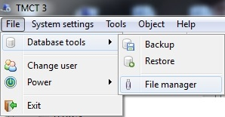
Figure 281 − Menu item «File manager»
When the item is selected, the «Database tools» window opens with the tab «File Manager». In the left part of the window there is a USB flash drive panel, on the right there is a panel with a list of files located on the Monitoring Server, see Figure 282. Information about the progress of the copy process will be displayed at the bottom of the window.

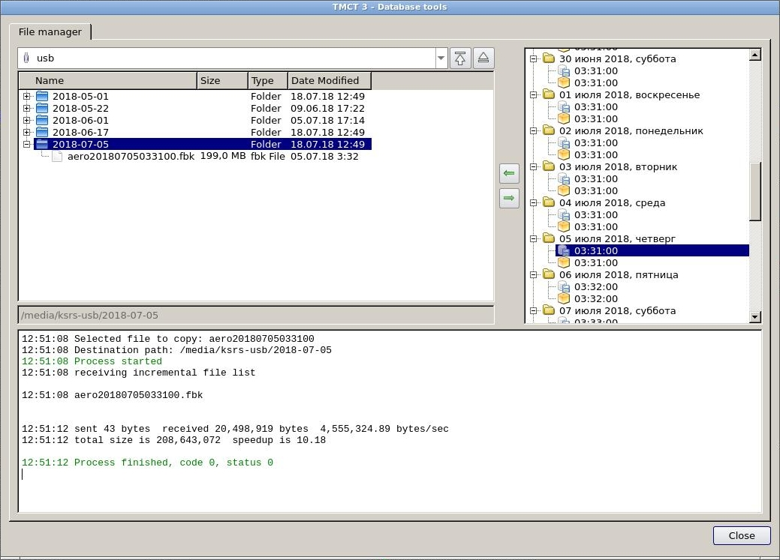
List of Monitoring Server files
USB flash drive panel
Figure 282 − The «File Manager» tab
Taking into account the direction of the copying, select the required files in the panels and click the corresponding button, see below.

The purpose of the buttons located on the tab «File Manager»:

– go to the root folder;
– safely eject USB flash drive;
– copy the selected backup file to a USB flash drive;
– copy the selected database backup file from the USB flash drive to the Monitoring Server.

14.2 Emergency recovery of a corrupted database
When a database file becomes corrupted for whatever reason (Database Server power failure, storage media physical damage, software errors, etc.), it is necessary to perform the procedure of the emergency recovery.
The recovery procedure requires exclusive access to Database Server and any connection to the database from other clients are prohibited. To achieve this, the following command must be performed:
gfix -shut –force 0 -user SYSDBA -password <your pass> \Path:\AERO.FDB

After that, to make sure that the database file is actually corrupted, the command Command 1 must be performed. Gfix, used in this command, is a tool designed to fix corrupted database, it is included in the each Firebird distribution. Gfix scans the database, checks data structures and records for corruptions and fixes them.
If, as a result of executing the above command, a message is received that the database file is corrupt and the required operation is impossible, then this is a critical case and you need to turn to the help of paid utilities to restore the damaged database.
For example, IBSurgeon FirstAID utility (http://ib-aid.com). IBSurgeon FirstAID is the tool that can automatically diagnose and recover corrupted Firebird databases, it can repair corruptions that cannot be repaired using standard utilities. It uses its own layer for low-level database access without using the Firebird engine. It is highly recommended to stop the Firebird Server process while using this tool. In addition, after you have finished using the tool, it is recommended to close it and then start Firebird Server.
If, as a result of executing this utility (or any other special tools), it was possible to fix the corrupted database file, then after that perform the standard database regeneration procedure:
- executeCommand 1 (integrity monitoring and fix database corruption);
- executeCommand 2 (preparation for corrupted DB saving);
- executeCommand 3 (saving of DB backup);
- restart Firebird Server or the whole operating system;
- executeCommand 4 (restore the DB from backup).
If these 5 steps are successfully completed, then the emergency regeneration of the database can be considered successfully completed, and the resultant database is able to continue to perform its functions in the future.
If, after executing Command 1, a list of integrity control errors is issued, then it can be assumed that the fixed errors can be eliminated in the standard way. Then follow these steps:
- executeCommand 2 (preparation for corrupted DB saving);
- executeCommand 3(saving of DB backup);
- restart Firebird Server or the whole operating system;
- executeCommand 4 (restore the DB from backup).
Command 1. The command to control the integrity and fix damage of the database
gfix -v -full -user SYSDBA -password <your pass> \Path\AERO.FDB
Command 2. The preparation command before saving the damaged database
gfix -mend -user SYSDBA -password <your pass> \Path\AERO.FDB
Command 3. The command to save the archive (backup) of the database
gbak -b -g -v -user SYSDBA -password <your pass> \Path\AERO.FDB \Path\backup.fbk
Command 4. The command to restore the database from the archive (backup)
gbak -c -p 16384 -v -user SYSDBA –password <your pass> \Path\backup.fbk \Path\AERO.FDB
After performing the required procedure, the following command must be executed to restore other clients’ access to the database:
gfix -online -user SYSDBA -password <your pass> \Path:\AERO.FDB

14.2.1 Transaction limit exceeding

In situations when the transaction counter ends, the following message appears in the activity log files of the collector:
Implementation limit exceeded. Transactions count exceeded.

The same message is issued when you try to execute a command backup (gbak -b -v -g -user SYSDBA -pas <your pas> AERO.FDB AERO.fbk) in the following form:
gbak:readied database AERO.FDB for backup
gbak:creating file AERO.fbk
gbak:starting transaction
gbak: ERROR:invalid transaction handle (expecting explicit transaction start)
gbak:Exiting before completion due to errors

Before creating backup-а, it is necessary to switch over a DB into a mode «only for reading»:
gfix -mode read_only -user SYSDBA -password <your pass> \Path\AERO.FDB

Next, you need to create backup:
gbak -b -g -v -user SYSDBA -password <your pass> \Path\AERO.FDB \Path\backup.fbk

After backup-а creation, DB needs its recovery:
gbak -c -p 16384 -v -user SYSDBA -password <your pass> \Path\backup.fbk \Path\AERO.FDB

After carrying out the required procedures, execute the command for DB switching over into a «read/write» mode:
gfix -mode read_write -user SYSDBA -password <your pass> \Path\AERO.FDB

15 User Change

Three access levels are used to work in IME: Administrator, Engineer, and Technician (for users setting see item 3.4 «Users setting» of this Manual).
By default, IME is loaded with access level «TECHNICIAN», the only available menu item is «Change user».
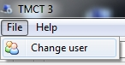

Figure 283 − User change
To change the user, select menu item File → Change user. In the authorization window enter user name and password to enter the system. The password is shown on the screen in the hidden mode as symbol «*».
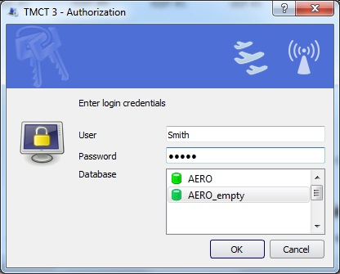

Figure 284 − User change, authorization
In this example, authorization is carried out with access level «Engineer». In case of successful authorization, TMCT is loaded with functions, available for authorized user.

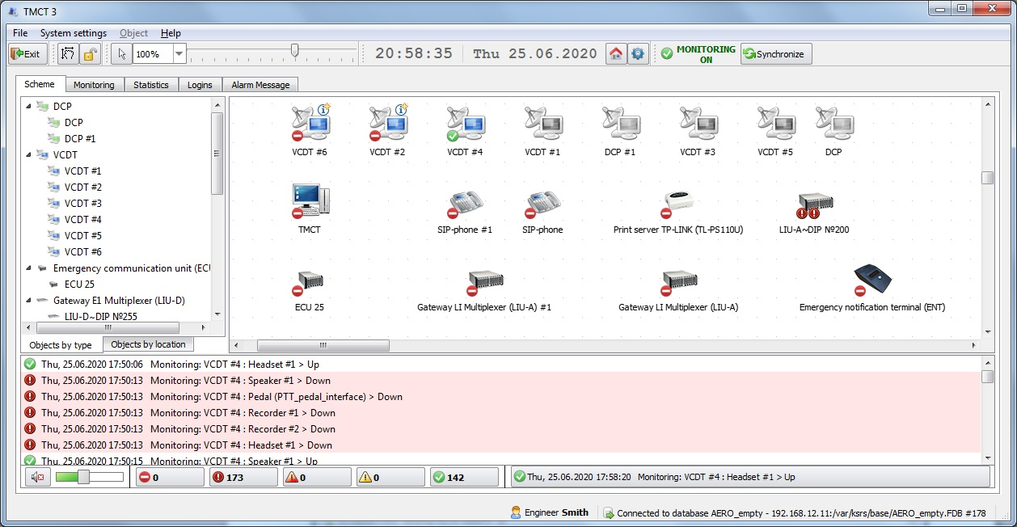
Figure 285 − Successful authorization, user «Engineer»

16 Power Supply Control

16.1 TMCT power control
During operation, the necessity may arise to reboot the system or TMCT interface. Menu item «Power» is intended for this purpose, see Figure 286.

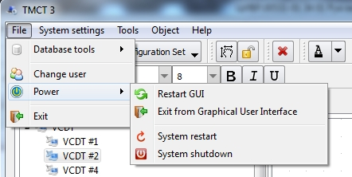

Figure 286 – Menu item «Power»
Menu item «Restart GUI» – a command to reboot graphical user interface is issued to IME. After rebooting IME is loaded with access level «Technician».

Menu item «Exit from Graphical User Interface» – completion of TMCT graphical user interface operation and quitting to operating system.

Menu item «System restart» – controller module hardware reboot.

Menu item «System shutdown» – hardware completion of controller module operation.

16.2 Remote power control of system objects
The TMCT has the ability to remotely control the power supply of system object components. Open the context menu with right mouse button and select item «Control».

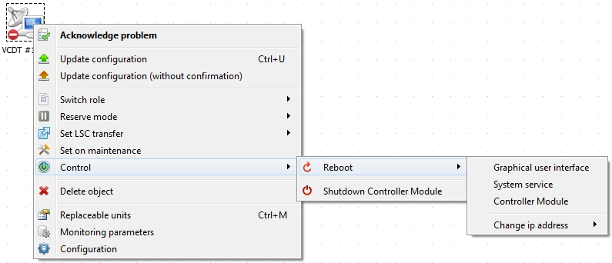
Figure 287 – Remote power control of system object components
Depending on the state of the system object, the following items will be available in the menu:

Menu item «Power on Controller Module»
Issuing a command to enable the system object. Available if you have one or more MAC addresses. MAC address(es) are set in the main settings of each system object.

Menu item «Shutdown Controller Module»
Issuing of command to switch off VCDT.

Menu item «Graphical user interface»
A command to reboot the graphic user interface is issued to VCDT. Depending on the terminal settings, the operator makes the final decision on restart.

Menu item «System service»
Button of VCDT server restart (completing server operation). In the standard mode, the server will be restarted automatically by the operating system.

Menu item «Controller Module»

VCDT operating system restart attempt.

Menu item «Change ip address»
The command allows to change ip address of certain network interface of controller module and reboot the operating system after that. IP address can be set manually or selected from the list, see Figure 288.

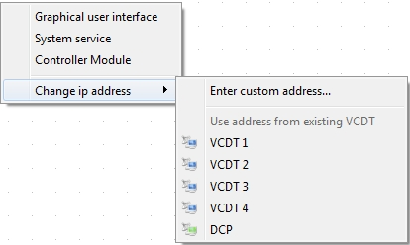
Figure 288 – Rebooting VCDT with IP address change
When you select the menu item «Enter custom address», specify new IP address in the opened window:
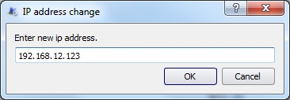
Figure 289 – Rebooting VCDT with IP address change manually

16.2.1 Power management of all VCDTs

To turn on/off all terminals of the system at once, right-click the «mouse» to open the context menu and select the appropriate item «Power management»→«Power on all VCDTs» or «Power off all VCDTs», see Figure 290.

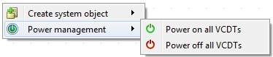
Figure 290 – Power management of all VCDTs
The menu item «Power Management» is available only to the Administrator. In this case, the «Enable Briefing and Training System (BTS) support» check box must be set, see item 3.1.1 «TMCT settings» of this Manual.
You can also access the on/off of all VCDTs using the main menu item «Tools»→ «Power Management», see Figure 291.

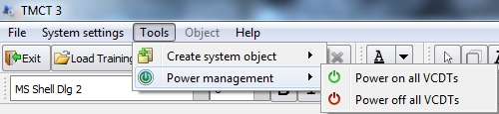
Figure 291 – Power management of all VCDTs using the main menu item «Tools»

Appendix A

(reference)

Setting of Printer Epson LX-350

Switch on the printer and insert a sheet of paper. To enter the menu, when the printer is switched on press two buttons «LF/FF» and «Load/Eject» at the same time, see Figure A.1.

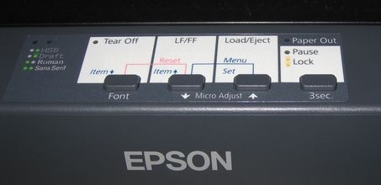

Figure A.1 − Location of buttons and indicators on printer Epson LX-350

When the buttons are pressed, the printer will print two lines with current menu language settings. By default, English is selected as menu language. Do not change this setting! Thus, press button «Set» only.
After that the printer will suggest to print out the current settings. Press button «Set» again, after that a sheet with settings will be printed out, see Figure A.2.

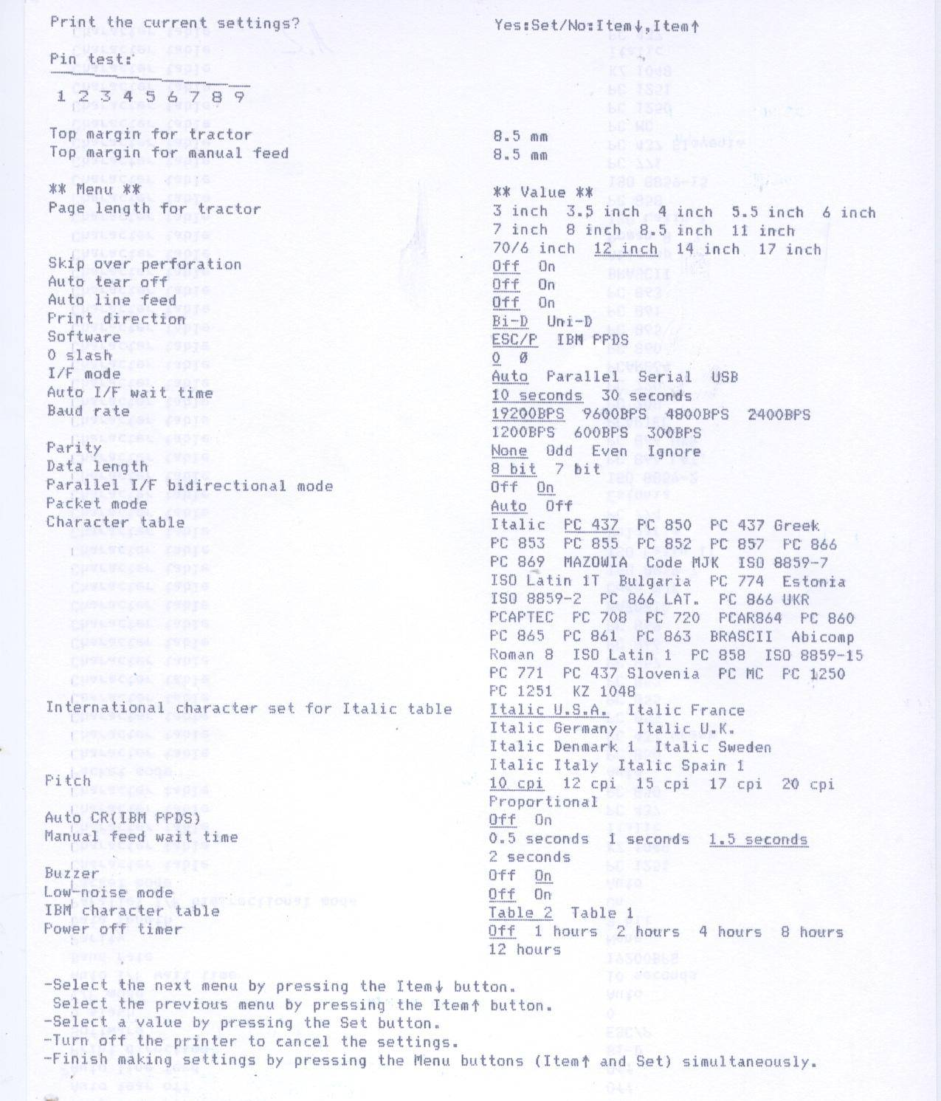

Figure A.2 − Current settings of printer Epson LX-350

In case all settings do not fit one sheet, insert a second sheet. At the bottom of the printed sheet there is an instruction how to change the settings:
- to select menu items use button «Item↓»,«Item↑»;
- to select values use button «Set»;
- to cancel changes switch off the printer;
- to save the changes, press buttons «LF/FF» and «Load/Eject» at the same time.

We shall change parameter Character table.
To change the parameter, enter the menu again by pressing buttons «LF/FF» and «Load/Eject» at the same time, then press button «Set» once, confirming selection of English.
Do not press button «Set» for the second time as an answer to the request to print out the settings. Press button «Item↓»instead several times until «Character table» is printed out. After that press button «Set» to search through all values of this parameter until the printer prints out value PC 1251, see Figure A.3.
To save the selected value, press buttons «LF/FF» and «Load/Eject» at the same time.

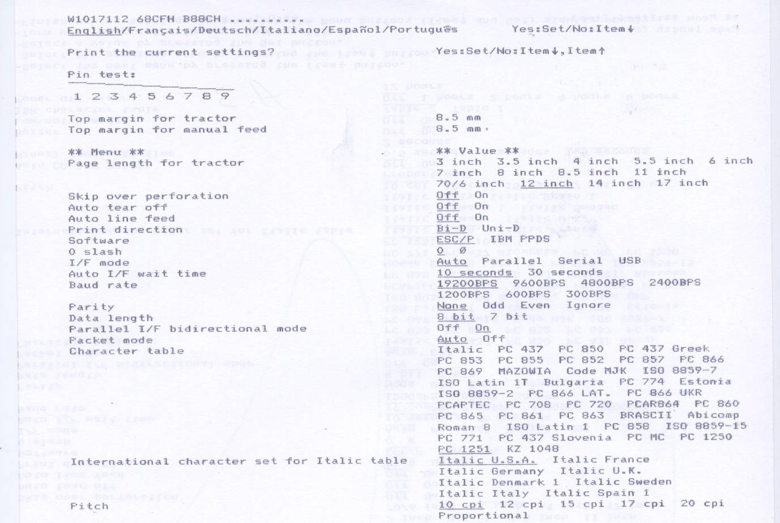

Figure A.3 − New settings of printer Epson LX-350

Setting of printer Epson LX-350 is completed.

Appendix B

(informative)

Gain Parameters

Gain parameters values are from 0 to 255. Dependence between gain parameter value and actual values is non-linear. Dependence between the parameter and actual gain value can be described using Table 1.

Table 1
Dependence of dB from GAIN |  | Dependence of dB from GAIN |  | Dependence of dB from GAIN |  | Dependence of dB from GAIN |  | Dependence of dB from GAIN |  | Dependence of dB from GAIN |  | Dependence of dB from GAIN |  | Dependence of dB from GAIN
GAIN | dB | GAIN | dB | GAIN | dB | GAIN | dB | GAIN | dB | GAIN | dB | GAIN | dB | GAIN | dB
0 | –45.0 | 32 | –14.1 | 64 | –7.7 | 96 | –3.5 | 128 | 0.0 | 160 | 3.5 | 192 | 7.7 | 224 | 14.1
1 | –38.8 | 33 | –13.8 | 65 | –7.6 | 97 | –3.4 | 129 | 0.1 | 161 | 3.7 | 193 | 7.9 | 225 | 14.3
2 | –35.2 | 34 | –13.5 | 66 | –7.4 | 98 | –3.3 | 130 | 0.2 | 162 | 3.8 | 194 | 8.0 | 226 | 14.6
3 | –32.7 | 35 | –13.3 | 67 | –7.3 | 99 | –3.2 | 131 | 0.3 | 163 | 3.9 | 195 | 8.2 | 227 | 14.9
4 | –30.7 | 36 | –13.0 | 68 | –7.1 | 100 | –3.1 | 132 | 0.4 | 164 | 4.0 | 196 | 8.3 | 228 | 15.2
5 | –29.1 | 37 | –12.8 | 69 | –7.0 | 101 | –3.0 | 133 | 0.5 | 165 | 4.1 | 197 | 8.5 | 229 | 15.5
6 | –27.8 | 38 | –12.5 | 70 | –6.8 | 102 | –2.8 | 134 | 0.6 | 166 | 4.2 | 198 | 8.7 | 230 | 15.9
7 | –26.6 | 39 | –12.3 | 71 | –6.7 | 103 | –2.7 | 135 | 0.8 | 167 | 4.4 | 199 | 8.8 | 231 | 16.2
8 | –25.6 | 40 | –12.1 | 72 | –6.6 | 104 | –2.6 | 136 | 0.9 | 168 | 4.5 | 200 | 9.0 | 232 | 16.6
9 | –24.7 | 41 | –11.9 | 73 | –6.4 | 105 | –2.5 | 137 | 1.0 | 169 | 4.6 | 201 | 9.2 | 233 | 16.9
10 | –23.8 | 42 | –11.6 | 74 | –6.3 | 106 | –2.4 | 138 | 1.1 | 170 | 4.7 | 202 | 9.3 | 234 | 17.3
11 | –23.1 | 43 | –11.4 | 75 | –6.1 | 107 | –2.3 | 139 | 1.2 | 171 | 4.9 | 203 | 9.5 | 235 | 17.7
12 | –22.4 | 44 | –11.2 | 76 | –6.0 | 108 | –2.2 | 140 | 1.3 | 172 | 5.0 | 204 | 9.7 | 236 | 18.1
13 | –21.7 | 45 | –11.0 | 77 | –5.9 | 109 | –2.1 | 141 | 1.4 | 173 | 5.1 | 205 | 9.9 | 237 | 18.5
14 | –21.1 | 46 | –10.8 | 78 | –5.7 | 110 | –2.0 | 142 | 1.5 | 174 | 5.2 | 206 | 10.0 | 238 | 19.0
15 | –20.5 | 47 | –10.6 | 79 | –5.6 | 111 | –1.8 | 143 | 1.6 | 175 | 5.4 | 207 | 10.2 | 239 | 19.5
16 | –20.0 | 48 | –10.4 | 80 | –5.5 | 112 | –1.7 | 144 | 1.7 | 176 | 5.5 | 208 | 10.4 | 240 | 20.0
17 | –19.5 | 49 | –10.2 | 81 | –5.4 | 113 | –1.6 | 145 | 1.8 | 177 | 5.6 | 209 | 10.6 | 241 | 20.5
18 | –19.0 | 50 | –10.0 | 82 | –5.2 | 114 | –1.5 | 146 | 2.0 | 178 | 5.7 | 210 | 10.8 | 242 | 21.1
19 | –18.5 | 51 | –9.9 | 83 | –5.1 | 115 | –1.4 | 147 | 2.1 | 179 | 5.9 | 211 | 11.0 | 243 | 21.7
20 | –18.1 | 52 | –9.7 | 84 | –5.0 | 116 | –1.3 | 148 | 2.2 | 180 | 6.0 | 212 | 11.2 | 244 | 22.4
21 | –17.7 | 53 | –9.5 | 85 | –4.9 | 117 | –1.2 | 149 | 2.3 | 181 | 6.1 | 213 | 11.4 | 245 | 23.1
22 | –17.3 | 54 | –9.3 | 86 | –4.7 | 118 | –1.1 | 150 | 2.4 | 182 | 6.3 | 214 | 11.6 | 246 | 23.8
23 | –16.9 | 55 | –9.2 | 87 | –4.6 | 119 | –1.0 | 151 | 2.5 | 183 | 6.4 | 215 | 11.9 | 247 | 24.7
24 | -16.6 | 56 | –9.0 | 88 | –4.5 | 120 | –0.9 | 152 | 2.6 | 184 | 6.6 | 216 | 12.1 | 248 | 25.6
25 | –16.2 | 57 | –8.8 | 89 | –4.4 | 121 | –0.8 | 153 | 2.7 | 185 | 6.7 | 217 | 12.3 | 249 | 26.6
26 | –15.9 | 58 | –8.7 | 90 | –4.2 | 122 | –0.6 | 154 | 2.8 | 186 | 6.8 | 218 | 12.5 | 250 | 27.8
27 | –15.5 | 59 | –8.5 | 91 | –4.1 | 123 | –0.5 | 155 | 3.0 | 187 | 7.0 | 219 | 12.8 | 251 | 29.1
28 | –15.2 | 60 | –8.3 | 92 | –4.0 | 124 | –0.4 | 156 | 3.1 | 188 | 7.1 | 220 | 13.0 | 252 | 30.7
29 | –14.9 | 61 | –8.2 | 93 | –3.9 | 125 | –0.3 | 157 | 3.2 | 189 | 7.3 | 221 | 13.3 | 253 | 32.7
30 | –14.6 | 62 | –8.0 | 94 | –3.8 | 126 | –0.2 | 158 | 3.3 | 190 | 7.4 | 222 | 13.5 | 254 | 35.2
31 | –14.3 | 63 | –7.9 | 95 | –3.7 | 127 | –0.1 | 159 | 3.4 | 191 | 7.6 | 223 | 13.8 | 255 | 38.8

Appendix C

(informative)

Typical LIU-A v.2 configurations set up examples

Example № 1.1. LIU-A v.2 gateway, LI 1.0, one radio channel with phantom signaling control via frame potential. Basic settings.

Page «System»
Section «Network configuration»
«IPADDR» | 192.168.12.133
«NTP_SERVER» | 192.168.12.1
Page «Configuration»
Section «Main settings»
Window « Traces»
«SNMP Trap receivers» | 192.168.12.1
Section «Boards configuration»
Window «Board #1»
«Board name» | slot1
«Board IP» | 192.168.12.133
Section «SIP/PJ»
Window «SIP/PJ #1»
«Local Contact» | IL-133<sip:IL-133@192.168.12.133:5060>
«Local addr» | 192.168.12.133
Section «LEMZGW configuration»
Window «Lemzgw #1»
«Board» | slot1
«Slot» | 0
«Group» | 20
«Pattern» | 4-wire interface with control of phantom signalling of frame potential
«Type» | radio
Window «Radio Channel #1»
«name» | lemzgw.radio.1
«group» | 21
«channel» | 0
«pattern» | Interface without control signalling
«wire» | 4-wire
Page «Routing»
Section «Connections»
Window «Connections #1»
«name» | lemzgw.radio.1
«type» | E2MLocalLEMZRadio
«radio.rx.addr» | 192.168.12.133
«radio.rx.port» | 30100
«radio.tx.addr» | 224.12.1.133
«radio.tx.port» | 31330
«e2m.board.no» | 0
«e2m.board.channel» | 0

Example №1.2. LIU-A v.2 gateway, LI 1.0, one radio channel with phantom signaling control via frame potential. Basic settings and recording to the server 192.168.12.211. The following settings are added to the settings from Example 1.1:

Page «Configuration»
Section «RTSP/PJ»
Window «RTSP/PJ #1»
«Local addr» | 192.168.12.133
Page «Routing»
Section «Recorders»
Window «Recorders #1»
«name» | aviator1
«type» | ed-137b
«signalling» | rtsp
«media» | rtp/avp/udp
«addr» | 192.168.12.211
«port» | 8554
Section «Recorder Patterns»
Window «Recorder Pattern #1»
«sign-type» | lemzgw
«slot» | 0
«channel» | 0
Window «Recorder #1»
«server» | aviator1
«user» | channel-133-0-0

Example №1.3. LIU-A v.2 gateway, LI 1.0, one radio channel with phantom signaling control via frame potential. Basic settings and redundancy. The following settings are added to the settings from Example 1.1:

Page «Configuration»
Section «Redundancy»
Window «hsp #1»
«Service» | radio
«Slot» | 0
«Channel» | 0
«Mode» | priority
«Host id» | 133
«Standby group» | 77
«Priority» | 1
«Hello time» | 400
«Hold time» | 800
«Info time» | 1000
«Transport» | «type» | «address» | «port» | «ttl»
 | udp | 224.254.12.77 | 35077
«Comment» | lemzgw.radio.1

Example №2.1. LIU-A v.2 gateway, LI 2.0, two radio channels, PTT controlled battery +27V. Basic settings.

Page «System»
Section «Network configuration»
«IPADDR» | 192.168.12.133
«NTP_SERVER» | 192.168.12.1
Page «Configuration»
Section «Main settings»
Window «Traces»
«SNMP Trap receivers» | 192.168.12.1
Section «Boards configuration»
Window «Board #1»
«Board name» | slot1
«Board IP» | 192.168.12.133
Section «SIP/PJ»
Window «SIP/PJ #1»
«Local Contact» | IL-133<sip:IL-133@192.168.12.133:5060>
«Local addr» | 192.168.12.133
Section «LEMZGW configuration»
Window «Lemzgw #1»
«Board» | slot1
«Slot» | 0
«Group» | 20
«Pattern» | Interface without control signalling
«Type» | radio
Window «Radio Channel #1»
«name» | lemzgw.radio.1
«group» | 21
«channel» | 0
«pattern» | 4-Wire Int. Tangenta +27v Phantom-SG
«wire» | 4-wire
Window «Radio Channel #2»
«name» | lemzgw.radio.2
«group» | 22
«channel» | 1
«pattern» | 4-Wire Int. Tangenta +27v Phantom-SG
«wire» | 4-wire
Page «Routing»
Section «Connections»
Window «Connections #1»
«name» | lemzgw.radio.1
«type» | E2MLocalLEMZRadio
«radio.rx.addr» | 192.168.12.133
«radio.rx.port» | 30100
«radio.tx.addr» | 224.12.1.133
«radio.tx.port» | 31330
«e2m.board.no» | 0
«e2m.board.channel» | 0
Window «Connections #2»
«name» | lemzgw.radio.2
«type» | E2MLocalLEMZRadio
«radio.rx.addr» | 192.168.12.133
«radio.rx.port» | 30102
«radio.tx.addr» | 224.12.2.133
«radio.tx.port» | 31332
«e2m.board.no» | 0
«e2m.board.channel» | 1

Example №2.2. LIU-A v.2 gateway, LI 2.0, two radio channels, PTT controlled battery +27V. Basic settings and recording to the server 192.168.12.211. The following settings are added to the settings from Example 2.1:

Page «Configuration»
Section «RTSP/PJ»
Window «RTSP/PJ #1 »
«Local addr» | 192.168.12.133
Page «Routing»
Section «Recorders»
Window «Recorders #1»
«name» | aviator1
«type» | ed-137b
«signalling» | rtsp
«media» | rtp/avp/udp
«addr» | 192.168.12.211
«port» | 8554
Section «Recorder Patterns»
Window «Recorder Pattern #1»
«sign-type» | lemzgw
«slot» | 0
«channel» | 0
Window «Recorder #1»
«server» | aviator1
«user» | channel-133-0-0
Window «Recorder Pattern #2»
«sign-type» | lemzgw
«slot» | 0
«channel» | 1
Window «Recorder #1»
«server» | aviator1
«user» | channel-133-0-1

Example №2.3. LIU-A v.2 gateway, LI 2.0, two radio channels, PTT controlled battery +27V. Basic settings and redundancy. The following settings are added to the settings from Example 2.1:

Page «Configuration»
Section «Redundancy»
Window «hsp #1»
«Service» | radio
«Slot» | 0
«Channel» | 0
«Mode» | priority
«Host id» | 133
«Standby group» | 77
«Priority» | 1
«Hello time» | 400
«Hold time» | 800
«Info time» | 1000
«Transport» | «type» | «address» | «port» | «ttl»
 | udp | 224.254.12.77 | 35077
Window «hsp #2»
«Comment» | lemzgw.radio.2
«Service» | radio
«Slot» | 0
«Channel» | 1
«Mode» | priority
«Host id» | 133
«Standby group» | 55
«Priority» | 1
«Hello time» | 400
«Hold time» | 800
«Info time» | 1000
«Transport» | «type» | «address» | «port» | «ttl»
 | udp | 224.254.12.55 | 35055
«Comment» | lemzgw.radio.2
Example №3.1. LIU-A v.2 gateway, LI 1.0, two LSC channels with 12 V direct current control. Call by number «sip:13300@192.168.12.133» is switched to channel zero. Call by number «sip:13301@192.168.12.133» is switched to the first channel. The call from the zero channel line is switched to «sip:60@192.168.12.60». The call from the first channel line is switched to «sip:61@192.168.12.61». Basic settings.

Page «System»
Section «Network configuration»
«IPADDR» | 192.168.12.133
«NTP_SERVER» | 192.168.12.1
Page «Configuration»
Section «Main settings»
Window «Traces»
«SNMP Trap receivers» | 192.168.12.1
Section «Boards configuration»
Window «Board #1»
«Board name» | slot1
«Board IP» | 192.168.12.133
Section «SIP/PJ»
Window «SIP/PJ #1»
«Group» | 10
«Local Contact» | IL-133<sip:IL-133@192.168.12.133:5060>
«Local addr» | 192.168.12.133
Section «LEMZGW configuration»
Window «Lemzgw #1»
«Board» | slot1
«Slot» | 0
«Group» | 20
«Pattern» | 2-wire LSC interface with DC signalling (12V)
«Type» | ggs
Window «GGS Channel #1»
«name» | lemzgw.ggs.1
«group» | 21
«channel» | 0
«pattern» | Interface without control signalling
«wire» | 2-wire
«ggs_type_call» | dc
«ggs_mode» | duplex
Window «GGS Channel #2»
«name» | lemzgw.ggs.2
«group» | 22
«channel» | 1
«pattern» | Interface without control signalling
«wire» | 2-wire
«ggs_type_call» | dc
«ggs_mode» | duplex
Page «Routing»
Section «Signalling targets»
Window «#1»
«name» | sip60
«called» | /^.*$/sip:60@192.168.12.60/
«caller» | /^.*$/sip:13300@192.168.12.133/
«codec set» | G.711-Alaw
«type» | sip
«group» | 10
Window «#2»
«name» | sip61
«called» | /^.*$/sip:61@192.168.12.61/
«caller» | /^.*$/sip:13301@192.168.12.133/
«codec set» | G.711-Alaw
«type» | sip
«group» | 10
Section «LEMZGW targets»
Window «#1»
«name» | lemzgw.ch0
«slot» | 0
«channel» | 0
«outcoming caller id» | /^.*$//
Window «#2»
«name» | lemzgw.ch1
«slot» | 0
«channel» | 1
«outcoming caller id» | /^.*$//
Section «Patterns»
Window «Pattern #1»
«name» | sip-to-ch0
«called» | ^sip:13300.*$
«caller» | ^.*$
«group»
targets | target | type | routing  timeout | answer  timeout | dial  timeout | vad  timeout
 | lemzgw.ch0 | native | 0 | 0 | 0 | 3
Window «Pattern #2»
«name» | sip-to-ch1
«called» | ^sip:13301.*$
«caller» | ^.*$
«group»
targets | target | type | routing  timeout | answer  timeout | dial  timeout | vad  timeout
 | lemzgw.ch1 | native | 0 | 0 | 0 | 3
Window «Pattern #3»
«name» | ch1-to-sip61
«called» | ^.*$
«caller» | ^.*$
«group» | 22
targets | target | type | routing  timeout | answer  timeout | dial  timeout | vad  timeout
 | sip61 | native | 0 | 0 | 0 | 3
Window «Pattern #4»
«name» | ch0-to-sip60
«called» | ^.*$
«caller» | ^.*$
«group» | 21
targets | target | type | routing  timeout | answer  timeout | dial  timeout | vad  timeout
 | sip60 | native | 0 | 0 | 0 | 3

Example №3.2. LIU-A v.2 gateway, LI 1.0, two LSC channels with 12V direct current control. Basic settings and recording to the server 192.168.12.211. The following settings are added to the settings from Example 3.1:

Page «Configuration»
Section «RTSP/PJ»
Window «RTSP/PJ #1»
«Local addr» | 192.168.12.133
Page «Routing»
Section «Recorders»
Window «Recorders #1»
«name» | aviator1
«type» | ed-137b
«signalling» | rtsp
«media» | rtp/avp/udp
«addr» | 192.168.12.211
«port» | 8554
Section «Recorder Patterns»
Window «Recorder Pattern #1»
«sign-type» | lemzgw
«slot» | 0
«channel» | 0
Window «Recorder #1»
«server» | aviator1
«user» | channel-133-0-0
Window «Recorder Pattern #2»
«sign-type» | lemzgw
«slot» | 0
«channel» | 1
Window «Recorder #1»
«server» | aviator1
«user» | channel-133-0-1

In fact, these are exactly the same settings as for two radio channels recording.
Example №3.3. LIU-A v.2 gateway, LI 1.0, two LSC channels with 12V direct current control. Basic settings and recording to the server 192.168.12.211. Recording is configured via SIP signaling. The following settings are added to the settings from Example 3.1:

Page «Configuration»
Section «RTSP/PJ»
Window «RTSP/PJ #1»
«Local addr» | 192.168.12.133
Page «Routing»
Section «Recorders»
Window «Recorders #1»
«name» | aviator1
«type» | ed-137b
«signalling» | rtsp
«media» | rtp/avp/udp
«addr» | 192.168.12.211
«port» | 8554
Section «Recorder Patterns»
Window «Recorder Pattern #1»
«sign-type» | sip
«caller» | ^.*$
«called» | ^.*$
Window «Recorder #1»
«server» | aviator1
«user» | /sip:// /(@.+$)// /(^.+$)/channel-133-\1/

Assume that an incoming SIP call by number «sip:13301@192.168.12.133» successfully switched. After that, the router will try to find a suitable recording pattern. The «Recorder Pattern #1» pattern is suitable both by type and by numbers. Next, the user name is generated and «sip:13301@192.168.12.133» number is replaced with «channel-sip-133-13301».
And then a recording session will be created with the uri «rtsp://192.168.12.211:8554/channel-sip-133-13301».

Example №3.4. LIU-A v.2 gateway, LI 1.0, one LSC channel with IVA voice frequency control. Call to the numbers «sip:1330XX@192.168.12.133» is switched to channel zero. The number «XX» is used as the number for the tone dial. The call from the zero channel line with the sending «3» is switched to «sip:61@192.168.12.61». The call from the zero channel line with the sending «7» is switched to «sip:62@192.168.12.62». The call from the zero channel line with all other sending is switched to «sip:99@192.168.12.99». Basic settings.

Page «System»
Section «Network configuration»
«IPADDR» | 192.168.12.133
«NTP_SERVER» | 192.168.12.1
Page «Configuration»
Section «Main settings»
Window «Traces»
«SNMP Trap receivers» | 192.168.12.1
Section «Boards configuration»
Window «Board #1»
«Board name» | slot1
«Board IP» | 192.168.12.133
Section «SIP/PJ»
Window «SIP/PJ #1»
«Group» | 10
«Local Contact» | IL-133<sip:IL-133@192.168.12.133:5060>
«Local addr» | 192.168.12.133
Section «LEMZGW configuration»
Window «Lemzgw #1»
«Board» | slot1
«Slot» | 0
«Group» | 20
«Pattern» | Interface without control signalling
«Type» | ggs
Window «GGS Channel #1»
«name» | lemzgw.ggs.1
«group» | 21
«channel» | 0
«pattern» | Interface without control signalling
«wire» | 4-wire
«ggs_type_call» | iva
«ggs_mode» | duplex
«signal_level» | -3
«detector_level» | -14
Page «Routing»
Section «Signalling targets »
Window «#1»
«name» | sip61
«called» | /^.*$/sip:61@192.168.12.61/
«caller» | /^.*$/sip:1330\C@192.168.12.133/
«codec set» | G.711-Alaw
«type» | sip
«group» | 10
Window «#2»
«name» | sip62
«called» | /^.*$/sip:62@192.168.12.62/
«caller» | /^.*$/sip:1330\C@192.168.12.133/
«codec set» | G.711-Alaw
«type» | sip
«group» | 10
Window «#3»
«name» | sip99
«called» | /^.*$/sip:99@192.168.12.99/
«caller» | /^.*$/sip:1330\C@192.168.12.133/
«codec set» | G.711-Alaw
«type» | sip
«group» | 10
Section «LEMZGW targets »
Window «#1»
«name» | lemzgw.ch0
«slot» | 0
«channel» | 0
«incoming caller id»
«outcoming caller id» | /^.*$//
«called» | /sip:1330// /@.+$//
Section «Patterns»
Window «Pattern #1»
«name» | sip-to-ch0
«called» | ^sip:1330.*$
«caller» | ^sip:.*$
«group»
targets | target | type | routing  timeout | answer  timeout | dial  timeout | vad  timeout
 | lemzgw.ch0 | native | 0 | 0 | 0 | 3
Window «Pattern #2»
«name» | ch0-to-sip61
«called» | ^3$
«caller» | ^.*$
«group» | ^21$
targets | target | type | routing  timeout | answer  timeout | dial  timeout | vad  timeout
 | sip61 | native | 0 | 0 | 0 | 3
Window «Pattern #3»
«name» | ch0-to-sip62
«called» | ^7$
«caller» | ^.*$
«group» | ^21$
targets | target | type | routing  timeout | answer  timeout | dial  timeout | vad  timeout
 | sip62 | native | 0 | 0 | 0 | 3
Window «Pattern #4»
«name» | ch0-to-sip99
«called» | ^.*$
«caller» | ^.*$
«group» | ^21$
targets | target | type | routing  timeout | answer  timeout | dial  timeout | vad  timeout
 | sip99 | native | 0 | 0 | 0 | 3

Revision Record Sheet

Rev. | Sheet (page) numbers |  |  |  | Total sheets (pages) in document | Doc. No. | Registration number of accompanying document and date | Signature | Date
 | revised | replaced | new | cancelled

